MATH NIGHT RESOURCES

Invitation Resources

Page

Parent letter 2
Customize before printing

Email invitation 4
Customize before sending

Printable invitation 5
Customize before printing

Flyer 6
Customize before printing

Follow-up Resources

Follow-up email sample 7
Customize before sending

Follow-up hard copy letter sample 8
Customize before printing

Welcome to Eureka Math²™.
Eureka Math²™ is your student’s revolutionary new math program. We are thrilled to provide your student(s) with the highest quality math curriculum available. Its learning design allows your student to build a deep conceptual understanding of mathematics that will better prepare them for college, career, and beyond.
Great Minds honors and celebrates the role caregivers play in each student achieving greatness. You are your student's most valuable advocate and most essential teacher at home. Here are just a few of the special features of Eureka Math² that make it unique:

Accessibility. We’ve put into practice the latest research to ensure all students find success. The instructional design, routines, and lesson-specific
strategies all combine to support students with understanding the why the behind the math.
Readability. Words should not stand in the way of learning math—or learning anything for that matter! The student-facing pages are designed with active consideration for the perspective of students who need support with reading, especially those with dyslexia.
Engagement. Students are fully engaged in their own learning as they collaborate and discuss mathematics with their peers. They use hands-on tools and participate in meaningful activities to both learn and practice concepts and skills. Colorful student pages with images are designed to enhance their learning – not hinder it!
Knowledge Building. From including fine art to digging into mathematics in the past, students are always connecting the math they are learning to the real world. Lively context videos shown in class provide engaging and accessible math concepts for students to notice and wonder about.
Learn and Apply books are the materials your student will use in the classroom and at home. You may see these resources come home as single pages, or they may be found in your student's online platform.

The Learn book includes student materials for in-class work. Within Learn, students will find:
- Lesson Pages that students use with the teacher
- Problem Sets for independent practice
The Apply book helps students deepen their understanding of the concepts they learned in class through practice at home. Apply has three components:
- Family Math letter describing the major concepts in a topic
- Practice with lesson-aligned problems
- Practice Partner that shows the thinking of an avatar solving problems like those in Practice
Note: Apply books are only available for levels 1–5. Family Math has been included in the Learn book for level K and levels 6–9.
Students also have a digital platform they may use to complete assignments, receive feedback, and interact with digital interactives. For more information and additional resources, visit https://gm.greatminds.org/eureka-math-squared-family-resources.
In summary, we hope you find Eureka Math² as revolutionary as we do.
May it serve as a cherished and supportive companion as you support your student(s) in the quest to achieve the vision we know is true: Every child is capable of greatness.

Sincerely,
<YOUR NAME>

[COPY/PASTE EMAIL INVITATION TEMPLATE – CUSTOMIZE BEFORE SENDING]

Suggested subject line: “You’re Invited: Math Night”

Dear Families OR <CAREGIVER NAME>,

On <DATE> from <TIME> we’ll be hosting a Math Night to review what your student will learn in math this year and how you can support their learning outside of the classroom with our math curriculum, Eureka Math². The information on this Parent Resources page may help answer some of your initial questions.

Please return the RSVP with the following information by <DATE> via email to <NAME> at <EMAIL ADDRESS> so we can be prepared with the necessary supplies for the evening.
- Attending? Yes or No
- Student Name(s)
- Grade(s)
- Number of Guests (adults/children)

I look forward to seeing you at our Math Night!

Sincerely,
<YOUR NAME>

P.S. If you’re interested in learning more info about Eureka Math² before our math night or if you are unable to attend, visit greatminds.org/eurekamathsquared

[PRINTABLE INVITATION – CUSTOMIZE BEFORE PRINTING]

YOU’RE INVITED: MATH NIGHT

Dear Families,

On <DATE> from <TIME> we’ll be hosting a Math Night to review what your student will learn in math this year and how you can support their learning outside of the classroom with our math curriculum, Eureka Math². The information found at gm.greatminds.org/eureka-math-squared-family-resources may help answer some of your initial questions.

Please return the RSVP card below by <DATE> via email to <NAME> at <EMAIL ADDRESS> or print and send to school with your student(s) so we can be prepared with the necessary supplies for the evening.

I look forward to seeing you at our Math Night!

Sincerely,
<YOUR NAME>

P.S. If you’re interested in learning more info about Eureka Math² prior to our math night or if you are unable to attend, visit greatminds.org/eurekamathsquared.

MATH NIGHT RSVP

Student Name: ____________________________
Grade:___
Teacher:___
Check one:
____ Yes, I/we will attend Family Math Night!
Number of people attending: adults___ children___
____ No, I am unable to attend Math Night, but please send me resources
to help me support my child with math.
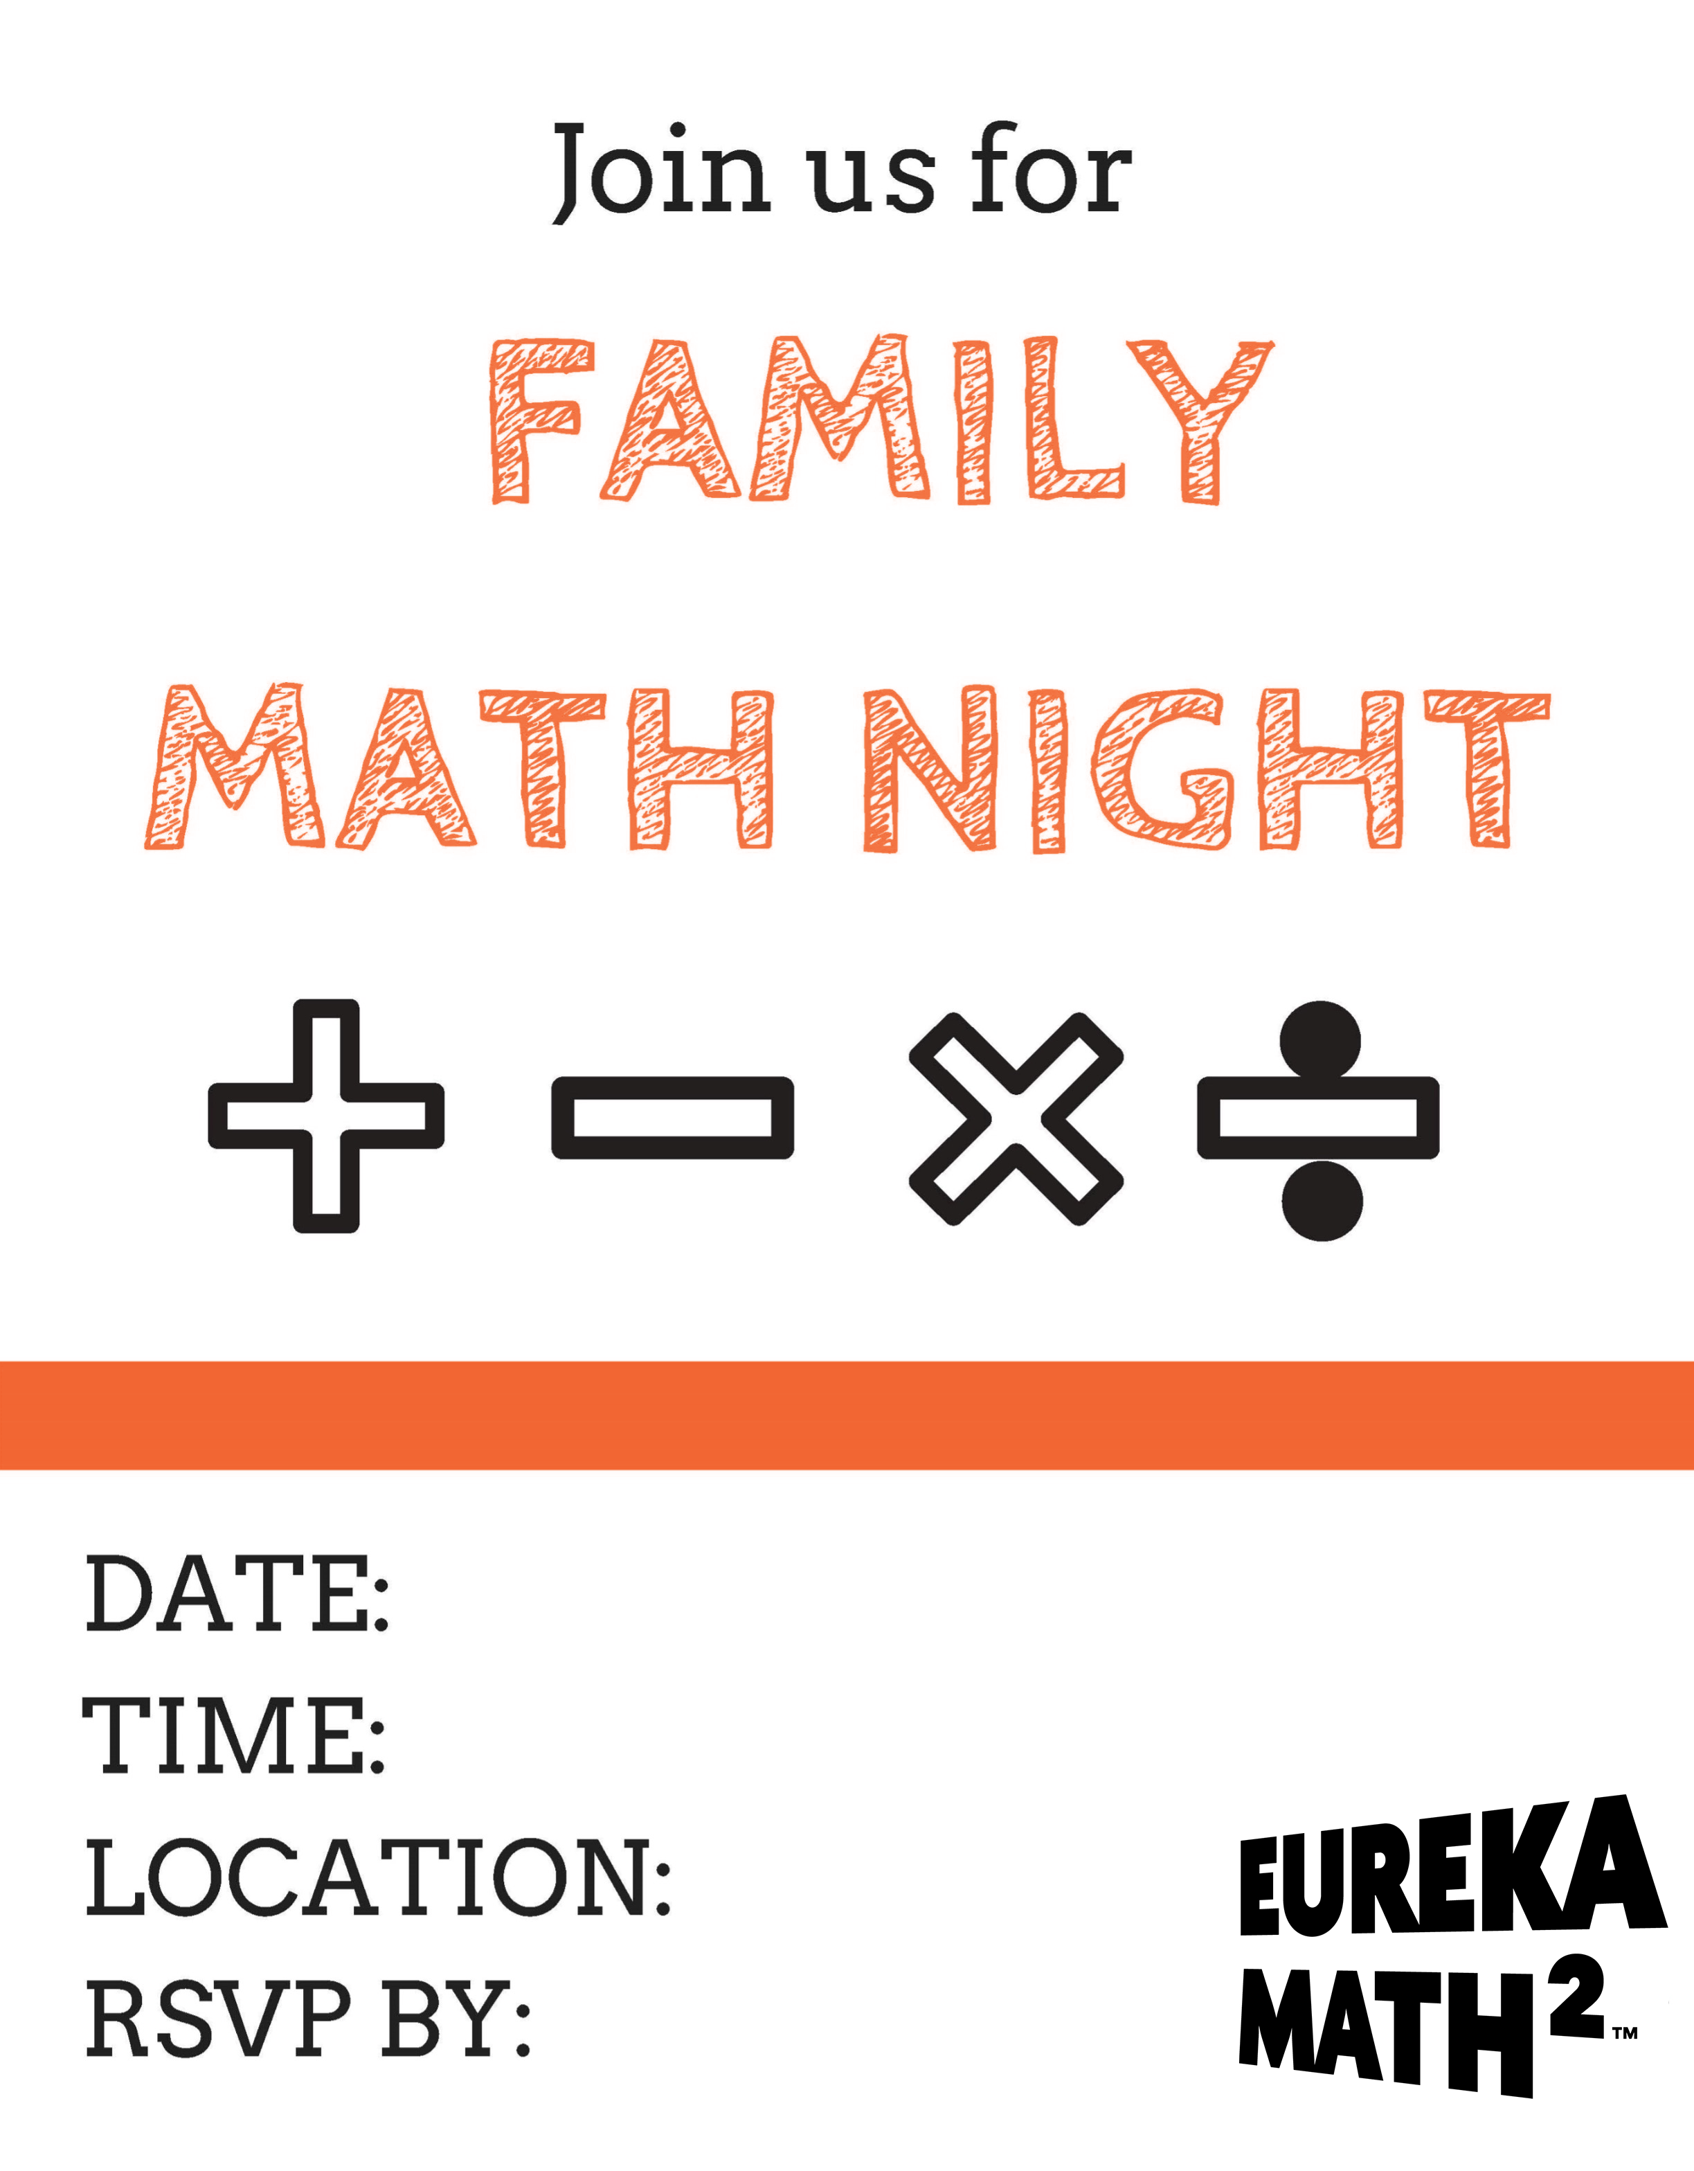
[COPY/PASTE FOLLOW-UP EMAIL – CUSTOMIZE BEFORE SENDING]

Dear Families OR <CAREGIVER NAME>,

Thank you to all the caregivers who attended our Math Night on <DATE>. It was great to see so many of you having fun with math while learning more about our curriculum, Eureka Math².

For those of you who could not make it, I’ve attached the handouts and some photos from our event. You can also visit gm.greatminds.org/eureka-math-squared-family-resources to review logging into the digital platform, and samples of the family resources available as part of the curriculum. Many of these resources are available in English and Spanish.

If you have any questions or suggestions for our next Math Night, please contact me via email.

I look forward to an inspiring and exciting school year!

Sincerely,
<TEACHER NAME>

[PRINTABLE FOLLOW-UP LETTER– CUSTOMIZE BEFORE PRINTING]

Dear Families,

Thank you to all the caregivers who attended our Math Night on <DATE>.
It was great to see so many people having fun with math while learning more about our curriculum, Eureka Math².

For those of you who could not make it, you can access the handouts on our class website or request that a copy be sent home with your child. You can also visit gm.greatminds.org/eureka-math-squared-family-resources to review logging into the digital platform, and samples of the family resources available as part of the curriculum. Many of these resources are available in English and Spanish.

If you have any questions or suggestions for our next Math Night, please contact me via email.

I look forward to an inspiring and exciting school year!

Sincerely,
<TEACHER NAME>

