Additional Guidance on Pacing for Differentiation
Purpose: This document, and the included templates were developed to help LEAs with unique pacing circumstances. The recommendations outlined below should be used in conjunction with LEAs and/or campus local context, and student data. As adjustments are being made to pacing, it is critical to keep in mind the importance of students having adequate time to develop conceptual understandings and are able to work through the concrete-pictorial-abstract progression.
Steps:
- Start with the upcoming school year calendar and count the number of instructional days in the school year (excluding: State assessment days, other assessments, field trips, flex days, etc.). It is important build in additional flex days to account for subs, and other potential pacing interruptions. Next, determine if there is a gap between the number of instructional days and the number of lessons that need to be taught to identify the number of lessons you may need to omit or combine.
- The templates at the end of this document can be used to help with this process
  - Pacing Guidance for Unique Schedules Instructional Days Worksheet
  - Pacing Guidance for Unique Schedules Year-Long Planning Template
  - Pacing Guidance for Unique Schedules Module-Level Planning Template

Leverage Data, Local Context, and Embedded Supports to Prioritize Lessons
- EM TEKS Provided Recommendations: Begin by looking at the “Note on Pacing for Differentiation” found within the Module Overview for each module to identify the recommended lessons that can be combined or omitted. See the example below from third grade Module 1.
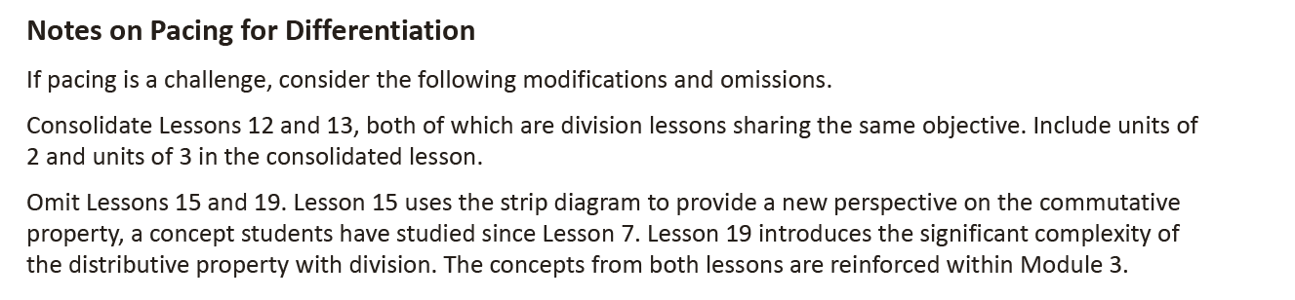
- Student data, teacher expertise, local context, and knowledge of students: Use these to identify lessons that may be quicker for students to grasp or have already mastered, as well as lessons that have similar content that can be combine.
- Gather grade level teachers together to review the suggestions made and then collaborate to create a common pacing calendar. Some suggestions of omissions or combinations may vary within the same grade level depending on student needs.

Some things to Consider:
- Follow the pacing calendar that is created and monitor timing of each lesson while still teaching every component. One recommendation is using a timer throughout the lesson to ensure lesson components are not exceeding the recommended time.
- Consider the most important topics for the grade level and the rigor of the standards before omitting any lessons.
- When thinking about lessons to condense or omit, consider where students are in the concrete-representational-abstract progression of the module. Students need sufficient time in the concrete and representational stages to develop deep conceptual understandings. Students will often work with these at the beginning of a module or topic, setting them up for success with the abstract.

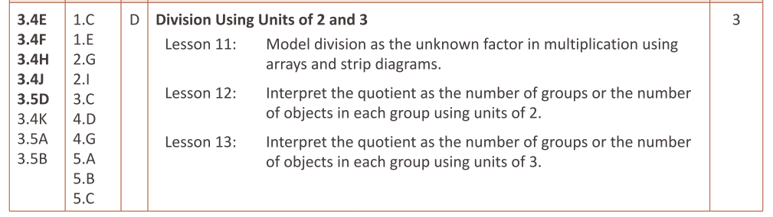
CRA Progression within a Topic (G3 M1)
Concrete/Representational

Abstract

CRA Progression within a Module (G4 M5)
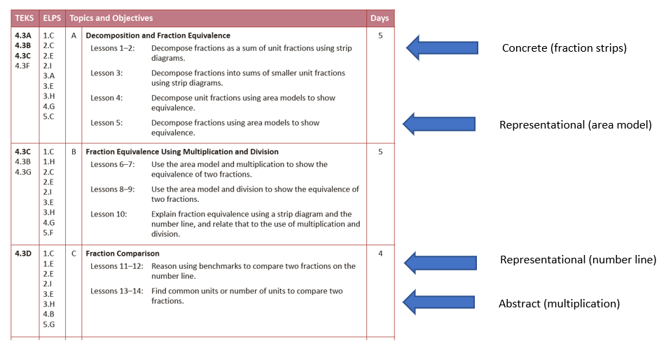

- Additionally, when combining lessons it is recommended that lessons be combined within a topic, so that the lessons are building the same conceptual understanding.
- In the scope and sequence of lessons found in the Module Overview, multiple days are given for the Mid- and End-of-Module Assessments (see image below from the Grade 3 Module 1 Overview of Module Topics and Lesson Objectives), these additional days can be reduced.
  - One recommendation is using one day for the assessment, and then leveraging a just-in-time intervention approach in the subsequent lessons. This may look like leveraging specific Fluencies, or strategies during the Application Problem or Concept Development
- Guidance for Combining Lessons
  - Start with the Exit Tickets - What end goal do the lessons have in common? What is different?
  - How could you adjust the Problem Set and the Concept Development to prepare students for the common understanding present in the Exit Ticket? Using the basis of the first lesson, think of what is needed from the next lesson to address any new understanding from the next lesson? (The Concept Development may include an additional problem to review or vocabulary that may need to be included. Two or three additional problems may need to be added to the Problem Set.)
  - Choose the Application Problem from either lesson based on skills that students need to practice or that support the understanding of the content in both lessons.
  - Choose Fluency activities based on which activity is designed to prepare students for the two combined lessons.
  - As customizations are made to combine the lessons, be sure to read the green margin notes, as well as the “Notes” under the Fluencies and Application Problem (see the screenshot below)
  - If there is a shortened number of school days, and longer class periods one recommendation would be to combine two lessons, and slightly extended the length of each lesson component as needed.
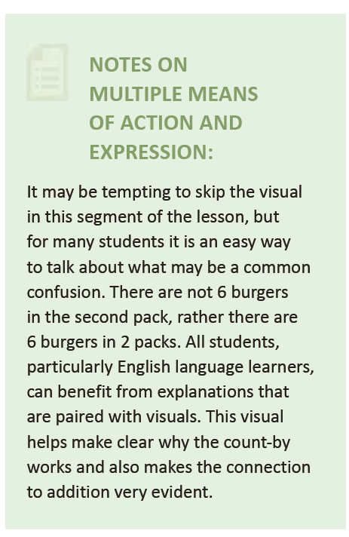
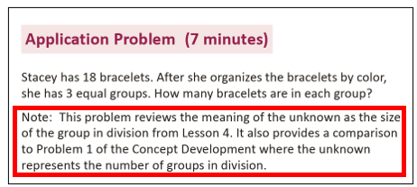
Application Problem G3 M1 L5 Concept Development G3 M1 L5

Pacing Guidance for Unique Schedules Instructional Days Worksheet

Number of Calendar Days
Number of Module Assessment Days: - _________
Number of State Assessment Days: - _________
Number of Other Assessment Days: - _________
Number of Field Trips/Non-teaching Days: - _________
Number of Flex Days: - _________

Number of Teaching Days =
Number of Lessons at Your Grade Level _________
How many lessons do we need to omit or combine?

Pacing Guidance for Unique Schedules Year-Long Planning Template

Module 1 | Module 2 | Module 3 | Module 4 | Module 5 | Module 6 | Module 7 | Module 8
Combine or omit #____  lessons | Combine or omit #____  lessons | Combine or omit #____  lessons | Combine or omit #____  lessons | Combine or omit #____  lessons | Combine or omit #____  lessons | Combine or omit #____  lessons | Combine or omit #____  lessons
List lessons to be omitted or combined: | List lessons to be omitted or combined: | List lessons to be omitted or combined: | List lessons to be omitted or combined: | List lessons to be omitted or combined: | List lessons to be omitted or combined: | List lessons to be omitted or combined: | List lessons to be omitted or combined:
Reasoning behind combining or omitting lessons: | Reasoning behind combining or omitting lessons: | Reasoning behind combining or omitting lessons: | Reasoning behind combining or omitting lessons: | Reasoning behind combining or omitting lessons: | Reasoning behind combining or omitting lessons: | Reasoning behind combining or omitting lessons: | Reasoning behind combining or omitting lessons:

Pacing Guidance for Unique Schedules Module-Level Planning Template
Module #
Lesson Number(s) | Omitted or Combined | Rationale | Fluencies Selected | Application Problem Selected | Concept Development Adjustments | Debrief Adjustments | Total Time
2 & 3 | Combined | The lessons have similar objectives | Lesson 2: Skip Counting  Lesson 3: How Many Equal Parts  Time: 10 min | Lesson 2: Independent  Practice  Time: 5 min | Lesson 2: skip the first problem in the Concept Development  Lesson 3: add problems two and three  Time: 26 min  Problem Set: Lesson 2 #1-3, Lesson 3 #1a-c, 2b-c  Time: 10 min | Debrief: Lesson 3 question #2  Time: 4 min  Exit Ticket: L3  Time: 5 min | 60 min

