Grade 3 Module 4: Properties of Multiplication and Division and Solving Problems with Units of 2-5 and 10
Topic A: Multiplication and the Meaning of Factors
Lesson 1 | Group Counting (3.4E) | Products in an Array (3.4D, 3.4E) | Count the Square Units (3.6C)
Lesson 2 | Group Counting (3.4E) | Products in an Array (3.4D, 3.4E | Find the Common Products (3.4E)
Lesson 3 | Group Counting (3.4E) | Write the Multiplication Fact (3.6C) | Products in an Array (3.4D, 3.4E)
Lesson 4 | Group Counting (3.4E) | Draw Rectangles (3.6C) | Draw Rectangular Arrays (3.6C)
Lesson 5 | Multiply by 6 (3.4E, 3.4F) | Group Counting (3.4E)
Topic B: Division as an Unknown Factor Problem
Lesson 6 | Group Counting (3.4E) | Find the Area (3.6C) | Decompose the Multiplication Equation (3.4K)
Lesson 7 | Group Counting (3.4E) | Find the Unknown Factor (3.5D)
Lesson 8 | Group Counting (3.4E) | Find the Unknown Factor (3.5D) | Find the Area (3.6C)
Topic C: Multiplication Using Units of 2 and 3
Lesson 9 | Group Counting (3.4E) | Multiply by 7 (3.4E, 3.4.F) | Find the Side Length (3.6C)
Lesson 10 | Group Counting (3.4E) | Find the Common Products (3.4E)
Lesson 11 | Group Counting (3.4E) | Multiply by 8 (3.4E, 3.4F) | Find the Area (3.6C, 3.6D)
Lesson 12 | Group Counting (3.4E) | Multiply by 9 ( 3.4E, 3.4F) | Find the Area (3.6C, 3.6D)
Lesson 13 | Group Counting (3.4E) | Multiply by 9 (3.4E, 3.4F) | Find the Area (3.6C, 3.6D)

TEKS Grade 3 Module 4 Fluencies
Lesson 1
Fluency Practice (12 minutes)
⬛ Group Counting 3.4E (3 minutes)
⬛ Products in an Array 3.4D, 3.4E (3 minutes)
⬛ Count the Square Units 3.6C (6 minutes)

Group Counting (3 minutes)
Note: Group counting reviews interpreting multiplication as repeated addition.
Instruct students to count forward and backward, occasionally changing the direction of the count.
⬛ Sixes to 60
⬛ Sevens to 70
⬛ Eights to 80
⬛ Nines to 90

Products in an Array (3 minutes)
Materials: (S) Personal white board
Note: This fluency activity anticipates relating multiplication with area.
T: (Project an array with 5 rows of 3 stars.) How many rows of stars do you see?
S: 5 rows.
T: How many stars are in each row?
S: 3 stars.
T: On your personal white board, write two different multiplication sentences that can be used to find
the total number of stars.
S: (Write 5 X 3 = 15 and 3 X 5 = 15.)
Continue with the following possible sequence: 4 X 6, 7 X 3, 8 X 5, and 9 X 7.

Count the Square Units (6 minutes)
Materials: (T) 12 square tiles
Note: This fluency activity reviews comparing the area of different shapes.
T: (Project an 8 X 1 tiled array.) How many square units are in the rectangle?
S: 8 square units.
T: (Write 8 square units next to the rectangle. Project a 4 X 2 tiled array.) How many square units are in
Back to top
the rectangle?
S: 8 square units.
T: (Write 8 square units next to the rectangle. Project a 2 X 4 tiled array.) How many square units are in
the rectangle?
S: 8 square units.
T: (Write 8 square units next to the rectangle. Project a 1 X 8 tiled array.) How many square units are in
the rectangle?
S: 8 square units.
T: (Write 8 square units next to the rectangle.) Do the four rectangles look the same?
S: No.
T: What do the rectangles have in common?
S: They are each composed of 8 square units.
Continue with the following possible sequence: 12 X 1, 1 X 12, 6 X 2, 3 X 4, 2 X 6, and 4 X 3.

Lesson 2
Fluency Practice (14 minutes)
⬛ Group Counting 3.4E (3 minutes)
⬛ Products in an Array 3.4D, 3.4E (3 minutes)
⬛ Find the Common Products 3.4E (8 minutes)

Group Counting (3 minutes)
Note: Group counting reviews interpreting multiplication as repeated addition.
Instruct students to count forward and backward, occasionally changing the direction of the count.
⬛ Threes to 30
⬛ Sixes to 60
⬛ Sevens to 70
⬛ Nines to 90

Back to top
Products in an Array (3 minutes)
Materials: (S) Personal white board
Note: This fluency activity anticipates relating multiplication with area.
T: (Project an array with 4 rows of 3 stars.) How many rows of stars do you see?
S: 4 rows.
T: How many stars are in each row?
S: 3 stars.
T: On your personal white board, write two multiplication sentences that can be used to find the total
number of stars.
S: (Write 4 X 3 = 12 and 3 X 4 = 12.)
Continue with the following possible sequence: 3 X 6, 7 X 5, 8 X 4, and 9 X 6.

Find the Common Products (8 minutes)
Materials: (S) Blank paper
Note: This fluency activity reviews multiplication patterns from Module 3.
T: (List the multiples of 4 and 8 in two different columns.)
Draw a line to match the products that appear in both
columns.
S: (Match 8, 16, 24, 32, and 40.)
T: (Write 2 X 4 = 8, etc., next to each matched product on the
left half of the paper.) Write the rest of the equations like
I did.
S: (Write equations.)
T: (Write 8 = 1 X 8, etc., next to each matched product on the
right half of the paper.) Write the rest of the equations like
I did.
S: (Write equations.)
Back to top
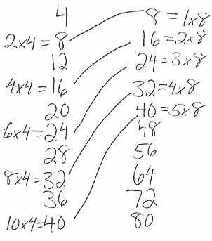
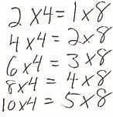
T: (Write 2 X 4 = ___ X 8.) Say the true equation.
S: 2 X 4 = 1 X 8.
T: (Write 2 X 4 = 1 X 8.) Write the remaining equal facts
as equations.
S: (Write 4 X 4 = 2 X 8, 6 X 4 = 3 X 8, 8 X 4 = 4 X 8, and 10 X 4 = 5 X 8.)
T: Discuss the patterns in your equations.
S: Each multiple of 8 is also a multiple of 4.

Lesson 3
Fluency Practice (12 minutes)
⬛ Group Counting 3.4E (4 minutes)
⬛ Write the Multiplication Fact 3.6C (4 minutes)
⬛ Products in an Array 3.4D, 3.4E (4 minutes)

Group Counting (4 minutes)
Note: Group counting reviews interpreting multiplication as repeated addition.
Instruct students to count forward and backward, occasionally changing the direction of the count.
Back to top
⬛ Sixes to 60
⬛ Sevens to 70
⬛ Eights to 80
⬛ Nines to 90

Write the Multiplication Fact (4 minutes)
Materials: (S) Personal white board
Note: This fluency activity reviews relating multiplication with area from Lesson 2.
T: (Project a 5 by 3 square unit tiled rectangle. Write ___ X ___ = 15.) There are 15 tiles altogether.
How many rows are there?
S: 5 rows.
T: (Write 5 X ___ = 15.) On your personal white board, fill in the blank to make the equation true.
S: (Write 5 X 3 = 15.)
T: (Project a 3 by 4 square unit tiled rectangle. Write ___ X ___ = 12.) There are 12 tiles altogether.
How many columns are there?
S: 4 columns.
T: (Write ___ X 4 = 12.) On your personal white board, fill in the blank to make the equation true.
S: (Write 3 X 4 = 12.)
Continue with the following possible sequence, asking students to first name either the number of rows or
the number of columns: 4 X 6, 6 X 7, 5 X 8, and 7 X 8.

Products in an Array (4 minutes)
Materials: (S) Personal white board
Note: This fluency activity supports the relationship between multiplication and area.
T: (Project an array with 2 rows of 6 stars.) How many rows of stars do you see?
S: 2 rows.
T: How many stars are in each row?
S: 6 stars.
T: On your personal white board, write two multiplication sentences that can be used to find the total
number of stars.
S: (Write 2 X 6 = 12 and 6 X 2 = 12.)
Continue with the following possible sequence: 3 × 7, 6 × 5, 8 × 6, and 4 × 9.

Back to top
Lesson 4
Fluency Practice (12 minutes)
⬛ Group Counting 3.4E (4 minutes)
⬛ Draw Rectangles 3.6C (4 minutes)
⬛ Draw Rectangular Arrays 3.6C (4 minutes)

Group Counting (4 minutes)
Note: Group counting reviews interpreting multiplication as repeated addition.
Instruct students to count forward and backward, occasionally changing the direction of the count.
⬛ Sixes to 60
⬛ Sevens to 70
⬛ Eights to 80
⬛ Nines to 90

Draw Rectangles (4 minutes)
Materials: (S) Grid paper
Note: This fluency activity reviews drawing a rectangle from a known area. Show student work that is correct but looks different (e.g., a 6 X 2 unit rectangle juxtaposed with a 4 X 3 unit rectangle).
T: Draw a rectangle that has an area of 6 square units.
S: (Draw a 6-square unit rectangle.)
Continue with the following possible sequence: 10 square units, 12 square units, 16 square units, 24 square units, and 35 square units.

Draw Rectangular Arrays (4 minutes)
Materials: (S) Grid paper
Note: This fluency activity reviews finding area using side lengths.
T: Draw a 4 X 2 rectangular array using the squares on your grid paper.
T: How many square units are in your array?
S: 8 square units.
Continue with the following possible sequence of rectangular arrays: 6 X 2, 4 X 3, 6 X 3, 9 X 2, 6 X 4, and 3 X 8.

Back to top
Lesson 5
Fluency Practice (11 minutes)
⬛ Multiply by 6 3.4E , 3.4F (8 minutes)
⬛ Group Counting 3.4E (3 minutes)

Multiply by 6 (8 minutes)
Materials: (S) Multiply by 6 (6–10) Pattern Sheet
Note: This activity builds fluency with respect to multiplication facts using units of 6. It works toward students knowing from memory all products of two one-digit numbers.
T: (Write 7 X 6 = ____.) Let us skip-count up by sixes. (Count with fingers to 7 as students count.)
S: 6, 12, 18, 24, 30, 36, 42.
T: Let us see how we can skip-count down to find the answer, too. (Show 10 fingers.) Start at 60.
(Count down with your fingers as students say numbers.)
S: 60, 54, 48, 42.
Continue with the following possible sequence: 9 × 6, 6 × 6, and 8 × 6.
T: Let us practice multiplying by 6. Be sure to work left to right across the page.
Directions for administration of a Multiply-By Pattern Sheet are as follows:
1. Allow a maximum of two minutes for students to complete as many problems as possible.
2. Direct students to work left to right across the page.
3. Encourage skip-counting strategies to solve unknown facts.

Group Counting (3 minutes)
Note: Group counting reviews interpreting multiplication as repeated addition.
Instruct students to count forward and backward, occasionally changing the direction of the count.
⬛ Fours to 40
⬛ Sevens to 70
⬛ Eights to 80
⬛ Nines to 90

Back to top
Lesson 6
Fluency Practice (12 minutes)
⬛ Group Counting 3.4E (4 minutes)
⬛ Find the Area 3.6C (4 minutes)
⬛ Decompose the Multiplication Equation 3.4K (4 minutes)

Group Counting (4 minutes)
Note: Group counting reviews interpreting multiplication as repeated addition.
Instruct students to count forward and backward, occasionally changing the direction of the count.
⬛ Fours to 40
⬛ Sevens to 70
⬛ Eights to 80
⬛ Nines to 90

Find the Area (4 minutes)
Note: This fluency activity reviews strategies for finding the area of a rectangle.
T: (Project a rectangular array with 2 rows of 4 units. Write 1 tile = 1 square meter.) What does 1 tile
equal?
S: 1 square meter.
T: (Point to the side length of 4 units.) What is the value of this side length?
S: 4 meters.
T: (Point to the side length of 2 units.) What is the value of this side length?
S: 2 meters.
T: Write a multiplication sentence to represent the area of the rectangle.
S: (Write 2 m X 4 m = 8 sq m or 4 m X 2 m = 8 sq m.)
Continue with the following possible sequence: 3 rows of 5 units, 3 rows of 7 units, 4 rows of 6 units, 4 rows of 9 units, and 6 rows of 8 units.

Back to top
Decompose the Multiplication Equation (4 minutes)
Materials: (S) Personal white board
Note: This activity anticipates the distributive property used in Lesson 7, while reviewing Module 3
concepts.
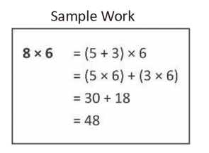

T: (Write 8 X 6 = (5 + ___) X 6.) Copy the equation on your
personal white board, and fill in the blank.
S: (Write 8 X 6 = (5 + 3) X 6.)
T: (Write = (___ X 6) + (___ X 6).) Copy the equation on
your personal white board, and fill in the blanks.
S: (Write (5 X 6) + (3 X 6).)
T: Solve the multiplication problems and write an addition equation.
Below it, write your answer.
S: (Write 30 + 18 and 48 below it.)
Continue with the following possible sequence: 7 X 6, 6 X 6, and 9 X 6.

Lesson 7
Fluency Practice (8 minutes)
⬛ Group Counting 3.4E (3 minutes)
⬛ Find the Unknown Factor 3.5D (5 minutes)

Group Counting (3 minutes)
Note: Group counting reviews interpreting multiplication as repeated addition.
Instruct students to count forward and backward, occasionally changing the direction of the count.
⬛ Sixes to 60
⬛ Sevens to 70
⬛ Eights to 80
⬛ Nines to 90
Back to top
Find the Unknown Factor (5 minutes)
Materials: (S) Personal white board
Note: This fluency activity anticipates finding all possible side lengths of rectangles with areas of 12, 24, 36, 48, and 72 square units in Lesson 8.
T: (Write 4 X ___ = 12.) Find the unknown factor, and say the equation.
S: 4 X 3 = 12.
Continue with the following possible sequence: 6 X ___ = 12, 2 X ___ = 12, and 3 X ___ = 12.
T: (Write 8 X ___ = 24.) Copy my equation on your personal white board, and fill in the unknown factor.
S: (Write 8 X 3 = 24.)

Continue with the following possible sequence:
6 × __ = 24
4 × __ = 24
9 × __ = 72
12 X __ = 36
4 × __ = 48
3 × __ = 24
4 × __ = 36
6 × __ = 48
12 X __ = 48
6 × __ = 72
6 × __ = 36
8 × __ = 72
2 × __ = 24
12 X __ = 72
3 × __ = 72
9 × __ = 36
8 × __ = 48
12 X __ = 24
3 × __ = 36

Back to top
Lesson 8
Fluency Practice (13 minutes)
⬛ Group Counting 3.4E (3 minutes)
⬛ Find the Unknown Factor 3.5D (5 minutes)
⬛ Find the Area 3.6C (5 minutes)

Group Counting (3 minutes)
Note: Group counting reviews interpreting multiplication as repeated addition.
Instruct students to count forward and backward, occasionally changing the direction of the count.
⬛ Sixes to 60
⬛ Sevens to 70
⬛ Eights to 80
⬛ Nines to 90

Find the Unknown Factor (5 minutes)
Materials: (S) Personal white board
Note: This fluency activity anticipates the objective of today’s lesson.
T: (Write 6 X ___ = 12.) Find the unknown factor, and say the equation.
S: 6 X 2 = 12.
Continue with the following possible sequence: 4 X ___ = 12, 2 X ___ = 12, and 3 X ___ = 12.
T: (Write 3 X ___ = 24.) Copy my equation on your personal white board, and fill in the unknown factor.
S: (Write 3 X 8 = 24.)
Continue with the following possible sequence: 4 X __ = 24, 8 X __ = 24, 6 X __ = 36, 4 X __ = 36, 6 X __ = 24, 9 X __ = 36, 9 X __ = 72, 6 X __ = 48, 8 X __ = 72, 8 X __ = 48, and 2 X __ = 24.

Back to top
Find the Area (5 minutes)
Materials: (S) Personal white board
Note: This fluency activity reviews using the distributive property
from Lesson 7.

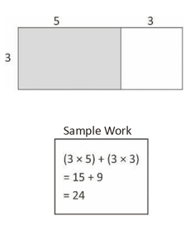

T: (Project the rectangle as shown.) On your personal
white board, write an expression that we could use to
find the area of the shaded rectangle.
S: (Write 3 X 5.)
T: On your board, write an expression that we could use to find
the area of the unshaded rectangle.
S: (Write 3 X 3.)
T: How can you use these expressions to find the area of the large
rectangle?
S: Add them!
T: Write an equation showing the sum of the shaded and
unshaded rectangles. Below it, write the area of the
entire rectangle.
S: (Write 15 + 9 = 24 and Area: 24 square units.)
Continue with the following possible sequence:
9 X 5 = (5 X 5) + (4 X 5), 13 X 4 = (10 X 4) + (3 X 4), and
17 X 3 = (10 X 3) + (7 X 3).

Lesson 9
Fluency Practice (15 minutes)
⬛ Group Counting 3.4E (3 minutes)
⬛ Multiply by 7 3.4E, 3.4.F (7 minutes)
Back to top
⬛ Find the Side Length 3.6C (5 minutes)

Group Counting (3 minutes)
Note: Group counting reviews interpreting multiplication as repeated addition.
Instruct students to count forward and backward, occasionally changing the direction of the count.
 Fours to 40
 Sixes to 60
 Eights to 80
 Nines to 90

Multiply by 7 (7 minutes)
Materials: (S) Multiply by 7 (6–10) Pattern Sheet
Note: This activity builds fluency with multiplication facts using units of 7. It works toward students knowing from memory all products of two one-digit numbers. See Lesson 5 for the directions for administration of a Multiply-By Pattern Sheet.
T: (Write 7 X 7 = ___.) Let’s skip-count up by sevens. (Count with fingers to 7 as students count.)
S: 7, 14, 21, 28, 35, 42, 49.
T: Let’s see how we can skip-count down to find the answer, too. (Show 10 fingers.) Start at 70.
(Count down with your fingers as students say numbers.)
S: 70, 63, 56, 49.
Continue with the following possible sequence: 9 X 7, 6 X 7, and 8 X 7.
T: Let’s practice multiplying by 7. Be sure to work left to right across the page.

Find the Side Length (5 minutes)
Materials: (S) Personal white board
Note: This fluency activity reviews the relationship between side lengths and area.
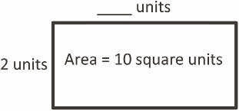
T: (Project a rectangle with a width of 2 units and an unknown length. Inside the rectangle, write
Area = 10 square units .) Say the area of the rectangle.
S: 10 square units.
T: What’s the width of the rectangle?
Back to top
S: 2 units.
T: (Write 2 units X __ units = 10 square units.) On your
personal white board, complete the equation, filling
in the unknown length.
S: (Write 2 units X 5 units = 10 square units.)
Continue with the possible following sequence: 1 unit X __ units = 8 square units, 5 units X __ units = 15 square units, 3 units X __ units = 18 square units, and 6 units X __ units = 24 square units.

Lesson 10
Fluency Practice (12 minutes)
⬛ Group Counting 3.4E (4 minutes)
⬛ Find the Common Products 3.4E (8 minutes)

Group Counting (4 minutes)
Note Group counting reviews interpreting multiplication as repeated addition.
Instruct students to count forward and backward, occasionally
changing the direction of the count.
 Threes to 30
 Sixes to 60
 Eights to 80
 Nines to 90
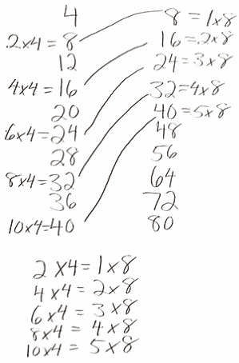
Back to top
Find the Common Products (8 minutes)
Materials: (S) Blank paper
Note: This fluency activity reviews multiplication patterns.
After listing the products of 4 and 8, guide students through the
following steps:
T: Draw a line to match the products that appear in both
columns.
S: (Match 8, 16, 24, 32, and 40.)
T: (Write 2 X 4 = 8, etc., next to each matched product on the left half of the paper.) Write the rest of
the number sentences like I did.
S: (Write number sentences.)
T: (Write 8 = 1 X 8, etc., next to each matched product on the right half of the paper.) Write the rest of
the number sentences like I did.
S: (Write number sentences.)
T: (Write 2 X 4 = __ X 8.) Say the true number sentence.
S: 2 X 4 = 1 X 8.
T: (Write 2 X 4 = 1 X 8.) Write the remaining equal facts as number sentences.
S: (Write 4 X 4 = 2 X 8, 6 X 4 = 3 X 8, 8 X 4 = 4 X 8, and 10 X 4 = 5 X 8.)
T: Discuss the patterns in your number sentences.

Lesson 11
Fluency Practice (15 minutes)
⬛ Group Counting 3.4E (3 minutes)
⬛ Multiply by 8 3.4E, 3.4F (7 minutes)
⬛ Find the Area 3.6C, 3.6D (5 minutes)

Group Counting (3 minutes)
Note: Group counting reviews interpreting multiplication as repeated addition.
Direct students to count forward and backward, occasionally changing the direction of the count.
Fours to 40
Sixes to 60
Sevens to 70
Nines to 90
Back to top
Multiply by 8 (7 minutes)
Materials: (S) Multiply by 8 (6–10) Pattern Sheet
Note: This activity builds fluency with multiplication facts using units of 8. It works toward students knowing from memory all basic facts through 10 X 10.
T: (Write 6 X 8 = ___.) Let’s skip-count up by eights to solve. (Count with fingers to 6 as students
count.)
S: 8, 16, 24, 32, 40, 48.
T: Let’s skip-count down to find the answer, too. Start at 80. (Count down with fingers as students
count.)
S: 80, 72, 64, 56, 48.
T: Let’s skip-count up again to find the answer, but this time, start at 40. (Count up with fingers as
students count.)
S: 40, 48.
Continue with the following possible sequence: 8 X 8, 7 X 8, and 9 X 8.
T: Let’s practice multiplying by 8. Be sure to work left to right across the page.

Find the Area (5 minutes)
Materials: (S) Personal white board
Note: This fluency activity reviews the relationship between side lengths and
area and supports the perception of the composite shapes by moving from part
to whole using a grid.
T: (Project the first figure on the right.) On your personal white board,
write a number sentence to show the area of the shaded rectangle.
S: (Write 5 X 2 = 10 or 2 X 5 = 10.)
T: Write a number sentence to show the area of the unshaded rectangle.
S: (Write 3 X 2 = 6 or 2 X 3 = 6.)
T: (Write __ sq units + __ sq units = __ sq units.) Using the areas of the
shaded and unshaded rectangle, write an addition sentence to show the
area of the entire figure.
S: (Write 10 sq units + 6 sq units = 16 sq units or
6 sq units + 10 sq units = 16 sq units.)
Continue with the other figures.

Back to top
Figures for Find the Area
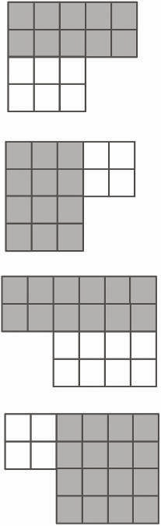

Back to top
Lesson 12
Fluency Practice (15 minutes)
⬛ Group Counting 3.4E (3 minutes)
⬛ Multiply by 9 3.4E, 3.4F (7 minutes)
⬛ Find the Area 3.6C, 3.6D (5 minutes)

Group Counting (3 minutes)
Note: Group counting reviews interpreting multiplication as repeated addition.
Instruct students to count forward and backward, occasionally changing the direction of the count.
Threes to 30
Sixes to 60
Sevens to 70
Eights to 80

Multiply by 9 (7 minutes)
Materials: (S) Multiply by 9 (1− 5) Pattern Sheet
Note: This activity builds fluency with multiplication facts using units of 9. It works toward students knowing all products of two one-digit numbers from memory. See Lesson 5 for the directions for administration of a Multiply-By Pattern Sheet.
T: (Write 5 X 9 = ____.) Let’s skip-count by nines to find the answer. (Count with fingers to 5 as
students count.)
S: 9, 18, 27, 36, 45. (Record on the board as students count.)
T: (Circle 45 and write 5 X 9 = 45 above it. Write 3 X 9 = ____.) Let’s skip-count up by nines again.
(Count with fingers to 3 as students count.)
S: 9, 18, 27.
T: Let’s see how we can skip-count down to find the answer, too. Start at 45 with 5 fingers,
1 for each 9. (Count down with your fingers as students say numbers.)
S: 45 (5 fingers), 36 (4 fingers), 27 (3 fingers).
Repeat the process for 4 X 9.
T: Let’s practice multiplying by 9. Be sure to work left to right across the page.

Find the Area (5 minutes)
Materials: (S) Personal white board
Note: This fluency activity reviews the relationship between side lengths and area; additionally, it supports the perception of the composite shape by moving from part to whole using a grid.
Back to top
T: (Project the figure on the right.) On your personal white board,
write a number sentence to show the area of the shaded
rectangle.
S: (Write 4 X 2 = 8 or 2 X 4 = 8.)
T: Write a number sentence to show the area of the unshaded
rectangle.
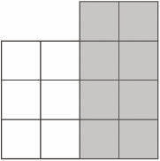
S: (Write 3 X 2 = 6 or 2 X 3 = 6.)
T: (Write __ sq units + __ sq units = __ sq units.) Using the areas of the shaded and unshaded
rectangles, write an addition sentence to show the area of the entire figure.
S: (Write 8 sq units + 6 sq units = 14 sq units or 6 sq units + 8 sq units = 14 sq units.)
Continue with the figures below:
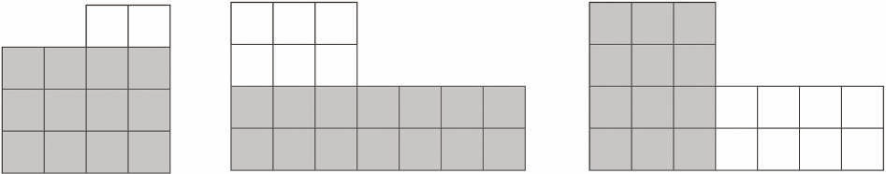

Lesson 13
Fluency Practice (15 minutes)
⬛ Group Counting 3.4E (3 minutes)
⬛ Multiply by 9 3.4E, 3.4F (7 minutes)
⬛ Find the Area 3.6C, 3.6D (5 minutes)

Back to top
Group Counting (3 minutes)
Note: Group counting reviews interpreting multiplication as repeated addition.
Instruct students to count forward and backward, occasionally changing the direction of the count.
 Sixes to 60
 Sevens to 70
 Eights to 80

Multiply by 9 (7 minutes)
Materials: (S) Multiply by 9 (6–10) Pattern Sheet
Note: This activity builds fluency with multiplication facts using units of 9. It works toward students knowing all products of two one-digit numbers from memory. See Lesson 5 for the directions for administration of a
Multiply-By Pattern Sheet.
T: (Write 6 X 9 = ____.) Let’s skip-count up by nine to solve. (Count with fingers to 6 as students count.)
S: 9, 18, 27, 36, 45, 54.
T: Let’s skip-count down to find the answer, too. Start at 90. (Count down with fingers as students
count.)
S: 90, 81, 72, 63, 54.
T: Let’s skip-count up again to find the answer, but this time start at 45. (Count up with fingers as
students count.)
S: 45, 54.
Continue with the following possible sequence: 8 X 9, 7 X 9, and 9 X 9.
T: Let’s practice multiplying by 9. Be sure to work left to right across the page.

Back to top
Find the Area (5 minutes)
Materials: (S) Personal white board
Note: This fluency activity reviews Lesson 11.
T: (Project the first figure on the right.) Find the areas of
the large rectangle and the unshaded rectangle. Then,
subtract to find the area of the shaded figure. (Write
Area = ____ square inches .)
S: (Work and write Area = 27 square inches .)
Continue with other figures.
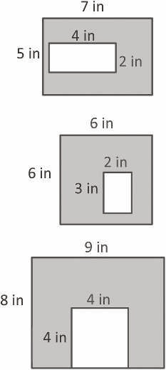
Back to top

