Grade 3 Module 7: Geometry and Measurement Word Problems
Topic A: Solving Word Problems
Lesson 1 | Name the Shape (2.8C) | Multiply by 3 (3.4E, 3.4F) | Equivalent Counting with Units of 2 3.4E
Lesson 2 | Name the Shape (2.8C) | Multiply by 3 (3.4E, 3.4F) | Equivalent Counting with Units of 4 3.4E
Lesson 3 | Name the Shape (2.8C) | Multiply by 4 (3.4E, 3.4F) | Equivalent Counting with Units of 3 3.4E
Topic B: Attributes of Two- and Three- Dimensional Figures
Lesson 4 | Multiply by 4 (3.4E, 3.4F) | Equivalent Counting with Units of 5 (3.4E)
Lesson 5 | Multiply by 5 (3.4E, 3.4F) | Equivalent Counting with Units of 6 (3.4E) | Classify the Polygon 3.6B
Lesson 6 | Equivalent Counting with Units of 7 (3.4E) | Multiply by 5 (3.4E, 3.4F)
Lesson 7 | Multiply by 6 (3.4E, 3.4F) | Physiometry (3.6A, 3.6B) | Classify the Polygon 3.6B
Lesson 8 | Multiply by 6 (3.4E, 3.4F) | Equivalent Counting with Units of 8 (3.4E) | Shade Rectangles of Equal Area 3.6E
Topic C: Problem Solving with Perimeter
Lesson 9 | Multiply by 7 (3.4E, 3.4F) | Equivalent Counting with Units of 9 (3.4E)
Lesson 10 | No fluency
Lesson 11 | Multiply by 7 (3.4E, 3.4F) | Equivalent Counting with Units of 3 (3.4E) | Area and Perimeter 3.6C
Lesson 12 | Multiply by 8 (3.4E, 3.4F) | Equivalent Counting with Units of 4 (3.4E) | Find the Perimeter 3.7B
Lesson 13 | Multiply by 8 (3.4E, 3.4F) | Equivalent Counting with Units of 7 (3.4E)
Lesson 14 | Multiply by 9 (3.4E, 3.4F) | Equivalent Counting with Units of 5 (3.4E) | Find the Perimeter 3.7B
Lesson 15 | Multiply by 9 (3.4E, 3.4F) | Equivalent Counting with Units of 6 (3.4E) | Find the Perimeter 3.7B
Lesson 16 | Factors (3.5D) | Equivalent Counting with Units of 8 (3.4E) | Find the Perimeter 3.7B
Topic D: Recording Perimeter and Area Data on Dot Plots
Lesson 17 | Find the Unknown Factors (3.5D) | Draw Strip Diagrams (3.4E) | Find the Area and Perimeter 3.6C, 3.7B
Lesson 18 | Sprint: Multiply or Divide by 2 (3.4F) | Find the Perimeter (3.7B)
Lesson 19 | Sprint: Multiply or Divide by 3 (3.4F)
Lesson 20 | Sprint: Multiply or Divide by 4 (3.4F)
Lesson 21 | Sprint: Multiply or Divide by 5 (3.4F) | Find the Perimeter and Area (3.6C, 3.7B)
Topic E: Problem Solving with Perimeter and Area
Lesson 22 | Sprint: Multiply or Divide by 6 (3.4F)
Lesson 23 | Sprint: Multiply or Divide by 7 (3.4F) | Find the Perimeter (3.7B)
Lesson 24 | Sprint: Multiply or Divide by 8 (3.4F) | Find the Perimeter (3.7B)
Topic F: Year in Review
Lesson 25 | Sprint: Multiply or Divide by 9 (3.4F) | Multiply and Divide (3.4F)
Lesson 26 | Sprint: Mixed Multiplication (3.4F) | Divide (3.4F)
Lesson 27 | Sprint: Mixed Division (3.4F) | Multiply (3.4F) | Mixed Review Games

Lesson 1
Fluency Practice (15 minutes)
⬛⬛ Name the Shape 2.8C (3 minutes)
⬛⬛ Multiply by 3 3.4E, 3.4F (8 minutes)
⬛⬛ Equivalent Counting with Units of 2 3.4E (4 minutes)

Name the Shape (3 minutes)
Note: This fluency activity reviews Grade 2 geometry concepts in preparation for Topic B.
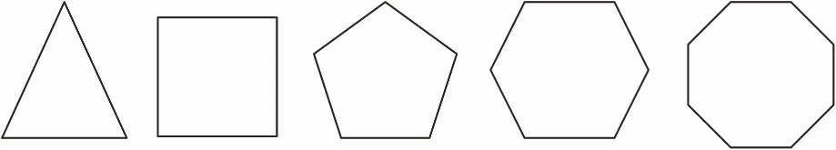
T: (Project the triangle.) What’s the name of the shape?
S: Triangle.
T: (Project the square.) What’s one name for this shape?
S: Square (or rectangle).
T: How many sides does a square have?
S: Four.
T: What’s the name for all four-sided figures?
S: Quadrilateral.
Continue with the following possible shapes: pentagon, hexagon, and octagon.

Multiply by 3 (8 minutes)
Materials: (S) Multiply by 3 (1–5) (Pattern Sheet)
Note: This activity builds fluency with multiplication facts using units of 3. It works toward students knowing from memory all products of two one-digit numbers.
T: (Write 5 X 3 = _____.) Let’s skip-count up by threes to find the answer. (Raise a finger for each
number to track the count. Record the skip-count answers on the board.)
S: 3, 6, 9, 12, 15.
T: (Circle 15, and write 5 X 3 = 15 above it. Write 3 X 3 = _____.) Let’s skip-count up by threes again.
(Track with fingers as students count.)
S: 3, 6, 9.
T: Let’s see how we can skip-count down to find the answer, too. Start at 15 with 5 fingers, 1 for each
three. (Count down with fingers as students say the numbers.)
S: 15 (5 fingers), 12 (4 fingers), 9 (3 fingers).
Repeat the process for 4 X 3.
T: Let’s practice multiplying by 3. Be sure to work left to right across the page.
Directions for Administration of Multiply-By Pattern Sheet
⬛⬛ Allow a maximum of two minutes for students to complete as many problems as possible.
⬛⬛ Direct students to work left to right across the page.
⬛⬛ Encourage skip-counting strategies to solve unknown facts.

Back to top
Equivalent Counting with Units of 2 (4 minutes)
Note: This activity builds fluency with multiplication facts using units of 2. The progression builds in
complexity. Work students up to the highest level of complexity where they can confidently participate.
T: Count to 10. (Write as students count. See the chart below.)
S: 1, 2, 3, 4, 5, 6, 7, 8, 9, 10.
T: (Write 1 two beneath the 1.) Count to 10 twos. (Write as students count.)
S: 1 two, 2 twos, 3 twos, 4 twos, 5 twos, 6 twos, 7 twos, 8 twos, 9 twos, 10 twos.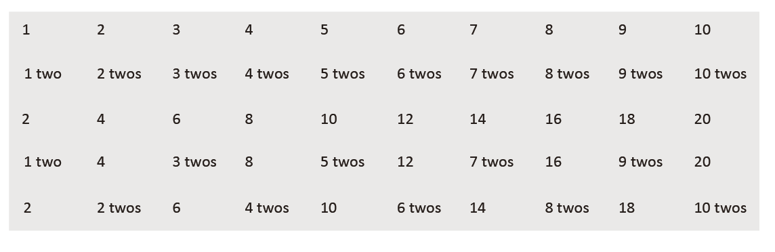
T: Count by twos to 20. (Write as students count.)
S: 2, 4, 6, 8, 10, 12, 14, 16, 18, 20.
T: (Write 1 two beneath the 2. Write 4 beneath the 4.) I’m going to give you a challenge. Let’s alternate
between saying the units of two and the number. (Write as students count.)
S: 1 two, 4, 3 twos, 8, 5 twos, 12, 7 twos, 16, 9 twos, 20.
T: (Write 2 beneath 1 two and 2 twos beneath the 4.) Let’s alternate again. (Write as students count.)
S: 2, 2 twos, 6, 4 twos, 10, 6 twos, 14, 8 twos, 18, 10 twos.

Lesson 2
Fluency Practice (15 minutes)
⬛⬛ Name the Shape 2.8C (3 minutes)
⬛⬛ Multiply by 3 3.4E, 3.4F (8 minutes)
⬛⬛ Equivalent Counting with Units of 4 3.4E (4 minutes)

Name the Shape (3 minutes)
Note: This activity reviews Grade 2 geometry concepts in
preparation for Topic B.
T: (Project the triangle.) What’s the name of the shape?
S: Triangle.
T: (Project the rectangle.) What’s one name for
this shape?
S: Rectangle (or parallelogram or quadrilateral).
T: How many sides does a rectangle have?
S: Four.
T: How many right angles does a rectangle
have?
S: Four!
T: What’s the name for all four-sided figures?
S: Quadrilateral.
Back to top
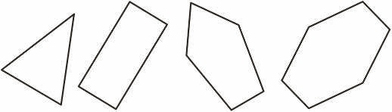
Continue with the following possible shapes: pentagon and hexagon.

Multiply by 3 (8 minutes)
Materials: (S) Multiply by 3 (6–10) Pattern Sheet
Note: This activity builds fluency with multiplication facts using units of 3. It works toward students knowing
from memory all products of two one-digit numbers. See Lesson 1 for the directions for administration of a Multiply-By Pattern Sheet.
T: (Write 7 X 3 = _____.) Let’s skip-count up by threes. I’ll raise a finger for each three. (Raise a finger for each number to track the count.)
S: 3, 6, 9, 12, 15, 18, 21.
T: Let’s skip-count by threes starting at 15. Why is 15 a good place to start?
S: It’s a fact we already know, so we can use it to figure out a fact we don’t know.
T: (Track with fingers as students say the numbers.)
S: 15 (5 fingers), 18 (6 fingers), 21 (7 fingers).
T: Let’s see how we can skip-count down to find the answer, too. Start at 30 with 10 fingers, 1 for each
three. (Count down with fingers as students say the numbers.)
S: 30 (10 fingers), 27 (9 fingers), 24 (8 fingers), 21 (7 fingers).
Continue with the following possible sequence: 9 X 3, 6 X 3, and 8 X 3.
T: Let’s practice multiplying by 3. Be sure to work left to right across the page.

Equivalent Counting with Units of 4 (4 minutes)
Note: This activity builds fluency with multiplication facts using units of 4. The progression builds in
complexity. Work students up to the highest level of complexity where they can confidently participate.
T: Count to 10. (Write as students count. See the chart below.)
S: 1, 2, 3, 4, 5, 6, 7, 8, 9, 10.
T: (Write 1 four beneath the 1.) Count to 10 fours. (Write as students count.)
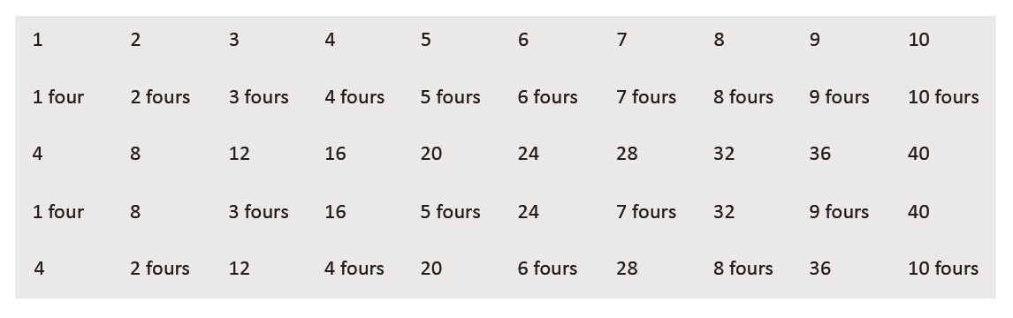
S: 1 four, 2 fours, 3 fours, 4 fours, 5 fours, 6 fours, 7 fours, 8 fours, 9 fours, 10 fours.
T: Count by fours to 40. (Write as students count.)
S: 4, 8, 12, 16, 20, 24, 28, 32, 36, 40.
T: (Write 1 four beneath the 4. Write 8 beneath the 8.) I’m going to give you a challenge. Let’s alternate
between saying the units of four and the number. (Write as students count.)
S: 1 four, 8, 3 fours, 16, 5 fours, 24, 7 fours, 32, 9 fours, 40.
T: (Write 4 beneath 1 four and 2 fours beneath the 8.) Let’s alternate again. (Write as students count.)
S: 4, 2 fours, 12, 4 fours, 20, 6 fours, 28, 8 fours, 36, 10 fours.
Back to top
Lesson 3
Fluency Practice (15 minutes)
⬛⬛ Name the Shape 2.8C (3 minutes)
⬛⬛ Multiply by 4 3.4E, 3.4F (8 minutes)
⬛⬛ Equivalent Counting with Units of 3 3.4E (4 minutes)

Name the Shape (3 minutes)
Note: This activity reviews Grade 2 geometry concepts in preparation for Topic B.

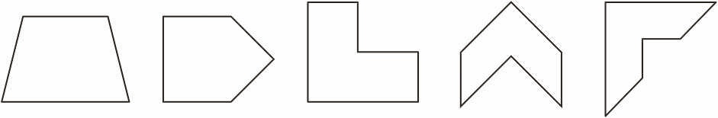
T: (Project the trapezoid.) How many sides does this shape have?
S: Four sides.
T: How many vertices does this shape have?
S: Four vertices.
T: What’s the name for all four-sided figures?
S: Quadrilateral.
T: (Project the pentagon.) How many sides does this shape have?
S: Five sides.
T: How many vertices does this shape have?
S: 5 vertices.
T: What’s the name for all five-sided figures?
S: Pentagon.
Continue the process for all three hexagons.

Multiply by 4 (8 minutes)
Materials: (S) Multiply by 4 (1–5) Pattern Sheet
Note: This activity builds fluency with multiplication facts using units of 4. It works toward students knowing from memory all products of two one-digit numbers. See Lesson 1 for the directions for administration of a Multiply-By Pattern Sheet.
T: (Write 5 X 4 = _____.) Let’s skip-count up by fours to find the answer. (Raise a finger for each
number to track the count. Record the skip-count answers on the board.)
S: 4, 8, 12, 16, 20.
T: (Circle 20, and write 5 X 4 = 20 above it. Write 3 X 4 = _____.) Let’s skip-count up by fours again.
(Track with fingers as students count.)
S: 4, 8, 12.
T: Let’s see how we can skip-count down to find the answer, too. Start at 20 with 5 fingers, 1 for each
four. (Count down with fingers as students say the numbers.)
S: 20 (5 fingers), 16 (4 fingers), 12 (3 fingers).
Repeat the process for 4 X 4.
T: Let’s practice multiplying by 4. Be sure to work left to right across the page.

Back to top
Equivalent Counting with Units of 3 (4 minutes)
Note: This activity builds fluency with multiplication facts using units of 3. The progression builds in
complexity. Work students up to the highest level of complexity where they can confidently participate.
T: Count to 10. (Write as students count. See the chart below.)
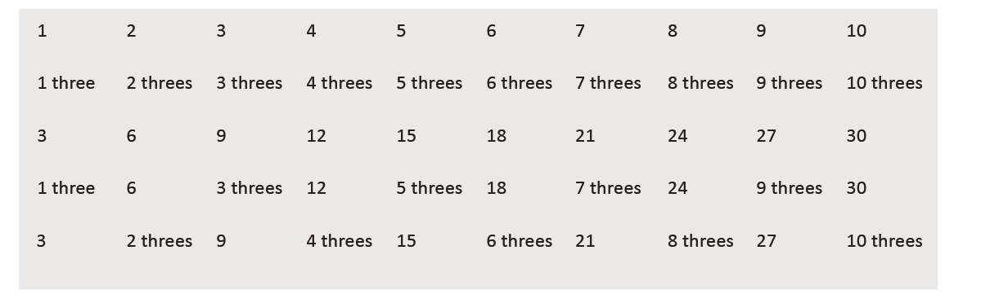
S: 1, 2, 3, 4, 5, 6, 7, 8, 9, 10.
T: (Write 1 three beneath the 1.) Count to 10 threes. (Write as students count.)
S: 1 three, 2 threes, 3 threes, 4 threes, 5 threes, 6 threes, 7 threes, 8 threes, 9 threes, 10 threes.
T: Count by threes to 30. (Write as students count.)
S: 3, 6, 9, 12, 15, 18, 21, 24, 27, 30.
T: (Write 1 three beneath the 3. Write 6 beneath the 6.) I’m going to give you a challenge.
Let’s alternate between saying the units of three and the number. (Write as students count.)
S: 1 three, 6, 3 threes, 12, 5 threes, 18, 7 threes, 24, 9 threes, 30.
T: (Write 3 beneath 1 three and 2 threes beneath the 6.) Let’s alternate again.
(Write as students count.)
S: 3, 2 threes, 9, 4 threes, 15, 6 threes, 21, 8 threes, 27, 10 threes.

Lesson 4
Fluency Practice (12 minutes)
⬛⬛ Multiply by 4 3.4E , 3.4F
⬛⬛ Equivalent Counting with Units of 5 3.4E
(8 minutes)
(4 minutes)

Multiply by 4 (8 minutes)
Materials: (S) Multiply by 4 (6–10) Pattern Sheet
Note: This activity builds fluency with multiplication facts using units of 4. It works toward students knowing from memory all products of two one-digit numbers. See Lesson 1 for the directions for administration of a Multiply-By Pattern Sheet.
T: (Write 7 X 4 = ____.) Let’s skip-count up by fours. I’ll raise a finger for each four. (Raise a finger for
each number to track the count.)
S: 4, 8, 12, 16, 20, 24, 28.
T: Let’s skip-count up by fours starting at 20. Why is 20 a good place to start?
S: It’s a fact we already know, so we can use it to figure out a fact we don’t know.
T: (Track with fingers as students say the numbers.)
S: 20 (5 fingers), 24 (6 fingers), 28 (7 fingers).
T: Let’s see how we can skip-count down to find the answer, too. Start at 40 with 10 fingers, 1 for each
four. (Count down with fingers as students say the numbers.)
S: 40 (10 fingers), 36 (9 fingers), 32 (8 fingers), 28 (7 fingers).
Continue with the following possible sequence: 9 X 4, 6 X 4, and 8 X 4.
T: Let’s practice multiplying by 4. Be sure to work left to right across the page.
Back to top
Equivalent Counting with Units of 5 (4 minutes)
Note: This activity builds fluency with multiplication facts using units of 5. The progression builds in
complexity. Work students up to the highest level where they can confidently participate.
T: Count to 10. (Write as students count. See the chart below.)
S: 1, 2, 3, 4, 5, 6, 7, 8, 9, 10.
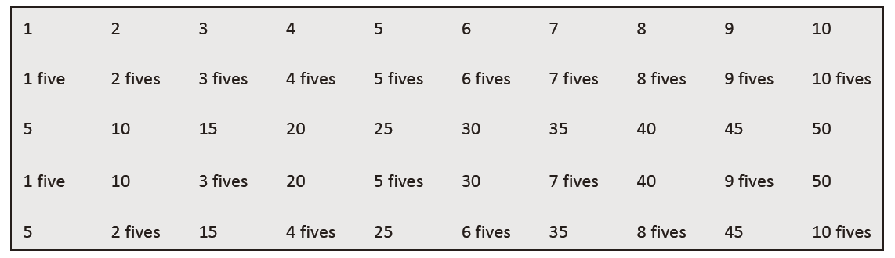
T: (Write 1 five beneath the 1.) Count to 10 fives. (Write as students count.)
S: 1 five, 2 fives, 3 fives, 4 fives, 5 fives, 6 fives, 7 fives, 8 fives, 9 fives, 10 fives.
T: Count by fives to 50. (Write as students count.)
S: 5, 10, 15, 20, 25, 30, 35, 40, 45, 50.
T: (Write 1 five beneath the 5. Write 10 beneath the 10.) I’m going to give you a challenge. Let’s
alternate between saying the units of five and the number. (Write as students count.)
S: 1 five, 10, 3 fives, 20, 5 fives, 30, 7 fives, 40, 9 fives, 50.
T: (Write 5 beneath 1 five and 2 fives beneath the 10.) Let’s alternate again. (Write as students count.)
S: 5, 2 fives, 15, 4 fives, 25, 6 fives, 35, 8 fives, 45, 10 fives.

Lesson 5
Fluency Practice (16 minutes)
⬛⬛ Multiply by 5 3.4E , 3.4F
⬛⬛ Equivalent Counting with Units of 6 3.4E
⬛⬛ Classify the Polygon 3.6B
(8 minutes)
(4 minutes)
(4 minutes)

Multiply by 5 (8 minutes)
Materials: (S) Multiply by 5 (1–5) Pattern Sheet
Note: This activity builds fluency with multiplication facts using units of 5. It works toward students knowing from memory all products of two one-digit numbers. See Lesson 1 for the directions for administration of a Multiply-By Pattern Sheet.
T: (Write 5 X 5 = ____.) Let’s skip-count up by fives to find the answer. (Raise a finger for each number
to track the count. Record the skip-count answers on the board.)
S: 5, 10, 15, 20, 25.
T: (Circle 25, and write 5 X 5 = 25 above it. Write 3 X 5 = ____.) Let’s skip-count up by fives again.
(Track with fingers as students count.)
S: 5 (one finger), 10 (two fingers), 15 (three fingers).
T: Let’s see how we can skip-count down to find the answer, too. Start at 25 with 5 fingers, 1 for each
five. (Count down with fingers as students say the numbers.)
S: 25 (five fingers), 20 (4 fingers), 15 (3 fingers).
Repeat the process for 4 X 5.
T: Let’s practice multiplying by 5. Be sure to work left to right across the page.
Back to top
Equivalent Counting with Units of 6 (4 minutes)
Note: This activity builds fluency with multiplication facts using units of 6. The progression builds in
complexity. Work students up to the highest level of complexity where they can confidently participate.
T: Count to 10. (Write as students count. See the chart below.)
S: 1, 2, 3, 4, 5, 6, 7, 8, 9, 10.
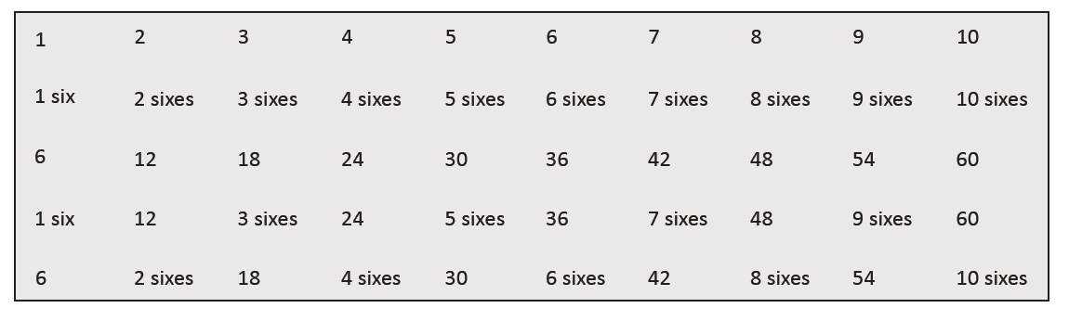
T: (Write 1 six beneath the 1.) Count to 10 sixes. (Write as students count.)
S: 1 six, 2 sixes, 3 sixes, 4 sixes, 5 sixes, 6 sixes, 7 sixes, 8 sixes, 9 sixes, 10 sixes.
T: Count by sixes to 60. (Write as students count.)
S: 6, 12, 18, 24, 30, 36, 42, 48, 54, 60.
T: (Write 1 six beneath the 6. Write 12 beneath the 12.) I’m going to give you a challenge. Let’s alternate
between saying the units of six and the number. (Write as students count.)
S: 1 six, 12, 3 sixes, 24, 5 sixes, 36, 7 sixes, 48, 9 sixes, 60.
T: (Write 6 beneath 1 six and 2 sixes beneath the 12.) Let’s alternate again. (Write as students count.)
S: 6, 2 sixes, 18, 4 sixes, 30, 6 sixes, 42, 8 sixes, 54, 10 sixes.

Classify the Polygon (4 minutes)
Materials: (S) Personal white board
Note: This activity reviews identifying attributes and naming polygons.
T: (Project a trapezoid.) How many sides does this
polygon have?
S: Four sides.
T: What do we call polygons that have four sides?
S: Quadrilaterals.
T: How many vertices does this quadrilateral have?
S: Four vertices.
T: How many sets of parallel sides does this quadrilateral have?
S: One set.
T: What do we call quadrilaterals that have exactly one
set of parallel sides?
S: Trapezoids.
T: (Project a parallelogram with no right angles.) Is this polygon a quadrilateral?
S: Yes.
T: How many vertices does this quadrilateral have?
S: Four vertices.
T: How many right angles does this particular quadrilateral have?
S: Zero right angles.
T: Is this quadrilateral a trapezoid?
S: No.
T: Why?
S: It has two sets of parallel sides.
T: How many sets of parallel sides do trapezoids have?
Back to top
S: Exactly one.
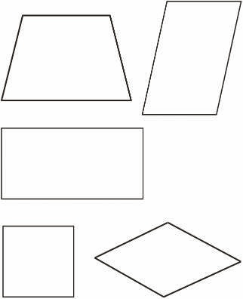
T: What do we call all quadrilaterals that have two sets of
parallel sides?
S: Parallelograms.
T: (Project a rectangle that is not a square.) Is this
polygon a quadrilateral?
S: Yes.
T: Write how many right angles this quadrilateral has.
S: (Write 4.)
T: Is this quadrilateral a trapezoid?
S: No.
T: Why?
S: It has two sets of parallel sides.
T: Is this polygon a parallelogram?
S: Yes.
T: Why?
S: It has two sets of parallel sides.
T: Is this parallelogram also a rectangle?
S: Yes.
T: Why?
S: It has two sets of parallel sides and four right angles.
T: (Project a rhombus that is not a square.) Is this polygon a quadrilateral?
S: Yes.
T: Why?
S: It has four sides.
T: How many vertices does this quadrilateral have?
S: Four vertices.
T: Write how many right angles this quadrilateral has.
S: (Write 0.)
T: Is this quadrilateral a trapezoid?
S: No.
T: Why?
S: It has two sets of parallel sides.
T: Is this polygon a parallelogram?
S: Yes.
T: Why?
S: It has two sets of parallel sides.
T: Is this parallelogram also a rectangle?
S: No.
T: Why?
Back to top
S: It has two sets of parallel sides but no right angles.
T: The sides of this parallelogram are equal. What do we call a parallelogram with 4 equal sides?
S: A rhombus.
T: What is a rhombus with 4 right angles called?
S: A square!
T: How else can a square be classified?
S: Quadrilateral. → Rectangle. → Parallelogram. → Polygon.

Lesson 6
Practice (12 minutes)
⬛⬛ Equivalent Counting with Units of 7 3.4E
⬛⬛ Multiply by 5 3.4E, 3.4F
(4 minutes)
(8 minutes)

Equivalent Counting with Units of 7 (4 minutes)
Note: This activity builds fluency with multiplication facts using units of 7. The progression builds in
complexity. Work students up to the highest level of complexity where they can confidently participate.
T: Count to 10. (Write as students count. See the chart below.)
S: 1, 2, 3, 4, 5, 6, 7, 8, 9, 10.

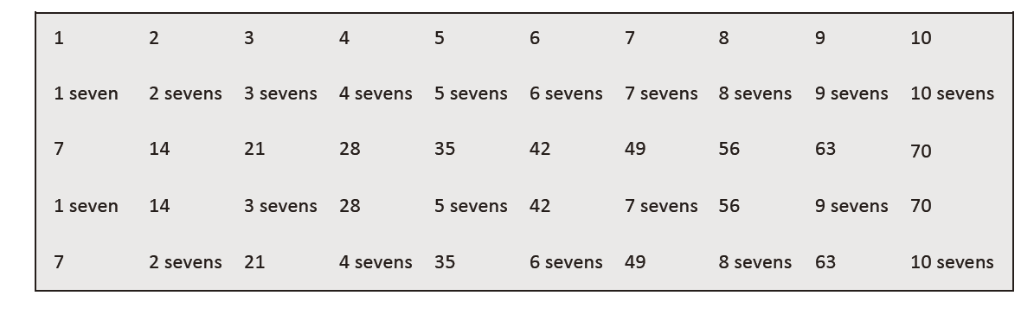
T: (Write 1 seven beneath the 1.) Count to 10 sevens. (Write as students count.)
S: 1 seven, 2 sevens, 3 sevens, 4 sevens, 5 sevens, 6 sevens, 7 sevens, 8 sevens, 9 sevens, 10 sevens.
T: Count by sevens to 70. (Write as students count.)
S: 7, 14, 21, 28, 35, 42, 49, 56, 63, 70.
T: (Write 1 seven beneath the 7. Write 14 beneath the 14.) I’m going to give you a challenge. Let’s
alternate between saying the units of seven and the number. (Write as students count.)
S: 1 seven, 14, 3 sevens, 28, 5 sevens, 42, 7 sevens, 56, 9 sevens, 70.
T: (Write 7 beneath 1 seven and 2 sevens beneath the 14.) Let’s alternate again. (Write as students
count.)
S: 7, 2 sevens, 21, 4 sevens, 35, 6 sevens, 49, 8 sevens, 63, 10 sevens.

Multiply by 5 (8 minutes)
Materials: (S) Multiply by 5 (6–10) Pattern Sheet
Note: This activity builds fluency with multiplication facts using units of 5. It works toward students knowing from memory all products of two one-digit numbers. See Lesson 1 for directions for administration of Multiply-By Pattern Sheet.
T: (Write 7 X 5 = ____.) Let’s skip-count up by fives. I’ll raise a finger for each five. (Raise a finger for
each number to track the count.)
S: 5, 10, 15, 20, 25, 30, 35.
Back to top
T: Let’s skip-count by fives starting at 25. Why is 25 a good place to start?
S: It’s a fact we already know, so we can use it to figure out a fact we don’t know.
T: (Track with fingers as students say the numbers.)
S: 25 (5 fingers), 30 (6 fingers), 35 (7 fingers).
T: Let’s see how we can skip-count down to find the answer, too. Start at 50 with 10 fingers, 1 for each
five. (Count down with fingers as students say the numbers.)
S: 50 (10 fingers), 45 (9 fingers), 40 (8 fingers), 35 (7 fingers).
Continue with the following possible sequence: 9 X 5, 6 X 5, and 8 X 5.
T: Let’s practice multiplying by 5. Be sure to work left to right across the page.

Lesson 7
Fluency Practice (15 minutes)
⬛⬛ Multiply by 6 3.4E, 3.4F
⬛⬛ Physiometry 3.6A, 3.6B
⬛⬛ Classify the Polygon 3.6B
(8 minutes)
(3 minutes)
(4 minutes)

Multiply by 6 (8 minutes)
Materials: (S) Multiply by 6 (1–5) Pattern Sheet
Note: This activity builds fluency with multiplication facts using units of 6. It works toward students knowing from memory all products of two one-digit numbers. See Lesson 1 for the directions for administration of a Multiply-By Pattern Sheet.
T: (Write 5 X 6 = ____.) Let’s skip-count up by sixes to find the answer. (Raise a finger for each number
to track the count. Record the skip-count answers on the board.)
S: 6, 12, 18, 24, 30.
T: (Circle 30, and write 5 X 6 = 30 above it. Write 3 X 6 = ____.) Let’s skip-count up by sixes again.
(Track with fingers as students count.)
S: 6, 12, 18.
T: Let’s see how we can skip-count down to find the answer, too. Start at 30 with 5 fingers, 1 for each
six. (Count down with fingers as students say the numbers.)
S: 30 (five fingers), 24 (4 fingers), 18 (3 fingers).
Repeat the process for 4 X 6.
T: Let’s practice multiplying by 6. Be sure to work left to right across the page.

Physiometry (3 minutes)
Note: Kinesthetic memory is strong memory. This activity reviews terms from Lessons 4 and 5.
T: Stand up.
S: (Stand up.)
T: (Stretch one arm up, directly toward the ceiling. Stretch the other arm parallel to the floor.) What
type of angle do you think I’m modeling with my arms?
S: Right angle.
T: Model a right angle with your arms.
S: (Mirror the teacher.)
T: (Stretch the arm parallel to the floor toward the ceiling. Move the arm pointing toward the ceiling
so that it points toward the opposite wall.) Model another right angle.
Back to top
S: (Mirror the teacher.)
T: How many sides does a triangle have?
S: Three sides.
T: Using your arms, model a triangle with the person standing next to you.
S: (Model a triangle in pairs.)
T: What do we call a four-sided figure?
S: Quadrilateral.
T: Use your body to make a quadrilateral with your partner.
S: (Model a quadrilateral in pairs.)
T: (Point to a side wall.) Point to the wall that runs parallel to the one to which I’m pointing.
S: (Point to the opposite side wall.)
T: (Point to the back wall so students point to the front wall.)
T: (Point to the front wall so students point to the back wall.)
T: Point to the walls that make a right angle with the wall to which I’m pointing.
T: (Point to the back wall so students point to the side walls.)
T: (Point to the side wall so students point to the front and back walls.)
Repeat with the front wall.

Classify the Polygon (4 minutes)
Materials: (S) Personal white board
Repeat Classify the Polygon from Lesson 5 with different shapes or orienting the same shapes differently.
Note: This activity reviews Lesson 4.

Lesson 8
Fluency Practice (15 minutes)
⬛⬛ Multiply by 6 3.4E , 3.4F
⬛⬛ Equivalent Counting with Units of 8 3.4E
⬛⬛ Shade Rectangles of Equal Area 3.6E
(8 minutes)
(4 minutes)
(3 minutes)

Multiply by 6 (8 minutes)
Materials: (S) Multiply by 6 (6–10) Pattern Sheet
Note: This activity builds fluency with multiplication facts using units of 6. It works toward students knowing from memory all products of two one-digit numbers. See Lesson 1 for the directions for administration of a Multiply-By Pattern Sheet.
T: (Write 7 X 6 = ____.) Let’s skip-count up by sixes. I’ll raise a finger for each six. (Raise a finger for each number to track the count.)
S: 6, 12, 18, 24, 30, 36, 42.
T: Let’s skip-count up by sixes starting at 30. Why is 30 a good place to start?
S: It’s a fact we already know, so we can use it to figure out a fact we don’t know.
T: (Track with fingers as students say the numbers.)
S: 30 (5 fingers), 36 (6 fingers), 42 (7 fingers).
T: Let’s see how we can skip-count down to find the answer, too. Start at 60 with 10 fingers, 1 for each
six. (Count down with fingers as students say the numbers.)
Back to top
S: 60 (10 fingers), 54 (9 fingers), 48 (8 fingers), 42 (7 fingers).
Continue with the following possible sequence: 9 X 6, 6 X 6, and 8 X 6.
T: Let’s practice multiplying by 6. Be sure to work left to right across the page.

Equivalent Counting with Units of 8 (4 minutes)
Note: This activity builds fluency with multiplication facts using units of 8. The progression builds in
complexity. Work students up to the highest level of complexity where they can confidently participate.
T: Count to 10. (Write as students count. See the chart below.)
S: 1, 2, 3, 4, 5, 6, 7, 8, 9, 10.

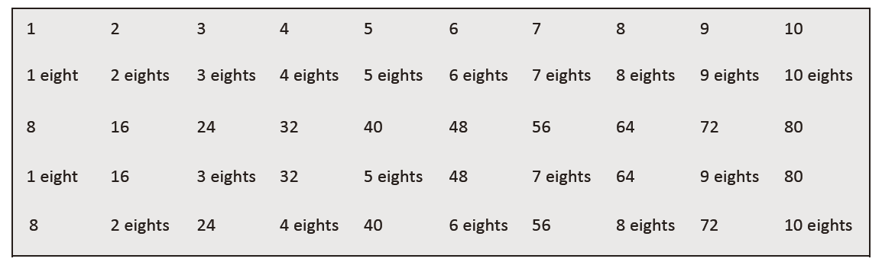
T: (Write 1 eight beneath the 1.) Count to 10 eights. (Write as students count.)
S: 1 eight, 2 eights, 3 eights, 4 eights, 5 eights, 6 eights, 7 eights, 8 eights, 9 eights, 10 eights.
T: Count by eights to 80. (Write as students count.)
S: 8, 16, 24, 32, 40, 48, 56, 64, 72, 80.
T: (Write 1 eight beneath the 8. Write 16 beneath the 16.) I’m going to give you a challenge. Let’s
alternate between saying the units of eight and the number. (Write as students count.)
S: 1 eight, 16, 3 eights, 32, 5 eights, 48, 7 eights, 64, 9 eights, 80.
T: (Write 8 beneath 1 eight and 2 eights beneath the 16.) Let’s alternate again. (Write as students
count.)
S: 8, 2 eights, 24, 4 eights, 40, 6 eights, 56, 8 eights, 72, 10 eights.

Shade Rectangles of Equal Area (3 minutes)
Materials: (S) Personal white board with grid paper
Note: This activity reviews the concept of area.
T: (Write Area = 6 square units.) On your grid paper, shade a rectangle with an area of 6 square units
with one row.
S: (Shade a 1 unit by 6 unit rectangle.)
T: Shade a rectangle with the same area using two rows.
S: (Shade a 2 unit by 3 unit rectangle.)
T: (Write Area = 8 square units.) Shade a rectangle with an area of 8 square units.
S: (Shade a 1 unit by 8 unit rectangle, 2 unit by 4 unit rectangle, 4 unit by 2 unit rectangle, or 8 unit by
1 unit rectangle.)
T: Shade a rectangle with different side lengths but the same area.
S: (Shade a rectangle with different side lengths but the same area.)
Repeat process for Area = 12 square units.

Back to top
Lesson 9
Fluency Practice (12 minutes)
⬛ Multiply by 7 3.4E, 3.4F (8 minutes)
⬛ Equivalent Counting with Units of 9 3.4E (4 minutes)

Multiply by 7 (8 minutes)
Materials: (S) Multiply by 7 (1–5) Pattern Sheet
Note: This activity builds fluency with multiplication facts using units of 7. It works toward students knowing from memory all the products of two one-digit numbers. See Lesson 1 for the directions for administration of a Multiply-By Pattern Sheet.
T: (Write 5 X 7 = .) Let’s skip-count up by sevens to find the answer. (Raise a finger for each
number to track the count. Record the skip-count answers on the board.)
S: 7, 14, 21, 28, 35.
T: (Circle 35, and write 5 X 7 = 35 above it. Write 3 X 7 = .) Let’s skip-count up by sevens again.
(Track with fingers as students count.)
S: 7, 14, 21.
T: Let’s see how we can skip-count down to find the answer, too. Start at 35 with 5 fingers, 1 for each
seven. (Count down with fingers as students say the numbers.)
S: 35 (5 fingers), 28 (4 fingers), 21 (3 fingers).
Repeat the process for 4 X 7.
T: Let’s practice multiplying by 7. Be sure to work left to right across the page.

Equivalent Counting with Units of 9 (4 minutes)
Note: This activity builds fluency with multiplication facts using units of 9. The progression builds in
complexity. Work students up to the highest level of complexity where they can confidently participate.
T: Count to 10. (Write as students count. See the chart below.)
S: 1, 2, 3, 4, 5, 6, 7, 8, 9, 10.
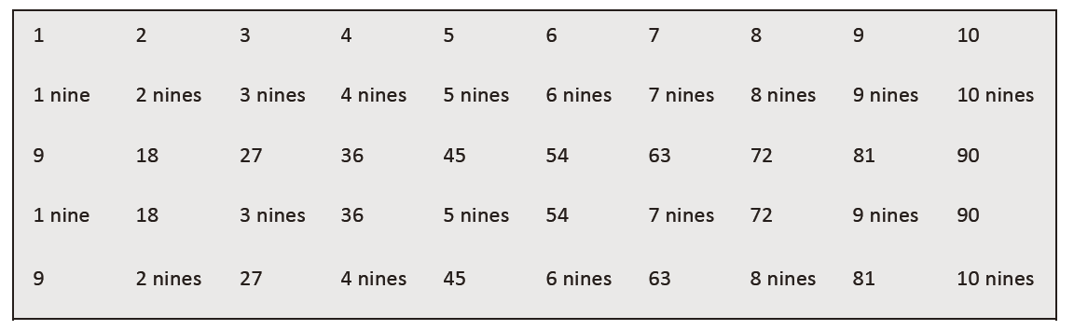
T: (Write 1 nine beneath the 1.) Count to 10 nines. (Write as students count.)
S: 1 nine, 2 nines, 3 nines, 4 nines, 5 nines, 6 nines, 7 nines, 8 nines, 9 nines, 10 nines.
T: Count by nines to 90. (Write as students count.)
S: 9, 18, 27, 36, 45, 54, 63, 72, 81, 90.
T: (Write 1 nine beneath the 9. Write 18 beneath the 18.) I’m going to give you a challenge. Let’s
alternate between saying the units of nine and the number. (Write as students count.)
S: 1 nine, 18, 3 nines, 36, 5 nines, 54, 7 nines, 72, 9 nines, 90.
T: (Write 9 beneath 1 nine and 2 nines beneath the 18.) Let’s
alternate again. (Write as students count.)
S: 9, 2 nines, 27, 4 nines, 45, 6 nines, 63, 8 nines, 81, 10 nines.

Back to top
Lesson 10
No fluency activity

Lesson 11
Fluency Practice (15 minutes)
⬛ Multiply by 7 3.4E, 3.4F (8 minutes)
⬛ Equivalent Counting with Units of 3 3.4E (4 minutes)
⬛ Area and Perimeter 3.6C (3 minutes)

Multiply by 7 (8 minutes)
Materials: (S) Multiply by 7 (6–10) Pattern Sheet
Note: This activity builds fluency with multiplication facts using units of 7. It works toward students knowing from memory all the products of two one-digit numbers. See Lesson 1 for the directions for administration of
a Multiply-By Pattern Sheet.
T: (Write 7 X 7 = .) Let’s skip-count up by sevens. I’ll raise a finger for each seven. (Raise a finger for
each number to track the count.)
S: 7, 14, 21, 28, 35, 42, 49.
T: Let’s skip-count up by sevens starting at 35. Why is 35 a good place to start?
S: It’s a fact we already know, so we can use it to figure out a fact we don’t know.
T: (Track with fingers as students say the numbers.)
S: 35 (5 fingers), 42 (6 fingers), 49 (7 fingers).
T: Let’s see how we can skip-count down to find the answer, too. Start at 70 with 10 fingers, 1 for each
seven. (Count down with fingers as students say the numbers.)
S: 70 (10 fingers), 63 (9 fingers), 56 (8 fingers), 49 (7 fingers).
Continue with the following possible sequence: 9 X 7, 6 X 7, and 8 X 7.
T: Let’s practice multiplying by 7. Be sure to work left to right across the page.

Equivalent Counting with Units of 3 (4 minutes)
Note: This activity builds fluency with multiplication facts using units of 3.
T: Count by threes to 30. (Write as students count.)
S: 3, 6, 9, 12, 15, 18, 21, 24, 27, 30.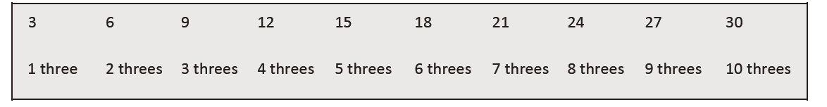
T: (Write 1 three beneath the 3.) Count to 10 threes. (Write as students count.)
S: 1 three, 2 threes, 3 threes, 4 threes, 5 threes, 6 threes, 7 threes, 8 threes, 9 threes, 10 threes.
T: Let’s count to 10 threes again. This time, stop when I raise my hand.
S: 1 three, 2 threes, 3 threes.
T: (Raise hand.) Say the multiplication sentence.
S: 3 X 3 = 9.
T: Continue.
S: 4 threes, 5 threes.
T: (Raise hand.) Say the multiplication sentence.
S: 5 X 3 = 15.
Continue the process up to 10 threes and down to 1 three.
Back to top
Area and Perimeter (3 minutes)
Materials: (S) Grid paper
Note: This activity reviews Lesson 9.
T: On your grid paper, shade a rectangle that is 2 units wide by 3 units long.
S: (Shade a 2 unit by 3 unit rectangle.)
T: What is the area of the rectangle?
S: 6 square units!
T: Draw a line around the perimeter of the rectangle.
S: (Draw line around the perimeter.)
T: At the signal, show your paper. (Signal.)
S: (Show paper with the perimeter marked.)
Continue with the following possible sequence: 4 units by 2 units and 5 units by 3 units.

Lesson 12
Fluency Practice (16 minutes)
⬛ Multiply by 8 3.4E, 3.4F (8 minutes)
⬛ Equivalent Counting with Units of 43.4E
(4 minutes)
⬛ Find the Perimeter 3.7B (4 minutes)

Multiply by 8 (8 minutes)
Materials: (S) Multiply by 8 (1–5) Pattern Sheet
Note: This activity builds fluency with multiplication facts using units of 8. It works toward students knowing from memory all the products of two one-digit numbers. See Lesson 1 for the directions for administration of a Multiply-By Pattern Sheet.
T: (Write 5 X 8 = .) Let’s skip-count up by eights to find the answer. (Raise a finger for each
number to track the count. Record the skip-count answers on the board.)
S: 8, 16, 24, 32, 40.
T: (Circle 40, and write 5 X 8 = 40 above it. Write 3 X 8 = .) Let’s skip-count up by eights again.
(Track with fingers as students count.)
S: 8, 16, 24.
T: Let’s see how we can skip-count down to find the answer, too. Start at 40 with 5 fingers, 1 for each
eight. (Count down with fingers as students say the numbers.)
S: 40 (5 fingers), 32 (4 fingers), 24 (3 fingers).
Repeat the process for 4 X 8.
T: Let’s practice multiplying by 8. Be sure to work left to right across the page.

Equivalent Counting with Units of 4 (4 minutes)
Note: This activity builds fluency with multiplication facts using units of 4.
T: Count by fours to 40. (Write as students count.)
S: 4, 8, 12, 16, 20, 24, 28, 32, 36, 40.
T: (Write 1 four beneath the 4.) Count to 10 fours. (Write as students count.)
Back to top
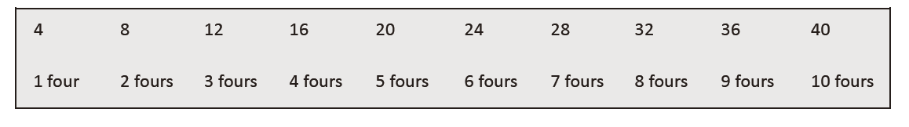
S: 1 four, 2 fours, 3 fours, 4 fours , 5 fours, 6 fours, 7 fours, 8 fours, 9 fours, 10 fours.
T: Let’s count to 10 fours again. This time, stop when I raise my hand.
S: 1 four, 2 fours, 3 fours.
T: (Raise hand.) Say the multiplication sentence.
S: 3 X 4 = 12.
T: Continue.
S: 4 fours, 5 fours.
T: (Raise hand.) Say the multiplication sentence.
S: 5 X 4 = 20.
T: Continue the process up to 10 fours and down to 1 four.

Find the Perimeter (4 minutes)
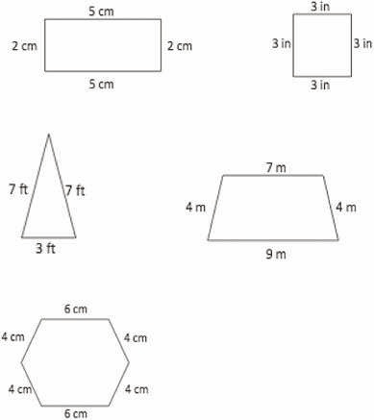
Materials: (S) Personal white board
Note: This activity reviews Lesson 10.
T: (Project 5 cm by 2 cm rectangle. Write
P = cm + cm + cm + cm.) Copy the equation on your personal white board, and fill in
the blanks.
S: (Write P = 5 cm + 2 cm + 5 cm + 2 cm.)
T: (Write P = cm.) Solve your equation to find the perimeter.
S: (Write P = 14 cm.)
Continue the process with the other polygons.

Back to top
Lesson 13
Fluency Practice (12 minutes)
⬛ Multiply by 8 3.4E, 3.4F (8 minutes)
⬛ Equivalent Counting with Units of 7 3.4E (4 minutes)

Multiply by 8 (8 minutes)
Materials: (S) Multiply by 8 (6–10) Pattern Sheet
Note: This activity builds fluency with multiplication facts using units of 8. It works toward students knowing from memory all the products of two one-digit numbers. See Lesson 1 for the directions for administration of a Multiply-By Pattern Sheet.
T: (Write 7 X 8 = .) Let’s skip-count up by eights. I’ll raise a finger for each eight. (Raise a finger
for each number to track the count.)
S: 8, 16, 24, 32, 40, 48, 56.
T: Let’s skip-count up by eights starting at 40. Why is 40 a good place to start?
S: It’s a fact we already know, so we can use it to figure out a fact we don’t know.
T: (Track with fingers as students say the numbers.)
S: 40 (5 fingers), 48 (6 fingers), 56 (7 fingers).
T: Let’s see how we can skip-count down to find the answer, too. Start at 80 with 10 fingers, 1 for each
eight. (Count down with fingers as students say the numbers.)
S: 80 (10 fingers), 72 (9 fingers), 64 (8 fingers), 56 (7 fingers).
Continue with the following possible sequence: 9 X 8, 6 X 8, and 8 X 8.
T: Let’s practice multiplying by 8. Be sure to work left to right across the page.

Equivalent Counting with Units of 7 (4 minutes)
Note: This activity builds fluency with multiplication facts using units of 7.
T: Count by sevens to 70. (Write as students count.)
S: 7, 14, 21, 28, 35, 42, 49, 56, 63, 70.
T: (Write 1 seven beneath the 7.) Count to 10 sevens. (Write as students count.)
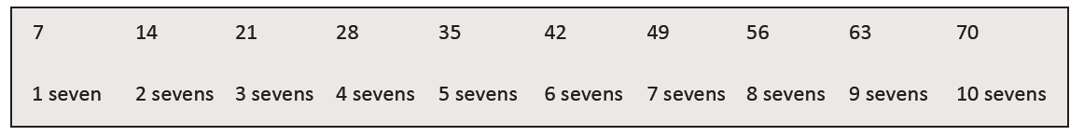
S: 1 seven, 2 sevens, 3 sevens, 4 sevens, 5 sevens, 6 sevens, 7 sevens, 8 sevens, 9 sevens, 10 sevens.
T: Let’s count to 10 sevens again. This time, stop when I raise my hand.
S: 1 seven, 2 sevens, 3 sevens.
T: (Raise hand.) Say the multiplication sentence.
S: 3 X 7 = 21.
T: Continue.
S: 4 sevens, 5 sevens.
T: (Raise hand.) Say the multiplication sentence.
S: 5 X 7 = 35.
T: Continue.
S: 6 sevens, 7 sevens, 8 sevens.
T: (Raise hand.) Say the multiplication sentence.
S: 8 X 7 = 56.
T: Continue.
S: 9 sevens, 10 sevens.
Back to top
T: (Raise hand.) Say the multiplication sentence.
S: 10 X 7 = 70.
T: Let’s count back down, starting at 10 sevens.
Continue the process back down to 1 seven.

Lesson 14
Fluency Practice (16 minutes)
⬛ Multiply by 9 3.4E, 3.4F (8 minutes)
⬛ Equivalent Counting with Units of 5 3.4E (4 minutes)
⬛ Find the Perimeter 3.7B (4 minutes)

Multiply by 9 (8 minutes)
Materials: (S) Multiply by 9 (1–5) Pattern Sheet
Note: This activity builds fluency with multiplication facts using units of 9. It works toward students knowing from memory all the products of two one-digit numbers. See Lesson 1 for the directions for administration of a Multiply-By Pattern Sheet.
T: (Write 7 X 9 = .) Let’s skip-count up by nines. I’ ll raise a finger for each nine. (Raise a finger for
each number to track the count.)
S: 9, 18, 27, 36, 45, 54, 63.
T: Let’s skip-count up by nines starting at 45. Why is 45 a good place to start?
S: It’s a fact we already know, so we can use it to figure out a fact we don’t know.
T: (Track with fingers as students say the numbers.)
S: 45 (5 fingers), 54 (6 fingers), 63 (7 fingers).
T: Let’s see how we can skip-count down to find the answer, too. Start at 90 with 10 fingers, 1 for each
nine. (Count down with fingers as students say the numbers.)
S: 90 (10 fingers), 81 (9 fingers), 72 (8 fingers), 63 (7 fingers).
Continue with the following possible sequence: 9 X 9, 6 X 9, and 8 X 9.
T: Let’s practice multiplying by 9. Be sure to work left to right across the page.

Equivalent Counting with Units of 5 (4 minutes)
Note: This activity builds fluency with multiplication facts using units of 5.
T: Count by fives to 50. (Write as students count.)
S: 5, 10, 15, 20, 25, 30, 35, 40, 45, 50.
T: (Write 1 five beneath the 5.) Count to 10 fives. (Write as students count.)
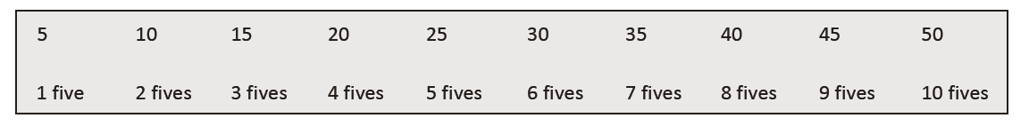
S: 1 five, 2 fives, 3 fives, 4 fives, 5 fives, 6 fives, 7 fives, 8 fives, 9 fives, 10 fives.
T: Let’s count to 10 fives again. This time, stop when I raise my hand.
S: 1 five, 2 fives, 3 fives.
T: (Raise hand.) Say the multiplication sentence.
S: 3 X 5 = 15.
T: Continue.
S: 4 fives, 5 fives.
T: (Raise hand.) Say the multiplication sentence.
S: 5 X 5 = 25.
Back to top
T: Continue.
S: 6 fives, 7 fives, 8 fives.
T: (Raise hand.) Say the multiplication sentence.
S: 8 X 5 = 40.
T: Continue.
S: 9 fives, 10 fives.
T: (Raise hand.) Say the multiplication sentence.
S: 10 X 5 = 50.
T: Let’s count back down starting at 10 fives.
Continue the process back down to 1 five.

Find the Perimeter (4 minutes)
Materials: (S) Personal white board
Note: This activity reviews finding perimeter.
T: (Project a square with side lengths of 7 inches. Write P = in + in
+ in + in.) Copy the equation on your personal white board,
and fill in the blanks. Then, write the perimeter of the square.
S: (Write P = 7 in + 7 in + 7 in + 7 in and P = 28 in.)
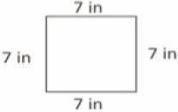
Continue the process with other polygons.
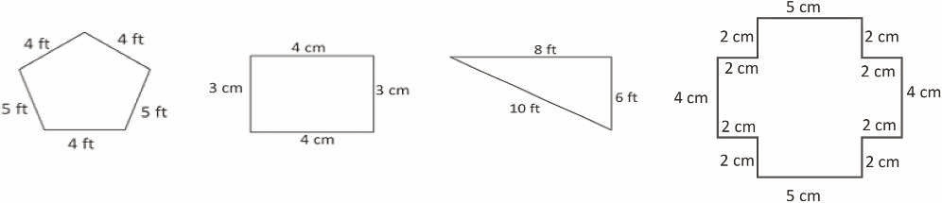
Lesson 15
Fluency Practice (16 minutes)
⬛ Multiply by 9 3.4E, 3.4F (8 minutes)
⬛ Equivalent Counting with Units of 6 3.4E (4 minutes)
⬛ Find the Perimeter 3.7B (4 minutes)

Multiply by 9 (8 minutes)
Materials: (S) Multiply by 9 (6–10) Pattern Sheet
Note: This activity builds fluency with multiplication facts using units of 9. It works toward students knowing from memory all the products of two one-digit numbers. See Lesson 1 for the directions for administration of a Multiply-By Pattern Sheet.
T: (Write 5 X 9 = .) Let’s skip-count up by nine to find the answer. (Raise a finger for each number
to track the count. Record the skip-count answers on the board.)
S: 9, 18, 27, 36, 45.
T: (Circle 45, and write 5 X 9 = 45 above it. Write 3 X 9 = .) Let’s skip-count up by nines again.
Back to top
(Track with fingers as students count.)
S: 9, 18, 27.
T: Let’s see how we can skip-count down to find the answer, too. Start at 45 with 5 fingers, 1 for each
nine. (Count down with fingers as students say the numbers.)
S: 45 (5 fingers), 36 (4 fingers), 27 (3 fingers).
Repeat the process for 4 X 9.
T: Let’s practice multiplying by 9. Be sure to work left to right across the page.

Equivalent Counting with Units of 6 (4 minutes)
Note: This activity builds fluency with multiplication facts using units of 6.
T: Count by sixes to 60. (Write as students count.)
S: 6, 12, 18, 24, 30, 36, 42, 48, 54, 60.
T: (Write 1 six beneath the 6.) Count to 10 sixes. (Write as students count.)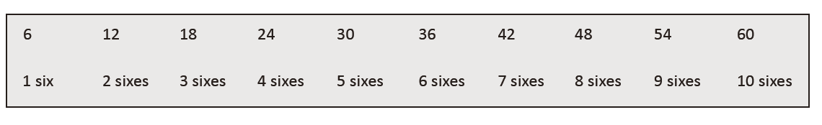
S: 1 six, 2 sixes, 3 sixes, 4 sixes, 5 sixes, 6 sixes, 7 sixes, 8 sixes, 9 sixes, 10 sixes.
T: Let’s count to 10 sixes again. This time, stop when I raise my hand.
S: 1 six, 2 sixes, 3 sixes.
T: (Raise hand.) Say the multiplication sentence.
S: 3 X 6 = 18.
T: Continue.
S: 4 sixes, 5 sixes.
T: (Raise hand.) Say the multiplication sentence.
S: 5 X 6 = 30.
T: Continue.
S: 6 sixes, 7 sixes, 8 sixes.
T: (Raise hand.) Say the multiplication sentence.
S: 8 X 6 = 48.
T: Continue.
S: 9 sixes, 10 sixes.
T: (Raise hand.) Say the multiplication sentence.
S: 10 X 6 = 60.
T: Let’s count back down, starting at 10 sixes.
Continue the pattern back down to 1 six.

Find the Perimeter (4 minutes)
Materials: (S) Personal white board
Note: This activity reviews Lesson 12.
T: (Project the rectangle with a given length of 5 cm and width of 3 cm.) What is the length of the
rectangle?
S: 5 centimeters.
T: What’s the width of the rectangle?
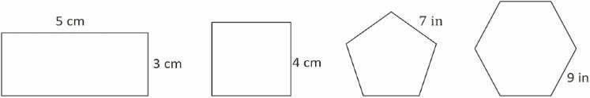
Back to top
S: 3 centimeters.
T: (Write P = cm + cm + cm + cm.) On your personal white board, find the perimeter by
writing an addition sentence.
S: (Write P = 5 cm + 3 cm + 5 cm + 3 cm and P = 16 cm beneath it.)
T: (Project the square with a given side length of 4 cm.) What’s the length of each side of the square?
S: 4 centimeters.
T: (Write P = cm + cm + cm + cm.) Write the perimeter as an addition sentence.
S: (Write P = 4 cm + 4 cm + 4 cm + 4 cm and P = 16 cm beneath it.)
Continue the process with a regular pentagon and a regular hexagon.

Lesson 16
Fluency Practice (12 minutes)
⬛ Factors 3.5D (4 minutes)
⬛ Equivalent Counting with Units of 8 3.4E (4 minutes)
⬛ Find the Perimeter 3.7B (4 minutes)

Factors (4 minutes)
Materials: (S) Personal white board
Note: This activity builds fluency with multiplication and division facts.
T: (Write 8 X = 8.) Say the equation, filling in the unknown
factor.
S: 8 X 1 = 8.
T: (Write 2 X = 8.) Say the equation, filling in the unknown factor.
S: 2 X 4 = 8.
T: (Write X 2 = 8.) Write the equation, filling in the unknown factor.
S: (Write 4 X 2 = 8.)
Continue with the following possible sequence of products: 12, 15, and 24.

Equivalent Counting with Units of 8 (4 minutes)
Note: This activity builds fluency with multiplication facts using units of 8.
T: Count by eights to 80. (Write as students count.)
S: 8, 16, 24, 32, 40, 48, 56, 64, 72, 80.
T: (Write 1 eight beneath the 8.) Count to 10 eights. (Write as students count.)
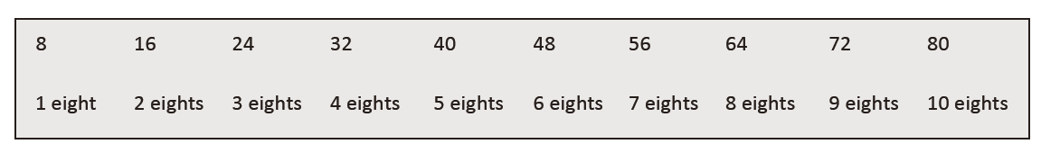
S: 1 eight, 2 eights, 3 eights, 4 eights, 5 eights, 6 eights, 7 eights, 8 eights, 9 eights, 10 eights.
T: Let’s count to 10 eights again. This time, stop when I raise my hand.
S: 1 eight, 2 eights, 3 eights.
T: (Raise hand.) Say the multiplication sentence.
S: 3 X 8 = 24.
T: Continue.
S: 4 eights, 5 eights.
T: (Raise hand.) Say the multiplication sentence.
S: 5 X 8 = 40.
T: Continue.
Back to top
S: 6 eights, 7 eights, 8 eights.
T: (Raise hand.) Say the multiplication sentence.
S: 8 X 8 = 64.
T: Continue.
S: 9 eights, 10 eights.
T: (Raise hand.) Say the multiplication sentence.
S: 10 X 8 = 80.
T: Let’s count back down, starting at 10 eights.
S: 10 eights, 9 eights.
T: (Raise hand.) Say the multiplication sentence.
S: 9 X 8 = 72.
Continue the process going back down to 1 eight.

Find the Perimeter (4 minutes)
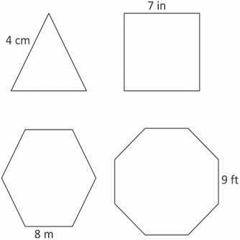
Materials: (S) Personal white board
Note: This activity reviews Lesson 14.
T: (Project the triangle with a given side length of 4 cm. Write
P = cm.) Each shape that I show you is a regular polygon.
Say the given side length of the triangle.
S: 4 centimeters.
T: (Write P = X cm.) Fill in the factors. Below, write the
perimeter of the triangle.
S: (Write P = 3 X 4 cm and P = 12 cm below it.)
Repeat the process for the other shapes.

Lesson 17
Fluency Practice (12 minutes)
⬛⬛ Find the Unknown Factors 3.5D (4 minutes)
⬛⬛ Draw Strip Diagrams 3.4E (4 minutes)
⬛⬛ Find the Area and Perimeter 3.6C, 3.7B (4 minutes)

Find the Unknown Factors (4 minutes)
Materials: (S) Personal white board
Note: This activity prepares students for today’s lesson.
Back to top
T: (Project the unknown factor multiplication equations equaling 6, shown to the
right.) On your personal white board, complete the unknown factors to create four
different multiplication equations.
S: (Write 1 X 6 = 6, 2 X 3 = 6, 3 X 2 = 6, 6 X 1 = 6.)
Continue with the following possible sequence of products: 8, 9, and 12.
1 X __ = 6
2 X __ = 6
3 X __ = 6
6 X __ = 6

Draw Strip Diagrams (4 minutes)
Materials: (S) Personal white board
Note: This activity prepares students for today’s lesson.
T: (Project a strip diagram with one small unit on the left and an
open end on the right. Write 2 inside the small unit.) On
your board, copy the diagram.
S: (Draw the diagram, and write 2 inside the small unit.)

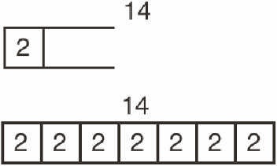

T: (Write 14 at the top of the strip diagram.) Complete your diagram with equal units. Close the strip
diagram when the total value of your units reaches 14.
S: (Draw 6 more units of 2.)
T: (Write ___ X 2 = 14.) Say the multiplication sentence.
S: 7 X 2 = 14.
T: (Write 2 X ___ = 14.) Say the multiplication sentence.
S: 2 X 7 = 14.
Continue with the following possible sequence: 8 units of 3, 4 units of 7, and 6 units of 9.

Find the Area and Perimeter (4 minutes)
Materials: (S) Grid paper, personal white board
Note: This activity reviews Lesson 12.
T: (Project a 2-unit by 4-unit rectangle.) What’s the length of
the rectangle?
S: 4 units.
Back to top
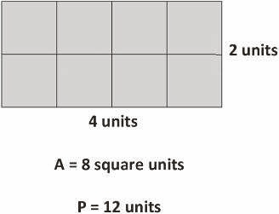
T: (Write 4 units below the rectangle.) What’s the width
of the rectangle?
S: 2 units.
T: (Write 2 units to the right of the rectangle. Beneath it, write
A = ___.) On your board, write the area.
S: (Write A = 8 square units.)
T: (Write A = 8 square units. Write P = ___.) Write the perimeter of the rectangle.
S: (Write P = 12 units.)
Continue with the following possible sequence: 4-unit by 3-unit rectangle, 2-unit by 6-unit rectangle, 4-unit by 4-unit square, 8-unit by 2-unit rectangle, and 3-unit by 6-unit rectangle.

Lesson 18
Fluency Practice (12 minutes)
⬛⬛ Sprint: Multiply or Divide by 2 3.4F (10 minutes)
⬛⬛ Find the Perimeter 3.7B (4 minutes)

Sprint: Multiply or Divide by 2 (10 minutes)
Materials: (S) Multiply or Divide by 2 Sprint
Note: This Sprint builds fluency with multiplication and division facts using units of 2.

Find the Perimeter (4 minutes)
Materials: (S) Grid paper
Note: This activity reviews Lesson 17.
T: Shade rectangles that have an area of 6 square units.
S: (Shade a 1 X 6 rectangle and a 2 X 3 rectangle.)
T: Next to each rectangle, write the perimeter.
S: (Next to the 1 X 6 rectangle, write P = 14 units. Next to
the 2 X 3 rectangle, write P = 10 units.)

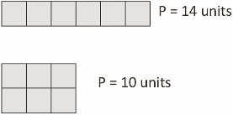
Continue with the following possible sequence: 8 square units and 12 square units.

Back to top
Lesson 19
Fluency Practice (10 minutes)
⬛⬛ Sprint: Multiply or Divide by 3 3.4F (10 minutes)

Sprint: Multiply or Divide by 3 (10 minutes)
Materials: (S) Multiply or Divide by 3 Sprint
Note: This Sprint builds fluency with multiplication and division facts using units of 3.

Lesson 20
Fluency Practice (10 minutes)
⬛⬛ Sprint: Multiply or Divide by 4 3.4F (10 minutes)

Sprint: Multiply or Divide by 4 (10 minutes)
Materials: (S) Multiply or Divide by 4 Sprint
Note: This Sprint builds fluency with multiplication and division facts using units of 4.

Lesson 21
Fluency Practice (13 minutes)
⬛⬛ Sprint: Multiply or Divide by 5 3.4F (10 minutes)
⬛⬛ Find the Perimeter and Area 3.6C, 3.7B (3 minutes)

Sprint: Multiply or Divide by 5 (10 minutes)
Materials: (S) Multiply or Divide by 5 Sprint
Note: This Sprint builds fluency with multiplication and division
facts using units of 5.

Find the Perimeter and Area (3 minutes)
Materials: (S) Personal white board
Note: This activity reviews finding perimeter and area.
T: (Project a square with a given length of 5 cm.) This shape is a
square. On your personal white board, calculate the
perimeter using an addition sentence.
S: (Write 5 cm + 5 cm + 5 cm + 5 cm = 20 cm.)
T: Calculate the area using a multiplication sentence.
S: (Write 4 X 5 cm = 20 sq cm.)
Repeat this process for the remaining rectangles.
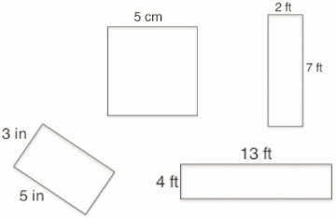
Back to top
Lesson 22
Fluency Practice (10 minutes)
⬛⬛ Sprint: Multiply or Divide by 6 3.4F (10 minutes)

Sprint: Multiply or Divide by 6 (10 minutes)
Materials: (S) Multiply or Divide by 6 Sprint
Note: This Sprint builds fluency with multiplication and division facts using units of 6.

Lesson 23
Fluency Practice (14 minutes)
⬛⬛ Sprint: Multiply or Divide by 7 3.4F
⬛⬛ Find the Perimeter 3.7B
(10 minutes)
(4 minutes)

Sprint Multiply or Divide by 7 (10 minutes)
Materials: (S) Multiply or Divide by 7 Sprint
Note: This Sprint builds fluency with multiplication and division facts using units of 7.

Find the Perimeter (4 minutes)
Materials: (S) Personal white board
Note: This activity prepares students for the word problems in today’s
Concept Development.
T: (Project the rectangle with a width of 2 cm. Inside the
rectangle, write Area = 10 sq cm.) On your personal
white board, write the length of this rectangle.
S: (Write 5 cm.)
T: (Write 5 cm on the length of the rectangle. Below the
rectangle, write Perimeter = .) On your board,
write the perimeter of this rectangle. Write a four-step
addition sentence if you need to.
S: (Write Perimeter = 14 cm.)
Back to top
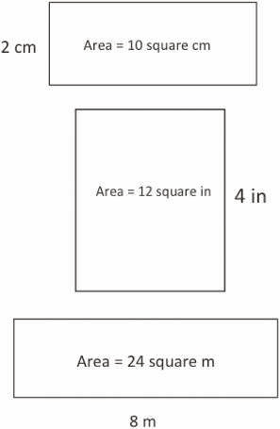
T: On your board, sketch a rectangle that has an area of 10 square cm but different side lengths from
this rectangle.
S: (Sketch a rectangle with side lengths of 1 cm and 10 cm.)
T: (Write Perimeter = .) Calculate the perimeter of the new rectangle.
S: (Write Perimeter = 22 cm.)
Repeat the process for the other rectangles.

Lesson 24
Fluency Practice (14 minutes)
⬛⬛ Sprint: Multiply or Divide by 8 3.4F
⬛⬛ Find the Perimeter 3.7B
(10 minutes)
(4 minutes)

Sprint: Multiply or Divide by 8 (10 minutes)
Materials: (S) Multiply or Divide by 8 Sprint
Note: This Sprint builds fluency with multiplication and division facts using units of 8.

Find the Perimeter (4 minutes)
Materials: (S) Personal white board
Note: This activity reviews finding perimeter using multiple steps.
T: (Project the rectangle with a width of 3 m. Inside the
rectangle, write Area = 24 square m.) On your personal
white board, write the length of this rectangle.
S: (Write 8 m.)
T: (Write 8 m on the length of the rectangle. Below the
rectangle, write Perimeter = .) On your board,
write the perimeter of this rectangle. Write a number
sentence if you need to.
S: (Write Perimeter = 22 m.)
Back to top

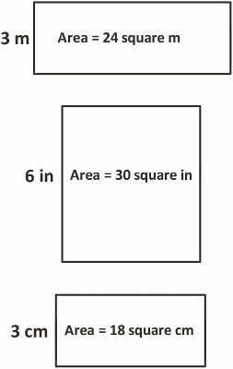
T: On your board, sketch a rectangle that has an area of 24 square meters but different side lengths
than this rectangle.
S: (Sketch a rectangle with side lengths of 1 m and 24 m, 4 m and 6 m, or 2 m and 12 m.)
T: (Write Perimeter = .) Calculate the perimeter of the new rectangle.
S: (Write Perimeter = 50 m, 20 m, or 28 m.)
Repeat the process with the other rectangles.

Lesson 25
Fluency Practice (14 minutes)
⬛ Sprint: Multiply or Divide by 9 3.4F (10 minutes)
⬛ Multiply and Divide 3.4F (4 minutes)

Sprint: Multiply or Divide by 9 (10 minutes)
Materials: (S) Multiply or Divide by 9 Sprint
Note: This Sprint builds fluency with multiplication and division facts using units of 9.

Multiply and Divide (4 minutes)
Materials: (S) Personal white board
Note: This activity focuses on student mastery of all products
and quotients within 100.
T: (Write 5 X 4 = ___.) Write the multiplication sentence.
S: (Write 5 X 4 = 20.)
Continue with the following possible sequence: 5 X 8, 7 X 8,
6 X 4, 6 X 8, 9 X 8, and 8 X 9.
T: (Write 6 ÷ 3 = ___.) Write the division sentence.
S: (Write 6 ÷ 3 = 2.)
Continue with the following possible sequence: 15 ÷ 3, 30 ÷ 6,
18 ÷ 3, 36 ÷ 6, 14 ÷ 7, 28 ÷ 7, and 56 ÷ 7.
T: (Write 3, 2.) Write two multiplication sentences and two division sentences using these factors.
S: (Write 3 X 2 = 6, 2 X 3 = 6, 6 ÷ 2 = 3, and 6 ÷ 3 = 2.)
Continue with the following possible sequence: 9 and 5, 6 and 4, and 7 and 8.
Back to top

Lesson 26
Fluency Practice (13 minutes)
⬛ Sprint: Mixed Multiplication 3.4F (10 minutes)
⬛ Divide 3.4F (3 minutes)

Sprint: Mixed Multiplication (10 minutes)
Materials: (S) Mixed Multiplication Sprint
Note: This Sprint focuses on student mastery of all products of one-digit numbers.

Divide (3 minutes)
Materials: (S) Personal white board
Note: This activity focuses on student mastery of all quotients within 100.
T: (Write 10 ÷ 2 = ____.) Say the division sentence.
S: 10 ÷ 2 = 5.
Continue with the following possible sequence: 4 ÷ 2, 8 ÷ 4, and 15 ÷ 3.
T: (Write 24 ÷ 4 = ____.) Write the answer.
S: (Write 24 ÷ 4 = 6.)
Continue with the following possible sequence: 45 ÷ 9, 63 ÷ 7, 48 ÷ 6, 56 ÷ 8, and 81 ÷ 9.

Lesson 27
Fluency Practice (50 minutes)
⬛ Sprint: Mixed Division 3.4F (10 minutes)
⬛ Multiply 3.4F (3 minutes)
⬛ Mixed Review Games (37 minutes)

Sprint: Mixed Division (10 minutes)
Materials: (S) Mixed Division Sprint
Note: This Sprint focuses on student mastery of all quotients within 100.

Multiply (3 minutes)
Materials: (S) Personal white board
Note: This activity focuses on student mastery of all products of two one-digit numbers.
T: (Write 4 X 2 = ___.) Say the multiplication sentence.
S: 4 X 2 = 8.
Continue with the following possible sequence: 3 X 4,
4 X 4, and 5 X 6.
T: (Write 7 X 6 = ___.) Write the answer.
S: (Write 42.)
Continue with the following possible sequence: 8 X 7 and 9 X 6.
T: (Write 3 X 2 = ___.) Say the multiplication sentence.
S: 3 X 2 = 6.
T: Flip the factors, and say it.
S: 2 X 3 = 6.
Back to top
Continue with the following possible sequence: 6 X 3, 7 X 5, 7 X 6, and 9 X 8.
Mixed Review Games (37 minutes)
Materials: (S) Fluency game materials (listed with each activity
and included at the end of the lesson), Problem Set
For the rest of today’s lesson, students review and play fluency
games from Grade 3. They play in pairs, alternating the role of
teacher. Students might periodically move around the room
selecting different partners or stay in the same grouping for the
duration of this practice. Choose a few ideas from the
suggested games, and let students choose which ones to play,
or select other fluency activity favorites based on the needs and
interests of the class.
Students should have their Problem Sets with them as they play
the fluency games and use them to keep a list of their favorite
activities. They reference the list in Lesson 28 when recording
the directions for their favorites in a summer practice booklet.

Lesson 28
Fluency Practice (43 minutes)
T: Think about all the fluency activities we did this year.
Which were your favorites?
S: (Discuss.)
T: Which ones helped you improve your fluency with
multiplication and division facts? Share with a partner.
S: Group Counting helped me skip-count forward and
backward. That made it simple to use an easy fact to
find a hard one. → I worked so hard on my Sprints.
They made me get so much faster! → Multiply-By
Pattern Sheets were like that for me. → Finding the
unknown factor made me get good at thinking of
multiplication and division in different ways.
T: Let’s do one last Grade 3 Sprint to celebrate just how
far we have come. Then, we will make Summer
Practice booklets of our favorite games so we can keep
playing at home in the weeks to come.
⬛ Sprint: Multiply and Divide 3.4F (10 minutes)
⬛ Summer Practice Booklet Assembly (10 minutes)
⬛ Mixed Review Fluency Activities (23 minutes)

Sprint: Multiply and Divide (10 minutes)
Materials: (S) Multiply and Divide Sprint
Note: This Sprint focuses on student mastery of all products and quotients within 100.

Summer Practice Booklet Assembly (10 minutes)
Materials: (S) 11” X 17” paper (light-colored construction paper or tagboard preferred),
scissors, (optional: game directions printouts from Lesson 27
for students to cut out and glue into booklets)
Model for students step by step, as shown in the photos to the right.
Back to top
T: Let’s make a booklet of practice materials that you can
use over the summer. Start with a blank piece of
paper. Lay it on your desk so that the long sides of the
rectangle are at the top and the bottom.
S: (Lay the paper on the desks.)
Back to top

