Grade 4 Module 4: Angle Measure and Plane Figures
Topic A: Lines and Angles
Lesson 1
Lesson 2
Lesson 3
Lesson 4
Topic B: Angle Measurement
Lesson 5
Lesson 6
Lesson 7
Lesson 8
Topic C: Problem Solving with the Addition of Angle Measures
Lesson 9
Lesson 10
Lesson 11
Topic D: Two-Dimensional Figures and Symmetry
Lesson 12
Lesson 13
Lesson 14
Lesson 15
Lesson 16

Grade 4 Module 4
Lesson 1
Fluency Practice (12 minutes)
⬛ Multiply Mentally 4.4D (4 minutes)
⬛ Add and Subtract 4.4A (4 minutes)
⬛ Sides, Angles, and Vertices 3.6A, 3.6B (4 minutes)

Multiply Mentally (4 minutes)
Materials: (S) Personal white board
Note: This fluency activity reviews Grade 4 Module 3 content.
T: (Write 43 X 2 = ____.) Say the multiplication sentence.
S: 43 X 2 = 86.
T: (Write 43 X 2 = 86. Below it, write 43 X 20 = ____.) Say the multiplication sentence.
S: 43 X 20 = 860.
T: (Write 43 X 20 = 860. Below it, write 43 X 22 = ____.) On your personal white boards, solve 43 X 22.
S: (Write 43 X 22 = 946.)
Continue with the following possible sequence: 32 X 3, 32 X 20, 32 X 23, 21 X 4, 21 X 30, and 21 X 34.

Add and Subtract (4 minutes)
Materials: (S) Personal white board
Note: This fluency activity reviews the yearlong Grade 4 fluency standard for adding and subtracting using the standard algorithm.
T: (Write 654 thousands 289 ones.) On your personal white boards, write this number in standard
form.
S: (Write 654,289.)
T: (Write 245 thousands 164 ones.) Add this number to 654,289 using the standard algorithm.
S: (Write 654,289 + 245,164 = 899,453 using the standard algorithm.)
Continue the process for 591,848 + 364,786.
T: (Write 918 thousands 670 ones.) On your board, write this number in standard form.
S: (Write 918,670.)
T: (Write 537 thousands 159 ones.) Subtract this number from 918,670 using the standard algorithm.
S: (Write 918,670 − 537,159 = 381,511 using the standard algorithm.)
Continue the process for 784,182 − 154,919 and 700,000 − 537,632.

Sides, Angles, and Vertices (4 minutes)
Materials: (S) Personal white board
Note: This fluency activity reviews features of various figures learned in previous grades.
T: (Project triangle.) Say the name of the shape.
S: Triangle.
T: How many sides are in a triangle?
S: Three.
T: How many angles are in a triangle?
S: Three.
T: (Point at one of the corners.) How many corners are in a triangle?
S: Three.
Continue the process for pentagon, hexagon, and rectangle.
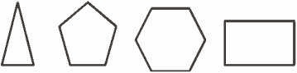

Lesson 2
Fluency Practice (12 minutes)
⬛ Multiply Using Partial Products 4.4D (3 minutes)
⬛ Identify Two-Dimensional Figures 4.6A (4 minutes)
⬛ Physiometry 4.6A (5 minutes)

Multiply Using Partial Products (3 minutes)
Materials: (S) Personal white board
Note: This fluency activity serves as a review of the Concept
Development in Grade 4 Module 3 Lessons 7–8.
T: (Write 322 X 7.) Say 322 in unit form.
S: 3 hundreds 2 tens 2 ones.
T: Say it as a three-product addition expression in unit
form.
S: 3 hundreds X 7 + 2 tens X 7 + 2 ones X 7.
T: Write 322 X 7 vertically and solve using the partial
product strategy.
Continue with the following possible sequence: 5 thousands 1 hundred 3 tens
2 ones X 3 and 4 X 4,312.
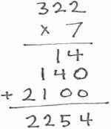

Identify Two-Dimensional Figures (4 minutes)
Materials: (S) Personal white board, straightedge
Note: This fluency activity reviews terms learned in Lesson 1.
T: (Project AB. Point to point A .) Say the term for what I’m pointing to.
S: Point A .
T: (Point to point B .) Say the term.
S: Point B .
T: (Point to AB.) Say the term.
S: Line segment AB.
T: Use your straightedge to draw CD on your personal white boards.
S: (Draw a segment with endpoints C and D .)
Continue with the following possible sequence:

EF ,GH ,and ∠ IKJ .
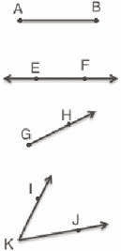

Physiometry (5 minutes)
Note: Kinesthetic memory is strong memory. This fluency activity reviews Lesson 1 terms.
T: Stand up.
S: (Stand up.)
T: (Extend arms straight so that they are parallel with the floor. Clench both hands into fists.)
What kind of figure do you think I’m modeling?
S: A line segment.
T: What do you think my fists might represent?
S: Points.
T: Make a line segment with your arms.
S: (Extend arms straight so that they are parallel with the floor. Clench both hands into fists.)
T: (Keep arms extended. Open fists, and point to side walls.) What kind of figure do you think I’m
modeling now?
S: A line.
T: What do you think my pointing fingers might represent?
S: Arrows.
T: Make a line.
S: (Keep arms extended, but open hands and point to the side walls.)
T: (Clench one hand in a fist, and extend arm forward to students.) Say the figure that you think I’m
modeling.
S: A point.
T: Make a point.
S: (Clench one hand in a fist, and extend arm forward.)
Use right angles to determine whether angles are equal to, greater
T: (Extend arms straight so that they are parallel with the floor. Clench one hand in a fist, and leave the
other hand open, pointing to a side wall.) Say the figure you think I’m modeling.
S: A ray.
T: Make a ray.
S: (Extend arms straight so that they are parallel with the floor. Clench one hand in a fist, and leave the
other hand open, pointing to a side wall.)
T: (Extend arms in an acute angle.) Say the figure I’m modeling.
S: An angle.
T: Make an angle.
S: (Extend arms in an acute angle.)
Next, move between figures with the following possible sequence: ray, angle, line segment, point, angle
made of two segments, and line.
Close the session by quickly cautioning students against the incorrect idea that lines and points are as thick as arms and fists when they are actually infinitely small.

Lesson 3
Fluency Practice (12 minutes)
⬛ Multiply Mentally 4.4D (3 minutes)
⬛ Identify Two-Dimensional Figures 4.6A (4 minutes)
⬛ Physiometry 4.6A (5 minutes)

Multiply Mentally (3 minutes)
Materials: (S) Personal white board
Note: This fluency activity reviews the Concept Developments from Grade 4 Module 3 Lessons 34–38.
T: (Write 34 X 2.) Say the multiplication sentence.
S: 34 X 2 = 68.
T: (Write 34 X 2 = 68. Below, write 34 X 20 = ____.) Say the multiplication sentence.
S: 34 X 20 = 680.
T: (Write 34 X 20 = 680. Below, write 34 X 22 = ____.) On your personal white board, solve 34 X 22.
S: 748.
Continue with the following possible sequence: 23 X 2, 23 X 30,
and 23 X 32.

Identify Two-Dimensional Figures (4 minutes)
Materials: (S) Personal white board
Note: This fluency activity reviews terms learned in Lessons 1–2.
T: (Project a line AB . Trace line AB .) Write the symbol
for what I’m pointing to.
S: AB
T: (Point to point A .) Say the term.
S: Point A .
T: (Point to point B .) Say the term.
S: Point B .
T: On your board, draw CD.
S: (Draw a line with points C and D on the line.)
Continue with the following possible sequence: EF, ∠ GIH , and JK.
T: (Project a right angle LNM .) Name the angle.
S: ∠ LNM .
T: What type of angle is it?
S: Right angle.
T: (Project an acute angle OQP .) Name the angle.
S: ∠ OQP .
T: Is it greater than or less than a right angle?
S: Less than.
T: What’s the term for an angle that’s less than a right angle?
S: Acute angle.
T: (Project an obtuse angle RTS .) Name the angle.
S: ∠ RTS .
T: Is it greater than or less than an acute angle?
S: Greater than.
T: Is it greater than or less than a right angle?
S: Greater than.
T: What’s the term for an angle greater than a right angle but less than a straight angle?
S: Obtuse angle.

Physiometry (5 minutes)
Note: Kinesthetic memory is strong memory. This fluency activity reviews terms from Lessons 1–2.
T: Stand up.
S: (Stand up.)
T: Model a line segment.
S: (Extend arms straight so that they are parallel with the floor. Clench both hands into fists.)
T: Model a line.
S: (Extend arms straight so that they are parallel with the floor. Open both hands and point at side
walls.)
T: Model a point.
S: (Clench one hand in a fist and extend arm forward.).
T: Model a ray.
S: (Extend arms straight so that they are parallel with the floor. Clench one hand in a fist, and leave the
point with a finger on the other hand.)
T: Model a ray pointing in the other direction.
S: (Clench open hand, and open clenched hand. Point with a finger on the open hand.)
T: (Stretch one arm up directly at the ceiling. Stretch the other arm directly toward a wall parallel to
the floor.) What type of angle do you think I’m modeling with my arms?
S: Right angle.
T: Model a right angle with your arms.
S: (Stretch one arm up directly at the ceiling. Stretch another arm directly toward a wall parallel to the
floor.)
T: (Stretch the arm pointing toward a wall directly up toward the ceiling. Move the arm pointing
toward the ceiling so that it points directly toward the opposite wall.) Model another right angle.
S: (Stretch the arm pointing toward a wall directly up toward the ceiling. Move the arm pointing
toward the ceiling so that it points directly toward the opposite wall.)
T: Model an acute angle.
S: (Model an acute angle with arms.)
T: Model an obtuse angle.
S: (Model an obtuse angle with arms.)
Next, move between figures with the following possible sequence: right angle, ray, line segment, acute angle, line, obtuse angle, point, and right angle.

Lesson 4
Fluency Practice (12 minutes)
⬛ Divide Mentally 4.4E, 4.4F (4 minutes)
⬛ Identify Two-Dimensional Figures 4.6A (4 minutes)
⬛ Physiometry 4.6A (4 minutes)

Divide Mentally (4 minutes)
Note: This activity reviews Grade 4 Module 3 content.
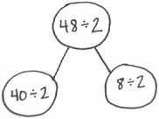
T: (Write 40 ÷ 2.) Say the completed division sentence in unit form.
S: 4 tens ÷ 2 = 2 tens.
T: (To the right, write 8 ÷ 2.) Say the completed division sentence in unit form.
S: 8 ones ÷ 2 = 4 ones.
T: (Above both number sentences, write 48 ÷ 2. Draw a number bond to connect the 2 original
problems to this problem.) Say the completed division sentence in unit form.
S: 4 tens 8 ones ÷ 2 = 2 tens 4 ones.
T: Say the division sentence in standard form.
S: 48 ÷ 2 = 24.
Continue with the following possible sequence: 48 ÷ 3, 96 ÷ 3, and 96 ÷ 4.

Identify Two-Dimensional Figures (4 minutes)
Materials: (S) Personal white board, straightedge
Note: This fluency activity reviews terms learned in Lessons 1–3.
T: (Project AB. Trace AB.) Name the figure.
S: Ray AB.
T: (Point to point A .) Say the term.
S: Point A .
T: (Point to point B .) Say the term.
S: Point B .
T: Use your straightedge to draw CD

on your personal white boards.
S: (Draw a ray with points C and D on the ray.)
Continue with the following possible sequence: EF, GH, and acute ∠ IKJ , obtuse ∠ LMN ,
and right ∠ OQP .
T: What’s the relationship between OQ and PQ?
S: The line segments are perpendicular.
T: Draw RS that is perpendicular to TV.
S: (Draw a line segment with endpoints R and S . Draw a line with points T and V that is perpendicular
to RS .)
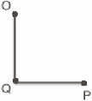
Physiometry (4 minutes)
Note: Kinesthetic memory is strong memory. This fluency activity reviews terms from Lessons 1–3.
T: Stand up.
S: (Stand up.)
T: Model a ray.
S: (Extend arms straight so that they are parallel with the floor. Clench one hand in a fist, and leave the
other hand open, pointing to a side wall.)
T: Model a ray pointing in the other direction.
S: (Open clenched hand, and clench open hand. Point with open hand.)
T: Model a line.
S: (Extend arms straight so that they are parallel with the floor. Open both hands, and point at the side
walls.)
T: Model a point.
S: (Clench one hand in a fist, and extend arm forward.)
T: Model a line segment.
S: (Extend arms straight so that they are parallel with the floor. Clench both hands into fists.)
T: Model a right angle.
S: (Stretch one arm up, directly at the ceiling. Stretch another arm directly toward a wall, parallel to
the floor.)
T: Model a different right angle.
S: (Stretch the arm pointing toward a wall directly up toward the ceiling. Move the arm pointing
toward the ceiling so that it points directly toward the opposite wall.)
T: Model an acute angle.
S: (Model an acute angle with arms.)
T: Model an obtuse angle.
S: (Model an obtuse angle with arms.)
Next, move between figures with the following possible sequence: right angle, point, line, obtuse angle, line segment, acute angle, and right angle.
T: (Stretch one arm up, pointing directly at the ceiling. Stretch another arm directly pointing toward a
wall, parallel to the floor.) Which type of angle do you think I’m modeling?
S: Right angle.
T: What is the relationship of the lines formed by right angles?
S: Perpendicular lines.
T: (Point at a wall to the side of the room.) Point at the walls that run perpendicular to the wall
I’m pointing to.
S: (Point at the front and back walls.)
T: (Point at the back wall.)
S: (Point at the side walls.)
Continue pointing to the other side wall and front wall.

Lesson 5
Fluency Practice (11 minutes)
⬛ Divide Using the Standard Algorithm 4.4E, 4.4F (3 minutes)
⬛ Identify Two-Dimensional Figures 4.6A (4 minutes)
⬛ Physiometry 4.6A (4 minutes)

Divide Using the Standard Algorithm (3 minutes)
Materials: (S) Personal white board
Note: This fluency activity reviews Grade 4 Module 3 Lesson 16 content.
T: (Write 48 ÷ 2.) On your personal white boards, solve the division problem using the vertical method.
Continue with the following possible sequence: 49 ÷ 2, 69 ÷ 3, 65 ÷ 3, 55 ÷ 5, 58 ÷ 5, 88 ÷ 4, and 86 ÷ 4.
Identify Two-Dimensional Figures (4 minutes)
Materials: (S) Personal white board, straightedge
Note: This fluency activity reviews terms learned in Lessons 1–4.
T: (Project AB. Point to A .) Say the term for what I’m pointing to.
S: Point A .
T: (Point to B .) Say the term.
S: Point B .
T: (Point to AB.) Say the term.
S: Line AB .
T: Use your straightedge to draw CD on your personal white boards.
S: (Draw a line with points C and D on the line.)
Continue with the following possible sequence: EF, GH, and obtuse ∠ IKJ , acute ∠LNM , and right ∠OQP .
T: What’s the relationship between QO and QP?
S: The line segments are perpendicular.
T: Draw RS.
S: (Draw RS.)
T: Draw TU that is perpendicular to RS.
S: (Draw TU.)
T: Draw VW that is perpendicular to RS and parallel to TU.
S: (Draw VW.)
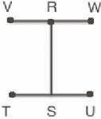

Physiometry (4 minutes)
Note: Kinesthetic memory is strong memory. This fluency activity reviews terms from Lessons 1–4.
T: Stand up.
S: (Stand up.)
T: Show me a point.
S: (Clench one hand in a fist, and extend arm forward.)
T: Show me a line.
S: (Extend arms straight so that they are parallel with the floor. Open both hands.)
T: Show me a ray.
S: (Extend arms straight so that they are parallel with the floor. Clench one hand in a fist, and leave the
other hand open.)
T: Show me a ray pointing in the other direction.
S: (Open clenched hand, and clench open hand.)
T: Show me a line segment.
S: (Extend arms straight so that they are parallel with the floor. Clench both hands into fists.)
T: Show me a right angle.
S: (Stretch one arm up directly at the ceiling. Stretch another arm directly toward a wall, parallel to the
floor.)
T: Show me a different right angle.
S: (Stretch the arm pointing toward a wall directly up toward the ceiling. Move the arm pointing
toward the ceiling so that it points directly toward the opposite wall.)
T: Show me an obtuse angle.
S: (Make an obtuse angle with arms.)
T: Show me an acute angle.
S: (Make an acute angle with arms.)
Continue with the following possible sequence: point, right angle, line segment, acute angle, line, right angle, and obtuse angle.
T: (Stretch one arm up directly at the ceiling. Stretch another arm directly toward a wall, parallel to the
floor.) What type of angle am I making?
S: Right angle.
T: What is the relationship of the lines formed by my arms?
S: Perpendicular lines.
T: (Point to the classroom’s back wall.) Point to the walls that run perpendicular to the wall I’m
pointing to.
S: (Point to the side walls.)
T: (Point to the front wall.)
S: (Point to the side walls.)
Continue pointing to one side wall, the back wall, the other side wall, and the front wall.
T: (Point to the back wall.) Point to the wall that runs parallel to the wall I’m pointing to.
S: (Point to the front wall.)
Continue pointing to one side wall, the front wall, and the other side wall.

Lesson 6
Fluency Practice (12 minutes)
Divide Using the Area Model 4.4E, 4.4F (4 minutes)
Draw and Identify Two-Dimensional Figures 4.6A (4 minutes)
Physiometry 4.6A (4 minutes)

Divide Using the Area Model (4 minutes)
Materials: (S) Personal white board
Note: This fluency activity reviews Grade 4 Module 3 Lesson 20 content.
T: (Project area model that shows 68 ÷ 2.) Write a division expression for this area model.
S: (Write 68 ÷ 2.)
T: Label the length of each rectangle in the area
model.
S: (Write 30 above the 60 and 4 above the 8.)
T: Solve using the standard algorithm.
S: (Solve.)
Continue with the following possible sequence: 69 ÷ 3, 78 ÷ 3, and 76 ÷ 4.

Draw and Identify Two-Dimensional Figures (4 minutes)
Materials: (S) Personal white board, straightedge
Note: This fluency activity reviews terms introduced in Lessons 1–5.
T: (Project AB. Point to A .) Say the term for what I’m pointing to.
S: Point A .
T: (Point to B .) Say the term.
S: Point B .
T: (Point to AB.) Say the term.
S: Line segment AB .
T: Use your straightedge to construct CD on your personal white boards.
S: (Draw CD.)
T: Beneath CD, draw EF that is parallel to CD.
S: (Beneath CD, draw EF that is parallel to CD.)
T: Draw GH that begins on EF and runs perpendicular through CD.
S: (Draw GH that begins on EF and runs perpendicular through CD.)
T: What’s the relationship between GH and CD?
S: GH is perpendicular to CD.
T: Draw IJ that is perpendicular to KL.
S: (Draw IJ. Draw KL that is perpendicular to IJ.)
T: Draw MN that is perpendicular to IJ and parallel to KL.
S: (Draw MN that is perpendicular to IJ and parallel to KL.)
T: (Project a right ∠ ACB .) Name the angle.
S: ∠ ACB .
T: What type of angle is it?
S: Right angle.
T: What’s the relationship of CA and CB?
S: They’re perpendicular.
T: How many degrees are in ∠ ACB ?
S: 90°.
T: (Project an acute ∠ DFE .) Name the angle.
S: ∠ DFE .
T: (Beneath ∠ DFE , write 30° or 150°.) Estimate. Is the measure of ∠ DFE 30° or 150°?
S: 30°.
T: How do you know?
S: Acute angles are less than 90°.
Continue with the other given angles.

Physiometry (4 minutes)
Note: Kinesthetic memory is strong memory. This fluency activity reviews terms from Lessons 1–5.
T: Stand up.
S: (Stand up.)
T: Show me a right angle.
S: (Stretch one arm up directly at the ceiling. Stretch another arm directly toward a wall, parallel to the
floor.)
T: Show me a different right angle.
S: (Stretch the arm pointing toward a wall directly up toward the ceiling. Move the arm pointing
toward the ceiling so that it points directly toward the opposite wall.)
T: Show me an obtuse angle.
S: (Make an obtuse angle with arms.)
T: Show me an acute angle.
S: (Make an acute angle with arms.)
T: Show me a right angle.
S: (Make a right angle with arms.)
T: Show me an angle that measures approximately 30°.
S: (Move arms closer together, lessening the space between their arms, so that it is approximately 30°.)
T: Show me an angle that measures approximately 60°.
S: (Open arms further apart to approximately 60°.)
Continue with the following possible sequence: 90°, 120°, 150°, 50°, 170°, 70°, and 180°.
T: What is the term for a 180° angle?
S: A straight angle.
T: Show me a line segment.
S: (Close fists.)
T: (Point at the classroom’s back wall.) Point to the walls that run perpendicular to the wall I’m
pointing to.
S: (Point to the side walls.)
T: (Point to the front wall.)
S: (Point to the side walls.)
Continue pointing to one side wall, the back wall, the other side wall, and the front wall.
T: (Point to the back wall.) Point to the wall that runs parallel to the wall I’m pointing to.
S: (Point to the front wall.)
Continue pointing to one side wall, the front wall, and the other side wall.

Lesson 7
Fluency Practice (12 minutes)
Break Apart 90, 180, and 360 4.7E (4 minutes)
Physiometry 4.6A (4 minutes)
Identify Angle Measures 4.7C, 4.7D (4 minutes)

Break Apart 90, 180, and 360 (4 minutes)
Materials: (S) Personal white board
Note: This fluency activity prepares students for unknown angle problems in Lessons 10–11.
T: (Project a number bond with a whole of 90. Fill in 10 for one of the parts.) On your
personal white boards, write the number bond, filling in the unknown part.
S: (Draw a number bond with a whole of 90 and with 10 and 80 as parts.)
Continue breaking apart 90 with the following possible sequence: 50, 40, and 45.
T: (Project a number bond with a whole of 180. Fill in 80 for one of the parts.)
On your boards, write the number bond, filling in the unknown part.
S: (Draw a number bond with a whole of 180 and with 80 and 100 as parts.)
Continue breaking apart 180 with the following possible sequence: 90, 120, 140, and 35.
T: (Project a number bond with a whole of 360. Fill in 300 for one of the parts.)
On your boards, write the number bond, filling in the unknown part.
S: (Draw a number bond with a whole of 360 and with 300 and 60 as parts.)
Continue breaking apart 360 with the following possible sequence: 100, 90, 180, 120, and 45.
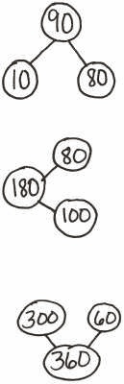

Physiometry (4 minutes)
Note: Kinesthetic memory is strong memory. This fluency activity reviews terms from Lessons 1–5.
T: Stand up.
S: (Stand up.)
T: Show me an acute angle.
S: (Make an acute angle with arms.)
T: Show me an obtuse angle.
S: (Make an obtuse angle with arms.)
T: Show me a right angle.
S: (Make a right angle with arms.)
T: Show me an angle that measures approximately 80°.
S: (Move arms closer together, lessening the space between their arms, so that it’s approximately 80°.)
T: Show me an angle that measures approximately 10°.
S: (Close arms more to approximately 10°.)
Continue with the following possible sequence: 90°, 100°, 170°, 150°, 60°, 140°, 70°, and 180°.
T: What is the term for a 180° angle?
S: A straight angle.
T: Show me a line segment.
S: (Close fists.)
T: Show me a ray.
S: (Open one hand while keeping the other hand clenched.)
T: Partner up with a classmate next to you. Decide who is Partner A and who is Partner B.
S: (Pair up with a partner. Decide who is Partner A and who is Partner B.)
T: Partner A, point at a side wall.
S: (Point at a side wall.)
T: Partner B, point at the walls that are perpendicular to the wall Partner A is pointing to.
S: (Point at front and back walls.)
T: Partner B, point to any wall in the room.
S: (Point at a wall.)
T: Partner A, point at the wall that is parallel to the wall Partner B is pointing to.
S: (Point at wall parallel to the wall Partner B is pointing to.)

Identify Angle Measures (4 minutes)
Materials: (S) Personal white board
Note: This fluency activity reviews Lesson 5.
T: How many degrees are in a right angle?
S: 90°.
T: (Project a right ∠DEF .) Name the angle.
S: ∠DEF .
T: What type of angle is it?
S: A right angle.
T: What’s the relationship of ED and EF?
S: They’re perpendicular.
T: How many degrees are in ∠ DEF ?
S: 90°.
T: (Project an acute ∠GIH .) Name the angle.
S: ∠GIH .
T: (Beneath ∠GIH , write 40° or 140°.) Estimate.
Is the measure of ∠GIH 40° or 140°?
S: 40°.
T: How do you know?
S: Acute angles are less than 90°.
Continue with the following possible sequence: obtuse angle measuring 130° or 50°, acute angle measuring 75° or 105°, and obtuse angle measuring 92° or 88°.
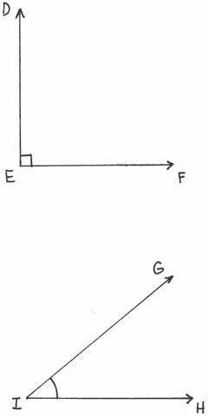

Lesson 8
Fluency Practice (12 minutes)
Count by 90° 4.7E (2 minutes)
Break Apart 90, 180, and 360 4.7E (4 minutes)
Physiometry 4.6A (2 minutes)
Sketch Angles 4.7C, 4.7D (4 minutes)

Count by 90° (2 minutes)
Note: This fluency activity prepares students for Lesson 8. If students struggle to connect counting groups
of 9, groups of 9 tens, and groups of 90, write the counting progressions on the board.

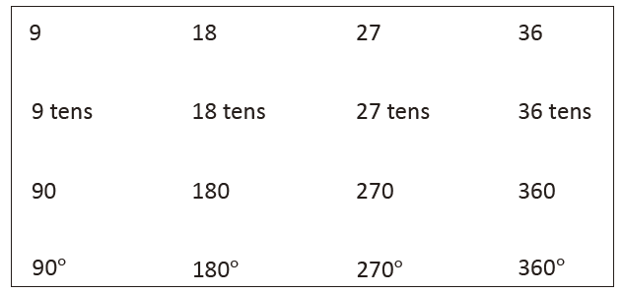
Direct students to count forward and backward:
Nines to 36
9 tens to 36 tens
90 to 360
90° to 360°

Break Apart 90, 180, and 360 (4 minutes)
Materials: (S) Personal white board
Note: This fluency activity prepares students for unknown angle problems in Lessons 10–11.
T: (Project a number bond with a whole of 90. Fill in 20 for one of the parts.) On your personal white
boards, write the number bond, filling in the unknown part.
S: (Draw a number bond with a whole of 90 and with 20 and 70 as parts.)
Continue breaking apart 90 with the following possible sequence: 60, 40, 50, and 45.
T: (Project a number bond with a whole of 180. Fill in 70 for one of the parts.) On your boards, write
the number bond, filling in the unknown part.
S: (Draw a number bond with a whole of 180 and with 70 and 110 as parts.)
Continue to break apart 180 with the following possible sequence: 90, 130, 40, and 135.
T: (Project a number bond with a whole of 360. Fill in 50 for one of the parts.) On your boards, write
the number bond, filling in the unknown part.
S: (Draw a number bond with a whole of 360 and with 50 and 310 as parts.)
Continue to break apart 360 with the following possible sequence: 200, 190, 180, 90, 120, and 45.

Physiometry (2 minutes)
Note: Kinesthetic memory is strong memory. This fluency activity reviews terms from Lessons 1–7.
T: Stand up.
S: (Stand up.)
T: Show me an acute angle.
S: (Make an acute angle with arms.)
T: Show me an obtuse angle.
S: (Make an obtuse angle with arms.)
T: Show me a right angle.
S: (Make a right angle with arms.)
T: Show me an angle that measures approximately 100°.
S: (Move arms further apart, increasing the space between their arms, so that it is approximately 100°.)
T: Show me an angle that measures approximately 150°.
S: (Move arms further apart to approximately 150°.)
Continue with the following possible sequence: 90°, 80°, 30°, 20°, 120°, 40°, 110°, and 180°.
T: What’s another name for a 180° angle?
S: A straight angle.
T: (Point to one of the classroom’s side walls.) Point to the walls that run perpendicular to the wall I’m
pointing to.
S: (Point to the front and back wall.)
T: (Point to the front wall.)
S: (Point to the side walls.)
Continue pointing to the other side wall and back wall.
T: (Point to the back wall.) Point to the wall that runs parallel to the wall I’m pointing to.
S: (Point to the front wall.)
Continue pointing to one side wall, the back wall, and the other side wall.

Sketch Angles (4 minutes)
Materials: (S) Personal white board
Note: This fluency activity reviews terms from Lesson 7.
T: On your personal white boards, show me ∠ABC that
measures about 90°.
S: (Sketch ∠ABC that measures approximately 90°.)
T: What do we call an angle that measures 90°?
S: Right angle.
T: On your boards, show me ∠ DEF that measures about
80°.
S: (Sketch ∠DEF that measures approximately 80°.)
T: What type of angle did you draw?
S: Acute.
Continue with the following possible sequence: 10°, 150°, 50°,
120°, and 45°.

Lesson 9
Fluency Practice (12 minutes)
⬛ Count by 90° 4.7E (1 minute)
⬛ Break Apart 90, 180, and 360 4.7E (4 minutes)
⬛ Sketch Angles 4.7C, 4.7D (3 minutes)
⬛ Physiometry 4.6A (4 minutes)

Count by 90° (1 minute)
Note: This fluency activity prepares students to do problem solving that involves 90° turns.
Direct students to count forward and backward, occasionally changing the direction of the count.
⬛ Nines to 36
⬛ 9 tens to 36 tens
⬛ 90 to 360
⬛ 90° to 360° (while turning)

Break Apart 90, 180, and 360 (4 minutes)
Materials: (S) Personal white board
Note: This fluency exercise prepares students for unknown angle problems in Lessons 10 and 11.
T: (Project a number bond with a whole of 90. Fill in 30 for one of the parts.) On your personal white
boards, write the number bond, filling in the unknown part.
S: (Draw a number bond with a whole of 90 and with 30 and 60 as parts.)
Continue to break apart 90 with the following possible sequence: 50, 45, 25, and 65.
T: (Project a number bond with a whole of 180. Fill in 120 for one of the parts.) On your boards, write
the number bond, filling in the unknown part.
S: (Draw a number bond with a whole of 180 and with 120 and 60 as parts.)
Continue to break apart 180 with the following possible sequence: 90, 75, 135, and 55.
T: (Project a number bond with a whole of 360. Fill in 40 for one of the parts.) On your boards, write
the number bond, filling in the unknown part.
S: (Draw a number bond with a whole of 360 and with 40 and 320 as parts.)
Continue to break apart 360 with the following possible sequence: 160, 180, 170, 270, 120, 90, and 135.

Sketch Angles (3 minutes)
Materials: (S) Personal white board
Note: This fluency activity reviews terms from Lesson 2.
T: Sketch ∠ ABC that measures 90°.
T: (Allow students time to sketch.) Is a 90° angle a right angle, an obtuse angle, or an acute angle?
S: Right angle.
T: Sketch ∠ DEF that measures 100°.
T: (Allow students time to sketch.) What type of angle did you draw?
S: Obtuse.
Continue with the following possible sequence: 170°, 30°, 130°, 60°, and 135°.

Physiometry (4 minutes)
Note: Kinesthetic memory is strong memory. This fluency exercise reviews terms from Lessons 1–8.
T: (Stretch one arm straight up, pointing at the ceiling. Straighten the other arm, pointing directly at a
side wall.) What angle measure do you think I’m modeling with my arms?
S: 90°.
T: (Straighten both arms so that they are parallel to the floor, pointing at both side walls.) What angle
measure do you think I’m modeling now?
S: 180°. → Straight angle.
T: (Keep one arm pointing directly to a side wall. Point directly down with the other arm.) Now?
S: (270°.) → 90°.
T: It could be 90°, but the angle I’m thinking of is larger than 180°, so that would be?
S: 270°.
Continue to 360°.
Quickly remind students that this is an illustration and that they should not make the mistake to think that
lines and points are as thick as arms. They are actually infinitely small.
T: Stand up.
S: (Stand.)
T: Model a 90° angle.
T: Model a 180° angle.
T: Model a 270° angle.
T: Model a 360° angle.
T: Point to the walls that run perpendicular to the front of the room.
S: (Point to the side walls.)
T: (Point to the side wall.) Turn 90° to your right.
T: Turn 90° to your right.
T: Turn 90° to your right.
T: Turn 90° to your right.
T: Turn 180°.
T: Turn 90° to your left.
T: Turn 180°.

Lesson 10
Fluency Practice (12 minutes)
⬛ Divide with Number Disks 4.4E, 4.4F (4 minutes)
⬛ Group Count by 90° 4.7E (1 minute)
⬛ Break Apart 90, 180, and 360 4.7E (4 minutes)
⬛ Physiometry 4.6A (3 minutes)

Divide with Number Disks (4 minutes)
Materials: (S) Personal white board
Note: This fluency activity reviews Module 3 content.
T: (Display 6 ÷ 2.) On your personal white boards, draw number disks to represent the expression.
S: (Draw 6 ones disks, and divide them into 2 groups of 3.)
T: Say the division sentence in unit form.
S: 6 ones ÷ 2 = 3 ones.
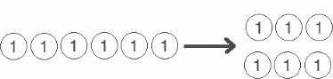
Continue with the following possible sequence: 60 ÷ 2; 600 ÷ 2; 6,000 ÷ 2; 9 tens ÷ 3; 12 tens ÷ 4; and
12 tens ÷ 3.

Group Count by 90° (1 minute)
Note: If students struggle to connect counting groups of 9, groups of 9 tens, and groups of 90, write the
counting progressions on the board.
Direct students to count forward and backward, occasionally changing the direction of the count.
⬛ Nines to 36
⬛ 9 tens to 36 tens
⬛ 90 to 360
⬛ 90° to 360° (while turning)

Break Apart 90, 180, and 360 (4 minutes)
Materials: (S) Personal white board
Note: This fluency exercise prepares students for unknown angle problems in Lessons 10 and 11.
T: (Project a number bond with a whole of 90. Fill in 45 for one of the parts.) On your personal white
boards, write the number bond, filling in the unknown part.
Continue to break apart 90 with the following possible sequence: 35, 25, 65, and 15.
T: (Project a number bond with a whole of 180. Fill in 170 for one of the parts.) On your boards, write
the number bond, filling in the unknown part.
Continue to break apart 180 with the following possible sequence: 90, 85, 45, and 125.
T: (Project a number bond with a whole of 360. Fill in 180 for one of the parts.) On your boards, write
the number bond, filling in the unknown part.
Continue to break apart 360 with the following possible sequence: 90, 45, 270, 240, and 315.

Physiometry (3 minutes)
Note: Kinesthetic memory is strong memory. This fluency activity reviews terms from Lessons 1–8.
T: Stand up. (Students stand and follow the series of directions below.)
T: Model a 90° angle with your arms.
T: Model a 180° angle with your arms.
T: Model a 270° angle.
T: Model a 360° angle.
T: Point to the walls that run perpendicular to the back of the room.
T: Turn 90° to your left.
T: Turn 90° to your left.
T: Turn 90° to your left.
T: Turn 90° to your left.
T: Turn 180°.
T: Turn 90° to your left.
T: Turn 180°.
T: Turn 270° to your right.
T: Turn 180° to your left.

Lesson 11
Fluency Practice (12 minutes)
⬛ Divide Different Units 4.4E, 4.4F (4 minutes)
⬛ Break Apart 90, 180, and 360 4.7E (4 minutes)
⬛ Find the Unknown Angle 4.7E (4 minutes)

Divide Different Units (4 minutes)
Materials: (S) Personal white board
Note: This fluency activity reviews Module 3 content.
T: (Write 6 ÷ 2 = __.) Say the division sentence in unit form.
S: 6 ones ÷ 2 = 3 ones.
T: (Write 6 ÷ 2 = 3. To the right, write 60 ÷ 2 = ___.)
Say the division sentence in unit form.
S: 6 tens ÷ 2 = 3 tens.
T: (Write 60 ÷ 2 = 30. To the right, write 600 ÷ 2 = __.)
Say the division sentence in unit form.
S: 6 hundreds ÷ 2 = 3 hundreds.
T: (Write 600 ÷ 2 = 300. To the right, write 6,000 ÷ 2 = __.)
Say the division sentence in unit form.
S: 6 thousands ÷ 2 = 3 thousands.
T: (Write 6,000 ÷ 2 = 3,000.)
T: (Write 8 tens ÷ 2 = _____.) On your personal white boards, write the division sentence in standard
form.
S: (Write 80 ÷ 2 = 40.)
Continue with the following possible sequence: 8 tens ÷ 2, 25 tens ÷ 5, 12 hundreds ÷ 4, 24 hundreds ÷ 4,
27 tens ÷ 3, 32 tens ÷ 4, 30 tens ÷ 5, and 40 hundreds ÷ 5.

Break Apart 90, 180, and 360 (4 minutes)
Materials: (S) Personal white board
Note: This fluency exercise prepares students for unknown angle problems in Lesson 11.
T: (Project a number bond with a whole of 90. Fill in 9 for one of the parts.) On your personal white
boards, write the number bond, filling in the unknown part.
S: (Draw a number bond with a whole of 90 and with 9 and 81 as parts.)
Continue to break apart 90 with the following possible sequence: 55, 35, and 75.
T: (Project a number bond with a whole of 180. Fill in 142 for one of the parts.) On your boards, write
the number bond, filling in the unknown part.
S: (Draw a number bond with a whole of 180 and with 142 and 38 as parts.)
Continue to break apart 180 with the following possible sequence: 47, 133, and 116.
T: (Project a number bond with a whole of 360. Fill in 58 for one of the parts.) On your boards, write
the number bond, filling in the unknown part.
S: (Draw a number bond with a whole of 360 and with 58 and 302 as parts.)
Continue to break apart 360 with the following possible sequence: 93, 261, and 48.

Find the Unknown Angle (4 minutes)
Materials: (S) Personal white board
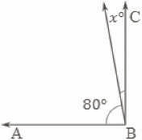
Note: This fluency activity reviews Lesson 10.
T: (Project ∠ ABC .) Angle ABC is a right angle. Say the given angle.
S: 80°.
T: On your personal white boards, write the measure of ∠ x . If you need to, write a subtraction
sentence to find the answer.
S: (Write x ° = 10°)
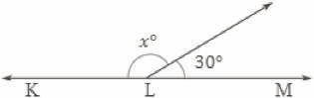
Continue with right angles using the following possible sequence: x ° = 30°, and x ° = 45°.
T: (Project ∠ KLM .) KLM is a straight angle. What’s the
measurement of a straight angle?
S: 180°.
T: On your boards, write the measure of ∠ x . If you need to, write a subtraction sentence to find the
answer.
S: (Write 150°.)
Continue with straight angles using the following possible sequence: x ° = 60°, x ° = 90°, and x ° = 135°.

Lesson 12
Fluency Practice (12 minutes)
⬛ Add and Subtract 4.4A (4 minutes)
⬛ Find the Quotient and Remainder 4.4E, 4.4F (4 minutes)
⬛ Find the Unknown Angle 4.7E (4 minutes)

Add and Subtract (4 minutes)
Materials: (S) Personal white board
Notes: This concept reviews adding and subtracting using the standard algorithm.
T: (Write 756 thousands 498 ones.) On your personal white boards, write this number in standard
form.
S: (Write 756,498.)
T: (Write 175 thousands 645 ones.) Add this number to 756,498 using the standard algorithm.
S: (Write 756,498 + 175,645 = 932,143 using the standard algorithm.)
Continue with the following possible sequence: 482,949 + 375,678.
T: (Write 800 thousands.) On your boards, write this number in standard form.
S: (Write 800,000.)
T: (Write 648 thousands 745 ones.) Subtract this number from 800,000 using the standard algorithm.
S: (Write 800,000 – 648,745 = 151,255 using the standard algorithm.)
Continue with the following possible sequence: 754,912 – 154,189.

Find the Quotient and Remainder (4 minutes)
Materials: (S) Personal white board
Note: This fluency activity reviews Module 3 Lesson 28’s Concept Development.
T: (Write 4,549 ÷ 2.) On your personal white boards, find the quotient and
remainder.
S: (Write the quotient and remainder.)
Continue with the following possible sequence: 6,761 ÷ 5; 1,665 ÷ 4; and 1,335 ÷ 4.

Find the Unknown Angle (4 minutes)
Materials: (S) Personal white board
Note: This fluency activity reviews Lesson 10.
T: (Project the first unknown angle problem. Run finger
over the larger angle.) This is a right angle. On your
personal white boards, write a number sentence to find
the measure of ∠ 𝑥 .
S: (Write 90° − 25° = 𝑥 °. Below it, write 𝑥 ° = 65°.)
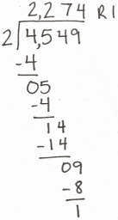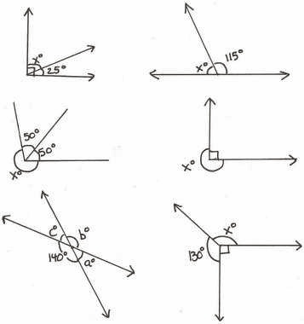
Continue with the remaining unknown angle problems.

Lesson 13
Fluency Practice (10 minutes)
⬛ Divide Three Different Ways 4.4E, 4.4F (5 minutes)
⬛ Physiometry 4.6B (3 minutes)
⬛ Lines of Symmetry 4.6B (2 minutes)

Divide Three Different Ways (5 minutes)
Materials: (S) Personal white board
Note: This fluency exercise reviews concepts covered in Module 3. Alternately, have students choose to
solve the division problem using just one of the three methods.
T: (Write 532 ÷ 4.) Solve this problem by drawing place value disks.
S: (Solve by drawing place value disks.)
T: Solve 532 ÷ 4 using the area model.
S: (Solve using the area model.)
T: Solve 532 ÷ 4 using the standard algorithm.
S: (Solve using the standard algorithm.)
Continue with this possible sequence: 854 ÷ 3.

Physiometry (3 minutes)
Note: Kinesthetic memory is strong memory. This fluency activity reviews terms learned in Lesson 12.
T: Stand up.
T: Am I trying to make my body position look symmetrical?
T: (Raise left arm so fingers point directly to the wall. Leave the other arm hanging down.) Is my
position symmetrical now?
S: No.
Continue with other symmetrical and non-symmetrical positions.
T: With your arms, model a line that runs parallel to the floor. Are you modeling a symmetrical
position?
S: Yes.
T: Model a right angle. Are you modeling a symmetrical position?
S: No.
T: Model a line segment that runs parallel to the floor. Are you modeling a symmetrical position?
S: Yes.
Lines of Symmetry (2 minutes)
Note: This fluency exercise reviews Lesson 12.
T: (Project arrow with a line of symmetry. Point to the line of symmetry.) Is this a line of symmetry?
S: Yes.
T: (Project the diamond. Point to the nonsymmetrical
line.) Is this a line of
symmetry?
S: No.
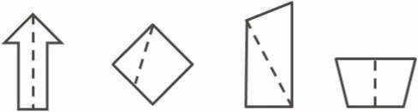
Continue process for the remaining graphics.

Lesson 14
Fluency Practice (12 minutes)
⬛ Divide Three Different Ways 4.4E, 4.4.F (4 minutes)
⬛ Physiometry 4.6B (4 minutes)
⬛ Classify the Triangle 4.6C (4 minutes)

Divide Three Different Ways (4 minutes)
Materials: (S) Personal white board
Note: This fluency activity reviews the content of Module 3 Lessons 24–26. Alternatively, have students
select a solution strategy.
T: (Write 148 ÷ 3.) Find the quotient by drawing place value disks.
S: (Solve by drawing place value disks.)
T: Find the quotient using the area model.
S: (Solve using the area model.)
T: Find the quotient using the standard algorithm.
S: (Solve using the standard algorithm.)
Continue with 1,008 ÷ 4.

Physiometry (4 minutes)
Note: Kinesthetic memory is strong memory. This fluency exercise reviews terms learned in Lesson 12.
T: Stand up.
T: I’m trying to make my body position look symmetrical.
T: (Raise left arm so fingers point directly to the wall. Leave the other arm hanging down.) Is my
position symmetrical now?
S: No.
Continue with other symmetrical and non-symmetrical positions.
T: With your arms, model a line that runs parallel to the floor. Are you modeling a position that has
symmetry?
S: Yes.
T: Model a ray. Are you modeling a position of symmetry?
S: No.
T: Model a line segment. Are you modeling a
position of symmetry?
S: Yes.

Classify the Triangle (4 minutes)
Note: This fluency activity reviews Lesson 13.
T: (Project triangle.) What’s the measure of the
largest given angle in this triangle?
S: 110°.
T: Is the same triangle acute, right, or obtuse?
S: Obtuse.
T: Why?
S: Because there’s an angle greater than 90°.
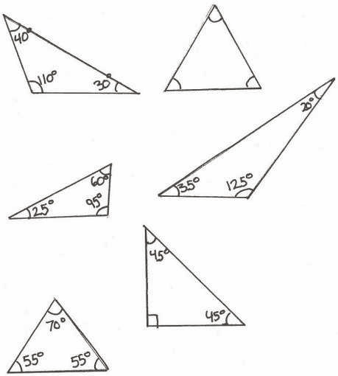
Continue the process for the other triangles.

Lesson 15
Fluency Practice (12 minutes)
⬛ Add and Subtract 4.4A (4 minutes)
⬛ Classify the Triangle 4.6C (3 minutes)
⬛ Find the Unknown Angle 4.7E (5 minutes)

Add and Subtract (4 minutes)
Materials: (S) Personal white board
Note: This concept reviews the yearlong Grade 4 fluency standard for adding and subtracting using the
standard algorithm.
T: (Write 543 thousands 178 ones.) On your personal white boards, write this number in standard
form.
S: (Write 543,178.)
T: (Write 134 thousands 153 ones.) Add this number to 543,178 using the standard algorithm.
S: (Write 543,178 + 134,153 = 677,331 using the standard algorithm.)
Continue with the following possible sequence: 481,737 + 253,675.
T: (Write 817 thousands 560 ones.) On your boards, write this number in standard form.
S: (Write 817,560.)
T: (Write 426 thousands 145 ones.) Subtract this number from 817,560 using the standard algorithm.
S: (Write 817,560 – 426,145 = 391,415 using the standard algorithm.)
Continue with the following possible sequence: 673,172 – 143,818 and 600,000 – 426,521.

Classify the Triangle (3 minutes)
Note: This fluency activity reviews Lesson 13.
T: Is the triangle acute, right, or obtuse?
S: Acute.
T: Why?
S: Because all the angles are less than 90°.
T: (Project triangle.) Say the measure of the largest
angle.
S: 130°.
T: Is the triangle acute, right, or obtuse?
S: Obtuse.
T: Why?
S: Because it has an angle greater than 90°.
Continue the process for the other triangles.
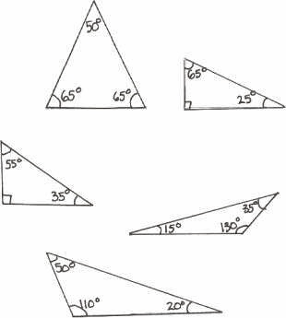

Find the Unknown Angle (5 minutes)
Materials: (S) Personal white board
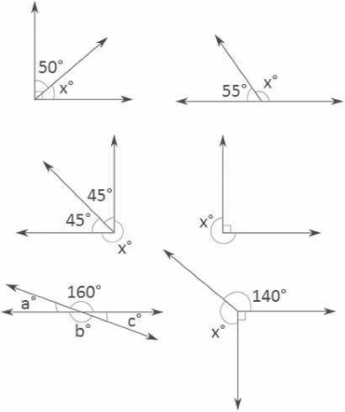
Note: This fluency exercise reviews Lesson 10.
T: (Project the first unknown angle problem. Run a
finger over the largest angle.) This is a right angle.
On your personal white boards, write a number
sentence to find the measure of ∠ 𝑥 .
S: (Write 90 – 50 = 𝑥 . Below it, write 𝑥 ° = 40°.)
Continue with the remaining unknown angle problems.

Lesson 16
Fluency Practice (12 minutes)
⬛ Add and Subtract 4.4A (4 minutes)
⬛ Find the Unknown Angle 4.7E (5 minutes)
⬛ Classify the Quadrilateral 4.6D (3 minutes)

Add and Subtract (4 minutes)
Materials: (S) Personal white board
Notes: This concept reviews the yearlong Grade 4 fluency standard for adding and subtracting using the
standard algorithm.
T: (Write 765 thousands 198 ones.) On your personal white boards, write this number in standard
form.
S: (Write 765,198.)
T: (Write 156 thousands 185 ones.) Add this number to 765,198 using the standard algorithm.
S: (Write 765,198 + 156,185 = 921,383 using the standard algorithm.)
Continue with the following possible sequence: 681,959 + 175,845.
T: (Write 716 thousands 450 ones.) On your boards, write this number in standard form.
S: (Write 716,450.)
T: (Write 325 thousands 139 ones.) Subtract this number from 716,450 using the standard algorithm.
S: (Write 716,450 – 325,139 = 391,311 using the standard algorithm.)
Continue with the following possible sequence: 451,151 – 122,616 and 500,000 – 315,415.

Find the Unknown Angle (5 minutes)
Materials: (S) Personal white board
Note: This fluency activity reviews Lesson 10.
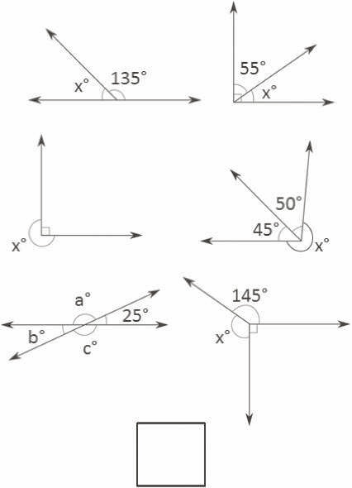
T: (Project the first unknown angle problem. Run a
finger along the horizontal line.) This is a straight
angle. On your personal white boards, write a
number sentence to find the measure of ∠ 𝑥 .
S: (Write 180 – 135 = 𝑥. Below it, write 𝑥 ° = 45°.)
Continue with the remaining unknown angle problems.

Classify the Quadrilateral (3 minutes)
Notes: This fluency exercise reviews Lesson 15.
T: (Project square.) How many sides does the
polygon have?
S: Four sides.
T: What’s the name for polygons with four sides?
S: Quadrilateral.
T: Each angle in this quadrilateral is 90°. It also has four equal sides. What’s a more specific name?
S: Square.
T: (Project second polygon.) Is this polygon a quadrilateral?
S: Yes.
T: Why?
S: Because it has four sides.
T: Is this quadrilateral a square?
S: No.
T: How do you know?
S: The sides are not the same length.
T: Each angle is 90°. What type of quadrilateral is it?
S: Rectangle.
T: Does a rectangle have two sets of parallel sides?
S: Yes.
T: (Project parallelogram.) Is this polygon a quadrilateral?
S: Yes.
T: This quadrilateral has two sets of parallel sides. Is it a rectangle?
S: No.
T: How do you know?
S: All four angles are not 90°.
T: What’s the name of a quadrilateral with two sets of parallel sides that best defines this figure?
S: Parallelogram.
T: (Project trapezoid.) Is this polygon a quadrilateral?
S: Yes.
T: How do you know?
S: It has four sides.
T: Is it a rectangle?
S: No.
T: How do you know?
S: Each angle doesn’t measure 90°.
T: Is it a parallelogram?
S: No.
T: How do you know?
S: It doesn’t have two sets of parallel sides.
T: Classify this quadrilateral.
S: It’s a trapezoid.
T: Describe its attribute.
S: It has exactly one pair of parallel sides.

