Grade 4 Module 5: Fraction Equivalence, Ordering, and Operations
Topic A: Decomposition and Fraction Equivalence
Lesson 1
Lesson 2
Lesson 3
Lesson 4
Lesson 5
Topic B: Fraction Equivalence Using Multiplication and Division
Lesson 6
Lesson 7
Lesson 8
Lesson 9
Lesson 10
Topic C: Fraction Comparison
Lesson 11
Lesson 12
Lesson 13
Lesson 14
Topic D: Fraction Addition and Subtraction
Lesson 15
Lesson 16
Lesson 17
Lesson 18
Topic E: Extending Fraction Equivalence to Fractions Greater Than 1
Lesson 19
Lesson 20
Lesson 21
Lesson 22
Lesson 23
Lesson 24
Topic F: Addition and Subtraction of Fractions by Decomposition
Lesson 25
Lesson 26
Lesson 27
Lesson 28
Lesson 29
Lesson 30
Lesson 31

Grade 4 Module 5
Lesson 1
Fluency Practice (9 minutes)
⬛ Read Strip Diagrams 3.4E (5 minutes)
⬛ Addition of Fractions in Unit Form 3.3C, 3.3D (4 minutes)

Read Strip Diagrams (5 minutes)
Materials: (S) Personal white board
Note: This fluency activity prepares students for Lesson 1.
T: (Project a strip diagram partitioned into 2 equal parts. Write 10 at the top.) Say the value of the
whole.
S: 10.
T: Write the value of one unit as a division problem.
S: (Write 10 ÷ 2 = 5.)
T: (Write 5 in both units.) Write the whole as a repeated addition
sentence.
S: (Write 5 + 5 = 10.)
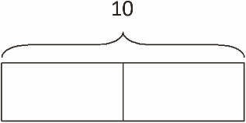
Continue with the following possible sequence: 6 ÷ 2, 15 ÷ 3, 6 ÷ 3, 12 ÷ 4, and 24 ÷ 4.

Addition of Fractions in Unit Form (4 minutes)
Materials: (S) Personal white board
Note: This fluency activity prepares students for Lesson 1.
T: (Project a circle partitioned into 2 equal parts with 1 part shaded.) How many circles do you see?
S: 1.
T: How many equal parts are in the circle?
S: 2.
T: What fraction of the circle is shaded?
S: 1/2.
T: (Write 1 half + 1 half = 2 halves = 1.) True or false?
S: True.
T: Explain why it is true to your partner.
S: 1 + 1 is 2. That's kindergarten. → Two halves is the same as 1. → Half an apple + half an apple is
1 apple.
T: (Project a circle partitioned into 4 equal parts with 1 part shaded.) How many circles do you see?
S: 1.
T: How many equal parts does this circle have?
S: 4.
T: Write the fraction that is represented by the shaded part.
S: (Write 1/4.)
T: (Write 1 fourth + 1 fourth + 1 fourth + 1 fourth = 4 fourths = 1.) True or false?
S: True.
Continue with the following possible fraction graphics:

Lesson 2
Fluency Practice (10 minutes)
⬛ Read Strip diagrams 3.4E (4 minutes)
⬛ Break Apart Fractions 4.4A, 4.4B (6 minutes)

Read Strip diagrams (4 minutes)
Materials: (S) Personal white board
Note: This fluency activity prepares students for today's lesson.
T: (Project a strip diagram partitioned into 3 equal parts. Write 15 at the top.) Say the value of the
whole.
S: 15.
T: Write the value of 1 unit as a division problem.
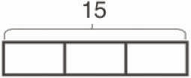
S: (Write 15 ÷ 3 = 5.)
T: (Write 5 in each unit.) Write the whole as a repeated addition sentence.
S: (Write 5 + 5 + 5 = 15.)
T: (Write 3 fives = 5 + 5 + 5 = 3 X ___.) Write the whole as a multiplication equation.
S: (Write 3 X 5 = 15.)
Continue with the following possible sequence: 8 ÷ 2, 20 ÷ 5, 12 ÷ 2, 8 ÷ 4, 21 ÷ 3, and 32 ÷ 4.
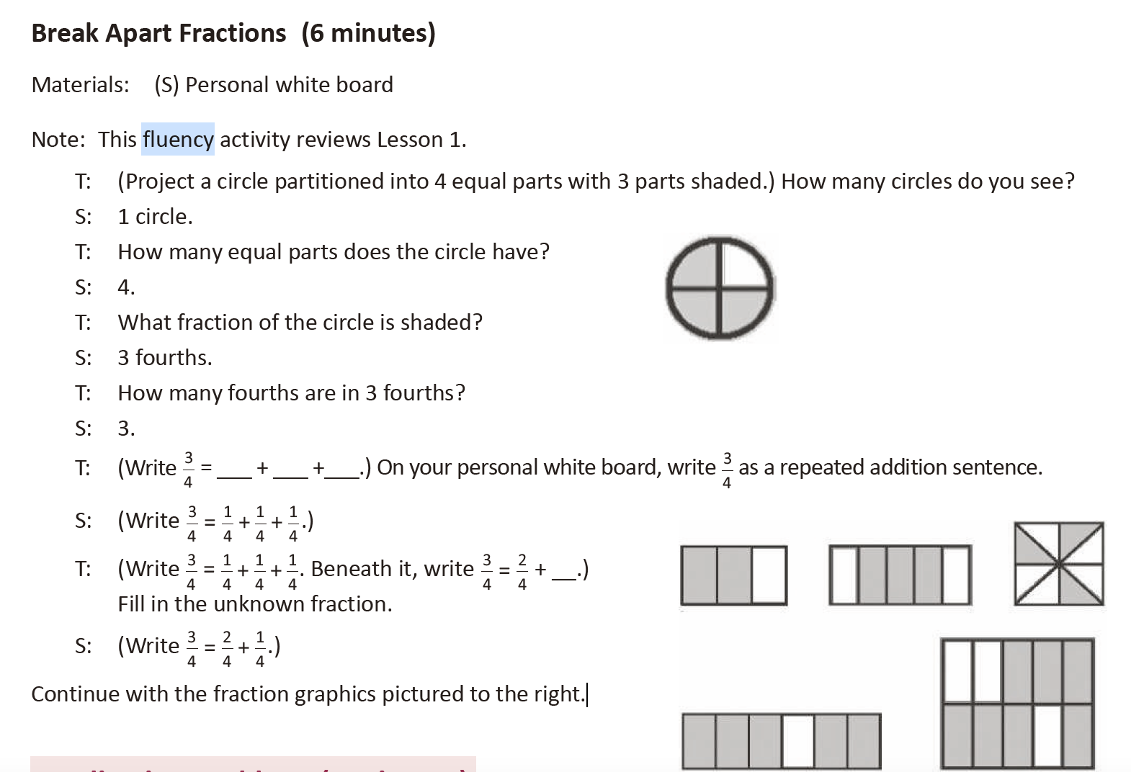

Lesson 3
Fluency Practice (12 minutes)
⬛ Break Apart Fractions 4.3A, 4.3B (7 minutes)
⬛ Count by Equivalent Fractions 4.3C (5 minutes)
Break Apart Fractions (7 minutes)
Materials: (S) Personal white board
Note: This fluency activity prepares students for the concepts in the lesson.
T: (Project a strip diagram partitioned into 3 equal units. Write 1 above it. Shade 2 units.) How many
equal parts does this 1 have?
S: 3 parts.
T: Say the value of 1 unit.
S: 1 third.
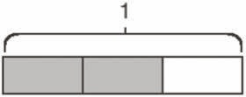
T: What fraction of 1 is shaded?
S: 2 thirds.
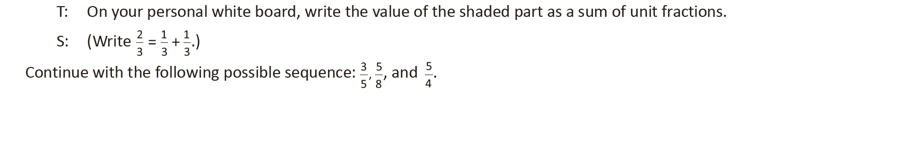
T: (Write 3/4.) Say the fraction.
S: 3 fourths.
T: On your board, draw a strip diagram of 3 fourths.
S: (Draw a strip diagram partitioned into 4 equal units. Shade 3 units.)
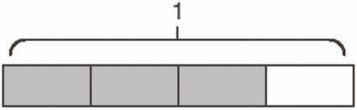
T: What's the value of each unit?
S: 1 fourth.
T: Express 3 fourths as a repeated addition sentence.
S: (Write ¾ = ¼ + ¼ + 1/4 .)
Continue with the following possible sequence: 4/5’ 8/5 and 6/3.

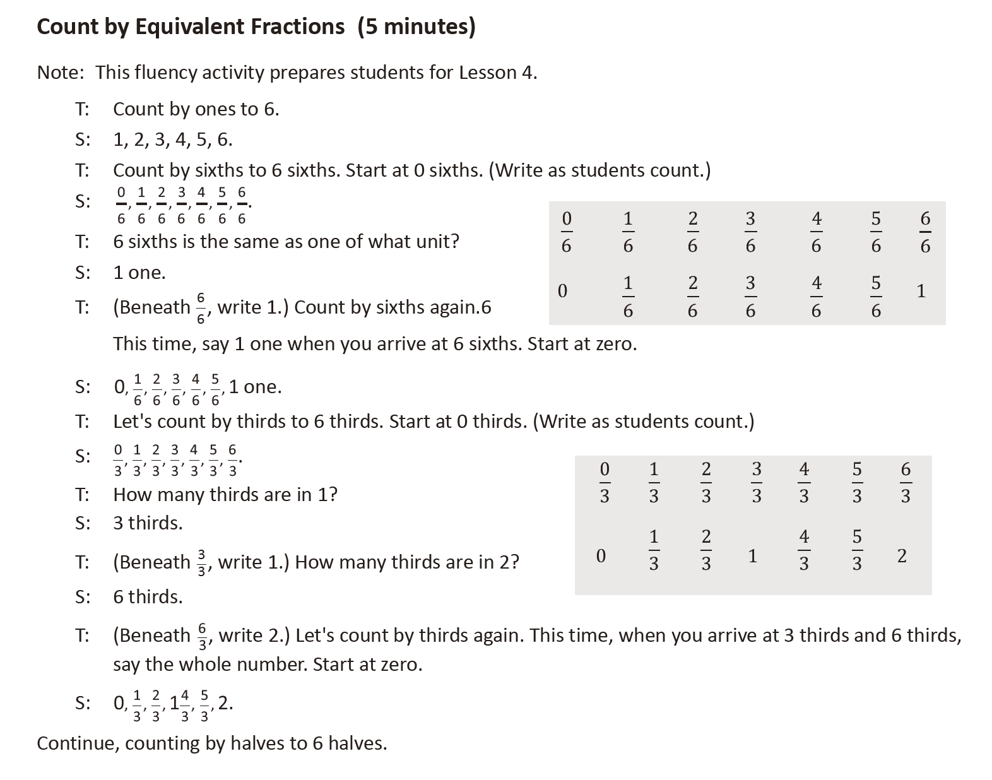

Lesson 4
Count by Equivalent Fractions (4 minutes)
Note: This fluency activity reviews Lesson 3.
T: Count from 0 fourths to 4 fourths by 1 fourths. (Write as students count.)

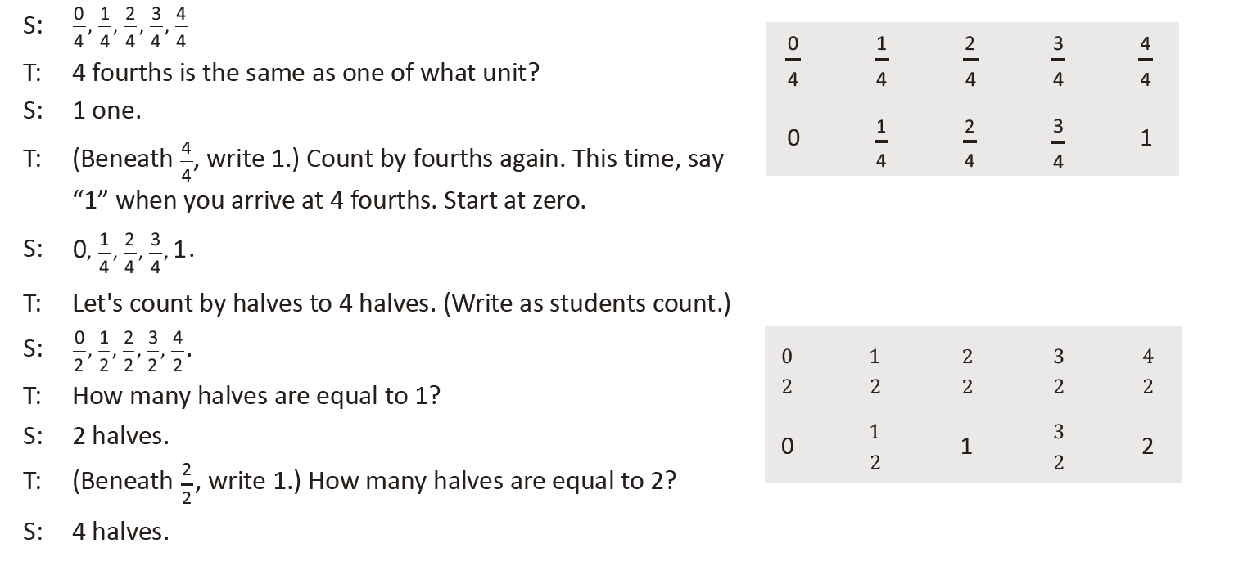
S:
0 , 1 , 2 , 3
4 4 4 4
4
4
S:
0 , 1 , 2 , 3
4 4 4 4
4
4
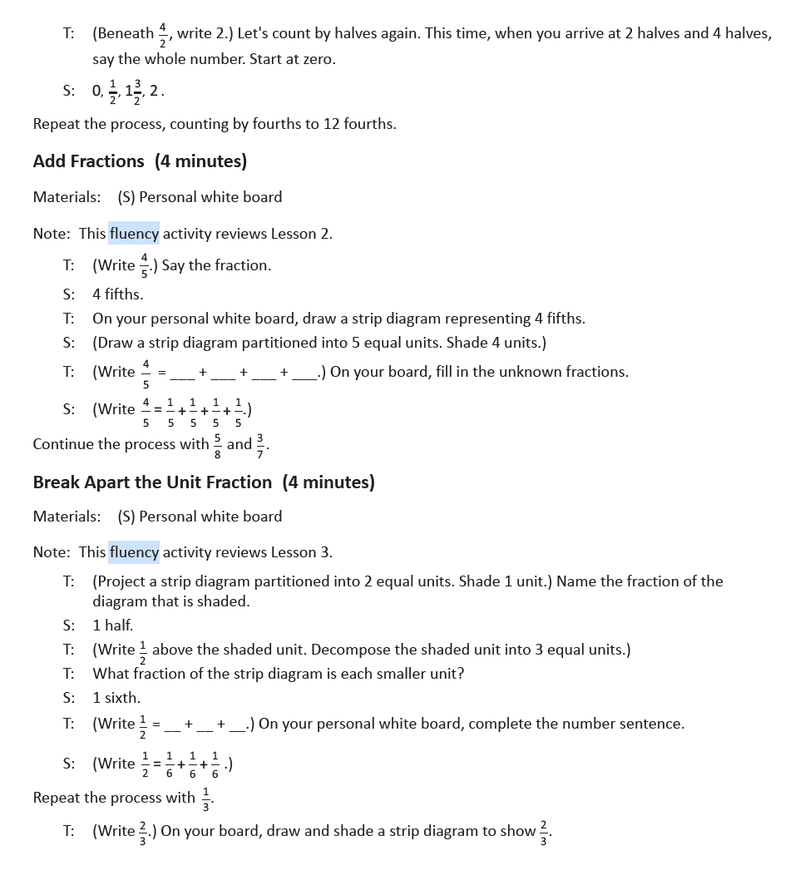
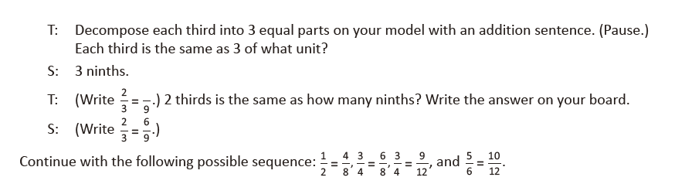
Lesson 5
Fluency Practice (12 minutes)
⬛ Add Fractions 4.3A (7 minutes)
⬛ Find Equivalent Fractions 4.3C (5 minutes)

Add Fractions (7 minutes)
Materials: (S) Personal white board
Note: This fluency activity reviews Lesson 2.

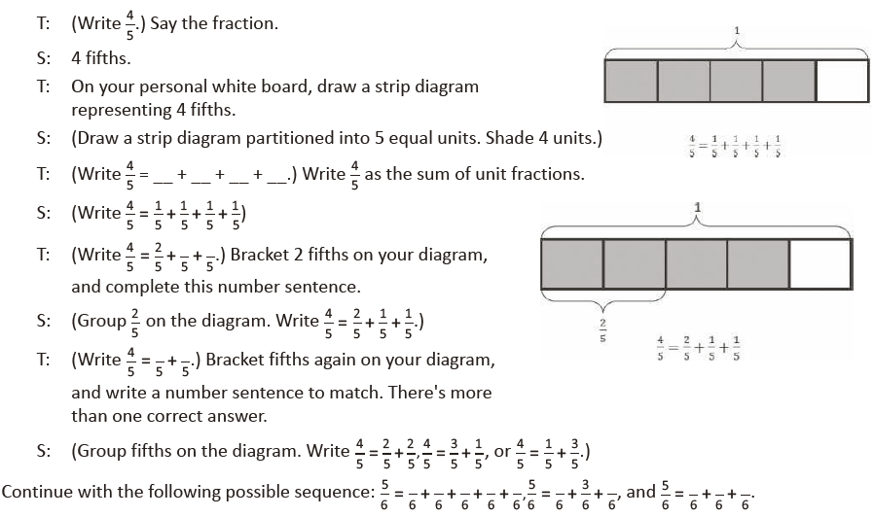
Find Equivalent Fractions (3 minutes)
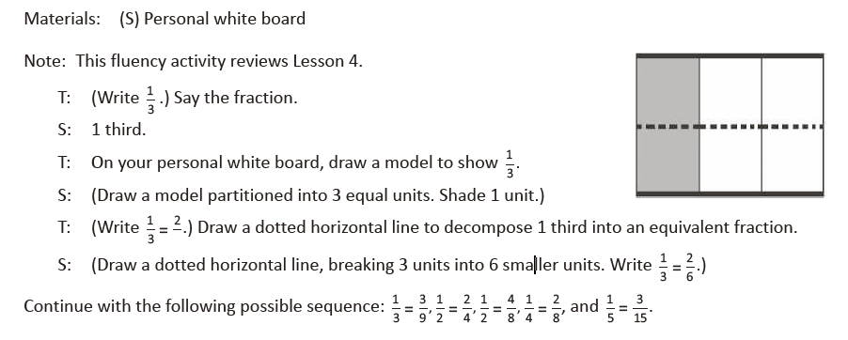

Lesson 6
Fluency Practice (12 minutes)
⬛ Break Apart Fractions 4.3A (4 minutes)
⬛ Count by Equivalent Fractions 4.3C (4 minutes)
⬛ Draw Equivalent Fractions 4.3C (4 minutes)

Break Apart Fractions (4 minutes)
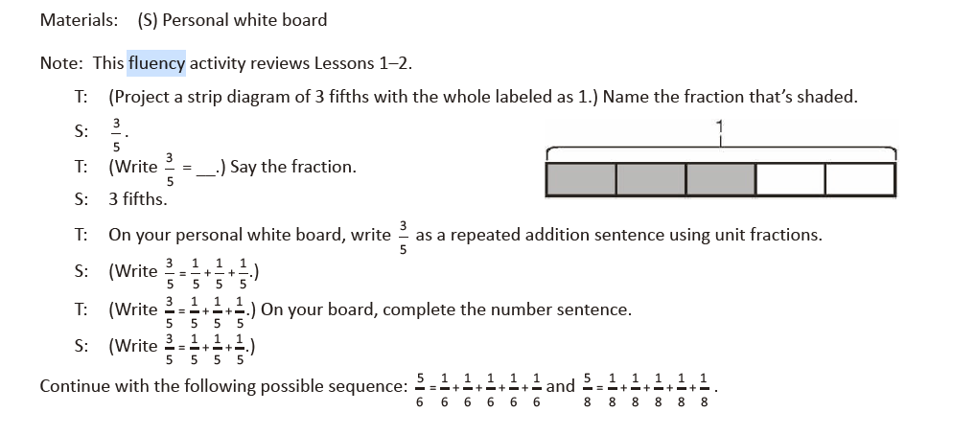
Count by Equivalent Fractions (4 minutes)
Materials: (S) Personal white board
Note: This fluency activity prepares students for lessons throughout this module.

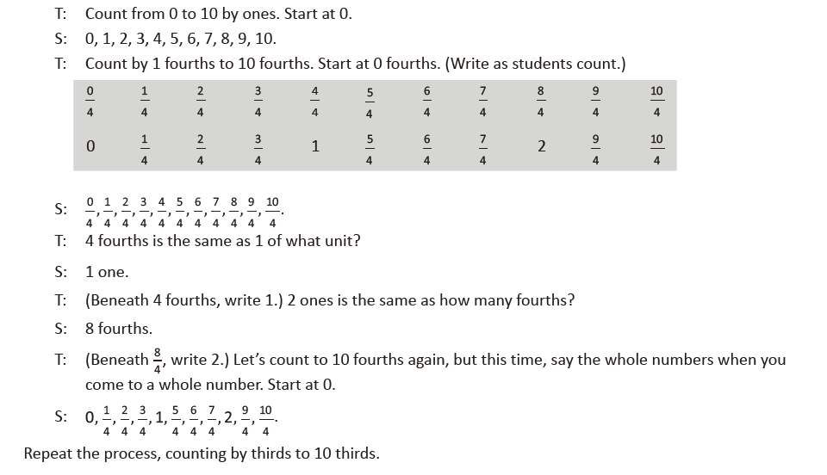
Draw Equivalent Fractions (4 minutes)
Materials: (S) Personal white board
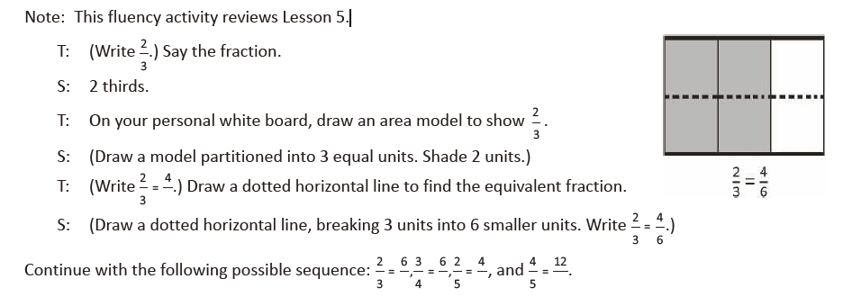
Lesson 7
Fluency Practice (12 minutes)
⬛ Multiply Mentally 4.4D (4 minutes)
⬛ Count by Equivalent Fractions 4.3C (4 minutes)
⬛ Draw Equivalent Fractions 4.3C (4 minutes)

Multiply Mentally (4 minutes)
Materials: (S) Personal white board
Note: This fluency activity reviews Module 3 content.
T: (Write 32 X 3 = ____.) Say the multiplication sentence.
S: 32 X 3 = 96.
T: (Write 32 X 3 = 96. Below it, write 32 X 20 = ____.) Say the multiplication sentence.
S: 32 X 20 = 640.
T: (Write 32 X 20 = 640. Below it, write 32 X 23 = ____ .) On your personal white board, solve 32 X 23.
S: (Write 32 X 23 = 736.)
Continue with the following possible sequence: 42 X 2, 42 X 20, 42 X 22; and 21 X 4, 21 X 40, 21 X 44.

Count by Equivalent Fractions (4 minutes)
Note: This fluency activity reviews Lesson 3.
T: Count by twos to 12. Start at 0.
S: 0, 2, 4, 6, 8, 10, 12.

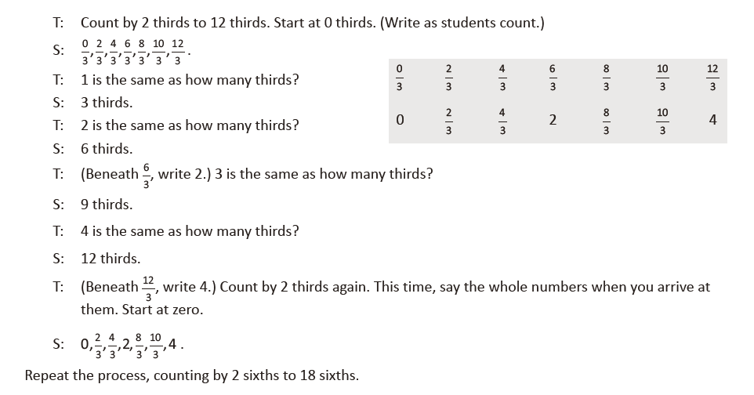

Draw Equivalent Fractions (4 minutes)
Materials: (S) Personal white board
Note: This fluency activity reviews Lesson 6.
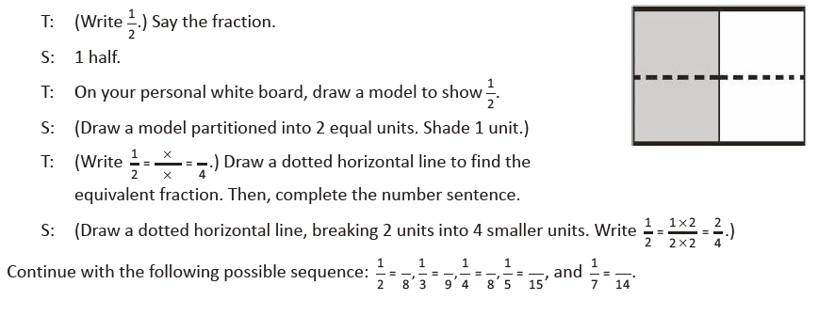
Lesson 8
Fluency Practice (12 minutes)
⬛ Add and Subtract 4.4A (4 minutes)
⬛ Find Equivalent Fractions 4.3C (4 minutes)
⬛ Draw Equivalent Fractions 4.3C (4 minutes)

Add and Subtract (4 minutes)
Materials: (S) Personal white board
Note: This fluency activity reviews the year-long Grade 4 fluency standard for adding and subtracting using
the standard algorithm.
T: (Write 532 thousands 367 ones.) On your personal white board, write this number in standard form.
S: (Write 532,367.)
T: (Write 423 thousands 142 ones.) Add this number to 532,367 using the standard algorithm.
S: (Write 532,367 + 423,142 = 955,509 using the standard algorithm.)
Continue the process for 671,526 + 264,756.
T: (Write 916 thousands 450 ones.) On your board, write this number in standard form.
S: (Write 916,450.)
T: (Write 615 thousands 137 ones.) Subtract this number from 916,450 using the standard algorithm.
S: (Write 916,450 – 615,137 = 301,313 using the standard algorithm.)
Continue with the following possible sequence: 762,162 – 335,616 and 500,000 – 358,219.

Find Equivalent Fractions (4 minutes)
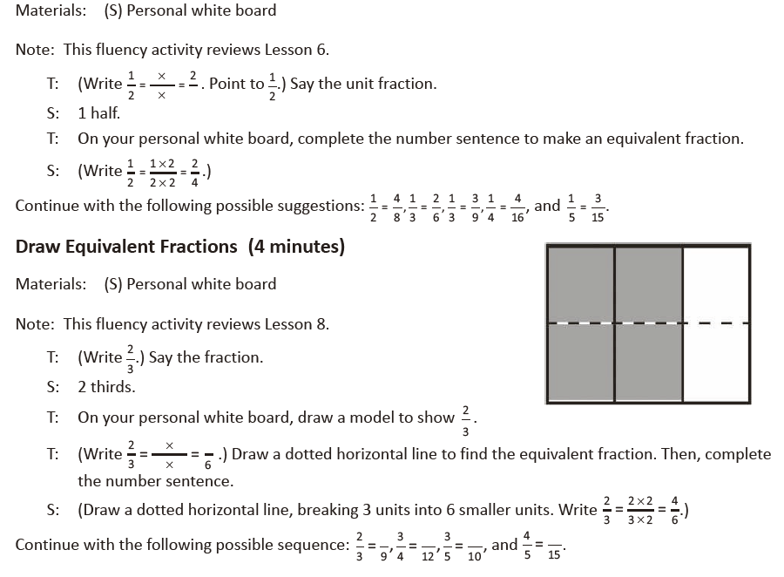
Lesson 9
Fluency Practice (12 minutes)
⬛ Count by Equivalent Fractions 4.3C (4 minutes)
⬛ Find Equivalent Fractions 4.3C (4 minutes)
⬛ Draw Equivalent Fractions 4.3C (4 minutes)

Count by Equivalent Fractions (4 minutes)
Note: This fluency activity reinforces Module 5 fraction
concepts.
T: Count by threes to 24. Start at zero.
S: 0, 3, 6, 9, 12, 15, 18, 21, 24.
T: Count by 3 fourths to 24 fourths. Start at 0 fourths.
(Write as students count.)
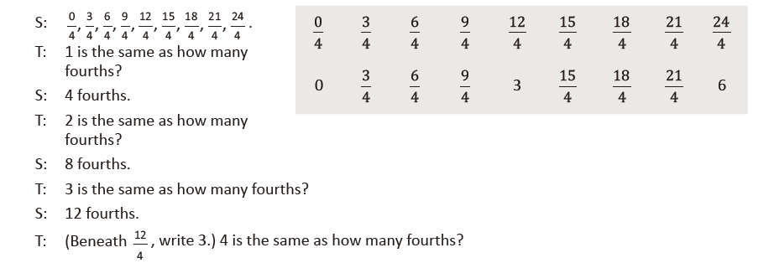
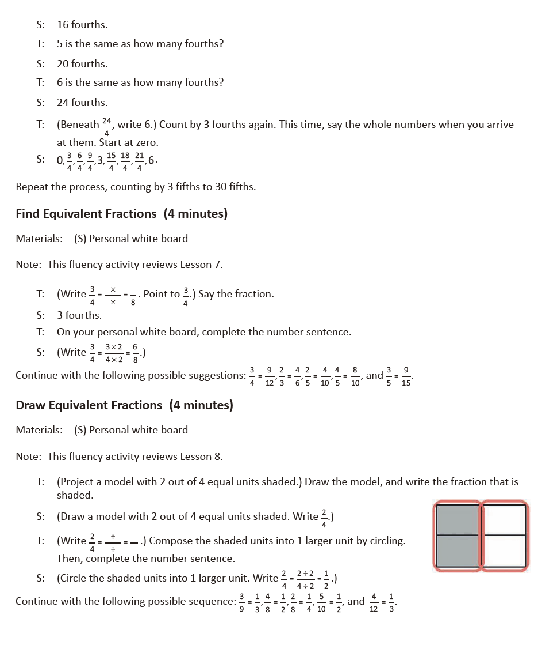
Lesson 10
Fluency Practice (12 minutes)
⬛ Find the Quotient and Remainder 4.4F (4 minutes)
⬛ Find Equivalent Fractions 4.3C (4 minutes)
⬛ Draw Equivalent Fractions 4.3C (4 minutes)
Find the Quotient and Remainder (4 minutes)
Materials: (S) Personal white board
Note: This fluency activity reviews Module 3 Lesson 24.
T: (Write 6,765 ÷ 2.) On your personal white board, find the quotient and remainder.
S: (Solve for and write 3,382 R1.)
Continue with the following possible sequence: 6,811 ÷ 5, 1,265 ÷ 4, and 1,736 ÷ 4.
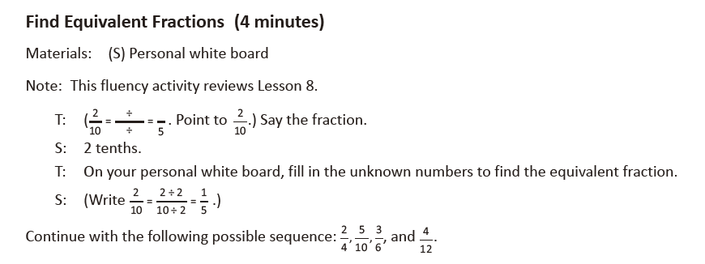
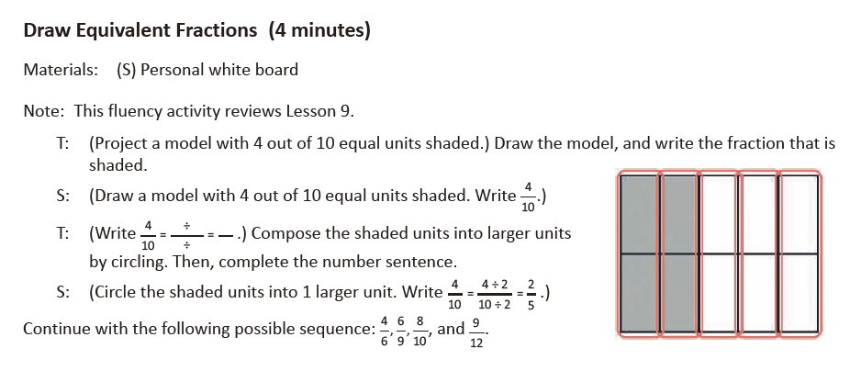
Lesson 11
Fluency Practice (12 minutes)
⬛ Add and Subtract 4.4A (4 minutes)
⬛ Find Equivalent Fractions 4.3C (4 minutes)
⬛ Construct a Number Line with Fractions 4.3G (4 minutes)

Add and Subtract (4 minutes)
Materials: (S) Personal white board
Note: This fluency activity reviews adding and subtracting using the standard algorithm.
T: (Write 547 thousands 686 ones.) On your personal white board, write this number in standard form.
S: (Write 547,686.)
T: (Write 294 thousands 453 ones.) Add this number to 547,686 using the standard algorithm.
S: (Write 547,686 + 294,453 = 842,139 using the standard algorithm.)
Continue the process with 645,838 + 284,567.
T: (Write 800 thousands.) On your board, write this number in standard form.
S: (Write 800,000.)
T: (Write 648 thousands 745 ones.) Subtract this number from 800,000 using the standard algorithm.
S: (Write 800,000 – 648,745 = 151,255 using the standard algorithm.)
Continue the process with 754,912 – 154,189.
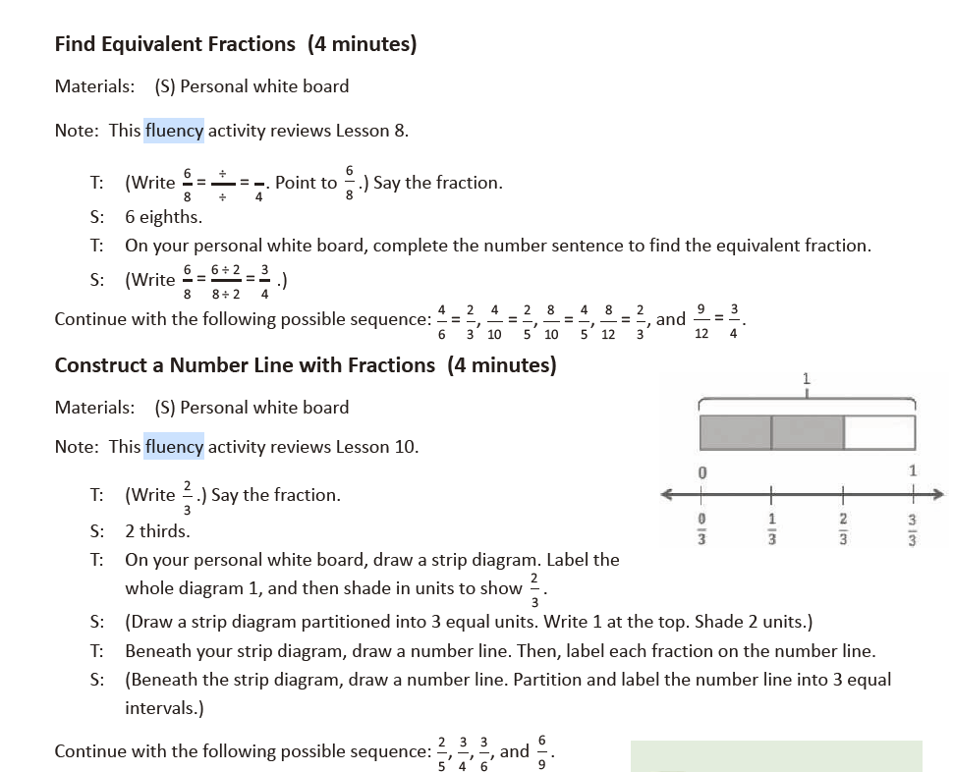

Lesson 12
Fluency Practice (12 minutes)
⬛ Divide 3 Different Ways 4.4E, 4.4F (4 minutes)
⬛ Count by Equivalent Fractions 4.3C (4 minutes)
⬛ Plot Fractions on a Number Line 4.3G (4 minutes)

Divide 3 Different Ways (4 minutes)
Materials: (S) Personal white board
Note: This fluency activity reviews concepts covered in Module 3. Alternately, have students choose to solve the division problem using one of the three methods.
T: (Write 435 ÷ 3.) Solve this problem by drawing place value disks.
S: (Solve.)
T: Solve 435 ÷ 3 using the area model.
S: (Solve.)
T: Solve 435 ÷ 3 using the standard algorithm.
S: (Solve.)
Continue with 184 ÷ 4.
Count by Equivalent Fractions (4 minutes)
Note: This fluency activity reinforces Module 5 fraction concepts and prepares students for today’s lesson.
T: Count by fours to 40. Start at zero.
S: 0, 4, 8, 12, 16, 20, 24, 28, 32, 36, 40.
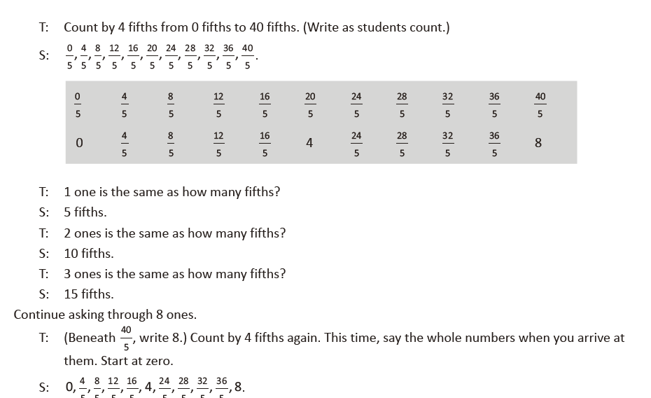
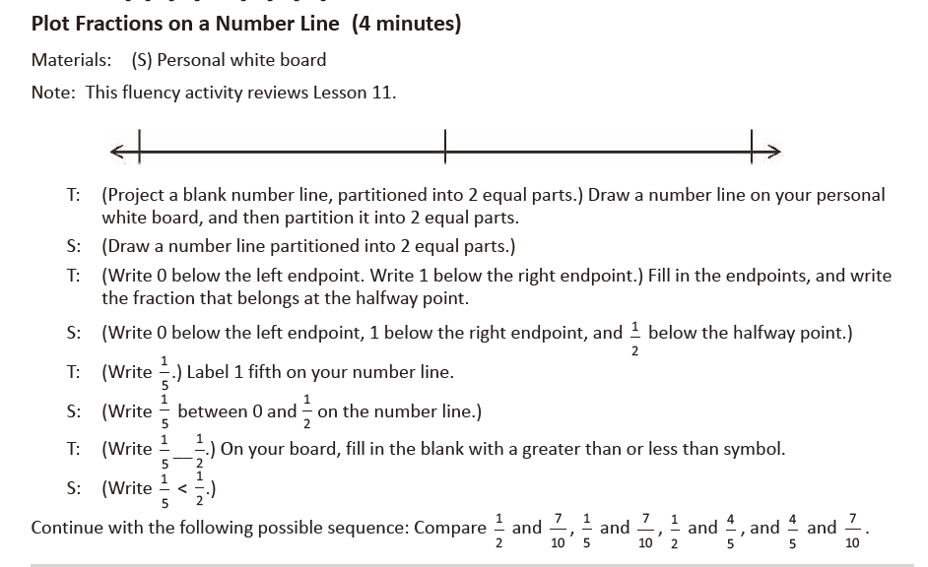
Lesson 13
Fluency Practice (12 minutes)
⬛ Add and Subtract 4.4A (4 minutes)
⬛ Compare Fractions 4.3D (4 minutes)
⬛ Construct a Number Line with Fractions 4.3G (4 minutes)

Add and Subtract (4 minutes)
Materials: (S) Personal white board
Note: This fluency activity reviews adding and subtracting using the standard algorithm.
T: (Write 458 thousands 397 ones.) On your personal white board, write this number in standard form.
S: (Write 458,397.)
T: (Write 281 thousands 563 ones.) Add this number to 458,397 using the standard algorithm.
S: (Write 458,397 + 281,563 = 739,960 using the standard algorithm.)
Continue the process with 456,919 + 292,689.
T: (Write 900 thousands.) On your board, write this number in standard form.
S: (Write 900,000.)
T: (Write 523 thousands 536 ones.) Subtract this number from 900,000 using the standard algorithm.
S: (Write 900,000 – 523,536 = 376,464 using the standard algorithm.)
Continue the process with 512,807 – 255,258.
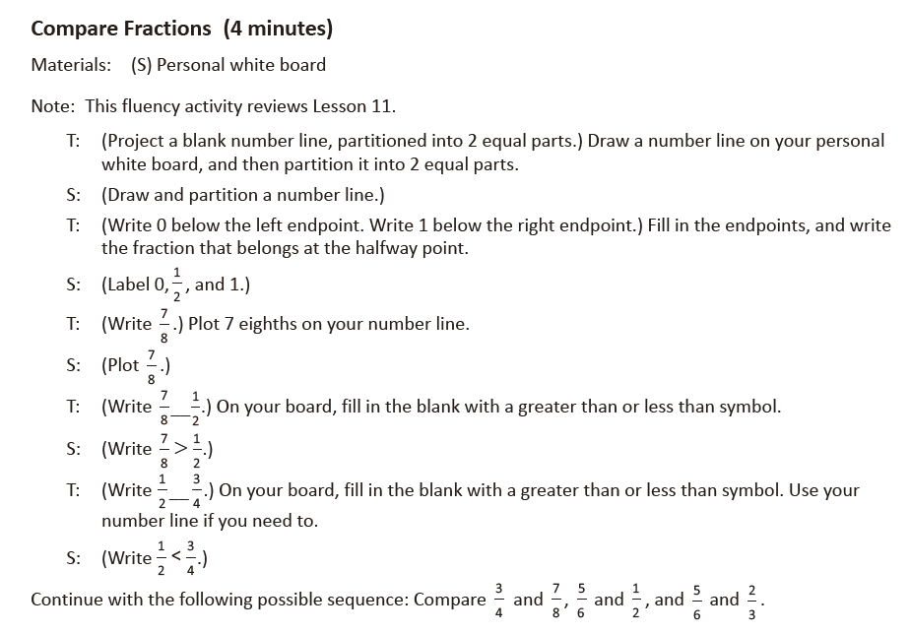
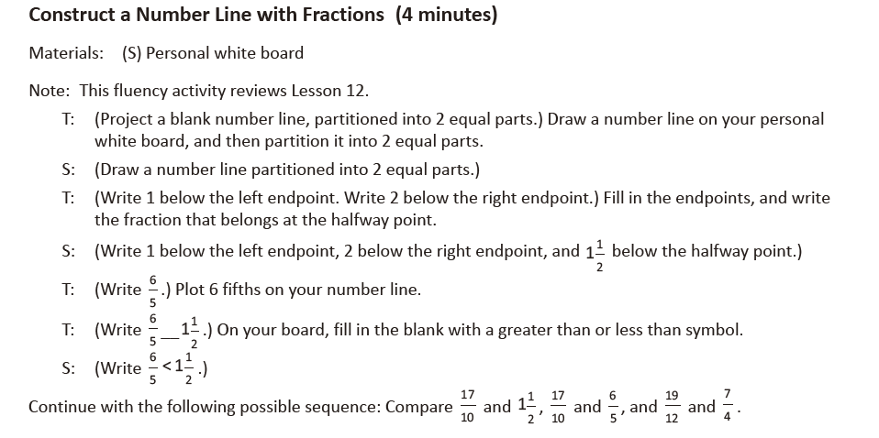
Lesson 14
Fluency Practice (12 minutes)
⬛ Count by Equivalent Fractions 4.3C (4 minutes)
⬛ Find Equivalent Fractions 4.3C (4 minutes)
⬛ Compare Fractions 4.3D (4 minutes)

Count by Equivalent Fractions (4 minutes)
Note: This activity builds fluency with equivalent fractions. The progression builds in complexity. Work
students up to the highest level of complexity at which they can confidently participate.
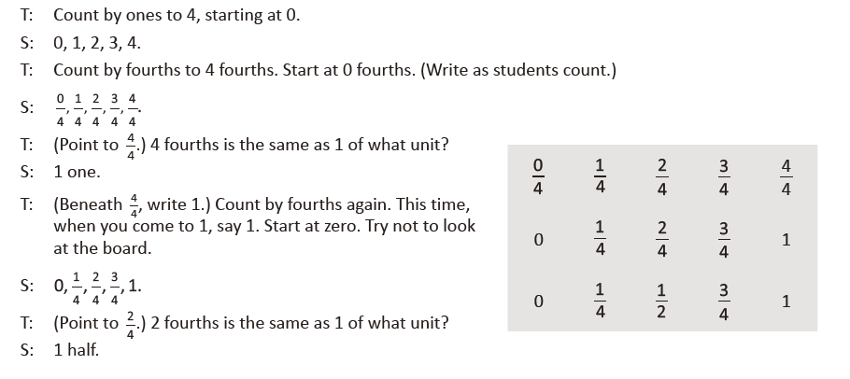
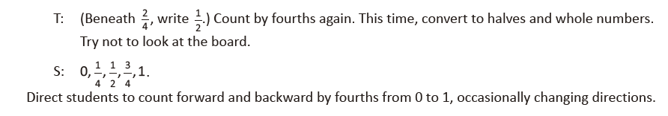

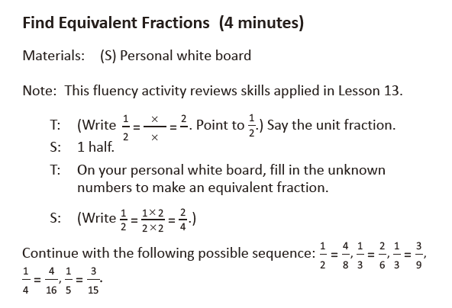

Compare Fractions (4 minutes)
Materials: (S) Personal white board
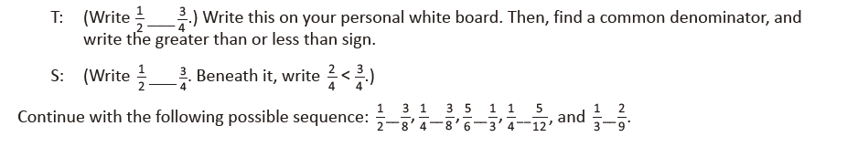
Lesson 15
Fluency Practice (12 minutes)
⬛ Count by Equivalent Fractions 4.3C (6 minutes)
⬛ Compare Fractions 4.3D (6 minutes)

Count by Equivalent Fractions (6 minutes)
Note: This activity builds fluency with equivalent fractions. The progression builds in complexity. Work
students up to the highest level of complexity in which they can confidently participate.
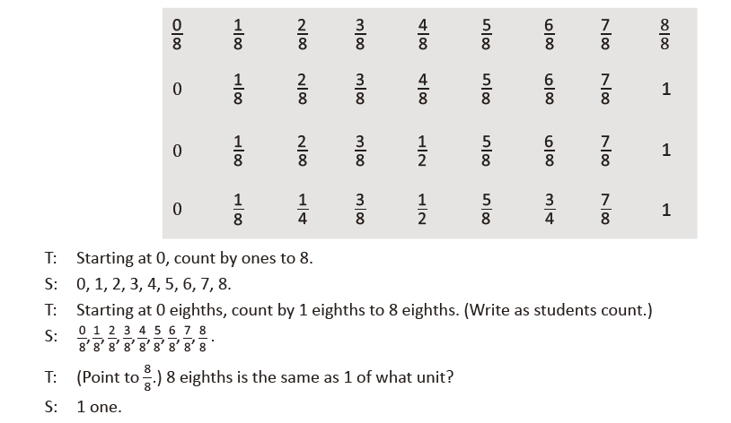
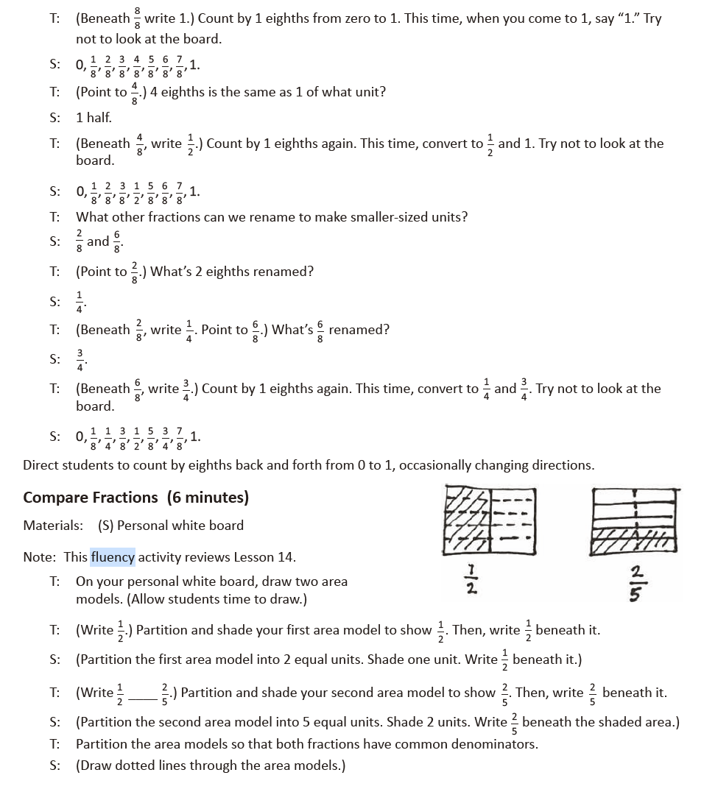

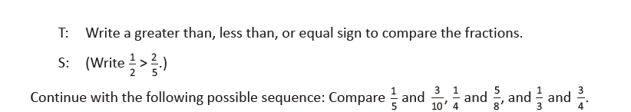

Lesson 16
Fluency Practice (12 minutes)
⬛ Count by Equivalent Fractions 4.3C (4 minutes)
⬛ Take Out the Whole Number 4.3A (4 minutes)
⬛ Draw Strip Diagrams 4.3E (4 minutes)

Count by Equivalent Fractions (4 minutes)
Note: This activity builds fluency with equivalent fractions. The progression builds in complexity. Work
students up to the highest level of complexity in which they can confidently participate.

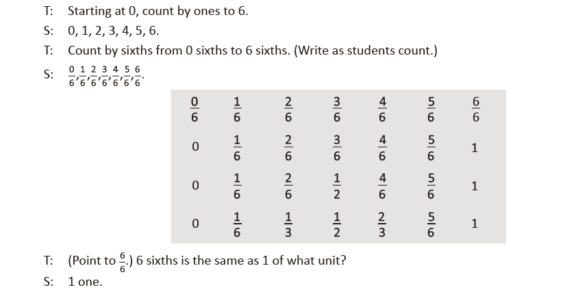
T: (Beneath 6/6 , write 1.) Count by 1 sixths again from 0 to 1. This time, when you come to 6/6, say 1. Try
not to look at the board. (Write as students count.)

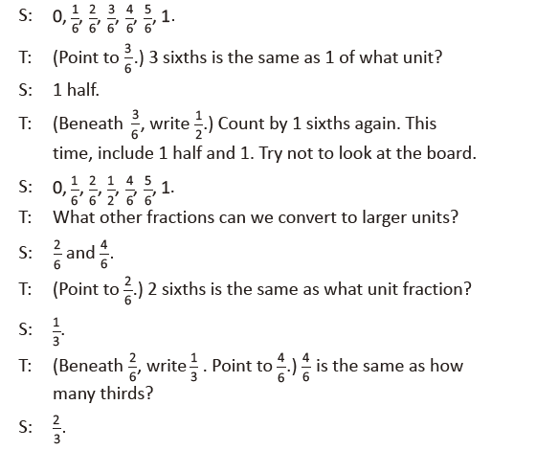
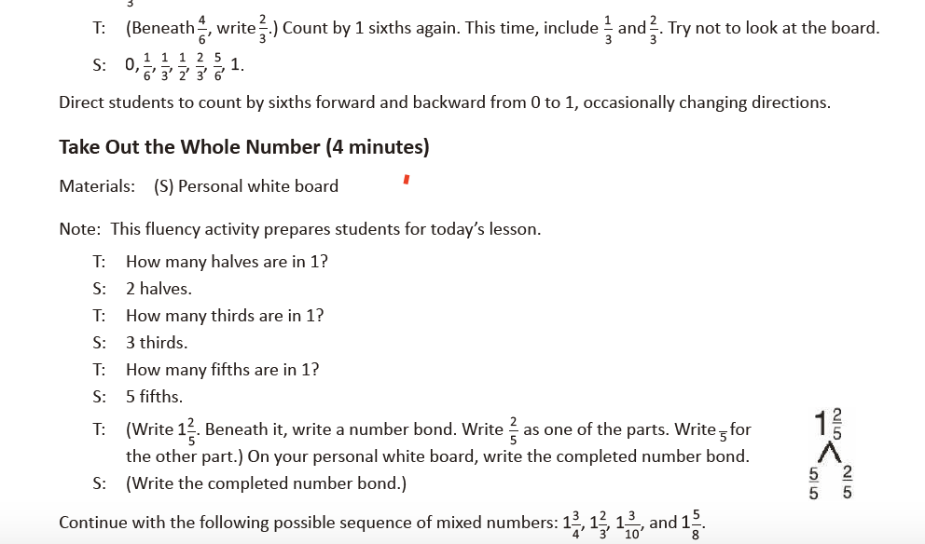
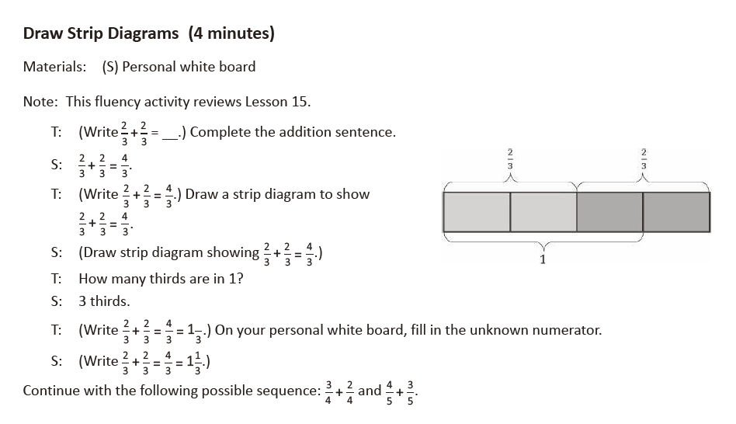
Lesson 17
Fluency Practice (12 minutes)
⬛ Count by Equivalent Fractions 4.3C (6 minutes)
⬛ Subtract Fractions 4.3E (6 minutes)

Count by Equivalent Fractions (6 minutes)
Note: This activity builds fluency with equivalent fractions. The progression builds in complexity. Work
students up to the highest level of complexity in which they can confidently participate.
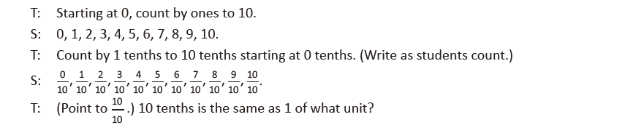
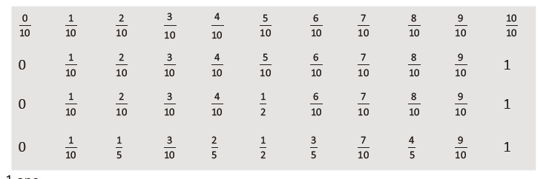
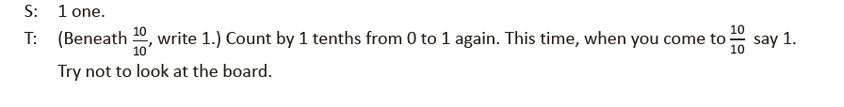
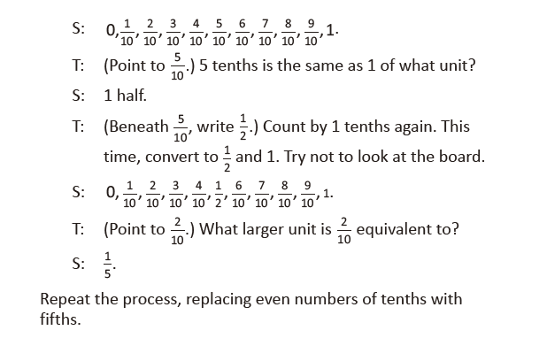
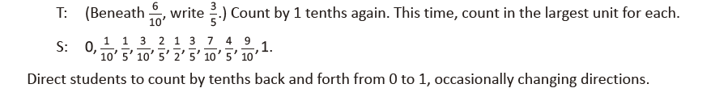
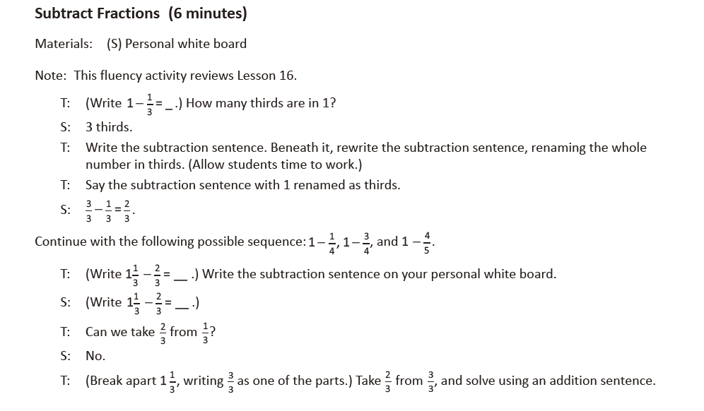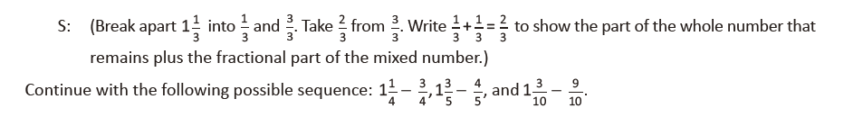

Lesson 18
Fluency Practice (12 minutes)
⬛ Count by Equivalent Fractions 4.3C (6 minutes)
⬛ Add and Subtract Fractions 4.3E (6 minutes)

Count by Equivalent Fractions (6 minutes)
Note: This activity builds fluency with equivalent fractions. The progression builds in complexity. Work
students up to the highest level of complexity in which they can confidently participate.
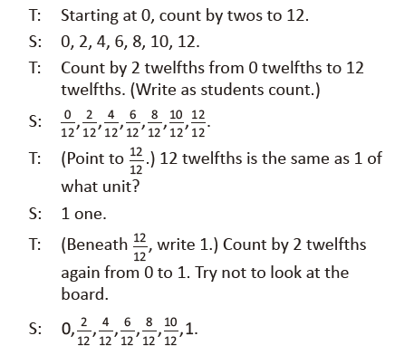
T: (Point to 6/12.) 6 twelfths is the same as what unit fraction?
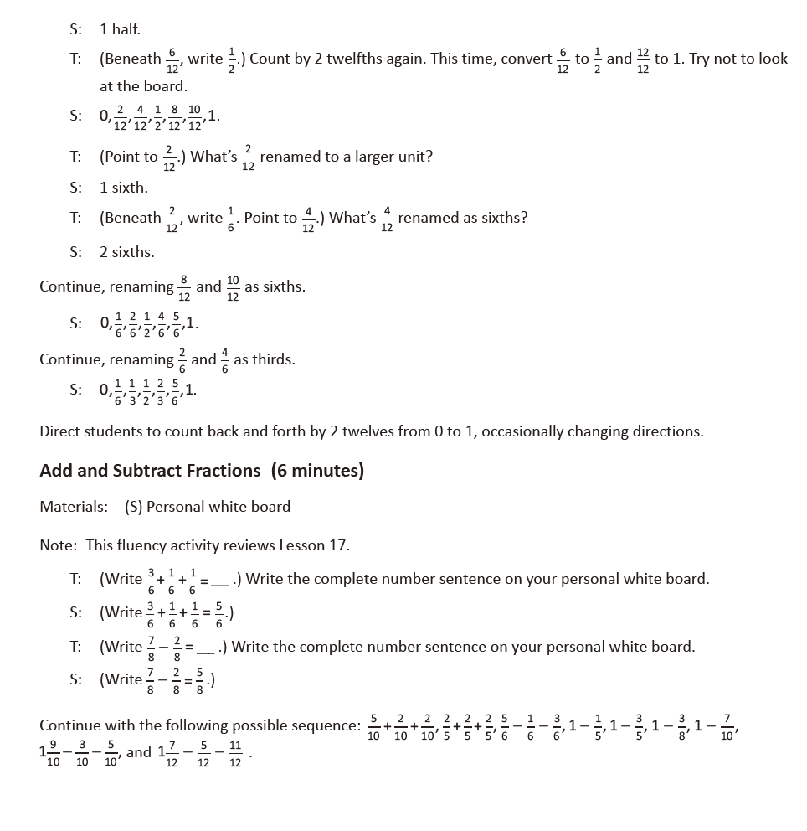
Lesson 19
Fluency Practice (12 minutes)
⬛ Sprint: Add Fractions 4.3E (8 minutes)
⬛ Count by Equivalent Fractions 4.3C (4 minutes)

Sprint: Add Fractions (8 minutes)
Materials: (S) Add Fractions Sprint
Note: This fluency activity reviews Lesson 15. This Sprint is designed for students to add fractions and
express their answers as fractions greater than one or as mixed numbers. Consider allowing students to not rename fractions and mixed numbers for larger units so that they do not have to perform additional
processes while they are focusing on adding fractions.
Count by Equivalent Fractions (4 minutes)
Note: This activity builds fluency with equivalent fractions. The progression builds in complexity. Work
students up to the highest level of complexity in which they can confidently participate.
T: Count by twos to 20 starting at 0.
S: 0, 2, 4, 6, 8, 10, 12, 14, 16, 18, 20.
T: Count by 2 tenths to 20 tenths starting at 0 tenths. (Write as students count.)
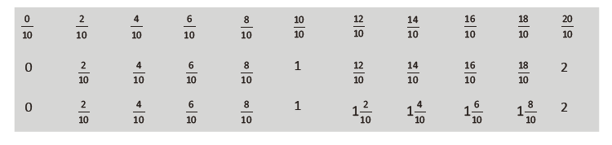
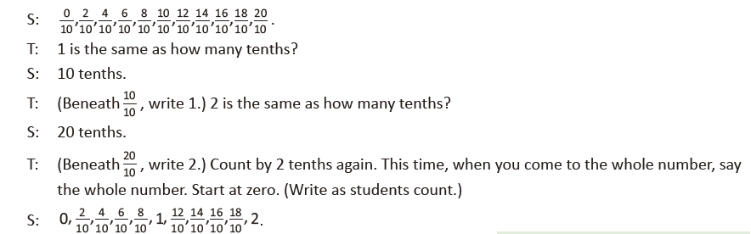
T: (Point to 12/10.) Say 12 tenths as a mixed number.
S: 1 2/10.
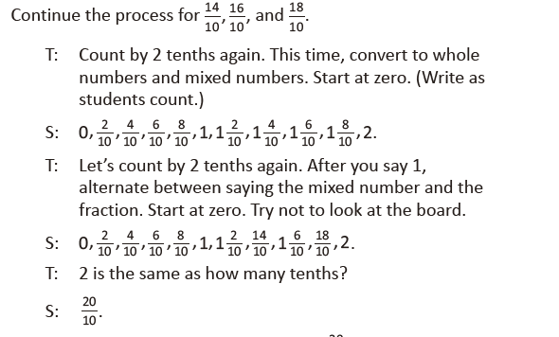
T: Let’s count backward starting at 20/10, alternating between fractions greater than one and mixed
numbers. Try not to look at the board.
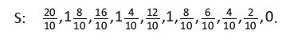

Lesson 20
Fluency Practice (12 minutes)
⬛ Add and Subtract 4.4A (4 minutes)
⬛ Count by Equivalent Fractions 4.3C (4 minutes)
⬛ Add and Subtract Fractions 4.3E (4 minutes)
Add and Subtract (4 minutes)
Materials: (S) Personal white board
Note: This fluency activity reviews adding and subtracting using the standard algorithm.
T: (Write 547 thousands 936 ones.) On your personal white board, write this number in standard form.
S: (Write 547,936.)
T: (Write 270 thousands 654 ones.) Add this number to 547,936 using the standard algorithm.
S: (Write 547,936 + 270,654 = 818,590 using the standard algorithm.)
Continue the process for 547,239 + 381,798.
T: (Write 500 thousands.) On your board, write this number in standard form.
S: (Write 500,000.)
T: (Write 213 thousands 724 ones.) Subtract this number from 500,000 using the standard algorithm.
S: (Write 500,000 – 213,724 = 286,276 using the standard algorithm.)
Continue the process for 635,704 – 395,615.

Count by Equivalent Fractions (4 minutes)
Note: This activity reviews counting by various fraction units.
T: Count by ones to 10, starting at 0.
S: 0, 1, 2, 3, 4, 5, 6, 7, 8, 9, 10.
T: Count by halves to 10 halves, starting at 0 halves. (Write as students count.)
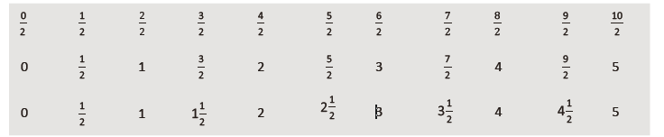
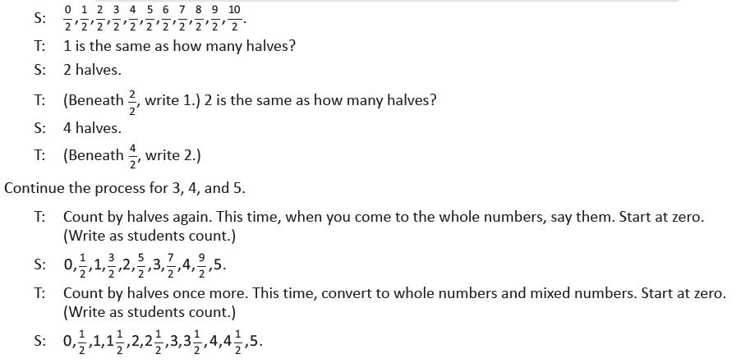

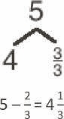
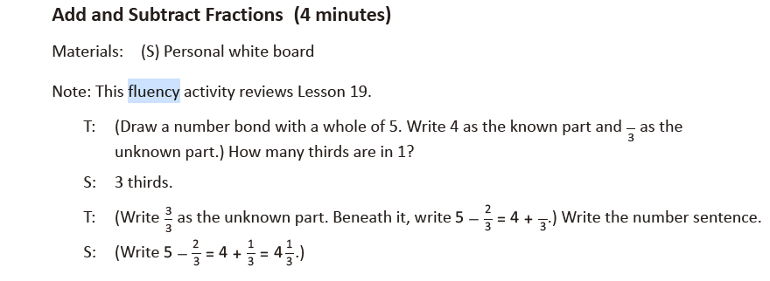
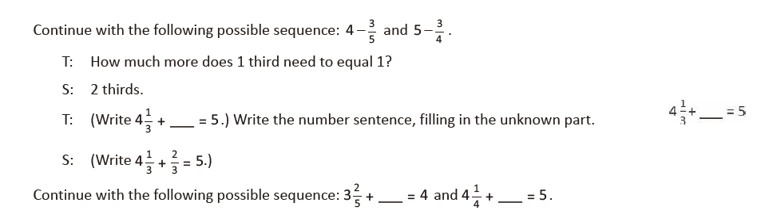
Lesson 21
Fluency Practice (12 minutes)
⬛ How Many Ones? 4.3C (3 minutes)
⬛ Add and Subtract Fractions 4.3E (4 minutes)
⬛ Change Fractions to Mixed Numbers 4.3B (5 minutes)

How Many Ones? (3 minutes)
Materials: (S) Personal white board
Note: This fluency activity prepares students for this lesson.
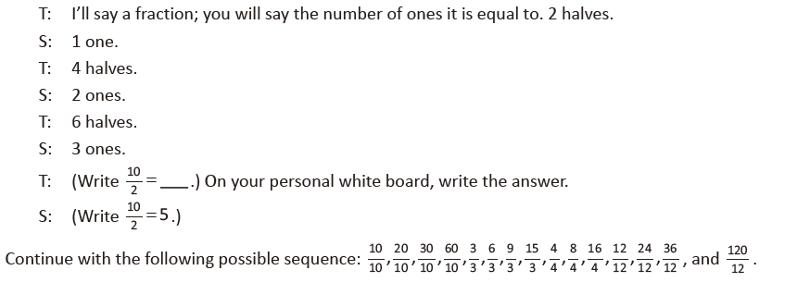
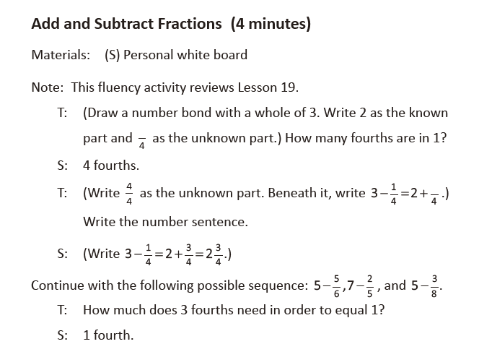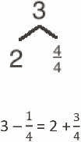

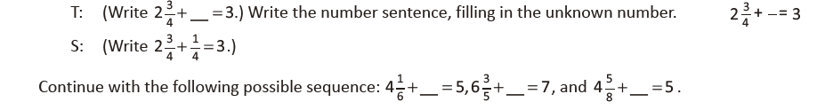
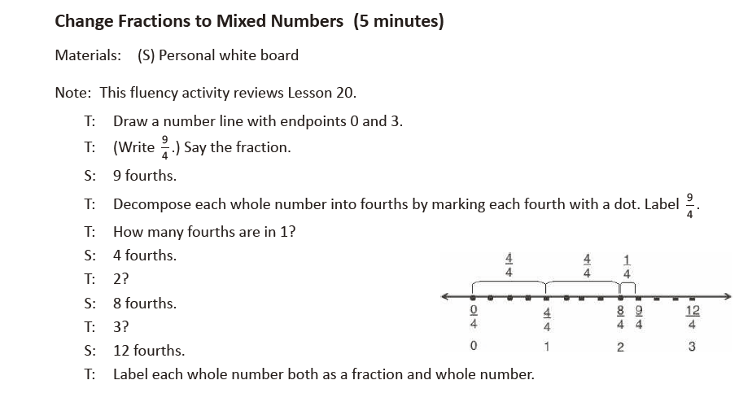
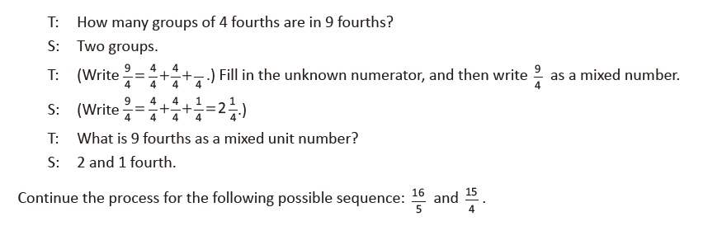
Lesson 22
Fluency Practice (10 minutes)
⬛ Change Fractions to Mixed Numbers 4.3B (4 minutes)
⬛ Change Mixed Numbers to Fractions 4.3B (6 minutes)

Change Fractions to Mixed Numbers (4 minutes)
Materials: (S) Personal white board
Note: This fluency activity reviews Lesson 20.
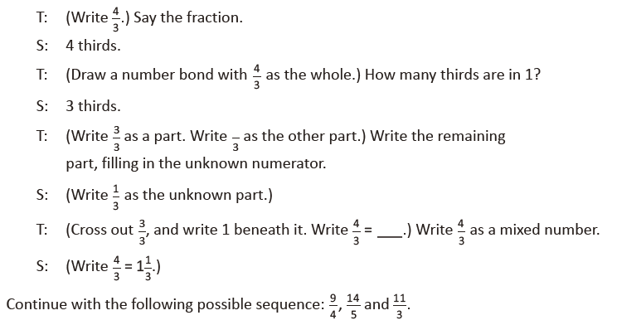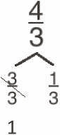
Change Mixed Numbers to Fractions (6 minutes)
Materials: (S) Personal white board
Note: This fluency activity reviews Lesson 21.

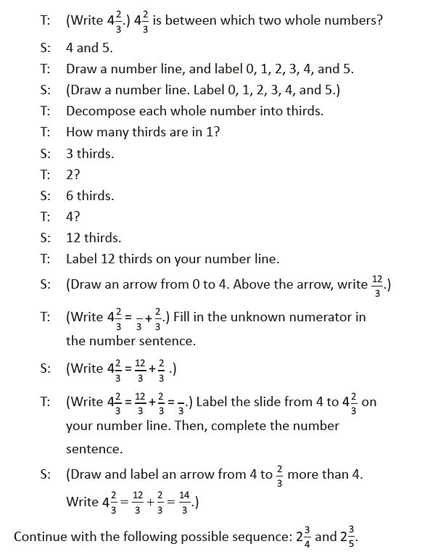

Lesson 23
Fluency Practice (12 minutes)
⬛ Add and Subtract Fractions 4.3E (3 minutes)
⬛ Change Fractions to Mixed Numbers 4.3B (4 minutes)
⬛ Change Mixed Numbers to Fractions 4.3B (5 minutes)

Add and Subtract Fractions (3 minutes)
Materials: (S) Personal white board
Note: This fluency activity reviews Lesson 19.
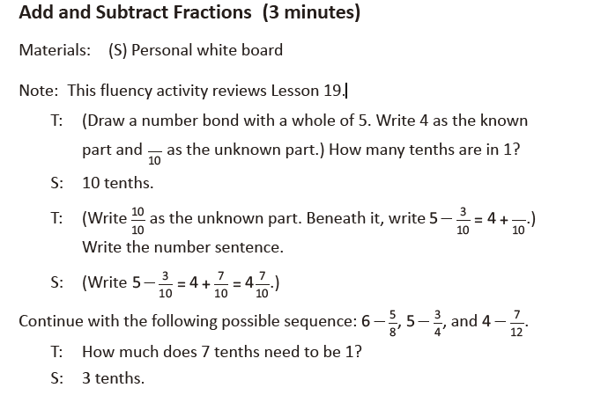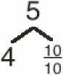
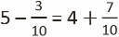

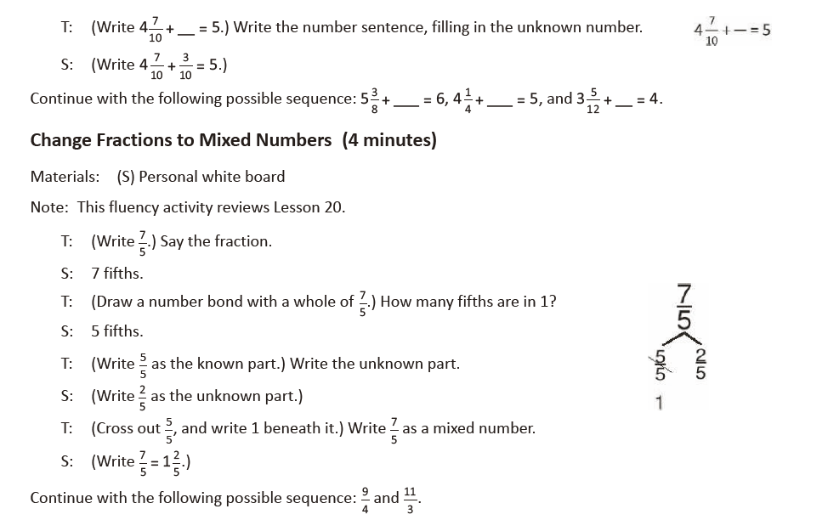
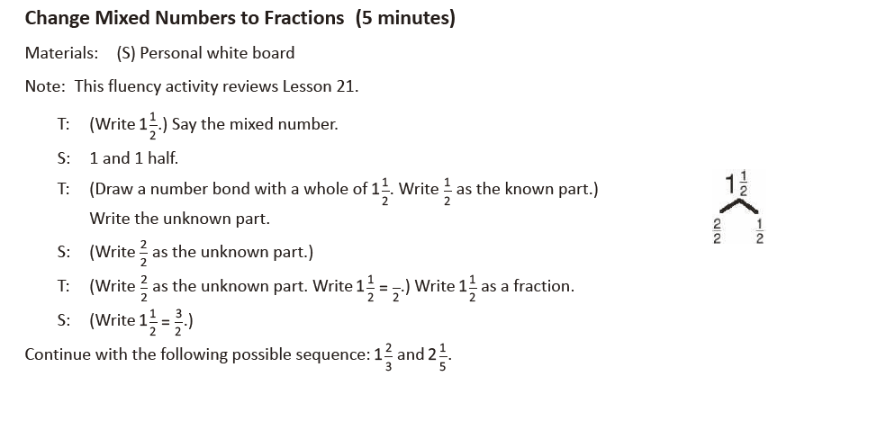

Lesson 24
Fluency Practice (12 minutes)
⬛ Change Mixed Numbers to Fractions 4.3B (6 minutes)
⬛ Compare Fractions 4.3D (6 minutes)

Change Mixed Numbers to Fractions (6 minutes)
Materials: (S) Personal white board
Note: This fluency activity reviews Lesson 21.
T: (Write 1 3/4.) Say the mixed number.
S: 1 and 3 fourths.
T: (Draw a number bond for 1 3/4. Write ¾ as a part.) Complete the bond.
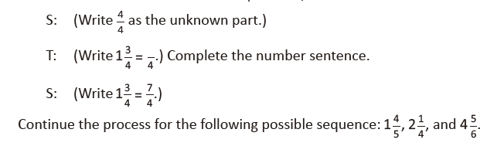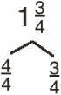
Compare Fractions (6 minutes)
Materials: (S) Personal white board
Note: This fluency activity reviews Lessons 22 and 23.
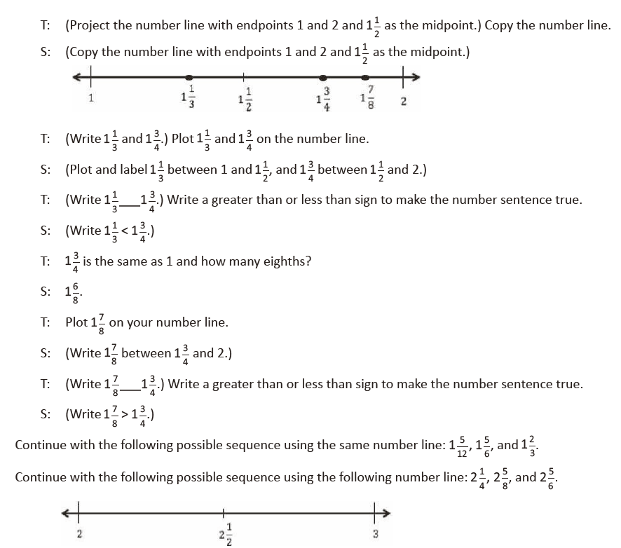
Lesson 25
Fluency Practice (12 minutes)
⬛ Count by Equivalent Fractions 4.3C (6 minutes)
⬛ Change Fractions to Mixed Numbers 4.3A, 4.3B (6 minutes)

Count by Equivalent Fractions (6 minutes)
Note: This activity reviews Lesson 20. The progression builds in complexity. Build students to the highest
level of complexity in which they can confidently participate.
T: Count by twos to 16, starting at 0.
S: 0, 2, 4, 6, 8, 10, 12, 14, 16.
T: Count by 2 fourths to 16 fourths, starting at 0 fourths. (Write as students count.)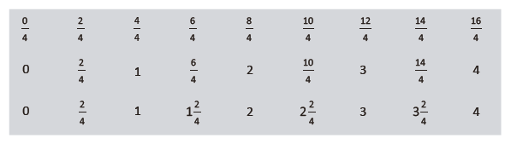
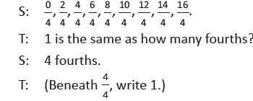
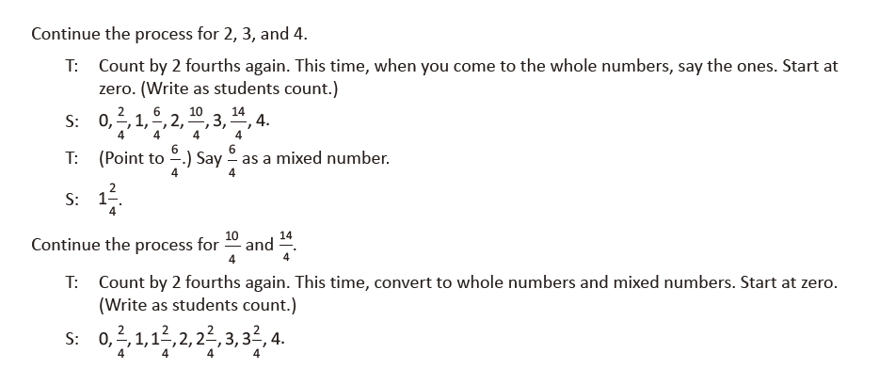
Change Fractions to Mixed Numbers (6 minutes)
Materials: (S) Personal white board
Note: This fluency activity reviews Lesson 20.
T: (Write 11/6.) Say the fraction.
S: 11 sixths.
T: (Draw a number bond with 11/6 as the whole.) How many sixths are in 1? 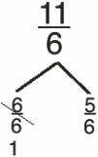
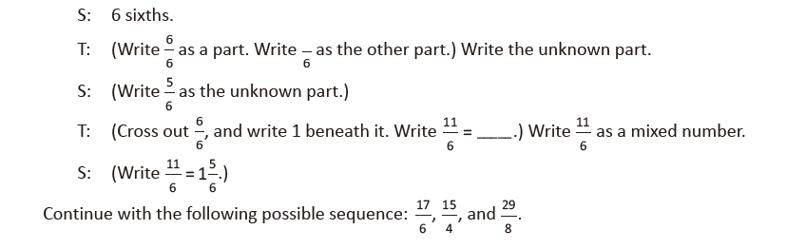

Lesson 26
Fluency Practice (12 minutes)
⬛ Sprint: Change Fractions to Mixed Numbers 4.3B (8 minutes)
⬛ Compare Fractions 4.3D (4 minutes)

Sprint: Change Fractions to Mixed Numbers (8 minutes)
Materials: Change Fractions to Mixed Numbers Sprint
Note: This fluency activity reviews Lesson 20.
Compare Fractions (4 minutes)
Materials: (S) Personal white board
Note: This fluency activity reviews Lesson 22.
T: (Write 19/5 .) How many ones are in 19 fifths?
S: 3 ones.
T: Between what two whole numbers is 19 fifths?
S: 3 and 4.
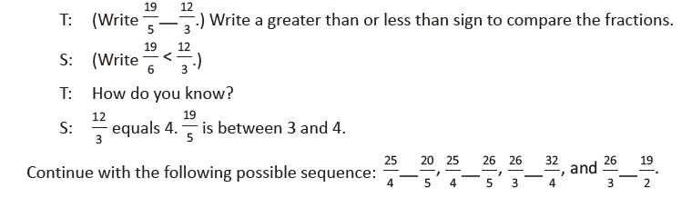
Lesson 27
Fluency Practice (12 minutes)
⬛ Sprint: Change Fractions to Mixed Numbers 4.3B (8 minutes)
⬛ Compare Fractions 4.3D (4 minutes)

Sprint: Change Fractions to Mixed Numbers (8 minutes)
Materials: (S) Change Fractions to Mixed Numbers Sprint
Note: This fluency activity reviews Lesson 20.

Compare Fractions (4 minutes)
Materials: (S) Personal white board
Note: This fluency activity reviews Lesson 22.
T: (Write 26/6.) How many ones are in 26 sixths?
S: 4 ones.
T: Between what two whole numbers is 26 sixths?
S: 4 and 5.
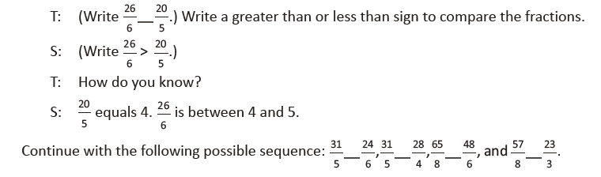
Lesson 28
Fluency Practice (12 minutes)
⬛ Count by Equivalent Fractions 4.3C (5 minutes)
⬛ Change Mixed Numbers to Fractions 4.3B (4
minutes)
⬛ Add Mixed Numbers 4.3E (3 minutes)
Count by Equivalent Fractions (5 minutes)
Note: This activity reviews Lessons 20 and 21. The progression builds in complexity. Work students up to the highest level of complexity in which they can confidently participate.
T: Count by twos to 18, starting at 0.
S: 0, 2, 4, 6, 8, 10, 12, 14, 16, 18.
T: Count by 2 sixths to 18 sixths, starting at 0 sixths. (Write as students count.)
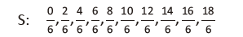
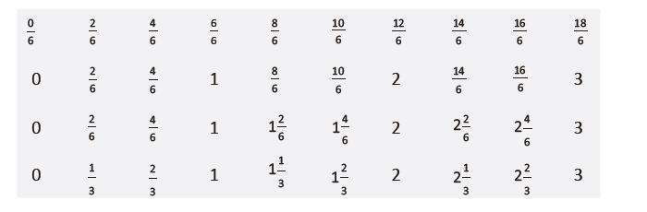
T: Zero is the same as how many sixths?
S: 0 sixths.
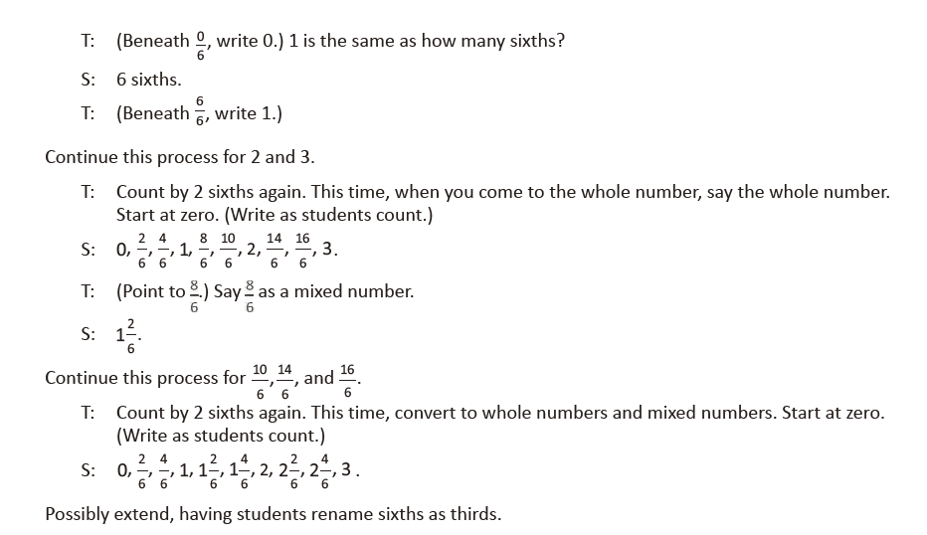

Lesson 29
Change Mixed Numbers to Fractions (4 minutes)
Materials: (S) Personal white board
Note: This fluency activity reviews Lesson 21.
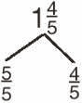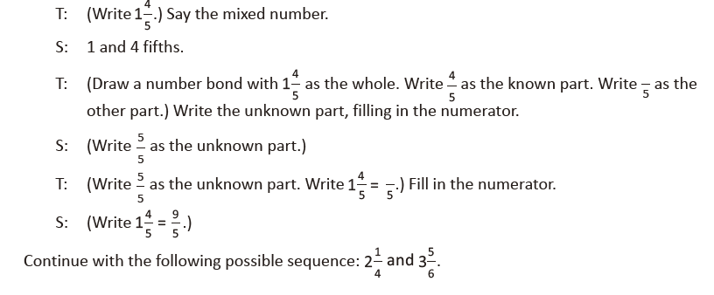

Add Mixed Numbers (3 minutes)
Note: This fluency activity reviews Lesson 27.
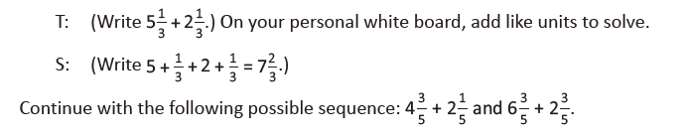
Lesson 29
Fluency Practice (12 minutes)
⬛ Sprint: Change Mixed Numbers to Fractions 4.3B (9 minutes)
⬛ Subtract Fractions from Whole Numbers 4.3E (3 minutes)

Sprint: Change Mixed Numbers to Fractions (9 minutes)
Materials: (S) Change Mixed Numbers to Fractions Sprint
Note: This fluency activity reviews Lesson 21.

Subtract Fractions from Whole Numbers (3 minutes)
Materials: (S) Personal white board
Note: This fluency activity reviews Lesson 16.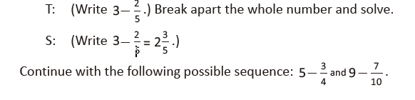
Lesson 30
Fluency Practice (12 minutes)
⬛ Sprint: Change Mixed Numbers to Fractions 4.3B (9 minutes)
⬛ Subtract Fractions from Whole Numbers 4.3E (3 minutes)

Sprint: Change Mixed Numbers to Fractions (9 minutes)
Materials: (S) Change Mixed Numbers to Fractions Sprint
Note: This fluency activity reviews Lesson 21.
Subtract Fractions from Whole Numbers (3 minutes)
Materials: (S) Personal white board
Note: This fluency activity reviews Lesson 16.
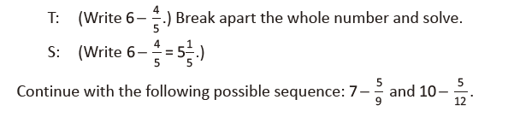
Lesson 31
Practice (12 minutes)
⬛ Add and Subtract 4.4A (4 minutes)
⬛ Count by Equivalent Fractions 4.3C (4 minutes)
⬛ Add and Subtract Mixed Numbers 4.3E (4 minutes)

Add and Subtract (4 minutes)
Materials: (S) Personal white board
Note: This fluency activity reviews adding and subtracting using the standard algorithm.
T: (Write 676 thousands 696 ones.) On your personal
white boards, write this number in standard form.
S: (Write 676,696.)
T: (Write 153 thousands 884 ones.) Add this number to
676,696 using the standard algorithm.
S: (Write 676,696 + 153,884 = 830,580 using the standard
algorithm.)
Continue the process for 678,717 + 274,867.
T: (Write 300 thousands.) On your boards, write this
number in standard form.
S: (Write 300,000.)
T: (Write 134 thousands 759 ones.) Subtract this number from 300,000 using the standard algorithm.
S: (Write 300,000 – 134,759 = 165,241 using the standard algorithm.)
Continue the process for 734,902 – 477,479.

Count by Equivalent Fractions (4 minutes)
Note: This activity reviews Lesson 20. The progression builds in complexity. Work students up to the highest level of complexity in which they can confidently participate.
T: Count by threes to 15, starting at 0.
S: 0, 3, 6, 9, 12, 15.
T: Count by 3 fifths to 15 fifths, starting at 0 fifths. (Write as students count.)
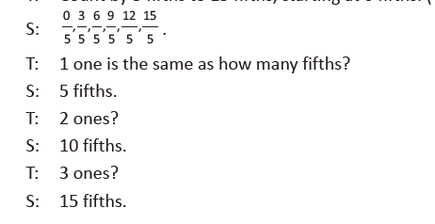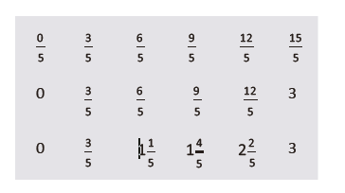
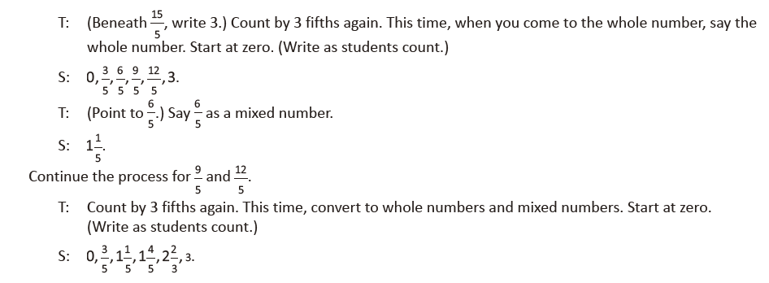
Add and Subtract Mixed Numbers (4 minutes)
Materials: (S) Personal white board
Note: This fluency activity reviews Lesson 27 and Lesson 29. Allow students to solve using any strategy.
