|  |  |  |  |
| --- | --- | --- | --- |
| **Grade 4 Module 6: Decimal Fractions and Financial Literacy** | | | |
| **Topic A: Exploration of Tenths** | | | |
| **Lesson 1** |  |  |  |
| **Lesson 2** |  |  |  |
| **Lesson 3** |  |  |  |
| **Topic B: Tenths and Hundredths** | | | |
| **Lesson 4** |  |  |  |
| **Lesson 5** |  |  |  |
| **Lesson 6** |  |  |  |
| **Lesson 7** |  |  |  |
| **Lesson 8** |  |  |  |
| **Topic C: Decimal Comparison** | | | |
| **Lesson 9** |  |  |  |
| **Lesson 10** |  |  |  |
| **Lesson 11** |  |  |  |
| **Topic D: Addition with Tenths and Hundredths** | | | |
| **Lesson 12** |  |  |  |
| **Lesson 13** |  |  |  |
| **Lesson 14** |  |  |  |
| **Topic E: Money Amounts as Decimal Numbers and Financial Literacy** | | | |
| **Lesson 15** |  |  |  |
| **Lesson 16** |  |  |  |
| **Lesson 17** |  |  |  |
| **Lesson 18** |  |  |  |

**Grade 4 Module 6**

**Lesson 1**

Fluency Practice (12 minutes)

⬛ Divide by 10 3.4J (4 minutes)

⬛ Sprint: Divide by 10 3.4J (8 minutes)

**Divide by 10 (4 minutes)**

Materials: (S) Personal white board

Note: This fluency activity prepares students for today’s lesson.

T: (Project a strip diagram with a value of 20 partitioned into 10 units.) Say the whole.

S: 20.

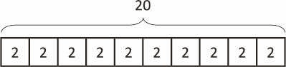

T: How many units is 20 divided into?

S: 10.

T: Say the division sentence.

S: 20 ÷ 10 = 2.

T: (Write 2 inside each unit. Write 20 ÷ 10 = 2 beneath the diagram.)

Continue with the following possible sequence: 200 ÷ 10, 240 ÷ 10, 400 ÷ 10, 430 ÷ 10, 850 ÷ 10, 8,500 ÷ 10,

8,570 ÷ 10, and 6,280 ÷ 10.

**Sprint: Divide by 10 (8 minutes)**

Materials: (S) Divide by 10 Sprint

Note: This Sprint prepares students for today’s lesson.

**Lesson 2**

Fluency Practice (12 minutes)

⬛ Divide by 10 4.2E (4 minutes)

⬛ Write the Decimal or Fraction 4.2G (3 minutes)

⬛ Count by Tenths 4.2G (5 minutes)

**Divide by 10 (4 minutes)**

Materials: (S) Personal white board

Note: This fluency activity reviews Lesson 1.

T: (Project a strip diagram with a value of 100 partitioned into 10 units.) Say the whole.

S: 100.

T: How many units is 100 divided into?

S: 10.

T: Say the division sentence.

S: 100 ÷ 10 = 10.

T: (Write 10 inside each unit. Write 100 ÷ 10 = 10 beneath the diagram.)

T: (Write 10 ÷ 10.) Draw a strip diagram showing 10 ÷ 10.

S: (Draw a strip diagram partitioned into 10 units. Write 10 at the top. Write 1 inside each unit.

Beneath the strip diagram, write 10 ÷ 10 = 1.)

**Write the Decimal or Fraction (3 minutes)**

Materials: (S) Personal white board

Note: This fluency activity reviews Lesson 1.

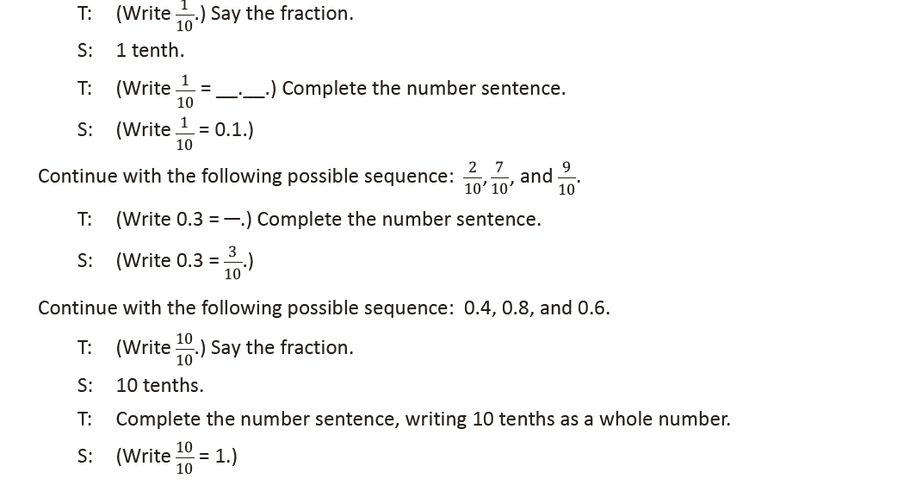

**Count by Tenths (5 minutes)**

Note: This fluency activity reviews Lesson 1.

**Lesson 3**

Fluency Practice (10 minutes)

⬛ Write the Decimal or Fraction 4.2G (5 minutes)

⬛ Count by Tenths 4.2G (5 minutes)

**Write the Decimal or Fraction (5 minutes)**

Materials: (S) Personal white board

Note: This fluency activity reviews Lessons 1–2.

**Count by Tenths (5 minutes)**

Materials: (T) Personal white board

Note: This fluency activity reviews Lessons 1–2.

T: Count by fives to 50, starting at zero.

S: 0, 5, 10, 15, 20, 25, 30, 35, 40, 45, 50.

T: Count by 5 tenths to 50 tenths, starting at 0 tenths. (Write as students count.)

**Lesson 4**

Fluency Practice (12 minutes)

⬛ Sprint: Write Fractions and Decimals 4.2G (9 minutes)

⬛ Count by Tenths 4.2G (3 minutes)

**Sprint: Write Fractions and Decimals (9 minutes)**

Materials: (S) Write Fractions and Decimals Sprint

Note: This Sprint reviews Lessons 1–3.

**Count by Tenths (3 minutes)**

Materials: (S) Personal white board

Note: This fluency activity reviews Lessons 1–3.

T: Count by twos to 20, starting at zero. (Write as students count.)

S: 0, 2, 4, 6, 8, 10, 12, 14, 16, 18, 20.

T: Count by 2 tenths to 20 tenths, starting at 0 tenths. (Write as students count.)

**Lesson 5**

Fluency Practice (12 minutes)

⬛ Divide by 10 4.2A (3 minutes)

⬛ Write the Decimal or Fraction 4.2G (4 minutes)

⬛ Count by Tenths and Hundredths 4.2G (5 minutes)

**Divide by 10 (3 minutes)**

Materials: (S) Personal white board

Note: This fluency activity reviews Lesson 4.

T: (Project one 1 hundred disk. Beneath it, write 100 = 10 ___.) 100 is the same as 10 of what unit?

Write the number sentence.

S: (Write 100 = 10 tens.)

T: (Write 100 = 10 tens.)

Continue with the following possible sequence: 10 = 10 ones, 1 = 10 tenths, and 1/10 = 10

hundredths

Write the Decimal or Fraction (4 minutes)

Materials: (S) Personal white board

Note: This fluency activity reviews Lesson 4.

T: (Write 1/100.) Say the fraction.

S: 1 hundredth.

**Count by Tenths and Hundredths (5 minutes)**

Note: This fluency activity reviews Lessons 1 and 4.

**Lesson 6**

Fluency Practice (12 minutes)

⬛ Count by Hundredths 4.2G (5 minutes)

⬛ Write the Decimal or Fraction 4.2G (4 minutes)

⬛ Break Apart Hundredths 4.2G (3 minutes)

**Count by Hundredths (5 minutes)**

Note: This fluency activity reviews Lessons 4–5.

**Write the Decimal or Fraction (4 minutes)**

Materials: (T) Hundredths area model (Fluency Template), personal white board (S) Personal white board Note: This fluency activity reviews Lessons 4–5.

Break Apart Hundredths (3 minutes)

Materials: (T/S) Personal white board

Note: This fluency activity reviews Lesson 5.

**Lesson 7**

Fluency Practice (11 minutes)

⬛ Count by Hundredths 4.2G (5 minutes)

⬛ Write the Decimal or Fraction 4.2E, 4.2G (3 minutes)

⬛ Write the Mixed Number 4.3C (3 minutes)

Count by Hundredths (5 minutes)

Note: This fluency activity reviews Lessons 4–5.

T: Count by twos to 20, starting at zero.

S: 0, 2, 4, 6, 8, 10, 12, 14, 16, 18, 20.

T: Count by 2 hundredths to 20 hundredths, starting at 0 hundredths. (Write as students count.)



**Write the Decimal or Fraction (3 minutes)**

Materials: (T) Hundredths area model (Lesson 6 Fluency Template) (S) Personal white board

Note: This fluency activity reviews Lessons 4–5.

T: (Project hundredths area model. Shade 7 units.) This 1 square is divided into 100 equal parts.

Write the fraction of the area that is shaded.

**Write the Mixed Number (3 minutes)**

Materials: (S) Personal white board

Note: This fluency activity reviews Lesson 6.

T: (Write 1 one 7 hundredths.) Write 1 one 7 hundredths as a mixed number.

S: (Write 1 7/100.)

Continue with the following possible sequence: 1 one 17 hundredths, 3 ones 37 hundredths, 7 ones

64 hundredths, and 9 ones 90 hundredths.

**Lesson 8**

Fluency Practice (12 minutes)

⬛ Sprint: Write Fractions and Decimals 4.2G (9 minutes)

⬛ Expanded Notation 4.2G (3 minutes)

**Sprint: Write Fractions and Decimals (9 minutes)**

Materials: (S) Write Fractions and Decimals Sprint

Note: This Sprint reviews Lessons 4–7.

**Expanded Notation (3 minutes)**

Materials: (T/S) Personal white board

Note: This fluency activity reviews Lesson 7.

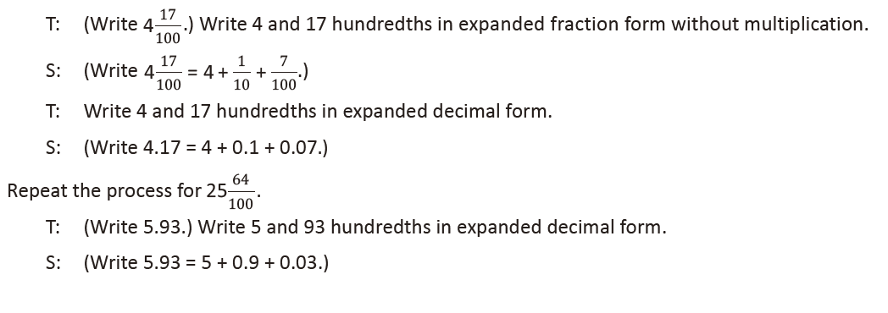

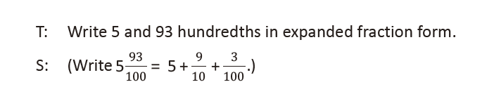

**Lesson 9**

Fluency Practice (10 minutes)

  Decompose Larger Units 4.2A (3 minutes)

  Decimal Fraction Equivalence 4.2G (5 minutes)

  Rename the Decimal 4.2G (2 minutes)

**Decompose Larger Units (3 minutes)**

Materials: (S) Personal white board, place value chart (Lesson 7 Template)

Note: This fluency activity reviews Lesson 8.

T: (Write 1.) Say the number in unit form.

S: 1 one.

T: Draw 1 one on your place value chart.

S: (Draw 1 one disk.)

T: (Write 1 one = ___ tenths.) Rename 1 one

for tenths.

S: (Cross out the one disk, and draw 10 tenth disks.)

Continue this process using the following possible sequence:

  Rename 1 one 2 tenths for tenths.

  Rename 1 tenth for hundredths.

  Rename 1 tenth 2 hundredths for hundredths.

  Rename 2 ones 3 tenths for tenths (leads into the next fluency activity).

**Decimal Fraction Equivalence (5 minutes)**

Materials: (S) Personal white board, place value chart (Lesson 7 Template)

Note: This fluency activity reviews Lesson 8. For 4 ones 23 hundredths, 1 ten 7 tenths, and 3 tens 4 ones

12 hundredths, have the students express their answers in tenths and hundredths.

Continue this process for the following possible sequence: 4 ones 23 hundredths, 1 ten 7 tenths, and 3 tens 4 ones 12 hundredths.

**Rename the Decimal (2 minutes)**

Materials: (S) Personal white board

Note: This fluency activity reviews Lesson 8.

**Lesson 10**

Fluency Practice (10 minutes)

  Decompose Larger Units 4.2A (3 minutes)

  Decimal Fraction Equivalence 4.2G (5 minutes)

  Rename the Decimal 4.2G (2 minutes)

**Decompose Larger Units (3 minutes)**

Materials: (S) Personal white board, place value chart (Lesson 7 Template)

Note: This fluency activity reviews Lesson 8.

T: (Write 2.) Say the number in unit form.

S: 2 ones.

T: Draw 2 ones on your place value chart.

S: (Draw 2 ones disks.)

T: (Write 2 ones = __ tenths.) Regroup 2

ones for tenths.

S: (Cross out the ones disks, and draw 20

tenths disks. Write 2 ones = 20 tenths.)

Continue with the following possible sequence:

  Regroup 2 ones 5 tenths for tenths.

  Regroup 2 tenths for hundredths.

  Regroup 2 tenths 4 hundredths for hundredths.

**Decimal Fraction Equivalence (5 minutes)**

Materials: (S) Personal white board, place value chart (Lesson 7 Template)

Note: This fluency activity reviews Lesson 8.

**Rename the Decimal (2 minutes)**

Materials: (S) Personal white board

Note: This fluency activity reviews Lesson 8.

**Lesson 11**

Fluency Practice (10 minutes)

  Expanded Notation 4.2B (3 minutes)

  Rename the Decimal 4.2G (4 minutes)

  Compare Decimal Numbers 4.2F (3 minutes)

**Expanded Notation (3 minutes)**

Materials: (S) Personal white board

Note: This fluency activity reviews Lesson 7.

**Rename the Decimal (4 minutes)**

Materials: (S) Personal white board

Note: This fluency activity reviews Lesson 8.

**Compare Decimal Numbers (3 minutes)**

Materials: (S) Personal white board

Note: This fluency activity reviews Lesson 10.

T: (Write 2.5 ___ 2.50.) Complete the number sentence, filling in a greater than, less than, or

equal sign.

S: (Write 2.5 = 2.50.)

Continue with the following possible sequence: 6.74 ____ 6.7, 4.16 ___ 4.61, 3.89 ___ 3.9, 8.64 ___ 8.46,

10.04 ___ 10.4, and 13.28 ___ 13.8.

**Lesson 12**

Fluency Practice (12 minutes)

⬛ Add and Subtract Whole Numbers 4.4A (3 minutes)

⬛ Compare Decimal Numbers 4.2F (4 minutes)

⬛ Convert Fraction Form to Decimal Form 4.2G (5 minutes)

**Add and Subtract Whole Numbers (3 minutes)**

Materials: (S) Personal white board

Note: This fluency activity reviews adding and subtracting

whole numbers using the standard algorithm.

T: (Write 473 thousands 379 ones + 473 thousands 379 ones.)

On your personal white board, write this addition sentence

in standard form.

S: (Write 473,379 + 473,379.)

T: Add using the standard algorithm.

S: (Write 473,379 + 473,379 = 946,758 using the

standard algorithm.)

Continue the process for 384,917 + 384,917.

T: (Write 700 thousand 1 ten.) On your board, write this

number in standard form.

S: (Write 700,010.)

T: (Write 199 thousands 856 ones.) Subtract this number from 700,010 using the standard algorithm.

S: (Write 700,010 − 199,856 = 500,154 in the standard algorithm.)

Continue the process with 900,080 − 288,099.

**Compare Decimal Numbers (4 minutes)**

Materials: (S) Personal white board

Note: This fluency activity reviews comparing decimal numbers.

T: (Write 3.20 __ 3.2.) Complete the number sentence using a greater than, less than or equal sign.

S: (Write 3.20 = 3.2.)

Continue with the following possible sequence: 7.8 __ 7.85, 5.72 __ 5.27, 2.9 __ 2.89, 6.24 __ 6.42,

10.8 __ 10.08, and 14.39 __ 14.9.

**Convert Fraction Form to Decimal Form (5 minutes)**

Materials: (S) Personal white board

Note: This fluency activity reviews converting numbers from decimal form to fraction form.

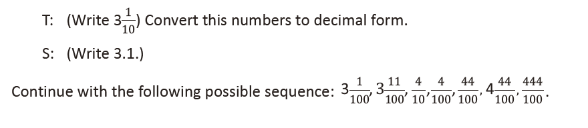

**Lesson 13**

Fluency Practice (12 minutes)

⬛ Rename the Units 4.2A (5 minutes)

⬛ Add Decimals 4.4A (7 minutes)

**Rename the Units (5 minutes)**

Materials: (S) Personal white board

Note: Decomposing units strengthens student understanding of

place value.

T: (Project 3.2.) Say the number.

S: Three and 2 tenths.

T: Say the number as tenths only.

S: 32 tenths.

T: Write 32 tenths in fraction form.

S: 32/10.

T: Say the number as hundredths only.

S: 320 hundredths.

T: Write 320 hundredths as a fraction.

S: 320/100.

Repeat the process for 4.5, 1.1, 0.6, and 0.8.

**Add Decimals (7 minutes)**

Materials: (S) Personal white board

Note: Adding tenths and hundredths reviews yesterday’s lesson.

T: (Project 3 tenths + 2 tenths = _______.) Write the addition sentence in decimal form.

S: 0.3 + 0.2 = 0.5.

Repeat the process for 5 hundredths + 4 hundredths, 35 hundredths + 4 hundredths,

5 hundredths + 42 hundredths, and 135 hundredths + 243 hundredths.

There is no way for me to see which professional development session a district has had.

There is no way for me to see which professional development session a district have had.

**Lesson 14**

Fluency Practice (12 minutes)

⬛ State the Value of the Coins 4.2E (2 minutes)

⬛ Add Decimals 4.4A (5 minutes)

⬛ Write in Expanded Decimal and Fraction Notation 4.2B (5 minutes)

**State the Value of the Coins (2 minutes)**

Materials: (S) Personal white board

Note: This fluency activity prepares students for Lessons 15–16.

T: (Write 1 dime = __ ¢.) What is the value of 1 dime?

S: 10¢.

T: 2 dimes?

S: 20¢.

T: 3 dimes?

S: 30¢.

T: 8 dimes?

S: 80¢.

T: (Write 10 dimes = ___dollar.) Write the number sentence.

S: (Write 10 dimes = 1 dollar.)

T: (Write 20 dimes = ___dollars.) Write the number sentence.

S: (Write 20 dimes = 2 dollars.)

T: (Write 1 penny = ___¢.) What is the value of 1 penny?

S: 1¢.

T: 2 pennies?

S: 2¢.

T: 3 pennies?

S: 3¢.

T: 9 pennies?

S: 9¢.

T: (Write 7 pennies = _¢.) Write the number sentence.

S: (Write 7 pennies = 7¢.)

**Add Decimals (5 minutes)**

Materials: (S) Personal white board

Note: This fluency activity reviews Lesson 13.

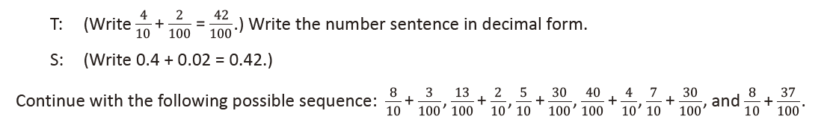

**Write in Expanded Decimal and Fraction Notation (5 minutes)**

Materials: (S) Personal white board

Note: This fluency activity reviews Lesson 12.

T: (Write 36.79.) Say the number.

S: 36 and 79 hundredths.

T: Write 36 and 79 hundredths in decimal expanded form without multiplication.

S: (Write 36.79 = 30 + 6 + 0.7 + 0.09.)

T: (Write 36.79 = (_ X 10) + (_ X 1) + (_ X 0.1) + (_ X 0.01).) Complete the number sentence.

S: (Write 36.79 = (3 X 10) + (6 X 1) + (7 X 0.1) + (9 X 0.01).)

T: Write 36 and 79 hundredths in fraction expanded form with multiplication.

S: (Write 36 79

100 = (3 X 10) + (6 X 1) + (7 X 1

10) + (9 X 1

100).)

Continue with the following possible sequence: 34.09 and 734.80.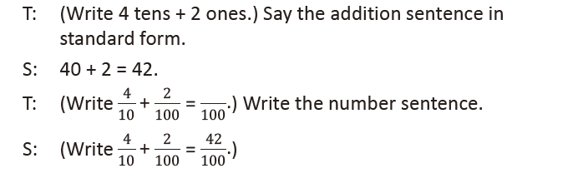

**Lesson 15**

Fluency Practice (10 minutes)

⬛ Add Fractions 4.3E (5 minutes)

⬛ State the Value of the Coins 3.4C (5 minutes)

**Add Fractions (5 minutes)**

Note: This fluency activity reviews Lesson 13.

State the Value of the Coins (5 minutes)

Note: This fluency activity prepares students for Lessons 15–16.

T: (Write 10¢ = 1 ________.) What coin has a value of 10 cents?

T: 1 dime.

T: 90¢ is the same as how many dimes?

T: 9 dimes.

T: (Write 25¢ = 1 ________.) What coin has a value of 25 cents?

T: 1 quarter.

T: 50¢ is the same as how many quarters?

T: 2 quarters.

T: 75¢ is the same as how many quarters?

T: 3 quarters.

T: 100¢ is the same as how many quarters?

T: 4 quarters.

T: What is the value of 2 quarters?

T: 50 cents.

T: What is the total value of 2 quarters and 2 dimes?

T: 70 cents.

T: What is the total value of 2 quarters and 6 dimes?

T: 110 cents.

Continue with the following possible sequence: 1 quarter 5 dimes, 3 quarters 2 dimes, 2 quarters 7 dimes, and 3 quarters 2 dimes 1 penny.

**Lesson 16**

Fluency Practice (15 minutes)

⬛ Add Decimals 4.4A (5 minutes)

⬛ Rename the Unit 4.2E (5 minutes)

⬛ State the Value of the Coins 4.2E (5 minutes)

**Add Decimals (5 minutes)**

Note: This fluency reviews addition of decimal numbers from Topic D.

T: (Write 50 + 3 = _____.) Say the complete equation in unit form.

S: 5 tens + 3 ones = 53 ones.

T: (Write 0.5 + 0.03 = _____.) Say the complete equation in unit form.

S: 5 tenths + 3 hundredths = 53 hundredths.

Continue with the following possible sequence: 20 + 8, 0.2 + 0.08, 40 + 6, and 0.4 + 0.06.

T: (Write 30 + 18 = _____.) Say the complete equation in unit form.

S: 3 tens + 18 ones = 48 ones.

T: (Write 0.3 + 0.18 = _____.) Say the complete equation in unit form.

S: 3 tenths + 18 hundredths = 48 hundredths.

Continue with the following possible sequence: 60 + 27, 0.6 + 0.27, 70 + 19, and 0.7 + 0.19.

**Rename the Unit (5 minutes)**

Materials: (S) Personal white board

Note: This fluency reviews decomposition of decimal numbers.

T: (Write 10 tenths.) Rename this number by using

a greater unit.

S: 1.

T: (Write 11 tenths.) Rename this number by using

a greater unit.

S: 1 and 1 tenth.

Continue with the following possible sequence: 36 tenths,

98 tenths, 100 tenths, 105 tenths, 10 hundredths, 100 hundredths,

and 130 hundredths.

**State the Value of the Coins (5 minutes)**

Materials: (S) Personal white board

Note: This fluency activity reviews expressing money amounts as decimal numbers.

T: (Write 2 quarters 4 dimes.) What is the value of 2 quarters and 4 dimes?

S: 90 cents.

T: Write 90 cents in decimal form using the dollar symbol.

S: (Write $0.90.)

T: (Write 5 quarters 1 nickel.) In cents, what is the value of 5 quarters and 1 nickel?

S: 130 cents.

T: Write 130 cents in decimal form using the dollar symbol.

S: (Write $1.30.)

Continue with the following possible sequence: 3 quarters 7 dimes, 1 quarter 9 dimes 12 pennies, and

5 dimes 20 pennies.

**Lesson 17**

Fluency Practice (12 minutes)

⬛ Add Decimals 4.4A (6 minutes)

⬛ Subtract Decimals 4.4A (6 minutes)

**Add Decimals (6 minutes)**

Materials: (S) Personal white board

Note: Reviewing these skills helps students master adding tenths and hundredths.

T: (Write 53 tenths + 1 hundredth = _____.) On your personal white board, write the addition sentence

in decimal form.

S: (Write 5.3 + 0.01 = 5.31.)

T: (Write 53 tenths + 1 tenth = ________.) Write the addition sentence in decimal form.

S: (Write 5.3 + 0.1 = 5.4.)

Continue with the following possible sequence: 53 tenths + 1 one, 53 tenths + 11 hundredths, 53 tenths + 11 tenths, 53 tenths + 1 one 11 hundredths, 84 tenths + 2 hundredths, 84 tenths + 2 tenths, 84 tenths + 2 ones, 84 tenths + 22 hundredths, 84 tenths + 22 tenths, and 84 tenths + 2 ones 22 tenths.

**Subtract Decimals (6 minutes)**

Materials: (S) Personal white board

Note: Reviewing these skills helps students master subtracting tenths and hundredths.

T: (Write 76 hundredths – 3 tenths = _____.) On your personal white board, write the subtraction

sentence in decimal form.

S: (Write 0.76 – 0.30 = 0.46.)

T: (Write 76 hundredths – 3 hundredths = ________.) Write the subtraction sentence in decimal form.

S: (Write 0.76 − 0.03 = 0.73.)

T: (Write 76 hundredths – 33 hundredths = _____.) Write the subtraction sentence in decimal form.

S: (Write 0.76 − 0.33 = 0.43.)

Continue with the following possible sequence: 85 tenths – 4 tenths, 85 tenths – 4 hundredths, 85 tenths –

44 hundredths, 5 ones 63 hundredths – 2 ones, 5 ones 63 hundredths – 2 tenths, 5 ones 63 hundredths – 2

hundredths, 5 ones 63 hundredths –22 tenths, and 5 ones 63 hundredths – 222 hundredths.

**Lesson 18**

Fluency Practice (12 minutes)

  Add Decimals 4.4A (6 minutes)

  Subtract Decimals 4.4A (6 minutes)

**Add Decimals (6 minutes)**

Materials: (S) Personal white board

Note: Reviewing these skills helps students to master adding tenths

and hundredths.

T: (Write 72 tenths + 1 hundredth = _____.) Write the

addition sentence in decimal form.

S: (Write 7.20 + 0.01 = 7.21.)

T: (Write 7 ones 25 hundredths + 1 hundredth = ________.)

Write the addition sentence in decimal form.

S: (Write 7.25 + 0.01 = 7.26.)

Continue with the following possible sequence: 7 ones 25

hundredths + 3 hundredths, 7 ones 25 hundredths + 4 tenths, 6 ones 45 hundredths + 4 hundredths, 2 ones 3 hundredths + 5 tenths, and 6 ones 3 tenths + 7 hundredths.

**Subtract Decimals (6 minutes)**

Materials: (S) Personal white board

Note: Reviewing these skills helps students to master subtracting tenths and hundredths.

T: (Write 4 ones 8 hundredths – 2 ones = _____.) Write the subtraction sentence in decimal form.

S: (Write 4.08 – 2.00 = 2.08.)

T: Write 97 hundredths – 4 hundredths = ________.) Write the subtraction sentence in decimal form.

S: (Write 0.97 – 0.04 = 0.93.)

Continue with the following possible sequence: 97 hundredths – 4 tenths, 4 ones 58 hundredths –

3 hundredths, 97 tenths – 4 tenths, and 4 ones 6 hundredths – 1 one 1 hundredth.

**Lesson 19**

**Lesson 20**

**Lesson 21**

**Lesson 22**