Grade 4 Module 7: Exploring Measurement with Multiplication and Data
Topic A: Measurement Conversion Tables
Lesson 1
Lesson 2
Lesson 3
Lesson 4
Lesson 5
Topic B: Problem Solving with Measurement
Lesson 6
Lesson 7
Lesson 8
Lesson 9
Lesson 10
Lesson 11
Topic C: Investigation of Measurements Expressed as Mixed Numbers
Lesson 12
Lesson 13
Lesson 14
Topic D: Data Analysis
Lesson 15
Lesson 16
Lesson 17
Topic E: Year in Review
Lesson 18
Lesson 19
Lesson 20
Lesson 21

Grade 4 Module 7
Lesson 1
Fluency Practice (12 minutes)
⬛ Sprint: Convert to Dollars 4.8C (9 minutes)
⬛ Add and Subtract 4.4A (3 minutes)

Sprint: Money (9 minutes)
Materials: (S) Convert to Dollars Sprint
Note: This Sprint reviews Module 6 Topic E.

Add and Subtract (3 minutes)
Materials: (S) Personal white board
Note: This fluency activity reviews adding and subtracting using
the standard algorithm.
T: (Write 699 thousands 999 ones.) On your personal
white board, write this number in standard form.
S: (Write 699,999.)
T: (Write 155 thousands 755 ones.) Add this number to
699,999 using the standard algorithm.
S: (Solve 699,999 + 155,755 = 855,754 using the standard
algorithm.)
Continue the process for 456,789 + 498,765.
T: (Write 400 thousand 1 one.) On your board, write this number in standard form.
S: (Write 400,001.)
T: (Write 235 thousands 165 ones.) Subtract this number from 400,001 using the standard algorithm.
S: (Solve 400,001 − 235,165 = 164,836 using the standard algorithm.)
Continue the process for 708,050 − 256,089.

Lesson 2
Fluency Practice (11 minutes)
⬛ Grade 4 Fluency Differentiated Practice Sets 4.4A (5 minutes)
⬛ Convert Length Units 4.8B (4 minutes)
⬛ Convert Capacity Units 4.8B (2 minutes)

Grade 4 Fluency Differentiated Practice Sets (5 minutes)
Materials: (S) Fluency Practice Sets
Note: In this lesson and throughout Module 7, Fluency Practice includes an opportunity for review and
mastery of the addition and subtraction algorithm by means of the Fluency Practice Sets. Four options are provided in this lesson:
⬛ Practice Set A is multi-digit addition.
⬛ Practice Set B is multi-digit subtraction.
⬛ Practice Set C is multi-digit subtraction with zeros in the minuend.
⬛ Practice Set D is multi-digit addition and subtraction.
All Practice Sets have a Part 1 and a Part 2. Note that Part 2 has fewer regroupings and may be used
for students working below grade level. The answers to both Part 1 and Part 2 are the same for ease of
correction.
Students complete as many problems as possible in 120 seconds. Collect any Practice Sets that have been completed within the 120 seconds, and check the answers. Students who do not finish in 120 seconds can be encouraged to use their Practice Sets for practice at home or for remedial practice in the classroom. The next time the Practice Sets are used, students who have successfully completed their set with 100% accuracy can move to the next level. Others should repeat the same level until mastery. Keep a record of student progress.

For early finishers, assign a counting pattern and start number. For example, “Finish early? Count by sevens starting at 168 on the back of your Practice Set.” Celebrate improvement and advancement. Encourage students to compete with themselves rather than with their peers. Notify caring adults of each child’s progress.

Convert Length Units (4 minutes)
Materials: (S) Personal white board
Note: This fluency activity reviews Lesson 1 and metric conversions from Module 2.
T: (Write 1 km = m.) How many meters are in 1 kilometer?
S: 1,000 m.
Repeat the process for 2 and 3 kilometers.
T: (Write 7,000 m = km.) Write the number sentence.
S: (Write 7,000 m = 7 km.)
T: (Write 1 m = cm.) How many centimeters are in 1 meter?
S: 100 cm.
Repeat the process for 2 and 3 meters.
T: (Write 800 cm = m.) Write the number sentence.
S: (Write 800 cm = 8 m.)
T: (Write 1 yd = ft.) How many feet are in 1 yard?
S: 3 feet.
Repeat the process for 2 and 3 yards.
T: (Write 30 ft = yd.) Write the number sentence.
S: (Write 30 ft = 10 yd.)
T: (Write 1 ft = in.) How many inches are in 1 foot?
S: 12 inches.
Repeat the process for 2 and 3 feet.

Convert Capacity Units (2 minutes)
Materials: (S) Personal white board
Note: This fluency activity reviews metric conversions from Module 2.
T: (Write 1 liter = mL.) How many milliliters are in 1 liter?
S: 1,000 mL.
Repeat the process for 2 and 3 liters.
T: (Write 6 liters = mL.) Write the number sentence.
S: (Write 6 liters = 6,000 mL.)

Lesson 3
Fluency Practice (8 minutes)
⬛ Grade 4 Fluency Differentiated Practice Sets 4.4A (4 minutes)
⬛ Convert Capacity Units 4.8B (4 minutes)

Grade 4 Fluency Differentiated Practice Sets (4 minutes)
Materials: (S) Fluency Practice Sets (Lesson 2 Fluency Practice Sets)
Note: During Topic A and for the remainder of the year, each day’s Fluency Practice may include an
opportunity for mastery of the addition and subtraction algorithm by means of the Fluency Practice Sets. The process is detailed and materials are provided in Lesson 2.

Convert Capacity Units (4 minutes)
Materials: (S) Personal white board
Note: This fluency activity reviews Lesson 2 and metric conversions from Module 2.
T: (Write 1 L = mL.) How many milliliters are in 1 liter?
S: 1,000 milliliters.
Repeat the process for 2 and 3 liters.
T: (Write 5 L = mL.) Write the number sentence.
S: (Write 5 L = 5,000 mL.)
T: (Write 1 gal = qt.) How many quarts are in 1 gallon?
S: 4 quarts.
Repeat the process for 2 and 3 gallons.
T: (Write 9 gal = qt.) Write the number sentence.
S: (Write 9 gal = 36 qt.)
T: (Write 1 qt = pt.) How many pints are in 1 quart?
S: 2 pints.
Repeat the process for 2 and 3 quarts.
T: (Write 7 qt = pt.) Write the number sentence.
S: (Write 7 qt = 14 pt.)
T: (Write 1 pt = c.) How many cups are in 1 pint?
S: 2 cups.
Repeat the process for 2 and 3 pints.
T: (Write 6 pt = c.) Write the number sentence.
S: (Write 6 pt = 12 c.)

Lesson 4
Fluency Practice (11 minutes)
⬛ Grade 4 Fluency Differentiated Practice Sets 4.4A (4 minutes)
⬛ Convert Length Units 4.8B (4 minutes)
⬛ Convert Weight Units 4.8B (3 minutes)

Grade 4 Fluency Differentiated Practice Sets (4 minutes)
Materials: (S) Fluency Practice Sets (Lesson 2 Fluency Practice Sets)
Note: During Topic A and for the remainder of the year, each day’s Fluency Practice may include an
opportunity for mastery of the addition and subtraction algorithm by means of the Fluency Practice Sets. The process is detailed and Practice Sets are provided in Lesson 2.

Convert Length Units (4 minutes)
Materials: (S) Personal white board
Note: This fluency activity reviews Lesson 1 and metric conversions from Module 2.
T: (Write 1,000 m.) 1,000 m is the same as 1 of what unit?
S: 1 kilometer.
T: (Write 1,000 m = 1 km.)
Repeat the process for 2,000 and 3,000 meters.
T: (Write 6,000 m = km.) Write the number sentence.
S: (Write 6,000 m = 6 km.)
T: (Write 100 cm.) 100 cm is the same as 1 of what unit?
S: 1 meter.
T: (Write 100 cm = 1 m.)
Repeat the process for 200 and 300 meters.
T: (Write 700 cm = m.) Write the number sentence.
S: (Write 700 cm = 7 m.)
T: (Write 3 ft.) 3 feet is the same as 1 of what unit?
S: 1 yard.
T: (Write 3 ft = 1 yd.)
Repeat the process for 6 and 9 yards.
T: (Write 21 ft = yd.) Write the number sentence.
S: (Write 21 ft = 7 yd.)
T: (Write 12 in.) 12 inches is the same as 1 of what unit?
S: 1 foot.
T: (Write 12 in = 1 ft.)
Repeat the process for 24 and 36 inches.

Convert Weight Units (3 minutes)
Materials: (T) Personal white board
Note: This fluency activity reviews Lesson 1 and metric conversions from Module 2.
T: (Write 1,000 g.) 1,000 g is the same as 1 of what unit?
S: 1 kg.
T: (Write 1,000 g = 1 kg.)
Repeat the process for 2,000 and 3,000 grams.
T: (Write 16 oz.) 16 ounces is the same as 1 of what unit?
S: 1 pound.
T: (Write 16 oz = 1 lb.)
Repeat the process for 32 and 48 ounces.

Lesson 5
Fluency Practice (12 minutes)
⬛ Sprint: Convert Length Units 4.8B (9 minutes)
⬛ Convert Length Units 4.8B (3 minutes)
Sprint: Convert Length Units (9 minutes)
Materials: (S) Convert Length Units Sprint
Note: This fluency activity reviews Lesson 1.

Convert Length Units (3 minutes)
Note: This fluency activity reviews Lesson 1.
T: (Write 1 yard = ____ feet.) How many feet are in 1 yard?
S: 3 feet.
Repeat the process with 2, 5, and 10 yards.
T: (Write 12 feet = ____ yards.) How many yards are in 12 feet?
S: 4 yards.
Repeat the process with 18, 24, and 33 feet.
T: (Write 1 foot = ____ inches.) How many inches in 1 foot?
S: 12 inches.
Repeat the process with 3, 4, and 6 feet. Then have students name the number of feet in 24, 60, and
120 inches.

Lesson 6
Fluency Practice (10 minutes)
▪ Grade 4 Fluency Differentiated Practice Sets 4.4A (4 minutes)
▪ Add Mixed Numbers 4.3E (3 minutes)
▪ Convert Capacity Units 4.8B (3 minutes)

Grade 4 Fluency Differentiated Practice Sets (4 minutes)
Materials: (S) Fluency Practice Sets (Lesson 2 Fluency Practice Sets)
Note: During Module 7, each day’s Fluency Practice may include an opportunity for mastery of the addition
and subtraction algorithm by means of the Fluency Practice Sets. The process is detailed and Practice Sets are provided in Lesson 2.

Add Mixed Numbers (3 minutes)
Materials: (S) Personal white board
Note: This fluency activity anticipates today’s lesson by
adding fractional units directly relevant to the measurement
units within the lesson: 1/2, ¼, and 1/8. Direct students to
respond chorally or with a written response.
T: 3 fourths + 2 fourths is how many fourths?
S: 5 fourths.
T: Express 5 fourths as ones and fourths.
S: 1 and 1 fourth.
T: 3 fourths + 3 fourths is how many fourths?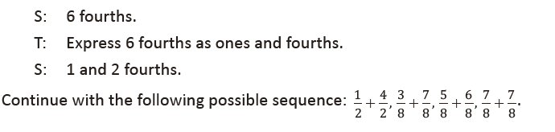
Convert Capacity Units (3 minutes)
Note: This fluency activity reviews Lesson 2 and anticipates work with capacity units.
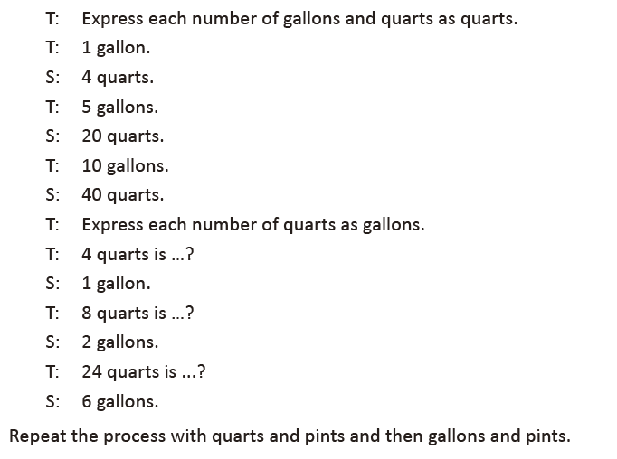
Lesson 7
Fluency Practice (12 minutes)
▪ Grade 4 Fluency Differentiated Practice Sets 4.4A (4 minutes)
▪ What's the Rule? 4.5B (4 minutes)
▪ Convert Length Units 4.8C (4 minutes)

Grade 4 Fluency Differentiated Practice Sets (4 minutes)
Materials: (S) Fluency Practice Sets (Lesson 2 Fluency Practice Sets)
Note: During Module 7, each day’s Fluency Practice may include an opportunity for mastery of the addition and subtraction algorithm by means of the Fluency Practice Sets. The process is detailed and Practice Sets are provided in Lesson 2.

What's the Rule? (4 minutes)
Materials: (T) Fluency Template (S) Personal white board
Note: This fluency activity gives students the opportunity to write a rule to represent the relationship
between the total number of equal sides and the number of squares.
T: (Display the Fluency Template.) The table shows the relationship
between the number of squares and the total number of equal sides.
On your white board, write the rule that represents how to find the
total number of equal sides when given the number of squares.
S: (Write sides = squares × 4.)
T: What is the total number of equal sides for 2 squares?
S: 8 sides.
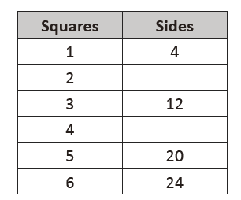
Continue with the following sequence: 4 squares, 12 squares, and 39 squares.
Extension: If given the total number of equal sides, how could the number of squares be determined?

Convert Length Units (4 minutes)
Materials: (S) Personal white board
Note: This fluency activity reviews Lesson 1 and anticipates
today’s work with length units. Use choral or written responses
during the activity.
T: Express each number of yards and feet as feet.
T: 1 yard.
S: 3 feet.
T: 1 yard 2 feet.
S: 5 feet.
T: 4 yards 1 foot.
S: 13 feet.
T: 3 yards 2 feet.
S: 11 feet.
T: Express each number of feet as yards.
T: 3 feet is … ?
S: 1 yard.
T: 6 feet is … ?
S: 2 yards.
T: 9 feet is … ?
S: 3 yards.
Repeat the process with feet and inches.

Lesson 8
Fluency Practice (12 minutes)
▪ Grade 4 Fluency Differentiated Practice Sets 4.4A (4 minutes)
▪ Add Mixed Numbers 4.3E (4 minutes)
▪ Convert Weight Units 4.8B (4 minutes)

Grade 4 Fluency Differentiated Practice Sets (4 minutes)
Materials: (S) Fluency Practice Sets (Lesson 2 Fluency Practice Sets)
Note: During Module 7, each day’s Fluency Practice may include an opportunity for mastery of the addition
and subtraction algorithm by means of the Fluency Practice Sets. The process is detailed and Practice Sets are provided in Lesson 2.

Add Mixed Numbers (4 minutes)
Materials: (S) Personal white board
Note: This fluency activity reviews Module 5’s fraction work and anticipates today’s lesson by adding mixed measurement units since sixteenths relate to pounds and ounces. Complete as a choral or white board activity.
T: 8 sixteenths + 11 sixteenths is how many sixteenths?
S: 19 sixteenths.
T: Express 19 sixteenths as ones and sixteenths.
S: 1 one and 3 sixteenths.
T: 13 sixteenths + 8 sixteenths is how many sixteenths?
S: 21 sixteenths.
T: Express 21 sixteenths as ones and sixteenths.
S: 1 one and 5 sixteenths.
Convert Weight Units (4 minutes)
Materials: (S) Personal white board
Note: This fluency activity reviews Lesson 1 and anticipates today’s work with weight units.
T: Respond on your personal white board. Express each number of pounds and ounces as ounces.
T: 1 pound?
S: (Write 16 ounces.)
T: 1 pound 3 ounces?
S: (Write 19 ounces.)
T: 1 pound 1 ounce?
S: (Write 17 ounces.)
T: 2 pounds?
S: (Write 32 ounces.)
T: Express each number of ounces as pounds and ounces if possible.
T: 16 ounces is … ?
S: (Write 1 pound.)
T: 32 ounces is … ?
S: (Write 2 pounds.)
Repeat the process with 2 pounds 1 ounce, 2 pounds 11 ounces, 3 pound 15 ounces, and 3 pounds 6 ounces.

Lesson 9
Fluency Practice (10 minutes)
⬛ Grade 4 Fluency Differentiated Practice Sets 4.4A (4 minutes)
⬛ Add Mixed Numbers 4.3A (3 minutes)
⬛ Convert Capacity Units 4.8B (3 minutes)

Grade 4 Fluency Differentiated Practice Sets (4 minutes)
Materials: (S) Fluency Practice Sets (Lesson 2 Fluency Practice Sets)
Note: During Module 7, each day’s Fluency Practice may include an opportunity for mastery of the addition and subtraction algorithm by means of the Fluency Practice Sets. The process is detailed and Practice Sets are provided in Lesson 2.

Add Mixed Numbers (3 minutes)
Materials: (S) Personal white board
Note: This fluency activity reviews Module 5’s fraction work and anticipates today’s lesson of adding mixed measurement units, specifically twenty-fourths and sixtieths, to prepare for work with the hours in a day, the seconds in a minute, and the minutes in an hour. Complete as a choral or white board activity.
T: 10 twenty-fourths + 17 twenty-fourths is how many twenty-fourths?
S: 27 twenty-fourths.
T: Express 27 twenty-fourths as ones and twenty-fourths.
S: 1 one and 3 twenty-fourths.
T: 20 twenty-fourths + 20 twenty-fourths is how many twenty-fourths?
S: 40 twenty-fourths.
T: Express 40 twenty-fourths as ones and twenty-fourths.
S: 1 one and 16 twenty-fourths.
Convert Capacity Units (3 minutes)
Materials: (S) Personal white board
Note: This fluency activity reviews Lesson 2 and anticipates the lesson’s work with Capacity units. Complete
as a choral or white board activity.
T: Express each number of pints as cups.
T: 4 pints.
S: 8 cups.
T: 30 pints.
S: 60 cups.
T: Express each number of cups as pints.
T: 12 cups is ….?
S: 6 pints.
T: 48 cups is …?
S: 24 pints.
T: 100 cups is …?
S: 50 pints.
Repeat the same process with pounds and ounces.

Lesson 10
Fluency Practice (12 minutes)
▪ Grade 4 Fluency Differentiated Practice Sets 4.4A (4 minutes)
▪ Add Mixed Numbers 4.3E (4 minutes)
▪ What's the Rule? 4.5B (4 minutes)
Grade 4 Fluency Differentiated Practice Sets (4 minutes)
Materials: (S) Fluency Practice Sets (Lesson 2 Fluency Practice Sets)
Note: During Module 7, each day’s Fluency Practice may include an opportunity for mastery of the addition and subtraction algorithm by means of the Fluency Practice Sets. The process is detailed and Practice Sets are provided in Lesson 2.

Add Mixed Numbers (4 minutes)
Materials: (S) Personal white board
Note: This fluency activity reviews Module 5’s fraction work and anticipates today’s lesson of adding mixed measurement units. Direct students to respond chorally to the questions or use a written response on their personal white boards, depending on which is most effective for them.
T: 3 fourths + 3 fourths is how many fourths?
S: 6 fourths.
T: Express 6 fourths as ones and fourths.
S: 1 one and 2 fourths.
T: 3 quarts + 3 quarts is how many quarts?
S: 6 quarts.
T: Express 6 quarts as gallons and quarts. Draw a number bond to pull out 4 quarts.
S: 1 gallon 2 quarts.
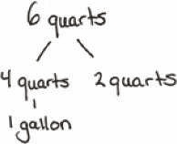
T: 7 twelfths + 7 twelfths is how many twelfths?
S: 14 twelfths.
T: Express 14 twelfths as ones and twelfths.
S: 1 one and 2 twelfths.
T: 7 inches + 7 inches is how many inches?
S: 14 inches.
T: Express 14 inches as feet and inches. Draw a number bond to pull out
12 inches.
S: 1 foot 2 inches.
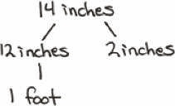
Continue with the following possible sequence: 6 eighths + 6 eighths related to
6 pints + 6 pints, and 11 sixteenths + 11 sixteenths related to 11 ounces + 11 ounces.

What’s the Rule? (4 minutes)
Materials: (T) Fluency Template (S) Personal white board
Note: This fluency activity gives students the opportunity to write a rule to represent the relationship
between a value in a sequence to the value’s position in the sequence.
T: (Display the Fluency Template.) The table shows the relationship
between the position of a number in a sequence and its value. On
your white board, write the rule that represents how to find the
value when given the position.
S: (Write value = position + 16.)
T: What is the value of the number in position 7?
S: 23.
Continue with the following positions: 11, 30, and 45.
Extension: If given a value in the sequence, how could the value’s position be determined?
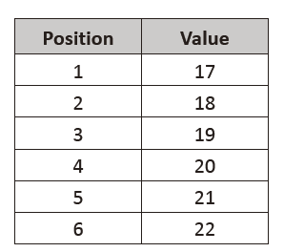

Lesson 11
Fluency Practice (12 minutes)
▪ Grade 4 Fluency Differentiated Practice Sets 4.4A (4 minutes)
▪ Add Mixed Numbers 4.3E (4 minutes)
▪ Convert Weight and Length Units 4.8B (4 minutes)

Grade 4 Fluency Differentiated Practice Sets (4 minutes)
Materials: (S) Fluency Practice Sets (Lesson 2 Fluency Practice Sets)
Note: During Module 7, each day’s Fluency Practice may include an opportunity for mastery of the addition
and subtraction algorithm by means of the Fluency Practice Sets. The process is detailed and Practice Sets are provided in Lesson 2.

Add Mixed Numbers (4 minutes)
Materials: (S) Personal white board
Note: This fluency activity reviews Module 5’s fraction work and anticipates today’s lesson of adding mixed measurement units. Direct students to respond chorally to the questions or to use written responses on their personal white boards, depending on which is most effective for them.
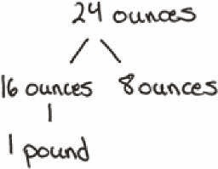
T: 9 sixteenths + 15 sixteenths is how many sixteenths?
S: 24 sixteenths.
T: Express 24 sixteenths as ones and sixteenths.
S: 1 one and 8 sixteenths.
T: 9 ounces + 15 ounces is how many ounces?
S: 24 ounces.
T: Express 24 ounces as pounds and ounces. Draw a number bond to pull out 16 ounces.
S: 1 pound 8 ounces.
T: 13 sixteenths + 17 sixteenths is how many sixteenths?
S: 30 sixteenths.
T: Express 30 sixteenths as ones and sixteenths.
S: 1 one and 14 sixteenths.
T: 13 ounces + 17 ounces is how many ounces?
S: 30 ounces.
T: Express 30 ounces as pounds and ounces. Draw a number bond to pull out 16 ounces.
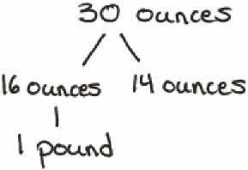
S: 1 pound 14 ounces.
Continue with the following possible sequence: 15 sixteenths + 15 sixteenths related to the same number of ounces.

Convert Weight and Length Units (4 minutes)
Materials: (S) Personal white board
Note: This fluency activity reviews Lessons 1 and 2 and anticipates today’s work. Complete as a choral or
white board activity.
T: Express each number of pounds and ounces as ounces or feet as yards and feet.
T: 1 pound.
S: 16 ounces.
T: 1 pound 10 ounces.
S: 26 ounces.
T: 36 feet.
S: 12 yards.
T: 38 feet.
S: 12 yards 2 feet.
Repeat the same process moving between ounces and pounds and then inches and feet.

Lesson 12
Fluency Practice (12 minutes)
⬛ Grade 4 Fluency Differentiated Practice Sets 4.4A (4 minutes)
⬛ Complete Length Units 4.8A (4 minutes)
⬛ Complete One with Fractional Units 4.3A (4 minutes)

Grade 4 Fluency Differentiated Practice Sets (4 minutes)
Materials: (S) Fluency Practice Sets (Lesson 2 Fluency Practice Sets)
Note: During Module 7, each day’s Fluency Practice may include an opportunity for mastery of the addition and subtraction algorithm by means of the Fluency Practice Sets. The process is detailed and Practice Sets are provided in Lesson 2.

Complete Length Units (4 minutes)
Materials: (S) Personal white board
Note: This fluency activity reviews measurement conversions and the important notion of completing the unit.
T: (Write 2 feet.) How many more feet are needed to make a yard?
S: (Write 1 foot.)
Continue the complete-the-unit work using the following possible sequence:
⬛ Yards: 1 foot.
⬛ Meters: 50 centimeters, 75 centimeters, 27 centimeters.
⬛ Kilometers: 900 meters, 750 meters, 250 meters, 168 meters.
⬛ Feet: 11 inches, 5 inches, 8 inches.

Complete One with Fractional Units (4 minutes)
Materials: (S) Personal white board
Note: This fluency activity reviews fraction work from Module 5 and allows students to see the relationship between measurement and fractional units in anticipation of today’s lesson.
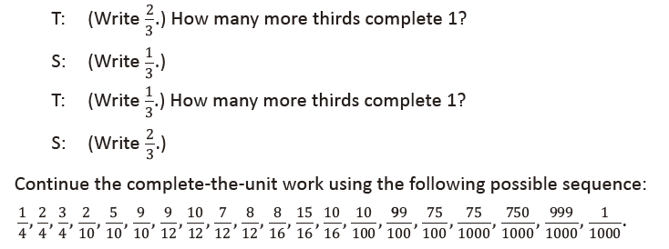

Lesson 13
Fluency Practice (10 minutes)
⬛ Grade 4 Fluency Differentiated Practice Sets 4.4A (4 minutes)
⬛ Complete Time Units 4.8A (3 minutes)
⬛ Complete Weight Units 4.8A (3 minutes)

Grade 4 Fluency Differentiated Practice Sets (4 minutes)
Materials: (S) Fluency Practice Sets (Lesson 2 Fluency Practice Sets)
Note: During Module 7, each day’s Fluency Practice may
include an opportunity for mastery of the addition and
subtraction algorithm by means of the Fluency Practice
Sets. The process is detailed and Practice Sets are provided in
Lesson 2.

Complete Time Units (3 minutes)
Materials: (S) Personal white board
Note: This fluency activity reviews Lesson 3. Depending on the
class, students might write responses on their personal white
boards or respond orally.
T: (Write 4 days.) How many more days complete the
week?
S: 3 days.
T: (Write 40 min.) How many more minutes complete the
hour?
S: 20 minutes.
T: (Write 25 min.) How many more minutes complete the hour?
S: 35 minutes.
T: (Write 18 min.) How many more minutes complete the hour?
S: 42 minutes.
T: (Write 18 hours.) How many more hours complete the day?
S: 6 hours.
T: (Write 10 hours.) How many more hours complete the day?
S: 14 hours.
T: (Write 20 seconds.) How many more seconds complete the minute?
S: 40 seconds.
T: (Write 34 seconds.) How many more seconds complete the minute?
S: 26 seconds.

Complete Weight Units (3 minutes)
Materials: (S) Personal white board
Note: This fluency activity reviews measurement conversions from Lesson 1 and the important concept of completing the unit.
T: (Write 15 ounces.) How many more ounces complete the pound?
S: (Write 1 ounce.)
Continue the complete-the-unit work using the following possible sequence: 8 ounces, 12 ounces, 4 ounces, and 7 ounces.

Lesson 14
Fluency Practice (6 minutes)
⬛ Complete Weight Units 4.8A (3 minutes)
⬛ Complete Capacity Units 4.8A (3 minutes)

Complete Weight Units (3 minutes)
Materials: (S) Personal white board
Note: This fluency activity reviews measurement conversions and the important concept of completing the unit.
T: (Write 10 ounces.) How many more ounces complete 1 pound?
S: (Write 6 ounces.)
Continue the complete-the-unit work using the following possible sequence:
⬛ Pounds: 8 ounces
⬛ Kilograms: 900 grams, 750 grams, 250 grams, 378 grams

Complete Capacity Units (3 minutes)
Materials: (S) Personal white board
Note: This fluency activity reviews measurement conversions and the important concept of completing the unit.
T: (Write 3 quarts.) How many more quarts complete 1 gallon?
S: (Write 1 quart.)
Continue the complete-the-unit work using the following possible sequence:
⬛ Gallons: 1 quart
⬛ Liters: 500 milliliters, 200 milliliters, 850 milliliters, 647 milliliters
⬛ Quarts: 2 cups, 1 cup

Lesson 15
Fluency Practice (11 minutes)
⬛ Compare Fractions 4.3D (4 minutes)
⬛ Use the Rule 4.5B (4 minutes)
⬛ Equivalent Fractions 4.3C (3 minutes)

Compare Fractions (4 minutes)
Materials: (S) Personal white board
Note: This fluency activity review prepares students for this lesson’s Concept Development.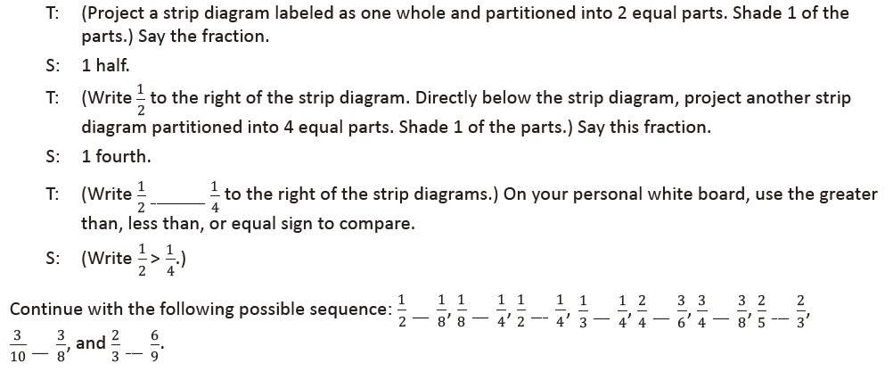
Use the Rule (4 minutes)
Materials: (T) Fluency Template (S) Fluency Template
Note: This fluency activity gives students the opportunity to apply a given
rule to complete an input-output table.
T: (Display the Fluency Template.) The rule for this table is subtract 6.
What is the output, if the input is 13?
S: 7.
T: Write 4 more inputs greater than 13 and an output for each input.
S: (Write.)

Rule: – 6
Input | Output
13
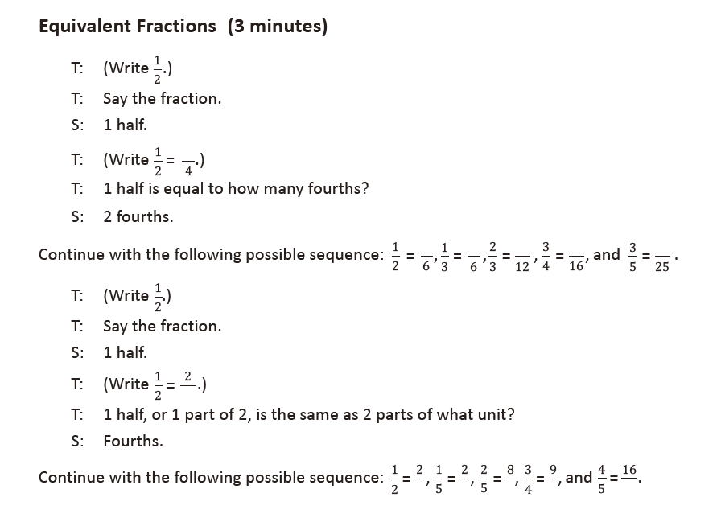
Lesson 16
Fluency Practice (6 minutes)
⬛ Rename the Units 4.2 A (3 minutes)
⬛ Use the Rule 4.5B (3 minutes)

Rename the Units (3 minutes)
Materials: (S) Personal white board
Note: This fluency activity reviews students’ place value understanding in preparation for constructing stem and-leaf plots. If students are unfamiliar with unit form, a place value chart or place value disks can be used to support them.
T: (Write 93.) Say the number.
S: 93.
T: (Write 93 = ____ tens ___ ones.) On your personal white boards, fill in the blanks.
S: (Write 93 = 9 tens 3 ones.)
Repeat process for 102, 135, 227, 409, and 2,154.

Use the Rule (3 minutes)
Materials: (T) Fluency Template (S) Fluency Template
Note: This fluency activity gives students the opportunity to apply a given rule to
complete an input-output table.
T: (Display the Fluency Template.) The rule for this table is divide by 9.
Complete the table.
S: (Complete the table by listing 1, 2, 3, 4, 5.)
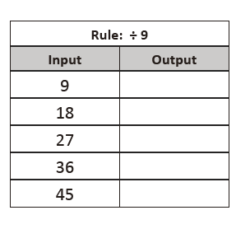

Lesson 17
Fluency Practice (8 minutes)
⬛ Compare Fractions 4.3D (4 minutes)
⬛ What’s the Rule? 4.5B (4 minutes)

Compare Fractions (4 minutes)
Materials: (S) Personal white board
Note: This fluency activity reviews concepts from Module 5.
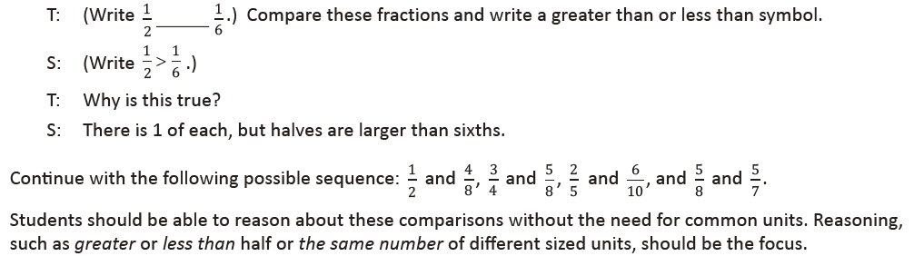

What’s the Rule? (4 minutes)
Materials: (T) Fluency Template (S) Personal white board
Note: This fluency activity gives students the opportunity to write a rule
to represent the relationship between a value in a sequence to the value’s
position in the sequence.
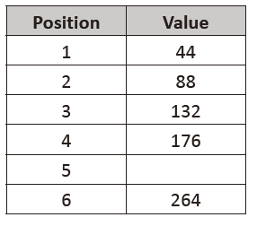
T: (Display the Fluency Template.) The table shows the relationship between the position of a number
in a pattern and its value. On your white board, write the rule that represents how to find the value
when given the position.
S: (Write value = position X 44.)
T: What is the value of the number in position 5?
S: 220.
Continue with the following positions: 10 and 23.
Extension: If given a value in the sequence, how could the value’s position be determined?

Lesson 18
Fluency Practice (9 minutes)
⬛ Mini-Personal White Board Set-Up (5 minutes)
⬛ Find the Area 4.5D (4 minutes)

Mini-Personal White Board Set-Up (5 minutes)
Materials: (S) Plastic page protector, manila folder, tape
Note: In Topic E, all homework pages are designed to become part of the take-home summer folder, created in this lesson. Therefore, students will only complete the top portion of each homework page and use the bottom portion as extra practice during the summer, inserting it into their mini-personal white boards.
Although the homework does not directly reflect the work on each lesson’s Problem Set, the work is directly related to the lesson and Grade 4 standards.
Today’s lesson is the first of four in the Fourth Grade Project. Each lesson involves the creation of an activity page that is later placed in a take-home summer folder. (See Debrief for further explanation.) The folder will contain materials, games, and activities for student reference and practice over the summer. Students create the mini-personal white board to use during lessons and continue to use it over the summer to complete activity pages.

Step 1: Model for students how to fold and cut a plastic page protector in
half horizontally. Discard the top piece, keeping the bottom half
that is closed like a pocket.
Step 2: The pocket of the page protector becomes the mini-personal white
board. It should be attached to the top of a manila folder as shown
by taping the three closed sides of the page protector to the folder.
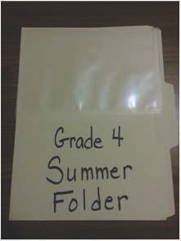

Find the Area (4 minutes)
Materials: (S) Mini-personal white board
Note: This fluency activity reviews area from Module 3 and prepares students for determining the area of composite shapes in this lesson.
T: (Project a rectangle with a width of 3 cm and a length of 10 cm.) Solve for the area of this rectangle.
S: 30 square centimeters.
T: (Project a rectangle with a width of 3 cm and a length of 6 cm.) Solve for the area of this rectangle.
S: 18 square centimeters.
T: (Project a rectangle with a width of 3 cm and a length of 16 cm.) Solve for the area of this rectangle.
S: 48 square centimeters.
Continue with the following possible sequence:
⬛ Rectangle with a width of 6 cm and length of 20 cm; width of 6 cm and length of 8 cm; width of 6 cm
and length of 28 cm.
⬛ Rectangle with a width of 4 cm and length of 40 cm; width of 4 cm and length of 7 cm; width of 4 cm
and length of 47 cm.

Lesson 19
Fluency Practice (9 minutes)
⬛ Grade 4 Fluency Differentiated Practice Sets 4.4A (4 minutes)
⬛ Find the Area 4.5D (5 minutes)

Grade 4 Fluency Differentiated Practice Sets (4 minutes)
Materials: (S) Fluency Practice Sets (Lesson 2 Fluency Practice Sets)
Note: During Module 7, each day’s Fluency Practice may include an opportunity for mastery of the addition and subtraction algorithm by means of the Fluency Practice Sets. The process is detailed and materials are provided in Lesson 2.

Find the Area (5 minutes)
Materials: (S) Personal white board
Note: This fluency activity reviews area and solving two-digit by two-digit multiplication using the area model from Module 3. It also reviews solving for composite areas in Lesson 18.
T: (Project a rectangle with a width of 23 cm and a length of 46 cm.) Decompose the width into tens
and ones.
S: 20 centimeters and 3 centimeters.
T: (Draw a horizontal line decomposing the width into 20 centimeters and 3 centimeters.) Decompose
the length into tens and ones.
S: (Draw a vertical line decomposing the width into 40 centimeters and 6 centimeters.) 40 centimeters
and 6 centimeters.
T: Solve for each smaller area. Then, solve for the total area of the rectangle.
S: 1,058 square centimeters.
Repeat the process for a rectangle with a width of 36 cm and a length of 25 cm.

Lesson 20
Fluency Practice (50 minutes)
⬛ Count by Equivalent Fractions (5 minutes)
⬛ Mixed Review Fluency (45 minutes)

Count by Equivalent Fractions (5 minutes)
Note: Students have practiced this fluency activity throughout the year.
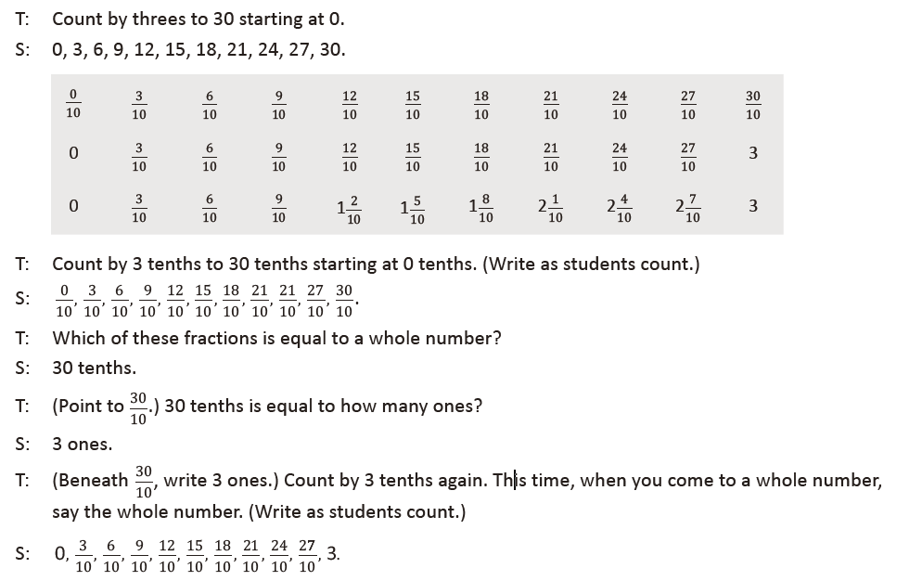
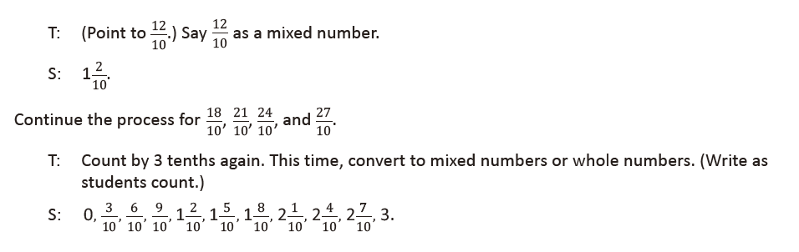
Mixed Review Fluency (45 minutes)
Materials: (T) List of module titles for Modules 1–7 for the
Debrief (S) Fluency cards (Template), mini-personal
white board, protractor
For the rest of today’s lesson students are engaged in fluency
activities reviewing the major work of Grade 4. They work and
play in pairs, alternating the role of teacher, using the cards
provided. Students might periodically move around the room
selecting different partners, or they may stay in the same
grouping for the duration of this practice. Also, consider letting
students select other fluency favorites based on their needs and
interests.
The New Problem component of each card may be best
completed after practice using the Teacher Card. The practice
helps students better understand all the blanks and the
movement of the teacher–student talk. They are then
empowered to extend each activity. Use the mini-personal
white board so that the New Problem remains usable for the
summer months.
After the session, the Fluency Cards are placed in the student
folders for use during the summer.

Lesson 21
Fluency Practice (8 minutes)
⬛ Grade 4 Fluency Differentiated Practice Sets 4.4A (4 minutes)
⬛ Draw and Identify Geometric Terms 4.6A, 4.6C (4 minutes)

Grade 4 Fluency Differentiated Practice Sets (4 minutes)
Materials: (S) Fluency Practice Sets (Lesson 2 Fluency Practice Sets)
Note: During Module 7, each day’s Fluency Practice may include an opportunity for mastery of the addition and subtraction algorithm by means of the Fluency Practice Sets. The process is detailed and materials are provided in Lesson 2. It is recommended these sets be sent home in the summer folder.

Draw and Identify Geometric Terms (4 minutes)
Materials: (S) Personal white board, protractor, ruler
Note: This fluency activity reviews Module 4 and prepares students for using geometric terms in today’s
lesson.
T: Use your protractor and ruler to draw a right, isosceles triangle.
S: (Draw as shown to the right, though student pictures may vary.)
T: Label vertices to identify the right angle as ∠ ABC.
S: (Label as shown to the right.)
T: AB and BC are what types of lines?
S: Perpendicular lines.
T: Use your protractor and ruler to draw a rectangle DEFG.
S: (Draw as shown to the right, though student pictures may vary.)
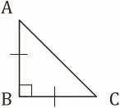

T: What type of lines are DE and FG?
S: Parallel lines.
T: Identify another pair of parallel lines.
S: EF and DG.

