Grade 5 Module 2: Multi-Digit Whole Number and Decimal Fraction Operations
Topic A: Prime and Composite Numbers
Lesson 1 | Divide Using the Area Model (4.4E, 4.4F) | Find the Unknown Factor (3.5D) | Mental Multiplication (4.4C, 4.4D)
Lesson 2 | Use Arrays to find Factors (4.4D) | Multiply Two Factors (4.4D) | Prime or Composite (5.4A)
Lesson 3 | Group Counting (3.4E) | Prime or Composite (5.4A) | Test for Factors (5.4A)
Lesson 4 | Test for Factors (5.4A) | Multiples are Infinite (4.2A, 4.4B) | Prime or Composite (5.4A)
Topic B: Mental Strategies for Multi-Digit Whole Number Multiplication
Lesson 5 | Multiply by 10, 100 and 1000 (5.2A) | Place Value (4.2A, 4.2B, 5l.2A) | Round to Different Place Values (4.2D)
Lesson 6 | Sprint: Multiply by 10, 100 and 1000 (5.2A) | Round to Different Place Values (4.2D) | Multiply by Multiples of 10 (5.3B)
Topic C: The Standard Algorithm for Multi-Digit Whole Number Multiplication
Lesson 7 | Multiply by Multiples of 10 (5.2A) | Estimate Products (5.3A) | Decompose a Factor: The Distributive Property (5.4A)
Lesson 8 | Estimate Products (5.3A) | Decompose Multiplication Sentences (3.5D) | Write the Value of the Expression (5.4F)
Lesson 9 | Estimate Products (5.3A) | Multiply Mentally (5.3B) | Multiply by Multiples of 100 (5.2A)
Lesson 10 | Multiply Mentally (5.3B) | Multiply by Multiples of 100 (5.2A) | Multiply Using the Area Model (5.3B, 5.4B)
Lesson 11 | Sprint: Multiply by Multiples of 10 and 100 (5.2A) | Multiply Using the Area Model (5.3B, 5.4B)
Lesson 12 | Multiply Using the Area Model with a Zero in One Factor (5.3B, 5.4B)
Lesson 13 | Multiply the Divide by Multiples of 10 (5.2A) | Estimate Products by Rounding (5.3A, 5.3B, 5.4B)
Topic D: Decimal Multi-Digit Multiplication
Lesson 14 | Multiply the Divide the Same Number (4.2A) | Decompose Decimals (5.2A)
Lesson 15 | Sprint: Multiply Decimals (5.3E) | Multiply then Divide by the Same Number (4.2A)
Lesson 16 | Unit Conversions (5.7) | State the Decimal (5.2A)
Topic E: Measurement Word Problems with Whole Number and Decimal Multiplication
Lesson 17 | Multiply by 0.1, 0.01, 0.001 (5.2A) | Multiply Using the Area Model (5.3D) | Unit Conversions (5.7)
Lesson 18 | Divide by Multiples of 10 (4.2A) | Unit Conversions (5.7) | Prime or Composite (5.4A)
Lesson 19 | Sprint: Convert Inches to Feet and Inches (5.7) | Divide by Multiples of 10 and 100 (5.3C)
Topic F: Mental Strategies for Multi-Digit Whole Number Division
Lesson 20 | Sprint: Divide by Multiples of 10 and 100 (4.2A) | Round to the Nearest Ten (4.2D) | Group Count by Multiples of 10 (4.2A)
Lesson 21 | Group Count by Multiples of 10 (4.2A) | Round to the Nearest Ten (4.2D) | Divide by Multiples of 10, 100, and 1,000 (5.3A, 5.3C)
Lesson 22 | Group Count by Multiples of 10 (4.2A) | Divide by Multiples of 10, 100, and 1,000 (5.3A, 5.3C) | Estimate and Divide (5.3A, 5.3C)
Topic G: Partial Quotients and Multi-Digit Whole Number Division
Lesson 23 | Estimate and Divide (5.3A, 5.3C) | Group Count by Multiples of 10 (4.2A) | Group Count by Multi-Digit Numbers (4.2D)
Lesson 24 | Group Count by Multi-Digit Numbers (4.2D) | Estimate and Divide (5.3A, 5.3C) | Divide by Multiples of Ten with Remainder (5.3C)
Lesson 25 | Group Count by Multi-Digit Numbers (4.2D) | Divide by Two-Digit Numbers (5.3A, 5.3C)
Lesson 26 | Divide Decimals (5.3A, 5.3F) | Group Count by Multi-Digit Numbers (4.2D) | Divide by Two- Digit Numbers (5.3A, 5.3C)
Lesson 27 | Divide Decimals (5.3F, 5.3G) | Rename Tenths and Hundredths (5.2A) | Divide by Two-Digit Numbers (5.3A, 5.3C)
Topic H: Partial Quotients and Multi-Digit Decimal Division
Lesson 28 | Rename Tenths and Hundredths (5.2A) | Divide Decimals (5.3F, 5.3G) | Divide by Two-Digit Numbers (5.3A, 5.3C)
Lesson 29 | Rename Tenths and Hundredths (5.2A) | Divide Decimals by 10 (5.3F, 5.3G) | Divide Decimals by Multiples of 10 (5.3F, 5.3G)
Lesson 30 | Rename Tenths and Hundredths (5.2A) | Divide Decimals by Multiples of 10 (5.3F, 5.3G) | Estimate the Quotient (5.3A)
Lesson 31 | Divide Decimals by Multiples of 10 (5.3F, 5.3G) | Unit Conversions (5.7) | Divide by Two-Digit Numbers (5.3A, 5.3C)
Topic I: Measurement Word Problems with Multi-Digit Division
Lesson 32 | Sprint: Divide Decimals by Multiples of 10 (5.3F, 5.3G) | Unit Conversions (5.7)
Lesson 33 | Unit Conversions (5.7) | Divide Decimals by Two-Digit Numbers (5.3F, 5.3G)

Grade 5 Module 2
Lesson 1
Fluency Practice (12 minutes)
⬛ Divide Using the Area Model 4.4E, 4.4F (4 minutes)
⬛ Find the Unknown Factor 3.5D (5 minutes)
⬛ Mental Multiplication 4.4C, 4.4D (3 minutes)

Divide Using the Area Model (4 minutes)
Materials: (S) Personal white board
Note: This fluency activity reviews content from Grade 4
in preparation for today’s lesson.
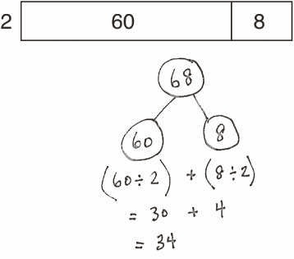
T: (Project an area model that shows 68 ÷ 2.) Write a
division expression for this area model.
S: (Write 68 ÷ 2.)
T: Label the length of each rectangle in the area model.
S: (Write 30 above the 60 and 4 above the 8.)
T: Solve using the standard algorithm or the distributive
property with a number bond.
Continue with the following possible sequence: 96 ÷ 3, 72 ÷ 3, and 72 ÷ 4.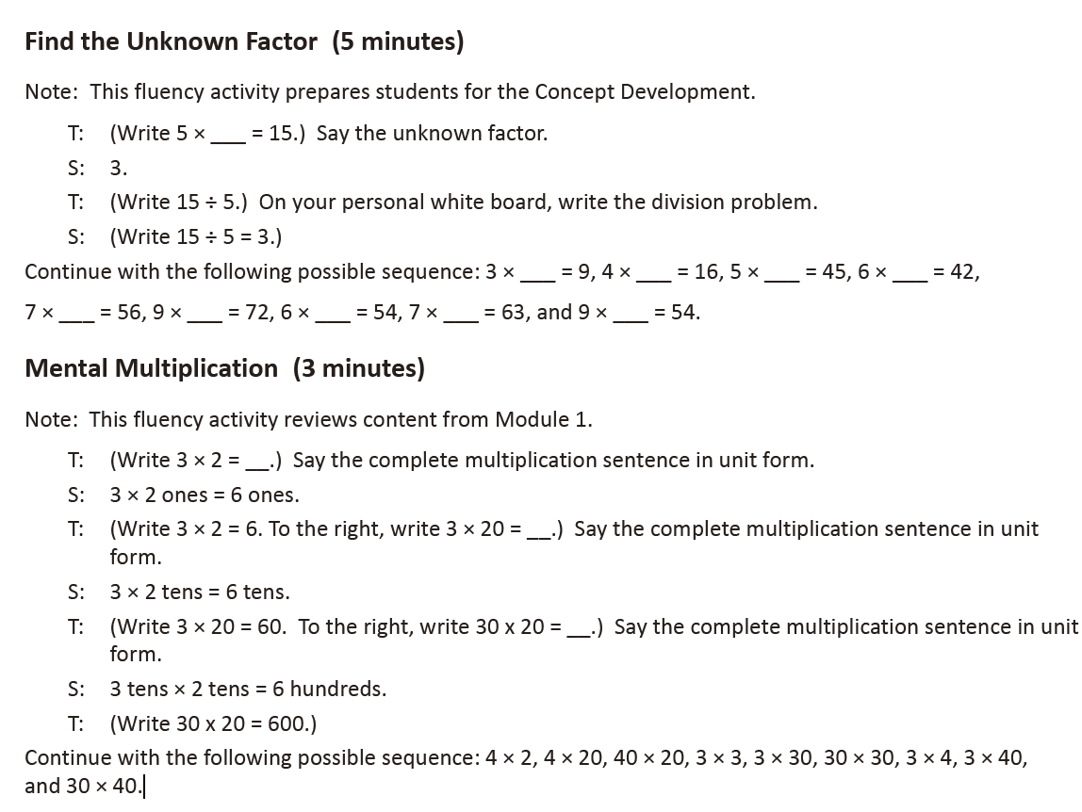

Lesson 2
Fluency Practice (12 minutes)
⬛ Use Arrays to Find Factors 4.4D (6 minutes)
⬛ Multiply Two Factors 4.4D (4 minutes)
⬛ Prime or Composite? 5.4A (2 minutes)

Use Arrays to Find Factors (6 minutes)
Materials: (S) Personal white board
Note: This fluency activity reviews Lesson 1’s content. To challenge students, have them construct the
arrays instead of having them projected.
T: (Project a 1 Å~ 8 array.) What is the width of the array?
S: 1 unit.
T: (Write 1.) What’s the length of the array?
S: 8 units.
T: (Write 8.) Write the multiplication sentence.
S: (Write 1 Å~ 8 = 8.)
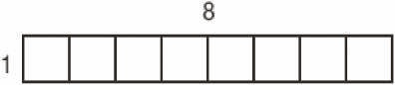
Repeat process for a 2 Å~ 4 array.
T: List the factors of 8.
S: (Write factors of 8: 1, 2, 4, 8.)
Continue with following possible sequence: factors of 12, factors of 16, and factors of 18.

Multiply Two Factors (4 minutes)
Materials: (S) Personal white board
Note: This fluency activity reviews the Concept Development from Lesson 1.
T: (Write 174 Å~ 2 = ____.) On your personal white board, solve the multiplication sentence using the
standard algorithm.
S: What are 4 factors of 348 you know right away?
S: 1 and 348, 2 and 174.
Repeat the process using the following possible sequence: 348 Å~ 2, 696 Å~ 2, and 1,392 Å~ 2. Students may realize that if 348 is a factor of 696, then 174 is, too!

Prime or Composite? (2 minutes)
Materials: (S) Personal white board
Note: This fluency activity reviews Lesson 1’s Concept
Development.
T: (Write 7.) Is it prime or composite?
S: Prime.
T: Write the factor pair of 7.
S: (Write 1 and 7.)
T: (Write 12.) Is it prime or composite?
S: Composite.
T: Write the factor pairs of 12.
S: (Write 1 and 12, 2 and 6, 3 and 4.)
Repeat the process for the following possible sequence: 15, 17, and 21.

Lesson 3
Fluency Practice (12 minutes)
⬛ Group Counting 3.4E (5 minutes)
⬛ Prime or Composite? 5.4A (2 minutes)
⬛ Test for Factors 5.4A (5 minutes)

Group Counting (5 minutes)
Note: Group counting reviews factors and patterns that students use during the Concept Development.
Direct students to count forward and backward, occasionally changing the direction of the count.
⬛ Twos to 20
⬛ Threes to 30
⬛ Fours to 40
⬛ Fives to 50
⬛ Sixes to 60
⬛ Tens to 100

Prime or Composite? (2 minutes)
Materials: (S) Personal white board
Note: This fluency activity reviews Lesson 1’s content.
Repeat the process from Lesson 2 for the following possible sequence: 5, 15, 12, 19, and 24.

Test for Factors (5 minutes)
Materials: (S) Personal white board
Note: This fluency activity reviews Lesson 2’s content.
T: (Project 30, 45, 48, and 56.) On your personal white board, write the number that has 10 as a factor.
S: (Write 30.)
T: Write the division equations that prove both 5 and 2 are factors of 30.
S: (Write 30 ÷ 5 = 6 and 30 ÷ 2 = 15.)
T: Write the numbers that have 6 as a factor.
S: (Write 30 and 48.)
T: Prove that both 3 and 2 are factors of 30 and 48, using the associative property.
S: (Write 30 ÷ 3 = 10, 30 ÷ 2 = 15, 48 ÷ 3 = 16, and 48 ÷ 2 = 24.)
T: Write the numbers that have 8 as a factor.
S: (Write 48 and 56.)
T: Prove that both 4 and 2 are factors of 48 and 56, using the associative property.

Lesson 4
Fluency Practice (12 minutes)
⬛ Test for Factors 5.4A (5 minutes)
⬛ Multiples Are Infinite 4.2A, 4.4B (5 minutes)
⬛ Prime or Composite? 5.4A (2 minutes)

Test for Factors (5 minutes)
Materials: (S) Personal white board
Note: This fluency activity reviews Lesson 2’s content.
T: (Project 40, 64, 54, and 42.) On your personal white board, write the number that has 10 as a factor.
S: (Write 40.)
T: Use division to prove both 4 and 2 are factors of 40.
T: Write the numbers that have 6 as a factor.
S: (Write 54 and 42.)
T: Prove that both 3 and 2 are factors of 54 and 42, using the associative property.
T: Write the numbers that have 8 as a factor.
S: (Write 40 and 64.)
T: Prove that both 4 and 2 are factors of 40 and 64, using the associative property.

Multiples Are Infinite (5 minutes)
Have students make groups of four. Assign each foursome a different number to count by starting at 0.
Allow students two minutes to count round robin in their groups.
T: Let’s share our results. (Call on each group to share.)
T: Could you have kept counting by (assigned number) after I told you to stop?
S: Yes, because we just kept adding on (assigned number) more. → Yes, because you can keep
counting forever.
T: (Allow all groups to share.) We now know the multiples for any number are infinite—they go on
forever. How is that different from the factors of a number? Turn and talk to your partner about
this question.
S: Every number has only a certain amount of factors but an unlimited number of multiples. → The
number of factors any number has is finite, but the number of multiples is infinite.

Prime or Composite? (2 minutes)
Materials: (S) Personal white board
Note: This fluency reviews Lesson 1's content.
Repeat the process from Lesson 2 for the following possible sequence: 10, 13, 20, 21, and 81.

Lesson 5
Fluency Practice (12 minutes)
⬛ Multiply by 10, 100, and 1,000 5.2A (3 minutes)
⬛ Place Value 4.2A, 4.2B, 5.2A (4 minutes)
⬛ Round to Different Place Values 4.2D (5 minutes)

Multiply by 10, 100, and 1,000 (3 minutes)
Note: This fluency activity reviews Module 1 skills and lays the
groundwork for today’s lesson in which both factors are
multiples of 10.
T: (Write 3 Å~ 10.) Say the product.
S: 30.
Repeat the process using the following possible sequence: 3 Å~ 100, 3 Å~ 1,000, 5 Å~ 1,000, 0.005 Å~ 1,000,
50 Å~ 100, 0.05 Å~ 100, 30 Å~ 100, 30 Å~ 1,000, 32 Å~ 1,000, 0.32 Å~ 1,000, 52 Å~ 100, 5.2 Å~ 100, 4 Å~ 10, 0.4 Å~ 10,
0.45 Å~ 1,000, 30.45 Å~ 1,000, 7 Å~ 100, 72 Å~ 100, and 7.002 Å~ 100.

Place Value (4 minutes)
Note: This fluency activity reviews composing and decomposing units, crucial to multiplying multiples of 10 in Lesson 6.
Materials: (S) Personal white board, millions to thousandths place value chart (Template)
T: (Project place value chart. Draw 4 tens disks in the tens column.) How many tens do you see?
S: 4 tens.
T: (Write 4 underneath the disks.) There are 4 tens and how many ones?
S: Zero ones.
T: (Write 0 in the ones column. Below it, write 4 tens = .) Fill in the blank.
S: 4 tens = 40.
Repeat the process for 4 ten thousands, 4 hundred thousands, 7 millions, and 2 thousands.
T: (Write 5 hundreds = .) Show the answer in your place value chart.
S: (Students write 5 in the hundreds column and 0 in the tens and ones columns.)
Repeat the process for 3 tens, 53 tens, 6 ten thousands, 36 ten thousands, 8 hundred thousands 36 ten
thousands, 8 millions 24 ten thousands, 8 millions 17 hundred thousands, and 1,034 hundred thousands.

Round to Different Place Values (5 minutes)
Note: Practicing rounding to different place values in isolation helps students when they estimate to find
products in Lesson 6.
Materials: (S) Personal white board
T: (Project 8,735.) Say the number.
S: 8,735.
T: Let’s round to the thousands, hundreds, and tens places.
T: Draw a vertical number line on your personal white board with two points and a midpoint between
them.
T: Between which two thousands is 8,735?
S: 8 thousand and 9 thousand.
T: Label the two outside points with these values.
S: (Label.)
T: What’s the midpoint for 8,000 and 9,000?
S: 8,500.
T: Label your number line. 8,500 is the same as how many hundreds?
S: 85 hundreds.
T: How many hundreds are in 8,735?
S: 87 hundreds.
T: (Write 8,735 ≈ .) Show 8,735 on your number line, and write the number sentence.
S: (Label 8,735 between 8,500 and 9,000 on the number line, and write 8,735 ≈ 9,000.)
Students round to the hundreds and tens. Follow the same process and procedure for 7,458.

Lesson 6
Lesson 7
Lesson 8
Lesson 9
Lesson 10
Lesson 11
Lesson 12
Lesson 13
Lesson 14
Lesson 15
Lesson 16
Lesson 17
Lesson 18
Lesson 19
Lesson 20
Lesson 21
Lesson 22
Lesson 23
Lesson 24
Lesson 25
Lesson 26
Lesson 27
Lesson 28
Lesson 29
Lesson 30
Lesson 31
Lesson 32
Lesson 33

