Grade 5 Module 3: Addition and Subtraction of Fractions
Topic A: Making Like Units Pictorially
Lesson 1 | Sprint: Find the Missing Numerator or Denominator (5.3H, 5.3K) | Adding Like Fractions (5.3H, 5.3K) | Rename the Fractions (4.3C)
Lesson 2 | Adding Fractions to Make One Whole (4.3A) | Skip Counting by ⅓ Yard (5.3K)
Lesson 3 | Sprint: Subtracting Fractions from a Whole Number (4.3A)
Lesson 4 | Name the Fraction to Complete the Whole (4.3B, 4.3C) | Taking from the Whole (5.3K) | Fraction Units to Ones and Fractions (5.3K)
Lesson 5 | Sprint: Circle the Equivalent Fraction (4.3D)
Topic B: Making Like Units Numerically
Lesson 6 | Adding Whole Numbers and Fractions (4.3A) | Subtracting Fractions from Whole Numbers (4.3A)
Lesson 7 | Adding Whole Numbers and Fractions with Like Units (4.3A) | Sprint: Add and Subtract Fractions with Like Units (4.3A)
Lesson 8 | Sprint: Add and Subtract Whole Numbers and Ones with Fraction Units (4.3E)
Lesson 9 | Subtracting Fractions from Whole Numbers (4.3A) | Adding and Subtracting Fractions with Like Units (4.3E)
Lesson 10 | Sprint: Subtract Fractions with Unlike Units (5.3H, 5.3K)
Topic C: Further Application
Lesson 11 | From Fractions to Decimals (4.2E, 4.2G) | Adding and Subtracting Fractions with Unlike Units (5.3H, 5.3K)
Lesson 12 | Sprint: Make Larger Units (5.3H, 5.3K) | Happy Counting with Mixed Numbers (4.3A)
Lesson 13 | Sprint: Circle the Smaller Fraction (4.3D)
Lesson 14 | Break Apart the Whole (4.3B) | Make a Like Unit (5.3H, 5.3K) | Add Fractions with Answers Greater than 1 (5.3K)

Grade 5 Module 3
Lesson 1
Fluency Practice (12 minutes)
⬛ Sprint: Find the Missing Numerator or Denominator 5.3H, 5.3K (8 minutes)
⬛ Adding Like Fractions 5.3H, 5.3K (2 minutes)
⬛ Rename the Fractions 4.3C (2 minutes)

Sprint: Find the Missing Numerator or Denominator (8 minutes)
Materials: (S) Find the Missing Numerator or Denominator Sprint
Note: Students generate common equivalent fractions mentally and with automaticity (i.e., without
performing the indicated multiplication).

Adding Like Fractions (2 minutes)
Note: This fluency activity reviews adding like units and lays the
foundation for today’s task of adding unlike units.
T: Let’s add fractions mentally. Say answers as whole
numbers when possible.
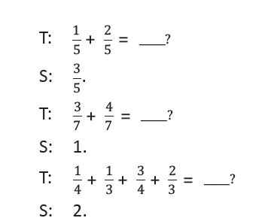
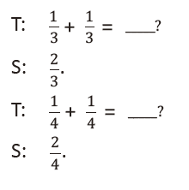
Continue and adjust to meet student needs. Use a variety of fraction combinations.

Rename the Fractions (2 minutes)
Materials: (S) Personal white board
Note: This fluency activity is a quick review of generating equivalent fractions in the largest unit possible
(simplified form), which students use as a strategy to add unlike units during today’s Concept Development.

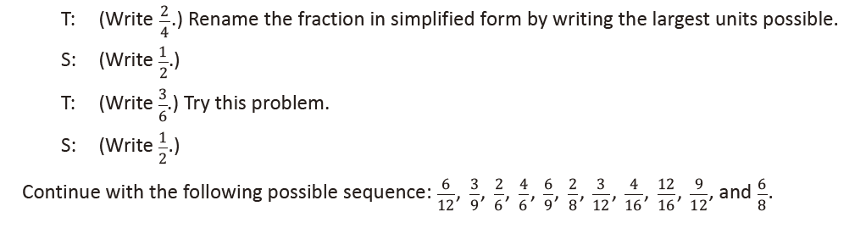
Lesson 2
Fluency Practice (8 minutes)
⬛ Adding Fractions to Make One Whole 4.3A (4 minutes)
⬛ Skip-Counting by 1/3
Yard 5.3K (4 minutes)

Adding Fractions to Make One Whole (4 minutes)
Note: This fluency activity is a quick mental exercise of part–part–whole understanding as it relates to
fractions.
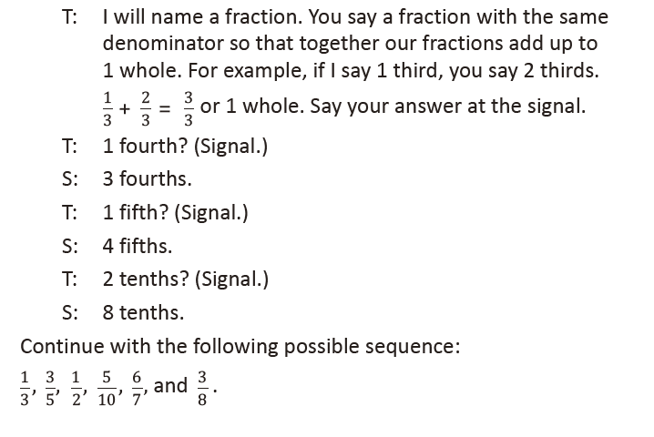

Skip-Counting by 1/3 Yard (4 minutes)
Note: This skip-counting fluency activity prepares students for success with addition and subtraction of
fractions between 1 and 2.
T: Let’s count by 1/3 yard. (Rhythmically point up until a change is desired. Show a closed hand, and
then point down. Continue, mixing it up.)
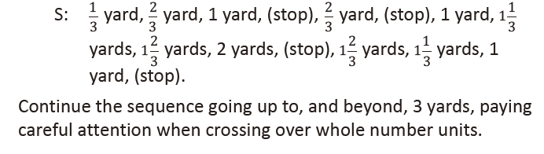

Lesson 3
Fluency Practice (12 minutes)
⬛ Sprint: Subtracting Fractions from a Whole Number 4.3A (12 minutes)

Sprint: Subtracting Fractions from a Whole Number (12 minutes)
Materials: (S) Subtracting Fractions from a Whole Number Sprint
Note: This Sprint is a quick mental exercise of part–part–whole understanding as it relates to fractions.
(Between correcting Sprint A and giving Sprint B, have students share their strategies for quickly solving the
problems. This very brief discussion may help some students catch on to a more efficient approach for
Sprint B.)

Lesson 4
Fluency Practice (10 minutes)
⬛ Name the Fraction to Complete the Whole 4.3B, 4.3C (4 minutes)
⬛ Taking from the Whole 5.3K (3 minutes)
⬛ Fraction Units to Ones and Fractions 5.3K (3 minutes)

Name the Fraction to Complete the Whole (4 minutes)
Note: This fluency activity is a quick mental exercise of
part–part–whole understanding as it relates to fractions.
T: I’ll say a fraction, and you say the missing part to make
one whole. Ready? 1/2.
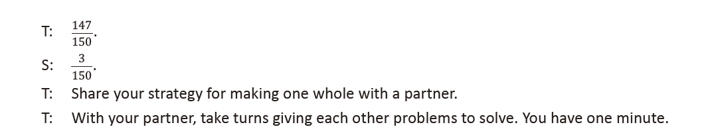
Taking from the Whole (3 minutes)
Materials: (S) Personal white board
Note: This fluency activity strengthens mental math and lays the foundation for today’s Concept
Development in which students subtract from numbers between 1 and 2.
T: I’ll say a subtraction expression. You say the answer.
1 – 1 half.
S: 1 half.
T: 1 – 1 third.
S: 2 thirds.
T: 1 – 2 thirds.
S: 1 third.
T: 1 – 2 fifths.
S: 3 fifths.
T: 1 – 4 fifths.
S: 1 fifth.

Lesson 5
Fluency Practice (12 minutes)
⬛ Sprint: Circle the Equivalent Fraction 4.3D (12 minutes)
Sprint: Circle the Equivalent Fraction (12 minutes)
Materials: (S) Circle the Equivalent Fraction Sprint
Note: Students rapidly recognize common equivalent fractions mentally (i.e., without using multiplication or division).

Lesson 6
Fluency Practice (6 minutes)
⬛ Adding Whole Numbers and Fractions 4.3A (3 minutes)
⬛ Subtracting Fractions from Whole Numbers 4.3A (3 minutes)

Adding Whole Numbers and Fractions (3 minutes)
Note: This fluency activity reviews decomposing a mixed
number into two addends—a whole number plus a fraction.
T: I’ll say the answer. You say the addition problem
as a whole number and a fraction. 3 and 1 half.
S: 3 + 1 half.
T: 5 and 1 half.
S: 5 + 1 half.
T: 2 and 3 fourths.
S: 2 + 3 fourths.
T: 1 and 5 sixths.
S: 1 + 5 sixths.
T: Let’s switch roles. I’ll say the addition problem.
You say the answer. 2 + 1 fifth.
S: 2 and 1 fifth.
T: 2 + 4 fifths.
S: 2 and 4 fifths.
T: 5 + 7 eighths.
S: 5 and 7 eighths.
T: 3 + 7 twelfths.
S: 3 and 7 twelfths.
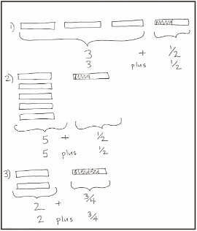

Subtracting Fractions from Whole Numbers (3 minutes)
Note: This fluency activity reviews subtraction of fractions. If students struggle with this activity, the problems can be written as shown in unit form.
T: I’ll say a subtraction sentence. You repeat the
sentence and give the answer. 1 – 1 half.
S: 1 – 1 half = 1 half.
T: 2 – 1 half.
S: 2 – 1 half = 1 and 1 half.
T: 2 and 1 half – 1 half.
S: 2 and 1 half – 1 half = 2.
T: 6 – 1 fourth.
S: 6 – 1 fourth = 5 and 3 fourths.
T: 6 and 3 fourths – 3 fourths.
S: 6 and 3 fourths – 3 fourths = 6.
Continue with the following possible sequence:
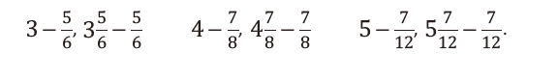
Lesson 7
Fluency Practice (10 minutes)
⬛ Adding and Subtracting Fractions with Like Units 4.3A (1 minute)
⬛ Sprint: Add and Subtract Fractions with Like Units 4.3A (9 minutes)

Adding and Subtracting Fractions with Like Units (1 minute)
Note: This quick fluency activity reviews adding and subtracting like units mentally.
T: I’ll say an addition or subtraction sentence. You say the answer. 2 fifths + 1 fifth.
S: 3 fifths.
T: 2 fifths - 1 fifth.
S: 1 fifth.
T: 2 fifths + 2 fifths.
S: 4 fifths.
T: 2 fifths - 2 fifths.
S: Zero.
T: 3 fifths + 2 fifths.
S: 1.
T: I’m going to write an addition sentence. You say whether it is true or false.
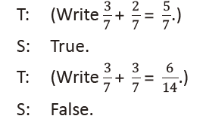
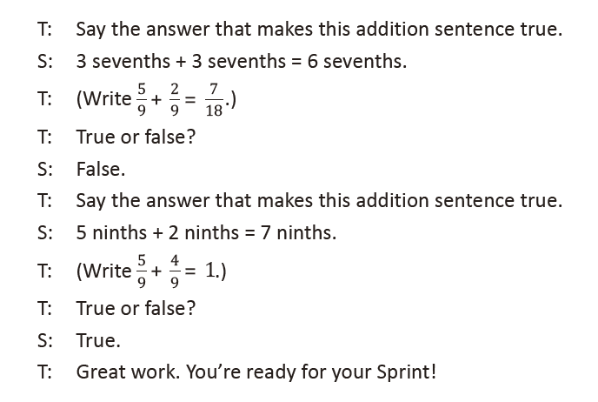
Sprint: Add and Subtract Fractions with Like Units
(9 minutes)
Materials: (S) Add and Subtract Fractions with Like Units Sprint
Note: This Sprint solidifies adding and subtracting fractions with
like units and lays the groundwork for more advanced work
with fractions.

Lesson 8
Fluency Practice (10 minutes)
⬛ Sprint: Add and Subtract Whole Numbers and Ones with Fraction Units 4.3E (10 minutes)

Sprint: Add and Subtract Whole Numbers and Ones with Fraction Units (10 minutes)
Materials: (S) Add and Subtract Whole Numbers and Ones with Fraction Units Sprint
Note: This Sprint strengthens prerequisite skills for today’s fractional work with sums greater than 2.

Lesson 9
Fluency Practice (8 minutes)
⬛ Subtracting Fractions from Whole Numbers 4.3A (5 minutes)
⬛ Adding and Subtracting Fractions with Like Units 4.3E (3 minutes)

Subtracting Fractions from Whole Numbers (5 minutes)
Note: This mental math fluency activity strengthens
part–part–whole understanding as it relates to fractions and
mixed numbers.
T: I’ll say a subtraction sentence. You say the subtraction
sentence with the answer. 1 – 1 half.
S: 1 – 1 half = 1 half.
T: 2 – 1 half.
S: 2 – 1 half = 1 and 1 half.
T: 3 – 1 half.
S: 3 – 1 half = 2 and 1 half.
T: 7 – 1 half.
S: 7 – 1 half = 6 and 1 half.
Continue with the following possible sequence:
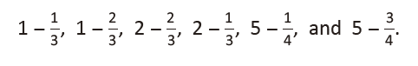
Adding and Subtracting Fractions with Like Units (3 minutes)
Note: This fluency activity reviews adding and subtracting like units mentally.
T: I’ll say an addition or subtraction sentence.
You say the answer. 3 sevenths + 1 seventh.
S: 4 sevenths.
T: 3 sevenths – 1 seventh.
S: 2 sevenths.
T: 3 sevenths + 3 sevenths.
S: 6 sevenths.
T: 3 sevenths – 3 sevenths.
S: 0.
T: 4 sevenths + 3 sevenths.
S: 1.
T: I’ll write an addition sentence. You say true or false.
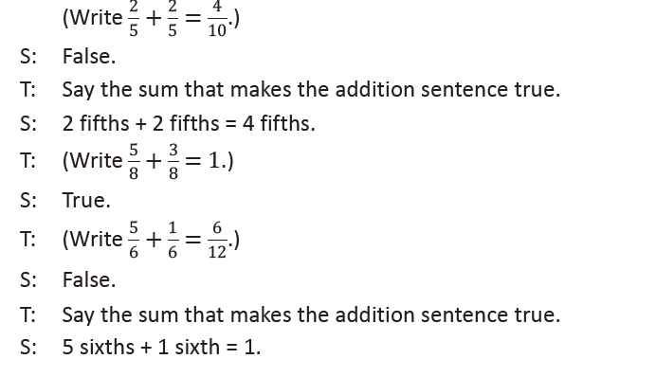

Lesson 10
Fluency Practice (12 minutes)
⬛ Sprint: Subtract Fractions with Unlike Units 5.3H, 5.3K (12 minutes)

Sprint: Subtract Fractions with Unlike Units (12 minutes)
Materials: (S) Subtract Fractions with Unlike Units Sprint
Note: This Sprint encourages students to strengthen their
mental math strategies while subtracting fractions with unlike
units.

Lesson 11
Fluency Practice (11 minutes)
⬛ From Fractions to Decimals 4.2E, 4.2G (5 minutes)
⬛ Adding and Subtracting Fractions with Unlike Units 5.3H, 5.3K (6 minutes)

From Fractions to Decimals (5 minutes)
Note: This fluency activity reviews decimals as they relate to
generating equivalent benchmark fractions.
T: (Write 1/10.) Say the fraction in unit form.
S: 1 tenth.
T: Say the fraction in decimal form.
S: Zero point one.
T: I’ll say a fraction in unit form. You say the fraction in decimal form. Ready? 3 tenths.
S: Zero point three.
T: 7 tenths.
S: Zero point seven.
T: (Write 1/2 = ___/10.) Say the equivalent fraction with the
missing numerator.
S: 1 half = 5 tenths.
T: Say 5 tenths as a decimal.
S: Zero point five.
T: Say 1 half as a decimal.
S: Zero point five.
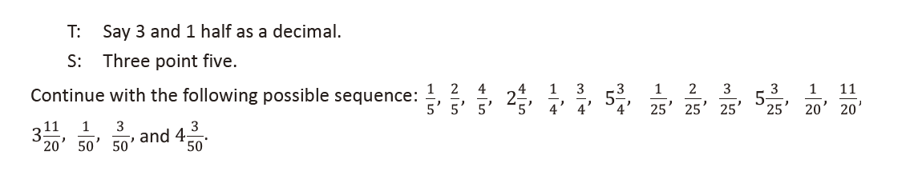

Adding and Subtracting Fractions with Unlike Units (6 minutes)
Materials: (S) Personal white board
Note: Students review adding unlike units and practice assessing the reasonableness of a sum in preparation for today’s Concept Development.
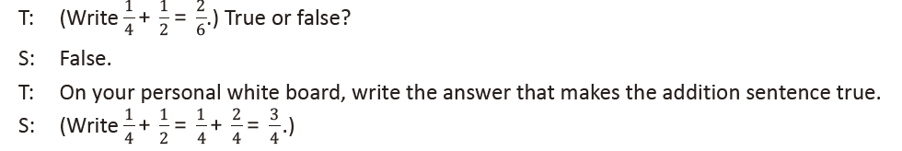
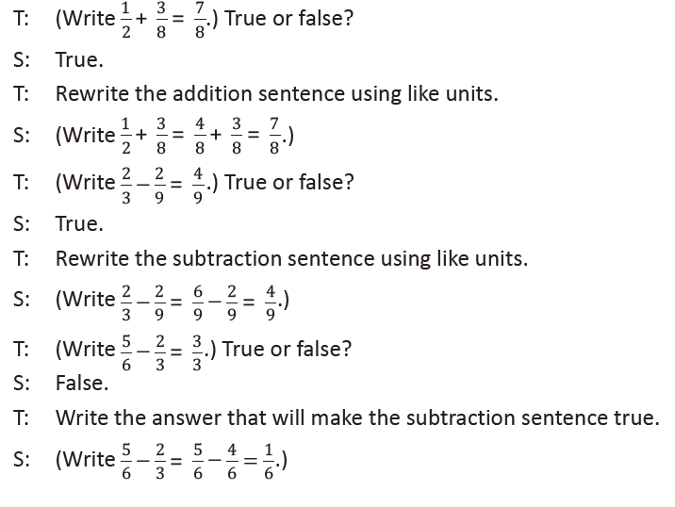

Lesson 12
Fluency Practice (13 minutes)
⬛ Sprint: Make Larger Units 5.3H, 5.3K (10 minutes)
⬛ Happy Counting with Mixed Numbers 4.3A (3 minutes)

Sprint: Make Larger Units (10 minutes)
Materials: (S) Make Larger Units Sprint
Note: This Sprint reviews making like units, a prerequisite skill
for today’s work with multi-term problems.

Happy Counting with Mixed Numbers (3 minutes)
Note: This activity builds comfort and fluency with mixed
numbers.
T: Let’s count by 1/2 with mixed numbers. Ready?
(Rhythmically point up until a change is desired. Show
a closed hand, and then point down. Continue, mixing
it up.)
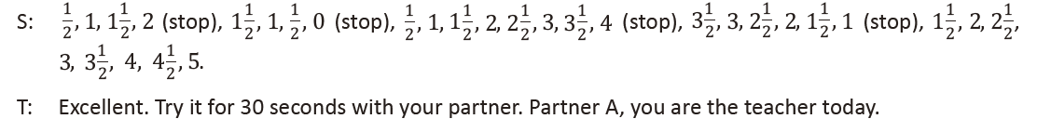
Lesson 13
Fluency Practice (12 minutes)
⬛ Sprint: Circle the Smaller Fraction 4.3D (12 minutes)

Sprint: Circle the Smaller Fraction (12 minutes)
Materials: (S) Circle the Smaller Fraction Sprint
Note: Students practice analyzing fractions in preparation for today’s task of assessing the reasonableness of a solution.

Lesson 14
Fluency Practice (15 minutes)
⬛ Break Apart the Whole 4.3B (5 minutes)
⬛ Make a Like Unit 5.3H, 5.3K (5 minutes)
⬛ Add Fractions with Answers Greater than 1 5.3K (5 minutes)

Break Apart the Whole (5 minutes)
Materials: (S) Personal white board
Note: Students decompose fractions greater than 1 (i.e., improper fractions) into a whole and a fraction in preparation for today’s Concept Development.
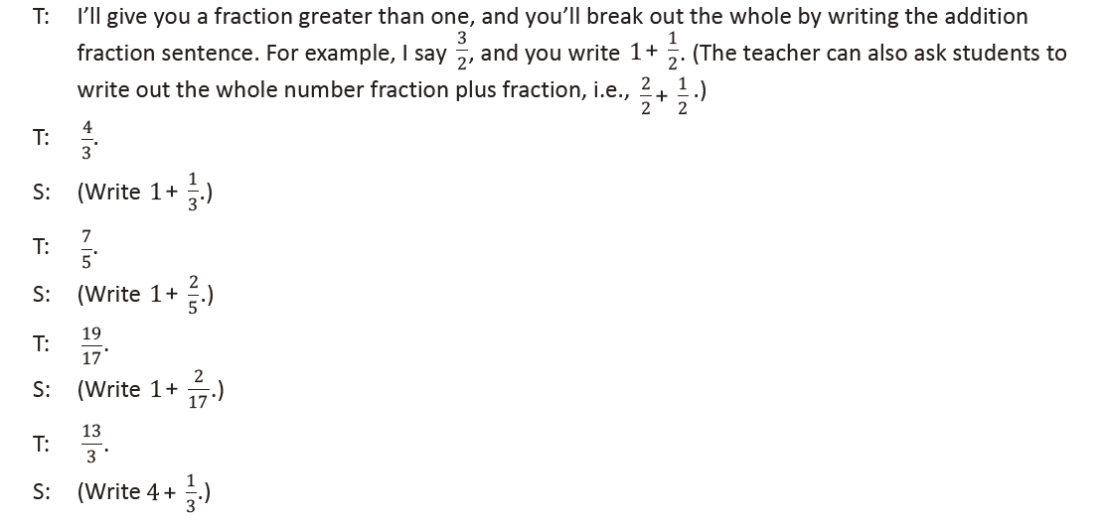
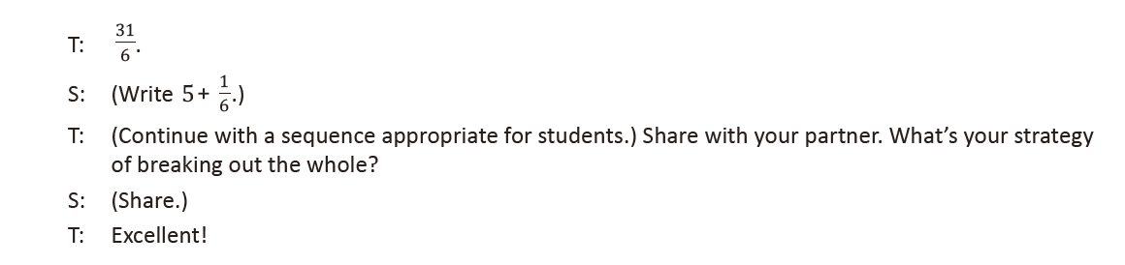
Make a Like Unit (5 minutes)
Materials: (S) Personal white board
Note: Students make like units, which is a prerequisite skill for advanced work with fractions.
T: What does like unit mean?
S: When you add or subtract fractions, if the
denominators are the same, then they are like units.
T: Tell your partner how we find like units.
S: (Share.)
T: I’ll say two numbers. You make a like unit and write it
on your personal white board.
T: 3 and 2.
S: (Write and show 6.)
Continue with the following possible sequence: 4 and 3; 2 and
4; 2 and 6; 3 and 9; 3 and 12; 4 and 8; 6 and 8.

Add Fractions with Answers Greater than 1 (5 minutes)
Materials: (S) Personal white board
Note: Students recognize and analyze fractions greater than 1
in preparation for today’s problem-solving set.
T: I’ll say an equation. You write and solve it. If the
answer is greater than 1, put a dot next to it. Leave
room to write all of the equations on your personal
white board without erasing.
