Grade 5 Module 4: Multiplication and Division of Fractions
Topic A: Repeated Addition of Fractions as Multiplication
Lesson 1 | Multiply Mentally (4.4B, 4.4D) | Repeated Addition as Multiplication (3.4E) | Add Fractions (3.3D)
Lesson 2 | Add and Subtract (5.3K) | Count by Equivalent Fractions (5.3H) | Add and Subtract Mixed Numbers (5.3K)
Lesson 3 | Count by Equivalent Fractions (5.3H) | Multiply Fractions (5.3I)
Lesson 4 | Add and Subtract (5.3K) | Multiply Fractions (5.3I)
Lesson 5 | Multiply Fractions (5.3I) | Multiply Mixed Numbers (5.3I)
Lesson 6 | Sprint: Multiply Whole Numbers Times Fraction (5.3I) | Multiply Mixed Numbers (5.3I)
Lesson 7 | Make a One (5.3) | Count by Equivalent Fractions (5.3H) | Multiply Mixed Numbers (5.3I)
Topic B: Multiplication of a Whole Number by a Fraction
Lesson 8 | Multiply a Fraction by a Whole Number (5.3I) | Compare Fractions (4.3D) | Decompose Fractions (5.3I)
Lesson 9 | Read Strip Diagrams (5.3I) | Half of Whole Numbers (5.3I) | Draw a Fraction of a Set (5.3I)
Lesson 10 | Convert Measures (4.8A, 4.8B) | Decompose Fractions (5.3I) | Multiply a Fraction Times a Whole Number (5.3I)
Lesson 11 | Multiply Whole Numbers by Fractions with Strip Diagrams (5.3I) | Convert Measures (4.8A, 4.8B) | Convert Measures (4.8A, 4.8B)
Topic C: Fraction Expressions and Word Problems
Lesson 12 | Convert Measures from Small to Large Units (4.8A, 4.8B) | Multiply a Fraction and Whole Number (5.3I) | Find the Unit Conversion (5.3I, 5.7)
Lesson 13 | Convert Measures (4.8A, 4.8B) | Multiply Whole Numbers by Fraction Using Two Methods (5.3I) | Write the Expression to Match the Diagram (5.3I, 5.4F)
Lesson 14 | Convert Measures (4.8A, 4.8B) | Convert Measures (4.8A, 4.8B) | Write the Expression to Match the Diagram (5.3I, 5.4F)
Lesson 15 | Multiply Decimals (5.3E) | Convert Measures (4.8A, 4.8B)
Lesson 16 | Count by Fractions (4.3E) | Convert Measures (4.8A, 4.8B) | Multiply Decimals (5.3E) | Find the Unit Conversions (5.7)
Topic D: Division of Fractions
Lesson 17 | Write Fractions as Decimals (5.2A) | Find the Unit Conversion (5.7)
Lesson 18 | Count by Fractions (4.3E) | Divide Whole Numbers by Fractions (5.3J, 5.3L) | Multiply Fractions by Whole Numbers (5.3I, 5.4H)
Lesson 19 | Count by Fractions (4.3E) | Divide Whole Numbers by Unit Fractions (5.3J, 5.3L) | Divide Unit Fractions by Whole Numbers (5.3J, 5.3L)
Lesson 20 | Count by Fractions (4.3E) | Divide Whole Numbers by Unit Fractions and Unit Fractions by Whole Numbers (5.3K, 5.3L)
Topic E: Applying Fraction and Decimal Multiplication to Personal Financial Literacy
Lesson 21 | Fraction of a Set (5.3I, 5.3J) | Find the Product (5.3E) | Round Decimals (5.2C)
Lesson 22 | Add and Subtract Decimals (5.3K) | Multiply a Decimal Fraction and Whole Number (5.3D) | Round Decimal Numbers (5.2C)
Lesson 23 | Multiply a Decimal Fraction Times a Whole Number (5.3D) | Round Decimals Numbers (5.2C) | Multiply then Divide by the Same Number (5.3E, 5.3G)
Lesson 24 | Add and Subtract Decimal Fractions (5.3K) | Multiply a Decimal Fraction and a Whole Number (5.3D) | Round Decimal Numbers (5.2C)
Topic F: Interpretation of Numerical Expressions
Lesson 25 | Order of Operations (5.4F) | Divide by 1 Tenth and 1 Hundredth (5.3J) | Divide Unit Fractions by Whole Numbers (5.3J)

Grade 5 Module 4
Lesson 1
Fluency Practice (12 minutes)
⬛⬛ Multiply Mentally 4.4B, 4.4D (4 minutes)
⬛⬛ Repeated Addition as Multiplication 3.4E (4 minutes)
⬛⬛ Add Fractions 3.3D (4 minutes)

Multiply Mentally (4 minutes)
Materials: (S) Personal white board
Note: This fluency activity reviews multiplication concepts.
T: (Write 34 X 2 = ____.) Say the multiplication sentence.
S: 34 X 2 = 68.
T: (Write 34 X 2 = 68. Below it, write 34 X 20 = ___.)
Say the multiplication sentence.
S: 34 X 20 = 680.
T: (Write 34 X 20 = 680. Below it, write 34 X 22 = ___.) On your personal white board, solve 34 X 22.
S: (Write 34 X 22 = 748.)
Continue with the following possible sequence: 23 X 3, 23 X 20, and 23 X 23; and 12 X 4, 12 X 30, and 12 X 34.

Repeated Addition as Multiplication (4 minutes)
Materials: (S) Personal white board
Note: This fluency activity reviews multiplication concepts.
T: (Write 2 + 2 + 2 = ___.) Say the addition sentence.
S: 2 + 2 + 2 = 6.
T: (Write 2 + 2 + 2 = 6. Beneath it, write ___ X 2 = 6.) On your personal white board, fill in the unknown factor.
S: (Write 3 X 2 = 6.)
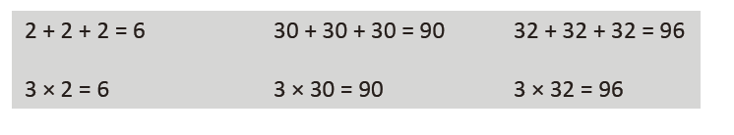
T: (Write 3 X 2 = 6. To the right,
write 30 + 30 + 30 = ___.)
Say the addition sentence.
S: 30 + 30 + 30 = 90.
T: (Write 30 + 30 + 30 = 90. Beneath it, write ___X 30 = 90.) Fill in the unknown factor.
S: (Write 3 X 30 = 90.)
T: (Write 3 X 30 = 90. To the right, write 32 + 32 + 32 = ___.) On your board, write the repeated addition sentence. Then, beneath it, write a multiplication sentence to reflect the addition sentence.
S: (Write 32 + 32 + 32 = 96. Beneath it, write 3 X 32 = 96.)
Continue with the following possible sequence: 1 + 1 + 1 + 1, 4 X 1; 20 + 20 + 20 + 20, 4 X 20;
21 + 21 + 21 + 21, 4 X 21; and 23 + 23 + 23, 3 X 23.

Add Fractions (4 minutes)
Materials: (S) Personal white board
Note: This fluency activity prepares students for today’s lesson.
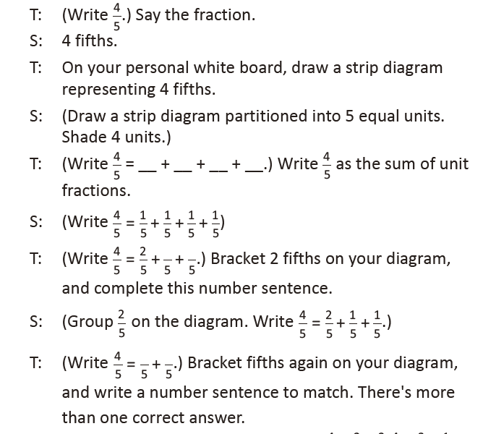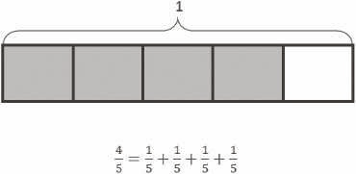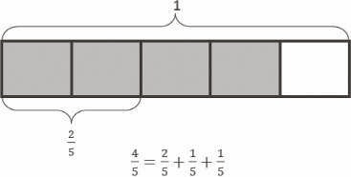

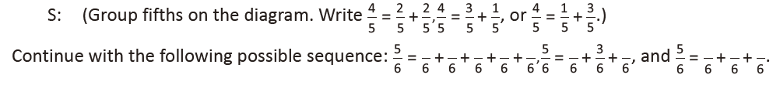

Lesson 2
Fluency Practice (12 minutes)
⬛⬛ Add and Subtract 5.3K (4 minutes)
⬛⬛ Count by Equivalent Fractions 5.3H (4 minutes)
⬛⬛ Add and Subtract Mixed Numbers 5.3K (4 minutes)

Add and Subtract (4 minutes)
Materials: (S) Personal white board
Note: This fluency activity reviews adding and subtracting using the standard algorithm.
T: (Write 676 thousands 696 ones.) On your personal
white boards, write this number in standard form.
S: (Write 676,696.)
T: (Write 153 thousands 884 ones.) Add this number to
676,696 using the standard algorithm.
S: (Write 676,696 + 153,884 = 830,580 using the standard
algorithm.)
Continue the process for 678,717 + 274,867.
T: (Write 300 thousands.) On your boards, write this
number in standard form.
S: (Write 300,000.)
T: (Write 134 thousands 759 ones.) Subtract this number from 300,000 using the standard algorithm.
S: (Write 300,000 – 134,759 = 165,241 using the standard algorithm.)
Continue the process for 734,902 – 477,479.

Count by Equivalent Fractions (4 minutes)
Note: This activity prepares students for today’s lesson. The progression builds in complexity. Work students up to the highest level of complexity in which they can confidently participate.
T: Count by threes to 15, starting at 0.
S: 0, 3, 6, 9, 12, 15.
T: Count by 3 fifths to 15 fifths, starting at 0 fifths. (Write as students count.)
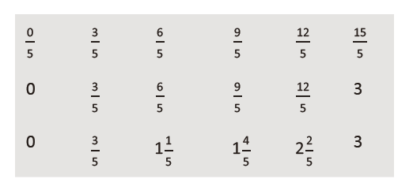
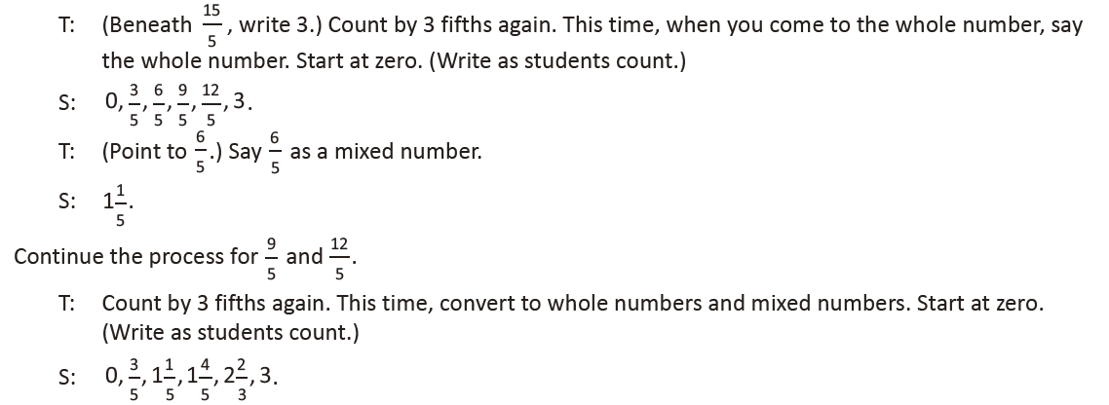

Add and Subtract Mixed Numbers (4 minutes)
Materials: (S) Personal white board
Note: This fluency activity prepares students for today’s lesson. Allow students to solve using any strategy.
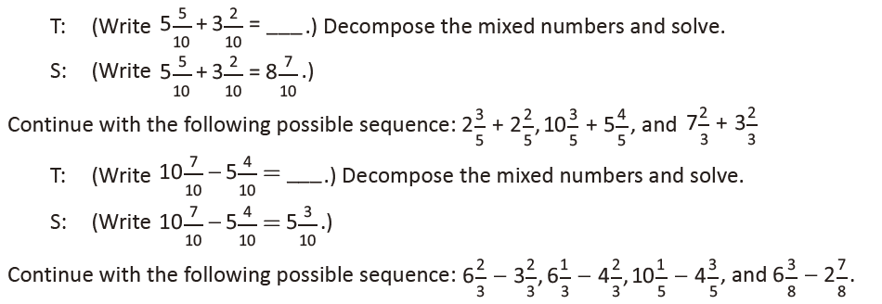

Lesson 3
Fluency Practice (10 minutes)
⬛⬛ Count by Equivalent Fractions 5.3H (5 minutes)
⬛⬛ Multiply Fractions 5.3I (5 minutes)

Count by Equivalent Fractions (5 minutes)
Note: This activity prepares students for today’s lesson. The progression builds in complexity. Work students
up to the highest level of complexity in which they can confidently participate.
T: Count by threes to 30, starting at 0.
S: 0, 3, 6, 9, 12, 15, 18, 21, 24, 27, 30.
T: Count by 3 tenths to 30 tenths, starting at 0 tenths. (Write as students count.)
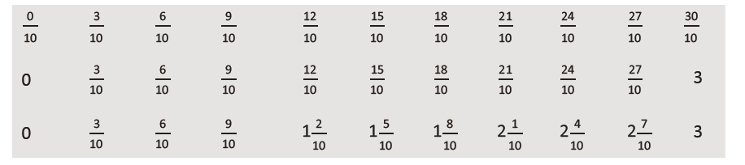
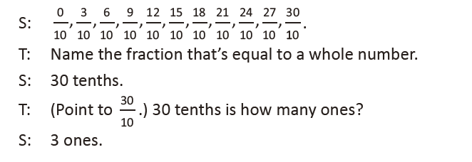
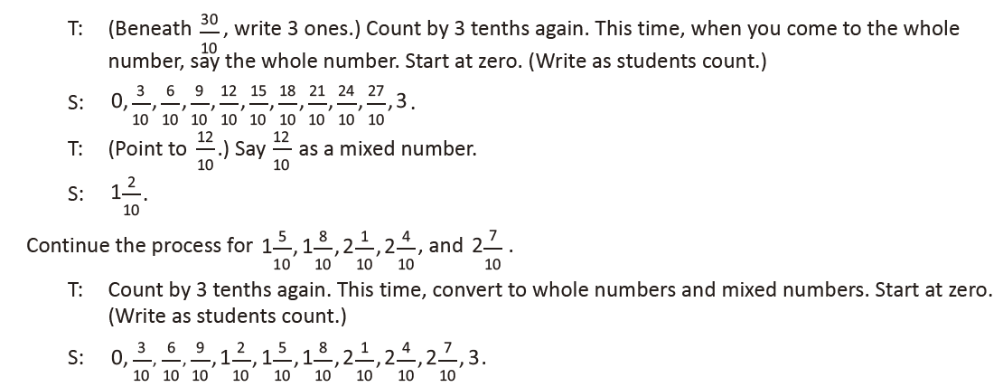

Multiply Fractions (5 minutes)
Materials: (S) Personal white board
Note: This fluency activity reviews Lesson 2.
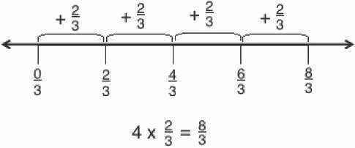
T: Draw a number line.
S: (Draw a number line.)
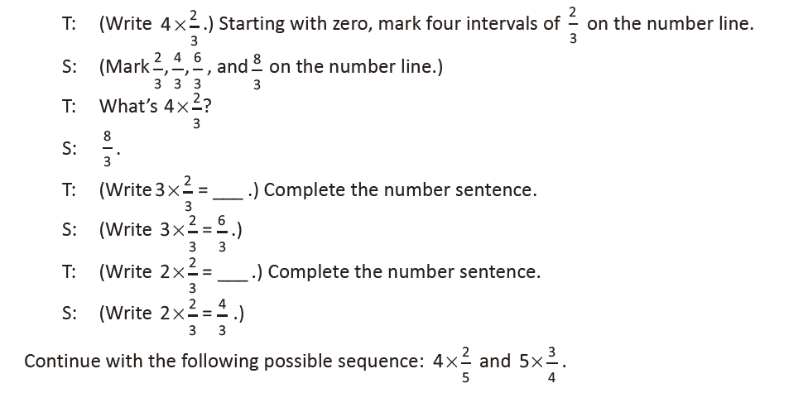
Lesson 4
Fluency Practice (10 minutes)
⬛⬛ Add and Subtract 5.3K (4 minutes)
⬛⬛ Multiply Fractions 5.3I (6 minutes)

Add and Subtract (4 minutes)
Materials: (S) Personal white board
Note: This fluency activity reviews adding and subtracting using the standard algorithm.
T: (Write 547 thousands 869 ones.) On your personal white boards, write this number
in standard form.
S: (Write 547,869.)
T: (Write 362 thousands 712 ones.) Add this number to 547,869 using the standard algorithm.
S: (Write 547,869 + 362,712 = 910,581 using the standard algorithm.)
Continue with the following possible sequence: 459,623 + 353,683.
T: (Write 800 thousands.) On your boards, write this number in standard form.
S: (Write 800,000.)
T: (Write 352 thousands 951 ones.) Subtract this number from 800,000 using the standard algorithm.
S: (Write 800,000 – 352,951 = 447,049 using the standard algorithm.)
Continue with the following possible sequence: 805,813 – 368,265.

Multiply Fractions (6 minutes)
Materials: (S) Personal white board
Note: This fluency activity reviews Lesson 3.
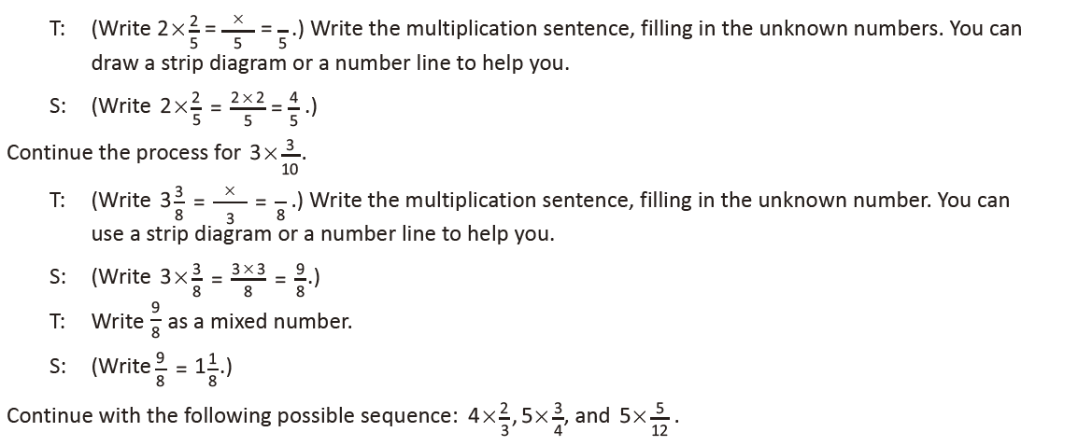

Lesson 5
Fluency Practice (10 minutes)
⬛⬛ Multiply Fractions 5.3I (5 minutes)
⬛⬛ Multiply Mixed Numbers 5.3I (5 minutes)

Multiply Fractions (5 minutes)
Materials: (S) Personal white board
Note: This fluency activity reviews Lesson 3.
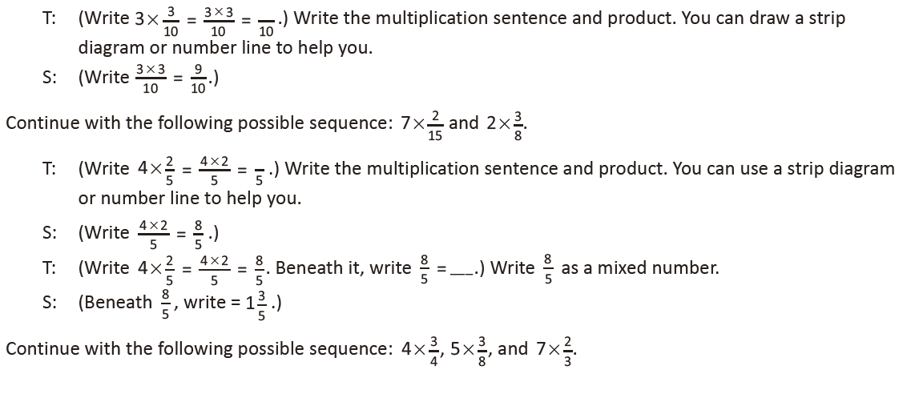
Multiply Mixed Numbers (5 minutes)
Materials: (S) Personal white board
Note: This fluency activity reviews Lesson 4.

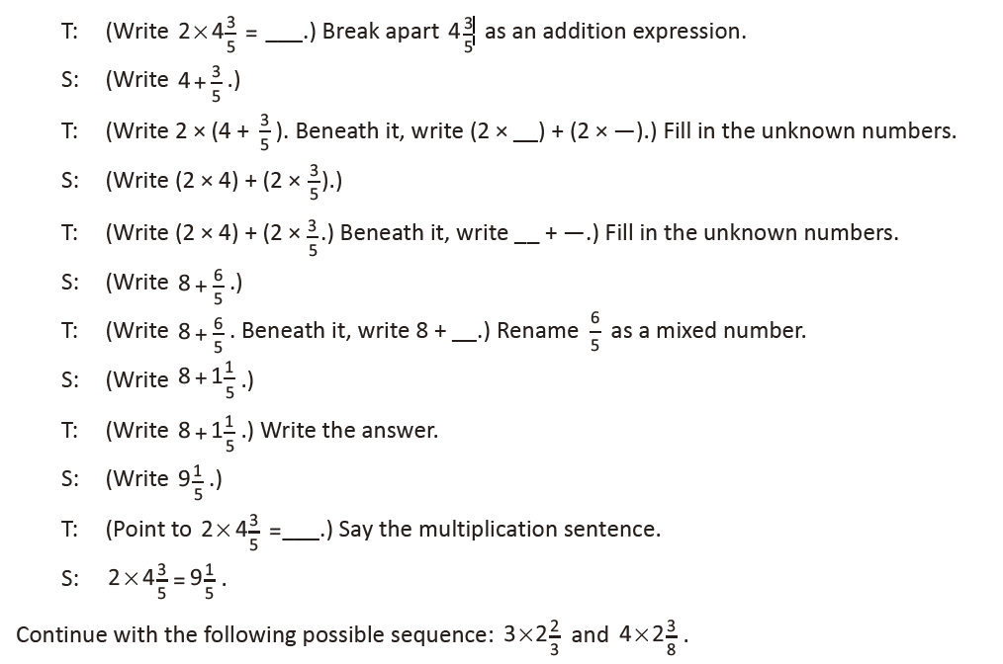

Lesson 6
Fluency Practice (12 minutes)
⬛⬛ Sprint: Multiply Whole Numbers Times Fractions 5.3I (8 minutes)
⬛⬛ Multiply Mixed Numbers 5.3I (4 minutes)
Sprint: Multiply Whole Numbers Times Fractions (8 minutes)
Materials: (S) Multiply Whole Numbers Times Fractions Sprint
Note: This fluency activity reviews Lesson 2.

Multiply Mixed Numbers (4 minutes)
Materials: (S) Personal white board
Note: This fluency activity reviews Lesson 4.
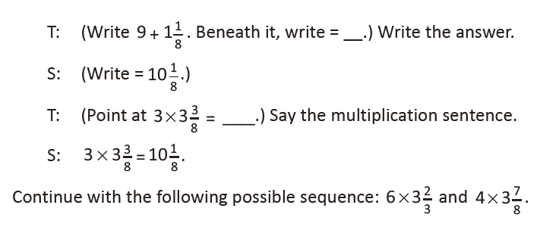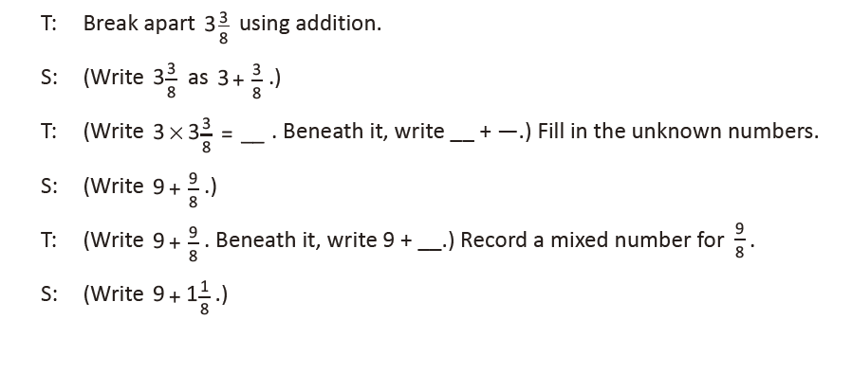
Lesson 7
Fluency Practice (13 minutes)
⬛⬛ Make a One 5.3K (4 minutes)
⬛⬛ Count by Equivalent Fractions 5.3H (5 minutes)
⬛⬛ Multiply Mixed Numbers 5.3I (4 minutes)

Make a One (4 minutes)
Materials: (S) Personal white board
Note: This fluency activity reviews adding fractions.
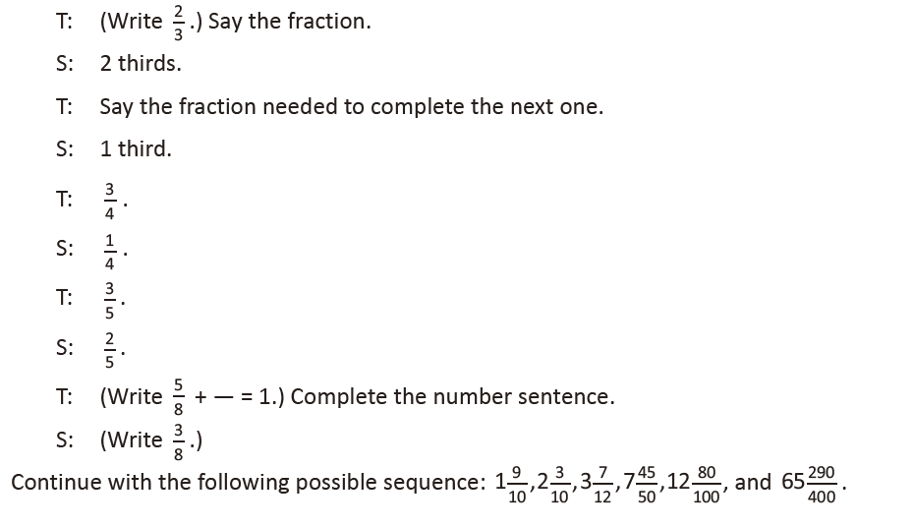
Count by Equivalent Fractions (5 minutes)
Note: This fluency activity prepares students for today’s lesson. The progression builds in complexity. Work students up to the highest level of complexity in which they can confidently participate.
T: Count by sevens to 70. Start at zero.
S: 0, 7, 14, 21, 28, 35, 42, 49, 56, 63, 70.
T: Count by 7 tenths to 70 tenths, starting at 0 tenths. (Write as students count.)
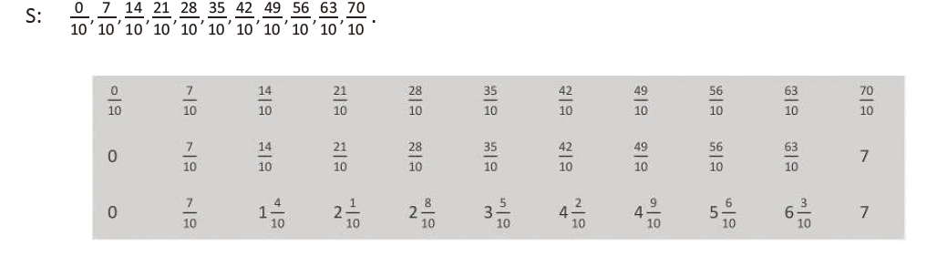
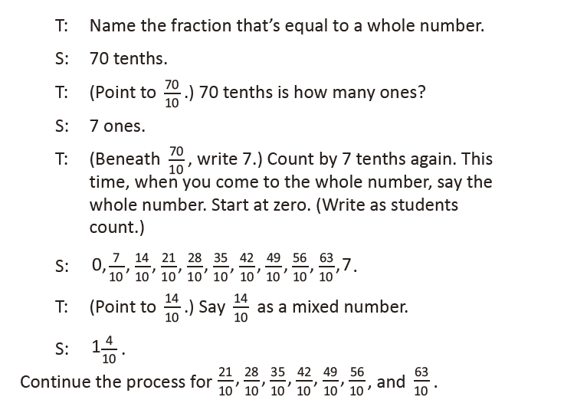
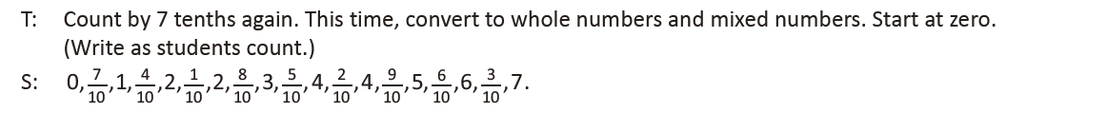
Multiply Mixed Numbers (4 minutes)
Materials: (S) Personal white board
Note: This fluency activity reviews Lesson 4.
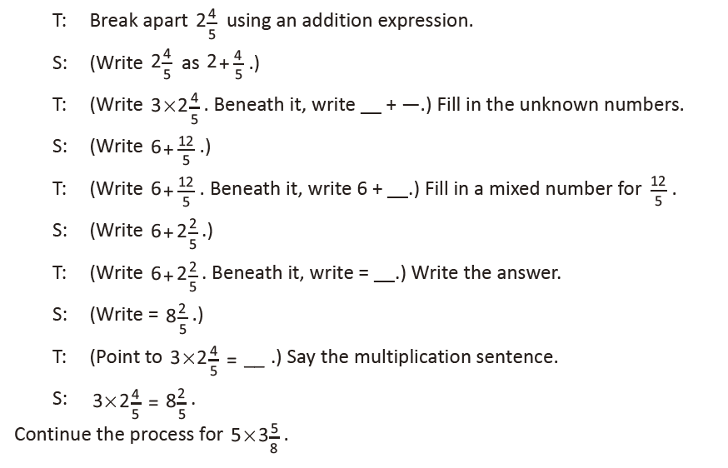

Lesson 8
Fluency Practice (12 minutes)
⬛⬛ Multiply a Fraction by a Whole Number 5.3I (4 minutes)
⬛⬛ Compare Fractions 4.3D (4 minutes)
⬛⬛ Decompose Fractions 5.3I (4 minutes)

Multiply a Fraction by a Whole Number (4 minutes)
Note: This fluency activity reviews repeated addition of fractions as multiplication from Lesson 1.
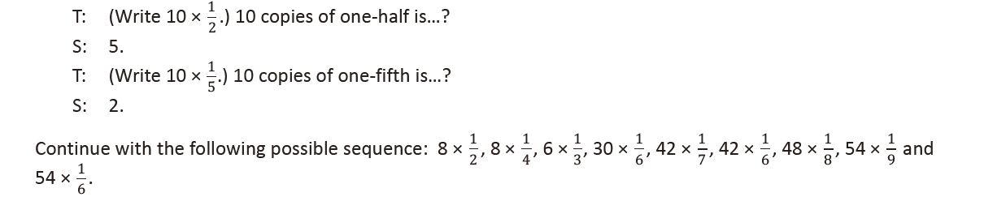
Compare Fractions (4 minutes)
Materials: (S) Personal white board
Note: This fluency reviews comparison of fractions. Encourage students to verbalize how they know which fraction is larger/smaller using reasoning rather than calculation.
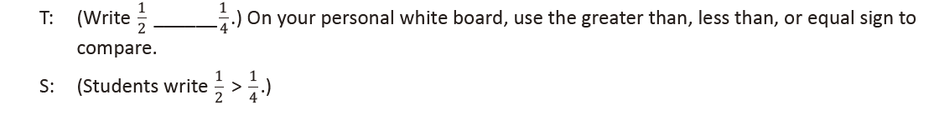
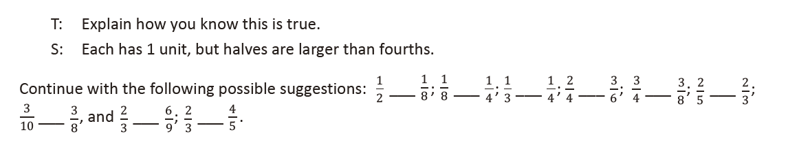
Decompose Fractions (4 minutes)
Materials: (S) Personal white board
Note: This fluency activity reviews multiplication of a fraction by a whole number.
T: (Write a number bond with 2/3
as the whole and 1/3 as the part.) Say the whole.
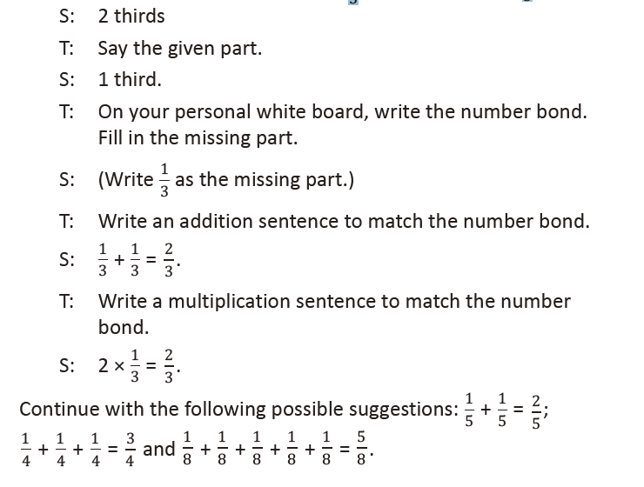

Lesson 9
Fluency Practice (12 minutes)
⬛⬛ Read Strip Diagrams 5.3I (4 minutes)
⬛⬛ Half of Whole Numbers 5.3I (4 minutes)
⬛⬛ Draw a Fraction of a Set 5.3I (4 minutes)

Read Strip Diagrams (4 minutes)
Materials: (S) Personal white board
Note: This fluency activity prepares students to multiply fractions by whole numbers during the Concept
Development.
T: (Project a strip diagram with 10 partitioned into 2 equal units.) Say the whole.
S: 10.
T: On your personal white board, write the division sentence.
S: (Write 10 ÷ 2 = 5.)
Continue with the following possible sequence: 6 ÷ 2, 9 ÷ 3, 12 ÷ 3, 8 ÷ 4, 12 ÷ 4, 25 ÷ 5, 40 ÷ 5, 42 ÷ 6, 63 ÷ 7, 64 ÷ 8, and 54 ÷ 9.

Half of Whole Numbers (4 minutes)
Materials: (S) Personal white board
Note: This fluency activity reviews content from Lesson 8 and prepares students for multiplying fractions by whole numbers during the Concept Development using strip diagrams.
T: Draw 4 counters. What’s half of 4?
S: 2.
T: (Write 1
2 of 4 = 2.) Say a division sentence that helps you find the answer.
S: 4 ÷ 2 = 2.
Continue with the following possible sequence: 1 half of 10, 1 half of 8, 1 half of 30, 1 half of 54, 1 fourth of 20, 1 fourth of 16, 1 third of 9, and 1 third of 18.

Draw a Fraction of a Set (4 minutes)
Materials: (S) Personal white board
Note: This fluency reaches back to Lesson 8's pictorial work with fraction of a set.
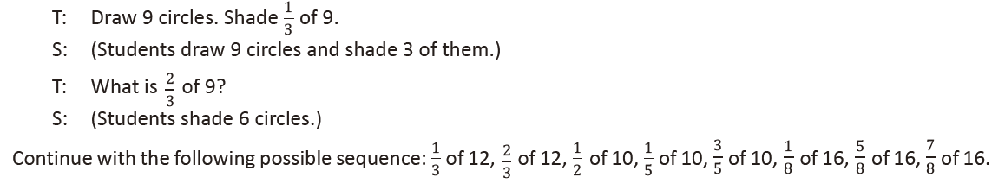
Lesson 10
Fluency Practice (12 minutes)
⬛⬛ Convert Measures 4.8A, 4.8B (5 minutes)
⬛⬛ Decompose Fractions 5.3I (3 minutes)
⬛⬛ Multiply a Fraction Times a Whole Number 5.3I (4 minutes)

Convert Measures (5 minutes)
Materials: (S) Personal white board, Grade 5 Mathematics Reference Sheet (Reference Sheet)
Note: This fluency activity prepares students for Lessons 11–14 content. Allow students to use the Grade 5 Mathematics Reference Sheet if they are confused, but encourage them to answer questions without
referring to it.
T: (Write 1 ft = ____ in.) How many inches are in 1 foot?
S: 12 inches.
T: (Write 1 ft = 12 in. Below it, write 2 ft = ____ in.) 2 feet?
S: 24 inches.
T: (Write 2 ft = 24 in. Below it, write 3 ft = ____ in.) 3 feet?
S: 36 inches.
T: (Write 3 ft = 36 in. Below it, write 4 ft = ____ in.) 4 feet?
S: 48 inches.
T: (Write 4 ft = 48 in. Below it, write 10 ft = ____ in.) On your personal white board, write the equation.
S: (Write 10 ft = 120 in.)
T: (Write 10 ft X ____ = ____ in.) Write the multiplication equation you used to solve it.
S: (Write 10 ft X 12 = 120 in.)
Continue with the following possible sequence: 1 pint = 2 cups, 2 pints = 4 cups, 3 pints = 6 cups, 9 pints = 18 cups, 1 yd = 3 ft, 2 yd = 6 ft, 3 yd = 9 ft, 7 yd = 21 ft, 1 gal = 4 qt, 2 gal = 8 qt, 3 gal = 12 qt, and 8 gal = 32 qt.

Decompose Fractions (3 minutes)
Materials: (S) Personal white board
Note: This fluency activity reviews multiplication of a fraction by a whole number in Lessons 2–3.
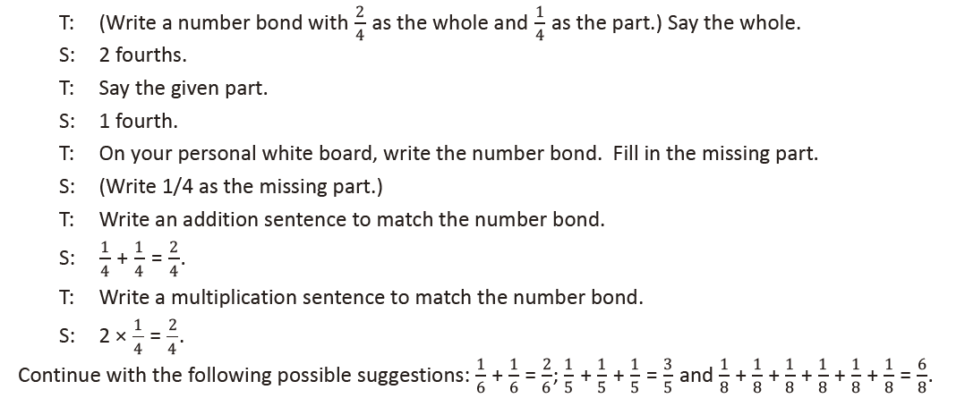
Multiply a Fraction Times a Whole Number (4 minutes)
Materials: (S) Personal white board
Note: This fluency activity reviews Lesson 9 content.

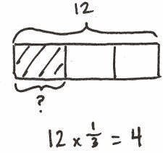

T: (Project a strip diagram of 12 partitioned into 3 equal
units. Shade in 1 unit.) What fraction of 12 is shaded?
S: 1 third.
T: (Write 12 X ____ = 4.) On your personal white board,
write the equation, filling in the missing fraction.
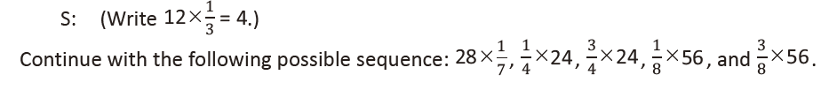

Lesson 11
Fluency Practice (12 minutes)
⬛⬛ Multiply Whole Numbers by Fractions with Strip Diagrams 5.3I (4 minutes)
⬛⬛ Convert Measures 4.8A, 4.8B (4 minutes)
⬛⬛ Multiply a Fraction and a Whole Number 5.3I (4 minutes)

Multiply Whole Numbers by Fractions with Strip Diagrams (4 minutes)
Materials: (S) Personal white board
Note: This fluency exercise reviews Lesson 9 content.
T: (Project a strip diagram of 8 partitioned into 2 equal units. Shade in 1 unit.) What fraction of 8 is
shaded?
S: 1 half.
T: (Write 8 X ____ = 4.) On your personal white board, write the equation, filling in the missing
fraction.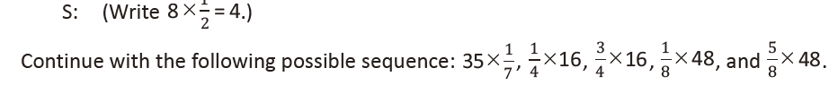
Convert Measures (4 minutes)
Materials: (S) Personal white board, Grade 5 Mathematics Reference Sheet (Lesson 10 Reference Sheet)
Note: This fluency activity prepares students for Lessons 11–14. Allow students to use the conversion
reference sheet if they are confused, but encourage them to answer questions without referring to it.
T: (Write 1 pt = ____ c.) How many cups are in 1 pint?
S: 2 cups.
T: (Write 1 pt = 2 c. Below it, write 2 pt = ____ c.) 2 pints?
S: 4 cups.
T: (Write 2 pt = 4 c. Below it, write 3 pt = ____ c.) 3 pints?
S: 6 cups.
T: (Write 3 pt = 6 c. Below it, write 7 pt = ____ c.) On your personal white board, write the equation.
S: (Write 7 pt = 14 c.)
T: Write the multiplication equation you used to solve it.
S: (Write 7 X 2 c = 14 c.)
Continue with the following possible sequence: 1 ft = 12 in, 2 ft = 24 in, 4 ft = 48 in, 1 yd = 3 ft, 2 yd = 6 ft, 3 yd = 9 ft, 9 yd = 27 ft, 1 gal = 4 qt, 2 gal = 8 qt, 3 gal = 12 qt, and 6 gal = 24 qt.

Multiply a Fraction and a Whole Number (4 minutes)
Materials: (S) Personal white board
Note: This fluency activity reviews Lesson 10 content.
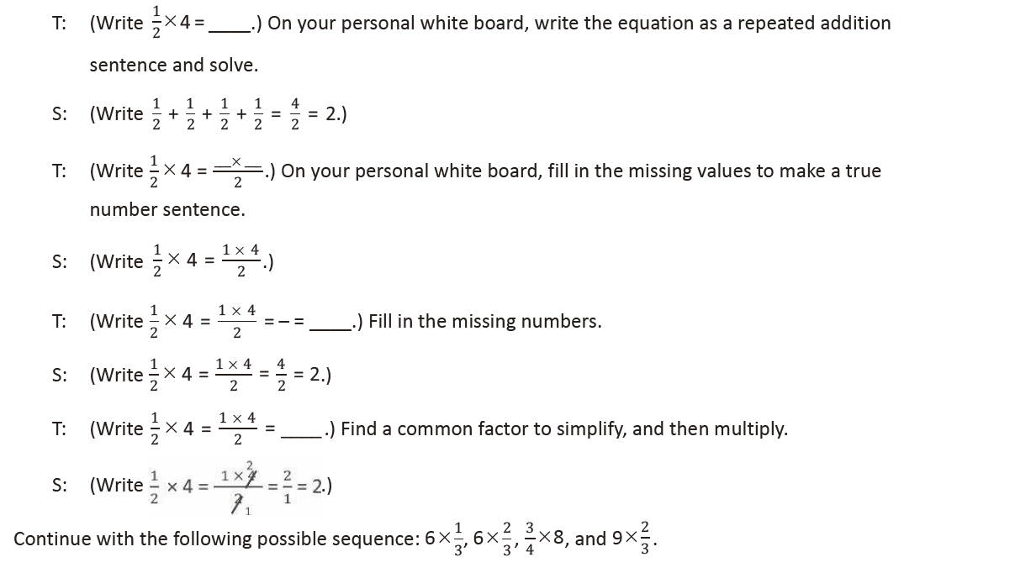

Lesson 12
Fluency Practice (12 minutes)
⬛⬛ Convert Measures from Small to Large Units 4.8A, 4.8B (5 minutes)
⬛⬛ Multiply a Fraction and a Whole Number 5.3I (3 minutes)
⬛⬛ Find the Unit Conversion 5.3I, 5.7 (4 minutes)

Convert Measures from Small to Large Units (5 minutes)
Materials: (S) Personal white board, Grade 5 Mathematics Reference Sheet (Lesson 10 Reference Sheet)
Note: This fluency activity reviews Lesson 11 and prepares students for Lessons 12–14 content. Allow
students to use the conversion reference sheet. Teachers may wish to present the conversions in a table to
afford students an opportunity to practice a format often found on the STAAR.
T: (Write 12 in = __ ft.) How many feet are in 12 inches?
S: 1 foot.
T: (Write 12 in = 1 ft. Below it, write 24 in = __ ft.) 24 inches?
S: 2 feet.
T: (Write 24 in = 2 ft. Below it, write 36 in = __ ft.) 36 inches?
S: 3 feet.
T: (Write 36 in = 3 ft. Below it, write 48 in = __ ft.) 48 inches?
S: 4 feet.
T: (Write 48 in = 4 ft. Below it, 120 in = __ ft.) On your personal white board, write the equation.
S: (Write 120 in = 10 ft.)
T: (Write 120 in ÷ __ = __ ft.) Write the division equation you used to solve it.
S: (Write 120 in ÷ 12 = 10 ft.)
Continue with the following possible sequence: 2 c = 1 pt, 4 c = 2 pt, 6 c = 3 pt, 16 c = 8 pt, 3 ft = 1 yd,
6 ft = 2 yd, 9 ft = 3 yd, 27 ft = 9 yd, 4 qt = 1 gal, 8 qt = 2 gal, 12 qt = 3 gal, and 24 qt = 6 gal.

Multiply a Fraction and a Whole Number (3 minutes)
Materials: (S) Personal white board
Note: This fluency activity reviews Lesson 10.
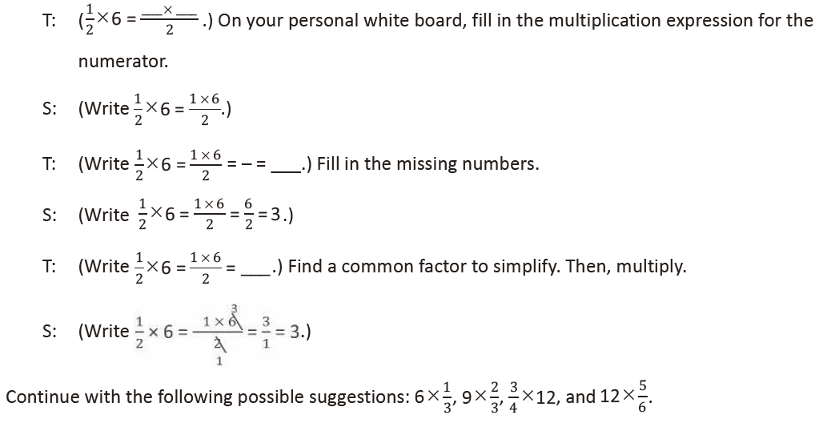
Find the Unit Conversion (4 minutes)
Materials: (S) Personal white board
Note: This fluency activity reviews Lesson 11.

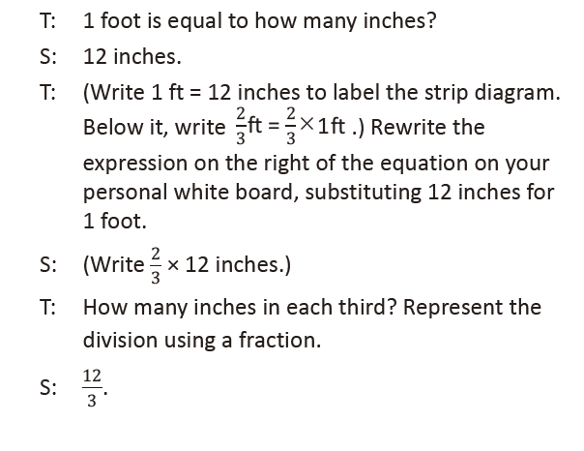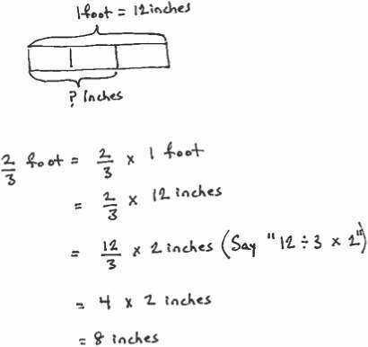
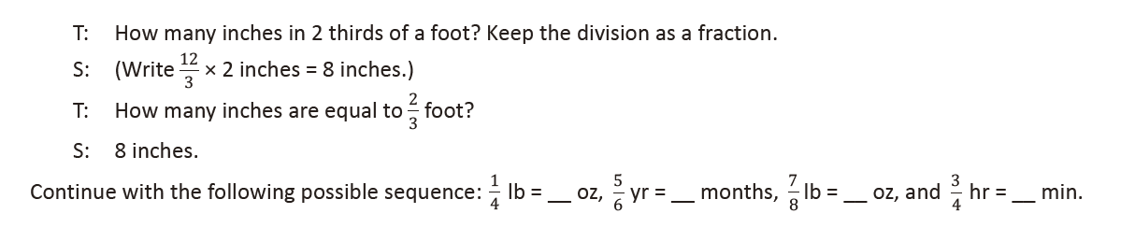
Lesson 13
Fluency Practice (12 minutes)
⬛⬛ Convert Measures 4.8A, 4.8B (5 minutes)
⬛⬛ Multiply Whole Numbers by Fractions Using Two Methods 5.3I (3 minutes)
⬛⬛ Write the Expression to Match the Diagram 5.3I, 5.4F (4 minutes)

Convert Measures (5 minutes)
Materials: (S) Personal white board, Grade 5 Mathematics Reference Sheet (Lesson 10 Reference Sheet)
Note: This fluency activity reviews Lessons 11–12 and prepares students for Lessons 13–14 content. Allow students to use the conversion reference sheet if they are confused, but encourage them to answer questions without referring to it.
T: (Write 2 c = __ pt.) How many pints are in 2 cups?
S: 1 pint.
T: (Write 2 c = 1 pt. Below it, write 4 c = __ pt.) 4 cups?
S: 2 pints.
T: (Write 4 c = 2 pt. Below it, write 6 c = __ pt.) 6 cups?
S: 3 pints.
T: (Write 6 c = 3 pt. Below it, write 20 c = __ pt.) On your personal white board, write the equation.
S: (Write 20 c = 10 pt.)
T: (Write 20 c ÷ __ = __ pt.) Write the division equation you used to solve it.
S: (Write 20 c ÷ 2 = 10 pt.)
Continue with the following possible sequence: 12 in = 1 ft, 24 in = 2 ft, 48 in = 4 ft, 3 ft = 1 yd, 6 ft = 2 yd, 9 ft = 3 yd, 24 ft = 8 yd, 4 qt = 1 gal, 8 qt = 2 gal, 12 qt = 3 gal, and 36 qt = 9 gal.

Multiply Whole Numbers by Fractions Using Two Methods (3 minutes)
Materials: (S) Personal white board
Note: This fluency activity reviews Lesson 10.
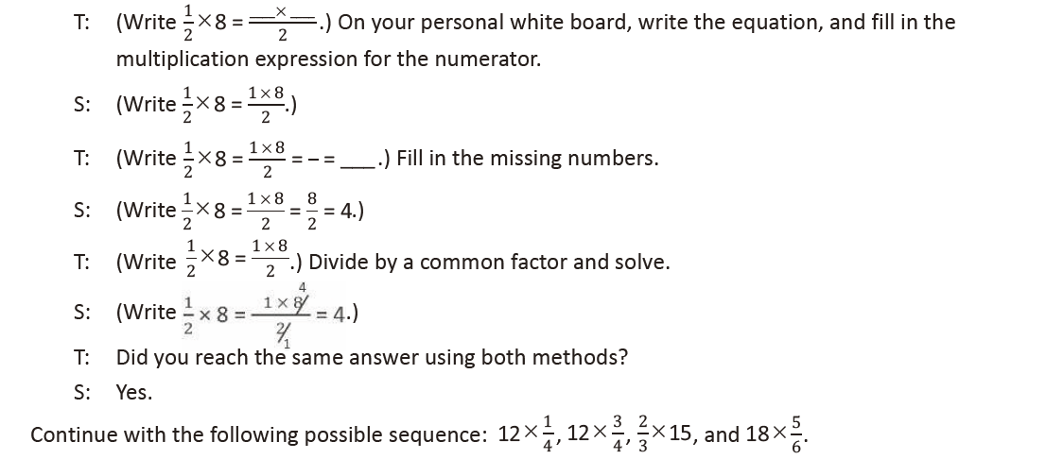
Write the Expression to Match the Diagram (4 minutes)
Materials: (S) Personal white board
Note: This fluency activity reviews Lesson 12.
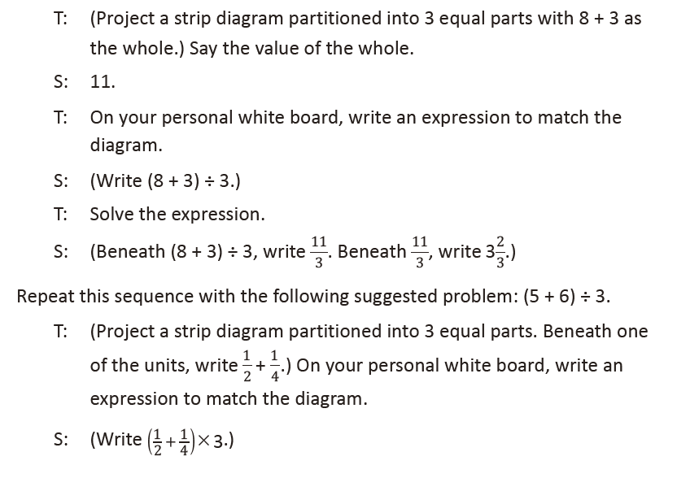
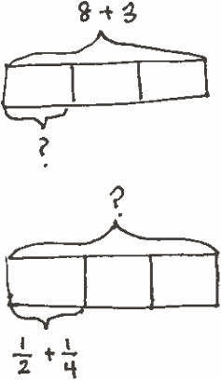
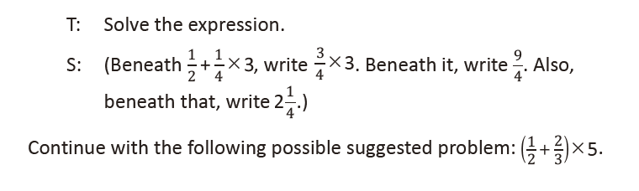

Lesson 14
Fluency Practice (12 minutes)
⬛⬛ Convert Measures 4.8A, 4.8B (4 minutes)
⬛⬛ Multiply a Fraction and a Whole Number 5.3I (4 minutes)
⬛⬛ Write the Expression to Match the Diagram 5.3I, 5.4F (4 minutes)

Convert Measures (4 minutes)
Materials: (S) Personal white board, Grade 5 Mathematics Reference Sheet (Lesson 10 Reference Sheet)
Note: This fluency activity reviews previous lessons. Allow students to use the conversion reference sheet if they are confused, but encourage them to answer questions without referring to it.
T: (Write 1 ft = __ in.) How many inches are in 1 foot?
S: 12 inches.
T: (Write 1 ft = 12 in. Below it, write 2 ft = __ in.) 2 feet?
S: 24 inches.
T: (Write 2 ft = 24 in. Below it, write 4 ft = __ in.) 4 feet?
S: 48 inches.
T: Write the multiplication equation you used to solve it.
S: (Write 4 ft X 12 = 48 in.)
Continue with the following possible sequence: 1 pint = 2 cups, 2 pints = 4 cups, 7 pints = 14 cups,
1 yard = 3 ft, 2 yards = 6 ft, 6 yards = 18 ft, 1 gal = 4 qt, 2 gal = 8 qt, and 9 gal = 36 qt.
T: (Write 2 c = __ pt.) How many pints are in 2 cups?
S: 1 pint.
T: (Write 2 c = 1 pt. Below it, write 4 c = __ pt.) 4 cups?
S: 2 pints.
T: (Write 4 c = 2 pt. Below it, write 10 c = __ pt.)
10 cups?
S: 5 pints.
T: Write the division equation you used to solve it.
S: (Write 10 c ÷ 2 = 5 pt.)
Continue with the following possible sequence: 12 in = 1 ft,
36 in = 3 ft, 3 ft = 1 yd, 12 ft = 4 yd, 4 qt = 1 gal, and 28 qt = 7 gal.

Multiply a Fraction and a Whole Number (4 minutes)
Materials: (S) Personal white board
Note: This fluency activity reviews lessons in Topic B.
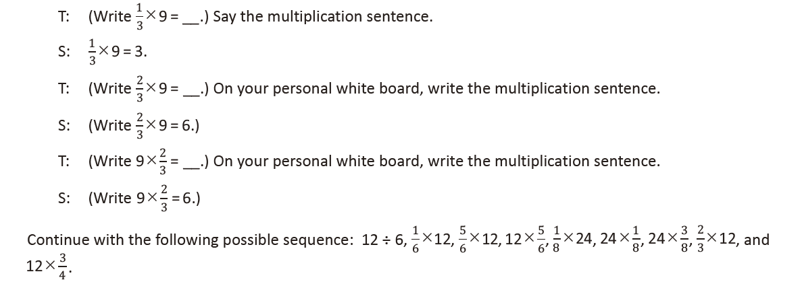

Write the Expression to Match the Diagram (4 minutes)
Materials: (S) Personal white board
Note: This fluency activity reviews previous lessons.
T: (Project a strip diagram partitioned into 3 equal units with 15 as the
whole and 2 units shaded.) Say the value of the whole.
S: 15.
T: On your personal white board, write an expression to match the diagram using a fraction.
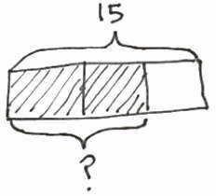
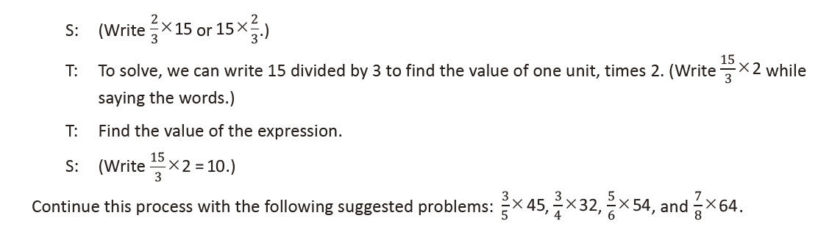

Lesson 15
Fluency Practice (8 minutes)
⬛⬛ Multiply Decimals 5.3E (4 minutes)
⬛⬛ Convert Measures 4.8A, 4.8B (4 minutes)

Multiply Decimals (4 minutes)
Materials: (S) Personal white board
Note: This fluency activity reviews the
multiplication of decimals.
T: (Write 4 × 2 = ____.) Say the number
sentence with the answer.
S: 4 × 2 = 8.
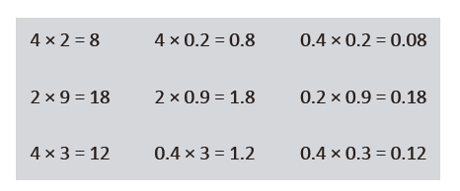
T: (Write 4 × 0.2 = ____.) On your personal white board, write the number sentence and the answer.
S: (Write 4 × 0.2 = 0.8.)
T: (Write 0.4 × 0.2 = ____.) Try this problem.
S: (Write 0.4 × 0.2 = 0.08.)
Continue this process with the following possible sequence: 2 × 9, 2 × 0.9, 0.2 × 0.9, 4 × 3, 0.4 × 3, and
0.4 × 0.3.

Convert Measures (4 minutes)
Materials: (S) Personal white board, Grade 5 Mathematics Reference Sheet (Lesson 10 Reference Sheet)
Note: This fluency activity prepares students for this lesson. Allow students to use the conversion reference sheet if they are confused, but encourage them to answer questions without looking at it.
T: (Write 1 yd = ____ ft.) How many feet are equal to 1 yard?
S: 3 feet.
T: (Write 1 yd = 3 ft. Below it, write 10 yd = ____ ft.) 10 yards?
S: 30 feet.
Continue with the following possible sequence: 1 pint = 2 cups, 8 pints = 16 cups, 1 ft = 12 in, 4 ft = 48 in,
1 gal = 4 qt, and 8 gal = 32 qt.
T: (Write 2 c = ____ pt.) How many pints are equal to 2 cups?
S: 1 pint.
T: (Write 2 c = 1 pt. Below it, write 16 c = ____ pt.) 16 cups?
S: 8 pints.
Continue with the following possible sequence: 12 in = 1 ft, 48 in = 4 ft, 3 ft = 1 yd, 24 ft = 8 yd, 4 qt = 1 gal, and 24 qt = 6 gal.

Lesson 16
Fluency Practice (12 minutes)
⬛ Count by Fractions 4.3E (3 minutes)
⬛ Convert Measures 4.8A, 4.8B (3 minutes)
⬛ Multiply Decimals 5.3E (3 minutes)
⬛ Find the Unit Conversion 5.7 (3 minutes)

Count by Fractions (3 minutes)
Note: This fluency activity
allows students to practice naming equivalent fractions.
T: Count by ones to 10.
(Write as students
count.)
S: 1, 2, 3, 4, 5, 6, 7, 8, 9,
10.
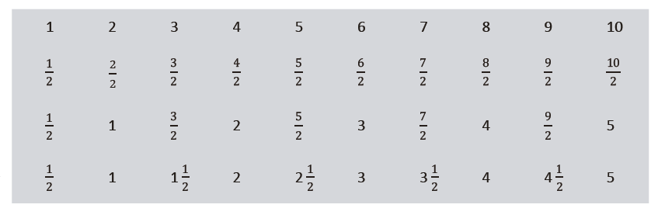
T: Count by halves to 10 halves. (Write as students count.)
S: 1 half, 2 halves, 3 halves, 4 halves, 5 halves, 6 halves, 7 halves, 8 halves, 9 halves, 10 halves.
T: Let’s count by halves again. This time, when we arrive at a whole number, say the whole number.
(Write as students count.)
S: 1 half, 1 whole, 3 halves, 2 wholes, 5 halves, 3 wholes, 7 halves, 4 wholes, 9 halves, 5 wholes.
T: Let’s count by halves again. This time, change improper fractions to mixed numbers. (Write as
students count.)
S: 1 half, 1, 1 and 1 half, 2, 2 and 1 half, 3, 3 and 1 half, 4, 4 and 1 half, 5.

Convert Measures (3 minutes)
Materials: (S) Personal white board, Grade 5 Mathematics Reference Sheet (Lesson 10 Reference Sheet)
Note: This fluency exercise reviews customary conversions, and prepares students for today’s lesson. Allow students to use the conversion reference sheet if they are confused, but encourage them to answer questions without referring to it.
T: (Write 1 ft = ____ in.) How many inches are equal to 1 foot?
S: 12 inches.
T: (Write 1 ft = 12 in. Below it, write 2 ft = ____ in.) 2 feet?
S: 24 inches.
T: (Write 2 ft = 24 in. Below it, write 4 ft = ____ in.) 4 feet?
S: 48 inches.
Continue with the following possible sequence: 1 pint = 2 cups, 7 pints = 14 cups, 1 yard = 3 feet,
6 yards = 18 feet, 1 gallon = 4 quarts, and 9 gallons = 36 quarts.
T: (Write 2 c = ____ pt.) How many pints are equal to 2 cups?
S: 1 pint.
T: (Write 2 c = 1 pt. Below it, write 4 c = ____ pt.) 4 cups?
S: 2 pints.
T: (Write 4 c = 2 pt. Below it, write 10 c = ____ pt.) 10 cups?
S: 5 pints.
Continue with the following possible sequence: 12 in = 1 ft, 36 in = 3 ft, 3 ft = 1 yd, 12 ft = 4 yd, 4 qt = 1 gal, and 28 qt = 7 gal.

Multiply Decimals (3 minutes)
Materials: (S) Personal white board
Note: This fluency activity reviews the multiplication
of decimals.
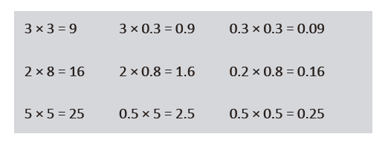
T: (Write 3 X 3 = ____.) Say the multiplication sentence with the answer.
S: 3 X 3 = 9.
T: (Write 3 X 0.3 = ____.) On your personal white board, write the number sentence and the answer.
S: (Write 3 X 0.3 = 0.9.)
T: (Write 0.3 X 0.3 = ____.) Solve this problem.

Find the Unit Conversion (3 minutes)
Materials: (S) Personal white board
Note: This fluency exercise reviews previous lessons.
T: How many feet are in 1 yard?
S: 3 feet.
T: (Write 3 ft = 1 yd. Below it, write 1 ft = ____ yd.)
What fraction of 1 yard is 1 foot?
S: 1 third.
T: On your personal white board, draw a strip diagram to explain your thinking.
Continue with the following possible sequence: 2 ft = ____ yd, 5 in = ____ ft, 1 in = ____ ft, 1 oz = ____ lb, 9 oz = ____ lb, 1 pt = ____ qt, 3 pt = ____ qt, 4 days = ____ week, and 18 hours = ____ day.
S: (Write 0.3 X 0.3 = 0.09.)

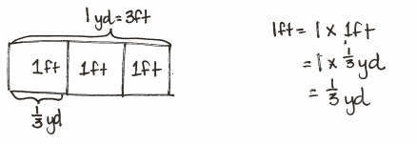
Continue this process with the following possible sequence: 2 X 8, 2 X 0.8, 0.2 X 0.8; 5 X 5, 0.5 X 5, and 0.5 X 0.5.

Lesson 17
Fluency Practice (12 minutes)
⬛⬛ Write Fractions as Decimals 5.2A (7 minutes)
⬛⬛ Find the Unit Conversion 5.7 (5 minutes)

Write Fractions as Decimals (7 minutes)
Materials: (S) Personal white board
Note: This fluency activity reviews converting fractions to decimals.
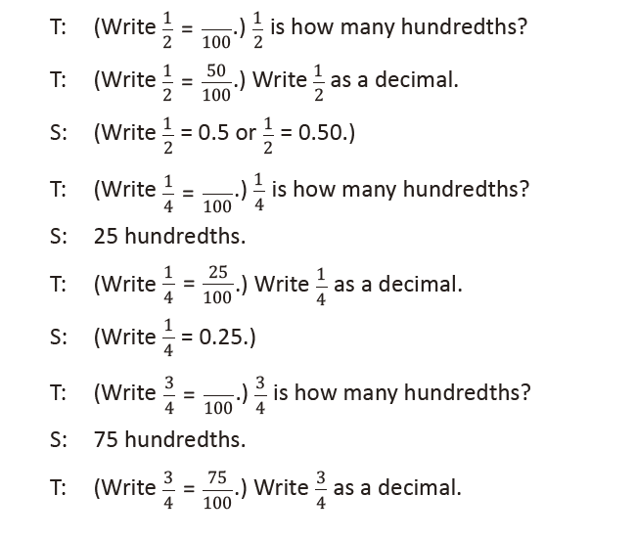
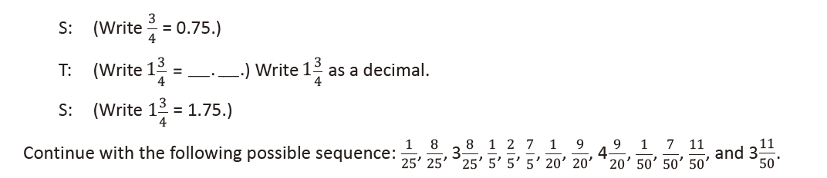
Find the Unit Conversion (5 minutes)
Materials: (S) Personal white board
Note: This fluency activity reviews Lesson 16.

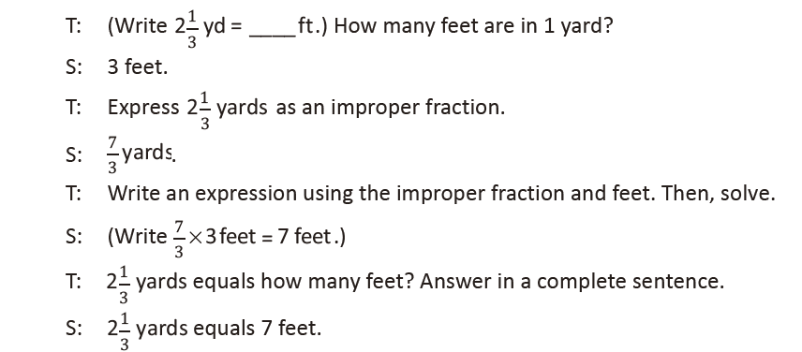
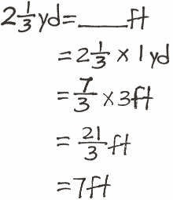

Lesson 18
Fluency Practice (12 minutes)
⬛⬛ Count by Fractions 4.3E (5 minutes)
⬛⬛ Divide Whole Numbers by Fractions 5.3J, 5.3L (4 minutes)
⬛⬛ Multiply Fractions by Whole Numbers 5.3I, 5.4H (3 minutes)
Count by Fractions (5 minutes)
Note: This fluency activity allows students to practice naming equivalent fractions.
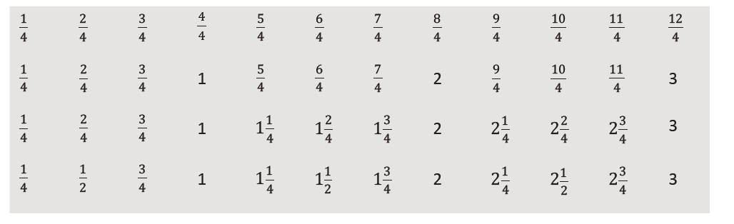
T: Count by fourths to 12 fourths. (Write as students count.)
S: 1 fourth, 2 fourths, 3 fourths, 4 fourths, 5 fourths, 6 fourths, 7 fourths, 8 fourths, 9 fourths,
10 fourths, 11 fourths, 12 fourths.
T: Let’s count by fourths again. This time, when we arrive at a whole number, say the whole number.
(Write as students count.)
S: 1 fourth, 2 fourths, 3 fourths, 1 whole, 5 fourths, 6 fourths, 7 fourths, 2 wholes, 9 fourths, 10 fourths,
11 fourths, 3 wholes.
T: Let’s count by fourths again. This time, change improper fractions to mixed numbers.
S: 1 fourth, 2 fourths, 3 fourths, 1 whole, 1 and 1 fourth, 1 and 2 fourths, 1 and 3 fourths, 2 wholes,
2 and 1 fourth, 2 and 2 fourths, 2 and 3 fourths, 3 wholes.
T: Let’s count by fourths again. This time, simplify 2 fourths to 1 half. (Write as students count.)
S: 1 fourth, 1 half, 3 fourths, 1 whole, 1 and 1 fourth, 1 and 1 half, 1 and 3 fourths, 2 wholes, 2 and
1 fourth, 2 and 1 half, 2 and 3 fourths, 3 wholes.
Continue the process, counting by fifths to 15 fifths.

Divide Whole Numbers by Fractions (4 minutes)
Materials: (S) Personal white board
Note: This fluency activity reviews Lesson 17.
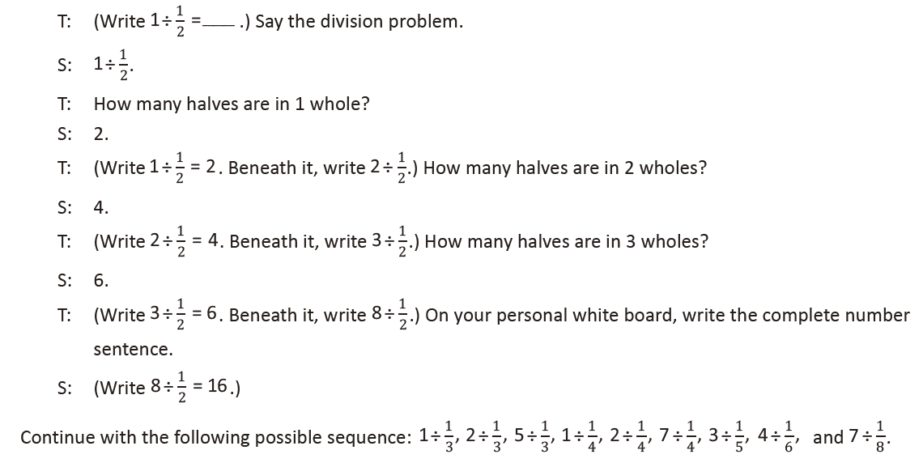
Multiply Fractions by Whole Numbers (3 minutes)
Materials: (S) Personal white board
Note: This fluency activity reviews the multiplication of fractions.
T: (Write Å~10 = ____
1/2 .) Say the multiplication sentence with the answer.
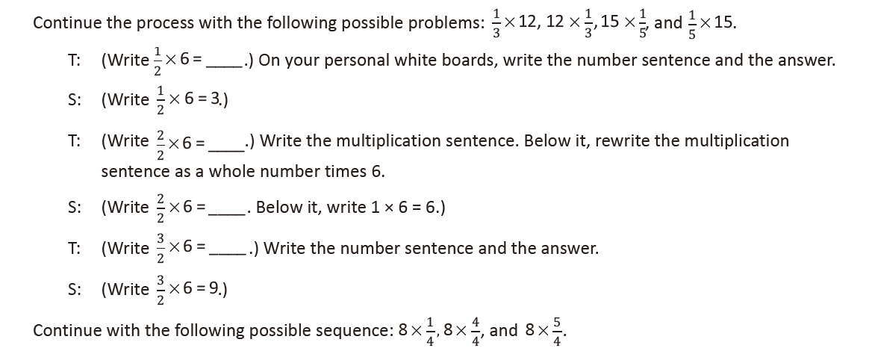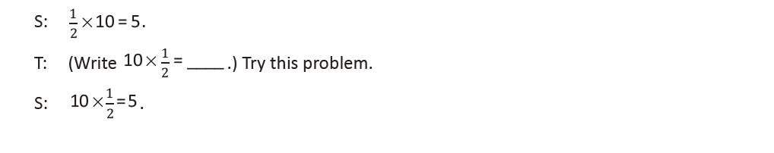

Lesson 19
Fluency Practice (12 minutes)
⬛⬛ Count by Fractions 4.3E (6 minutes)
⬛⬛ Divide Whole Numbers by Unit Fractions 5.3J, 5.3L (3 minutes)
⬛⬛ Divide Unit Fractions by Whole Numbers 5.3J, 5.3L (3 minutes)

Count by Fractions (6 minutes)
Note: This fluency activity allows students to practice naming equivalent fractions.
T: Count by sixths to 12 sixths. (Write as students count.)
S: 1 sixth, 2 sixths, 3 sixths, 4 sixths, 5 sixths, 6 sixths, 7 sixths, 8 sixths, 9 sixths, 10 sixths, 11 sixths,
12 sixths.
T: Let’s count by sixths again. This time, when we arrive at a whole number, say the whole number.
(Write as students count.)
S: 1 sixth, 2 sixths, 3 sixths, 4 sixths, 5 sixths, 1 whole, 7 sixths, 8 sixths, 9 sixths, 10 sixths, 11 sixths,
2 wholes.
T: Let’s count by sixths again. This time, change improper fractions to mixed numbers. (Write as
students count.)
S: 1 sixth, 2 sixths, 3 sixths, 4 sixths, 5 sixths, 1 whole, 1 and 1 sixth, 1 and 2 sixths, 1 and 3 sixths, 1 and
4 sixths, 1 and 5 sixths, 2 wholes.
T: Let’s count by sixths again. This time, simplify 3 sixths to 1 half. (Write as students count.)
S: 1 sixth, 2 sixths, 1 half, 4 sixths, 5 sixths, 1 whole, 1 and 1 sixth, 1 and 2 sixths, 1 and 1 half, 1 and
4 sixths, 1 and 5 sixths, 2 wholes.
T: Let’s count by sixths again. This time, simplify 2 sixths to 1 third and 4 sixths to 2 thirds. (Write as
students count.)
S: 1 sixth, 1 third, 1 half, 2 thirds, 5 sixths, 1 whole, 1 and 1 sixth, 1 and 1 third, 1 and 1 half, 1 and
2 thirds, 1 and 5 sixths, 2 wholes.
Continue the process counting by eighths to 8 eighths or, if time allows, 16 eighths.

Divide Whole Numbers by Unit Fractions (3 minutes)
Materials: (S) Personal white board
Note: This fluency activity reviews Lesson 17.
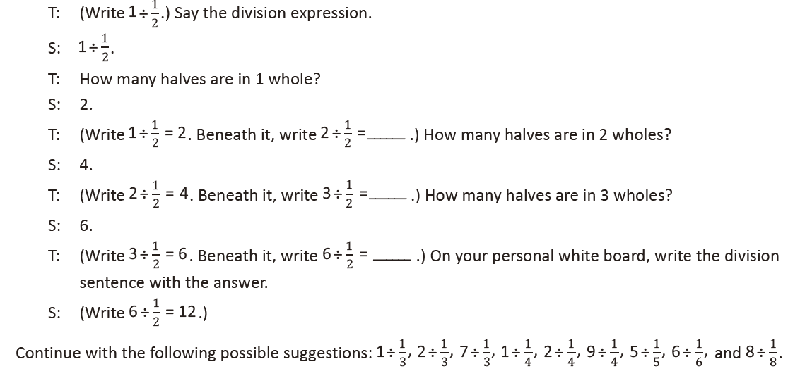
Divide Unit Fractions by Whole Numbers (3 minutes)
Materials: (S) Personal white board
Note: This fluency activity reviews Lesson 18.
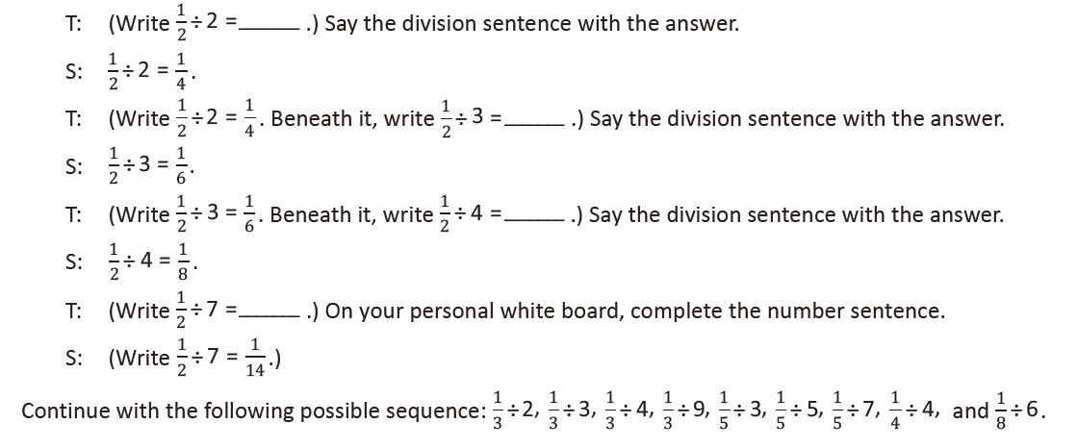
Lesson 20
Fluency Practice (10 minutes)
⬛⬛ Count by Fractions 4.3E (5 minutes)
⬛⬛ Divide Whole Numbers by Unit Fractions and Unit Fractions by Whole Numbers 5.3J, 5.3L (5 minutes)

Count by Fractions (5 minutes)
Materials: (S) Personal white board
Note: This fluency activity allows students to practice naming equivalent fractions.
T: Count by tenths to 20 tenths. (Write as students count.)
S: 1 tenth, 2 tenths, … , 20 tenths.
T: Let’s count by tenths again. This time, when we arrive at a whole number, say the whole number.
(Write as students count.)
S: 1 tenth, 2 tenths, … , 1, 11 tenths, 12 tenths, … , 2.
T: Let’s count by tenths again. This time, say the tenths as you would write them in decimal form. (Write
as students count.)
S: Zero point 1, zero point 2, … .
T: How many tenths are in 1 whole?
S: 10 tenths.
T: (Write 1 = 10 tenths. Beneath it, write 2 = ____ tenths.) How many tenths are in 2 wholes?
S: 20 tenths.
T: 3 wholes?
S: 30 tenths.
T: (Write 9 = ____ tenths.) On your personal white board, fill in the unknown number.
S: (Write 9 = 90 tenths.)
T: (Write 10 = ____ tenths.) Fill in the unknown number.
S: (Write 10 = 100 tenths.)

Divide Whole Numbers by Unit Fractions and Unit Fractions by Whole Numbers (5 minutes)
Materials: (S) Personal white board
Note: This fluency activity reviews Lessons 17–18 and prepares students for today’s lesson.
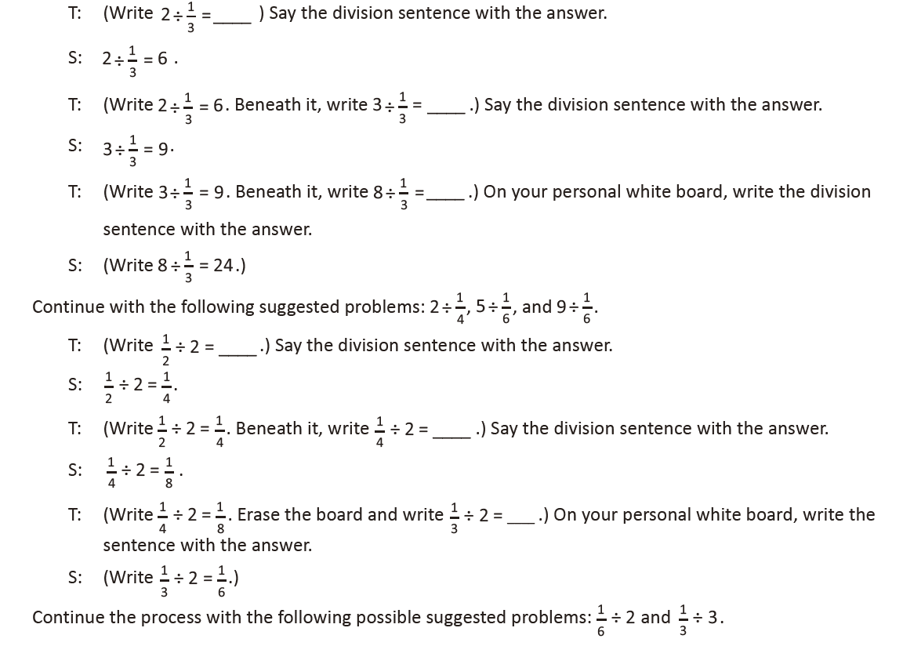

Lesson 21
Fluency Practice (12 minutes)
⬛⬛ Fraction of a Set 5.3I, 5.3J (4 minutes)
⬛⬛ Find the Product 5.3E (4 minutes)
⬛⬛ Round Decimals 5.2C (4 minutes)

Fraction of a Set (4 minutes)
Materials: (S) Personal white board
Note: This fluency activity reviews fraction of a set.
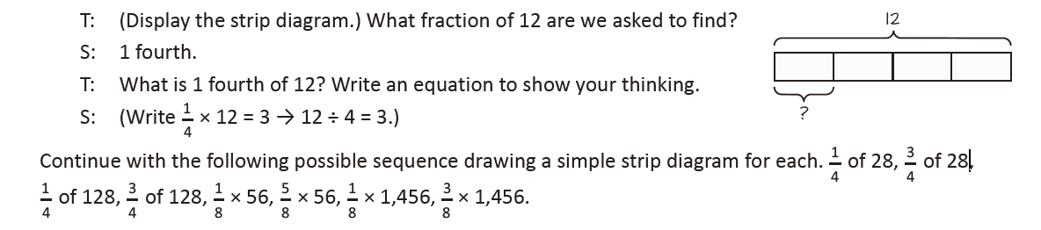
Find the Product (4 minutes)
Materials: (S) Personal white board
Note: This fluency activity reviews multiplication of decimal numbers.
T: (Write 2 X 3 tenths = ____.) Write the multiplication sentence.
S: 2 X 0.3 = 0.6.
T: Say the multiplication sentence in unit form.
S: 2 X 3 tenths = 6 tenths.
Repeat the process for 2 X 0.03, 7 X 3, 7 X 0.3, 7 X 0.03, 8 X 7, 8 X 0.7, 8 X 0.07, and 80 X 0.07.

Round Decimals (4 minutes)
Materials: (S) Personal white board
Note: This fluency activity reviews content taught in previous lessons.
T: (Project 7.465.) Say the number.
S: 7 and 465 thousandths.
T: On your personal white boards, round the number to the nearest one.
S: (Write 7.)
T: Round the number to the nearest tenth.
S: (Write 7.465 ≈ 7.5.)
T: Round the number to the nearest hundredth.
S: (Write 7.465 ≈ 7.47.)
Repeat the process, rounding 38.524 to the nearest one, tenth, and hundredth.

Lesson 22
Fluency Practice (12 minutes)
⬛⬛ Add and Subtract Decimals 5.3K (4 minutes)
⬛⬛ Multiply a Decimal Fraction and a Whole Number 5.3D (4 minutes)
⬛⬛ Round Decimal Numbers 5.2C (4 minutes)

Add and Subtract Decimal Numbers (4 minutes)
Materials: (S) Personal white board
Note: This fluency activity prepares students for today’s lesson.
T: (Project 10.53 – 3.48.) Solve on your white board.
T: What is the difference of 10.53 and 3.48?
S: 7.05.
T: (Project 320.45 + 789.76.) Solve on your white board.
T: What is the sum of 320.45 and 789.76?
S: 1,110.21.
Repeat the process with 43.4 – 7.59 and 89.79 + 541.34.

Multiply a Decimal Fraction and a Whole Number (4 minutes)
Materials: (S) Personal white board
Note: This fluency activity prepares students for this lesson. Keep each equation visible in order to encourage students to use place value patterns to find the products.
T: (Project 0.4 X 32.) Find the product on your white board. What is 4 tenths of 32?
S: 12.8.
T: Explain why your product is reasonable. Talk to your partner.
S: 1 tenth of 32 is 3.2, and 12.8 is four copies of that. → 4 tenths is a little less than 5 tenths, which is
the same as 1 half ½ of 32 is 16, and 12.8 is a little less than 16.
T: (Project 0.04 X 32.) Find the product on your white board. What is 4 hundredths of 32?
S: 1.28.
T: Explain why your product is reasonable.
S: I know that 0.04 is 1/10 of 0.4. So the product of 0.04 and 32 is 1/10
as much as the product of 0.4 X 32.
Continue with the following possible sequence: 0.04 X 320; 0.04 X 32,000; 0.4 X 320,000.

Round Decimal Numbers (4 minutes)
Materials: (S) Personal white board
Note: This fluency activity reviews students’ understanding of rounding decimals to different place values.
T: (Project 0.625.) Say the number.
S: 625 thousandths.
T: On your personal white board, round the number to the nearest tenth.
S: (Write 0.625 ≈ 0.6.)
T: On your personal white boards, round the number to the nearest hundredth.
S: (Write 0.625 ≈ 0.63.)
Continue with the following possible sequence, rounding each number to the nearest tenth and hundredth: 0.763, 2.598, 31.496.

Lesson 23
Fluency Practice (14 minutes)
⬛⬛ Multiply a Decimal Fraction Times a Whole Number 5.3D (4 minutes)
⬛⬛ Round Decimal Numbers 5.2C (4 minutes)
⬛⬛ Multiply then Divide by the Same Number 5.3E, 5.3G (6 minutes)

Multiply a Decimal Fraction Times a Whole Number (4 minutes)
Materials: (S) Personal white board
Note: This fluency activity prepares students for this lesson.
T: (Project 0.2 X 100.) Find the product. What is 2 tenths X 100?
S: 20.
T: (Project 0.2 X 1,000.) Find the product. What is 2 tenths X 1,000?
S: 200.
T: Did anyone find that product without actually calculating?
S: Because 2 tenths X 100 = 20, and 1,000 is 10 X 100, this product is 10 times 20.
Continue with the following possible sequence: 0.02 X 10,000; 0.02 X 100; and 0.02 X 1,000.

Round Decimal Numbers (4 minutes)
Materials: (S) Personal white board
Note: This fluency helps solidify student understanding of rounding decimals to different place values.
T: (Project 1.425.) Say the number.
S: 1 and 425 thousandths.
T: On your personal white boards, round the number to the nearest tenth.
S: (Write 1.425 ≈ 1.4.)
T: On your personal white boards, round the number to the nearest hundredth.
S: (Write 1.425 ≈ 1.43.)
Continue with the following possible sequence, rounding each number to the nearest tenth and hundredth:
3.707, 21.781, 46.073.

Multiply then Divide by the Same Number (6 minutes)
Materials: (S) Personal white board
Note: This fluency activity reviews concepts explored in previous lessons.
T: 3 X 2 is …?
S: 6.
T: 3 × 2 × 10 ÷ 10 is …?
S: 6.
T: 5 X 0.3 is …?
S: 1.5.
T: 5 × 0.3 × 10 ÷ 10 is …?
S: 1.5.
T: (Continue the sequence with 3 X 2.5 and 2 X 3.4.)
T: Why are the products the same when we multiply by 10 and then divide by 10?
S: We multiplied by 10, and then undid what we did by dividing by 10. → We’re moving the digits of the
first product over one place to the left on the place value chart and then back to the right again. →
Because it’s just like multiplying by 1.

Lesson 24
Fluency Practice (12 minutes)
⬛⬛ Add and Subtract Decimal Fractions 5.3K (4 minutes)
⬛⬛ Multiply a Decimal Fraction and a Whole Number 5.3D (4 minutes)
⬛⬛ Round Decimal Numbers 5.2C (4 minutes)
Add and Subtract Decimal Fractions (4 minutes)
Materials: (S) Personal white board
Note: This fluency will prepare students for today’s lesson.
T: (Project 50,320.45 + 9,857.76.) Solve on your white board.
T: What is the sum of 50,320.45 and 9,857.76?
S: 60,178.21.
T: (Project 20,000 – 2,103.48.) Solve on your white board.
T: What is the difference between 20,000 and 2,103.48?
S: 17,896.52.
Repeat with 40,000 – 19,893.4 and 25,498 + 788.3.

Multiply a Decimal Fraction and a Whole Number (4 minutes)
Materials: (S) Personal white board
Note: This fluency activity prepares students for this lesson.
T: (Project 0.4 X 26.) Find the product on your white board. What is 0.4 X 26?
S: 10.4.
T: (Project 0.04 X 26.) What is 0.04 X 26?
S: 1.04.
Continue with the following possible sequence: 0.04 X 260; 0.04 X 26,000; 0.4 X 260,000.

Round Decimal Numbers (4 minutes)
Materials: (S) Personal white board
Note: This review fluency helps solidify student understanding of rounding decimals to different place values.
T: (Project 0.555.) Say the number.
S: 555 thousandths.
T: On your personal white boards, round the number to the nearest tenth.
S: (Write 0.555 ≈ 0.6.)
T: On your personal white boards, round the number to the nearest hundredth.
S: (Write 0.555 ≈ 0.56.)
Continue with the following possible sequence, rounding each number to the nearest tenth and hundredth: 1.393, 20.498, 361.535.

Lesson 25
Fluency Practice (12 minutes)
⬛⬛ Order of Operations 5.4F (3 minutes)
⬛⬛ Divide by 1 Tenth and 1 Hundredth 5.3J (3 minutes)
⬛⬛ Divide Unit Fractions by Whole Numbers 5.3J (6 minutes)

Order of Operations (3 minutes)
Materials: (S) Personal white board
Note: This fluency activity prepares students for today’s lesson.
T: (Write 12 ÷ 3 + 1 = ____.) On your personal white board, write
the complete number sentence.
S: (Write 12 ÷ 3 + 1 = 5.)
T: (Write 12 ÷ (3 + 1) = ____.) Copy the expression on your
personal white board.
S: (Write 12 ÷ (3 + 1) = ____.)
T: Write the complete number sentence, performing the operation inside the parentheses.
S: (Beneath 12 ÷ (3 + 1) = ____, write 12 ÷ 4 = 3.)
Continue with the following possible sequence: 20 – 4 ÷ 2, (20 – 4) ÷ 2, 25 – 5 ÷ 2 × 3, [(25 – 5) ÷ 2] × 3.
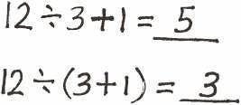

Divide by 1 Tenth and 1 Hundredth (3 minutes)
Materials: (S) Personal white board
Note: This fluency activity reviews division of a whole number by a fraction.
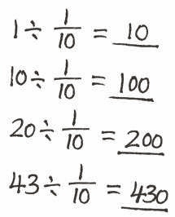
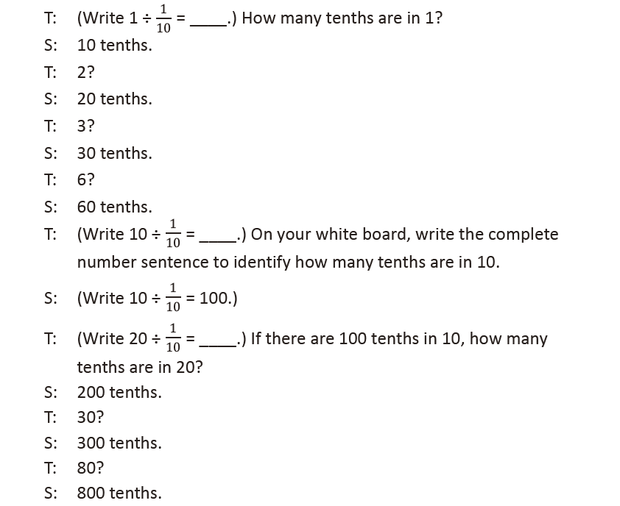
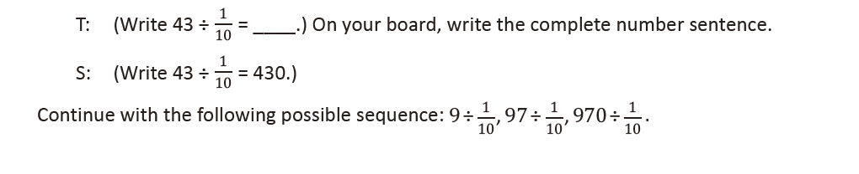
Divide Unit Fractions by Whole Numbers (6 minutes)
Materials: (S) Personal white board
Note: This fluency activity reviews dividing a fraction by a whole number, from Lesson 18.
