Grade 5 Module 5: Addition and Multiplication with Volume and Area
Topic A: Concepts of Volume
Lesson 1 | Multiply Whole Numbers Times Fractions Using Two Methods (5.3I) | Find the Area (4.5C, 4.5D)
Lesson 2 | Multiply a Fraction and a Whole Number (5.3I) | Find the Area (4.5C, 4.5D) | Find the Volume (5.6A)
Lesson 3 | Sprint: Multiply a Fraction and a Whole Number (5.3I) | Find the Volume (4.5C, 4.5D)
Topic B: Volume and the Operation of Multiplication and Addition
Lesson 4 | Multiply a Fraction and a Whole Number (5.3I) | Find the Area (4.5C, 4.5D) | Find the Volume (5.6A)
Lesson 5 | Count by Cubic Centimeters (2.6A) | Find the Area (4.5C, 4.5D) | Find the Volume (5.6A)
Lesson 6 | Multiply a Fraction and a Whole Number (5.3I) | Count by Cubic Centimeters (2.6A) | Find the Volume (5.6A)
Lesson 7 | Sprint: Multiply a Fraction and a Whole Number (5.3I) | Find the Volume (5.6A)
Lesson 8 | Multiply Whole Numbers and Decimals (5.3E) | Mixed Numbers to Improper Fractions (4.3A, 4.3B) | Multiply Mixed Numbers (5.3I)
Lesson 9 | Multiply Decimals (5.3E) | Multiply Mixed Numbers (5.3I)
Topic C: Fraction Expressions and Word Problems
Lesson 10 | Multiply Decimals (5.3E) | Change Mixed Numbers to Fractions (4.3A, 4.3B) | Multiply Mixed Numbers (5.3I)
Lesson 11 | Multiplying a Fraction and a Whole Number (5.3I) | Find the Volume (5.6B)
Lesson 12 | Multiplying a Fraction and a Whole Number (5.3I) | Find the Volume (5.6B)
Lesson 13 | Multiply a Fraction and a Whole Number (5.3I) | Find the Volume (5.6B) | Physiometry (4.6A)
Lesson 14 | Divide whole Number by Unit Fractions and Unit Fractions by Whole Numbers (5.3L) | Quadrilaterals (3.6A)
Topic D: Drawing, Analysis and Classification of Two-Dimensional Shapes
Lesson 15 | Classify the Triangle by the Angle Measure (4.6C) | Physiometry (4.6B) | Lines of Symmetry (4.6B)
Lesson 16 | Multiply a Fraction and a Whole Number (5.3I) | Find the Volume (5.6B) | Classify the Triangle (4.6C, 5.5)
Lesson 17 | Divide whole Number by Unit Fractions and Unit Fractions by Whole Numbers (5.3L) | Quadrilaterals (3.6A)
Lesson 18 | Multiply Multiples of 10 and 100 (5.2A) | Divide whole Number by Unit Fractions and Unit Fractions by Whole Numbers (5.3L)
Lesson 19 | Sprint: Divide whole Number by Unit Fractions and Unit Fractions by Whole Numbers (5.3L) | Multiply Multiples of 10 and 100 (5.2A)
Lesson 20 | Sprint: Multiply Multiples of 10 and 100 (5.2A) | Divide by Multiples of 10 and 100 (5.2A)
Lesson 21 | Divide by Multiples of 10 and 100 (5.2A) | Find the Volume (5.6B)
Lesson 22 | Sprint: Divide by Multiples of 10 and 100 (5.2A) | Prime or Composite? (5.4A)

Grade 5 Module 5
Lesson 1
Fluency Practice (10 minutes)
⬛ Multiply Whole Numbers Times Fractions Using Two Methods 5.3I (5 minutes)
⬛ Find the Area 4.5C, 4.5D (5 minutes)

Multiply Whole Numbers Times Fractions Using Two Methods (5 minutes)
Materials: (S) Personal white board
Note: This fluency activity reviews Module 4 content.
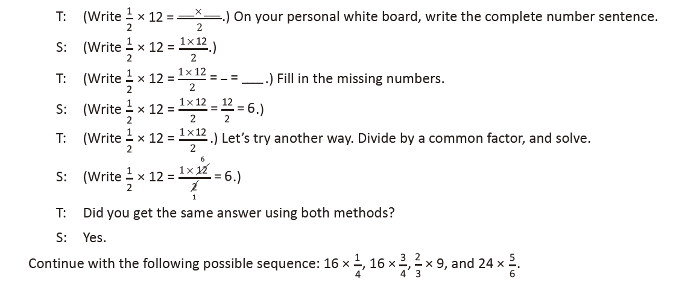
Find the Area (5 minutes)
Materials: (S) Personal white board
Note: Reviewing this Grade 4 concept prepares students to explore volume.
T: (Project a 4-inch by 2-inch rectangle.)
Name the shape.
S: Rectangle. → Parallelogram.
Quadrilateral.
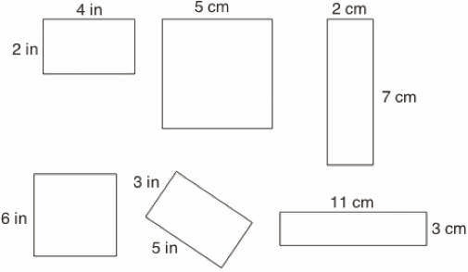
T: (Write __ in X __ in = __ in2.) This shape is
a rectangle, though we could also call it a
quadrilateral or parallelogram . On your
personal white boards, write the area of
the rectangle as a multiplication sentence
starting with the length of the longest side.
S: (Write 4 in X 2 in = 8 in2.)
T: (Project a square with side lengths of 5 cm.) Name the shape.
S: Square. → Rhombus. → Quadrilateral. → Parallelogram.
T: This shape is a square, but it is also correct to call it a rhombus, quadrilateral , or parallelogram .
What is the measure of one of the square’s sides?
S: 5 centimeters.
T: (Write __ cm X __ cm = __ cm2.) On your boards, write the area of the square as a multiplication
sentence using the measure of the square’s sides.
S: (Write 5 cm X 5 cm = 25 cm2.)
Continue this process for the other squares and rectangles.

Lesson 2
Fluency Practice (12 minutes)
⬛ Multiply a Fraction and a Whole Number 5.3I (4 minutes)
⬛ Find the Area 4.5C, 4.5D (4 minutes)
⬛ Find the Volume 5.6A (4 minutes)

Multiply a Fraction and a Whole Number (4 minutes)
Materials: (S) Personal white board
Note: This fluency activity reviews Module 4 Lessons 8–10.
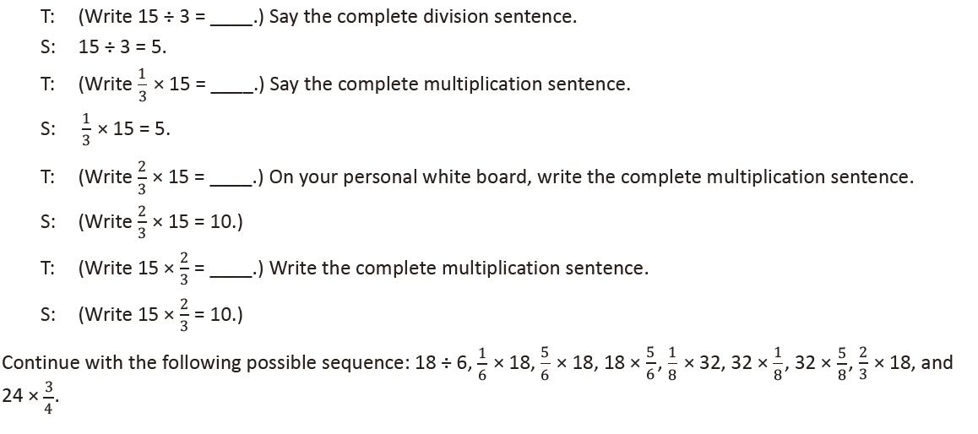
Find the Area (4 minutes)
Materials: (S) Personal white board
Note: Reviewing this Grade 4 concept prepares
students to calculate volume.
T: (Project an 8 ft by 2 ft rectangle.)
Name the shape.
S: Rectangle. → Parallelogram.
→ Quadrilateral.
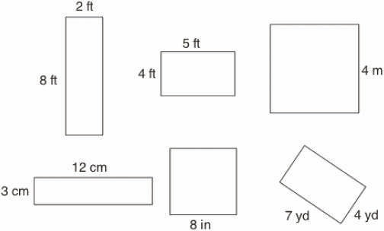

T: (Write ____ ft X ____ ft = ____ ft2.)
This shape is a rectangle, although we
could also call it a parallelogram
or quadrilateral . On your
personal white board, write the area of
the rectangle as a multiplication
sentence starting with the length of
the longest side.
S: (Write 8 ft X 2 ft = 16 ft2.)
T: (Project a square with side lengths 4 m.) Name the shape.
S: Square. → Rhombus. → Rectangle. → Parallelogram. → Quadrilateral.
T: (Write ____ m X ____ m = ____ m2.) On your personal white board, write the area of the square as a
multiplication sentence using the measure of the square’s sides.
S: (Write 4 m X 4 m = 16 m2.)
Continue the process for the other squares and rectangles.

Find the Volume (4 minutes)
Materials: (S) Personal white board
Note: This fluency activity reviews Lesson 1.
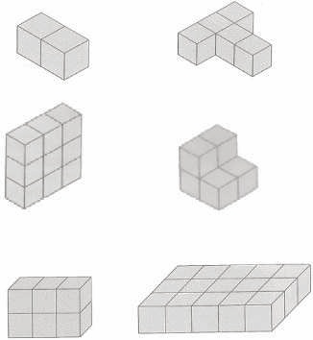
T: (Project the first of the images to the right.)
Each cube is 1 cubic centimeter.
T: (Write Volume = ____ cubic cm.) On your personal
white board, complete the equation.
S: (Write Volume = 2 cubic cm.)
Continue the process for the remaining images.

Lesson 3
Fluency Practice (12 minutes)
⬛ Sprint: Multiply a Fraction and Whole Number 5.3I (8 minutes)
⬛ Find the Volume 5.6A (4 minutes)

Sprint: Multiply a Fraction and Whole Number (8 minutes)
Materials: (S) Multiply a Fraction and Whole Number Sprint
Note: This Sprint reviews content from Module 4 Lessons 8–10.

Find the Volume (4 minutes)
Materials: (S) Personal white board
Note: This fluency activity reviews Lessons 1–2.
T: (Project Image A, pictured to the right.)
Each cube is 1 cubic centimeter. How
many cubes are there? Respond on your
personal white board.
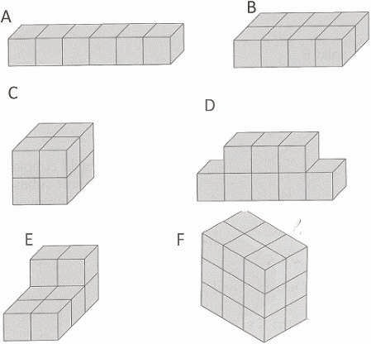
S: 6.
T: Write the volume on your personal white
board with the correct units.
S: 6 cubic centimeters.
Follow this sequence for the other images pictured
to the right.

Lesson 4
Fluency Practice (12 minutes)
⬛ Multiply a Fraction and a Whole Number 5.3I (4 minutes)
⬛ Find the Area 4.5C, 4.5D (4 minutes)
⬛ Find the Volume 5.6A (4 minutes)
Multiply a Fraction and a Whole Number (4 minutes)
Materials: (S) Personal white board
Note: This fluency exercise reviews Module 4 content.
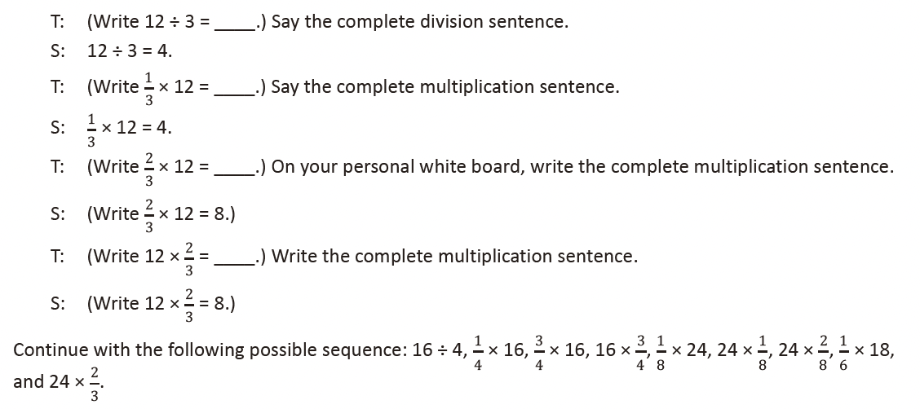

Find the Area (4 minutes)
Materials: (S) Personal white board
Note: Reviewing this Grade 4 concept prepares students to calculate volume.
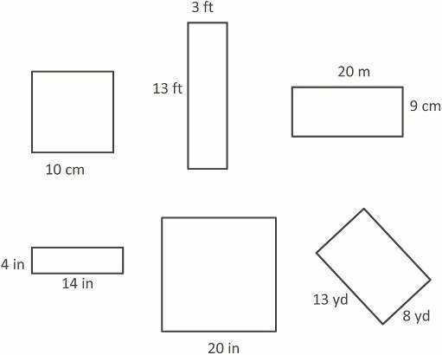
T: (Project the square with side lengths 10 cm.)
T: How long are the square’s sides?
S: 10 cm.
T: (Write ____ cm X ____ cm = ____ cm2.) On
your personal white board, write the area of
the square as a multiplication sentence,
including the units.
S: (Write 10 cm X 10 cm = 100 cm2.)
T: (Project a rectangle labeled 3 ft by 13 ft.)
T: What is the measure of the rectangle’s
longest side?
S: 13 ft.
T: What is the measure of the rectangle’s
shortest side?
S: 3 ft.
T: (Write ____ ft X ____ ft = ____ ft2.) Write the area of the rectangle as a multiplication sentence
starting with the length of the longest side.
S: (Write 13 ft X 3 ft = 39 ft2.)
Continue this process with the other rectangles and square.

Find the Volume (4 minutes)
Materials: (S) Personal white board
Note: This fluency activity reviews Lessons 1 and 2.
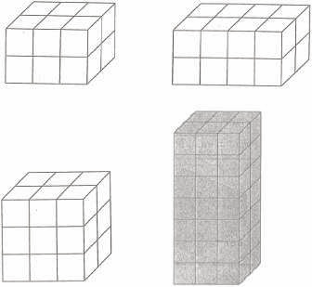
T: (Project the first image to the right. Number of horizontal
layers: 2.) Each cube is 1 cubic centimeter.
T: (Underneath, write Number of cubes in each horizontal layer:
____.) Fill in the blank.
S: (Write Number of cubes in each horizontal layer: 6.)
T: (Write Number of cubes in each horizontal layer: 6. Beneath it,
write Volume = ____ cubic centimeters + ____ cubic centimeters.)
Fill in the blanks.
S: (Write Volume = 6 cubic centimeters + 6 cubic centimeters.)
T: (Write Volume = 6 cubic centimeters + 6 cubic centimeters. Beneath it, write Volume = ____ cubic
centimeters.)
S: (Write Volume = 12 cubic centimeters.)
Continue this process for the remaining prisms.

Lesson 5
Fluency Practice (12 minutes)
⬛ Count by Cubic Centimeters 2.6A (2 minutes)
⬛ Find the Area 4.5C, 4.5D (4 minutes)
⬛ Find the Volume 5.6A (6 minutes)

Count by Cubic Centimeters (2 minutes)
Note: This fluency activity prepares students for today’s lesson.
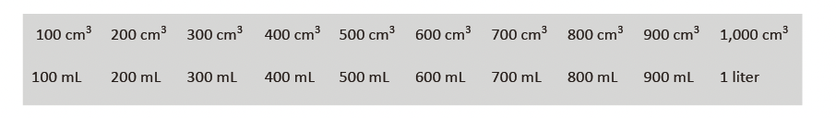

T: Count by 100 cubic centimeters to 1,000 cubic centimeters. (Write as students count.)
100 cm3 200 cm3 300 cm3 400 cm3 500 cm3 600 cm3 700 cm3 800 cm3 900 cm3 1,000 cm3
100 mL 200 mL 300 mL 400 mL 500 mL 600 mL 700 mL 800 mL 900 mL 1 liter
S: 100 cm3, 200 cm3, 300 cm3, 400 cm3, 500 cm3, 600 cm3, 700 cm3, 800 cm3, 900 cm3, 1,000 cm3.
T: Count by 100 mL. (Write as students count.)
S: 100 mL, 200 mL, 300 mL, 400 mL, 500 mL, 600 mL, 700 mL, 800 mL, 900 mL, 1,000 mL.
T: 1,000 mL = 1 liter. Count by 100 mL again. This time, when you come to 1,000 mL, say 1 liter.
(Write as students count.)
S: 100 mL, 200 mL, 300 mL, 400 mL, 500 mL, 600 mL, 700 mL, 800 mL, 900 mL, 1 liter.

Find the Area (4 minutes)
Materials: (S) Personal white board
Note: Reviewing this Grade 4 concept prepares students to calculate volume. Images not drawn to scale.
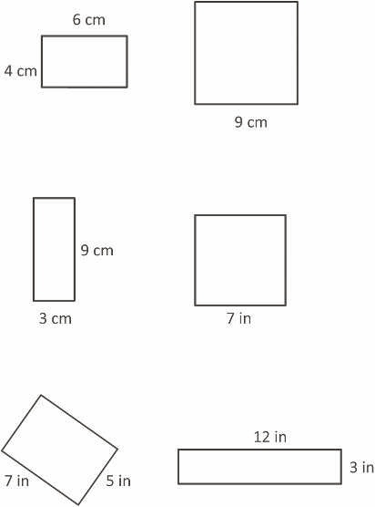
T: (Project a rectangle with side lengths of 6 cm and 4 cm.)
What is the length of the rectangle’s longest side?
S: 6 cm.
T: What is the length of the rectangle’s shortest
side?
S: 4 cm.
T: (Write __ cm X __ cm = __ cm2.) On your
personal white board, write the area of the
rectangle as a multiplication sentence
including the units.
S: (Write 6 cm X 4 cm = 24 cm2.)
T: (Project a square with a given length of 9 cm.)
Name the shape.
S: Square.
T: What is the length of the square’s sides?
S: 9 cm.
T: (Write __ cm X __ cm = __ cm2.) Write the area of the
square as a multiplication sentence including the
units.
S: (Write 9 cm X 9 cm = 81 cm2.)
Continue this process for the other rectangles and squares.

Find the Volume (6 minutes)
Materials: (S) Personal white board
Note: This fluency exercise reviews Lesson 4. Images not drawn to
scale.
T: (Project the 4 cm by 5 cm by 2 cm rectangular prism illustrated
to the right.) What’s the length of the rectangular prism?
S: 4 cm.
T: What’s the width?
S: 5 cm.
T: What’s the height?
S: 2 cm.
T: (Write __ cm X __ cm X __ cm = __
cm3.) On your personal white board,
calculate the volume.
S: (Write 4 cm X 5 cm X 2 cm = 40 cm3.)
Repeat this process for the 3 cm by 3 cm by 8 cm rectangular prism.

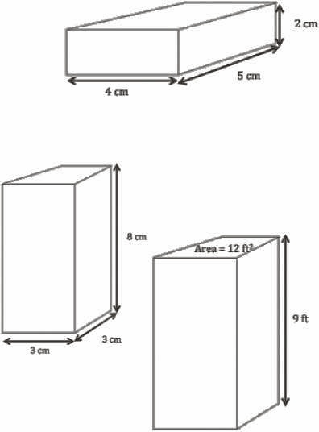
T: (Project the 4 cm by 5 cm by 2 cm rectangular prism illustrated
to the right.) What’s the length of the rectangular prism?
S: 4 cm.
T: What’s the width?
S: 5 cm.
T: What’s the height?
S: 2 cm.
T: (Write __ cm X __ cm X __ cm = __
cm3.) On your personal white board,
calculate the volume.
S: (Write 4 cm X 5 cm X 2 cm = 40 cm3.)
Repeat this process for the 3 cm by 3 cm by 8 cm rectangular prism.

T: (Project the rectangular prism to the right.) Say the given area
of the rectangular prism’s front face.
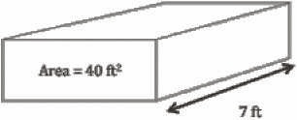
S: 40 ft2.
T: Say the given width.
S: 7 ft.
T: (Write V = __ ft3.) On your personal white board, calculate the volume.
S: (Write V = 280 ft3.)
Repeat this process for the rectangular prism with a face of 12 ft2 and a height of 9 ft.

Lesson 6
Fluency Practice (12 minutes)
⬛ Multiply a Fraction and a Whole Number 5.3I (3 minutes)
⬛ Count by Cubic Centimeters 2.6A (3 minutes)
⬛ Find the Volume 5.6B (6 minutes)

Multiply a Fraction and a Whole Number (3 minutes)
Materials: (S) Personal white board
Note: This fluency exercise reviews Module 4.
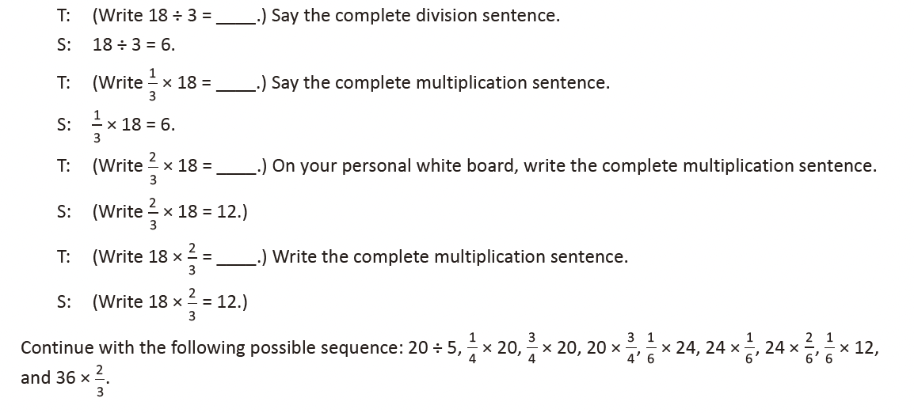
Count by Cubic Centimeters (3 minutes)
Note: This fluency activity prepares students for today’s lesson.
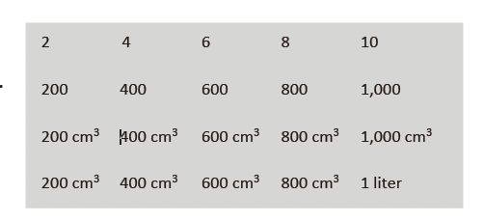
T: Count by twos to 10. (Write as students count.)
S: 2, 4, 6, 8, 10.
T: Count by two-hundreds to 1,000. (Write as students
count.)
S: 200, 400, 600, 800, 1,000.
T: Count by 200 cm3 to 1,000 cm3. (Write as students
count.)
S: 200 cm3, 400 cm3, 600 cm3, 800 cm3, 1,000 cm3.
T: Count by 200 cm3. This time, when you come to
1,000 cm3, say 1 liter. (Write as students count.)
S: 200 cm3, 400 cm3, 600 cm3, 800 cm3, 1 liter.

Find the Volume (6 minutes)
Materials: (S) Personal white board
Note: This fluency activity reviews Lesson 4. Images not drawn to scale.
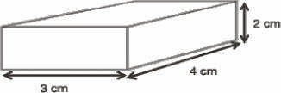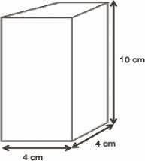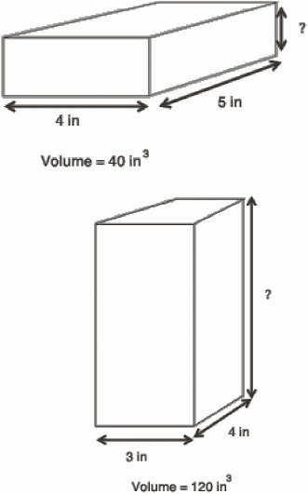
T: (Project a 3 cm by 4 cm
by 2 cm rectangular prism.)
What’s the length of the
rectangular prism?
S: 3 cm.
T: What’s the width?
S: 4 cm.
T: What’s the height?
S: 2 cm.
T: (Write __ cm × __ cm × __ cm = __ cm3.) On your
personal white board, calculate the volume.
S: (Write 3 cm × 4 cm × 2 cm = 24 cm3.)
Repeat the process for the 4 cm by 4 cm by 10 cm rectangular prism.
T: (Project the rectangular prism that has a given volume
of 40 in3, length of 4 in, and width of 5 in.) What’s the
length of the rectangular prism?
S: 4 in.
T: What’s the width of the rectangular prism?
S: 5 in.
T: What’s the volume of the rectangular prism?
S: 40 in3.
T: (Write 40 in3 = 4 in X 5 in X __ in.) On your personal white board, fill in the missing side length. If you
need to, write a division sentence to calculate your answer.
S: (Write 40 in3 = 4 in X 5 in X 2 in.)
Repeat the process for the rectangular prism with a given volume of
120 in3, length of 3 in, and width of 4 in.
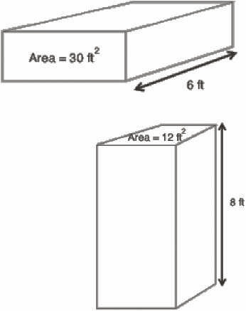
T: (Project the rectangular prism with a face having a given area
of 30 ft2 and a given width of 6 ft.) Say the given area of the
prism’s front face.
S: 30 ft2.
T: Say the given width.
S: 6 ft.
T: (Write V = __ ft3.) On your personal white board, calculate
the volume.
S: (Write V = 180 ft3.)
Repeat the process for the rectangular prism with a face having a
given area of 12 ft2 and a height of 8 ft.

Lesson 7
Fluency Practice (12 minutes)
⬛ Sprint: Multiply a Whole Number by a Fraction 5.3I (8 minutes)
⬛ Find the Volume 5.6B (4 minutes)

Sprint: Multiply a Whole Number by a Fraction (8 minutes)
Materials: (S) Multiply a Whole Number by a Fraction Sprint
Note: This fluency activity reviews Module 4.

Find the Volume (4 minutes)
Materials: (S) Personal white board
Note: This fluency exercise reviews Lesson 5.
Images not drawn to scale.
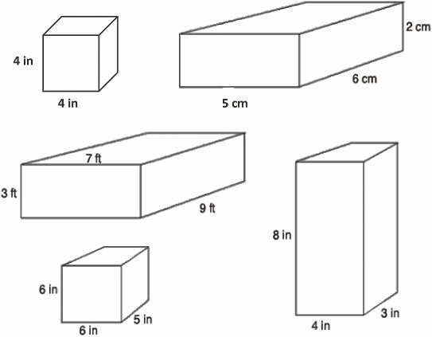
T: On your personal white board,
write the formula for finding the
volume of a rectangular prism.
S: (Write V = l X w X h.)
T: (Write V = l X w X h.) Project a
rectangular prism with a length
of 5 cm, width of 6 cm, and
height of 2 cm.
T: Write a multiplication sentence to
express the volume of the
rectangular prism.
S: (Beneath V = l X w X h, write V = 5 cm X 6 cm X 2 cm. Beneath it, write V = 60 cm3.)
Continue this process with the other rectangular prisms.
T: (Project a cube with side lengths equal to 4 inches.) Name the prism.
S: Cube.
T: Write a multiplication sentence to show the volume of the cube.
S: (Write V = 4 in X 4 in X 4 in. Beneath it, write V = 64 in3.)

Lesson 8
Fluency Practice (12 minutes)
⬛ Multiply Whole Numbers and Decimals 5.3E (4 minutes)
⬛ Mixed Numbers to Improper Fractions 4.3A, 4.3B (4 minutes)
⬛ Multiply Mixed Numbers 5.3I (4 minutes)

Multiply Whole Numbers and Decimals (4 minutes)
Materials: (S) Personal white board
Note: This fluency exercise reviews content from Module 4.
T: (Write 3 X 2 = ____.) Say the complete number sentence.
S: 3 X 2 = 6.
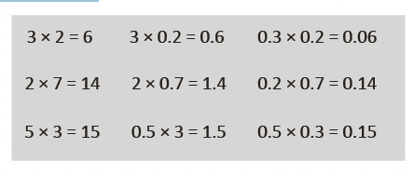
T: (Write 3 X 0.2 = ____.) On your personal white board, write the complete number sentence.
S: (Write 3 X 0.2 = 0.6.)
T: (Write 0.3 X 0.2 = ____.) Write the complete number sentence.
S: (Write 0.3 X 0.2 = 0.06.)
Continue with the following possible sequence: 2 X 7, 2 X 0.7, 0.2 X 0.7, 5 X 3, 0.5 X 3, and 0.5 X 0.3.

Mixed Numbers to Improper Fractions (4 minutes)
Materials: (S) Personal white board
Note: This fluency activity prepares students for Lesson 10.
T: How many halves are in 1?
S: 2.
T: How many halves are in 2?
S: 4.
T: How many halves are in 3?
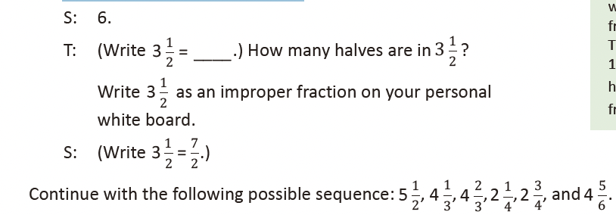
Multiply Mixed Numbers (4 minutes)
Materials: (S) Personal white board
Note: This fluency activity prepares students for Lesson 10.
Format as illustrated to the right.

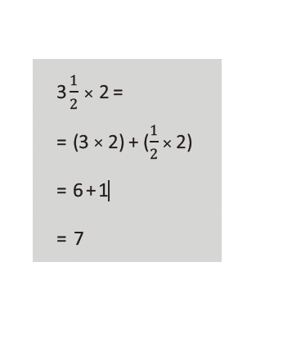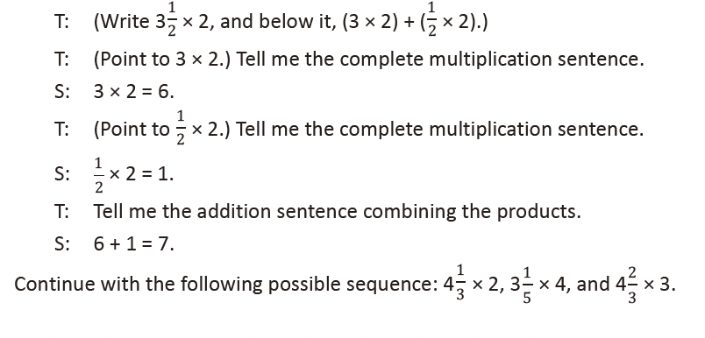
Lesson 9
Fluency Practice (7 minutes)
⬛ Multiply Decimals 5.3E (3 minutes)
⬛ Multiply Mixed Numbers 5.3I (4 minutes)

Multiply Decimals (3 minutes)
Materials: (S) Personal white board
Note: This fluency exercise reviews content from Module 4.
T: (Write 4 X 2 = ____.) Say the number sentence.
S: 4 X 2 = 8.
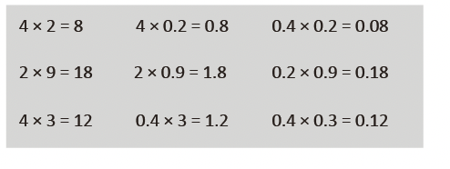
T: (Write 4 X 0.2 = ____.) On your personal white board, write the number sentence.
S: (Write 4 X 0.2 = 0.8.)
T: (Write 0.4 X 0.2 = ____.) Write the number sentence.
S: (Write 0.4 X 0.2 = 0.08.)
Continue with the following possible sequence: 2 X 9, 2 X 0.9, 0.2 X 0.9, 4 X 3, 0.4 X 3, and 0.4 X 0.3.

Multiply Mixed Numbers (4 minutes)
Materials: (S) Personal white board
Note: This fluency exercise prepares students for Lesson 10. Format writing as
illustrated to the right.

4 3 × 2

1

= (4 × 2)+ (3 × 2)

= 8 + 3

= 8 3

1

2

2

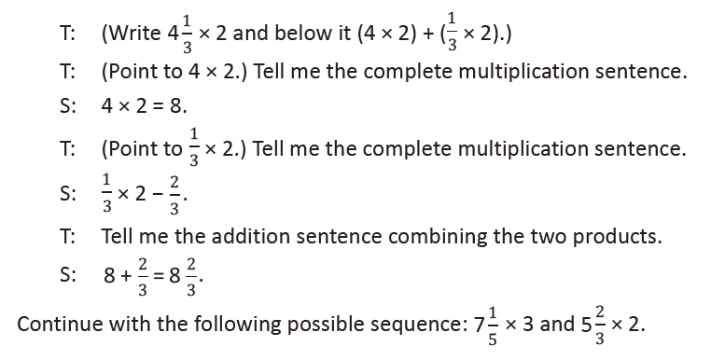
Lesson 10
Fluency Practice (12 minutes)
⬛ Multiply Decimals 5.3E (4 minutes)
⬛ Change Mixed Numbers to Fractions 4.3A, 4.3B (4 minutes)
⬛ Multiply Mixed Numbers 5.3I (4 minutes)

Multiply Decimals (4 minutes)
Materials: (S) Personal white board
Note: This fluency activity reviews content from Module 4.
T: (Write 2 X 2 = ____.) Say the multiplication sentence with the answer.
S: 2 X 2 = 4.
T: (Write 2 X 0.2 = ____.) On your
personal white board, write the
number sentence and the answer.
S: (Write 2 X 0.2 = 0.4.)
T: (Write 0.2 X 0.2 = ____.) Try this
problem.
S: (Write 0.2 X 0.2 = 0.04.)
Continue with the following possible sequence: 3 X 4, 3 X 0.4, 0.3 X 0.4, 5 X 7, 0.5 X 7, and 0.5 X 0.7.
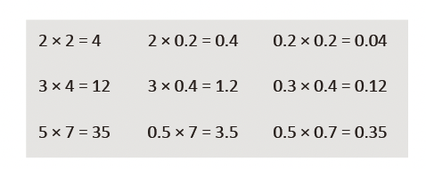
Change Mixed Numbers to Fractions (4 minutes)
Materials: (S) Personal white board
Note: This fluency activity prepares students for today’s lesson.
T: How many fourths are in 1?
S: 4.
T: How many fourths are in 2?
S: 8.
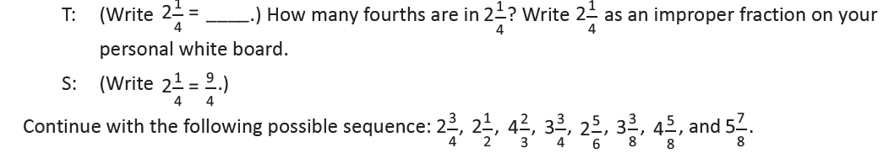
Multiply Mixed Numbers (4 minutes)
Materials: (S) Personal white board
Note: This fluency activity prepares students for today’s lesson.
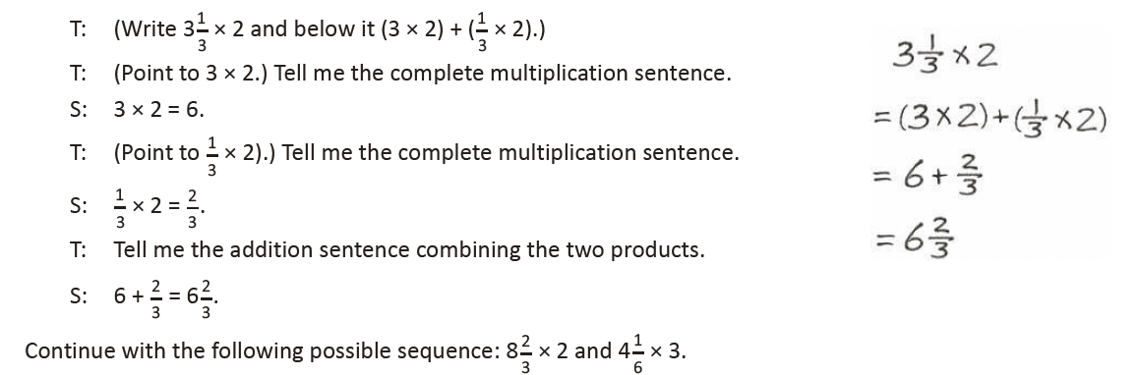

Lesson 11
Fluency Practice (10 minutes)
⬛ Multiplying a Fraction and a Whole Number 5.3I (4 minutes)
⬛ Find the Volume 5.6B (6 minutes)

Multiplying a Fraction and a Whole Number (4 minutes)
Materials: (S) Personal white board
Note: This fluency activity prepares students for Lesson 12.
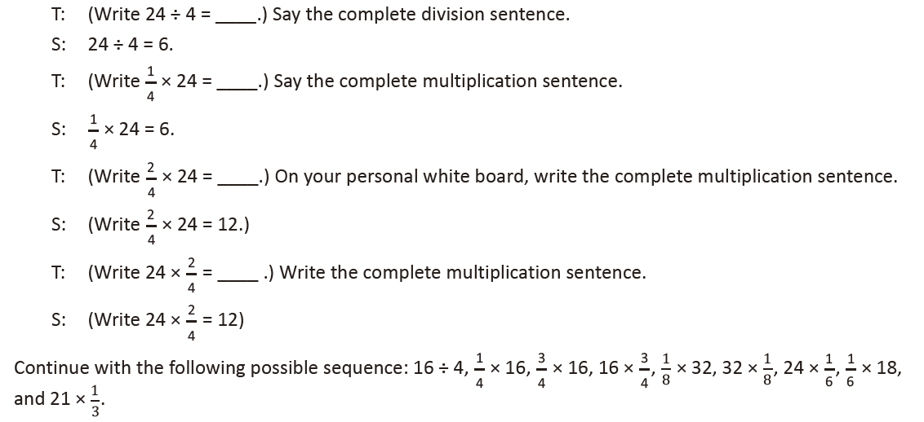

Find the Volume (6 minutes)
Materials: (S) Personal white board
Note: This fluency activity reviews volume concepts and formulas.
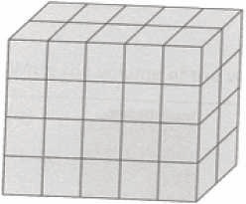
T: (Project a prism 5 units X 2 units X 4 units. Write V = ____ units X ____ units X ____ units.)
Find the volume.
S: (Write 5 units X 2 units X 4 units = 40 units3.)
T: How many layers of 10 cubes are in the prism?
S: 4 layers.
T: (Write 4 X 10 units3 = ____.) Four copies of 10 cubic units is… ?
S: 40 cubic units.
T: How many layers of 8 cubes are there?
S: 5 layers.
T: (Write 5 X 8 units3 = ____.) Five copies of 8 cubic units is… ?
S: 40 cubic units.
T: How many layers of 20 cubes are there?
S: 2 layers.
T: Write a multiplication sentence to find the volume of the prism, starting with the number of layers.
(Point.)
S: (Write 2 units X 20 units2 = 40 units3.)
Repeat the process with the following prisms.
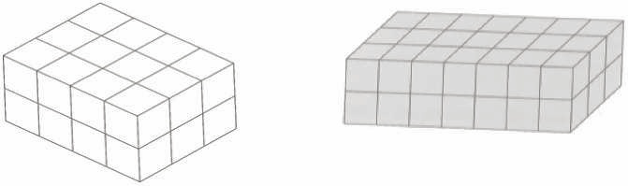

Lesson 12
Fluency Practice (10 minutes)
⬛ Multiplying a Fraction and a Whole Number 5.3I (4 minutes)
⬛ Find the Volume 5.6B (6 minutes)

Multiplying a Fraction and a Whole Number (4 minutes)
Materials: (S) Personal white board
Note: This fluency activity prepares students for today’s lesson.
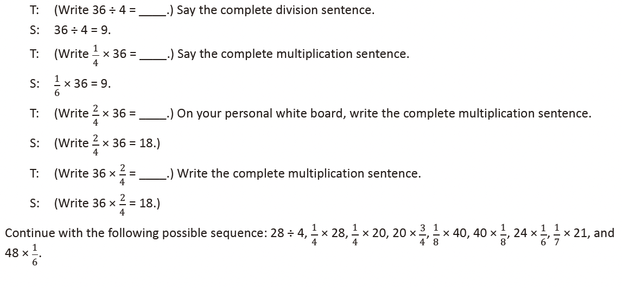
Find the Volume (6 minutes)
Materials: (S) Personal white board
Note: This fluency activity reviews volume concepts and formulas.
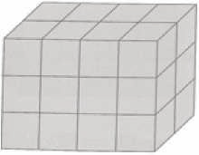
T: (Project a prism 4 units X 2 units X 3 units.
Write V = ____ units X ____ units X ____ units.) Find the volume.
S: (Write 4 units X 2 units X 3 units = 24 units3.)
T: How many layers of 6 cubes are in the prism?
S: 4 layers.
T: (Write 4 X 6 units3.) Four copies of 6 cubic units is… ?
S: 24 cubic units.
T: How many layers of 8 cubes are there?
S: 3 layers.
T: (Write 3 X 8 units3.) Three copies of 8 cubic units is… ?
S: 24 cubic units.
T: How many layers of 12 cubes are there?
S: 2 layers.
T: Write a multiplication equation to
find the volume of the prism, starting
with the number of layers.
S: (Write 2 X 12 units3 = 24 units3.)
Repeat the process for the prisms pictured.
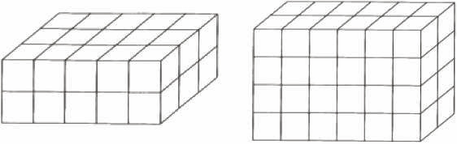

Lesson 13
Fluency Practice (12 minutes)
⬛ Multiply a Fraction and a Whole Number 5.3I (4 minutes)
⬛ Find the Volume 5.6A, 5.6B (5 minutes)
⬛ Physiometry 4.6A (3 minutes)

Multiply a Fraction and a Whole Number (4 minutes)
Materials: (S) Personal white board
Note: This fluency activity reviews Module 4 content.
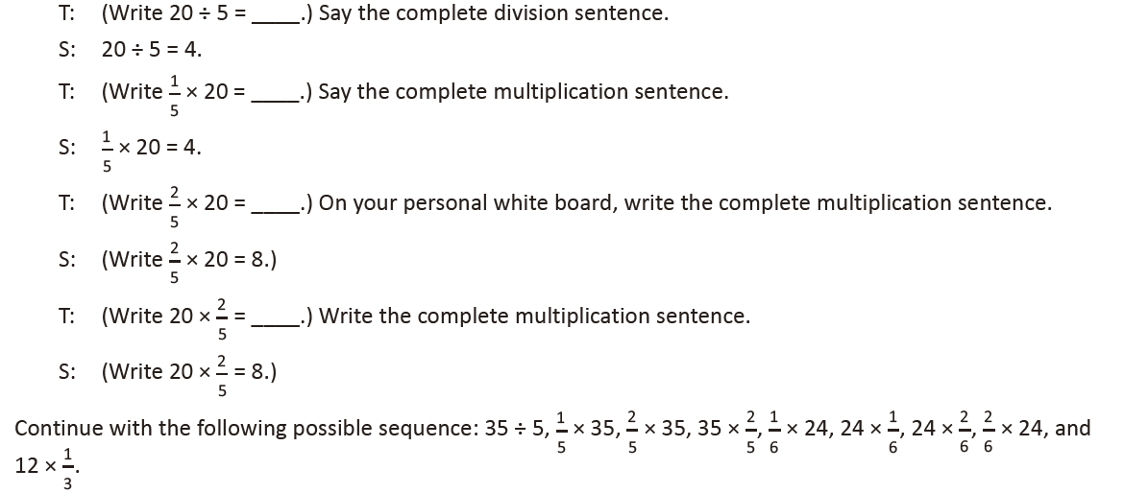
Find the Volume (5 minutes)
Materials: (S) Personal white board
Note: This fluency activity reviews volume concepts and formulas.
T: (Project a prism 3 units X 2 units X 7 units.
Write V = ____ units X ____ units X ____ units.) Find the volume.
S: (Write 3 units X 2 units X 7 units = 42 units3.) 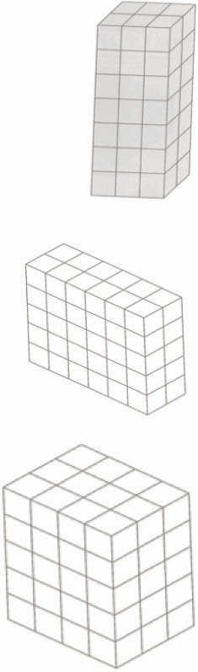
T: How many layers of 6 cubes are in the prism?
S: 7 layers.
T: Write a multiplication sentence to find the volume starting with the
number of layers.
S: (Write 7 X 6 units3 = 42 units3.)
T: How many layers of 21 cubes are there?
S: 2 layers.
T: Write a multiplication sentence to find the volume starting with the
number of layers.
S: (Write 2 X 21 units3 = 42 units3.)
T: How many layers of 14 cubes are there?
S: 3 layers.
T: Write a multiplication sentence to find the volume starting with the
number of layers.
S: (Write 3 X 14 units3 = 42 units3.)
Repeat the process for the other prisms.

Physiometry (3 minutes)
Materials: (S) Personal white board
Note: Kinesthetic memory is strong memory. This fluency activity prepares students for Lesson 16.
T: Stand up.
S: (Stand up.)
T: (Point at the side wall.) Point to the wall that runs parallel to the one I am pointing to.
S: (Point to the opposite wall.)
T: (Point to the back wall.)
S: (Point to the front wall.)
T: (Point to the side wall.)
S: (Point to the opposite side wall.)
T: (Point at the front wall.)
S: (Point at the back wall.)
T: (Stretch one arm up, directly at the ceiling. Stretch the other arm directly toward a wall, parallel to
the floor.) What type of angle do you think I am modeling with my arms?
S: A right angle.
T: Model a right angle with your arms.
S: (Stretch one arm up, directly at the ceiling. Stretch another arm directly toward a wall, parallel to
the floor.)
T: (Stretch the arm pointing toward a wall directly up toward the ceiling. Move the arm pointing
toward the ceiling so that it points directly toward the opposite wall.) Model another right angle.
S: (Stretch the arm pointing toward a wall directly up toward the ceiling. Move the arm pointing
toward the ceiling so that it points directly toward the opposite wall.)

Lesson 14
Fluency Practice (10 minutes)
⬛ Divide Whole Numbers by Unit Fractions and Unit Fractions by Whole Numbers 5.3L (6 minutes)
⬛ Quadrilaterals 3.6A, 3.6B (4 minutes)

Divide Whole Numbers by Unit Fractions and Unit Fractions by Whole Numbers (6 minutes)
Materials: (S) Personal white board
Note: This fluency activity reviews Module 4.
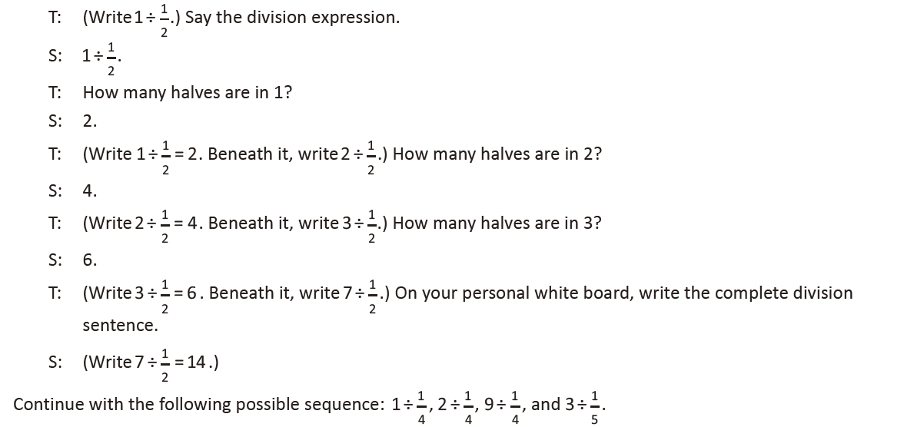
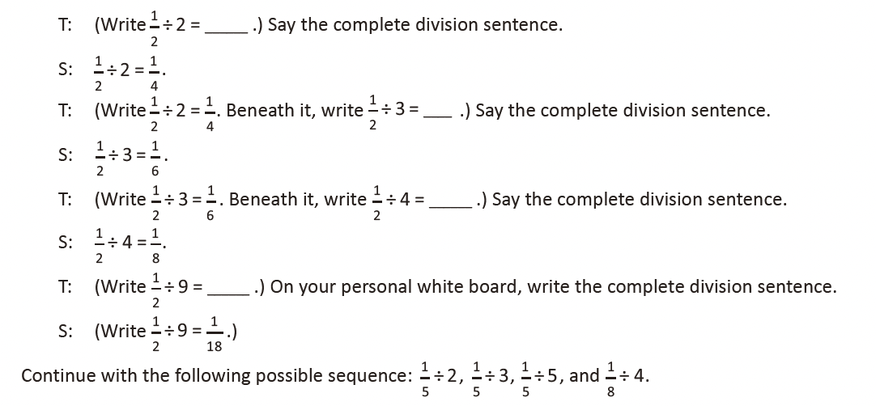
Quadrilaterals (4 minutes)
Materials: (T) Shape sheet (Template)
Note: This fluency activity reviews
Grade 3 geometry concepts in
anticipation of Topic D content. The
sheet can be duplicated if preferred.
T: (Project the shape sheet
template and the list of
attributes.) Take one minute
to discuss the attributes of the
shapes you see. You can use
the list to support you.
S: Some have right angles. → All
have straight sides. → They all
have four sides. → B and G, 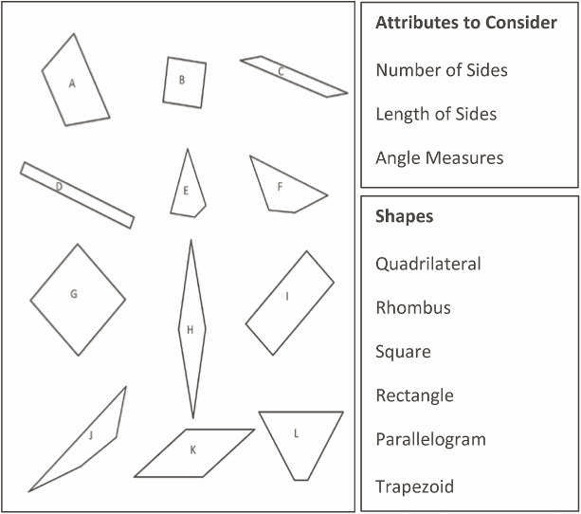
and maybe H and K, have all
equal sides. I am not really
sure.
T: If we wanted to verify whether
the sides are equal, what could
we do?
S: Measure with a ruler.
T: What about the angles? How could you verify that they are right angles?
S: I could compare it to something that I know is a right angle. → I could use a set square. → I could
use a protractor to measure.
T: Now, look at the shape names. Determine which shapes might fall into each category. (Post the
shape names.)
S: B and G might be squares. → All of them are quadrilaterals. → H and K might be rhombuses. It is
hard to know if their sides are equal. → D and I are rectangles. Oh yeah, and B and G are, too.
→ L and A look like trapezoids.
T: Which are quadrilaterals?
S: All of them.
T: Which shapes appear to be rectangles?
S: B, D, G, and I.
T: Which appear to have opposite sides of equal length but are not rectangles?
S: C, H, and K. → A and L have one pair of opposite sides that look the same.
T: Squares are rhombuses with right angles. Do you see any other shapes that might have four equal
sides without right angles?
S: H and K.

Lesson 15
Fluency Practice (10 minutes)
⬛ Classify the Triangle by Angle Measure 4.6C (5 minutes)
⬛ Physiometry 4.6B (3 minutes)
⬛ Lines of Symmetry 4.6B (2 minutes)

Classify the Triangle by Angle Measure (5 minutes)
Note: This activity prepares students for today’s lesson.

T: (Project an acute triangle.) Is this triangle right, acute, or obtuse?
S: Acute.
T: How do you know?
S: Because all of the angles are less
than 90°.
T: (Project a right triangle.) What is the
measure of the largest angle of this
triangle?
S: 90°.
T: How do you know?
S: It has the little square in the angle. → It has a 90° angle symbol.
T: Is this triangle right, acute, or obtuse?
S: It is a right triangle.
T: (Project an obtuse triangle.) Is the measure of the largest angle of this triangle more or less than 90°?
S: More than 90°.
T: Is this triangle right, acute, or obtuse?
S: Obtuse.
T: How many angles do you need to consider when classifying a triangle by angle measurement?
S: Just one. → You just have to look at the largest angle. → The measure of the largest angle classifies
the triangle.

Physiometry (3 minutes)
Note: Kinesthetic memory is strong memory. This fluency activity reviews terms learned in Grade 4.
T: Stand up.
T: Am I trying to make my body position look symmetric?
T: (Raise left arm so fingers point directly to the wall. Leave the other arm hanging down.) Is my
position symmetric now?
S: No.
Continue with other symmetric and non-symmetric positions.
T: With your arms, model a line that runs parallel to the floor. Are you modeling a symmetric position?
S: Yes.
T: Model a right angle. Are you modeling a symmetric position?
S: No.
T: Model a line segment that runs perpendicular to the floor. Are you modeling a symmetric position?
S: Yes.

Lines of Symmetry (2 minutes)
Note: This fluency exercise reviews concepts learned in Grade 4.

T: (Project the square with the dotted line.
Point to the dotted line.) Is this a line of
symmetry?
S: No.
T: (Project the rectangle. Point to the dotted line.)
Is this a line of symmetry?
S: Yes.
Continue process for the remaining graphics.

Lesson 16
Fluency Practice (12 minutes)
⬛ Multiply a Fraction by a Whole Number 5.3I (4 minutes)
⬛ Find the Volume 5.6B (4 minutes)
⬛ Classify the Triangle 4.6C, 5.5 (4 minutes)

Multiply a Fraction by a Whole Number (4 minutes)
Materials: (S) Personal white board
Note: This fluency activity reviews the content of Module 4.
T: (Write 18 ÷ 3 = ____.) Say the complete division sentence.
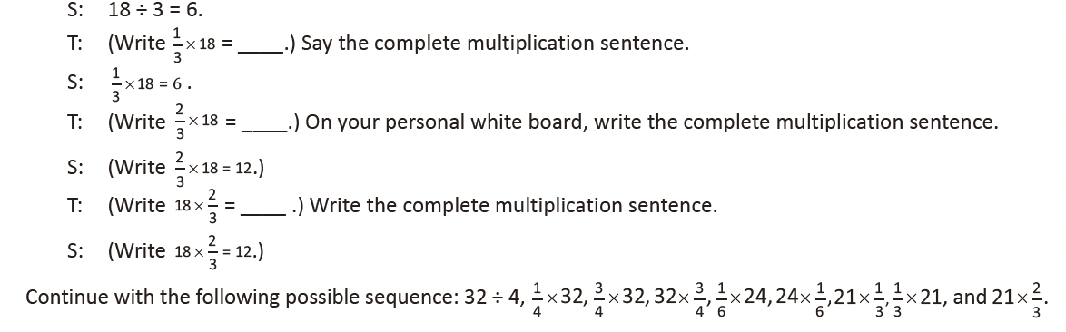

Find the Volume (4 minutes)
Materials: (S) Personal white board
Note: This fluency activity reviews volume concepts and formulas.
T: (Project a prism 4 units X 2 units X 6 units.
Write V = _____ units X ______ units X ______ units.) Find the volume.
S: (Write 4 units X 2 units X 6 units = 48 units3.)
T: How many layers of 8 cubes are in the prism?
S: 6 layers.
T: Write a multiplication sentence to find the volume starting
with the number of layers.
S: (Write 6 X 8 units3 = 48 units3.)
T: How many layers of 24 cubes are there?
S: 2 layers.
T: Write a multiplication sentence to find the volume starting
with the number of layers.
S: (Write 2 X 24 units3 = 48 units3.)
T: How many layers of 12 cubes are there?
S: 4 layers.
T: Write a multiplication sentence to find the volume starting
with the number of layers.
S: (Write 4 X 12 units3 = 48 units3.)
Repeat the process for the other prisms.

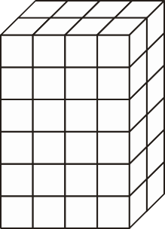
.

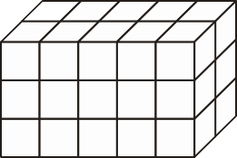

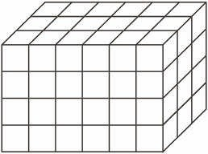
Classify the Triangle (4 minutes)
Note: This fluency activity reviews Lesson 15.
T: (Project triangle.) What’s the measure of the
largest given angle in this triangle?
S: 110°.
T: Is the triangle equilateral, scalene, or isosceles?
S: Scalene.
T: Why?
S: Because all the sides are different lengths.
T: Is the same triangle acute, right, or obtuse?
S: Obtuse.
T: Why?
S: Because there’s an angle greater than 90°.
Continue the process for the other triangles.
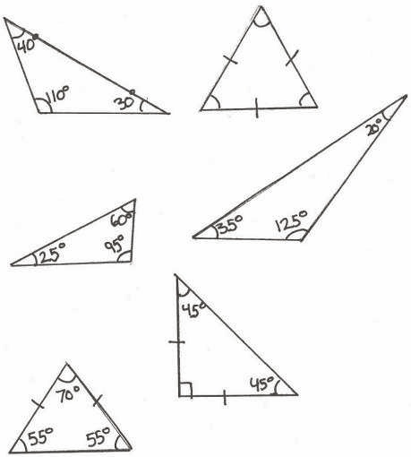

Lesson 17
Fluency Practice (9 minutes)
⬛ Divide Whole Numbers by Unit Fractions and Unit Fractions by Whole Numbers 5.3L (5 minutes)
⬛ Quadrilaterals 3.6A (4 minutes)

Divide Whole Numbers by Unit Fractions and Unit Fractions by Whole Numbers (5 minutes)
Materials: (S) Personal white board
Note: This fluency activity reviews Module 4.
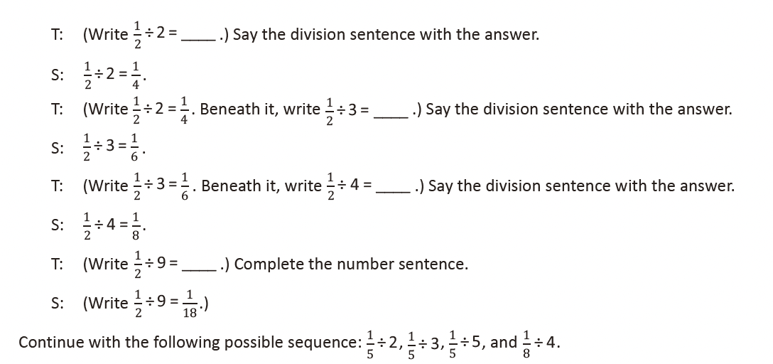
Quadrilaterals (4 minutes)
Materials: (T) Shape sheet (Lesson 14 Template) (S) Personal white board
Note: This fluency activity reviews Grade 3 geometry concepts in anticipation of this lesson’s content.
T: (Project the shape sheet that includes the following:
square; rhombus that is not a square; rectangle that
is not a square; and several quadrilaterals that are
not squares, rhombuses, or rectangles.) How many
sides does each polygon have?
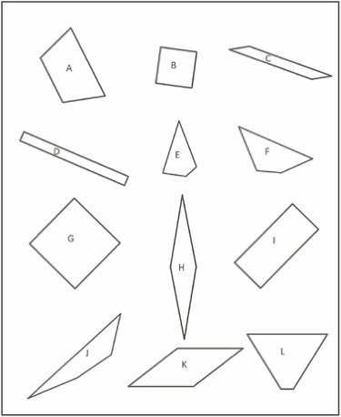
S: 4.
T: On your personal white board, write down the name
for any four-sided polygon.
S: (Write quadrilateral.)
T: (Point to Shape B.) This quadrilateral has four equal
sides and four right angles. On your board, write the
name of this quadrilateral that is the most specific.
S: (Write square.)
T: Rhombuses are parallelograms with four equal sides.
(Point to Shape G.) Is this polygon a rhombus?
S: Yes.
T: Is it a rectangle?
S: Yes.
T: Is a square also a rhombus?
S: Yes!
T: (Point to Shape K.) This polygon has four equal sides. Is it a square?
S: No.
T: Is a rhombus always a square?
S: No!
T: (Point to Shape I.) This polygon has four equal angles, but the sides are not equal. Write the name
of this quadrilateral. There is more than one answer.
S: (Write rectangle. → Parallelogram.)
T: Draw a quadrilateral that is not a square, rhombus, or rectangle.
S: (Draw.)

Lesson 18
Fluency Practice (10 minutes)
⬛ Multiply by Multiples of 10 and 100 5.2A (4 minutes)
⬛ Divide Whole Numbers by Unit Fractions
and Unit Fractions by Whole Numbers 5.3L
(6 minutes)

Multiply by Multiples of 10 and 100 (4 minutes)
Materials: (S) Personal white board
Note: This fluency activity reviews Modules 1 and 2.
T: (Write 31 X 10 = _____.) Say the multiplication sentence.
S: 31 X 10 = 310.
T: (Write 31 X 10 = 310. Below it, write 310 X 2 = _____.) Say the multiplication sentence.
S: 310 X 2 = 620.
T: (Write 310 X 2 = 620. Below it, write 31 X 20 = 31 X _____ X ____ = _____.) Say 31 X 20 as a three factor multiplication sentence with 10 as one factor.
S: 31 X 10 X 2 = 620.
Follow the same process for 21 X 40.
T: (Write 32 X 30 = 32 X _____ X ____ = _____.) Write 32 X 30 as a three-factor multiplication sentence,
and solve.
S: (Write 32 X 30 = 32 X 10 X 3 = 960.)
Repeat the process for 241 X 20.
T: (Write 21 X 100 = _____.) Say the multiplication sentence.
S: 21 X 100 = 2,100.
T: (Write 21 X 100 = 2,100. Below it, write 2,100 X 3 = ____.) Say the multiplication sentence.
S: 2,100 X 3 = 6,300.
T: (Write 2,100 X 3 = 6,300. Below it, write 21 X 300 = _____.) Say 21 X 300 as a three-factor
multiplication sentence with 100 as one factor.
S: 21 X 3 X 100 = 6,300.
T: (Write 21 X 300 = 6,300.)
Direct students to solve using the same method for 42 X 400 and 34 X 300.

Divide Whole Numbers by Unit Fractions and Unit Fractions by Whole Numbers (6 minutes)
Materials: (S) Personal white board
Note: This fluency activity reviews Module 4 Lessons 17–19.
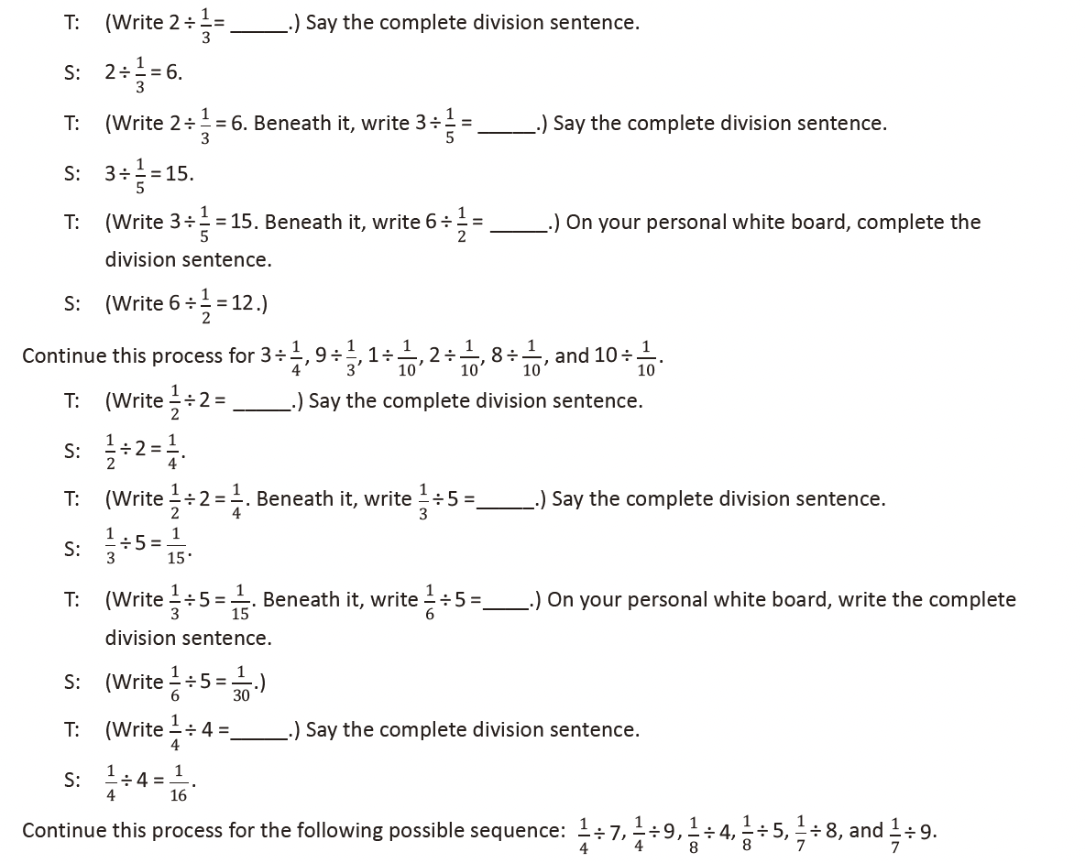
Lesson 19
Fluency Practice (12 minutes)
⬛ Sprint: Divide Whole Numbers by Fractions and Fractions by
Whole Numbers 5.3F, 5.3G
(9 minutes)
⬛ Multiply by Multiples of 10 and 100 5.2A (3 minutes)

Sprint: Divide Whole Numbers by Fractions and Fractions by Whole Numbers (9 minutes)
Materials: (S) Divide Whole Numbers by Fractions and Fractions by Whole Numbers Sprint
Note: This fluency activity reviews Module 4.

Multiply by Multiples of 10 and 100 (3 minutes)
Materials: (S) Personal white board
Note: This fluency activity reviews Modules 1–2.
T: (Write 42 X 10 = _____.) Say the multiplication sentence.
S: 42 X 10 = 420.
T: (Write 42 X 10 = 420. Below it, write 420 X 2 = _____.) Say the multiplication sentence.
S: 420 × 2 = 840.
T: (Write 420 × 2 = 840. Below it, write 42 × 20 = 42 × _____ × _____ = ____.) Say 42 × 20 as a three
Factor multiplication sentence with 10 as one of the factors.
S: 42 × 10 × 2 = 840.
Follow the same process for 23 X 30.
T: (Write 213 X 30 = 213 X _____ X ____ = _____.) Write 213 X 30 as a three-factor multiplication
sentence with 10 as one of the factors, and solve.
S: (Write 213 X 30 = 213 X 10 X 3 = 6,390.)
Repeat the process for 4,213 X 20.
T: (Write 31 X 100 = _____.) Say the multiplication sentence.
S: 31 X 100 = 3,100.
T: (Write 31 X 100 = 3,100. Below it, write 3,100 X 3 = _____.) Say the multiplication sentence.
S: 3,100 X 3 = 9,300.
T: (Write 3,100 X 3 = 9,300. Below it, write 31 X 300 = _____.) Say 31 X 300 as a three-factor
multiplication sentence with 100 as one of the factors.
S: 31 X 100 X 3 = 9,300.
T: (Write 31 X 300 = 9,300.)
Direct students to solve 43 X 300 using the same method.

Lesson 20
Fluency Practice (12 minutes)
⬛ Sprint: Multiply by Multiples of 10 and 100 5.2A (8 minutes)
⬛ Divide by Multiples of 10 and 100 5.2A (4 minutes)

Sprint: Multiply by Multiples of 10 and 100 (8 minutes)
Materials: (S) Multiply by Multiples of 10 and 100 Sprint
Note: This fluency activity reviews Module 2.

Divide by Multiples of 10 and 100 (4 minutes)
Materials: (S) Personal white board
Note: This fluency activity reviews Module 2.
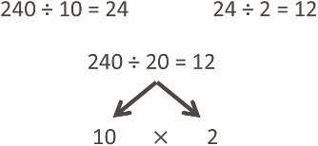

T: (Write 240 ÷ 10 = _____.) Say the division sentence.
S: 240 ÷ 10 = 24.
T: (Write 240 ÷ 10 = 24. To the right, write
24 ÷ 2 = _____.) Say the division sentence.
S: 24 ÷ 2 = 12.
T: (Write 24 ÷ 2 = 12. Below it, write 240 ÷ 20 = _____.)
Say 240 ÷ 20 as a division sentence, but divide first by
10 and then by 2 rather than by 20.
S: 240 ÷ 10 ÷ 2 = 12.
T: (Write 240 ÷ 20 = 12.)
Continue the process for the following possible sequence: 690 ÷ 30, 8,600 ÷ 20, 4,800 ÷ 400, and
9,600 ÷ 300.

Lesson 21
Fluency Practice (10 minutes)
⬛ Divide by Multiples of 10 and 100 5.2A (4 minutes)
⬛ Find the Volume 5.4H, 5.6B (6 minutes)

Divide by Multiples of 10 and 100 (4 minutes)
Materials: (S) Personal white board
Note: This fluency activity reviews Module 2.
T: (Write 930 ÷ 10 = _____.) Say the competed division
sentence.
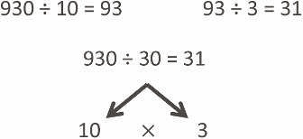
S: 930 ÷ 10 = 93.
T: (Write 930 ÷ 10 = _____. To the right, write 93 ÷ 3 = _____.)
Say the complete division sentence.
S: 93 ÷ 3 = 31.
T: (Write 93 ÷ 3 = 31. Below it, write 930 ÷ 30 = _____.)
Say 930 ÷ 30 as a division sentence, but divide first by
10 and then by 3.
S: 930 ÷ 10 ÷ 3 = 31.
T: (Write 930 ÷ 30 = 31.)
Continue the process for the following possible sequence: 420 ÷ 20, 4,800 ÷ 40, 8,400 ÷ 400, and 6,900 ÷ 300.

Find the Volume (6 minutes)
Materials: (S) Personal white board
Note: This fluency activity reviews Topic B.
T: Say the formula for finding the volume of a rectangular
prism.
S: Length times width times height.
T: (Project the figure below.) Visualize a line that breaks
the figure into two rectangular prisms.
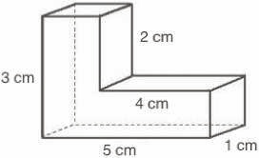
T: Find the volume of the composite figure by adding the volumes of
each rectangular prism.
S: (Write 3 cm X 1 cm X 1 cm = 3 cubic cm, 4 cm X 1 cm X 1 cm =
4 cubic cm, and 3 cubic cm + 4 cubic cm = 7 cubic cm.)
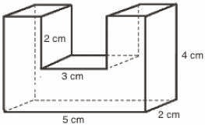
Continue the process for the composite figure to the right.

Lesson 22
Fluency Practice (12 minutes)
⬛ Sprint: Divide by Multiples of 10 and 100 5.2A (8 minutes)
⬛ Prime or Composite? 5.4A (4 minutes)

Sprint: Divide by Multiples of 10 and 100 (8 minutes)
Materials: (S) Divide by Multiples of 10 and 100 Sprint
Note: This fluency activity reviews Module 2.

Prime or Composite? (4 minutes)
Materials: (S) Personal white board
Note: This fluency activity reviews prime and composite numbers from Module 2.
T: I’ll say a number. You say if it is prime or composite. 18.
S: Composite
T: How do you know?
S: 18 has more than 1 and itself as factors.
T: Name one other factor of 18 besides 1 or 18.
S: 3. → 6. → 2. → 9.
T: 23?
S: Prime.
T: How do you know?
S: 23 only has 1 and itself as factors.
Continue the sequence with 27, 29, 39, 61, and 63.

