Grade 5 Module 6: Problem Solving with the Coordinate Plane
Topic A: Coordinate System
Lesson 1 | Count by Equivalent Fractions (4.3C) | Find the Missing Number on a Number Line (4.2H) | Physiometry (4.6D)
Lesson 2 | Count by Equivalent Fractions (4.3C) | Find the Missing Number on a Number Line (4.2H)
Lesson 3 | Name the Parts of the Coordinate Grid (5.8A) | Find the Missing Number on a Number Line (4.2H) | Name Coordinates on a Coordinate Grid (5.8B)
Lesson 4 | Multiply (5.3B) | Name the Parts of the Coordinate Grid (5.8A) | Name Coordinates on a Coordinate Grid (5.8B)
Lesson 5 | Multiply (5.3B) | Count by Decimals (4.2A) | Decimals on Number Lines (4.2H)
Lesson 6 | Multiply and Divide by 10, 100, 1,000 (5.2A) | Count by Decimals (4.2A) | Find the Missing Number on a Number Line (4.2H)
Topic B: Patterns in the Coordinate Plane and Graphing Number Patterns from Rules
Lesson 7 | Multiply and Divide Decimals by 10, 100, 1,000 (5.2A) | Name Coordinates (5.8B)
Lesson 8 | Sprint: Multiply Decimals by 10, 100, 1,000 (5.2A) | Plot Points on a Coordinate Grid (5.8A)
Lesson 9 | Round to the Nearest One (5.2C) | Add and Subtract Decimals (5.3K) | Plot Points on a Coordinate Grid (5.8B)
Lesson 10 | Count by Equivalent Fractions (4.3C) | Round to the Nearest One (5.2C) | Add and Subtract Decimals (5.3K)
Lesson 11 | Sprint: Round to the Nearest One (5.2C) | Add and Subtract Decimals (5.3K)
Lesson 12 | Sprint: Subtract Decimals (5.3K) | Make a Number Pattern (5.4C)
Lesson 13 | Sprint: Subtracting Fractions from a Whole Number (5.3H) | Express Fractions as Decimals (4.2G)
Topic C: Data Representation and Analysis
Lesson 14 | Find the Missing Number on a Number Line (4.2H) | Express Fractions as Decimals (4.3G) | Multiply Multi-Digit Whole Numbers (5.3B)
Lesson 15 | Decimal Place Value (5.2A) | Convert Units (4.8B) | Multiply Multi-Digit Whole Numbers (5.3B)
Lesson 16 | Identify Points on a Coordinate Plane (5.8B) | Plot Points on Coordinate Grid (5.8B) | Multiply and Divide Decimals (5.3E, 5.3G)
Lesson 17 | Identify Points on a Coordinate Plane (5.8B) | Find the Missing Number on a Number Line (4.2H) | Make Larger Units (4.3C)
Lesson 18 | Multiply and Divide Decimals (5.3E, 5.3G) | Make Larger Units (4.3C) | Subtract Fractions (5.3K)
Topic D: Multi-Step Word Problem
Lesson 19 | Change Mixed Number to Improper Fractions (4.3B) | Add Unlike Denominators (5.3H, 5.3K)
Lesson 20 | Multiply (5.3B) | Change Mixed Number to Improper Fractions (4.3B) | Add Unlike Denominators (5.3H, 5.3K)
Lesson 21 | Sprint: Change Mixed Number to Improper Fractions (4.3B)
Lesson 22 | Subtract Unlike Denominators (5.3H, 5.3K) | Order of Operations (5.4F) | Multiply by Multiples of 10 (4.4B)
Lesson 23 | Multiply (5.3B) | Order of Operations (5.4F) | Subtract Unlike Denominators (5.3H, 5.3K)
Topic E: The Years in Review: A Reflection on A Story of Units
Lesson 24 | Make Larger Units (4.3C) | Unknown Angles (4.7E)
Lesson 25 | Sprint: Make Larger Units (4.3C) | Subtract a Fraction from A Whole (5.3H)
Lesson 26 | Order of Operations (5.4F) | Multiply a Fraction by Whole Number (5.3I) | Multiply Decimals (5.3E)
Lesson 27 | Multiply a Fraction by Whole Number (5.3I) | Multiply Decimals (5.3E) | Multiply Mentally (5.3B)
Lesson 28 | Part 1: Reflect on Fluency | Part 2: Select and Engage in Fluency Activities | Part 3: Create Reference Cards
Lesson 29 | Sprint: Multiply Decimals (5.3E) | Multiply Mentally (5.3B)
Lesson 30 | Multiply (5.3B) | Unit Conversions (5.7)
Lesson 31 | Divide Whole Numbers by Unit Fractions and Unit Fractions by Whole Numbers (5.3J) | Divide by Two-Digit Numbers (5.3C)
Lesson 32 | Multiply (5.3B) | Divide by Two-Digit Numbers (5.3C) | The Fibonacci Sequence (5.3A)
Lesson 33 | Find the Volume (5.4H)
Lesson 34 | Multiply (5.3B) | Divide by Two-Digit Numbers (5.3C) | Find the Volume (5.4H)

Grade 5 Module 6
Lesson 1
Fluency Practice (12 minutes)
⬛ Count by Equivalent Fractions 4.3C (6 minutes)
⬛ Find the Missing Number on a Number Line 4.2H (4 minutes)
⬛ Physiometry 4.6D (2 minutes)

Count by Equivalent Fractions (6 minutes)
Note: This fluency activity prepares students for today’s lesson.
T: Count by 1 half to 10 halves. Start at zero halves.
(Write as students count.)
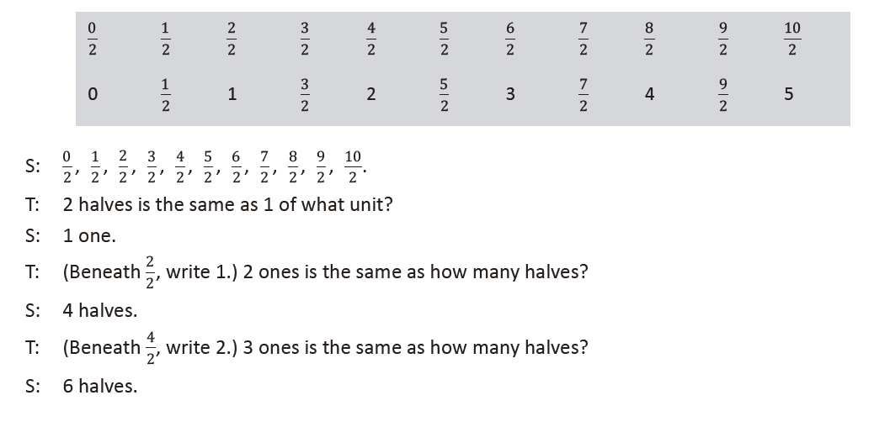
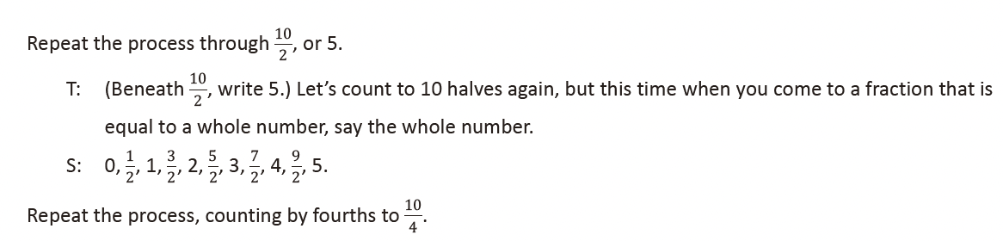

Find the Missing Number on a Number Line (4 minutes)
Materials: (S) Personal white board
Note: This fluency activity prepares students for today’s lesson.
T: (Project a number line partitioned into 10 unit intervals. Label 0 and 10 as the endpoints. Point to
the A .) What’s the value of A ?
S: 9.
T: (Point to B .) What’s the value of B ?
S: 2.
T: Write the value of C .
S: (Write 5.)
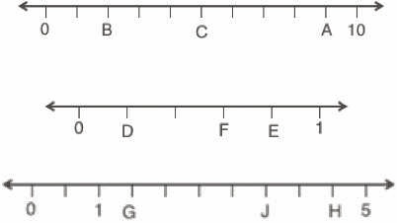
Continue the process for the other number lines.

Physiometry (2 minutes)
Note: This fluency activity prepares students for Lesson 2.
T: (Stretch one arm up, directly toward the ceiling. Stretch the other arm out, directly toward a wall and
parallel to the floor.) What type of angle do you think I am making?
S: Right angle.
T: What is the relationship of the lines formed by my arms?
S: Perpendicular.
T: (Point to a wall on the side of the room.) Point to the walls that run perpendicular to the wall to
which I am pointing.
S: (Point to the front and back walls.)
T: (Point to the back wall.)
S: (Point to the side walls.)
Continue the exercise, pointing to the remaining walls and asking students to respond.
T: (Point to the back wall.) Point to the wall that runs parallel to the wall to which I am pointing.
S: (Point to the front wall.)
Continue the exercise, pointing to the remaining walls and asking students to respond.

Lesson 2
Fluency Practice (10 minutes)
⬛ Count by Equivalent Fractions 4.3C (6 minutes)
⬛ Find the Missing Number on a Number Line 4.2H (4 minutes)

Count by Equivalent Fractions (6 minutes)
Note: This fluency activity reviews Lesson 1 and prepares students for today’s lesson.
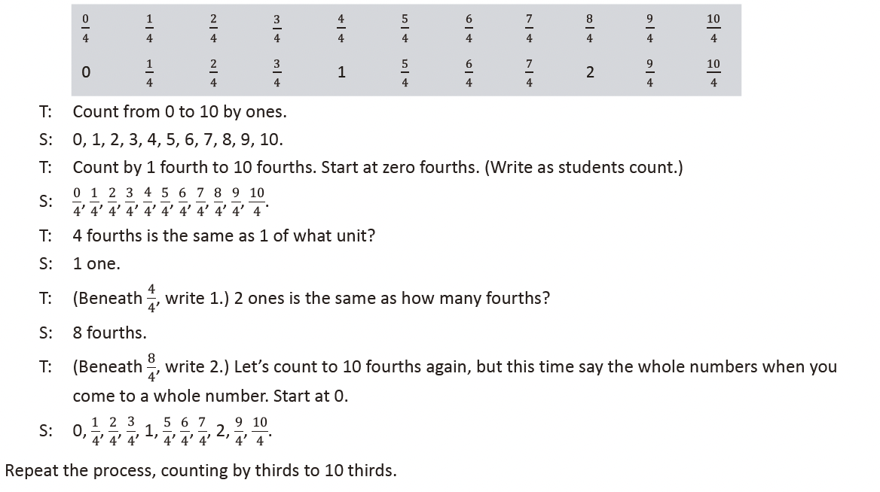
Find the Missing Number on a Number Line (4 minutes)
Materials: (S) Personal white board
Note: This fluency activity reviews Lesson 1. For the last number line, challenge students by having them
write simplified fractions.
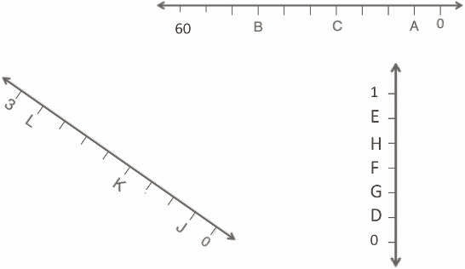
T: (Project a number line partitioned
into 10 intervals. Label 60 and 0 as
the endpoints. Point to A .) What is
the value of A ?
S: 6.
T: What is the value of B ?
S: 42.
T: Write the value of C .
S: (Write 24.)
Continue the process for the other number lines.

Lesson 3
Fluency Practice (12 minutes)
⬛ Name the Parts of the Coordinate Grid 5.8A (1 minute)
⬛ Find the Missing Number on a Number Line 4.2H (5 minutes)
⬛ Name Coordinates on a Coordinate Grid 5.8B (6 minutes)

Name the Parts of the Coordinate Grid (1 minute)
Materials: (T) Coordinate plane (Lesson 2 Template)
Note: This fluency activity reviews Lesson 2.
T: (Project the coordinate plane template. Point to the horizontal axis.) Name the axis.
S: x -axis.
T: (Point to the vertical axis.) Name the axis.
S: y -axis.
T: The x -axis and y -axis intersect at what angle measure?
S: 90 degrees.
T: Lines that intersect at right angles are called … ?
S: Perpendicular lines.
T: (Point to the origin.) Name the coordinate pair.
S: Zero, zero.
T: What else can we call this point?
S: Origin.

Find the Missing Number on a Number Line (5 minutes)
Materials: (S) Personal white board
Note: This fluency activity reviews Lesson 1.
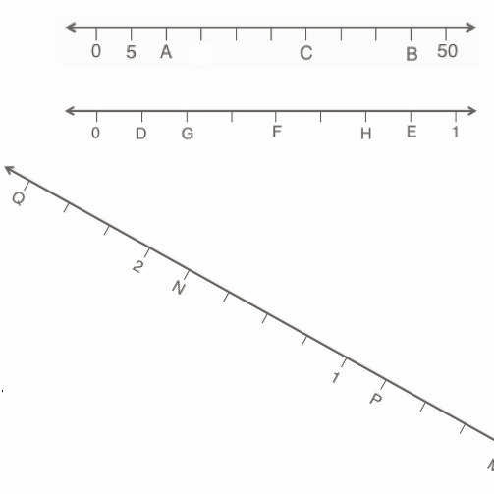
T: (Project a number line partitioned into
10 intervals. Label 0 and 50 as the
endpoints. Point to A .) What is the
value of A ?
S: 10.
T: What is the value of B?
S: 45.
T: Write the value of C.
S: (Write 30.)
Continue the process for the other number lines.

Name Coordinates on a Coordinate Grid (6 minutes)
Materials: (T) Coordinate grid (Template 1) (S) Personal white board
Note: This fluency activity reviews Lesson 2.
T: (Project coordinate grid (a) shown below.) Write the coordinate pair for A .
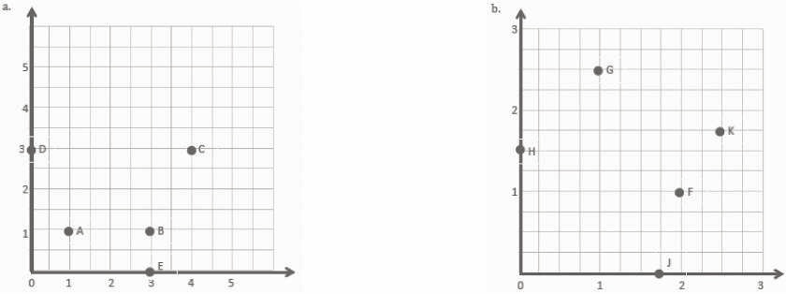
S: (Write (1, 1).)
Continue the process for letters B –E .
T: (Project coordinate grid (b) shown above and to the right.) Write the coordinate pair for F .
S: (Write (2, 1).)
Continue the process for the remaining letters.

Lesson 4
Fluency Practice (11 minutes)
⬛ Multiply 5.3B (4 minutes)
⬛ Name the Parts of the Coordinate Grid 5.8A (1 minute)
⬛ Name Coordinates on a Coordinate Grid 5.8B (6 minutes)

Multiply (4 minutes)
Materials: (S) Personal white board
Note: This fluency activity reviews year-long fluency standards.
T: Solve 34 × 21 using the standard algorithm.
S: (Solve 34 × 21 using the standard algorithm. The product is 714.)
Continue the process for 234 × 21, 46 × 32, 146 × 32, and 537 × 35.

Name the Parts of the Coordinate Grid (1 minute)
Materials: (T) Coordinate plane (Lesson 2 Template)
Note: This fluency activity reviews Lesson 2.
T: (Project a coordinate grid. Point to the horizontal axis.) Name the axis.
S: x -axis.
T: (Point to the vertical axis.) Name the axis.
S: y -axis.
T: The x -axis and y -axis intersect at a 90-degree angle. What kind of lines intersect to form right angles?
S: Perpendicular lines.
T: (Point to the origin.) Name the coordinate pair.
S: Zero, zero.
T: What’s the term for the coordinate pair of zero, zero?
S: Origin.

Name Coordinates on a Coordinate Grid (6 minutes)
Materials: (T) Coordinate grid (Fluency Template) (S) Personal white board
Note: This fluency activity reviews Lesson 2.
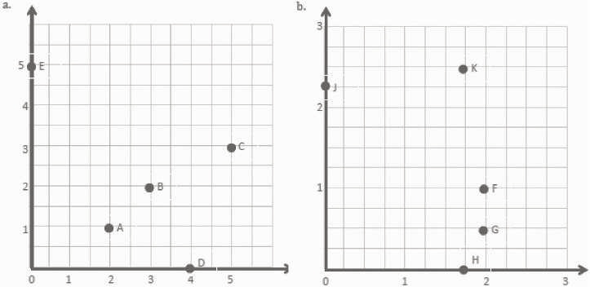
T: (Project coordinate grid (a) shown above.) Write the coordinate pair for A .
S: (Write (2, 1).)
Continue the process for letters B –E .
T: (Project coordinate grid (b) shown above.) Write the coordinate pair for F .
S: (Write (2, 1).)
Continue the process for the remaining letters.

Lesson 5
Fluency Practice (12 minutes)
⬛ Multiply 5.3B (4 minutes)
⬛ Count by Decimals 4.2A (4 minutes)
⬛ Decimals on Number Lines 4.2H (4 minutes)

Multiply (4 minutes)
Materials: (S) Personal white board
Note: This fluency activity reviews year-long fluency standards.
T: (Write 4 tens 5 ones × 3 tens 1 one = ____ × ____.) Write the multiplication expression in standard
form.
S: (Write 45 × 31.)
T: Solve 45 × 31 using the standard algorithm or the area model.
S: (Solve 45 × 31. The product is 1,395.)
Continue the process for 345 × 31, 47 × 23, 247 × 23, and 753 × 35.

Count by Decimals (4 minutes)
Materials: (S) Personal white board
Note: This fluency activity prepares students for Lesson 6.
T: Count with me by ones to ten, starting at zero.
S: 0, 1, 2, 3, 4, 5, 6, 7, 8, 9, 10.
T: Count by tenths to 10 tenths, starting at zero.
S: 0 tenths, 1 tenth, 2 tenths, 3 tenths, 4 tenths, 5 tenths, 6 tenths, 7 tenths, 8 tenths, 9 tenths,
10 tenths.
T: (Write 10 tenths = 1 ____.) Write the number sentence.
S: (Write 10 tenths = 1 one.)
T: Starting at zero, count by tenths again. This time, when you come to a whole number, say the whole
number.
S: 0 tenths, 1 tenth, 2 tenths, 3 tenths, 4 tenths, 5 tenths, 6 tenths, 7 tenths, 8 tenths, 9 tenths, 1.
T: Write the fraction equivalent to zero point one.
S: (Write 1
10.)
T: Count from 0 tenths to 1 again. When I raise my hand, stop.
S: 0 tenths, 1 tenth, 2 tenths, 3 tenths.
T: (Raise a hand.) Write 3 tenths as a decimal.
S: (Write 0.3.)
Continue the process counting up to 1 one and down from 1 one to zero, stopping students at various points to write the numbers in decimal form.

Decimals on Number Lines (4 minutes)
Materials: (S) Personal white board
Note: This fluency activity reviews Lesson 1.
T: (Project a number line partitioned into 10 intervals.
Label 4 and 5 as the endpoints. Point to A .) What is
the value of A as a decimal?
S: 4.9.
T: What is the value of B ?
S: 4.1.
T: Write the value of C .
S: (Write 4.7.)
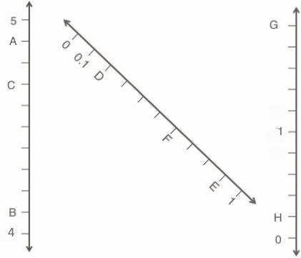
Continue the process for the other number lines.

Lesson 6
Fluency Practice (12 minutes)
⬛ Multiply and Divide by 10, 100, and 1,000 5.2A (4 minutes)
⬛ Count by Decimals 4.2A (4 minutes)
⬛ Find the Missing Number on a Number Line 4.2H (4 minutes)

Multiply and Divide by 10, 100, and 1,000 (4 minutes)
Materials: (T) Millions through thousandths place value chart (Fluency Template) (S) Personal white board
Note: This fluency activity reviews Module 1 topics.
T: (Project the millions through thousandths place value chart.) What is 0.003 × 10?
S: 0.03.
Repeat the process for this possible sequence: 0.005 × 100, 0.005 × 1,000, 1.005 × 1,000, 1.035 × 100,
1.235 × 100, 1.235 × 10, and 1.235 × 1,000.
Repeat the process for dividing by 10, 100, and 1,000 for this possible sequence: 2 ÷ 10, 2.1 ÷ 10, 2.1 ÷ 100,
21 ÷ 1,000, and 547 ÷ 1,000.

Count by Decimals (4 minutes)
Materials: (S) Personal white board
Note: This fluency activity prepares students for Lesson 6.
T: Count by twos to twenty, starting at zero.
S: 0, 2, 4, 6, 8, 10, 12, 14, 16, 18, 20.
T: Count by 2 tenths to 20 tenths, starting at zero.
S: 0 tenths, 2 tenths, 4 tenths, 6 tenths, 8 tenths, 10 tenths, 12 tenths, 14 tenths, 16 tenths, 18 tenths,
20 tenths.
T: (Write 10 tenths = 1 _____.) Write the number sentence.
S: (Write 10 tenths = 1 one.)
T: (Write 20 tenths = _____ ones.) Try this problem.
S: (Write 20 tenths = 2 ones.)
T: Starting at zero, count by 2 tenths again. This time, when you come to a whole number, say the
whole number.
S: 0 tenths, 2 tenths, 4 tenths, 6 tenths, 8 tenths, 1, 12 tenths, 14 tenths, 16 tenths, 18 tenths, 2.
T: (Write 0.2 = –-.) Write 2 tenths as a fraction.
S: (Write 0.2 = 2
10.)
T: Count from zero tenths to 2 again. When I raise my hand, stop.
S: 0 tenths, 2 tenths, 4 tenths, 6 tenths.
T: (Raise a hand.) Write 6 tenths as a decimal.
S: (Write 0.6.)
T: Continue.
S: 8 tenths, 1, 12 tenths, 14 tenths, 16 tenths.
Continue up to and down from 2 ones, stopping to have students write various numbers in decimal form.

Find the Missing Number on a Number Line (4 minutes)
Materials: (S) Personal white board
Note: This fluency activity reviews Lesson 1. For the last
number line, challenge students by having them write
simplified fractions.
T: (Project the number line partitioned into 10
intervals. Label 0 and 1 as the endpoints. Point to
A .) What is the value of A ?
S: 1 tenth.
T: What is the value of B ?
S: 2 tenths.
T: Write the value of C .
S: (Write 0.8.)
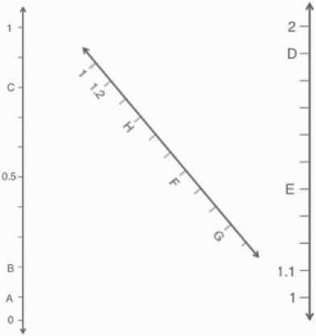
Continue the process for the other number lines.

Lesson 7
Fluency Practice (11 minutes)
⬛ Multiply and Divide Decimals by 10, 100, and 1,000 5.2A (5 minutes)
⬛ Name Coordinates 5.8B (6 minutes)
Multiply and Divide Decimals by 10, 100, and 1,000 (5 minutes)
Materials: (T) Millions through thousandths place value chart (Lesson 6 Fluency Template) (S) Personal
white board
Note: This fluency activity reviews Module 1 topics. The suggested place value chart allows students to see the symmetry of the decimal system around one.
T: (Project the place value chart. Draw 4 disks in the tens column, 3 disks in the ones column, and 5
disks in the tenths column.) Say the value as a decimal.
S: Forty-three and five tenths.
T: Write the number on your personal white board. (Pause.) Multiply it by 10.
S: (Write 43.5 on the place value chart, cross out each digit, and shift the number one place value to
the left to show 435.)
T: Show 43.5 divided by 10.
S: (Write 43.5 on the place value chart, cross out each digit, and shift the number one place value to
the right to show 4.35.)
Repeat the process and sequence for 43.5 X 100, 43.5 ÷ 100, 948 ÷ 1,000, and 0.529 X 1,000.

Name Coordinates (6 minutes)
Materials: (T) Coordinate grid (Fluency Template) (S) Personal white board
Note: This fluency activity reviews Lesson 6.
T: (Project coordinate grid (a), shown below.) Write the coordinate pair that is positioned at A.
S: (Write (6, 5).)
Continue the process for letters B–E.
T: (Project coordinate grid (b) shown below.) Write the coordinate pair that is positioned at A.
S: (Write (0.5, 1.0).)
Continue the process for the remaining letters.
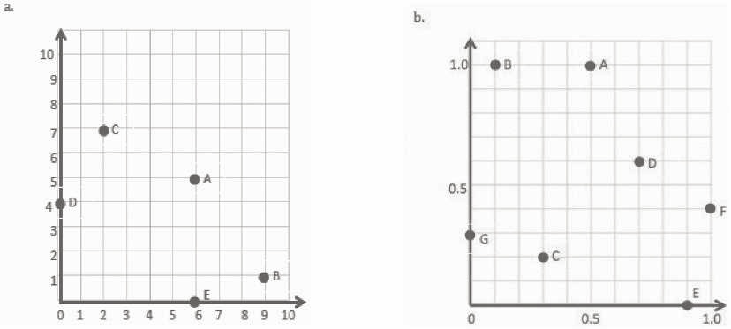

Lesson 8
Fluency Practice (12 minutes)
⬛ Sprint: Multiply Decimals by 10, 100, and 1,000 5.2A (8 minutes)
⬛ Plot Points on a Coordinate Grid 5.8B (4 minutes)

Sprint: Multiply Decimals by 10, 100, and 1,000 (8 minutes)
Materials: (S) Multiply Decimals by 10, 100, and 1,000 Sprint
Note: This fluency activity reviews Module 1 concepts.
Plot Points on a Coordinate Grid (4 minutes)
Materials: (S) Personal white board, coordinate grid insert (Fluency Template)
Note: This fluency activity reviews Lesson 7.
T: Label the x - and y -axes.
S: (Label the axes.)
T: Label the origin.
S: (Write 0 at the origin.)
T: Along both axes, label each interval, counting by ones to 5.
S: (Label 1, 2, 3, 4, and 5 along each axis.)
T: (Write (0, 1).) Plot the point on your coordinate grid.
S: (Plot the point at (0, 1).)
Continue with the following possible sequence: (1, 2), (2, 3), and (3, 4).
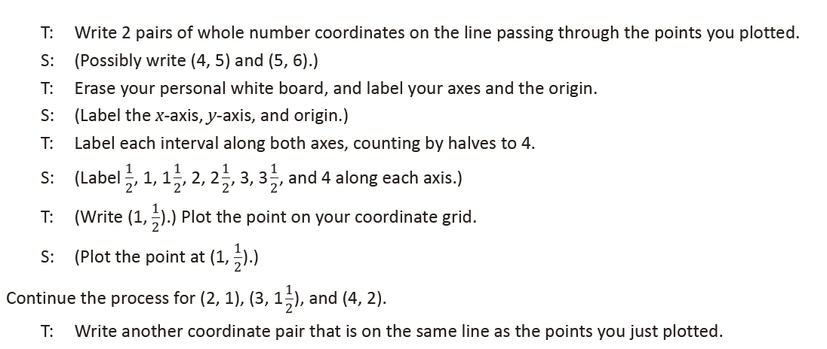

Lesson 9
Fluency Practice (12 minutes)
⬛ Round to the Nearest One 5.2C (4 minutes)
⬛ Add and Subtract Decimals 5.3K (5 minutes)
⬛ Plot Points on a Coordinate Grid 5.8B (3 minutes)

Round to the Nearest One (4 minutes)
Materials: (S) Personal white board
Note: This fluency activity reviews Module 1 concepts.
T: (Write 4 ones 1 tenth.) Write 4 ones and 1 tenth as a decimal.
S: (Write 4.1.)
T: (Write 4.1 ≈ ____.) Round 4 and 1 tenth to the nearest whole number.
S: (Write 4.1 ≈ 4.)
Continue with the following possible sequence: 4.9, 14.9, 3.4, 23.4, 2.5, 32.5, 5.17, 8.76, and 17.51.

Add and Subtract Decimals (5 minutes)
Materials: (S) Personal white board
Note: This fluency activity reviews Module 1 concepts.
T: (Write 5 + 1.) Say the answer.
S: 6.

T: 5 tenths + 1 tenth?
S: 6 tenths.
T: 5 hundredths + 1 hundredth?
S: 6 hundredths.
T: 5 thousandths + 1 thousandth?
S: 6 thousandths.
Continue with the following possible sequence: 5 – 1, 5 tenths – 1 tenth, 5 hundredths – 1 hundredth, and
5 thousandths – 1 thousandth.
T: (Write 4 + 1 = ____.) Complete the number sentence.
S: (Write 4 + 1 = 5.)
T: (Write 4.8 + 1 = ____.) Complete the number sentence.
S: (Write 4.8 + 1 = 5.8.)
Continue with the following possible sequence: 4.8 – 1, 4.83 + 1, 4.83 – 1, 0.6 + 0.2, 0.6 – 0.2, 0.63 + 0.2,
0.63 – 0.2, 0.638 + 0.2, 0.638 – 0.2, 1.746 + 0.02, 1.746 – 0.02, 3.456 + 0.003, and 3.456 – 0.003.

Plot Points on a Coordinate Grid (3 minutes)
Materials: (S) Personal white board, coordinate grid insert (Lesson 8 Fluency Template)
Note: This fluency activity reviews Lesson 8.
T: Label the x - and y -axes.
S: (Label the x - and y -axes.)
T: Label the origin.
S: (Write 0 at the origin.)
T: Along both axes, label every other grid line, counting by twos to 12.
S: (Label 2, 4, 6, 8, 10, and 12 along each axis.)
T: (Write (0, 2).) Plot the point on your coordinate grid.
S: (Plot the point at (0, 2).)
Continue with the following possible sequence: (1, 4), (2, 6), (3, 8), and (4, 10).
T: Draw a line to connect these points.
S: (Draw a line.)
T: Plot the points that fall on this line when x is 5 and when x is 6.
S: (Plot points at (5, 12) and (6, 14).)
T: Erase your personal white board. (Write (0, 0).) Plot the point on your coordinate grid.
S: (Plot the point at the origin.)
Continue the process for (1, 1) and (2, 2).
T: Draw a line to connect these points.
T: Write 2 coordinate pairs for points that fall on this line whose x -coordinates are larger than 12.
S: (Write 2 coordinates with the same digit for x and y that are larger than 12.)

Lesson 10
Fluency Practice (12 minutes)
⬛ Count by Equivalent Fractions 4.3C (4 minutes)
⬛ Round to the Nearest One 5.2C (4 minutes)
⬛ Add and Subtract Decimals 5.3K (4 minutes)

Count by Equivalent Fractions (4 minutes)
Note: This fluency activity prepares students for Lesson 11.
T: Count by ones to 9, starting at 0.
S: 0, 1, 2, 3, 4, 5, 6, 7, 8, 9.
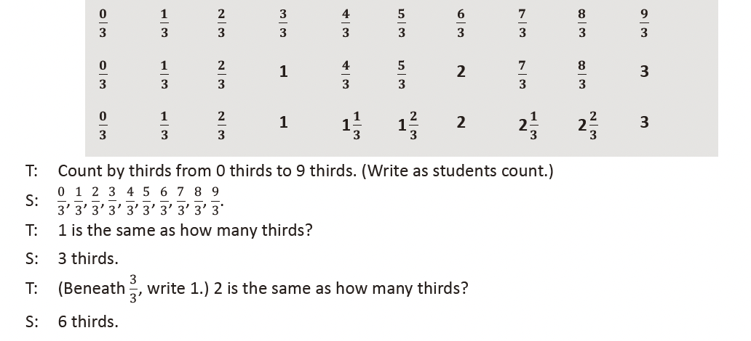
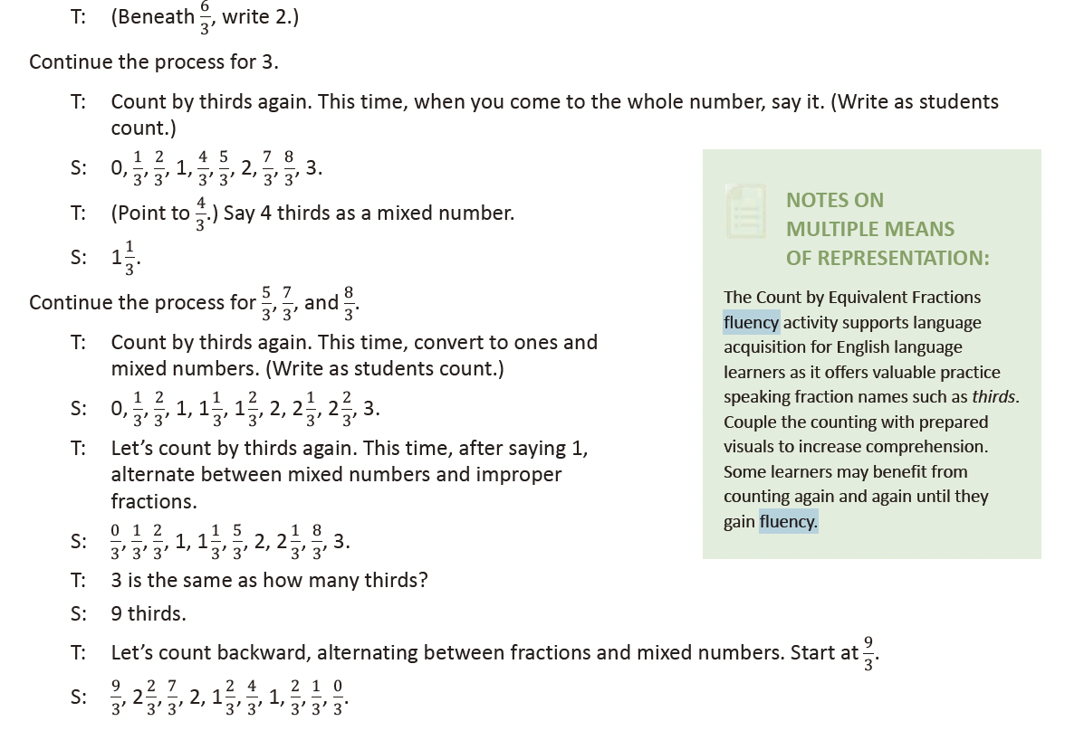
Round to the Nearest One (4 minutes)
Materials: (S) Personal white board
Note: This fluency activity reviews Module 1 concepts.
T: (Write 3 ones 2 tenths.) Write 3 ones and 2 tenths as a decimal.
S: (Write 3.2.)
T: (Write 3.2 ≈ ____.) Round 3 and 2 tenths to the nearest whole number.
S: (Write 3.2 ≈ 3.)
Continue with the following possible sequence: 3.7, 13.7, 5.4, 25.4, 1.5, 21.5, 6.48, 3.62, and 36.52.
Add and Subtract Decimals (4 minutes)
Materials: (S) Personal white board
Note: This fluency activity reviews Module 1 concepts.
T: (Write 3.812 + 1 = _____.) Complete the number sentence.
S: (Write 3.812 + 1 = 4.812.)
T: (Write 3.812 – 1 = _____.) Complete the number sentence.
S: (Write 3.812 – 1 = 2.812.)
Continue with the following possible sequence: 3.812 – 0.1, 3.812 + 0.1, 2.764 + 0.02, 2.764 – 0.02,
5.015 – 0.003, 5.015 + 0.003, and 8.426 – 0.006.

Lesson 11
Fluency Practice (12 minutes)
⬛ Sprint: Round to the Nearest One 5.2C (8 minutes)
⬛ Add and Subtract Decimals 5.3K (4 minutes)

Sprint: Round to the Nearest One (8 minutes)
Materials: (S) Round to the Nearest One Sprint
Note: This Sprint reviews Module 1 concepts.

Add and Subtract Decimals (4 minutes)
Materials: (S) Personal white board
Note: This fluency activity reviews Module 1 concepts.
T: (Write 5.634 + 1 = _____.) Complete the number sentence.
S: (Write 5.634 + 1 = 6.634.)
T: (Write 5.634 − 1 = _____.) Complete the number sentence.
S: (Write 5.634 − 1 = 4.634.)
Continue with the following possible sequence: 5.634 – 0.1, 5.634 + 0.1, 5.937 + 0.02, 5.937 – 0.02,
7.056 – 0.003, 7.056 + 0.003, and 4.304 – 0.004.

Lesson 12
Fluency Practice (12 minutes)
⬛ Sprint: Subtract Decimals 5.3K (8 minutes)
⬛ Make a Number Pattern 5.4C (4 minutes)
Sprint: Subtract Decimals (8 minutes)
Materials: (S) Subtract Decimals Sprint
Note: This Sprint reviews Module 1 concepts.

Make a Number Pattern (4 minutes)
Materials: (S) Personal white board, coordinate grid insert (Lesson 8
Fluency Template)
Note: This fluency activity reviews Lesson 11.
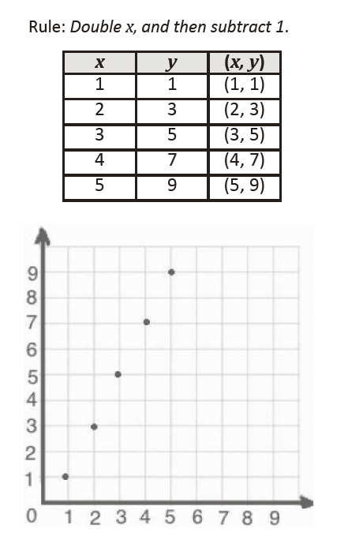
T: (Project the table with only the x -values filled in. Write Rule:
Double x, and then subtract 1 .) Fill in the table, and plot the
points.
S: (Complete the table, and plot (1, 1), (2, 3), (3, 5), (4, 7), and
(5, 9).)
T: Write the next two coordinates in the pattern.
S: (Write (6, 11) and (7, 13).)

Lesson 13
Fluency Practice (12 minutes)
⬛ Sprint: Subtracting Fractions from a Whole Number 5.3H (9 minutes)
⬛ Express Fractions as Decimals 4.2G (3 minutes)

Sprint: Subtracting Fractions from a Whole Number (9 minutes)
Materials: (S) Subtracting Fractions from a Whole Number Sprint
Note: This Sprint reviews Module 3 concepts.

Express Fractions as Decimals (3 minutes)
Materials: (S) Personal white board
Note: This fluency activity reviews Module 4 content.
T: (Write 1/2 on the board.) Express the fraction in hundredths.
S: 50 hundredths.
T: Write this number as a decimal.
S: (Write 0.50.)
T: (Write 1/20 on the board.) Express the fraction in hundredths.
S: 5 hundredths.
T: Write this number as a decimal.
S: (Write 0.05.)

Lesson 14
Fluency Practice (11 minutes)
⬛ Find the Missing Number on a Number Line 4.2H (4 minutes)
⬛ Express Fractions as Decimals 4.3G (3 minutes)
⬛ Multiply Multi-Digit Whole Numbers 5.3B (4 minutes)

Find the Missing Number on a Number Line (4 minutes)
Materials: (S) Personal white board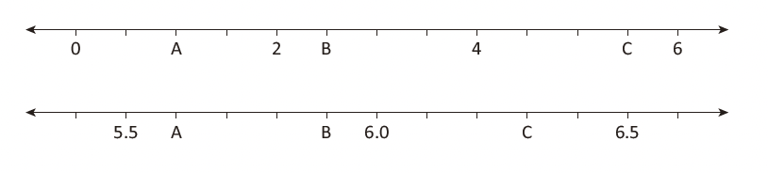
Note: This fluency activity reviews Lesson 1 and prepares students for today’s lesson.
T: (Project the first number line.)
What is the value of A?
S: 1.
T: What is the value of B
as a decimal?
S: 2.5.
T: Write the value of C
as a decimal.
S: (Write 5.5.)
Repeat this activity with the second number line.

Express Fractions as Decimals (3 minutes)
Materials: (S) Personal white board
Note: This fluency activity reviews Module 4 content and prepares students for today’s lesson.
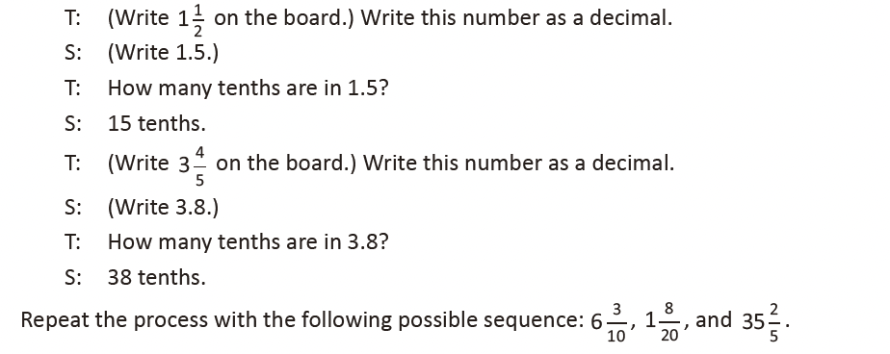
Multiply Multi-Digit Whole Numbers (4 minutes)
Materials: (S) Personal white board
Note: This fluency activity reviews year-long fluency standards.
T: Solve 43 X 23 by using the standard algorithm.
S: (Solve 43 X 23 = 989 by using the standard algorithm.)
Continue the process the following possible sequence: 543 X 23, 49 X 32, 249 X 32, and 954 X 25.

Lesson 15
Fluency Practice (10 minutes)
⬛ Decimal Place Value 5.2A (3 minutes)
⬛ Convert Units 4.8B (3 minutes)
⬛ Multiply Multi-Digit Whole Numbers 5.3B (4 minutes)

Decimal Place Value (3 minutes)
Materials: (S) Personal white board
T: (Draw an unlabeled, six-column place value chart.) Draw 5 tens disks in the tens column. How many
tens do you see?
S: 5 tens.
T: (Write 5 underneath the disks.) There are 5 tens and how many ones?
S: Zero ones.
T: (Write 0 in the ones column. Below it, write 5 tens = ___.) Fill in the blank.
S: 5 tens = 50.
Repeat the process with 5 tenths = 0.5.
T: (Write 6 tenths = ___.) Draw a place value chart like mine. Show the answer in your place value chart.
S: (Draw six 1 tenth disks. Below them, write 0.6.)
Repeat the process with the following possible sequence: 2 hundredths, 21 hundredths, 21 thousandths,
5 tens 3 tenths, 2 tens 6 ones 89 hundredths, and 2 tens 6 ones 89 thousandths.

Convert Units (3 minutes)
Note: This fluency prepares students to convert between millimeters and centimeters in this lesson.
T: (Write 1 cm = ____ mm.) 1 centimeter is the same as how many millimeters?
S: 10 millimeters.
Repeat the process with the following possible sequence: 2 cm, 3 cm, 20 cm, 25 cm.
T: (Write 10 mm = ____ cm.) How many centimeters are in 10 millimeters?
S: 1 centimeter.
Repeat the process with the following possible sequence: 20 mm, 34 mm, 75 mm, and 4 mm.

Multiply Multi-Digit Whole Numbers (4 minutes)
Materials: (S) Personal white board
Note: This drill reviews year-long fluency standards.
T: Solve 45 X 25 using the standard algorithm.
S: (Solve 45 X 25 = 1,125 using the standard algorithm.)
Continue the process for 345 X 25, 59 X 23, 149 X 23,
and 756 X 43.

Lesson 16
Fluency Practice (10 minutes)
⬛ Identify Points on a Coordinate Grid 5.8B (3 minutes)
⬛ Plot Points on a Coordinate Grid 5.8B (4 minutes)
⬛ Multiply and Divide Decimals 5.3E, 5.3G (3 minutes)

Identify Points on a Coordinate Grid (3 minutes)
Materials: (T) Coordinate grid (Fluency Template) (S) Personal white board
Note: This fluency activity reviews Lesson 6.
T: (Project the Fluency Template, shown below.) Write the coordinate pair that is positioned at A.
S: (Write (1.1, 0.7).)
Continue the process for letters B–E.

Plot Points on a Coordinate Grid (4 minutes)
Materials: (S) Personal white board, coordinate grid
insert (Lesson 8 Fluency Template)
Note: This fluency activity reviews Lesson 7.
T: Label the x- and y-axes.
S: (Label the axes.)
T: Label the origin.
S: (Write 0 at the origin.)
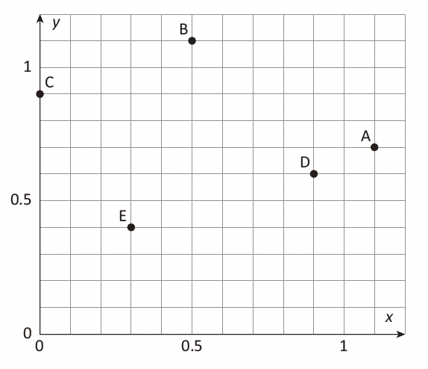
T: Along both axes, label each interval, counting by decimal halves to 6.
S: (Label 0.5, 1, 1.5, 2, 2.5, 3, 3.5, 4, 4.5, 5, 5.5, and 6 along each axis.)
T: (Write (1.5, 4).) Plot the point on your coordinate grid.
S: (Plot the point at (1.5, 4).)
Continue with the following possible sequence: (3, 3.5), (0, 4.5), and (2, 1.5).

Multiply and Divide Decimals (3 minutes)
Materials: (S) Personal white board
Note: This fluency activity reviews Module 2 concepts.
T: (Write 4 X 2 = ___.) What is 4 X 2?
S: 8.
T: (Write 4 X 2 = 8. Beneath it, write 0.4 X 2 = ___.) What
is 0.4 X 2?
S: 0.4 X 2 = 0.8.
T: (Write 0.4 X 2 = 0.8. Beneath it, write 0.04 X 2 = ___.)
Write the number sentence.
S: (Write 0.04 X 2 = 0.08.)
T: (Write 800 ÷ 10 = ___.) What is 800 ÷ 10?
S: 80.
T: (Write 800 ÷ 10 = 80. Beneath it, write 80 ÷ 10 = ___.) What is 80 ÷ 10?
S: 8.
T: (Write 80 ÷ 10 = 8. Beneath it, write 8 ÷ 10 = ___.) Write the number sentence.
S: (Write 8 ÷ 10 = 0.8.)
T: (Write 8 ÷ 10 = 0.8. Beneath it, write 8 ÷ 20 = ___.) Write the number sentence.
S: (Write 8 ÷ 20 = 0.4.)
Continue with the following possible sequence: 8 ÷ 40, 15 ÷ 5, 15 ÷ 50, 2.5 ÷ 10, 2.5 ÷ 50, and 0.12 ÷ 3.

Lesson 17
Fluency Practice (11 minutes)
⬛ Identify Points on a Coordinate Grid 5.8B (3 minutes)
⬛ Find the Missing Number on a Number Line 4.2H (4 minutes)
⬛ Make Larger Units 4.3C (4 minutes)

Identify Points on a Coordinate Grid (3 minutes)
Materials: (T) Coordinate grid (Fluency Template) (S) Personal white board
Note: This fluency activity reviews Lesson 6.
T: (Project the coordinate grid, shown below.) Write the coordinate pair that is positioned at point A.
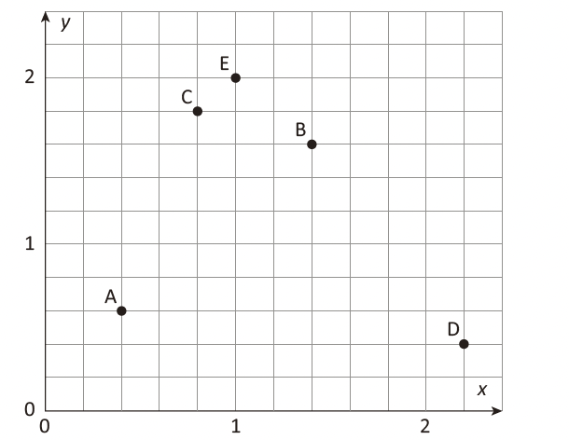
S: (Write (0.4, 0.6).)
Continue the process for points B–E.

Find the Missing Number on a Number Line (4 minutes)
Materials: (S) Personal white board
Note: This fluency activity reviews Lesson 1 and prepares students for today’s lesson.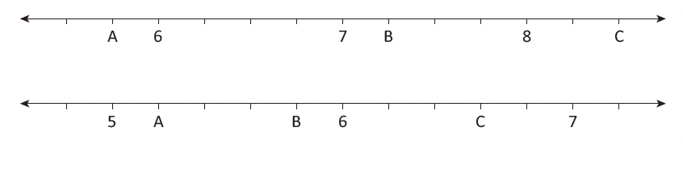
T: (Project the first
number line.) What
is the value of A
as a decimal?
S: 5.75.
T: What is the value
of B as a decimal?
S: 7.25.
T: Write the value of C as a decimal.
S: (Write 8.5.)
Repeat this activity with the second number line.

Make Larger Units (4 minutes)
Materials: (S) Personal white board
Note: This fluency activity reviews Module 3 concepts.
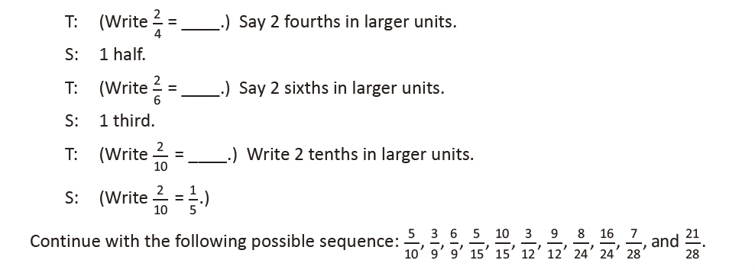

Lesson 18
Fluency Practice (11 minutes)
⬛ Multiply and Divide Decimals 5.3E, 5.3G (4 minutes)
⬛ Make Larger Units 4.3C (3 minutes)
⬛ Subtract Fractions 5.3K (4 minutes)

Multiply and Divide Decimals (4 minutes)
Materials: (S) Personal white board
Note: This fluency activity reviews Module 2 concepts.
T: (Write 3 X 2 = .) What is 3 X 2?
S: 6.
T: (Write 3 X 2 = 6. Beneath it, write 0.3 X 2 = .) What is 0.3 X 2?
S: 0.3 X 2 = 0.6.
T: (Write 0.3 X 2 = 0.6. Beneath it, write 0.03 X 2 = .) Write the number sentence.
S: (Write 0.03 X 2 = 0.06.) T: (Write 60 ÷ 10 = .) What is 60 ÷ 10?
S: 6.
T: (Write 60 ÷ 10 = 6. Beneath it, write 6 ÷ 10 = .) Write the number sentence.
S: (Write 6 ÷ 10 = 0.6.)
T: (Write 6 ÷ 10 = 0.6. Beneath it, write 6 ÷ 20 = .) Write the number sentence.
S: (Write 6 ÷ 20 = 0.3.)
Continue with the following possible sequence: 6 ÷ 30, 25 ÷ 5, 25 ÷ 50, 1.5 ÷ 10, 1.5 ÷ 30, 1.2 ÷ 4,
and 0.12 ÷ 4.

Make Larger Units (3 minutes)
Materials: (S) Personal white board
Note: This fluency activity reviews Module 3 concepts.
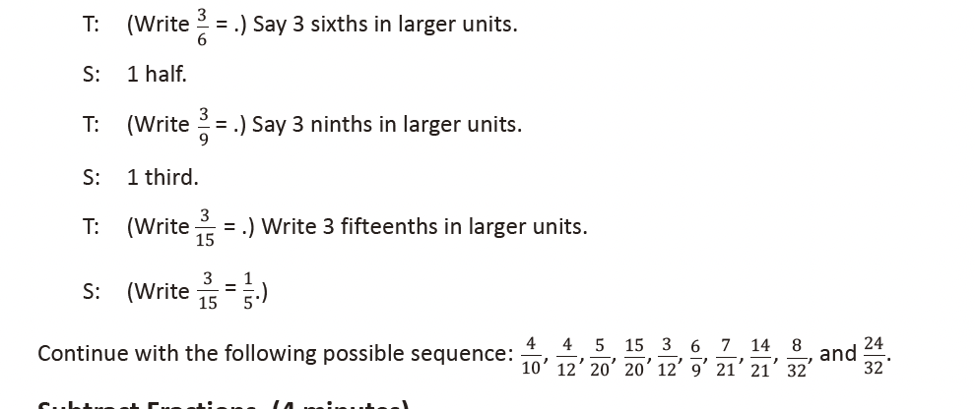

Subtract Fractions (4 minutes)
Materials: (S) Personal white board
Note: This fluency activity reviews Module 3 concepts.
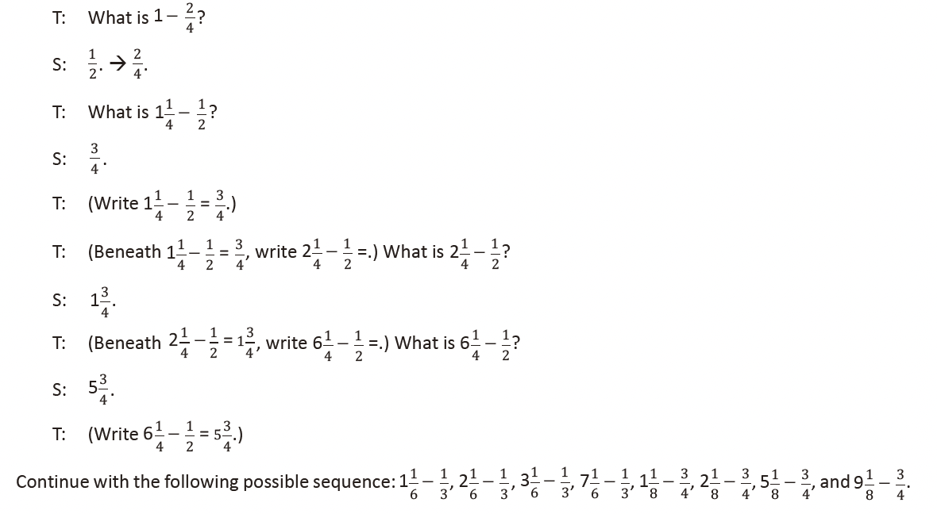

Lesson 19
Fluency Practice (8 minutes)
⬛ Change Mixed Numbers to Improper Fractions 4.3B (4 minutes)
⬛ Add Unlike Denominators 5.3H, 5.3K (4 minutes)

Change Mixed Numbers to Improper Fractions (4 minutes)
Materials: (S) Personal white board
Note: This fluency activity reviews Module 3 concepts.
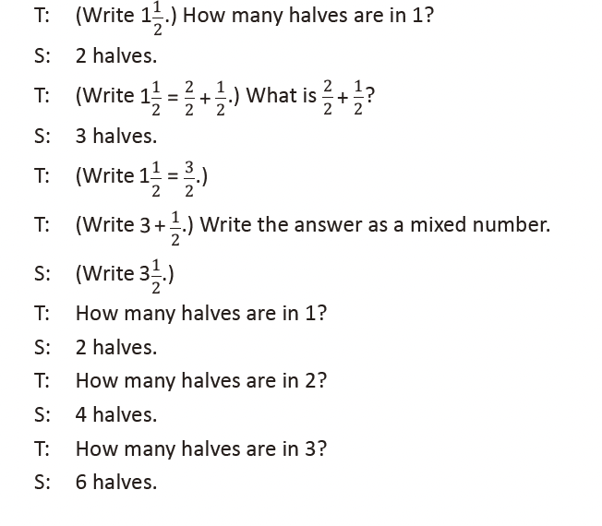
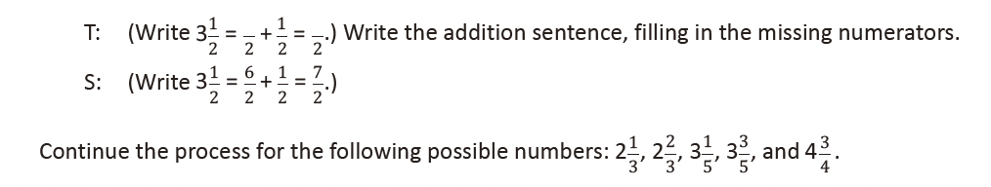
Add Unlike Denominators (4 minutes)
Materials: (S) Personal white board
Note: This fluency activity reviews content from Module 3.
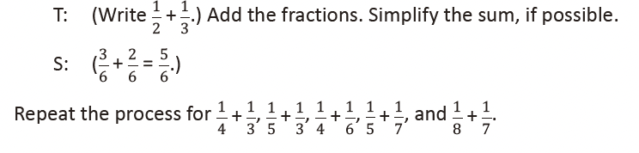

Lesson 20
Fluency Practice (10 minutes)
⬛ Multiply 5.3B (4 minutes)
⬛ Change Mixed Numbers to Improper Fractions 4.3B (3 minutes)
⬛ Add Unlike Denominators 5.3H, 5.3K (3 minutes)
Multiply (4 minutes)
Materials: (S) Personal white board
Note: This fluency activity reviews year-long fluency standards.
T: Solve 34 X 24 using the standard algorithm.
S: (Solve.)
Continue the process with these suggested problems: 134 X 24,
46 X 42, 346 X 42, and 768 X 37.
Change Mixed Numbers to Improper Fractions
(3 minutes)
Materials: (S) Personal white board
Note: This fluency activity reviews Module 3 concepts.
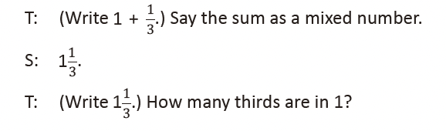
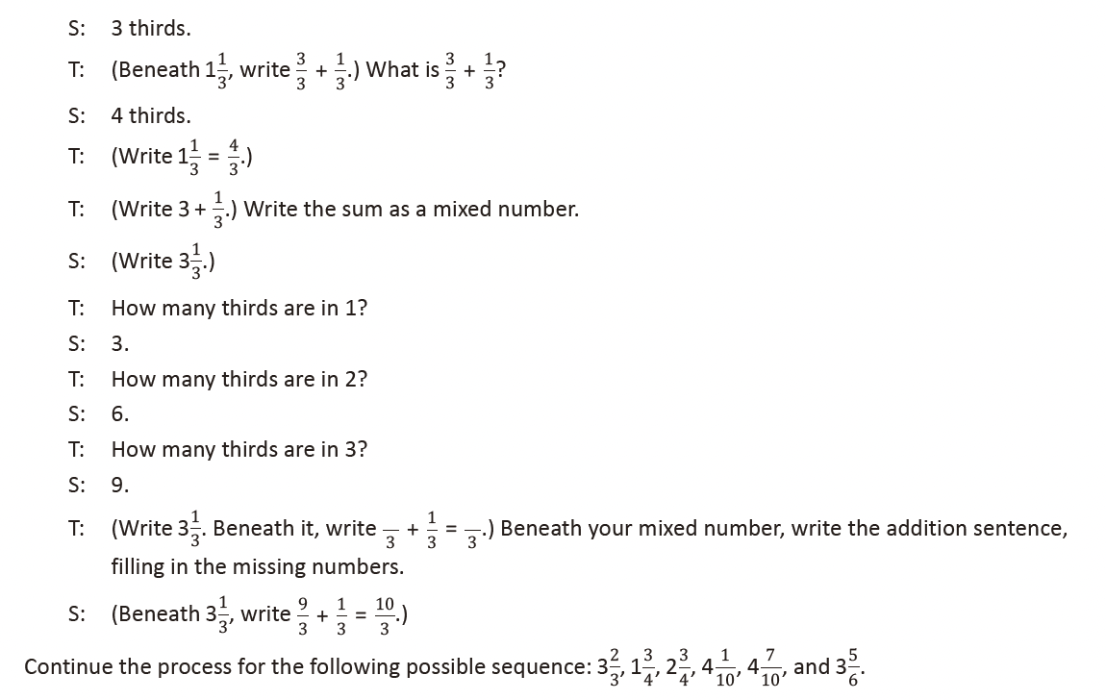

Add Unlike Denominators (3 minutes)
Materials: (S) Personal white board
Note: This fluency activity reviews content from Module 3.
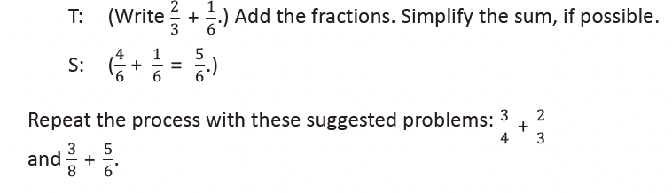

Lesson 21
Fluency Practice (10 minutes)
⬛ Sprint: Change Mixed Numbers into Improper Fractions 4.3B (10 minutes)

Sprint: Change Mixed Numbers into Improper Fractions (10 minutes)
Materials: (S) Change Mixed Numbers into Improper Fractions Sprint
Note: This Sprint reviews Module 3 concepts.

Lesson 22
Fluency Practice (10 minutes)
⬛ Subtract Unlike Denominators 5.3H, 5.3K (4 minutes)
⬛ Order of Operations 5.4F (3 minutes)
⬛ Multiply by Multiples of 10 4.4B (3 minutes)

Subtract Unlike Denominators (4 minutes)
Materials: (S) Personal white board
Note: This fluency activity reviews Module 3 content.
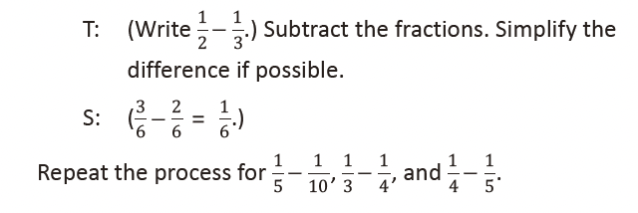
Order of Operations (3 minutes)
Materials: (S) Personal white board
Note: This fluency activity prepares students for today’s lesson.
T: (Write 12 ÷ 3 + 1 = _____.) On your personal white
boards, write the complete number sentence.
S: (Write 12 ÷ 3 + 1 = 5.)
T: (Write 12 ÷ (3 + 1).) On your boards, copy the expression.
S: (Write 12 ÷ (3 + 1).)

T: Write the complete number sentence, performing the operation inside the parentheses.
S: (Beneath 12 ÷ (3 + 1) = ____, write 12 ÷ 4 = 3.)
Continue this process with the following possible sequence: 20 – 6 ÷ 2, (20 – 6) ÷ 2, 7 X 4 + 3, and 7 X (4 + 3).

Multiply by Multiples of 10 (3 minutes)
Materials: (S) Personal white board
Note: This fluency review helps preserve skills students
learned and mastered in Module 1 and lays the groundwork
for future concepts.
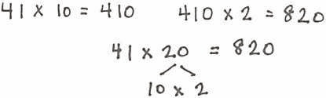
T: (Write 41 X 10 = ______.) Say the complete
multiplication sentence.
S: 41 X 10 = 410.
T: (Write 410 X 2 = ______ beside 41 X 10 = 410.) Say
the complete multiplication sentence.
S: 410 X 2 = 820.
T: (Write 41 X 20 = _____ below 410 X 2 = 820.)
Write 41 X 20 as a three-factor multiplication sentence,
using a number bond to factor 20 as 10 X 2.
S: 41 X 10 X 2 = 820.
T: Show your personal white board. (Check for accuracy.)
Direct students to solve using the same method for 32 X 30 and
43 X 30.

Lesson 23
Fluency Practice (11 minutes)
⬛ Multiply 5.3B (4 minutes)
⬛ Order of Operations 5.4F (3 minutes)
⬛ Subtract Unlike Denominators 5.3H, 5.3K (4 minutes)

Multiply (4 minutes)
Materials: (S) Personal white board
Note: This fluency activity reviews year-long fluency standards.
T: (Write 4 tens 9 ones X 4 tens 3 ones = __ X __.) Write the
multiplication sentence in standard form.
S: (Write 49 X 43 = _____.)
T: Solve 49 X 43 using the standard algorithm.
S: (Solve 49 X 43 = 2,107 using the standard algorithm.)
Continue the process for the following suggested sequence:
249 X 43, 67 X 32, 867 X 32, and 938 X 27.

Order of Operations (3 minutes)
Materials: (S) Personal white board
Note: This fluency activity prepares students for today’s lesson.
T: (Write 24 ÷ 3 + 1 = _____.) On your personal white board, write the complete number sentence.
S: (Write 24 ÷ 3 + 1 = 9.)
T: (Write 24 ÷ (3 + 1).) On your board, copy the expression.
S: (Write 24 ÷ (3 + 1).)
T: Write the complete number sentence, performing the operation inside the parentheses first.
S: (Beneath 24 ÷ (3 + 1) = ____, write 24 ÷ 4 = 6.)
Continue this process with the following possible sequence: 5 X 4 – 2, 5 X (4 – 2), 36 ÷ 6 – 2, and 36 ÷ (6 – 2).

Subtract Unlike Denominators (4 minutes)
Materials: (S) Personal white board
Note: This fluency activity reviews Module 3 content.
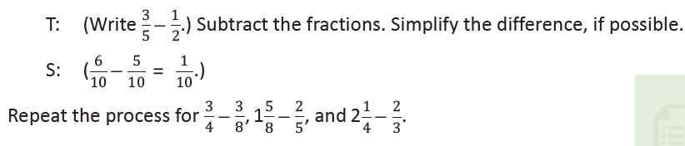

Lesson 24
Fluency Practice (11 minutes)
⬛ Make Larger Units 4.3C (4 minutes)
⬛ Unknown Angles 4.7E (7 minutes)

Make Larger Units (4 minutes)
Materials: (S) Personal white board
Note: This fluency activity reviews Module 3 concepts.
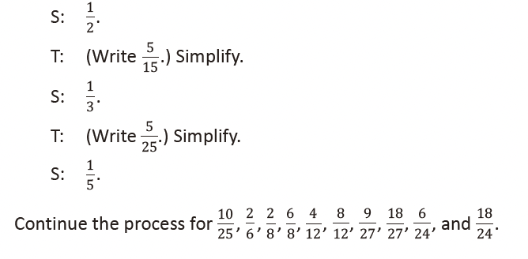
Unknown Angles (7 minutes)
Materials: (S) Blank paper, ruler, protractor
Note: This fluency activity reviews concepts from Grade 4 in preparation for today’s lesson.
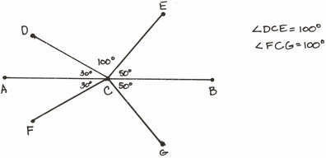
T: Draw a 4-inch segment AB .
T: Plot point C at the 2-inch mark.
T: Draw a 30° angle opening to the left from point C
with AB as one side. Label its endpoint D .
T: Draw a segment symmetric to CD about AB, and
label its endpoint F .
T: Draw an angle less than 90° opening to the right
from point C with AB as one side. Label its
endpoint E .
T: Draw a segment symmetric to CE about AB, and label its endpoint G .
T: What is the measure of ∠ DCE ?
T: What angle has the same measure?
T: Share your work with a partner. What is the measure of ∠ DCE in your partner’s drawing?
As time permits, repeat the process by possibly beginning with a 75° angle.

Lesson 25
Fluency Practice (13 minutes)
⬛ Sprint: Make Larger Units 4.3C (9 minutes)
⬛ Subtract a Fraction from a Whole 5.3H (4 minutes)

Sprint: Make Larger Units (9 minutes)
Materials: (S) Make Larger Units Sprint
Note: This Sprint reviews Module 3 concepts.

Subtract a Fraction from a Whole (4 minutes)
Materials: (S) Personal white board
Note: This fluency activity reviews Module 3 concepts.
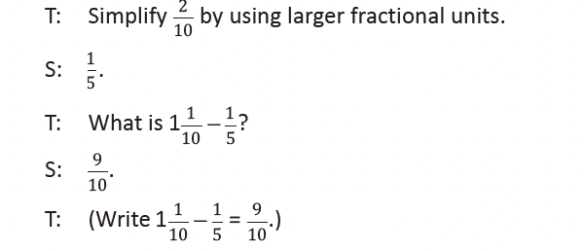
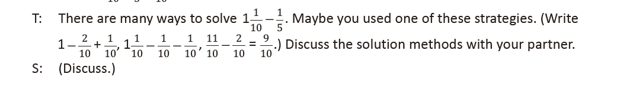
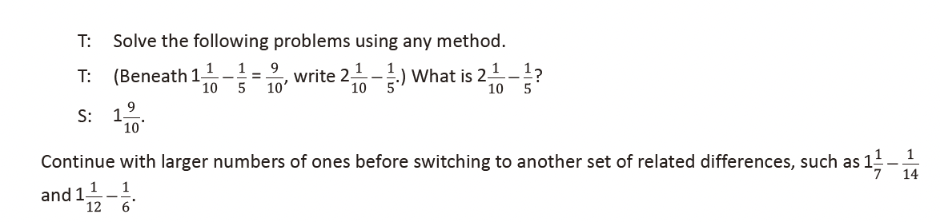

Lesson 26
Fluency Practice (10 minutes)
⬛ Order of Operations 5.4F (3 minutes)
⬛ Multiply a Fraction and a Whole Number 5.3I (3 minutes)
⬛ Multiply Decimals 5.3E (4 minutes)

Order of Operations (3 minutes)
Materials: (S) Personal white board
Note: This fluency activity prepares students for today’s lesson.
T: (Write (6 X 3) + 2 = _____.) Complete the number sentence.
S: (Write (6 X 3) + 2 = 20.)
T: (Write 6 X (3 + 2) = _____.) Complete the number sentence.
S: (Write 6 X (3 + 2) = 30.)
T: (Write 28 – (8 ÷ 2) = _____.) Complete the number sentence.
S: (Write 28 – (8 ÷ 2) = 24.)
T: (Write (28 – 8) ÷ 2 = _____.) Complete the number sentence.
S: (Write (28 – 8) ÷ 2 = 10.)
T: When there are no parentheses, we put imaginary parentheses around multiplication and division
and do them first. We do not need the parentheses in these two expressions: (6 X 3) + 2 and
28 – (8 ÷ 2). We would solve them the same way even without the parentheses.
Continue with the following possible sequence: 5 X 3 + 4 and 5 X (3 + 4).

Multiply a Fraction and a Whole Number (3 minutes)
Materials: (S) Personal white board
Note: This fluency activity reviews Module 4 Lesson 10.
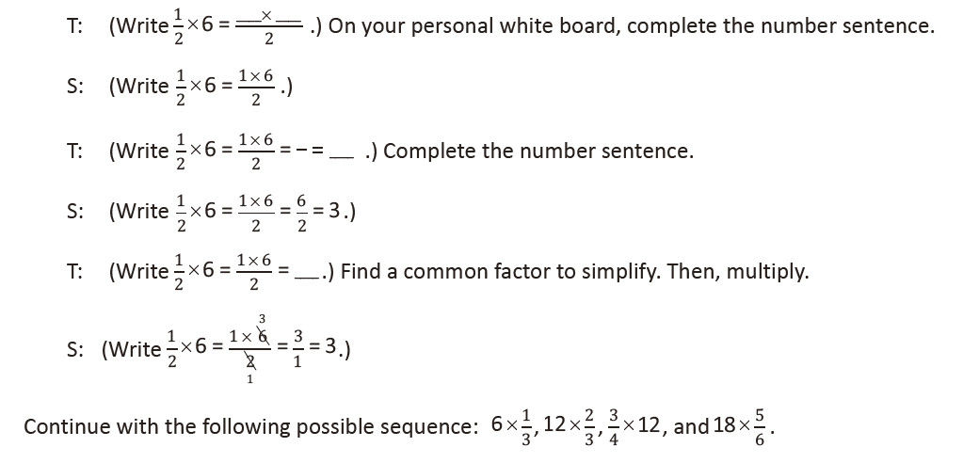
Multiply Decimals (4 minutes)
Materials: (S) Personal white board
Note: This fluency activity reviews Module 4.
T: (Write 3 X 2 = ____.) Say the
number sentence.
S: 3 X 2 = 6.
T: (Write 3 X 0.2 = ____.) On your
personal white board, write the
number sentence.
S: (Write 3 X 0.2 = 0.6.)
T: (Write 0.3 X 0.2 = ____.) Write the number sentence.
S: (Write 0.3 X 0.2 = 0.06.)
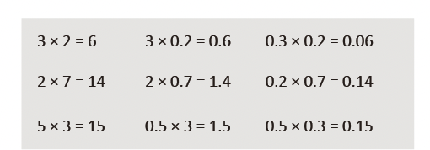
Continue with the following possible sequence: 2 X 7, 2 X 0.7, 0.2 X 0.7, 5 X 3, 0.5 X 3, and 0.5 X 0.3.

Lesson 27
Fluency Practice (12 minutes)
⬛ Multiply a Fraction and a Whole Number 5.3I (4 minutes)
⬛ Multiply Decimals 5.3E (4 minutes)
⬛ Multiply Mentally 5.3B (4 minutes)

Multiply a Fraction and a Whole Number (4 minutes)
Materials: (S) Personal white board
Note: This fluency activity reviews Module 4.
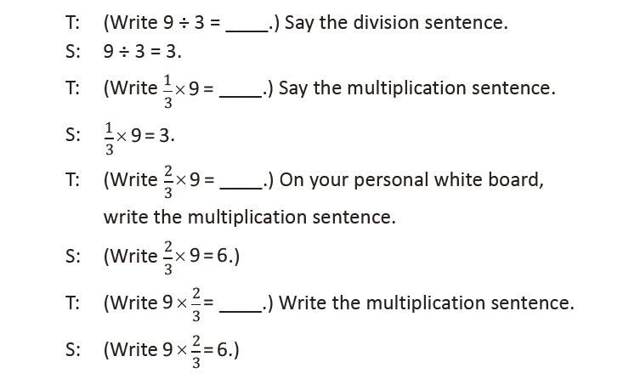
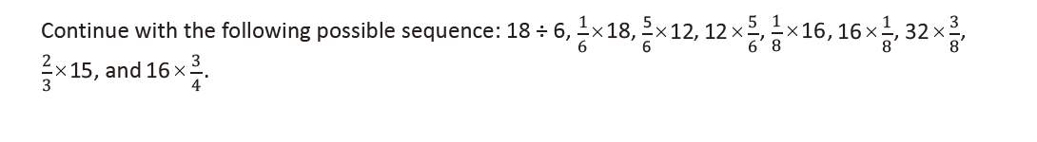
Multiply Decimals (4 minutes)
Materials: (S) Personal white board
Note: This fluency activity reviews Module 4.
T: (Write 3 X 3 = ____.) Say the
multiplication sentence.
S: 3 X 3 = 9.
T: (Write 3 X 0.3 = ____.) On your
personal white board, write the
number sentence.
S: (Write 3 X 0.3 = 0.9.)
T: (Write 0.3 X 0.3 = ____.) Write the number sentence.
S: (Write 0.3 X 0.3 = 0.09.)
Continue with the following possible sequence: 2 X 6, 2 X 0.6, 0.2 X 0.6, 7 X 5, 0.7 X 5, and 0.7 X 0.5.

Multiply Mentally (4 minutes)
Materials: (S) Personal white board
Note: This fluency activity helps bolster students’ understanding of and automaticity with the distributive property of multiplication.
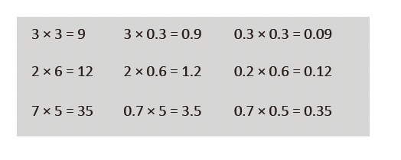
T: (Write 8 X 10 = ____.) Say the multiplication sentence.
S: 8 X 10 = 80.
T: (Write 8 X 9 = 80 – ____ below 8 X 10 = 80.) On your personal white board, write the number
sentence, filling in the blank.
S: (Write 8 X 9 = 80 – 8.)
T: What is 8 X 9?
S: 72.
Continue with the following possible sequence: 8 X 100, 8 X 99, 12 X 10, 12 X 9, 25 X 100, and 25 X 99.

Lesson 28
Fluency Practice (50 minutes)

Mixed Review Fluency Activities
Materials: (S) Fluency activities (Template), Problem Set,
personal white board
Part 1: Reflect on fluency.
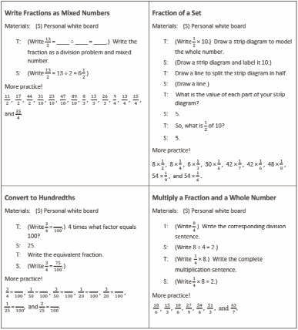
T: This year, we devoted time each day to practice
different skills. Think about these fluency activities as
you answer the questions in the Problem Set.
S: (Answer the six components of Problem 1 listed
below.)
Problem 1: Answer the following questions about fluency.
a. What does being fluent with a math skill mean to
you?
b. Why is fluency with certain math skills important?
c. With which math skills do you think you should be
fluent?
d. With which math skills do you feel most fluent?
Least fluent?
e. How can you continue to improve your fluency?
Part 2: Select and engage in fluency activities .
⬛ Pass out the fluency activities. (There are a total of
16 activities. An example is shown to the right.)
⬛ In pairs or small groups, students alternate the role of
teacher and engage in the activities of their choice.
⬛ As they play, students complete Problems 2 and 3 from
the Problem Set.
Part 3: Create reference cards.
⬛ Students cut out the 16 cards.
⬛ On the back of the fluency activities they have chosen
for intensive summer practice, students make
examples of expressions, equations, models, diagrams,
and/or figures that represent the skill.
Students will store these fluency reference cards in the summer
activity boxes that they create in Lessons 33–34.

Lesson 29
Fluency Practice (12 minutes)
⬛ Sprint: Multiply Decimals 5.3E (8 minutes)
⬛ Multiply Mentally 5.3B (4 minutes)

Sprint: Multiply Decimals (8 minutes)
Materials: (S) Multiply Decimals Sprint
Note: This fluency activity reviews Module 4 concepts.

Multiply Mentally (4 minutes)
Materials: (S) Personal white board
Note: This fluency activity helps bolster students’
understanding of and automaticity with the distributive
property of multiplication.
T: (Write 7 X 10 = ____.) Say the multiplication sentence.
S: 7 X 10 = 70.
T: (Write 7 X 9 = 70 – ____ below 7 X 10 = 70.) On your
personal white board, write the complete number
sentence.
S: (Write 7 X 9 = 70 – 7.)
T: 7 X 9 is … ?
S: 63.
Continue with the following possible sequence: 7 X 99, 15 X 9,
and 31 X 99.

Lesson 30
Fluency Practice (10 minutes)
⬛ Multiply 5.3B (5 minutes)
⬛ Unit Conversions 5.7 (5 minutes)

Multiply (5 minutes)
Materials: (S) Personal white board
Note: This fluency activity reviews year-long fluency standards.
T: Solve 57 X 37 using the standard algorithm.
S: (Write 57 X 37 = 2,109 using the standard algorithm.)
Continue with the following possible sequence: 457 X 37, 68 X 43, 568 X 43, and 749 X 72.

Unit Conversions (5 minutes)
Materials: (S) Personal white board
Note: This fluency activity reviews Module 4 concepts.
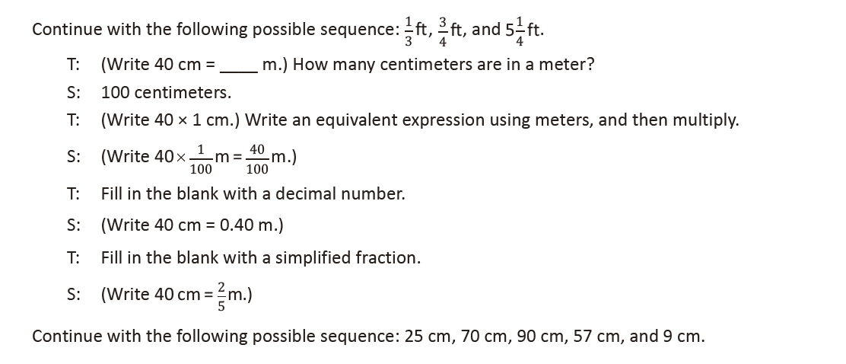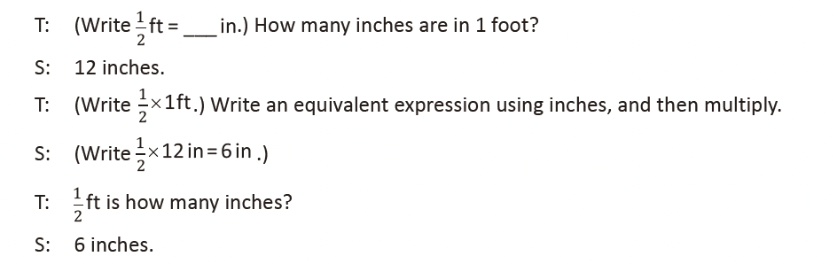

Lesson 31
Fluency Practice (10 minutes)
⬛ Divide Whole Numbers by Unit Fractions and
Unit Fractions by Whole Numbers 5.3J (4 minutes)
⬛ Divide by Two-Digit Numbers 5.3C (6 minutes)

Divide Whole Numbers by Unit Fractions and Unit Fractions by Whole Numbers (4 minutes)
Materials: (S) Personal white board
Note: This fluency activity reviews Module 4 concepts.
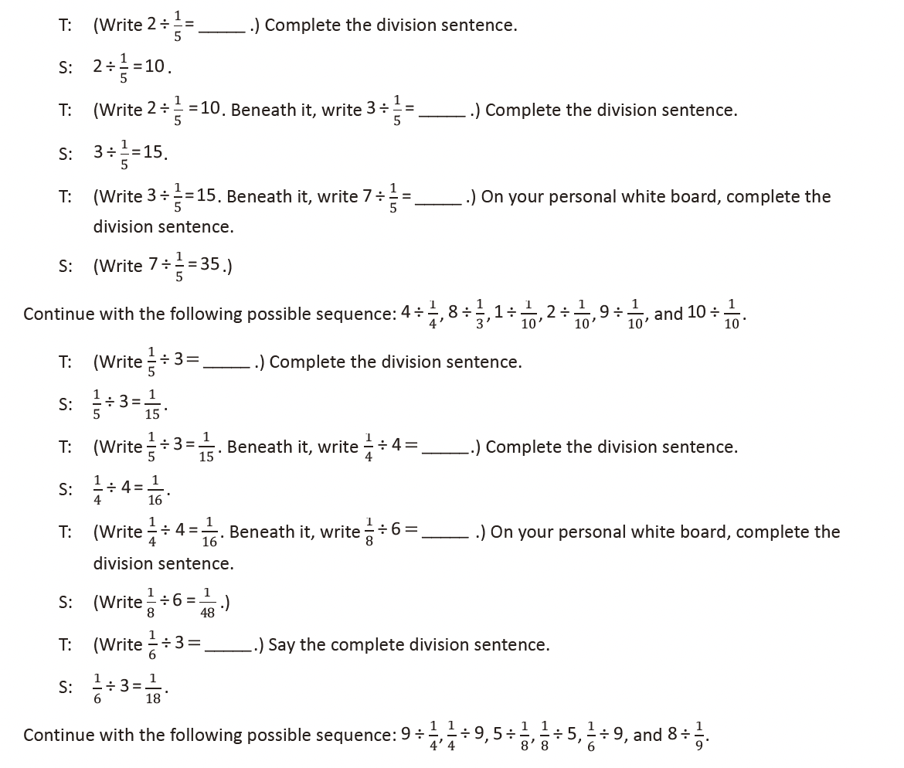
Divide by Two-Digit Numbers (6 minutes)
Materials: (S) Personal white board
Note: This fluency activity reviews Module 2 content and
directly leads into today’s lesson where students use a calculator
to find quotients in order to see patterns.
T: (Write 61 ÷ 19.) On your personal white board, find the
quotient.
S: (Solve and check as exemplified in the illustration.)
Continue with the following possible sequence: 79 ÷ 22 and 97 ÷ 31.
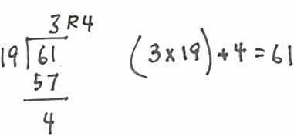

Lesson 32
Fluency Practice (12 minutes)
⬛ Multiply 5.3B (4 minutes)
⬛ Divide by Two-Digit Numbers 5.3C (4 minutes)
⬛ The Fibonacci Sequence 5.3A (4 minutes)

Multiply (4 minutes)
Materials: (S) Personal white board
Note: This fluency activity reviews year-long fluency standards.
T: (Write 6 tens 8 ones X 4 tens 3 ones = ____ X ____ = ____.) Write the multiplication sentence in
standard form.
S: (Write 68 X 43 = ____.)
T: Solve 68 X 43 using the standard algorithm.
S: (Write 68 X 43 = 2,924 using the standard algorithm.)
Continue with the following possible sequence: 368 × 43, 76 × 54, 876 × 54, and 978 × 86.

Divide by Two-Digit Numbers (4 minutes)
Materials: (S) Personal white board
Note: This fluency activity reviews Module 2 content and directly leads into today’s lesson in which students use calculators to find quotients and uncover patterns.
T: (Write 87 ÷ 31.) On your personal white board, find the
quotient.
S: (Solve and check as shown to the right.)
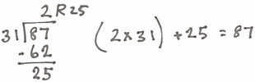
Continue with the following possible sequence: 82 ÷ 23 and 95 ÷ 27.

The Fibonacci Sequence (4 minutes)
Materials: (S) Personal white board
Note: This fluency activity reviews Lesson 31 and leads into today’s lesson.
T: For 90 seconds, write as many numbers in the Fibonacci sequence as you can. Take your mark, get
set, go.
S: (Write.)
T: Stop! Check your sequence with a partner for one minute.
S: (Check.)
T: Write down the last number you wrote at the top of your personal white board. Now, see if you can
get further than you did before. Take 90 seconds to write the sequence again. Take your mark, get
set, go!
S: (Write.)
T: Raise your hand if you were able to write more numbers in the sequence this time.

Lesson 33
Fluency Practice (12 minutes)
⬛ Find the Volume 5.4H (6 minutes)

Find the Volume (6 minutes)
Materials: (S) Personal white board
Note: This fluency activity reviews Module 5.
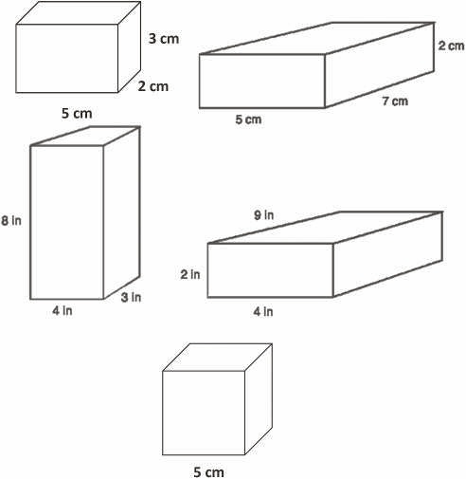
T: On your personal white board, write the
formula for finding the volume of a
rectangular prism.
S: (Write V = l X w X h .)
T: (Write V = l X w X h . Project the rectangular
prism with a length of 5 cm, width of 2 cm,
and height of 3 cm. Point to the length.)
Say the length.
S: 5 cm.
T: (Point to the width.) Say the width.
S: 2 cm.
T: (Point to the height.) Say the height.
S: 3 cm.
T: On your personal white board, write a
multiplication sentence to express the
volume of the rectangular prism.
S: (Beneath V = l X w X h , write V = 5 cm X 2 cm X 3 cm. Beneath it, write V = 30 cm3.)
Continue the process for other rectangular prisms.
T: (Project the cube with side lengths equal to 5 cm.) Name the
prism.
S: Cube.
T: What is the length of each side of the cube?
S: 5 cm.
T: On your personal white board, write a multiplication sentence
to show the volume of the cube.
S: (Write V = 5 cm X 5 cm X 5 cm. Beneath it, write V = 125 cm3.)

Lesson 34
Fluency Practice (12 minutes)
⬛ Multiply 5.3B (4 minutes)
⬛ Divide by Two-Digit Numbers 5.3C (4 minutes)
⬛ Find the Volume 5.4H (4 minutes)

Multiply (4 minutes)
Materials: (S) Personal white board
Note: This fluency activity reviews year-long fluency standards.
T: Solve 97 X 64 using the standard algorithm.
S: (Write 97 X 64 = 6,208 using the standard algorithm.)
Continue with the following possible sequence: 897 X 64,
89 X 67, 789 X 67, and 698 X 86.

Divide by Two-Digit Numbers (4 minutes)
Materials: (S) Personal white board
Note: This fluency activity reviews content from Module 2.
T: (Write 163 ÷ 12.) On you personal white board, find the
quotient.
S: Solve and check.
Continue with the following possible sequence: 278 ÷ 51 and 741 ÷ 23.

Find the Volume (4 minutes)
Materials: (S) Personal white board
Note: This fluency activity reviews Module 5 content.
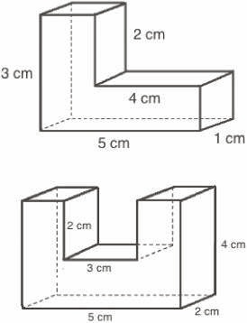
T: Say the formula for finding the volume of a rectangular
prism.
S: Length times width times height.
T: (Project the composite figure.) Sketch the composite figure.
S: (Sketch.)
T: Draw a line that breaks the figure into 2 rectangular prisms.
S: (Draw a line.)
T: Find the volume of the composite figure by adding the
volumes of each rectangular prism.
S: (Write 3 cm X 1 cm X 1 cm = 3 cm3. 4 cm X 1 cm X 1 cm = 4 cm3.
3 cm3 + 4 cm3 = 7 cm3.)
Continue the process for the other composite figure.

