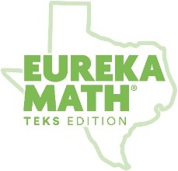
Module 1
Version 1.3.2

Numbers to 10

SUPPORT TOWARD MASTERY
Use the following activities from the curriculum with students who need additional support to master the key concepts in the checklist and notecards. Employ the help of instructional support staff, classroom volunteers, or older students to facilitate some of these activities.

Mid-Module (Topics A–D)

Matches two objects; describes matching and nonmatching attributes (color, size, shape, type, use) [K.8A]
The curriculum revisits this key concept in Module 2 Topic A. Return to these supports if this key concept still challenges students after Module 2.
• Module 1 Lesson 1, Lesson 2, and Lesson 3 Problem Sets—Cut out the pictures and have students match the animals or objects. Have students discuss the attributes (color, size, shape, type, use) in each match. This can be a center activity.
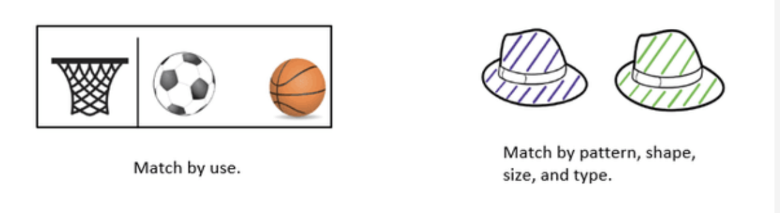

Classifies 6–10 objects into groups (color, size, shape, type, use) [K.8A]
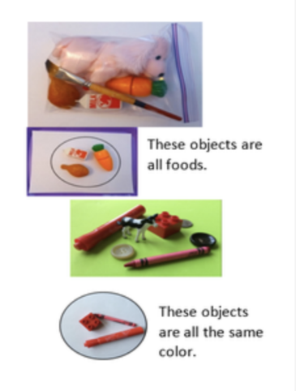

Module 2 Topic A revisits this key concept. Return to these supports if this key concept challenges students after Module 2.
• Prepare small bags of sorting items with two categories (e.g., two types of pasta, two colors of construction paper, big and small paper clips, crayons and pencils). Have students sort the items in the bags and say why the items in each group belong together and what makes the groups different.

Counts a group of up to 5 objects—Number Word List [K.2A, K.2C, K.2E, K.2I]
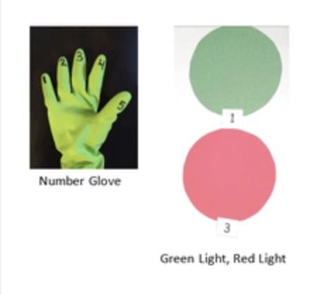
- Module 1 Lesson 1 Fluency: Counting with the Number Glove to 3 —(Extend this activity by continuing to count up to 5.)
- Module 1 Lesson 2 Fluency: Rekenrek to 3—(Extend this activity by continuing to count up to 5.)
- Module 1 Lesson 5 Fluency: Pop Up Number
- Module 1 Lesson 5 Fluency: Green Light, Red Light
- Module 1 Lesson 6 Fluency: Happy Counting Within 5 —(Count forward and backward within 5.)
- Module 1 Lesson 7 Fluency: Sunrise/Sunset Counting to 5

Counts a group of up to 5 objects—1:1 Correspondence [K.2A, K.2C, K.2]
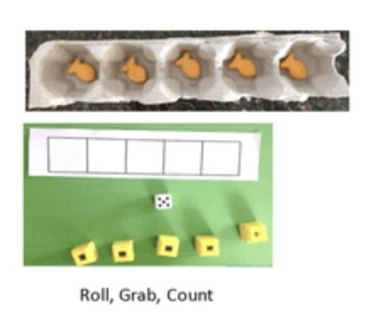
- Cut an egg carton so it has five cups in a line. When students count a set, have them place one object in each slot as they say each number until they have counted all the objects. In the second half of the module, students count 6–10 objects, in an egg carton, in a 5-group configuration with five slots on top and five slots on bottom.
- Module 1 Lesson 1 Fluency: Show Me Beans (Up to 5)
- Module 1 Lesson 5 Fluency: Birthday Candles
- Module 1 Lesson 7 Fluency: Roll, Grab, Count

Counts a group of up to 5 objects—Cardinality [K.2A, K.2C, K.2]
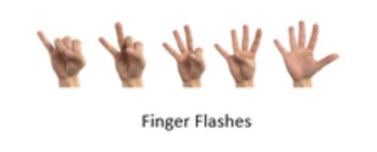
- Module 1 Lesson 4 Fluency: Finger Flashes to 5
- Module 1 Lesson 8 Fluency: How Many Dots? (Up to 5 dots)
- Module 1 Lesson 9 Fluency: 5-Frame Peek-a-Boo
- Module 1 Lesson 10 Fluency: Line Up, Sprinkle, Circle (Up to 5 beans)
- 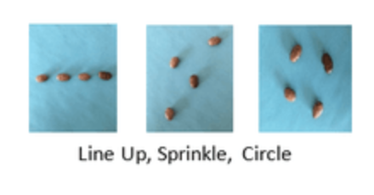
- Module 1 Lesson 8 and Lesson 10 Problem Sets—Cut up the problem sets and have students count and say how many objects are in each set. To review classifying and sorting, have students sort so all the groups of 1 are together, groups of 2 are together, and so on.

Matches a numeral with a group of objects to 5 [K.2C, K.2D, K.2E]
- Module 1 Lesson 7 Concept Development—Have sets of one to five linking cube towers and one to five 5-group cards that match. This activity can be an independent center activity. (Find 5-group cards in Module 1 Lesson 7 Template 2 or in the Hide Zero Cards Student Pack.)
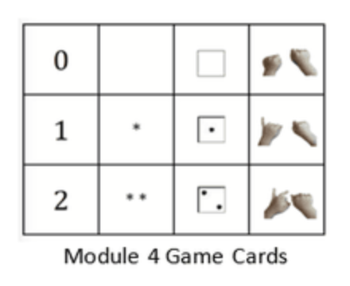

- Module 1 Lesson 8, Lesson 9, and Lesson 10 Problem Sets—Cut out pictures of objects and dots from the Problem Sets and match 5-group cards to them. This activity can be a center activity.
- Module 1 Lesson 8 Fluency: Finger Counting—Cut out the Matching Game Cards. (GK M4 Lesson 1 Template 2). Match a numeral with a group of up to 5 objects.

Uses zero to describe a group with no objects [K.8A, K.2A, K.2B, K.2C, K.2D. K.2E]
- During snack time, give each student three crackers. Direct students to eat the crackers one at a time. After they eat each cracker, ask how many are left. When students have eaten all the crackers, encourage students to say zero instead of none.
- Module 1 Lesson 12 Homework—Cut out pictures and digits to work on matching numerals to groups of objects and the concept of zero.
- Module 1 Lesson 13 Problem Set (page 2)—Use other picture and digit cards you have to duplicate the activity in the Lesson 13 Problem Set.

Writes numerals 0–5 [K.8A, K.2A, K.2B, K.2C, K.2D. K.2E]
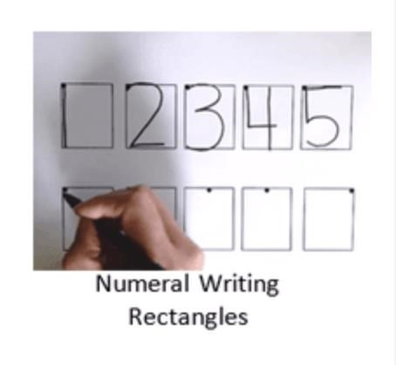
- Module 1 Lesson 12, Lesson 13, and Lesson 15 Practice Sheets—Use the numeral writing practice sheets with personal whiteboards at a center. Send home the practice sheets as homework.
- Module 1 Lesson 15 Fluency: See, Count, Write Numbers to 3 (Extend to 5). Consider using the Numeral Writing Rectangles Template in the personal whiteboard.

End-of-Module (Topics E–H)

Counts out up to 10 objects from a larger group [K.2A, K.2C, K.2E]
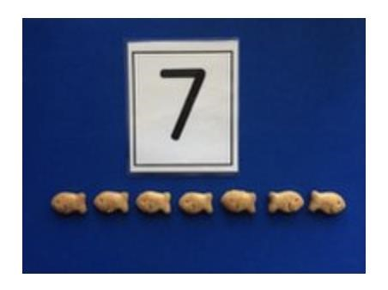
- Module 1 Lesson 5 Fluency: Birthday Candles—Use a 10-sided die or numeral cards 0–9 to extend the activity beyond 6.
- When passing out materials, put all items (e.g., teddy bear counters, pencils, napkins) in a pile and have students count out their materials from the larger pile.

Counts a group of 6–10 objects—Number Word List; 1:1 Correspondence; Cardinality [K.2A, K.2C, K.2E, K.8A]
If students are struggling with one of these aspects of the number core (number word list, 1:1, cardinality) for groups of 6–10 objects, see the activities listed previously in the Mid-Module (Topics A–D) section. Extend those activities to 10 as students are ready. The following supports target counting in different configurations by using multiple aspects of the number core.
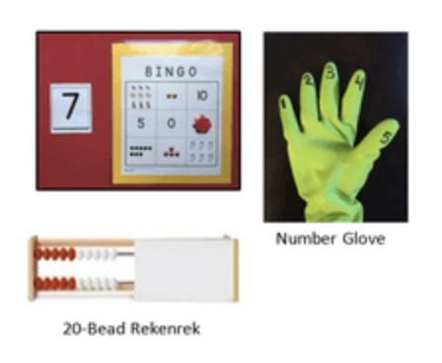

Linear
- Module 1 Lesson 1 Fluency: Counting with the Number Glove to 3—Extend this activity by continuing to count up to 10.
- Module 1 Lesson 2 Fluency: Rekenrek to 3—Extend this activity by continuing to count up to 10.

Array
• Module 1 Lesson 8 Fluency: How Many Dots?—Use cards 0–10. Create dot cards the array configurations for 4, 6, 8, 9, and 10.
Note: While 5-group cards for 6–9 are incomplete arrays, they require Similar organization skills.

Circular

- Module 1 Lesson 5 Fluency: Pop Up Number—Count around the circle to 10 with varying Pop Up numbers.
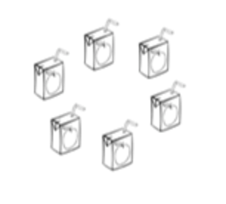

- Module 1 Lesson 6 Fluency: Counting Around the Circle to 5 (up to 10)
- Module 1 Lesson 22 Problem Set Use Problem Sets or Homework in a whiteboard at a center to provide independent practice with counting 4–10 objects in varied configurations.

Scattered
• Module 1 Lesson 10 Fluency: Line Up, Sprinkle, Circle (Up to 10 beans)
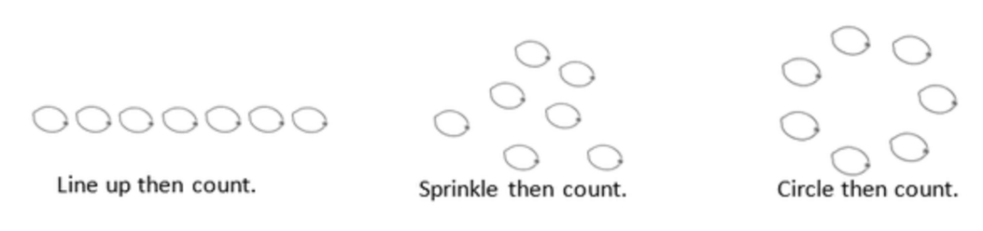

Demonstrates understanding of 5-group configurations (recognizes, counts, organizes, draws) [K.2D]

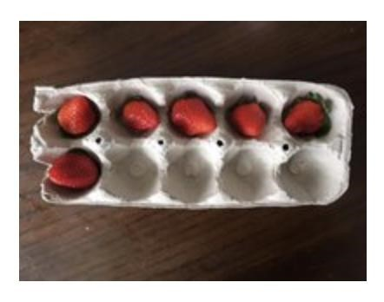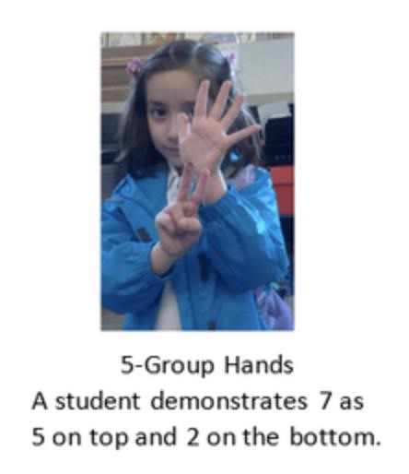
Students will need fluency with 5-groups beginning in Module 4. If students are still counting dots individually at the end of Module 1, consider exchanging one Fluency Practice in each lesson of Module 2 for a fluency activity involving 5-groups.
- Module 1 Lesson 19 Fluency: 5-Groups (Count On from 5)
- Module 1 Lesson 19 Fluency: Show Me Beans (Color Change at 5)
- Module 1 Lesson 22 Fluency: 5-Group Peek-a-Boo
- Module 1 Lesson 24 Fluency: Hands Number Line to 10
- Module 1 Lesson 25 Fluency: Five Shortcut
- Module 3 Lesson 9 Fluency: 5-Group Hands

Counts a group. Adds 1 and knows how many without recounting [K.2A, K.2C, K.2D, K.2E, K.2F, K.5]
- Module 1 Lesson 8 Fluency: How Many Dots?—Extend this activity by asking students to say how many there would be if there were one more dot.
- Module 1 Lesson 30 Fluency: Show Me 1 More
- Module 1 Lesson 31 Fluency: Roll and Write 1 More
- Module 1 Lesson 31 Fluency: Show Me 1 More (the Math Way)

Writes numerals 6–10 [K.2B]
- Module 1 Lesson 18, Lesson 20, Lesson 22, Lesson 24, and Lesson 26 Practice Sheets— Use the numeral writing practice sheets in personal whiteboards at a center. Send home the practice sheets as homework. Consider making one sheet containing numerals 6–10. Numeral Writing Rectangles Template
- Module 1 Lesson 30 Homework—Use this as an opportunity for students to write numerals 0–10 in order.

