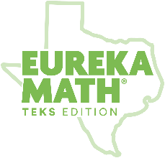

Eureka Math
TEKS Edition
Grade K • Module 1
Observational Assessment

 | Names 2D  and 3D  shapes in the environment | Describes  attributes of  2D shapes  T–triangle  R–rectangle  S–square  C–circle  H–hexagon | Correctly  names 3D  shapes in multiple sizes and orientations  SP–sphere  CB–cube  CN–cone  CL–cylinder | Describes  attributes of  3D shapes including 2D components  SP–sphere  CB–cube  CN–cone  CL–cylinder | Classifies and sorts regular and irregular and two- and three- dimensional figures | Correctly  names 2D  shapes in multiple sizes and orientations  T–triangle  R–rectangle  S–square  C–circle  H–hexagon | Collects and sorts data into categories and creates graphs | Identifies shapes as flat (2D) of solid (3D) | Notes
Topic | A, B, | A, B | B | B | A, B | A | A, B | C
Standard(s)  Student Name Below | K.6A | K.6D | K.6B | K.6B, K.6C | K.6D | K.6E | K.8A, K.8B, K.8C | K.6A, K.6B, K.6C, K.6E

