Module 2
Version 1.3.2

Two-Dimensional and Three-Dimensional Shapes

SUPPORT TOWARD MASTERY

Use the following list of activities from the curriculum with students who need additional support to master the key concepts listed in the checklist and cards. Employ the help of instructional support staff, classroom volunteers, or older students to facilitate some of these activities.

End-of-Module (Topics A–C)
Correctly names 2D shapes in multiple sizes and orientations (triangle, rectangle, square, circle, hexagon) [K.6E]
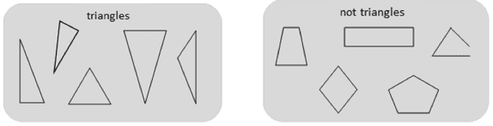
- Module 2 Lesson 3 Fluency: Triangle or Not—Continue to provide additional exposure and experiences recognizing and naming the shape based on its attributes. This fluency can be repeated using whichever shape students need particular practice with.
- Module 2 Lesson 5 Fluency: Groups of Shapes—Continue to provide students opportunities to connect the attributes students identify with the shape names.
- Module 2 Lesson 5 Fluency: Peek-a-Boo Shapes—Continue to provide students opportunities to recognize the same shape across varied sizes and orientations.
Describes attributes of 2D shapes (triangle, rectangle, square, circle, hexagon) [K.6.D]
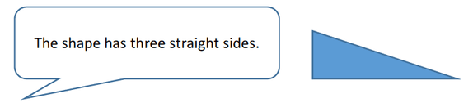
- Module 2 Lesson 3 Fluency: Triangle or Not—Continue to provide additional exposure and experiences describing the shape based on its attributes. This fluency can be repeated using whichever shape students need particular practice with.
- Module 2 Lesson 5 Fluency: Peek-a-Boo Shapes—Continue to provide students opportunities to describe shapes based on attributes.
- Module 2 Lesson 5 Fluency: Groups of Shapes—Continue to provide students opportunities to describe the attributes of shapes seen in their environment.
Correctly names 3D shapes in multiple sizes and orientations (sphere, cube, cone, cylinder) [K.6.E]
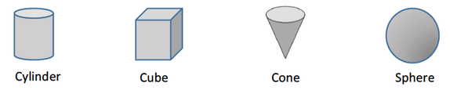
- Module 2 Lesson 7 Fluency: Show Me Shapes—Continue to provide students opportunities to identify 3D shapes in multiple sizes and orientations. Ask students to name the solids they choose.
- Module 2 Lesson 5 Fluency: Groups of Shapes—Use 3D shapes instead of 2D shapes. Continue to provide students opportunities to name the shapes seen in their environment.

Describes attributes of 3D shapes (sphere, cube, cone, cylinder) [K.6.B]
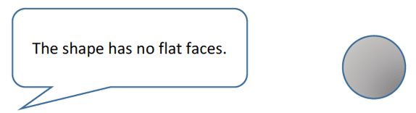
- Module 2 Lesson 7 Fluency: Show Me Shapes—Focus students on describing the attributes of the 3D shapes as they engage in this activity with partners.
- Module 2 Lesson 5 Fluency: Groups of Shapes—Use 3D shapes instead of 2D shapes. Once students are in groups, ask students to describe the attributes of their solid.
Names 2D and 3D shapes in the environment [K.6.A]
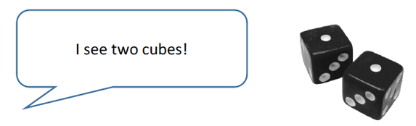
- Module 2 Lesson 1, Lesson 4, and Lesson 6 Concept Development—Continue inviting students to be shape detectives in the classroom and around their school and home environments. When possible, hang a sign with the shape name and example near the object found in the environment or keep a running chart to list objects of the various shapes.

Identifies shapes as flat (2D) or solid (3D) [K.6.E]
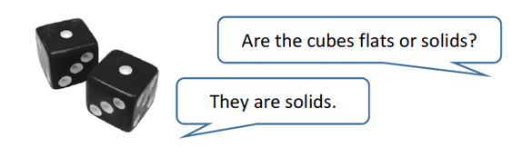
- Increase student encounters with 2D and 3D shapes through recess materials, learning center materials, and other daily integrations of both flat and solid shapes. Simply ask, “Is this shape a flat or a solid?”

