Comparison of Length, Weight, Capacity, and Numbers to 10

SUPPORT TOWARD MASTERY
Use the following list of activities from the curriculum with students who need additional support to master the key concepts in the checklist and cards. Employ the help of instructional support staff, classroom volunteers, or older students to facilitate some of these activities.

Mid-Module (Topics A–D)
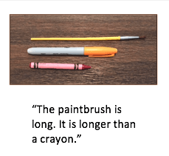
Describes several measurable attributes of an object [K.7A, K.7B]
- Module 3 Lesson 3 Homework—Place three objects at a table. Use Lesson 3 Homework as a sentence starter to describe the objects. Make other sentence starters by using longer, shorter, heavier, lighter, more, and less.
- Describe objects around the classroom—Have pairs of students or classroom helpers describe objects around the classroom. Remind students to focus on measurable attributes (height, length, weight, volume) in their descriptions.
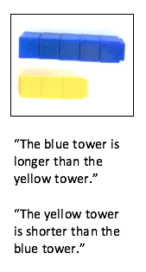

Compares lengths of two objects [K.7A, K.7B]
- Module 3 Lesson 2 Fluency: Show Me Taller/Shorter
- Module 3 Lesson 2 Concept Development—Give students pieces of string to compare the lengths of objects around the classroom.
- Module 3 Lesson 3 Homework—Compare a new crayon to the pictures of cars in the Homework or create another page of images for comparison. Place the page in a personal whiteboard for durability.
- Module 3 Lesson 5 Concept Development—Compare linking cube towers, and state which is longer and which is shorter. Consider reducing the number of linking cube stairs if 10 stairs are visually overwhelming or create a distraction.
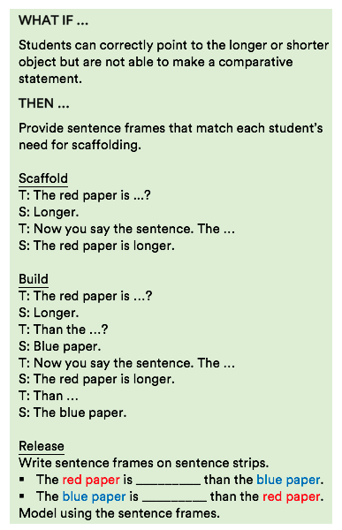
Aligns endpoints when comparing length or height [K.7A, K.7B]
- Attend to endpoint alignment while doing the comparison activities described in the key concept, Compares lengths of two objects, above.
- Module 3 Lesson 1 Problem Set—Cut paper strips for students to compare. Use different-color paper for each pair of comparison strips. Remind students to align the endpoints of the strips with the end of the desk when they compare to find which strip is longer or shorter. This activity may be done at a station.
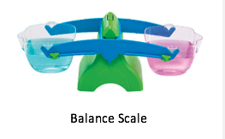
Compares weights of two objects [K.7A, K.7B]
- Module 3 Lesson 9 Concept Development—Set up a balance scale at a station. Place several objects in a box for students to compare by using the balance scale. Be sure to have students use comparative statements as they test their guesses with the balance scale.
- Students can rotate to this station during the day as time allows.
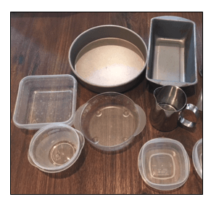
Compares volume of two containers [K.7A, K.7B]
- Module 3 Lesson 13 Concept Development—Set up a volume station (may be done outside). Place several containers at the station for students to compare volume by using sand or water. Use two equal containers of sand or water to test the containers they are comparing. Be sure to have students use comparative statements as they test their guesses by pouring the contents of one container into another container to see which holds more, less, or the same.
Tells how many smaller units are the same capacity as a larger unit
- This key concept provides exposure to a G2 standard and does not require mastery in Kindergarten. Students will have additional exposure to this concept in Grades 1 and 2.

End-of-Module (Topics E–H)
Matches to compare sets [K.2E, K.2G]
- Module 3 Lesson 16 and Lesson 18 Problem Sets and Lesson 16 and Lesson 18 Homework—For clarity, cut all text from these worksheets so only the pictures are visible. Place the sheets in a personal white board and have students draw lines to match the sets. Be sure to have students make comparative statements after they draw lines to match the sets. Students tend to make statements that use more with greater frequency than statements that use less or fewer. Ask students for both statements. “There are more plates than forks. There are fewer forks than plates.”
- Module 3 Lesson 17 Homework—Same directions as above.
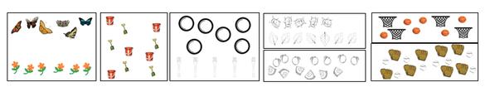
Counts to compare sets [K.7B, K.2E, K.2G]
- Module 3 Lesson 5 Concept Development Compare linking cube towers by counting each cube. Compare lengths by stating which tower has more or fewer cubes.
- Module 3 Lesson 16 and Lesson 18 Problem Sets and Lesson 16 and Lesson 18 Homework—Using the modified sheets from Matches to Compare Sets (see key concept above), have students count each object and use numbers in their comparative statements (e.g., 6 plates is more than 5 forks). If students are struggling, encourage them to match objects by drawing lines to find out which set has more or less, or if the sets are the same. Then have the students count each set and write the numbers before they make comparative statements by using numbers.
- 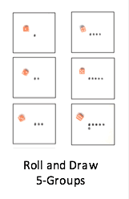
Creates a set to show more than, less/fewer than, and the same as [K.7B, K.2D, K.2E, K.2F, K.2G]
- Module 3 Lesson 7 Fluency: Roll and Draw 5-Groups
- Module 3 Lesson 18 Fluency: Show Me 1 More, 1 Less
- Module 3 Lesson 22 Concept Development—Play the game at the end of the Concept Development. Allow students to play at recess or invite older students or parent helpers to play the game with the students.
- Module 3 Lesson 21, Lesson 22, and Lesson 23 Problem Sets and Lesson 21, Lesson 22, and Lesson 23 Homework—Use these sheets in a personal whiteboard for practice creating sets that are greater than, less than, and the same as. If drawing is too time-consuming, allow students to use small stamp and ink pads to create sets.
Compares numbers 1–10 with sets of objects [K.2G, K.2H]
- Module 3 Lesson 24 and Lesson 25 Concept Development—Set up a comparison station with sets of objects (up to 10) in small containers. Students choose two sets, count each set, match or write a numeral for each set, and then make comparison statements (e.g., 6 is more than 4. 4 is less than 6).
Compares numbers 1–10 presented as written numerals (without objects) [K.2H]
- Module 3 Lesson 27 Concept Development—Can students tell which number of chimes are more or less? For more personalized assessment, give sets of chimes to individual students. This is a fun, engaging activity.
- Module 3 Lesson 27 Concept Development Game, Which Number Is Less?—Play the game as described at the end of the Concept Development. If the cards are equal, players flip two more cards. The player whose card is less keeps all the cards. When one person has no more cards, the game is over. Alternate between playing the game where the student with the lower number and the higher number keeps all the cards.
- Module 3 Lesson 27 Problem Set—Place the Problem Set in a personal whiteboard for practice comparing numbers independently. Use whiteout or stickers to change the numbers as needed.

