Name: GK Module 4 Mid-Module

(Topics A–H)
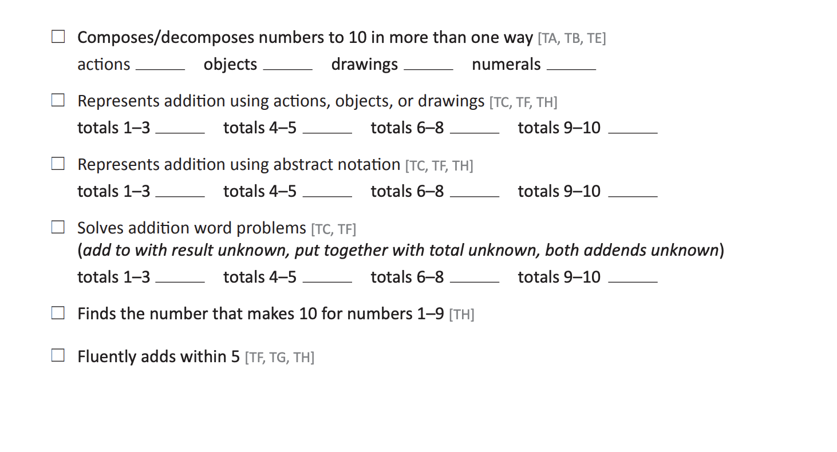

Copyright © 2021 Great Minds
®

Name: GK Module 4 Mid-Module

(Topics A–H)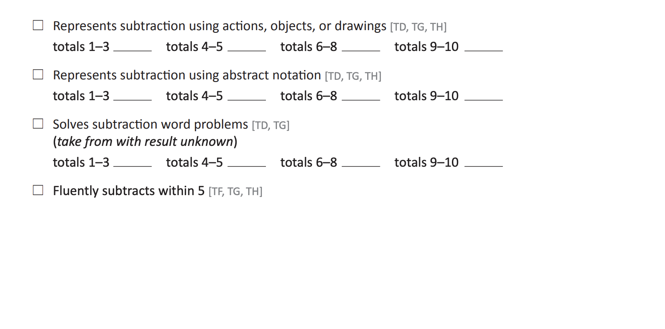

Copyright © 2021 Great Minds
®

