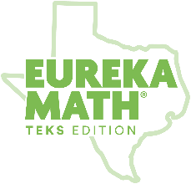

Eureka Math
TEKS Edition
Grade K • Module 4
Observational Assessment

GK Module 4 Mid-Module Checklist (Topics A-D)

 | Composes/ decomposes numbers up to 10 with objects and pictures | Model the action of joining to represent addition and the action of separating to represent subtraction | Solve word problems using objects and drawings to find sums up to 10 and differences within 10 | explain the strategies used to solve problems involving adding and subtracting within 10 using spoken words, concrete and pictorial models, and number sentences | NOTES:
Topic | ABCD | ABD | BCD | CD
Standard(s) | K.2I | K.3A | K.3B | K.3C
Student Name Below

GK Module 4 End-of-Module Checklist (Topics E-H)

 | Composes/decomposes numbers up to 10 with objects and pictures | Model the action of joining to represent addition and the action of separating to represent subtraction | Solve word problems using objects and drawings to find sums up to 10 and differences within 10 | Explain the strategies used to solve problems involving adding and subtracting within 10 using spoken words, concrete and pictorial models, and number sentences | NOTES:
Topic | EFGH | GH | FGH | FGH
Standard(s) | K.2I | K.3A | K.3B | K.3C
Student Name Below

