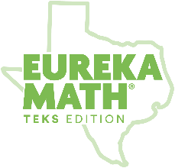

Eureka Math
TEKS Edition
Grade K • Module 5
Observational Assessment

GK Module 5 Mid-Module Checklist
(Topics A–C)

 | Count forward and backward generating one more or one less  R– regular way  ST– Say Ten way | Read, write, and represent whole numbers from 0-20 with or without objects or pictures | Recognize instantly the quantity of a small group of objects randomly and generate a set using concrete and pictorial models | Recite numbers up to at least 100 by ones and tens | Count a set of objects up to at least 20 | Compare sets of objects up to at least 20 | NOTES:
Topic | A–E  L1–24 | A–E  L1–24 | C–E  L10–24 | A, D | C  L10–14 | C, E  L10–14, L20–24
Standard(s) | K.2A, K.2F | K.2B | K.2D, K.2E | K.5 | K.2C | K.2G
Student Name Below

GK Module 5 End-of-Module Checklist
(Topics D–E)

 | Use comparative language to describe two numbers up to 20 | Identify U.S. coins by name | Identify ways to earn income, differentiate money as income or gifts, list simple skills, and distinguish between wants and needs | NOTES:
Topic | E  L20-24 | F  25–27 | F  25–27
Standard(s) | K.2H | K.4 | K.9A, K.9B, K.9C, K.9D
Student Name Below

