Numbers 10–20 and Counting to 100

SUPPORT TOWARD MASTERY

Mid-Module (Topics A–C)
Use the following list of activities from the curriculum with students who need additional support to master the key concepts listed in the checklist and cards. Employ the help of instructional support staff, classroom volunteers, or older students to facilitate some of these activities.
Counts the Say Ten way and the regular way interchangeably to 20
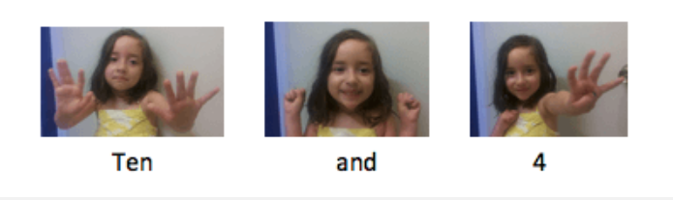
- Module 3 Lesson 1 Fluency: Say Ten Push-Ups
- Module 5 Lesson 9 Problem Set (page 1)—Consider placing the Problem Set in a personal whiteboard so students may practice several times using the same materials. Use the Problem Set to make an additional page using different teen numbers.
- Module 5 Lesson 22 Fluency: Count Teen Numbers

Counts a group of 11–20 objects
Linear
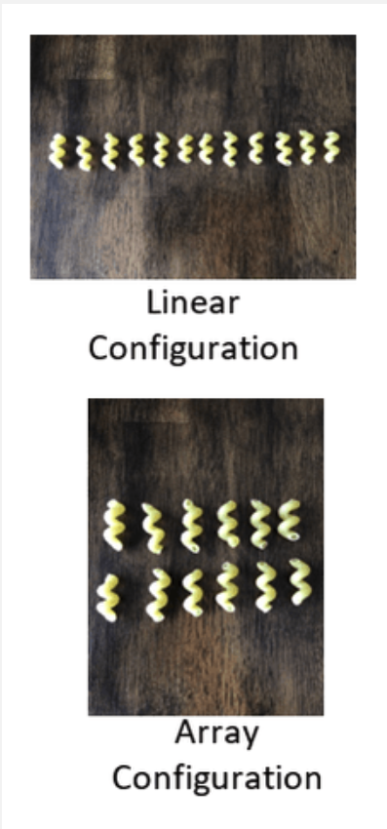
- Module 5 Lesson 2 Concept Development—Use the bags of objects prepared for this lesson. Place a teen number of objects in a linear configuration for students to count.
- Module 5 Lesson 4 Fluency Template—Consider placing the template in a personal whiteboard so students may practice several times using the same materials.
Array
- Module 5 Lesson 2 Concept Development—Use the bags of objects prepared for this lesson. Place a teen number of objects in an array configuration for students to count.
- Module 5 Lesson 4 Fluency Template—Consider placing the template in a personal whiteboard so students may practice several times using the same materials.

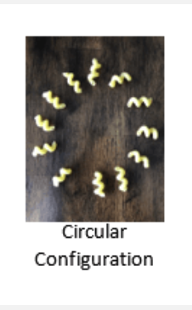
Circular

- Module 5 Lesson 2 Concept Development—Use the bags of objects prepared for this lesson. Place a teen number of objects in a circular configuration for students to count.
- Module 5 Lesson 14 Problem Set, Exit Ticket, and Homework—Consider placing problem sheets in a personal whiteboard so students may practice several times using the same materials.
- Module 5 Lesson 15 Fluency: Teen Circular-Counting

Represents teen numbers as 10 ones and ___ ones
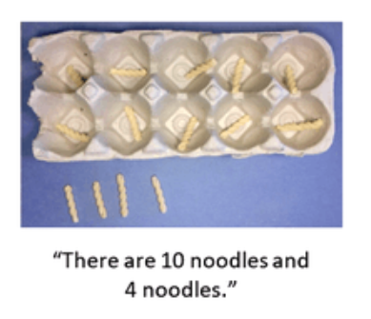
Objects
- Module 5 Lesson 2 Concept Development—Use the bags of objects prepared for this lesson at a station. Have students count objects into 10 things and ___ things. Then students should say, “10 pennies and 6 pennies, sixteen or ten six.” Use a ten-frame or ten-slot egg carton if needed.
- Module 5 Lesson 11 Fluency: Counting on a Rekenrek—Say or show teen numbers, and have students show the number on a Rekenrek. Watch for students who count each bead one at a time instead of sliding the whole row of 10 beads over at once.
- Module 5 Lesson 22 Fluency: Teen Numbers on the Rekenrek

Pictures
- Module 5 Lesson 3 Problem Set and Homework (page 1 of each)—Consider placing the Problem Set and/or Homework in a personal whiteboard so students may practice several times using the same materials. To limit distractions, cut the instructions off of the Problem Set or Homework and provide oral instructions instead. They may write 10 ones and ___ ones or just say the answer aloud if writing is a challenge.
- Module 5 Lesson 5 Fluency: Circling 10 Ones

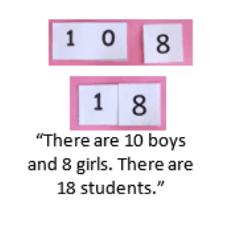
Hide Zero™ Cards
- Module 5 Lesson 6 Problem Set—Use the Problem Set to make an additional page using different teen numbers.
- Module 5 Lesson 7 Fluency: Decompose Teen Numbers
- Module 5 Lesson 15 Fluency: Hide Zero for Teen Numbers
Number Bonds
- Module 5 Lesson 7 Problem Set and Homework—Consider placing the Problem Set and/or Homework in a personal whiteboard so students may practice several times using the same materials.
- Module 5 Lesson 8 Fluency: Teen Number Bonds
Matches a numeral with a group of up to 20 objects
- Module 5 Lesson 5 Problem Set and Circle 10 Ones Template—Use the images on these pages and the teen number cards from Lesson 14. Scaffold by cutting the images to make cards. Give students only five images and their matching teen number cards.
- Module 5 Lesson 23 Fluency: Matching Dot and Number Cards—Extend this fluency activity by using the teen number and dot cards as a memory matching game.
Writes numerals 11–20
- Module 5 Lesson 6 Problem Set, Exit Ticket, and Homework—Consider placing the Problem Set, Exit Ticket, and Homework in a personal whiteboard so students may practice several times using the same materials.
- Module 5 Lesson 11 Problem Set and Homework—Fill in the bar and picture graph on the Problem Set and Homework. Enlarge the space provided to write the teen numbers and remove existing numerals to give students practice writing all the teen numbers.

Counts a group up to 20; adds 1 and knows how many without recounting

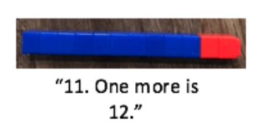
- Module 5 Lesson 11 Concept Development—Employ the help of instructional support staff, a parent volunteer, or an older student helper to conduct the one more activity of the concept development. If help is not available, place a ten-stick of one color and 10 loose cubes of another color at a station. Students build on the ten-stick by adding one cube at a time and saying, “Ten. One more is 11. Eleven. One more is 12. Twelve. One more is 13.”
Note: One less is not a Kindergarten standard. However, if time allows, the above activity may be used in reverse to support proficiency with one less.

End-of-Module (Topics D–E)
Counts by tens to 100
- Module 5 Lesson 15 Problem Set and Homework (page 1)—Consider placing the Problem Set and Homework in a personal whiteboard so students may practice several times using the same materials.
- Module 5 Lesson 16 Fluency: Count by Tens the Say Ten Way
- Module 5 Lesson 16 Fluency: Count with Ten-Frame Cards
Counts by ones to 100
Within Tens

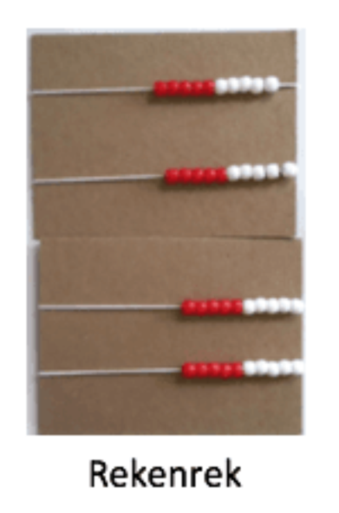
- Module 5 Lesson 16 Problem Set, Exit Ticket, and Homework—Eliminate all the counting down problems and directions on these pages to facilitate students practicing counting by ones independently. Consider placing the pages in a personal whiteboard so students may practice several times using the same materials.
- Module 5 Lesson 17 Fluency: Count Within Tens
- Module 5 Lesson 18 Fluency: Count on the Rekenrek—Modify this activity to focus on counting beads within groups of 10.
Across Tens
- Module 5 Lesson 17 Exit Ticket—Use the number path templates to create counting sequences that cross groups of 10. For example: 27, 28, __, 30, __, __, __.
- Module 5 Lesson 18 Fluency: Count on the Rekenrek—Modify this activity to focus on counting beads across groups of 10.
- Module 5 Lesson 20 Fluency: Count Crossing Tens
Starting at Any Number
- Module 5 Lesson 18 Fluency: Count on the Rekenrek—Modify this activity to focus on counting beads from any given number on the Rekenrek.
- Module 5 Lesson 19 Homework—Consider placing the Homework in a personal whiteboard so students may practice several times using the same materials.
Represents teen numbers as 10 ones and ___ ones.
Objects

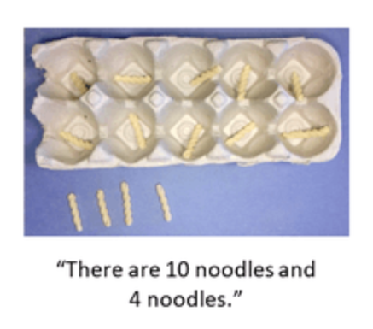
- Module 5 Lesson 2 Concept Development—Use the bags of objects prepared for this lesson at a station. Have students count objects into 10 things and ___ things. Then students should say, “10 pennies and 6 pennies, sixteen or ten six.” Use a ten-frame or ten-slot egg carton if needed
- Module 5 Lesson 11 Fluency: Counting on a Rekenrek—Say or show teen numbers, and have students show the number on a Rekenrek. Watch for students who count each bead one at a time as opposed to those who can slide the whole row of 10 beads over at one time.
- Module 5 Lesson 22 Fluency: Teen Numbers on the Rekenrek
Pictures
- Module 5 Lesson 3 Problem Set and Homework (page 1 of each)—Consider placing the Problem Set and/or Homework in a personal whiteboard so students may practice several times using the same materials. To limit distractions, cut the instructions off of the Problem Set or Homework and provide oral instructions instead. They may write 10 ones and ___ones or just say it aloud if writing is a challenge.
- Module 5 Lesson 5 Fluency: Circling 10 Ones

Hide Zero™ Cards
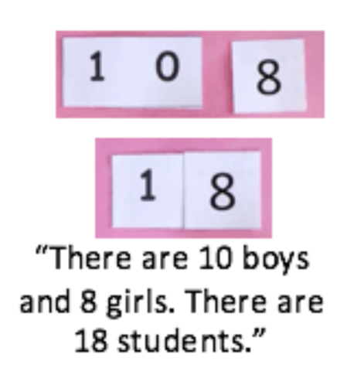
- Module 5 Lesson 6 Problem Set—Use the Problem Set to make an additional page using different teen numbers.
- Module 5 Lesson 7 Fluency: Decompose Teen Numbers
- Module 5 Lesson 15 Fluency: Hide Zero for Teen Numbers
Number Bonds
- Module 5 Lesson 7 Problem Set and Homework—Consider placing the Problem Set and/or Homework in a personal whiteboard so students may practice several times using the same materials.
- Module 5 Lesson 8 Fluency: Teen Number Bonds
Addition Sentence

- Module 5 Lesson 20 Problem Set—Consider placing the Problem Set in a personal whiteboard so students may practice several times using the same materials.

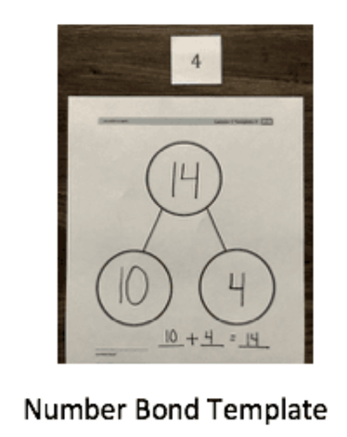
- Module 4 Lesson 1 Number Bond Template and Digit Cards 1–9—Write a 10 in one of the parts of the number bond and an empty addition sentence on the bottom of the number bond. Place the template in a personal whiteboard. Students flip over a digit card and write the number in the other part of the bond and then complete the bond. Finally, they write the addition sentence. Repeat.

