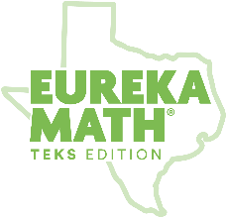

Eureka Math
TEKS Edition
Grade K • Module 6
Observational Assessment

GK Module 6 End-of- Module Checklist
(Topics A–B)
 | Creates 2D shapes using a variety of materials  C- circle  T- triangle  R- rectangle  S-square | Draws 2D shapes  C- circle  T- triangle  R- rectangle  S-square | Identifies 2D components of 3D objects | Puts simple shapes together to compose larger shapes | Notes:
Topic | A | A | A | A, B
Lessons | 1-2, 5, 8 | 5, 8 | 3 | 3, 5-8
Standards(s)  Student Name Below | K.6D, K.6F | K.6D, K.6F | K.6C | K.6C, K.6F

