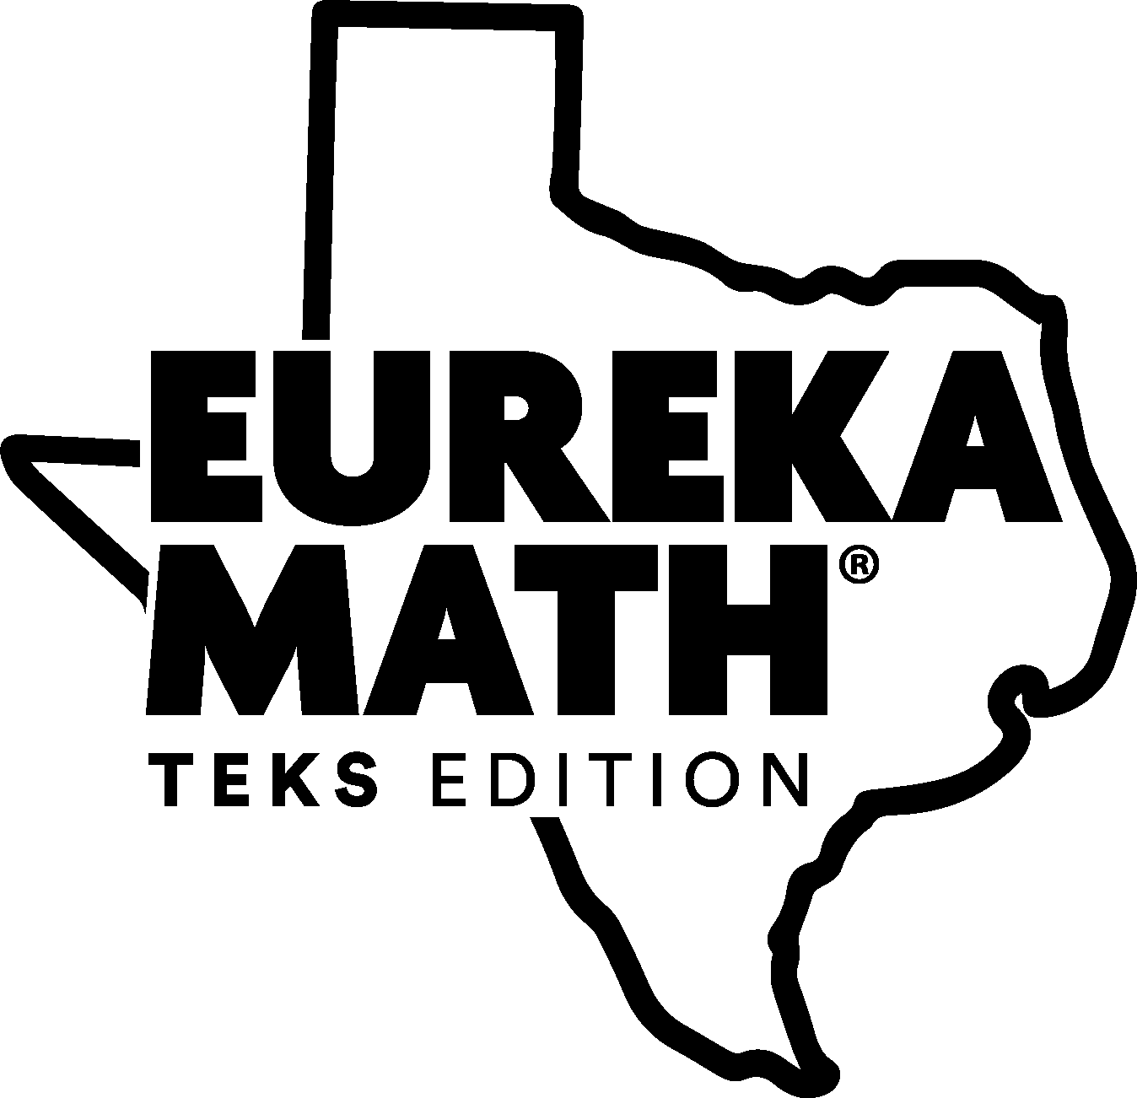

Third Grade Assessment Question Analysis by Readiness Standard

Table of Contents
3.2A pg 2
3.2D pg 3
3.3F pg 5
3.3H pg 6
3.4A pg 8
3.4K pg 11
3.5A pg 14
3.5B pg 15
3.5E pg 16
3.6A pg 17
3.6C pg 20
3.7B pg 21
3.8A pg 23

TEKS: 3.2A Compose and decompose number up to 100,000 as a sum of so many ten thousands, so many thousands, so many hundreds, so many tens, and so many ones using objects, pictorial models, and numbers, including expanded notation as appropriate.
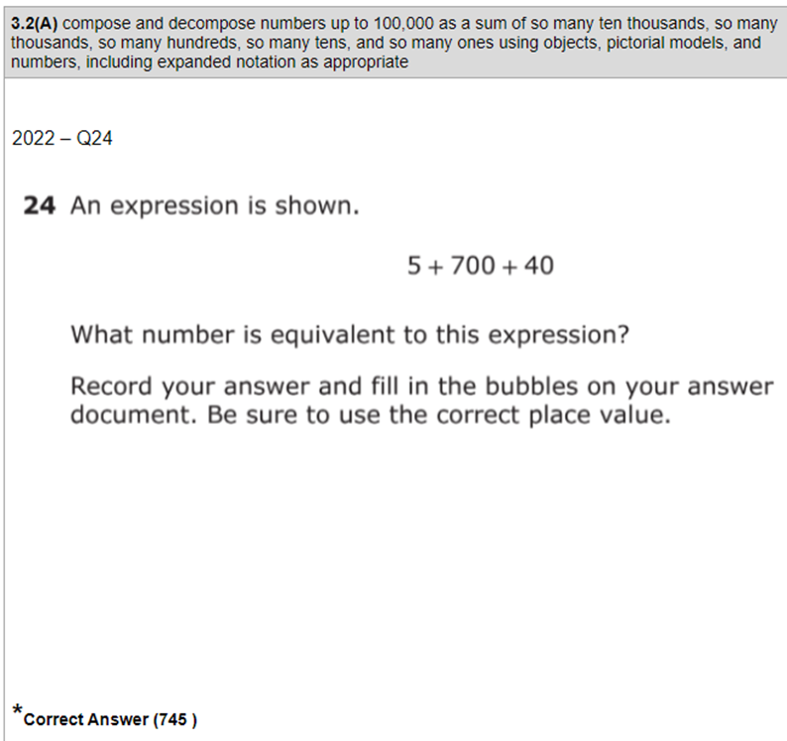 | Module 2 Mid-Module Assessment #1  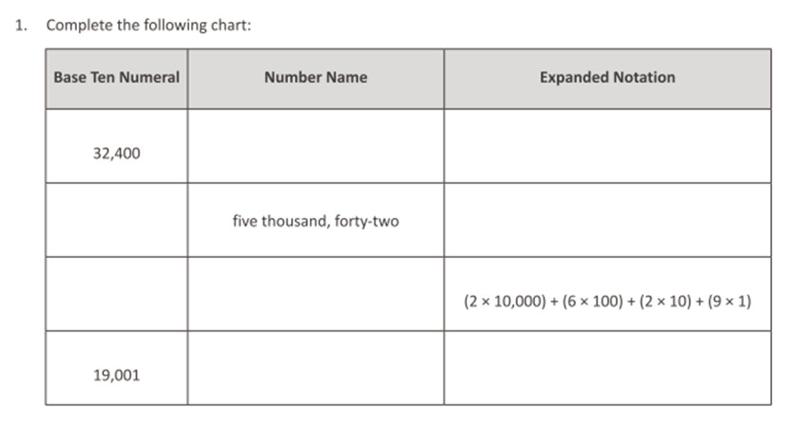
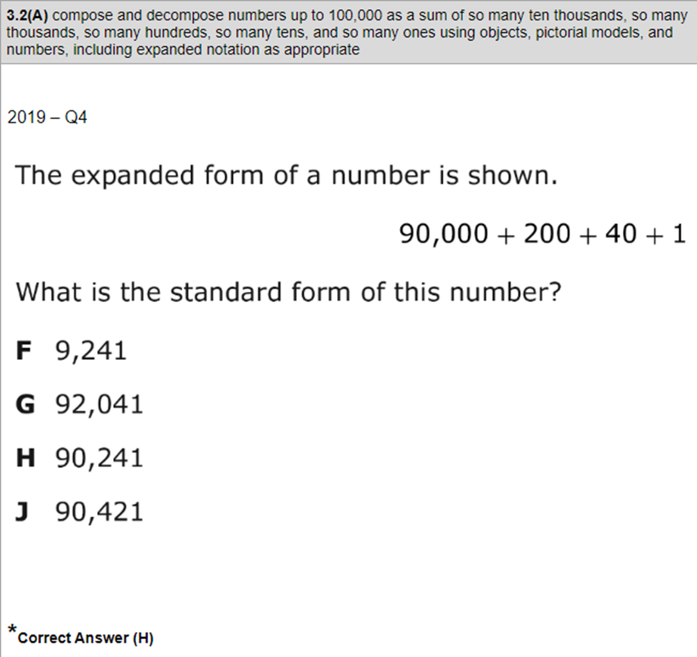 | Module 2 Topic C Lesson 10 Exit Ticket  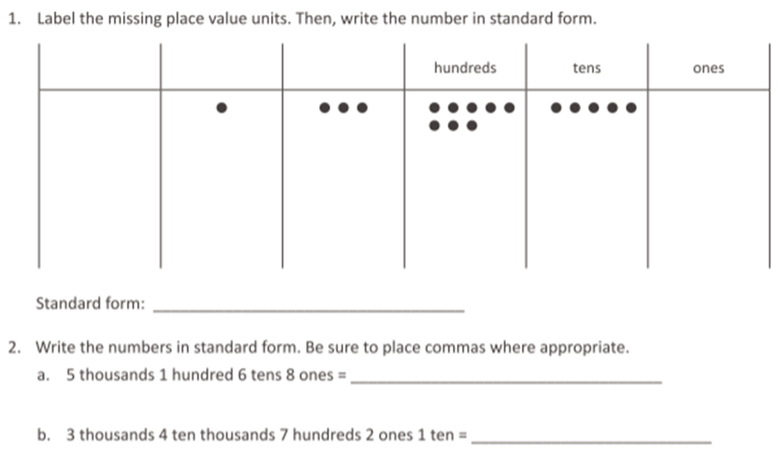
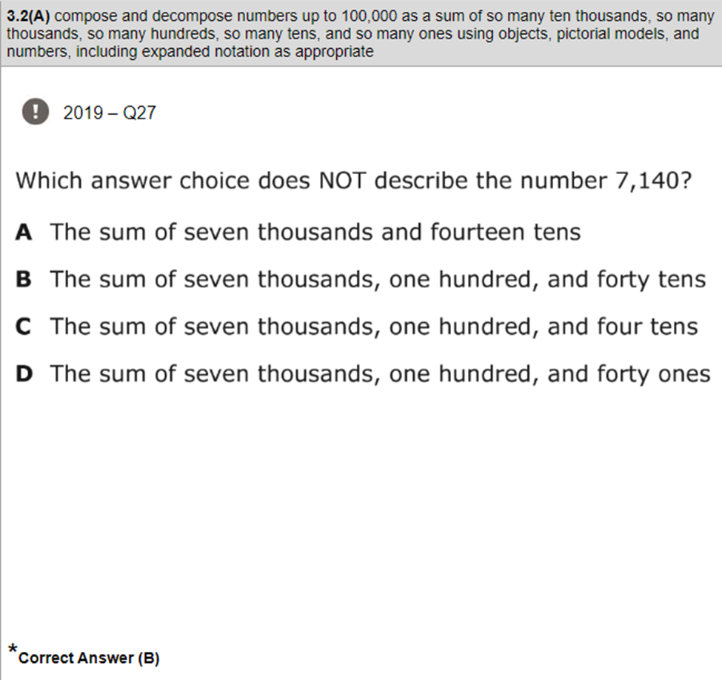 | Module 2 Lesson 11 Exit Ticket  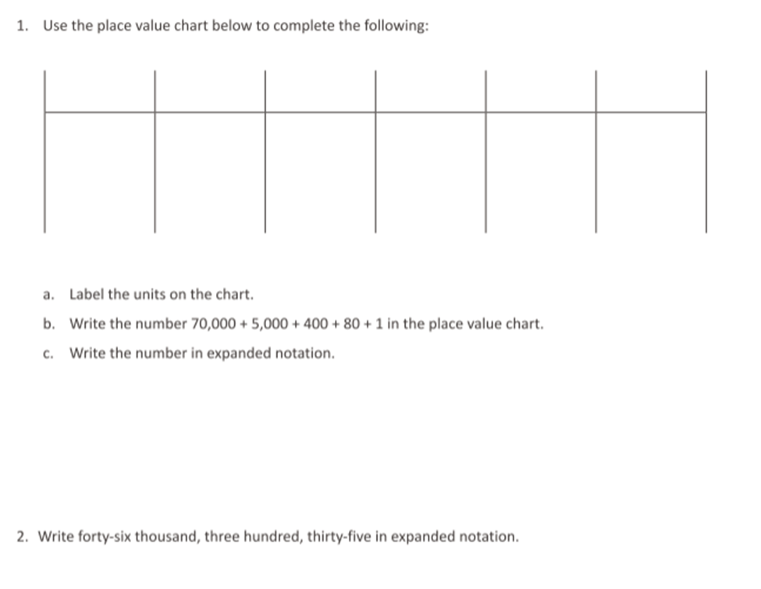
TEKS: 3.2D Compare and order whole numbers up to 100,000 and represent comparisons using symbols >,<, or =
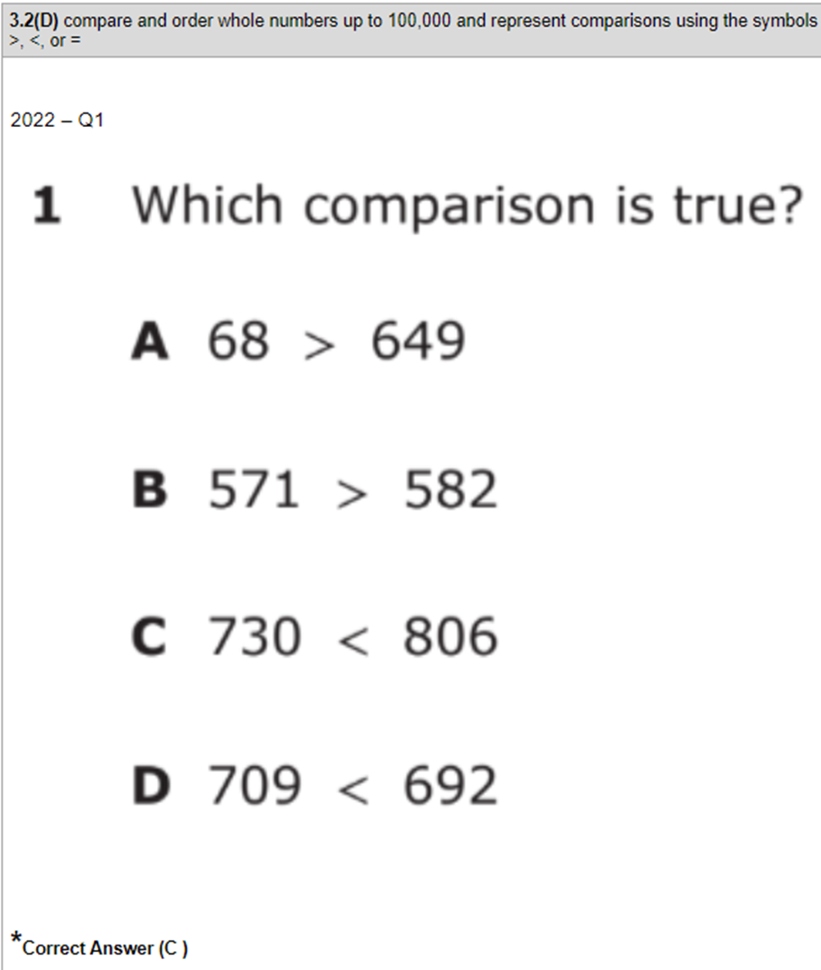 | Module 2 Mid Module Assessment  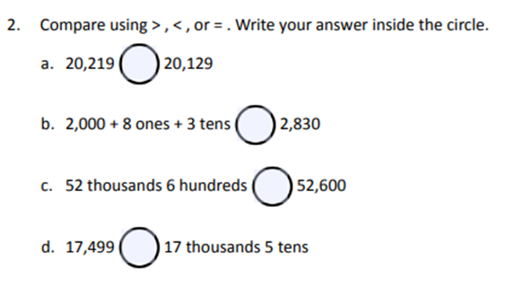
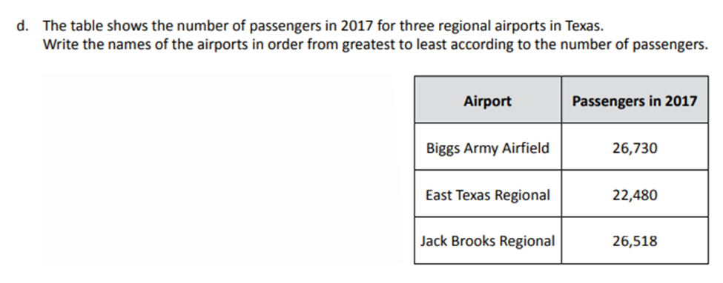  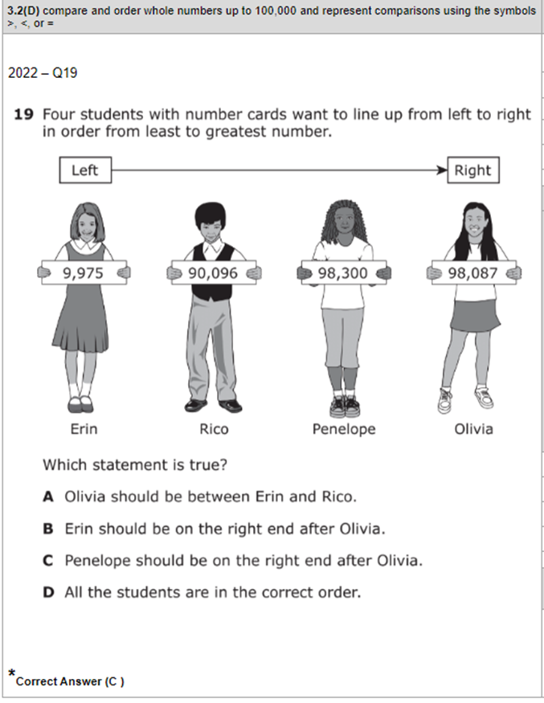 | Module 2 End of Module, 5D
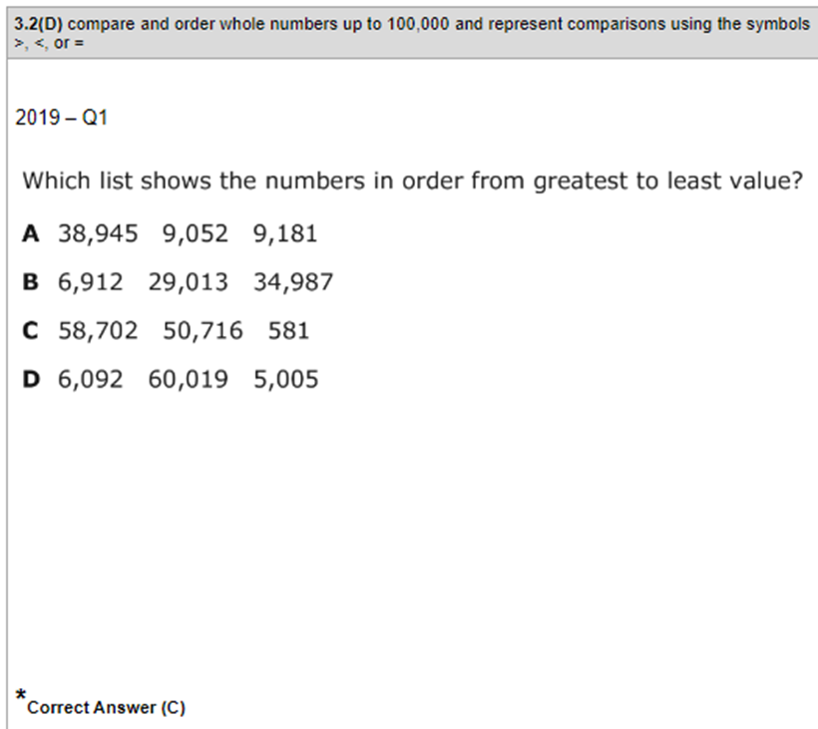 | Module 2 End of Module, 7  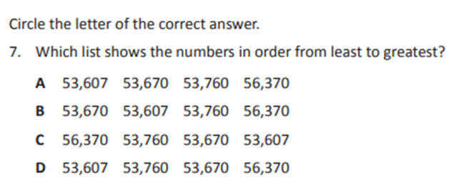
TEKS: 3.3F Represent equivalent fractions with denominators of 2, 3, 4, 6, and 8 using a variety of objects and pictorial models, including number lines.
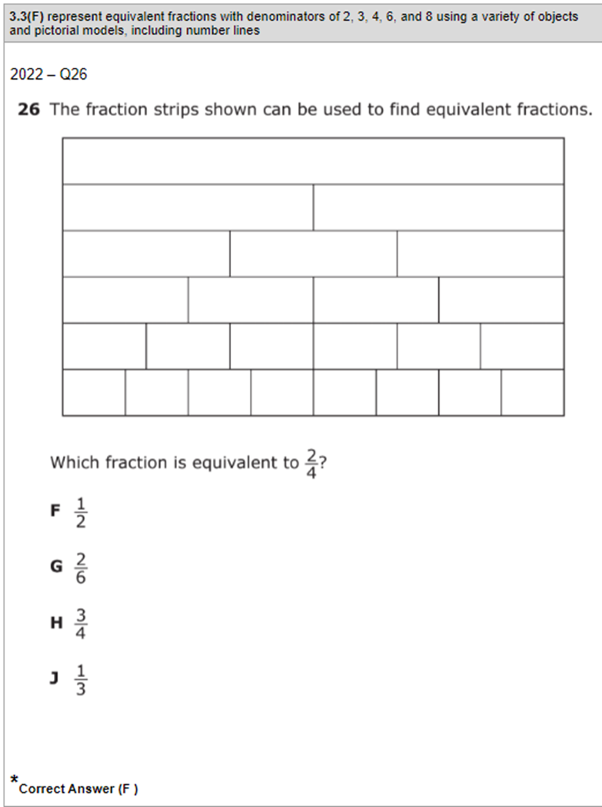 | Module 5 End of Module, 2  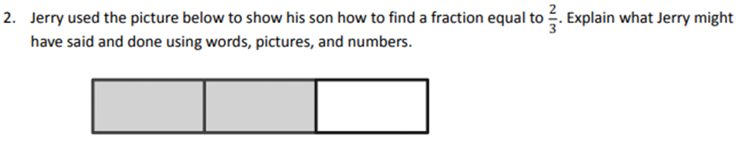
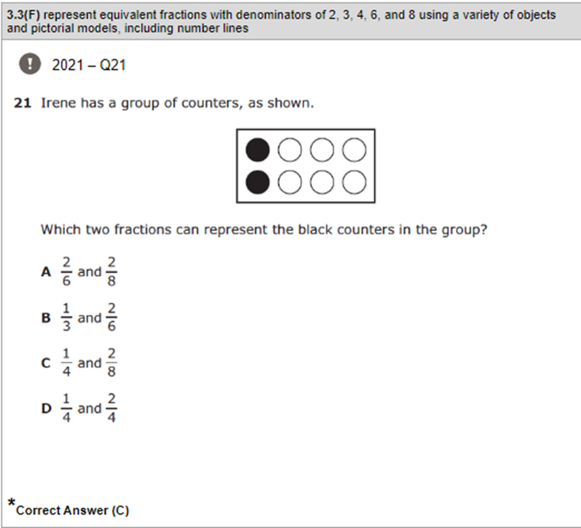 | 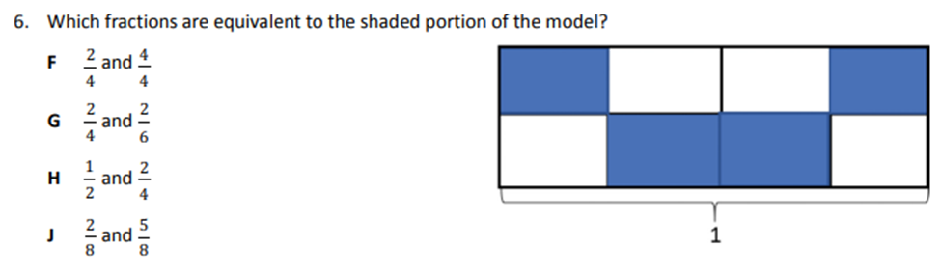
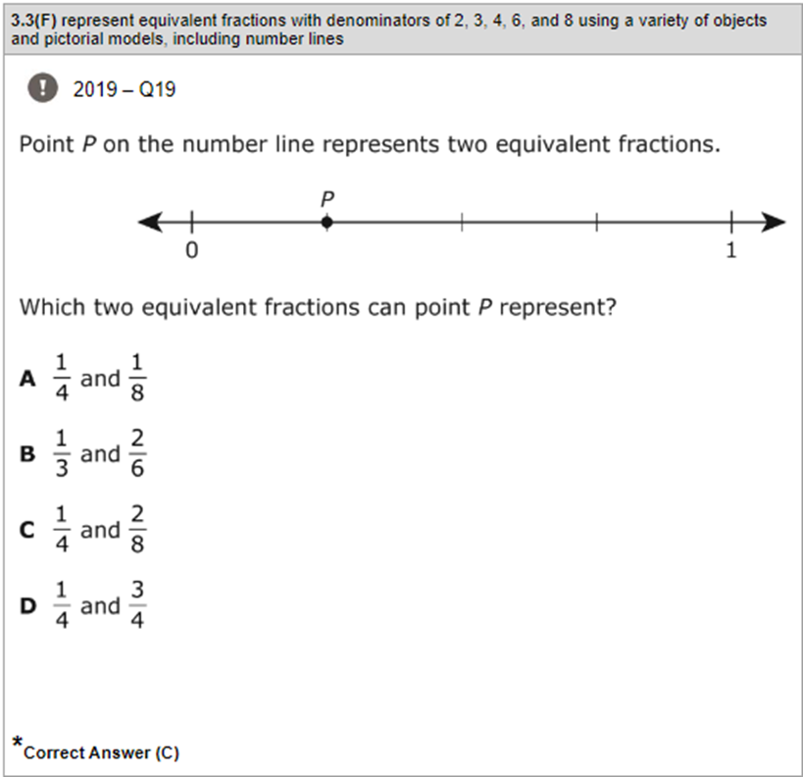 | Module 5 End of Module Assessment  #4 Part C  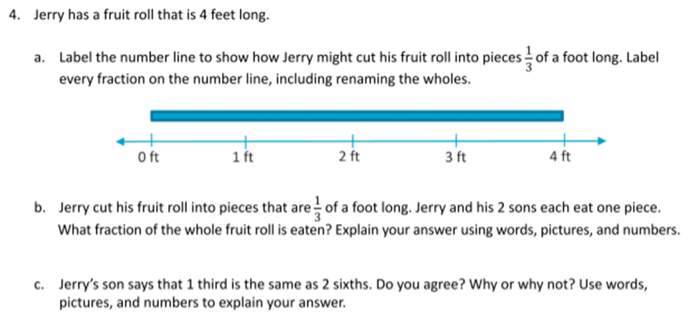
TEKS: 3.3H Compare two fractions having the same numerator or denominator in problems by reasoning about their sizes and justifying the conclusion using symbols, words, objects, and pictorial models.
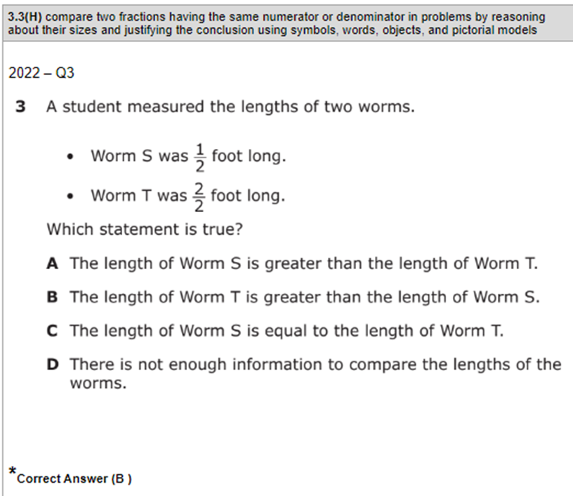 | Module 5 End of Module Assessment  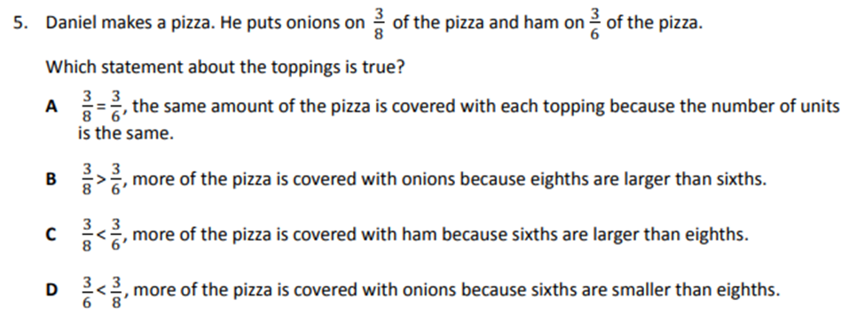
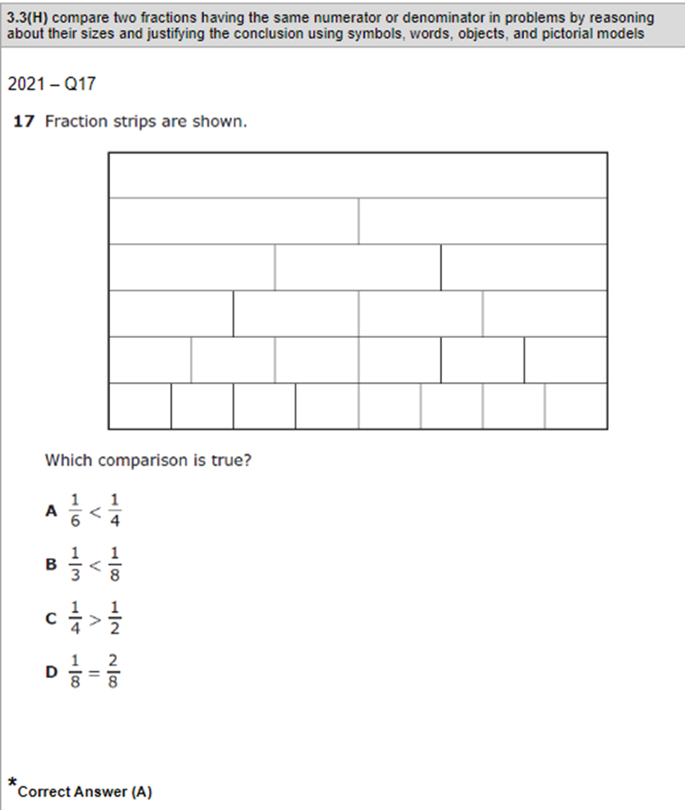 | Module 5 Lesson 30 Exit Ticket  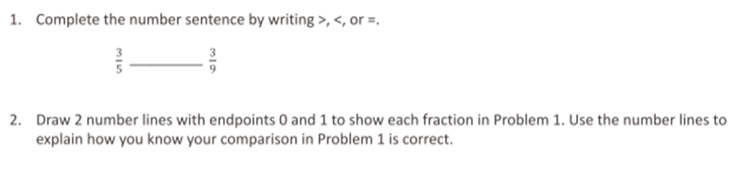
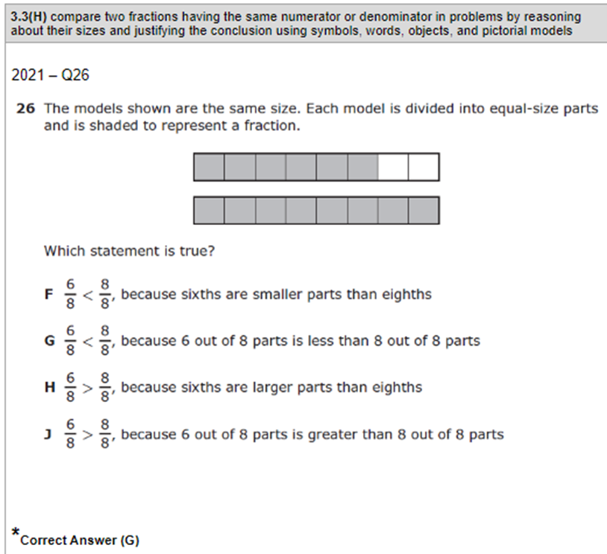 | Module 5 End of Module Assessment  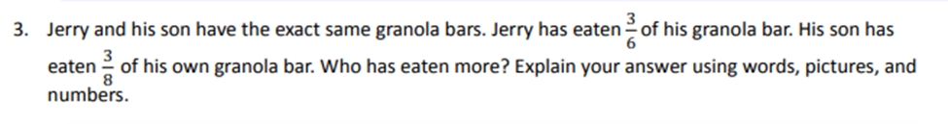
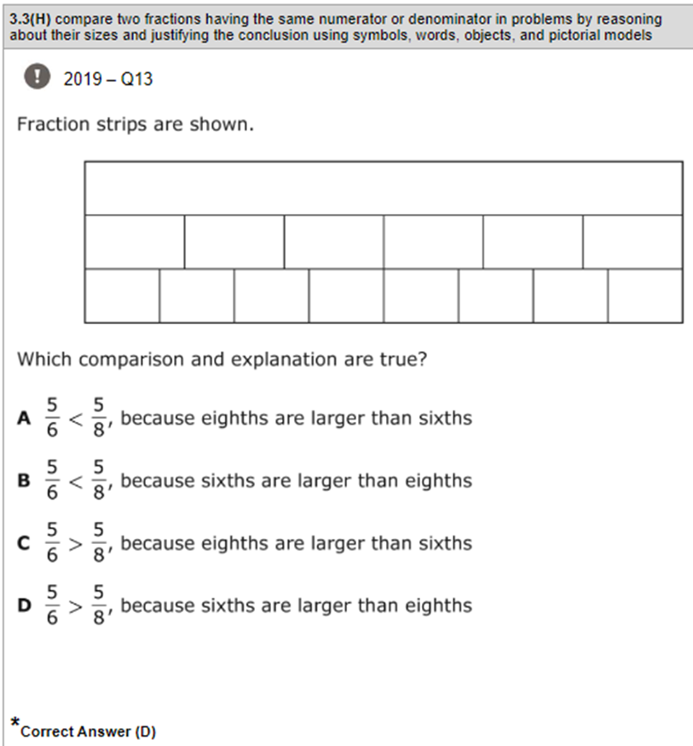 | Module 5 Mid Module Assessment  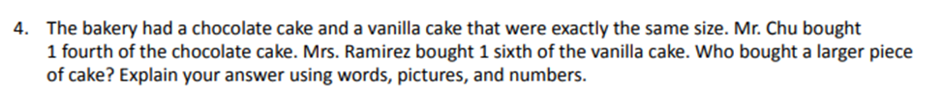
TEKS: 3.4A The student is expected to: solve with fluency one-step and two-step problems involving addition and subtraction within 1,000 using strategies based on place value, properties of operations, and the relationship between addition and subtraction.
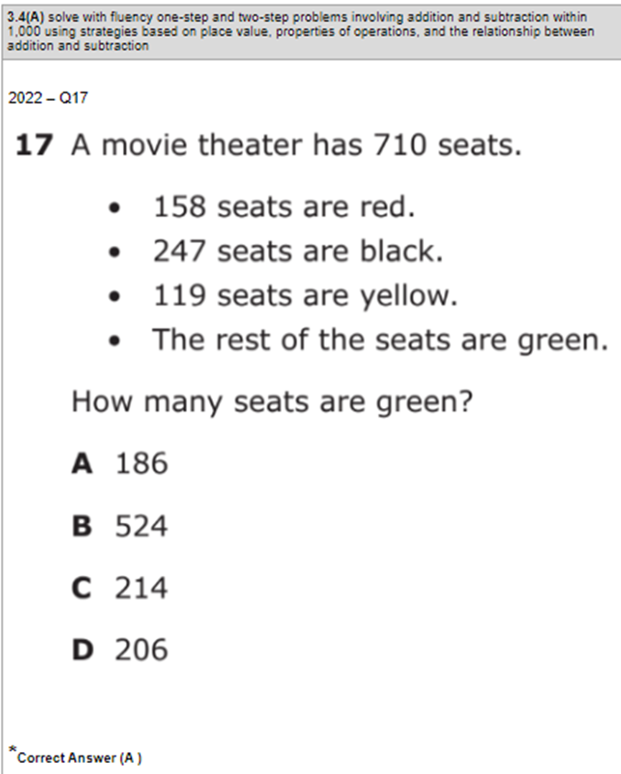 | Module 2 Lesson 20 Problem Set
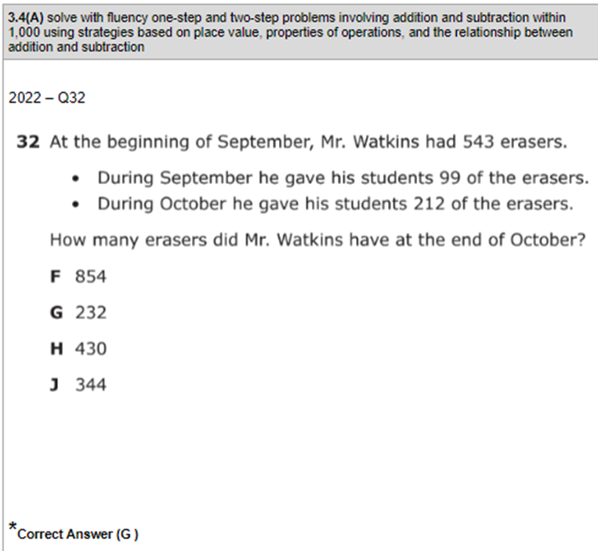 | Module 2 Lesson 22 Exit Ticket  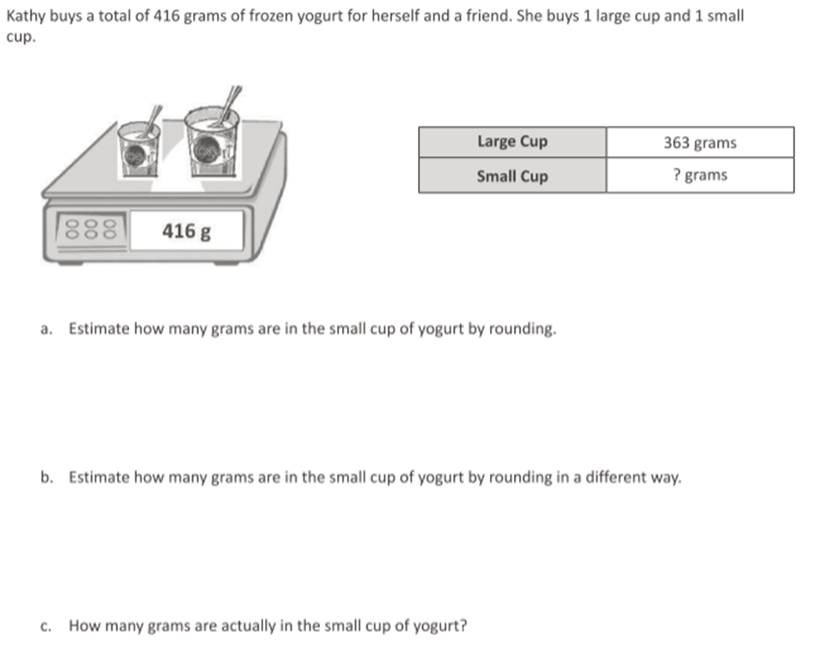
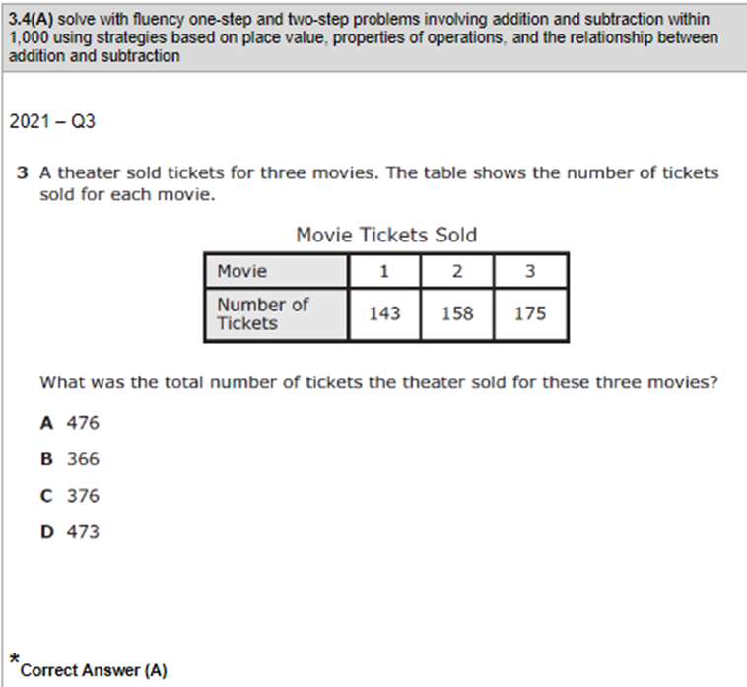 | Module 2 Lesson 18 Exit Ticket  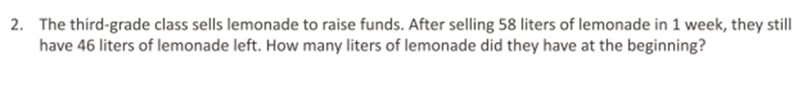
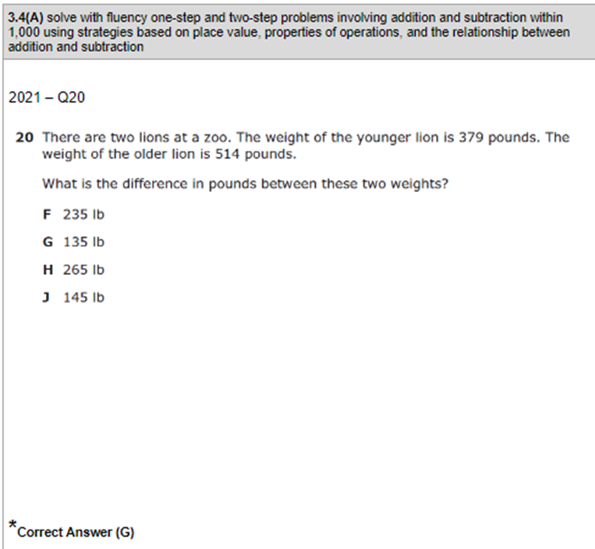 | Module 2 Lesson 22 Problem Set  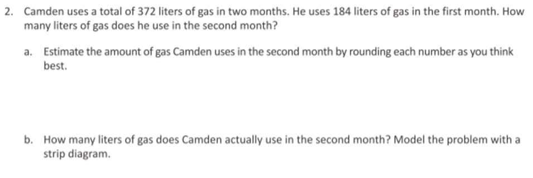
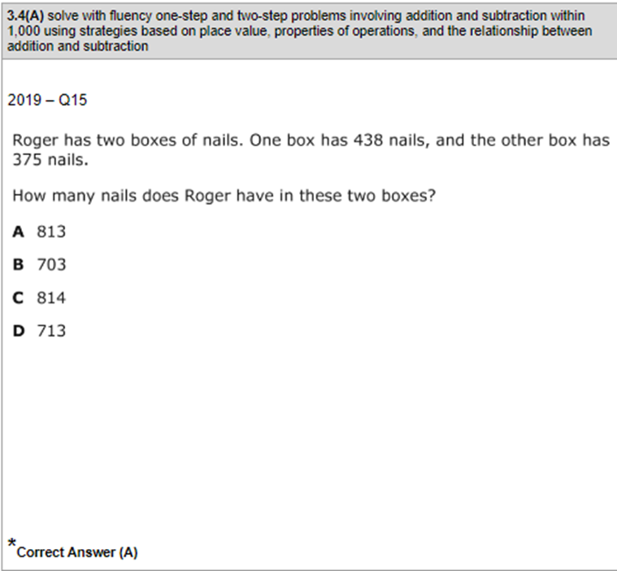 | Module 2 Lesson 22 Problem Set  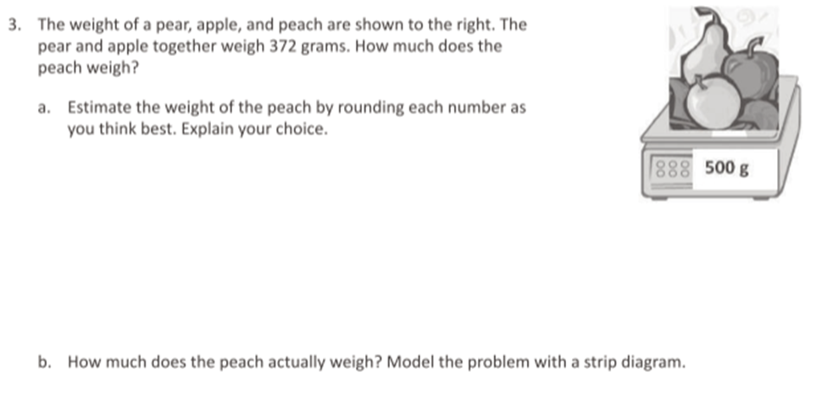
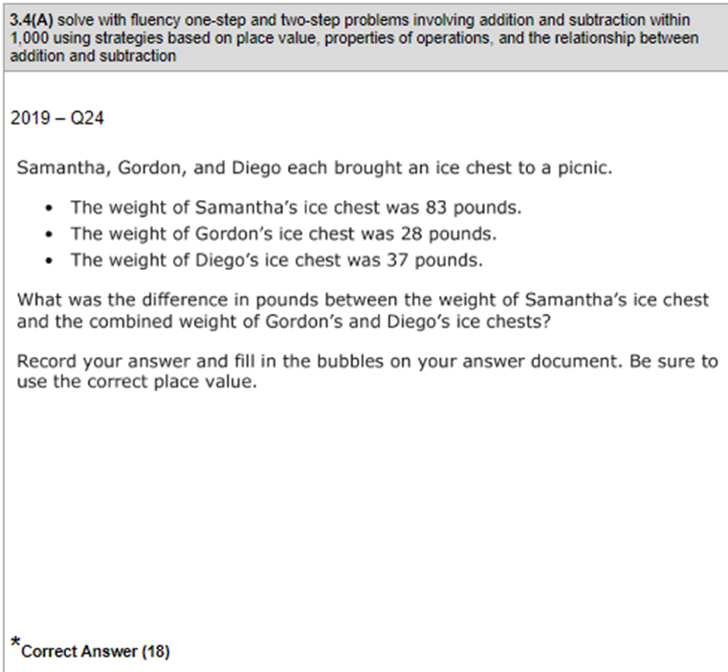 | Module 2 Lesson 23 Problem Set  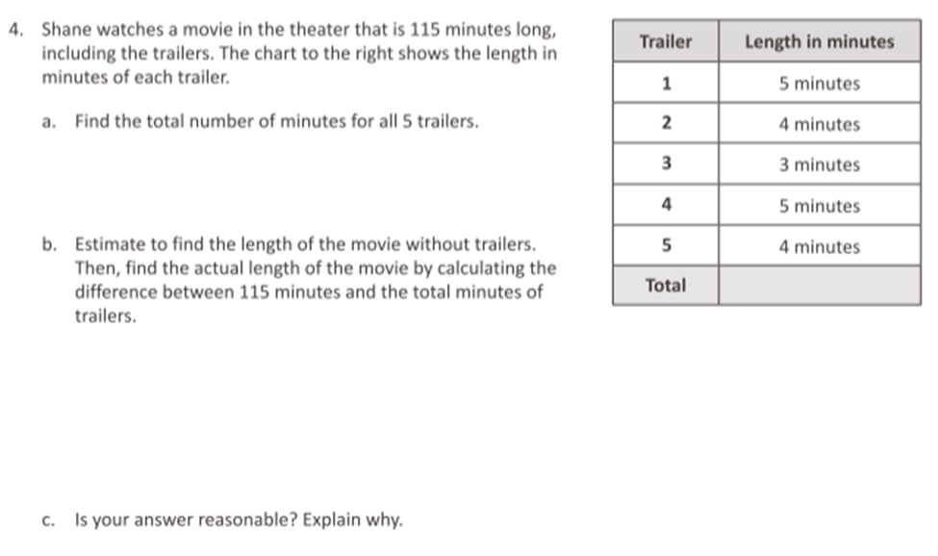
TEKS: 3.4K Solve one-step and two-step problems involving multiplication and division within 100 using strategies based on objects; pictorial models, including arrays, area models, and equal groups; properties of operations; or recall of facts
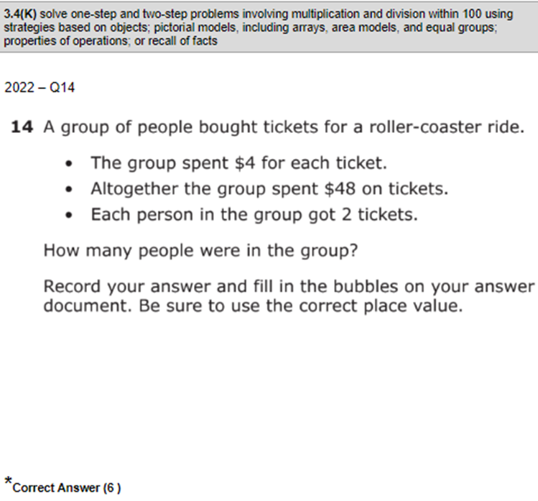 | Module 3 Lesson 14 Exit Ticket
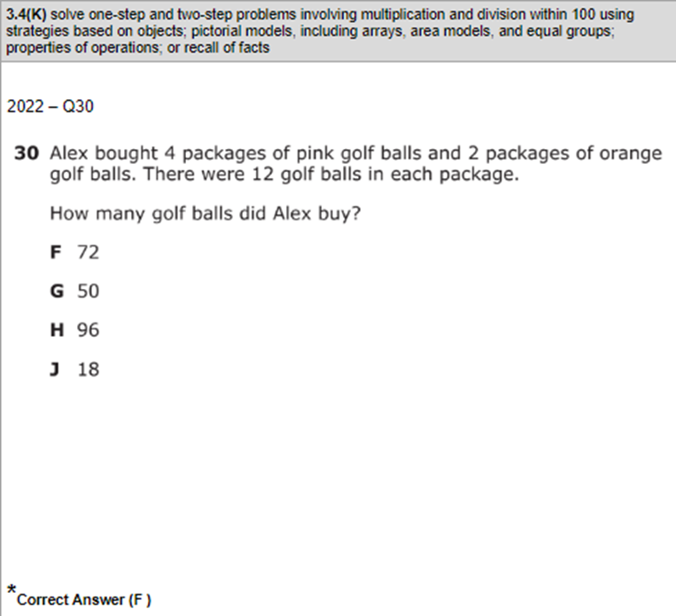 | Module 1 End of Module Assessment  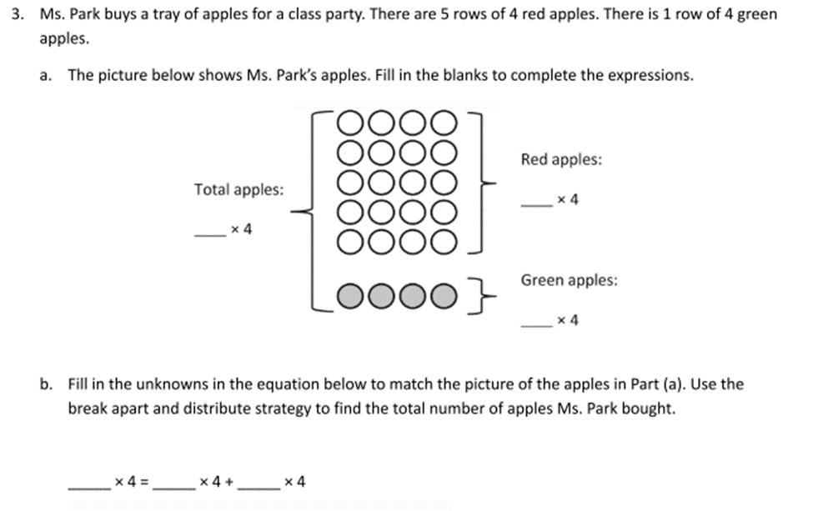
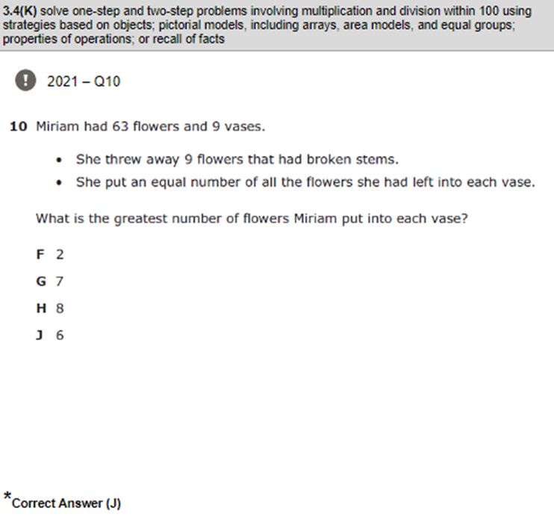 | Module 3 Lesson 17 Problem Set
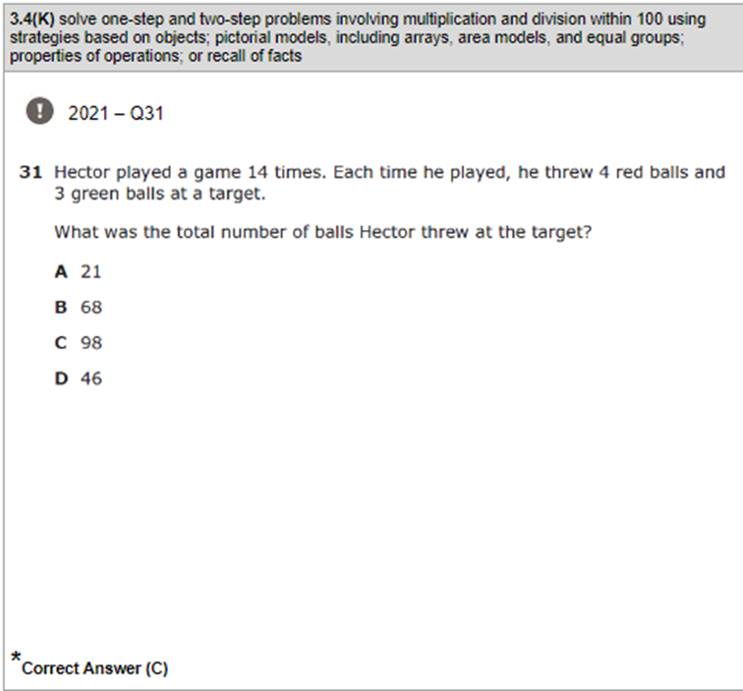 | Module 3 End of Module Assessment  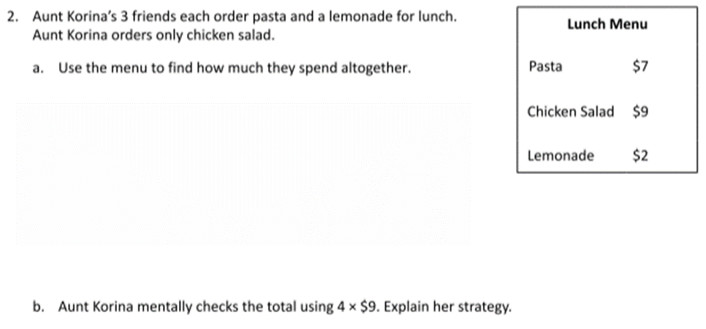
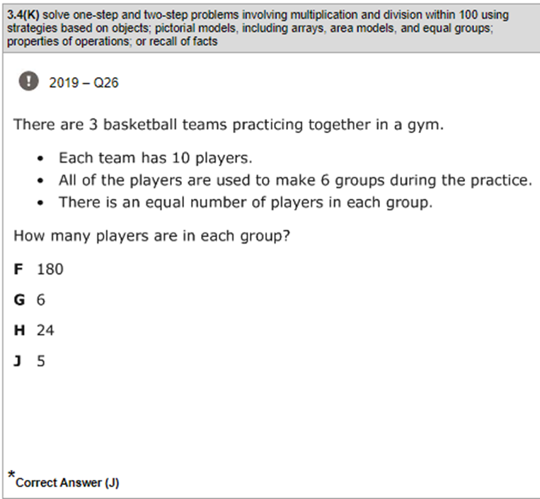
TEKS: 3.5A Represent one- and two-step problems involving addition and subtraction of whole numbers to 1,000 using pictorial models, number lines, and equations
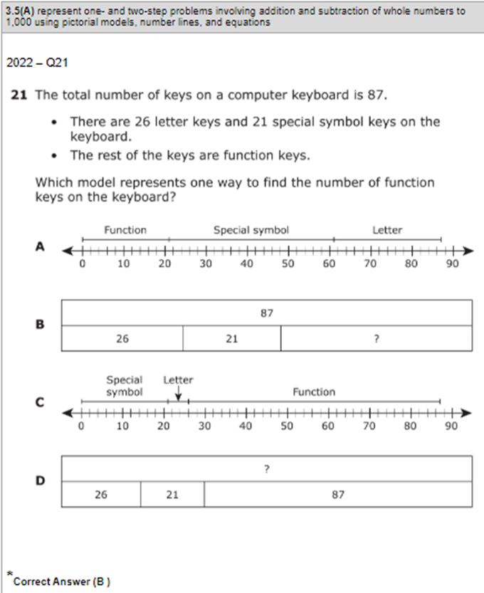 | Module 2 Lesson 18 Problem Set  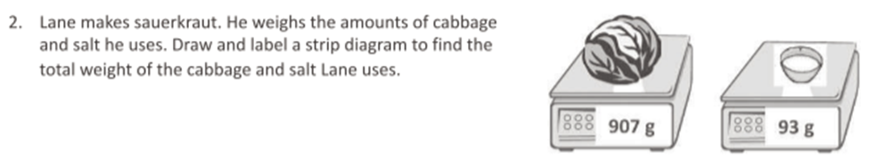
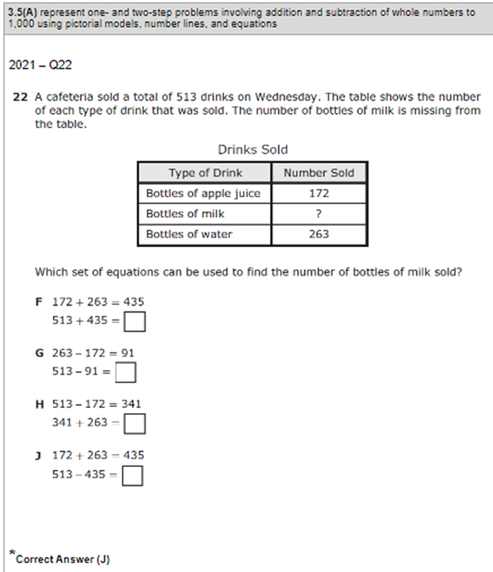
TEKS: 3.5B Represent and solve one and two step multiplication and division problems within 100 using arrays, strip diagrams, and equations
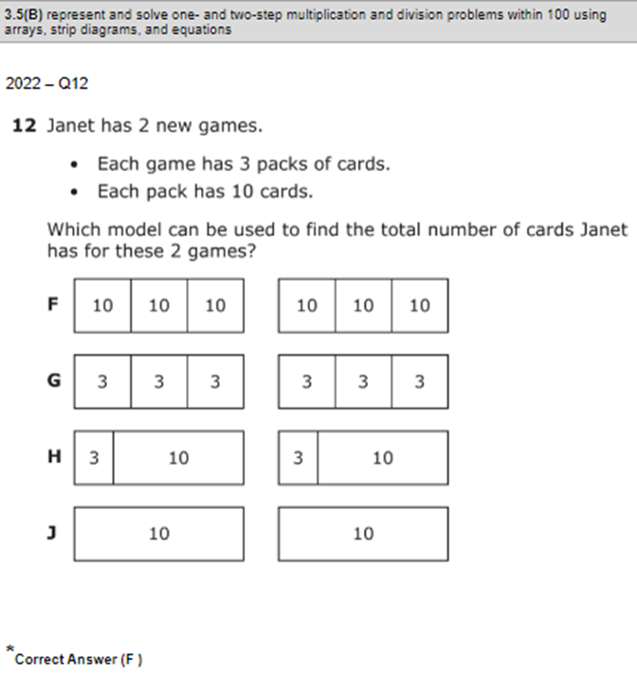 | Module 1 Lesson 21 Problem Set  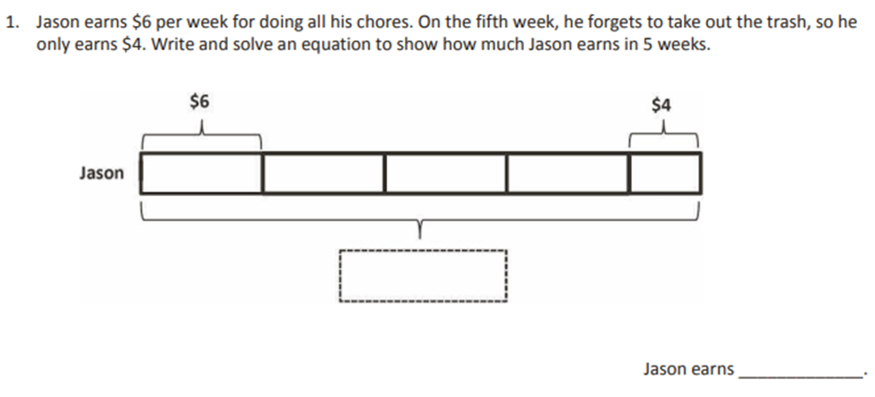
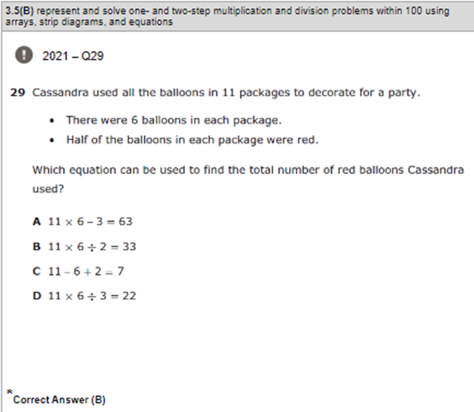 | Module 1 End of Module Assessment  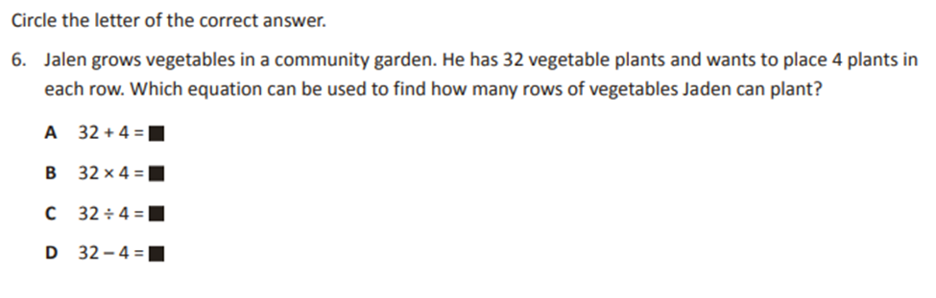
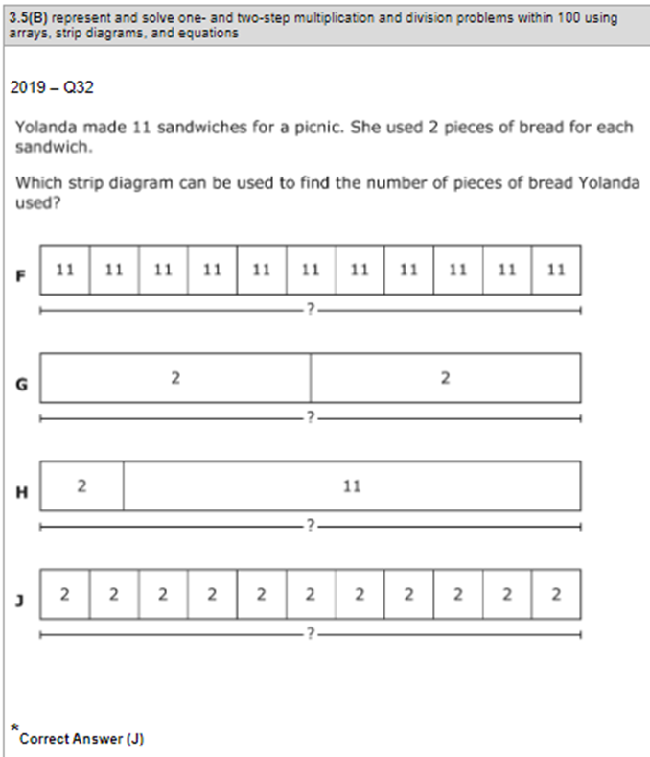 | Module 1 Lesson 20 Exit Ticket  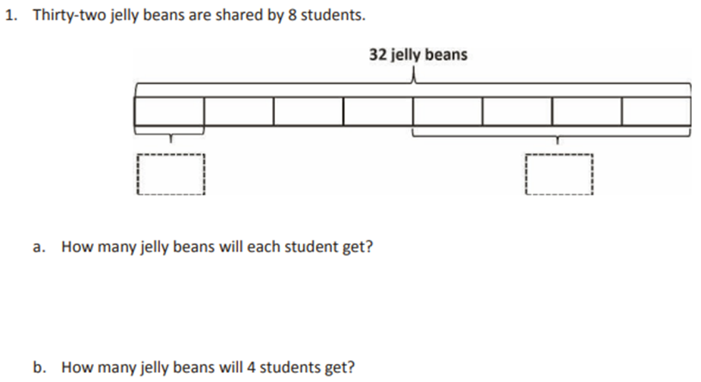
TEKS: 3.5E Represent real world relationships using number pairs in a table and verbal descriptions
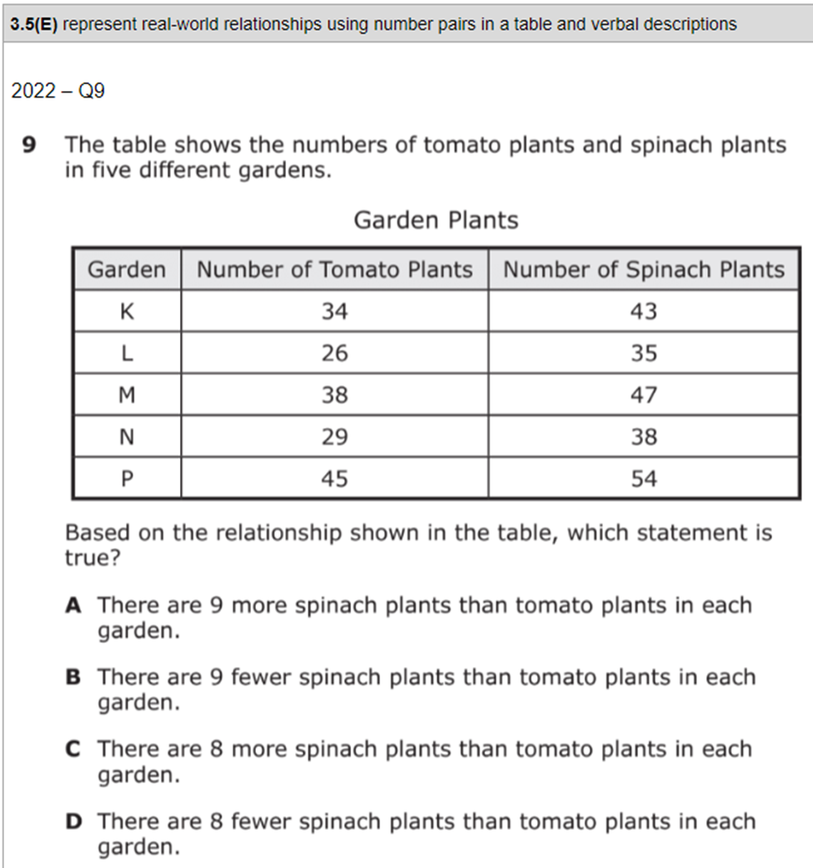 | Module 3 Mid Module Assessment (multiplicative comparison only)  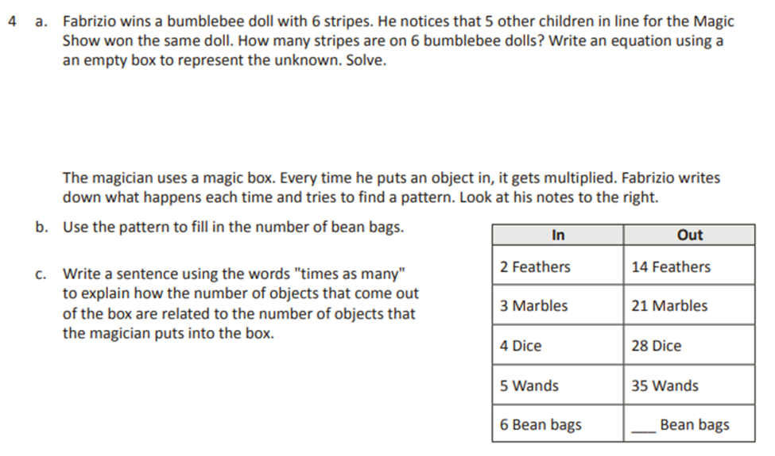
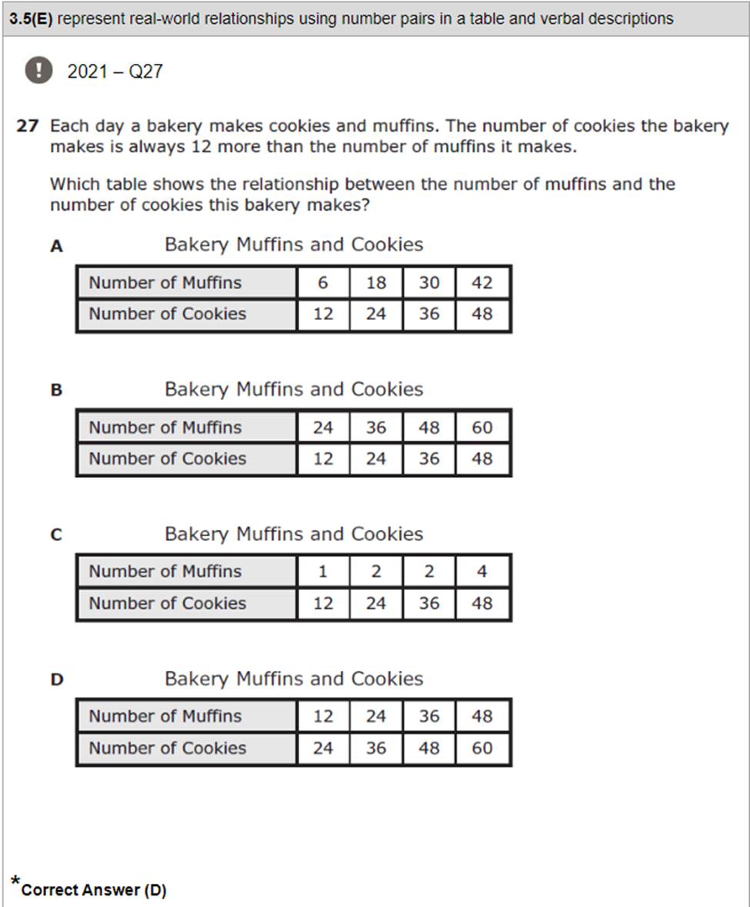
TEKS: 3.6A Classify and sort two and three dimensional figures, including cones, cylinders, spheres, triangular and rectangular prisms, and cubes, based on attributes using formal geometric language.
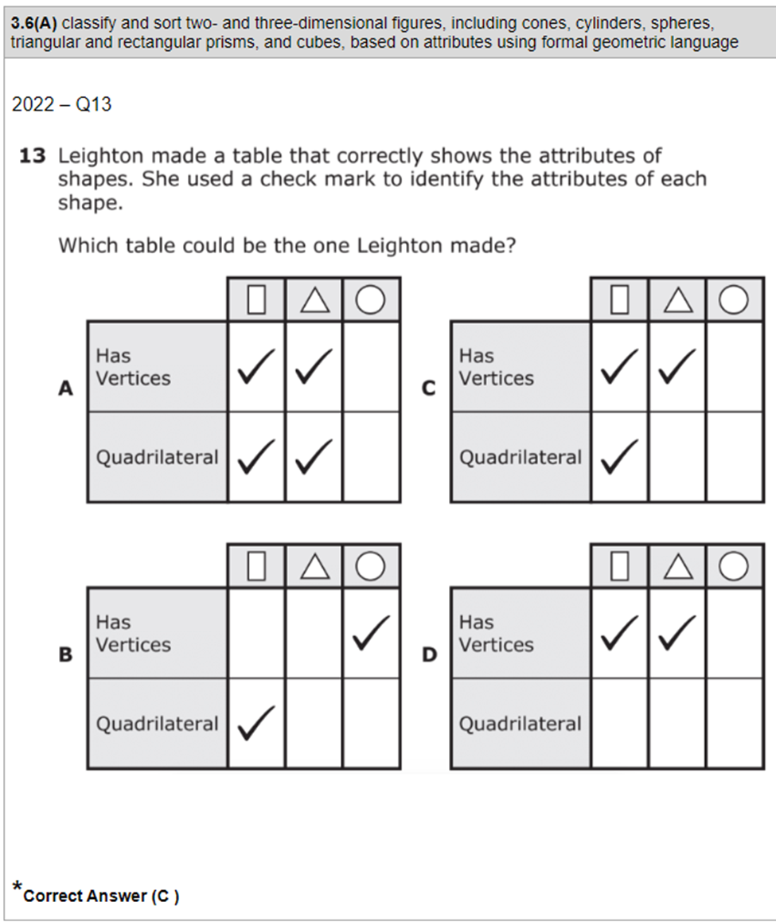 | Module 7 Mid Module Assessment  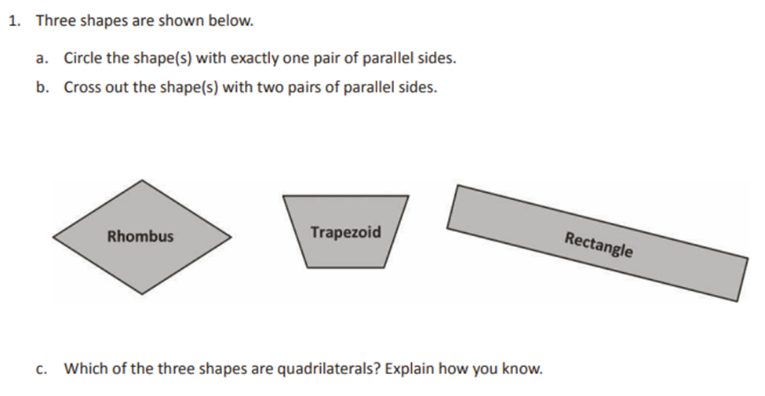  Module 7 Lesson 4 Problem Set  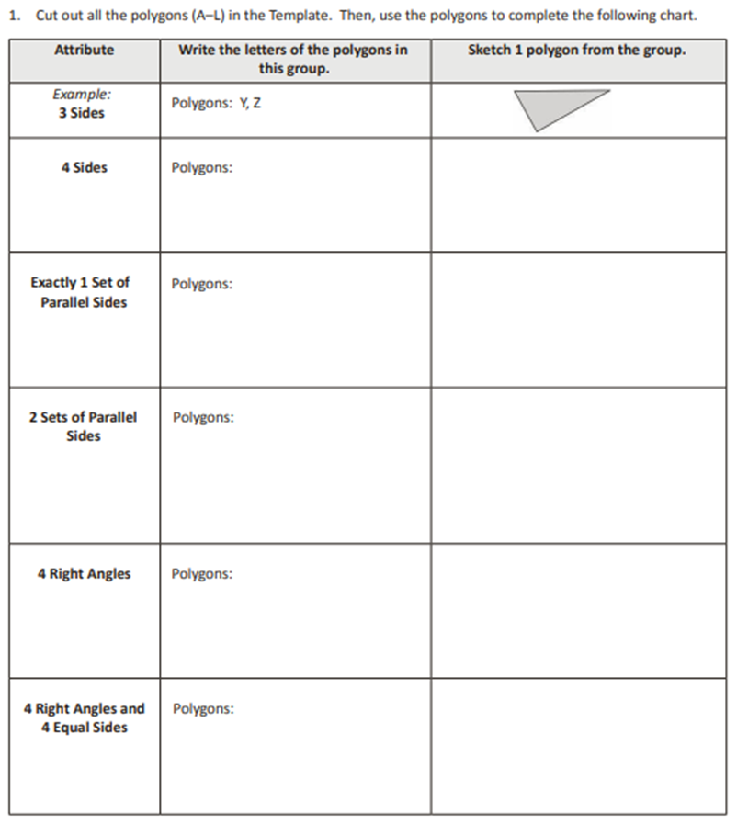
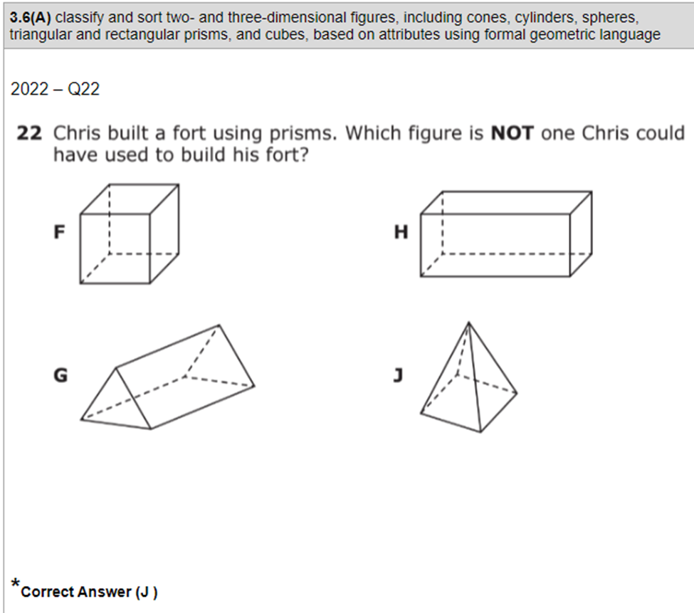 | Module 7 Mid Module Assessment  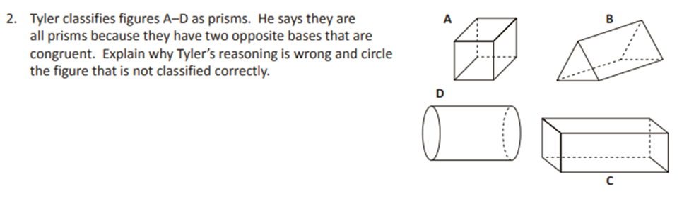
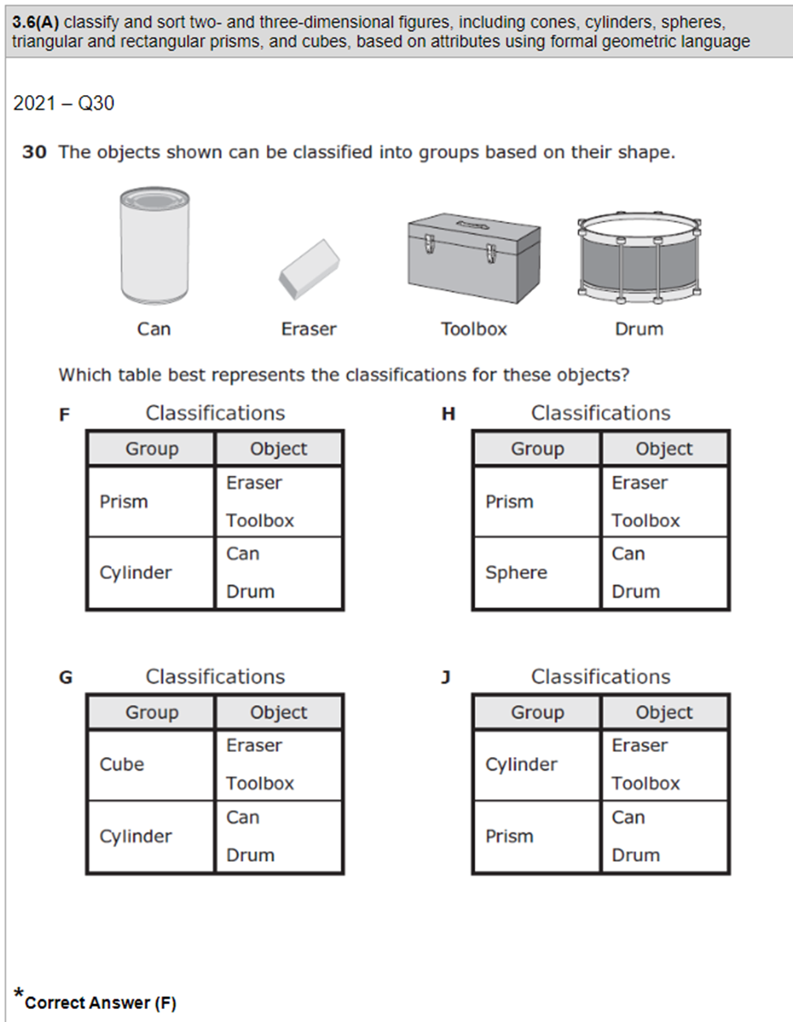 | Module 7 Lesson 7 Exit Ticket  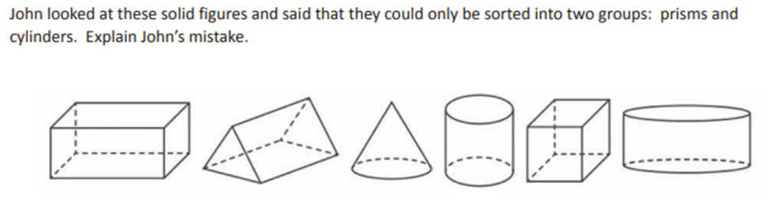
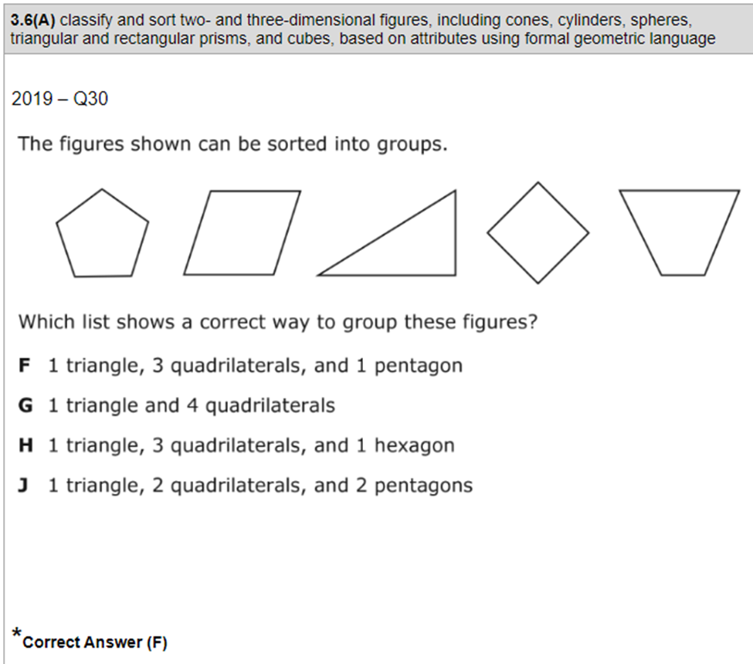
TEKS: 3.6C determine the area of rectangles with whole number side lengths in problems using multiplication related to the number of rows times the number of unit squares in each row.
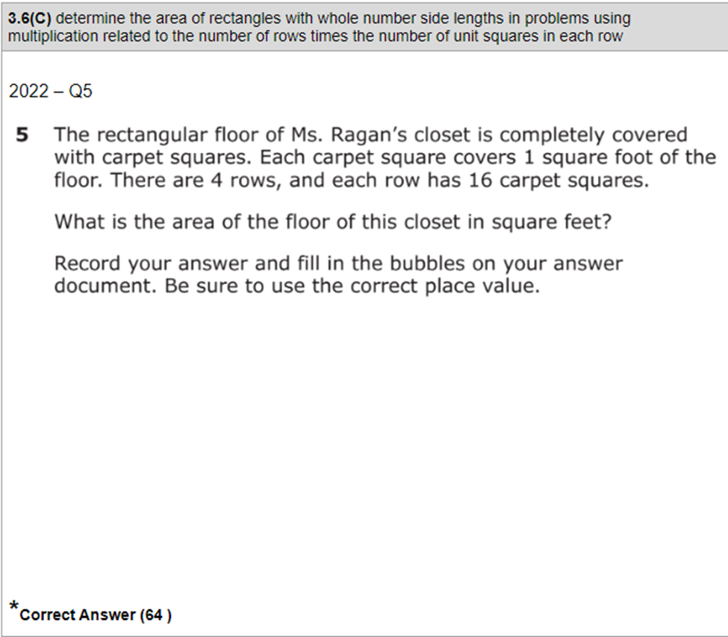 | Module 4 End of Module Assessment  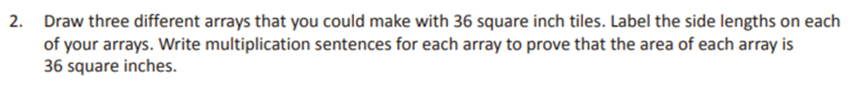
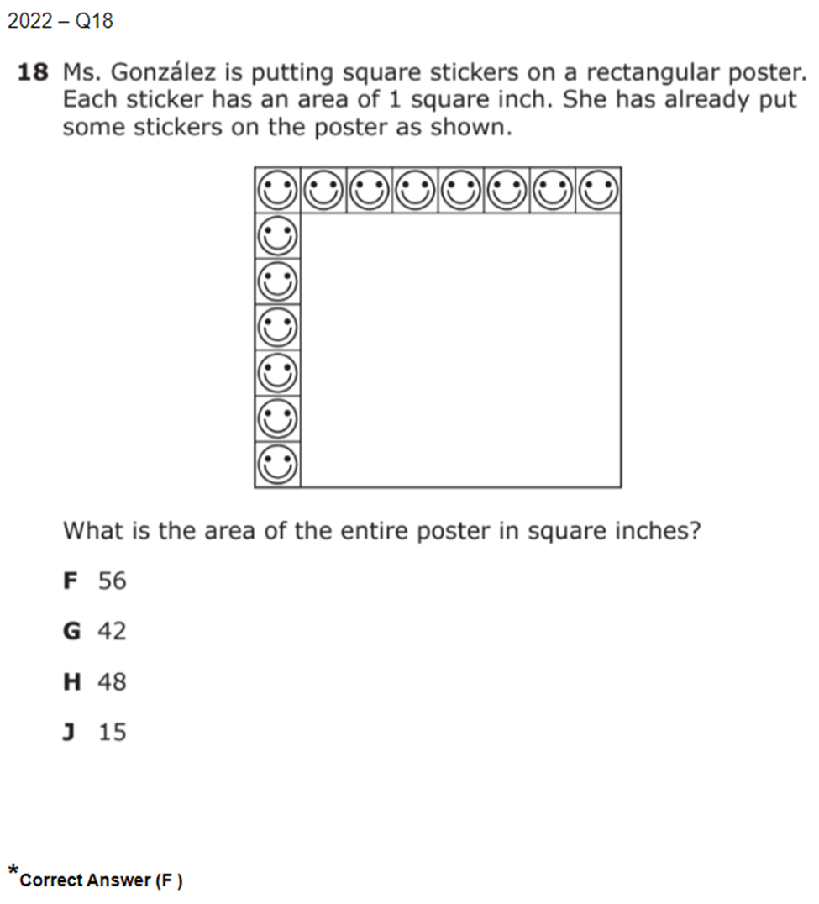 | Module 4 Mid Module Assessment  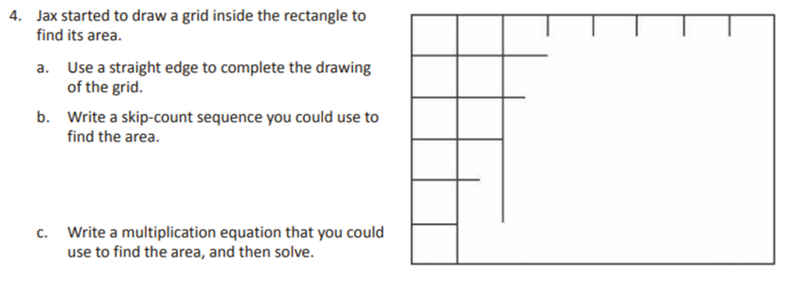  Module 4 Lesson 3 Problem Set  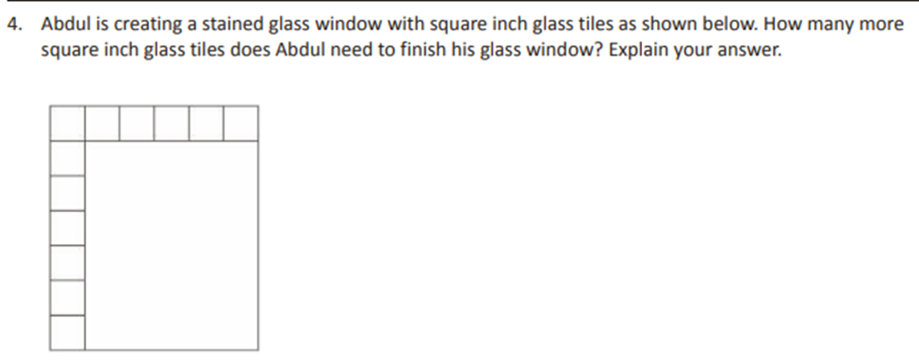
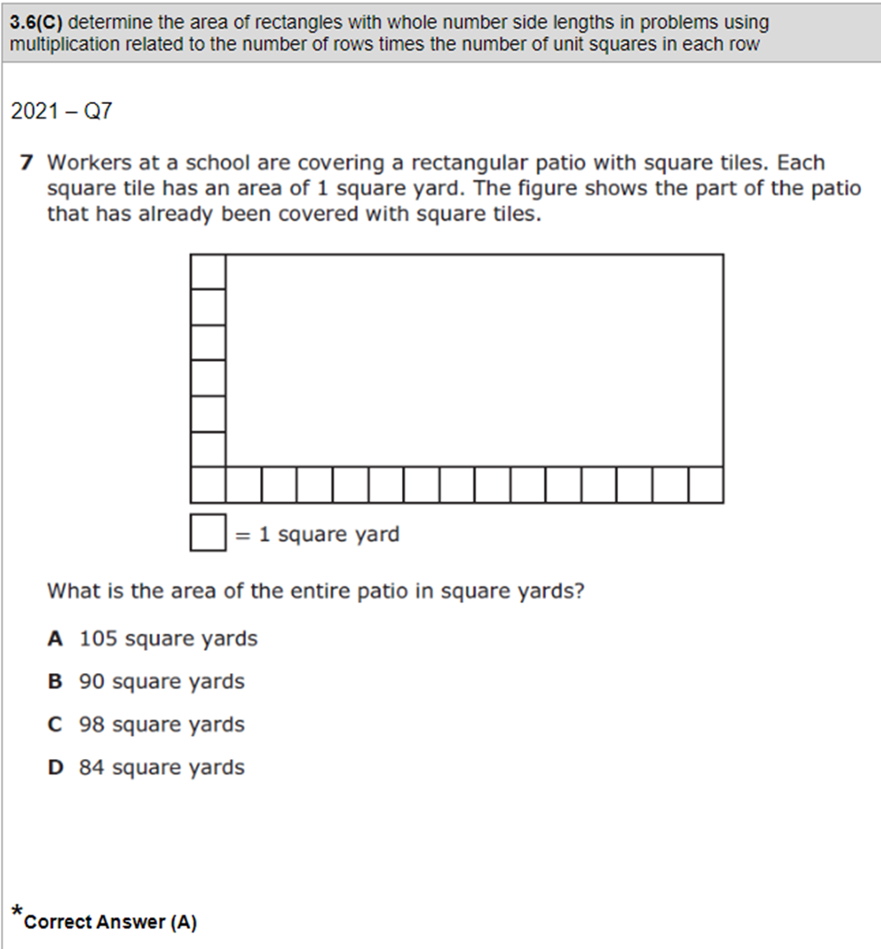 | Module 4 End of Module Assessment  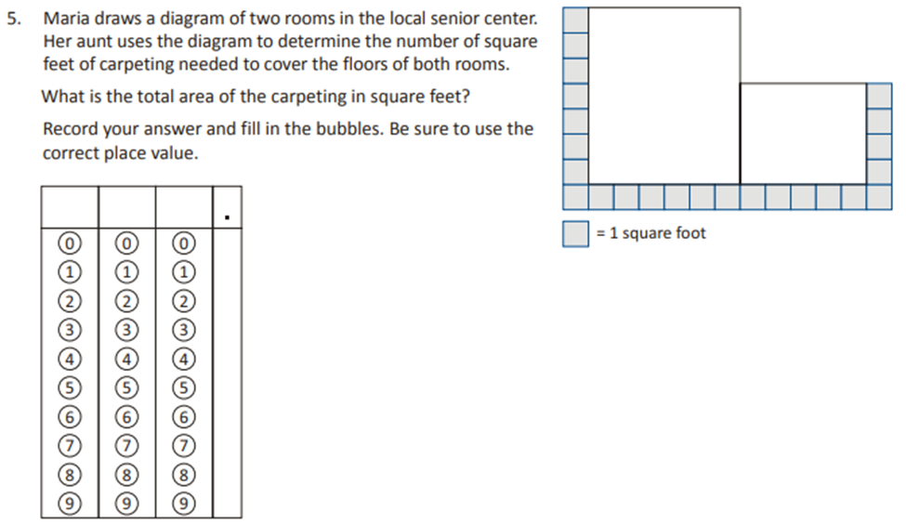
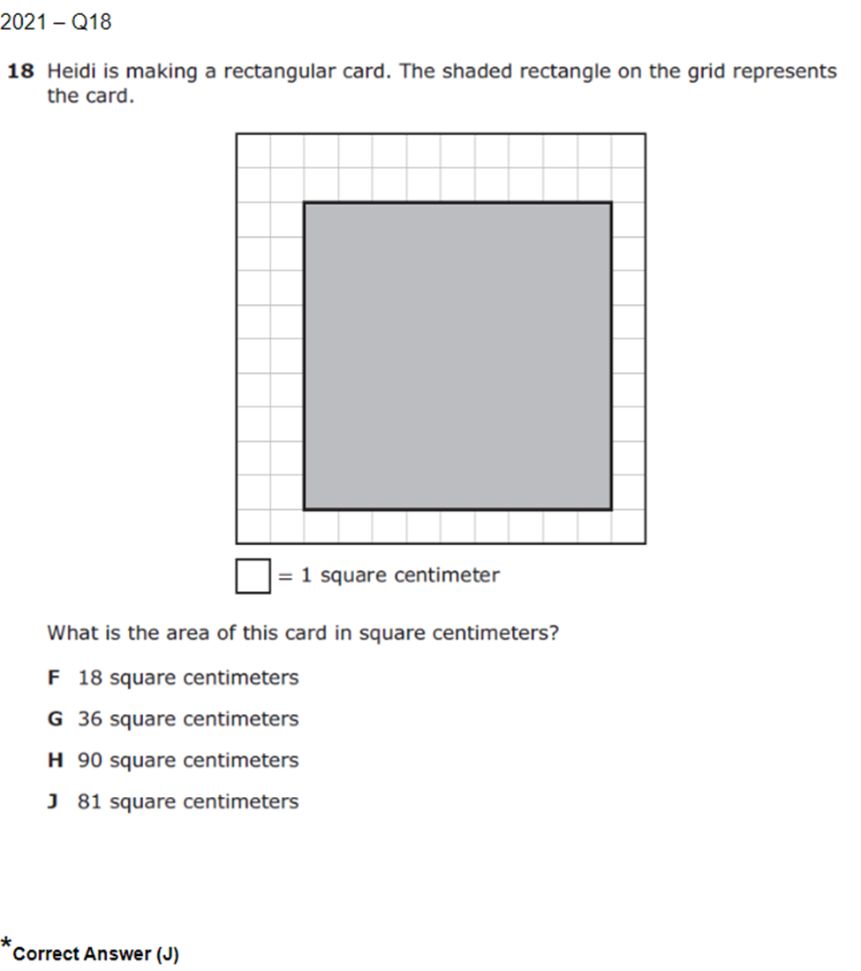 | Module 4 End of Module Assessment  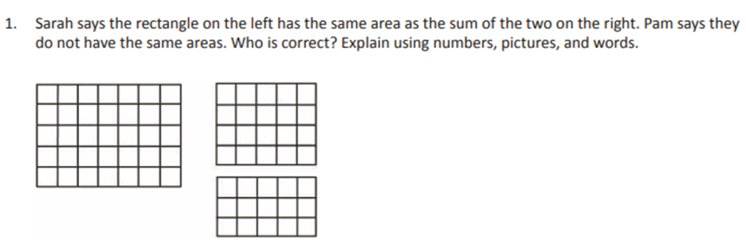  Module 4 Lesson 4 Problem Set  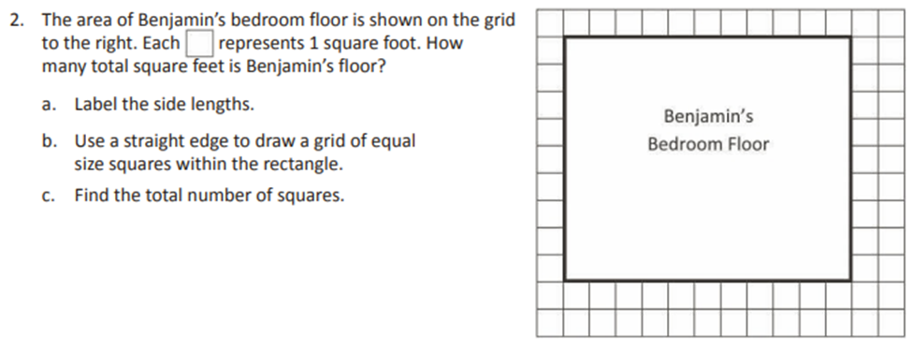
TEKS: 3.7B determine the perimeter of a polygon or a missing length when given perimeter and remaining side lengths in problems.
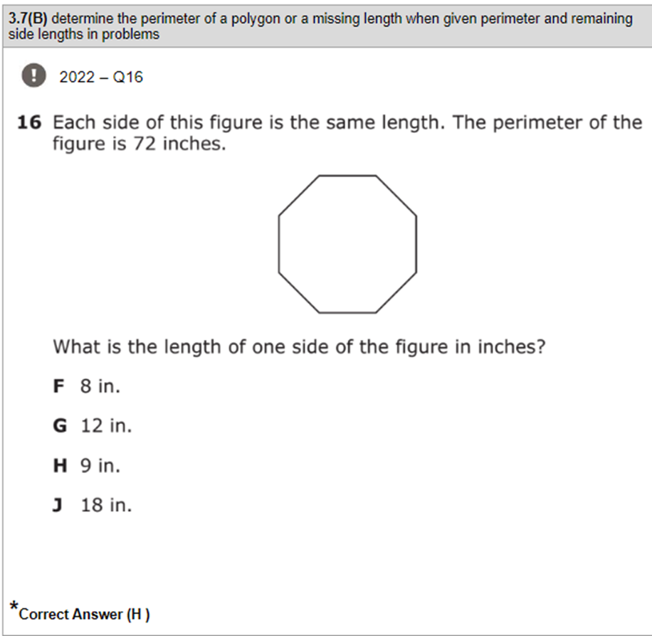 | Module 7 End of Module Assessment  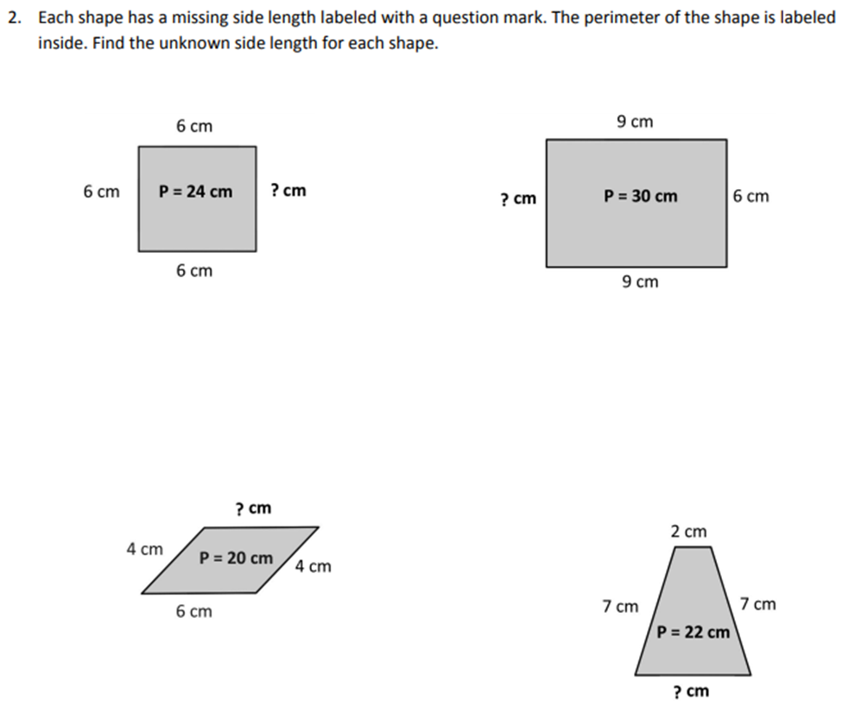
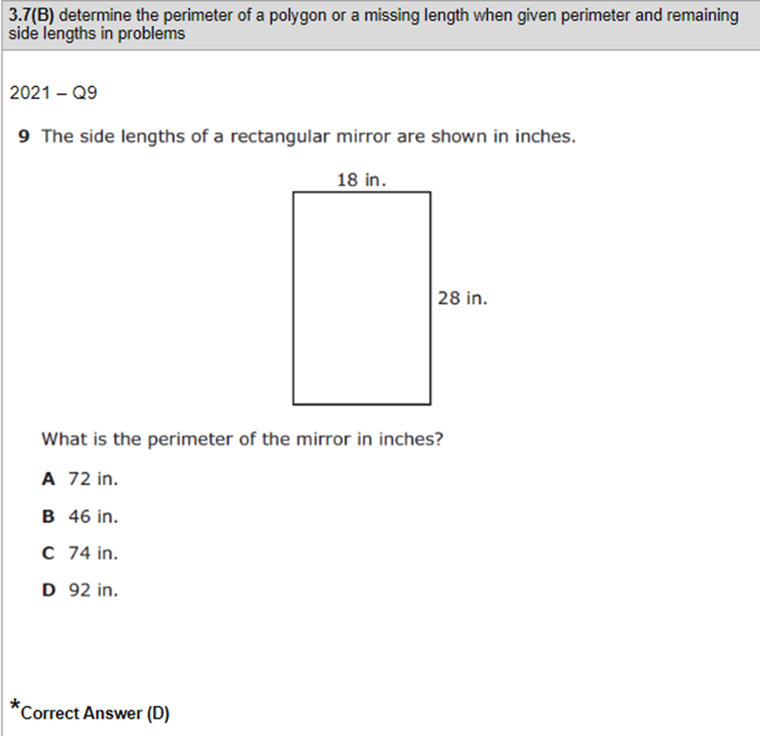 | Module 7 End of Module Assessment  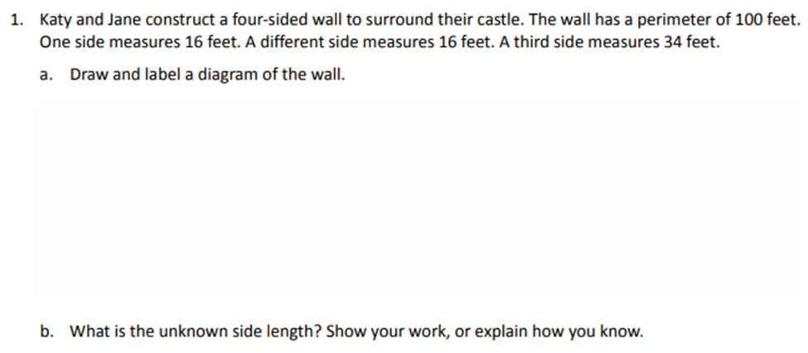
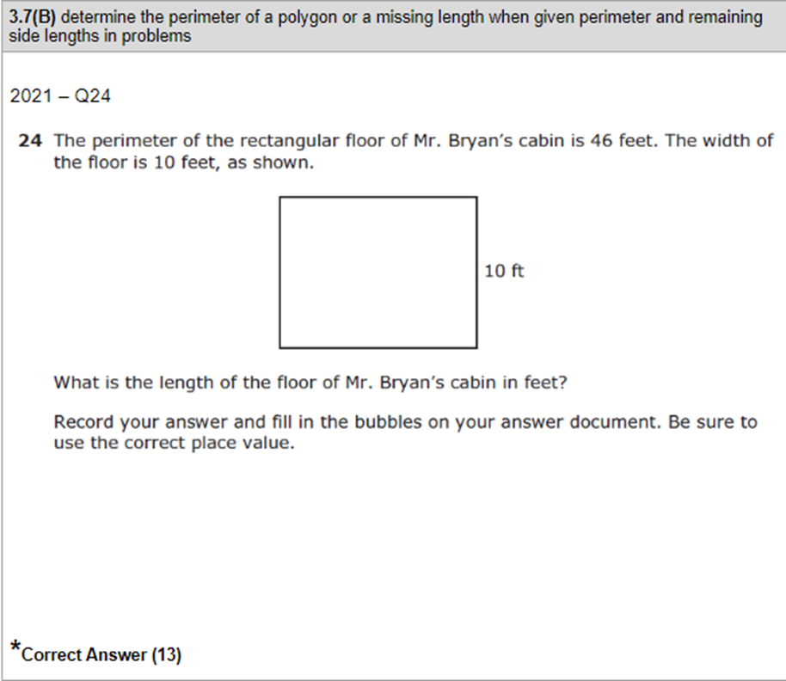 | Module 7 End of Module Assessment  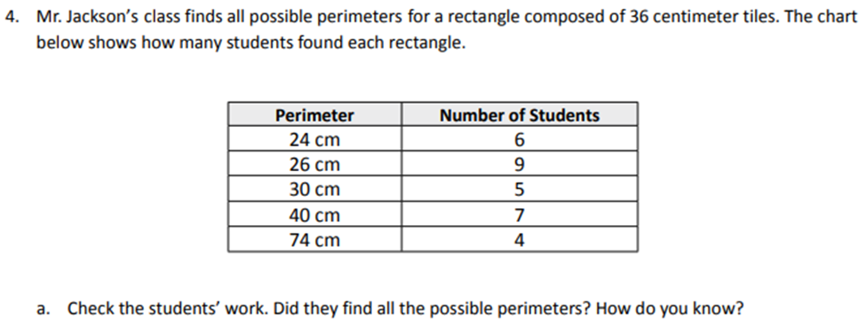
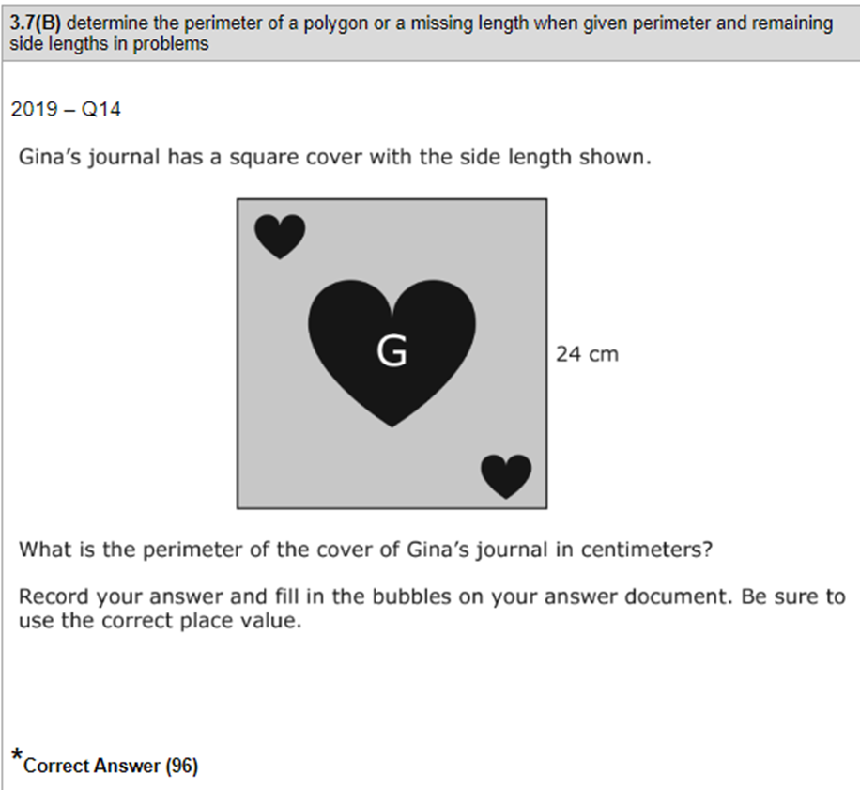 | Module 7 Lesson 14 Exit Ticket
TEKS: 3.8A summarize a data set with multiple categories using a frequency table, dot plot, pictograph, or bar graph with scaled intervals.
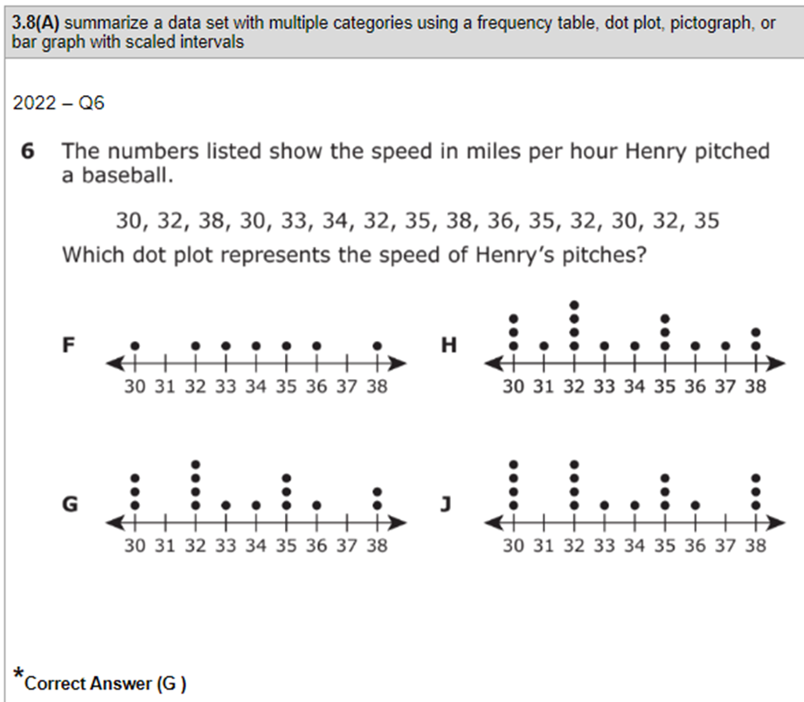 | Module 6 Lesson 14 Problem Set  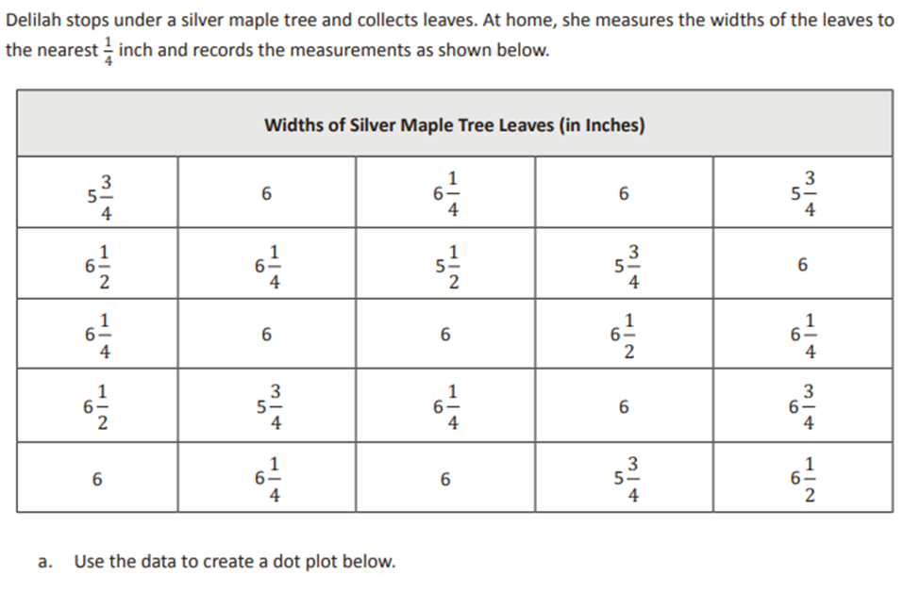
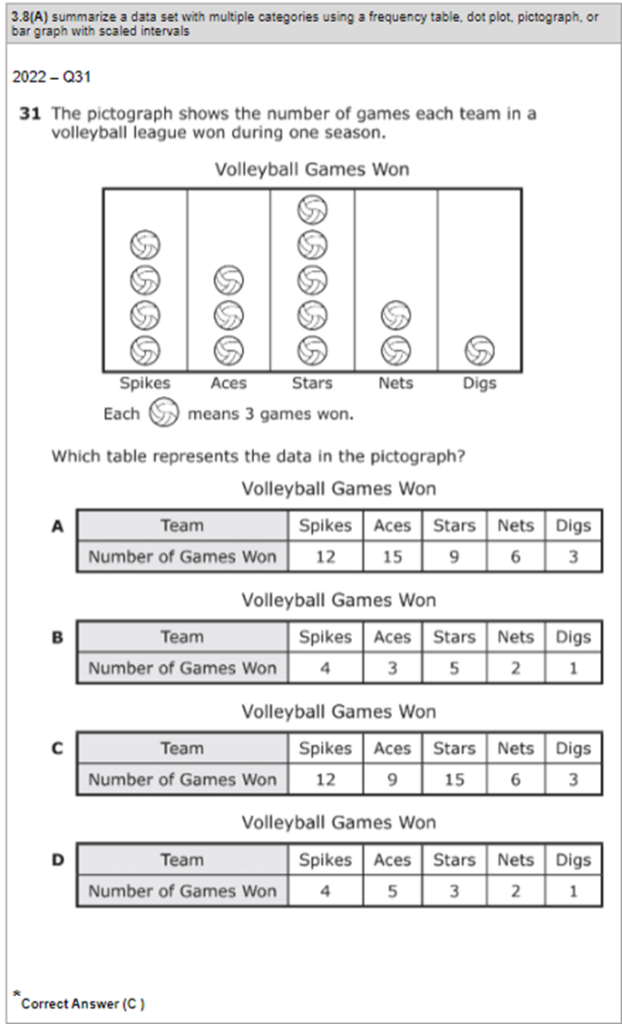 | Module 6 End of Module Assessment  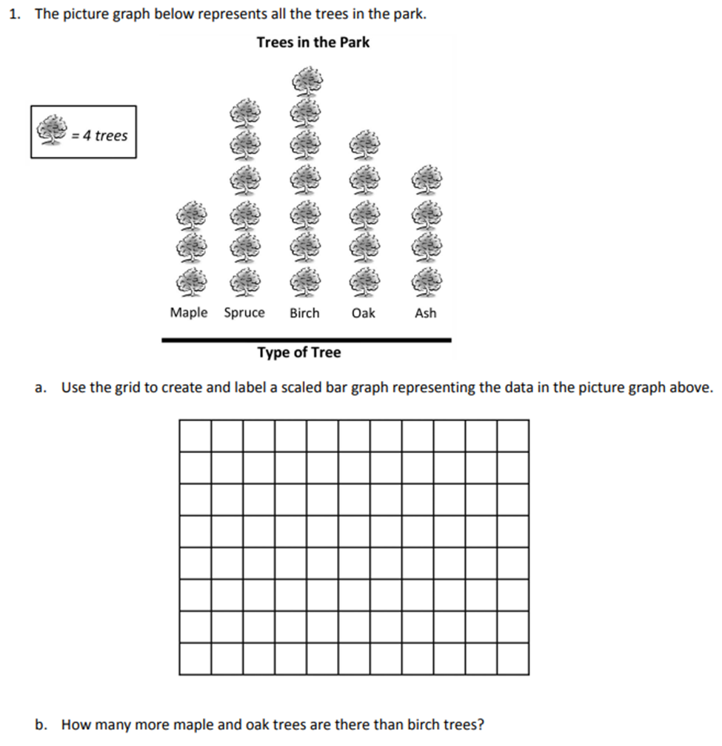
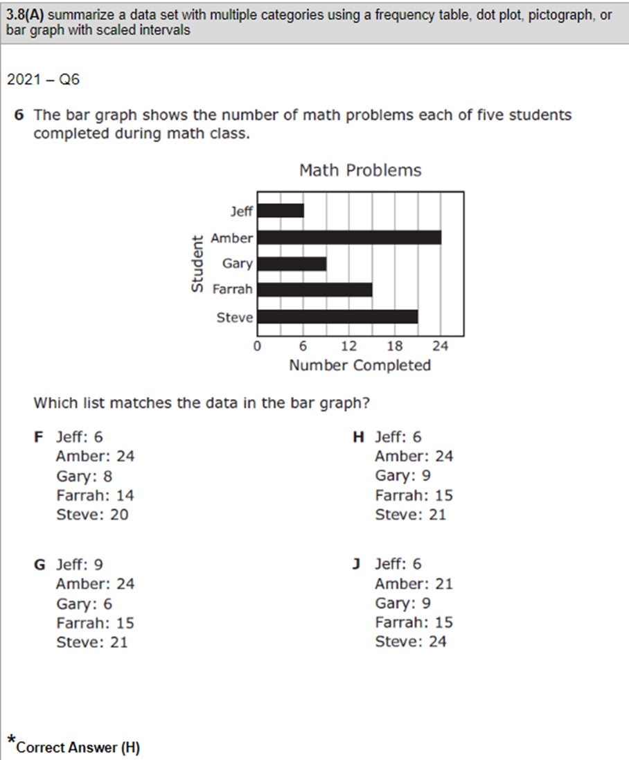 | Module 6 Lesson 7 Problem Set  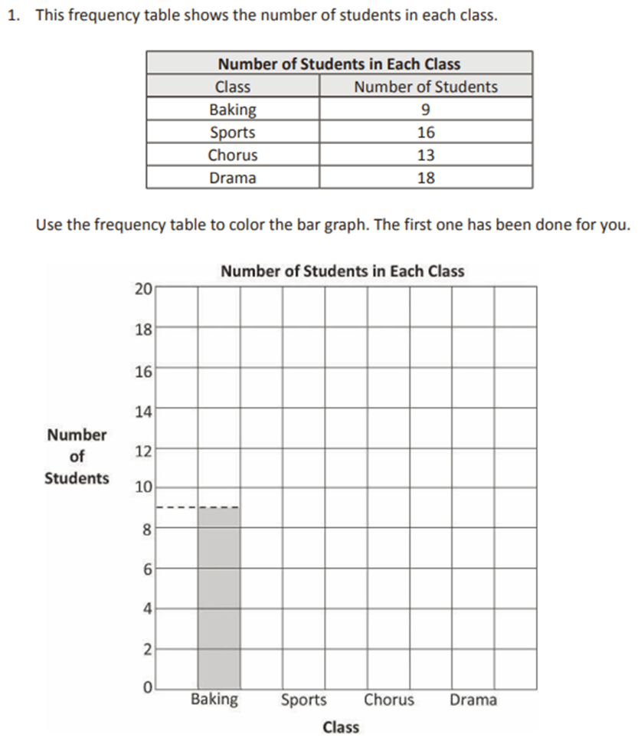
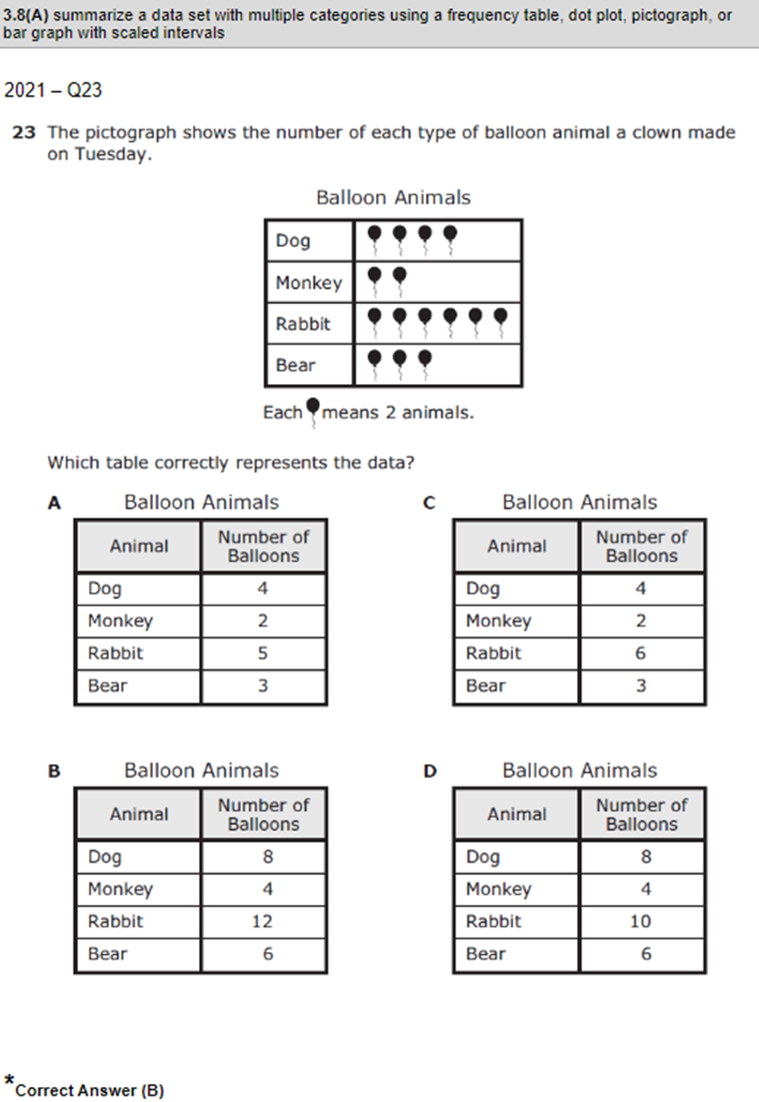 | Module 6 Lesson 5 Exit Ticket  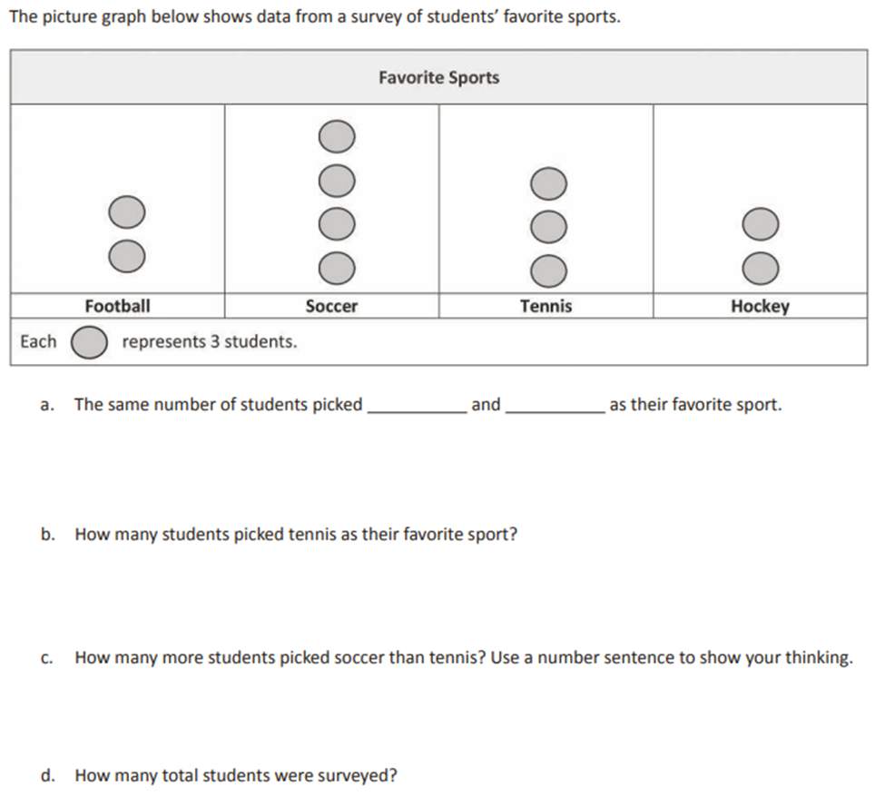
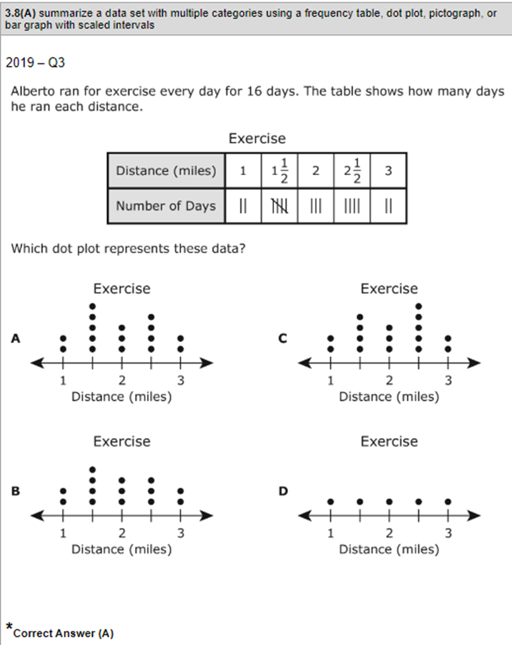 | Module 7 End of Module Assessment  