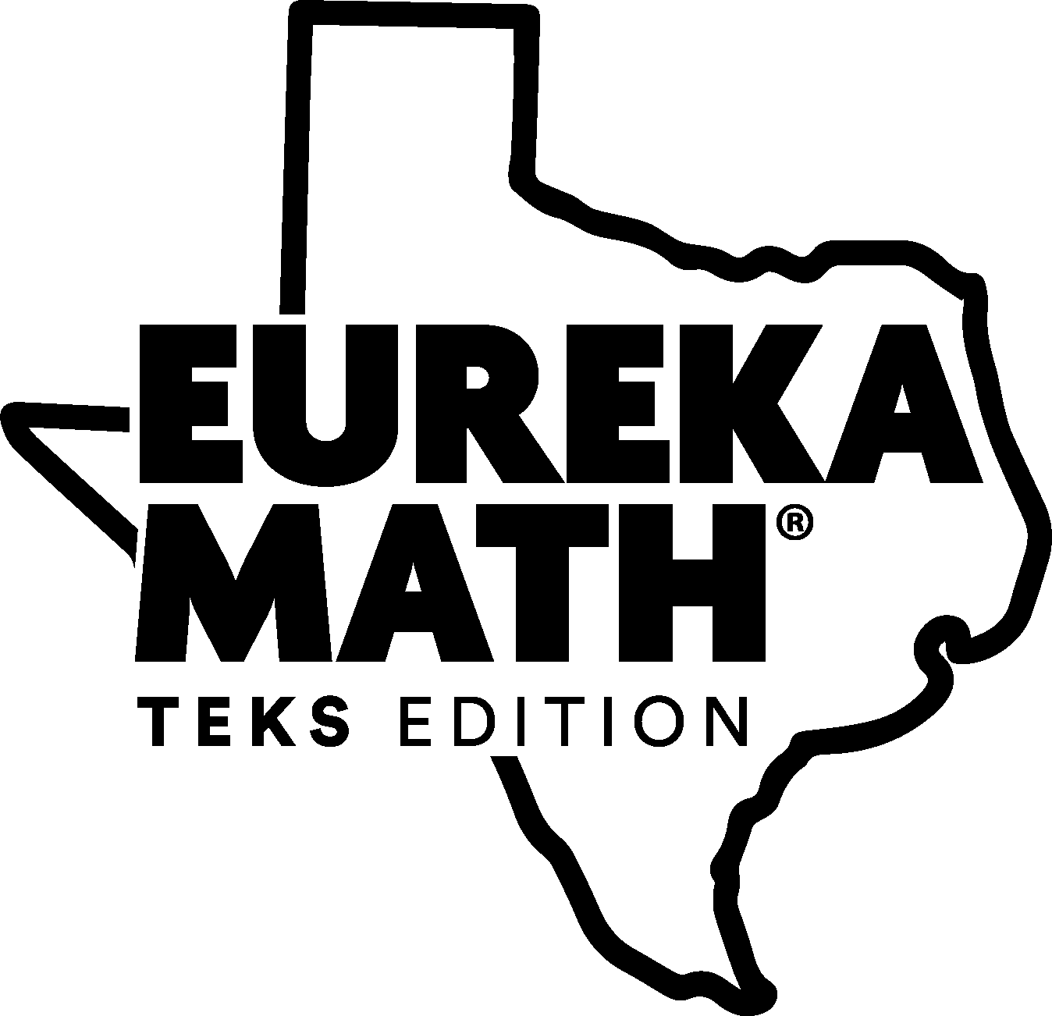

Fourth Grade Assessment Question Analysis by Readiness Standard

Table of Contents
4.2B pg 2
4.4A pg 6
4.2G pg 9
4.3D pg 11
4.3E pg 12
4.4H pg 14
4.5A pg 16
4.5B pg 16

Fourth Grade Eureka and STAAR Question Analysis
TEKS 4.2(B) - Represent the value of the digit in whole numbers through 1,000,000,000 and decimals to the hundredths using expanded notation and numerals.
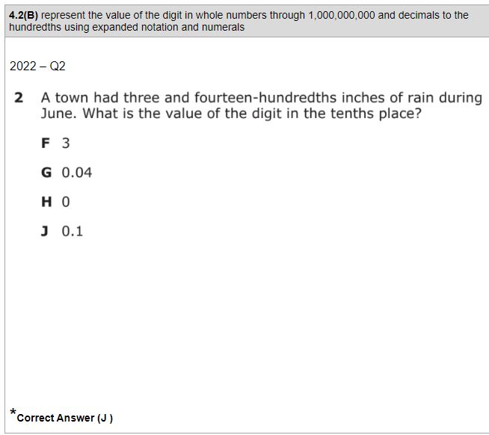 | Module 1 Lesson 4 Concept Development  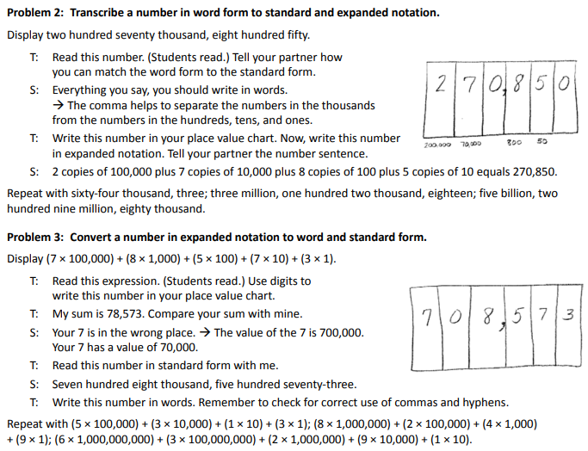
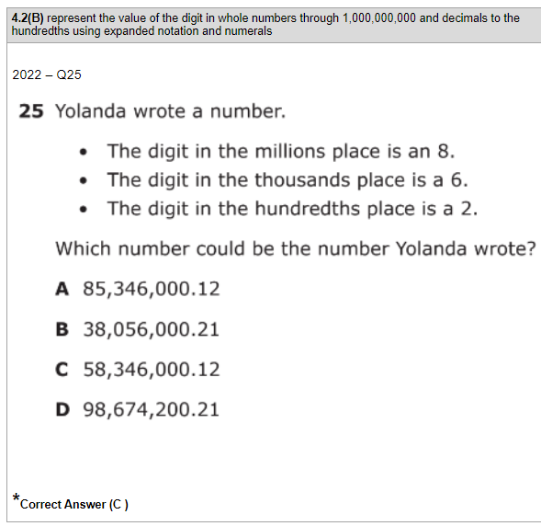 | Module 1 Lesson 4 Problem Set  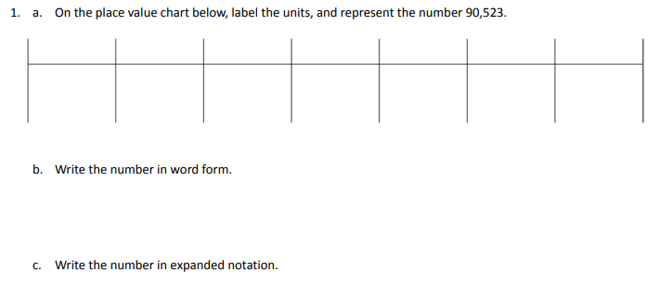  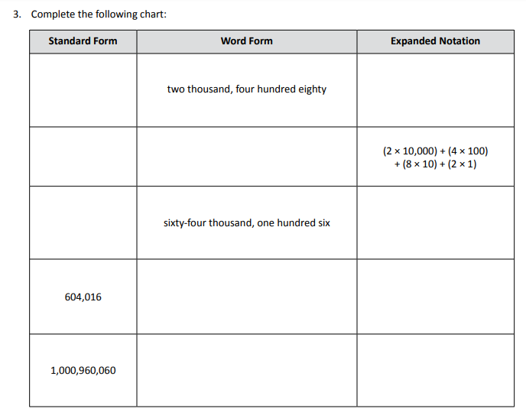
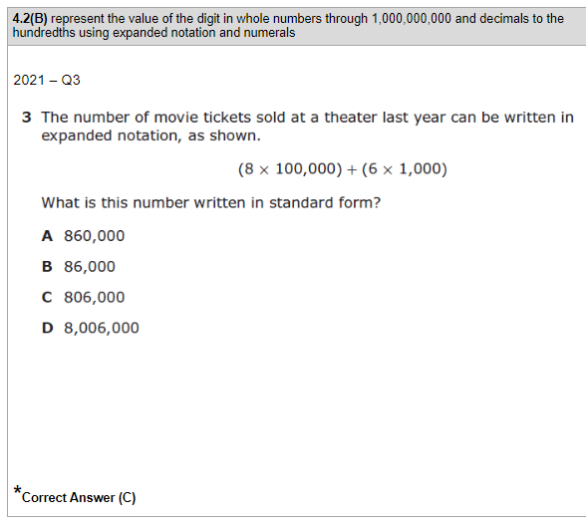 | Module 1 Lesson 4 Exit Ticket  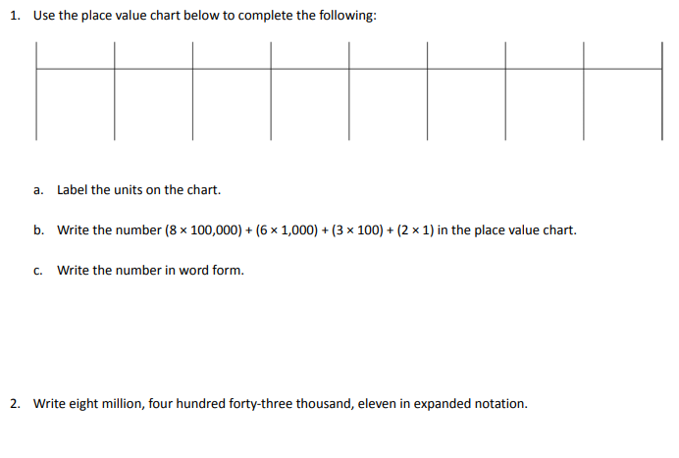
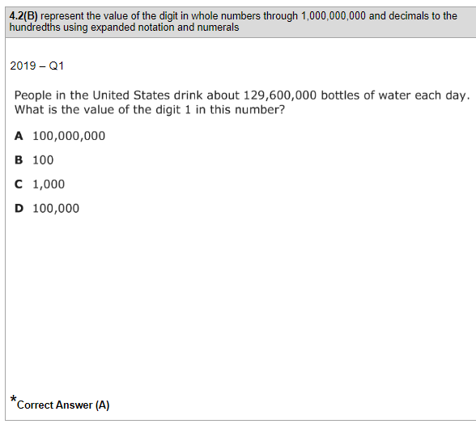 | Module 1 Mid-Module Assessment  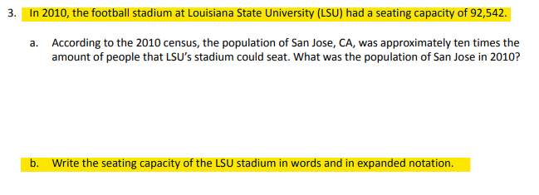
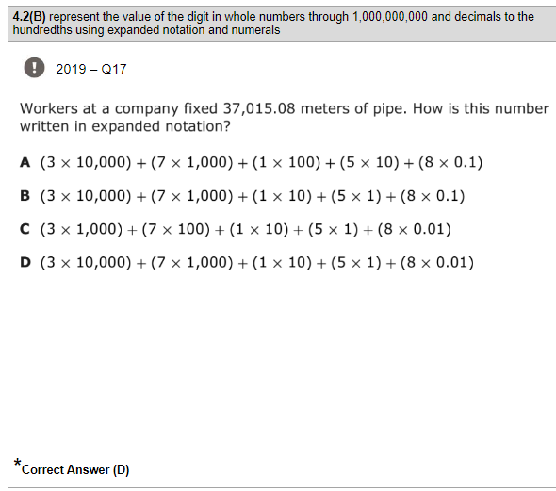 | Module 1 End-of-Module Assessment
Module 6 Lesson 7 Concept Development
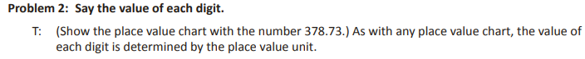
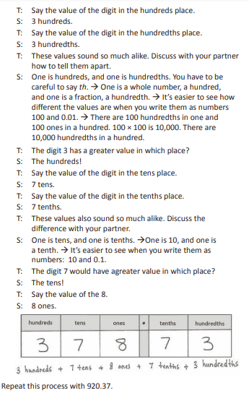
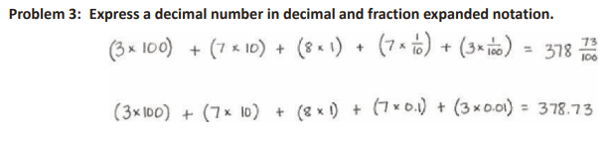
Module 6 Lesson 7 Problem Set/Exit Ticket
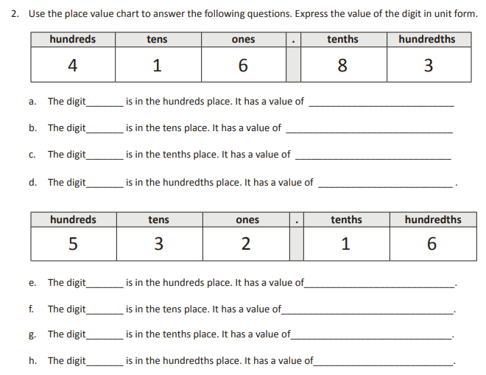
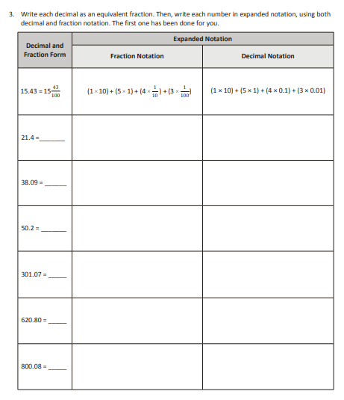
Module 6 Mid-Module Assessment
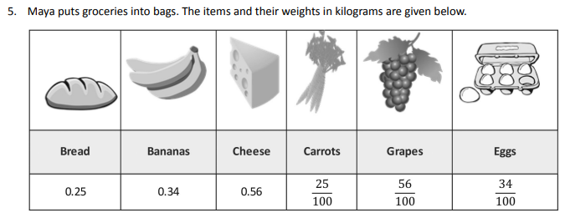
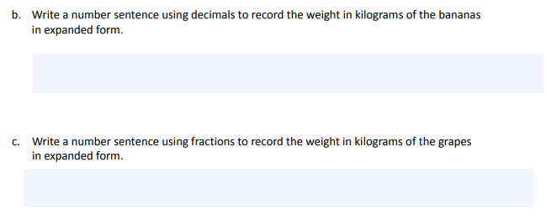

TEKS 4.4(A) - Add and subtract whole numbers and decimals to the hundredths place using the standard algorithm.
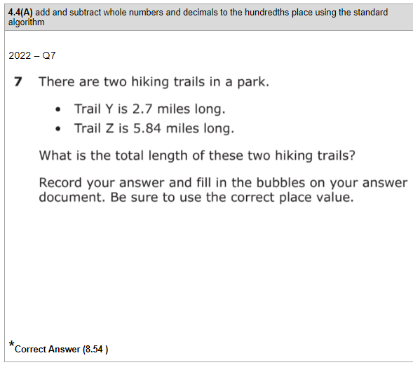 | Module 1 Lesson 12 Concept Development  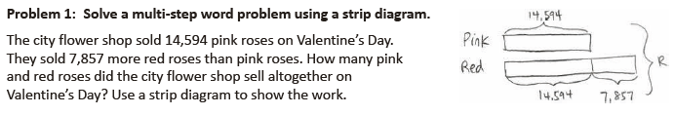  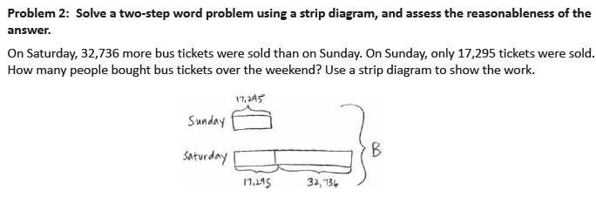  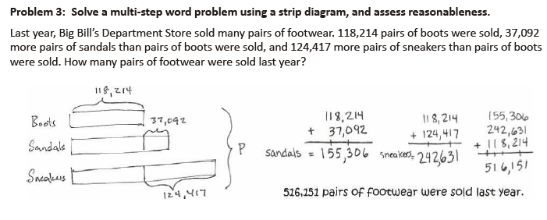
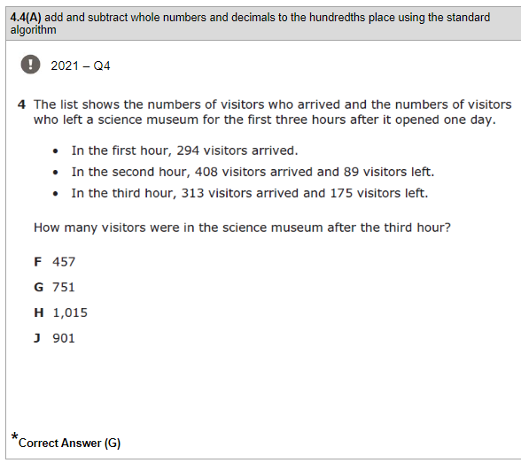 | Module 1 Lesson 12 Problem Set/Exit Ticket  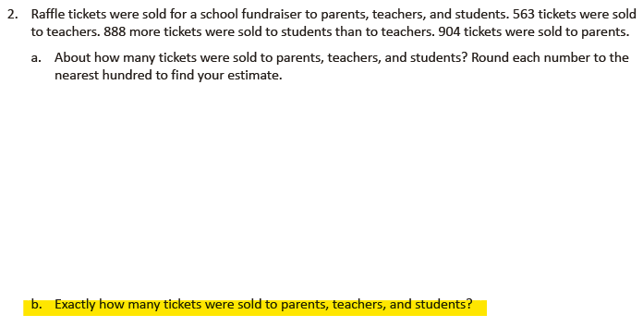  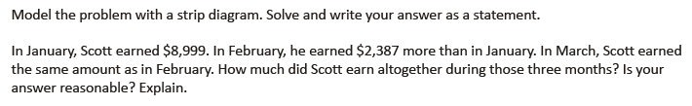
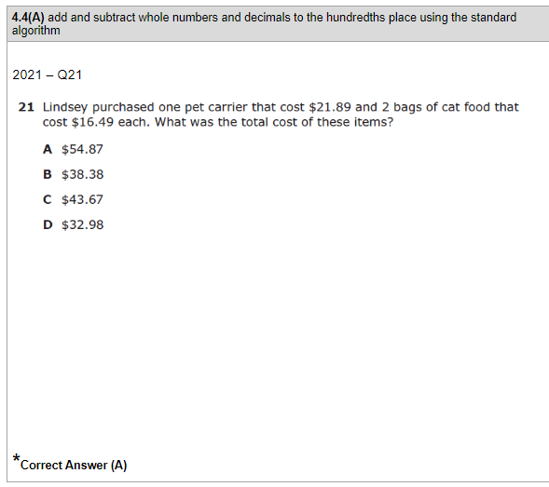 | Module 1 End-of-Module Assessment  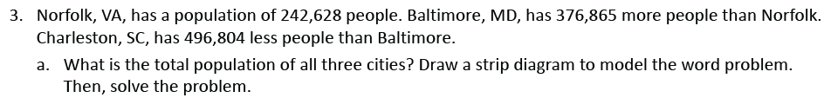
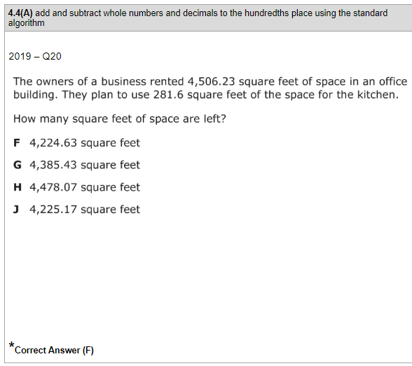 | Module 6 Lesson 12 Problem Set
Module 6 Lesson 14 Problem Set
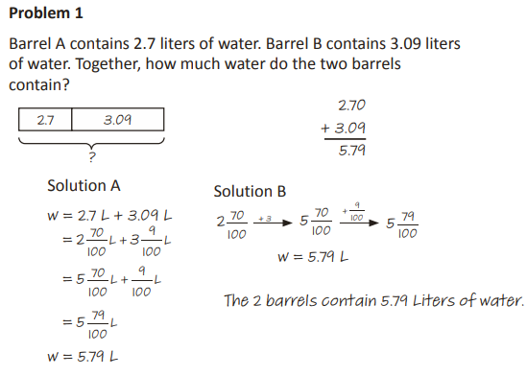
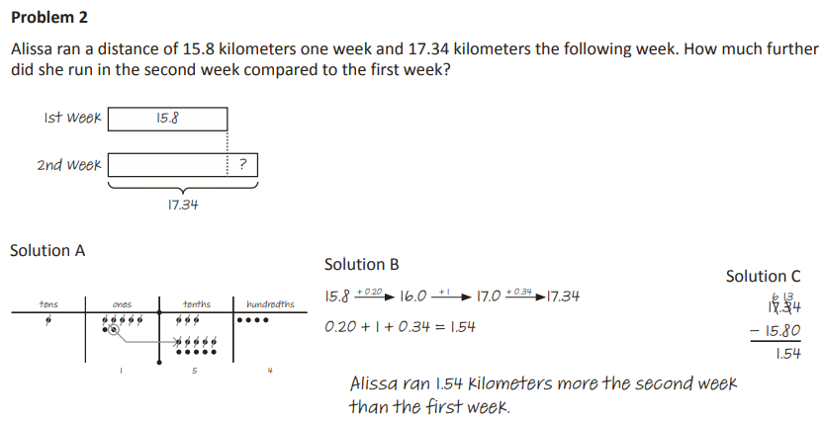
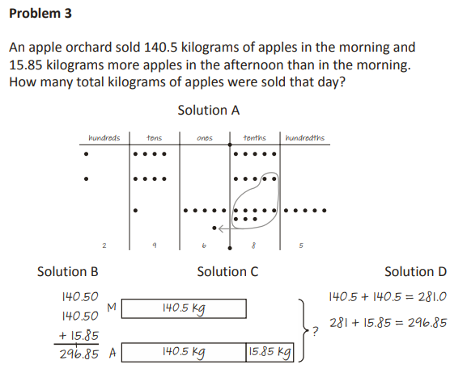
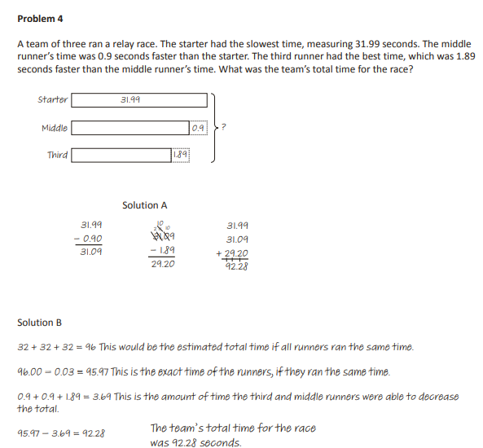
TEKS 4.2(G) - Relate decimals to fractions that name tenths and hundredths.
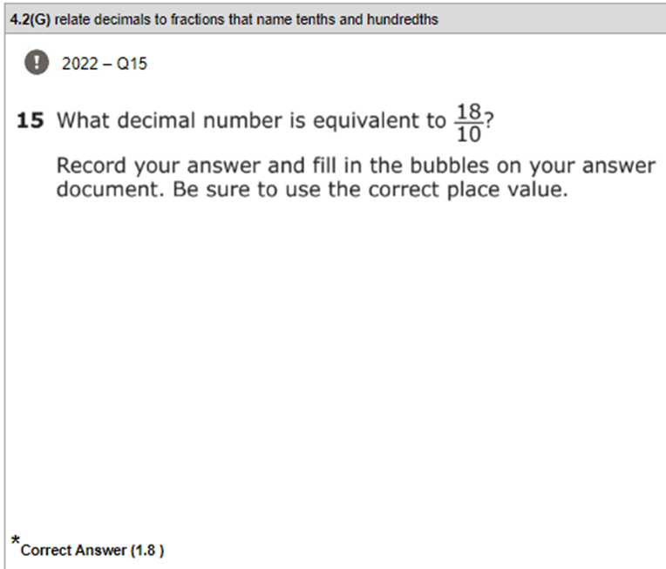 | Module 6 End of Module Assessment  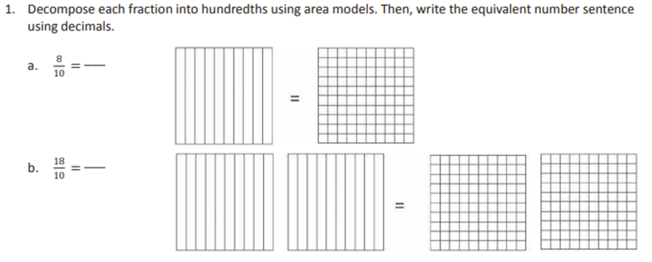  Module 6 Lesson 11 Exit Ticket  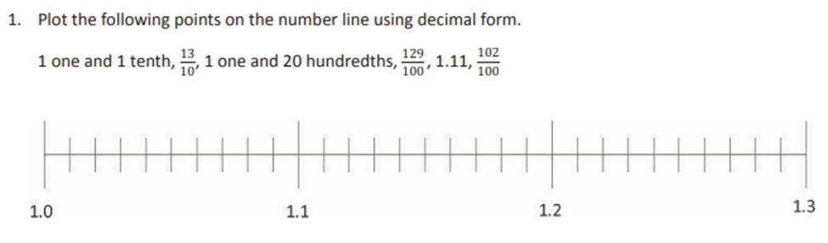
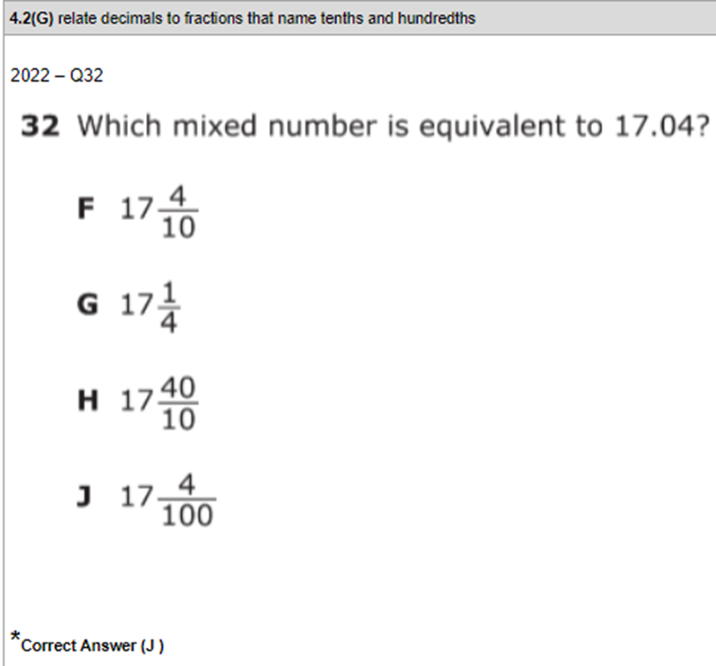 | Module 6 End of Module Assessment  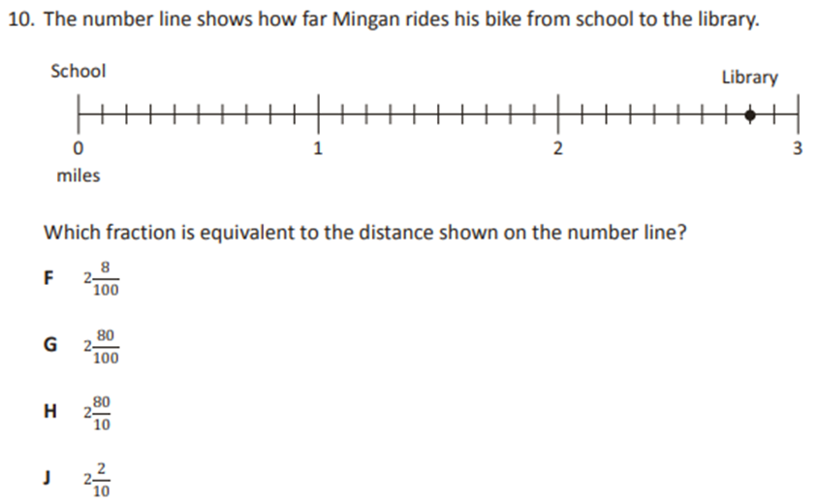
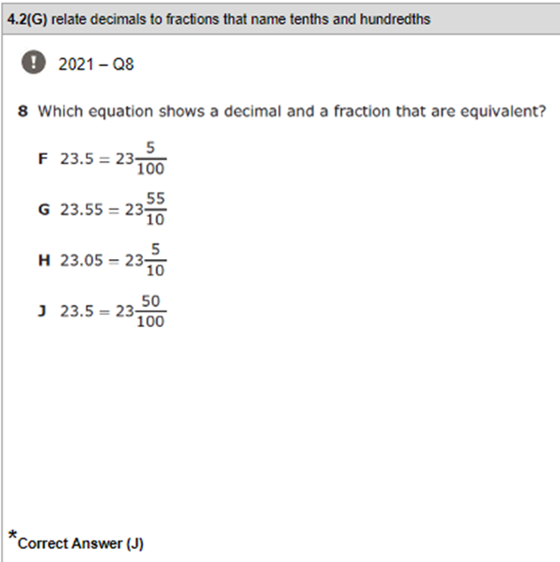 | Module 6 Mid Module Assessment  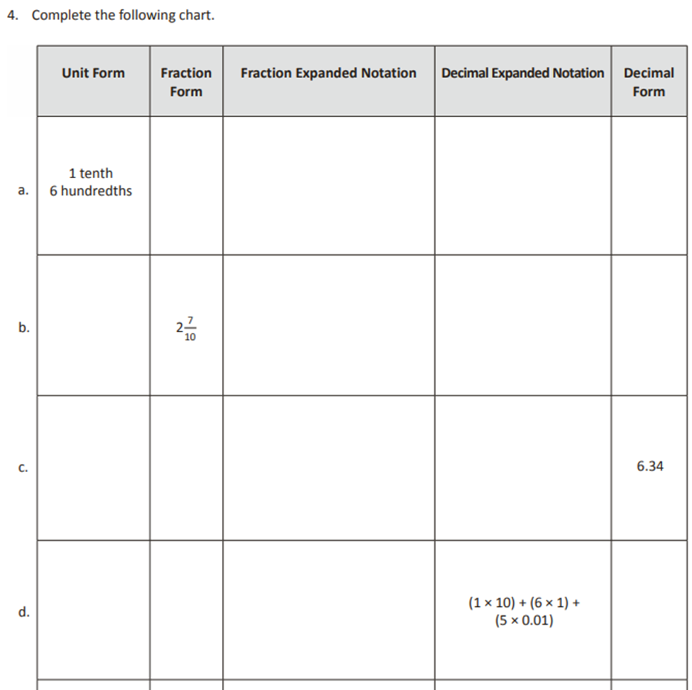
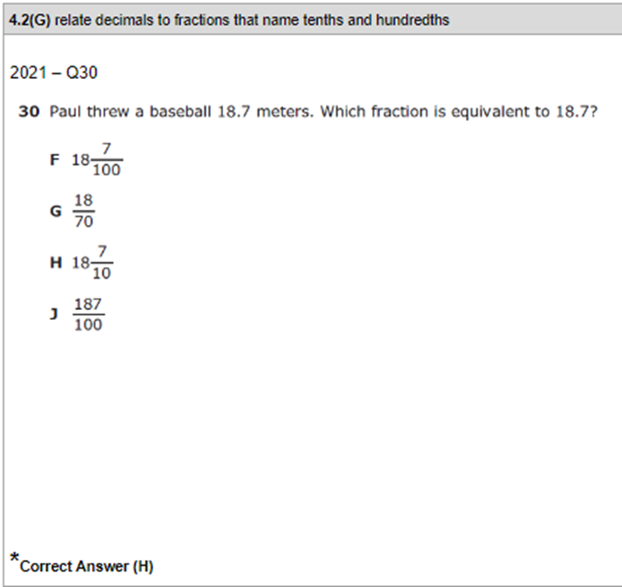 | Module 6 Mid Module  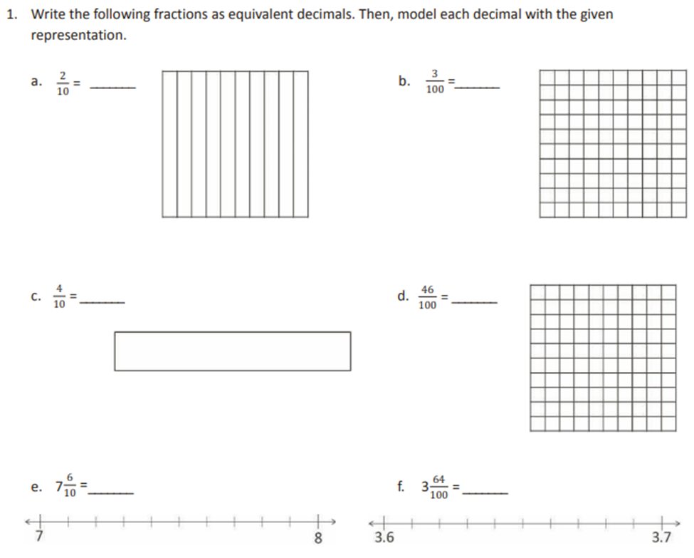
TEKS 4.3(D) - Compare two fractions with different numerators and different denominators and represent the comparison using the symbols >,<, =
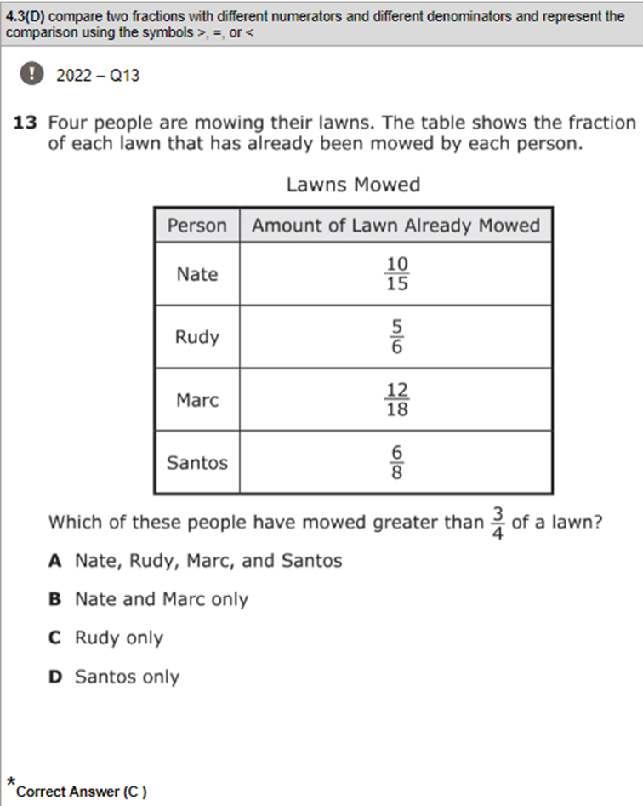 | Module 5 Mid Module Assessment  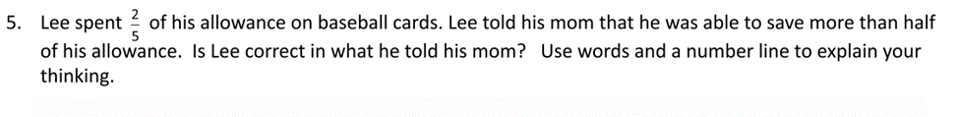  Module 5 End of Module Assessment  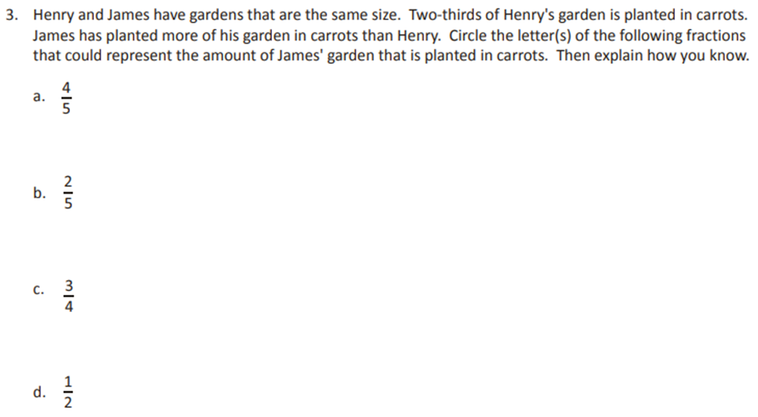
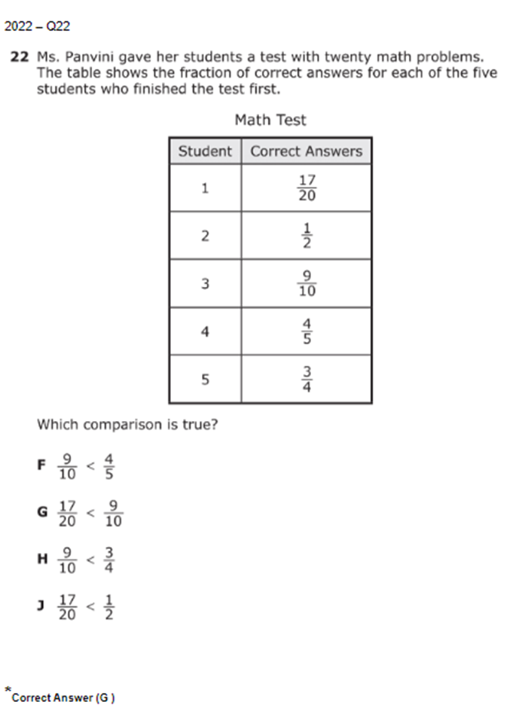 | Module 5 Mid Module Assessment  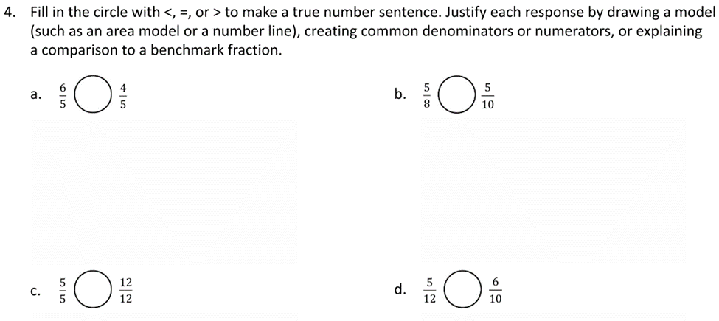  Module 5 End of Module Assessment  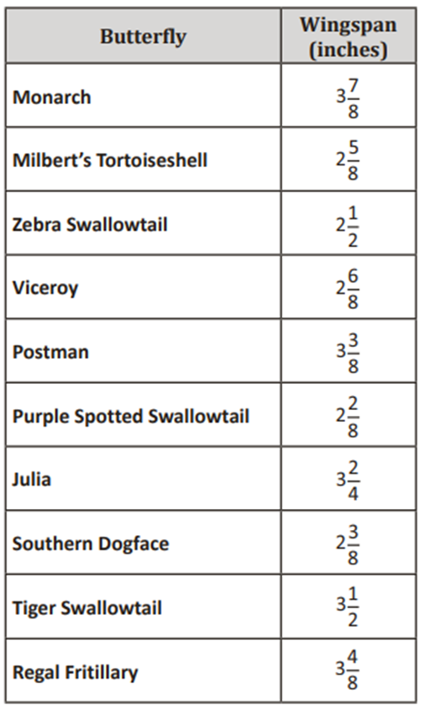
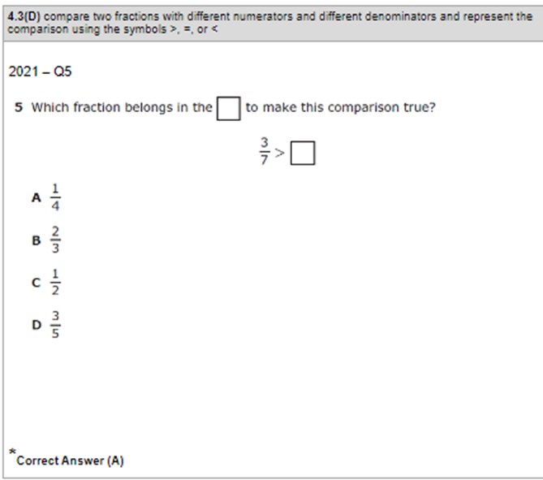 | Module 5 Lesson 13 Exit Ticket  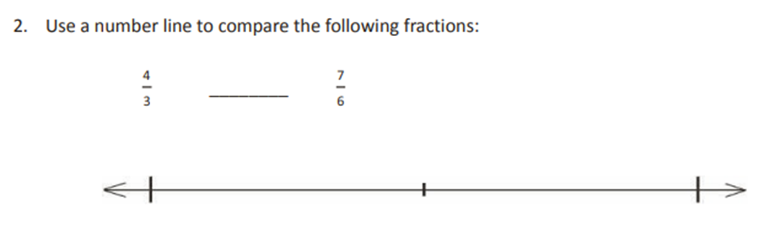
TEKS 4.3(E) - Represent and solve addition and subtraction of fractions with equal denominators using objects and pictorial models that build to the number line and properties of operations.
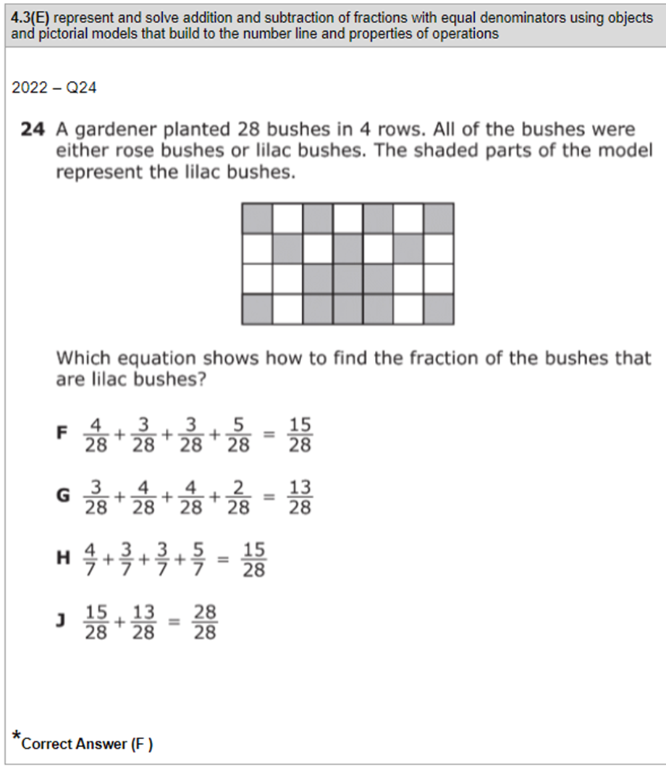 | Module 5 End of Module Assessment  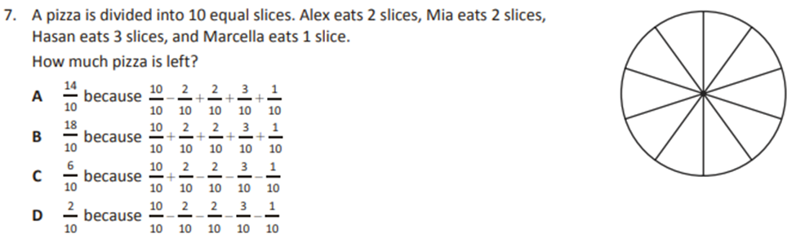
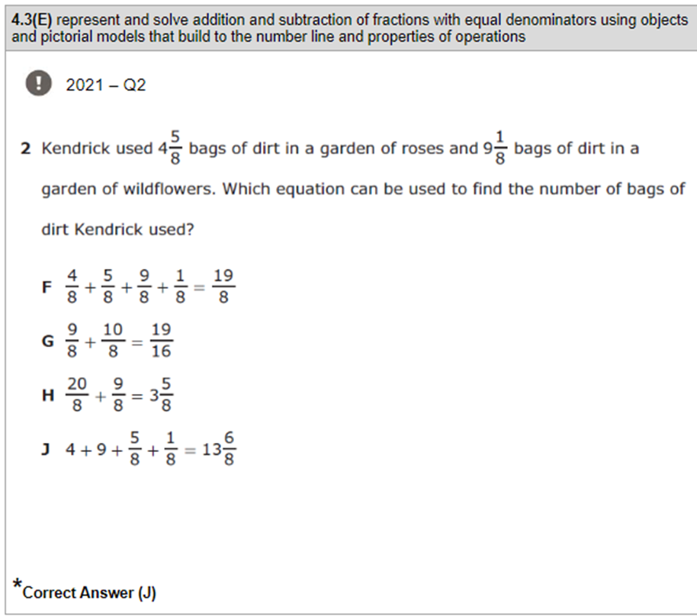 | Module 5 Lesson 28 Problem Set  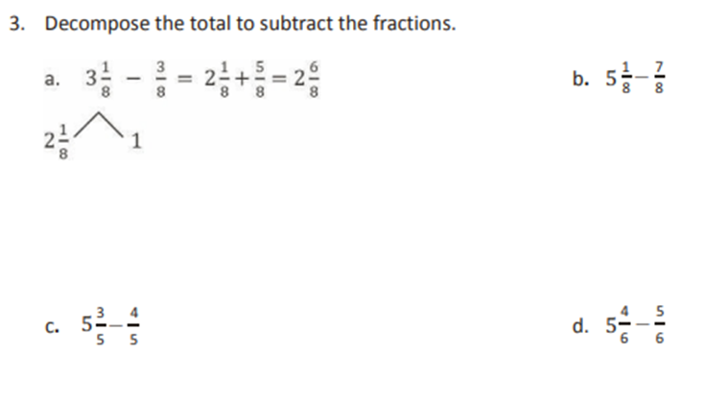
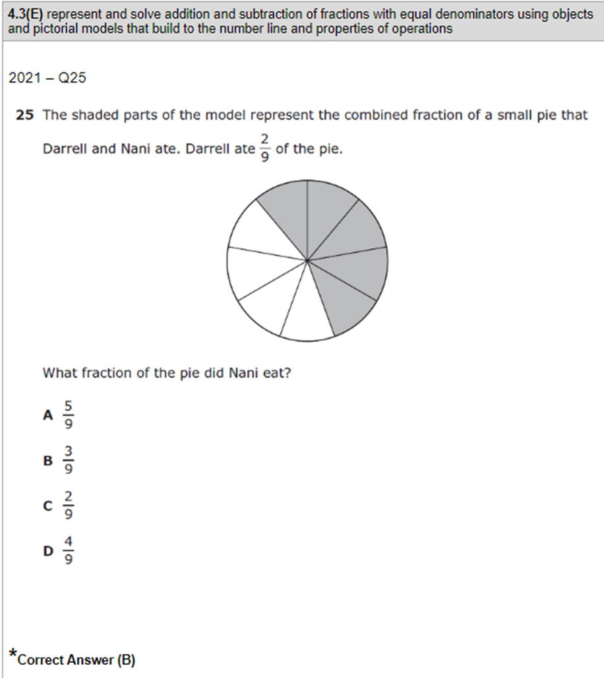
TEKS 4.4(H) - Solve with fluency one and two step problems involving multiplication and division, including interpreting remainders.
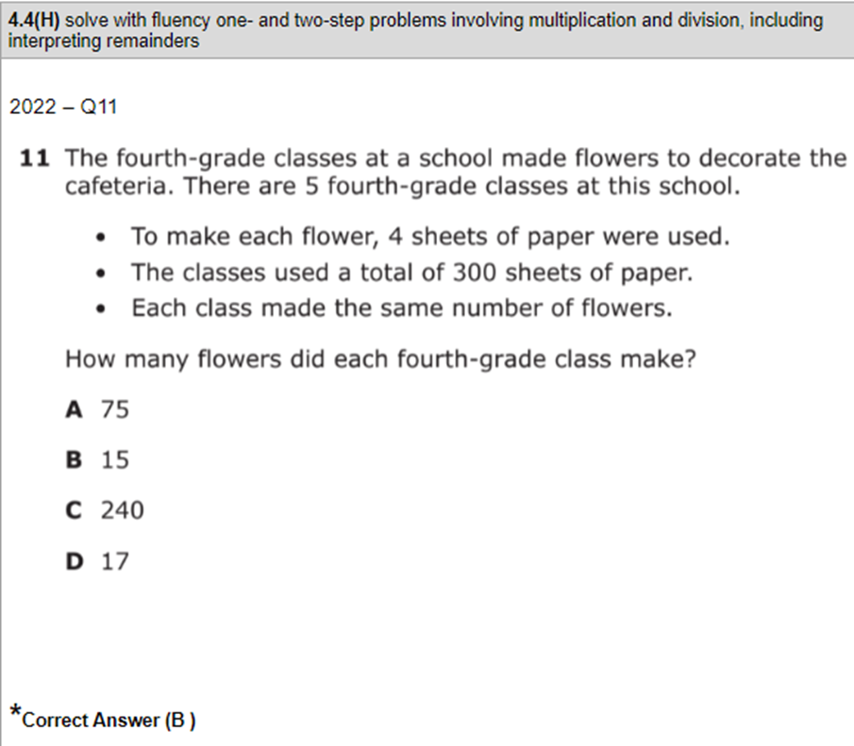 | Module 3 End of Module Assessment  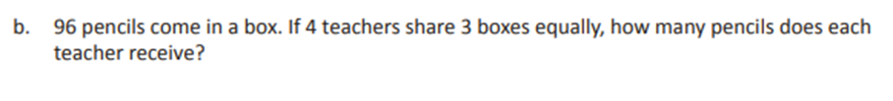
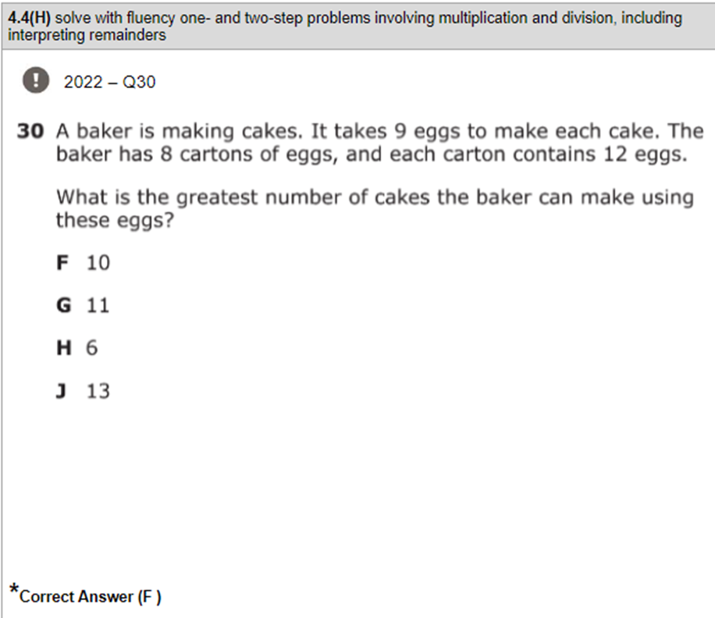 | Module 3 End of Module Assessment  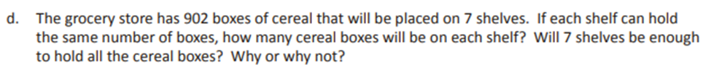
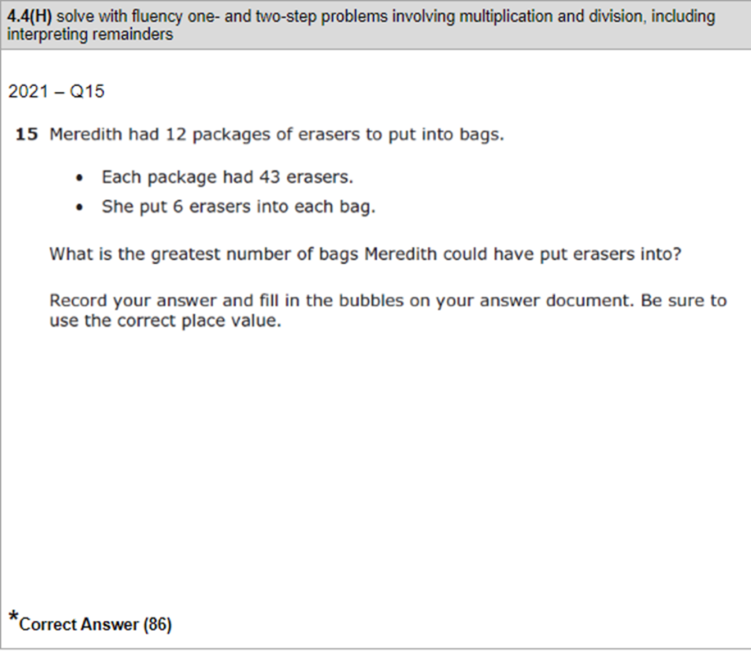 | Module 3 End of Module Assessment  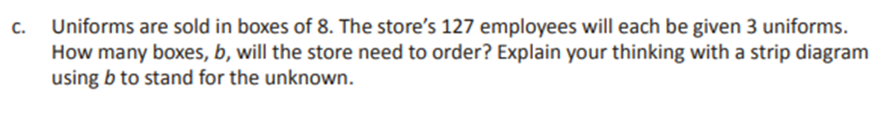
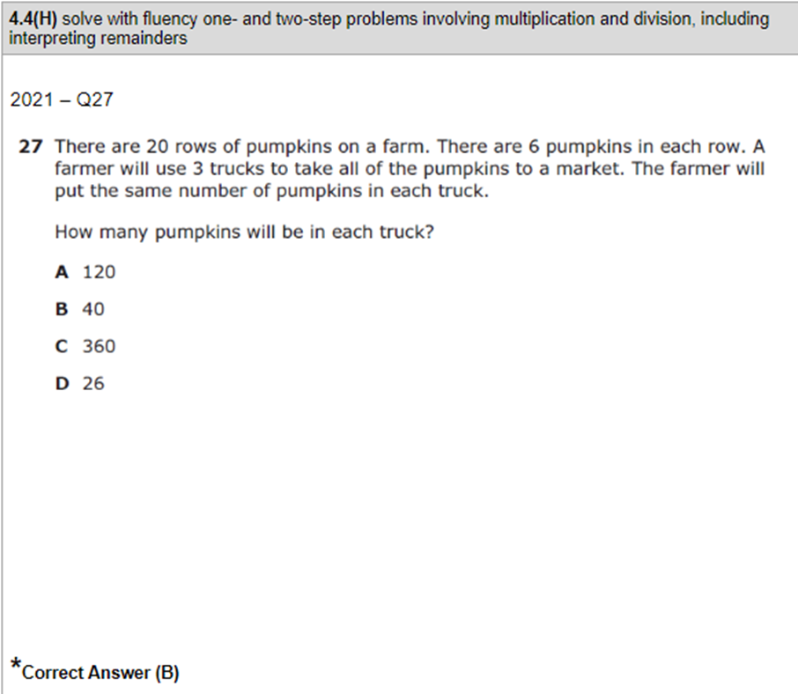 | Module 3 Lesson 28 Problem Set
TEKS 4.5(A) - Represent multi-step problems involving the four operations with whole numbers using strip diagrams and equations with a letter standing for the unknown quantity.
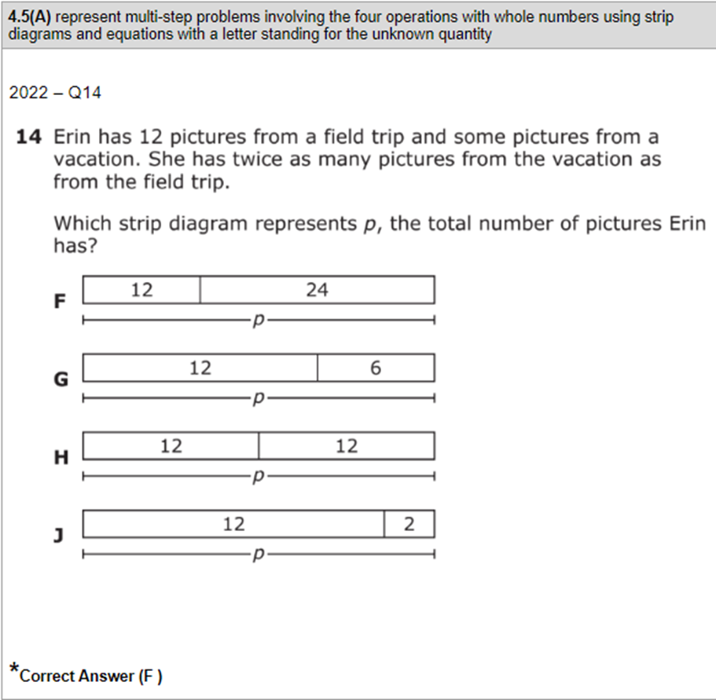 | Module 1 End of Module Assessment  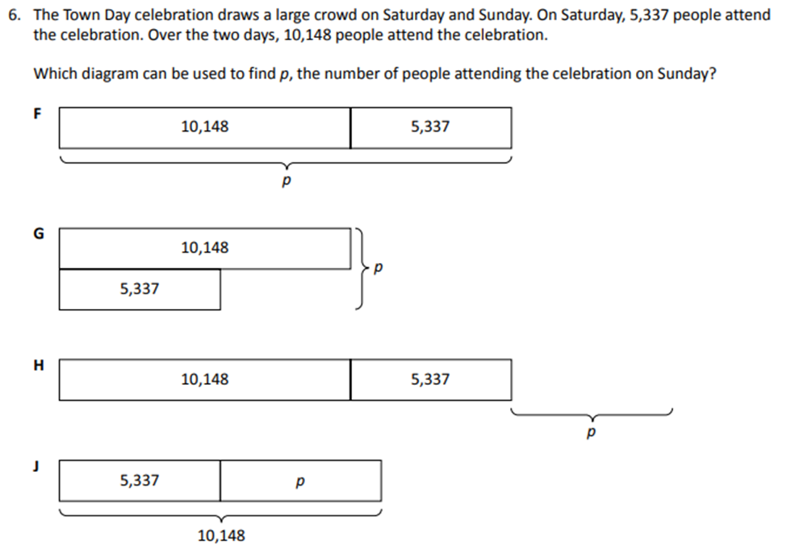
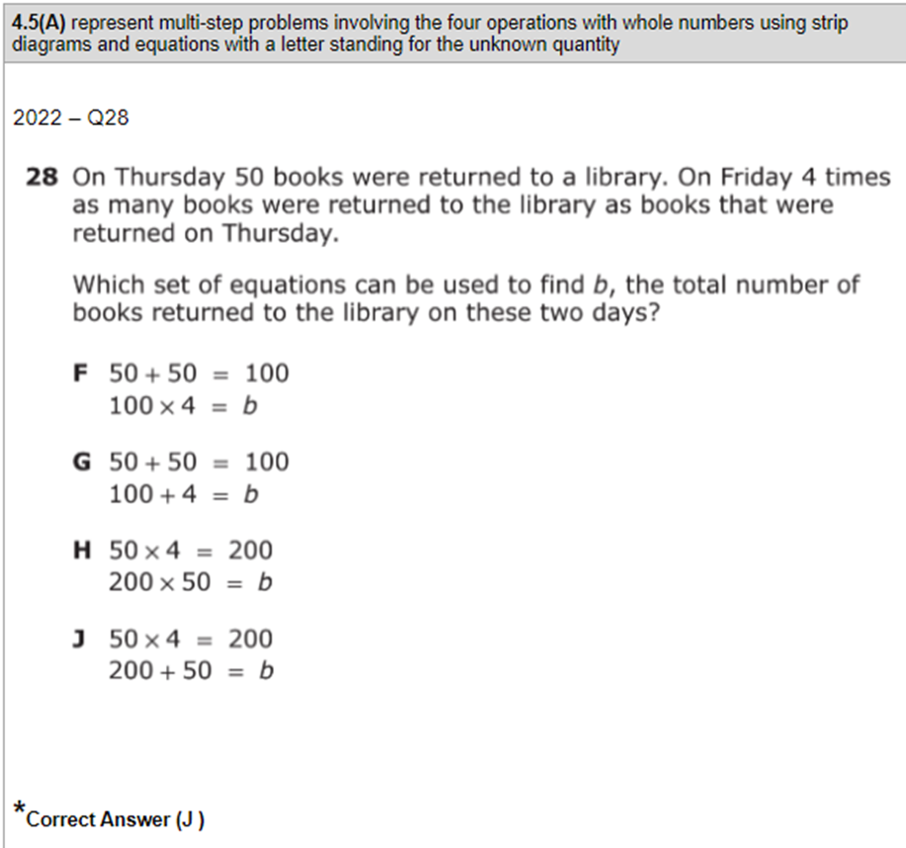 | Module 1 End of Module Assessment  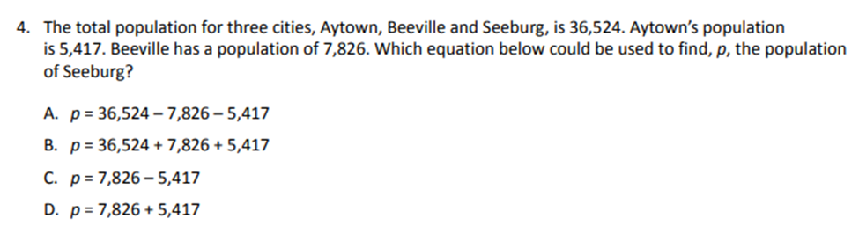
TEKS 4.5(B) - Represent problems using an input output table and numerical expressions to generate a number pattern that follows a given rule representing the relationship of the values in the resulting sequence and their position in the sequence.
*This standard is not found as a focus standard until Module 7. Supplemental material may be necessary.
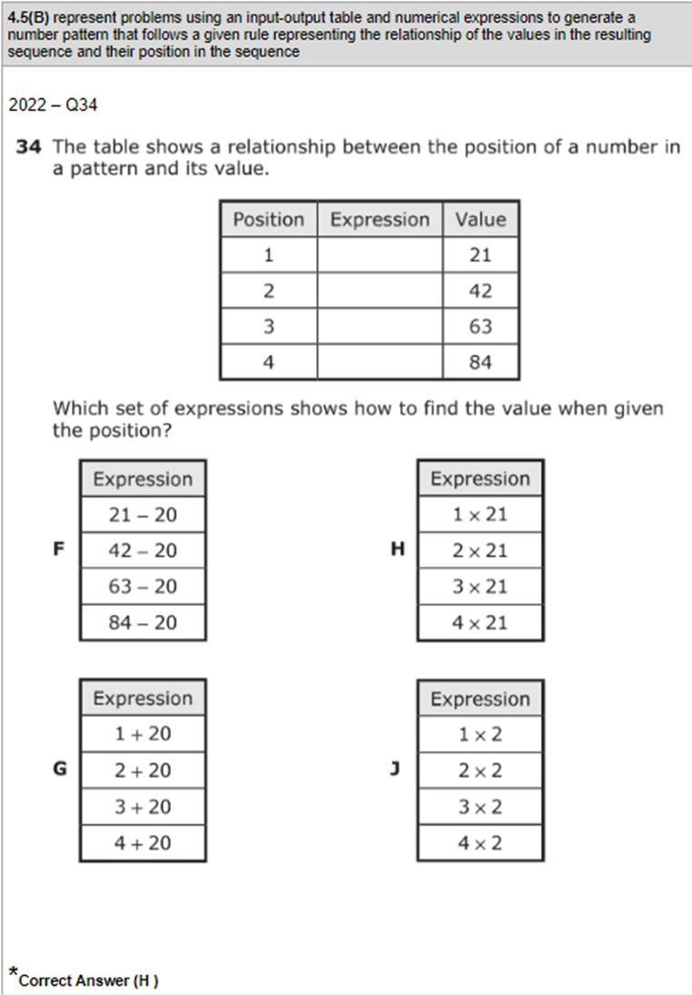 | Module 7 Lesson 3 Problem Set  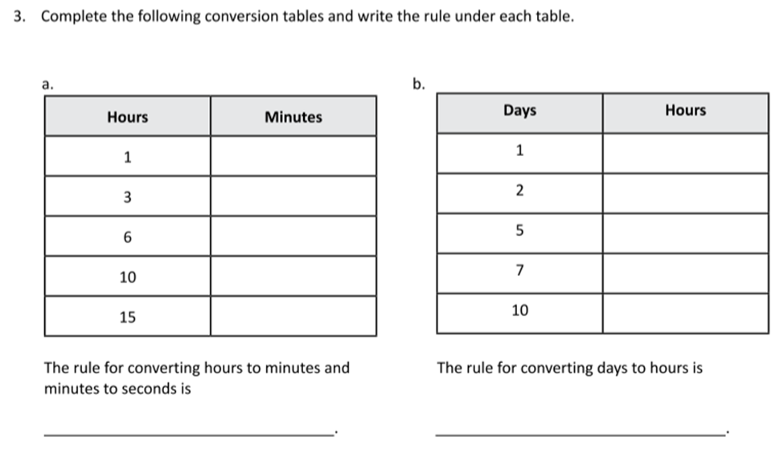
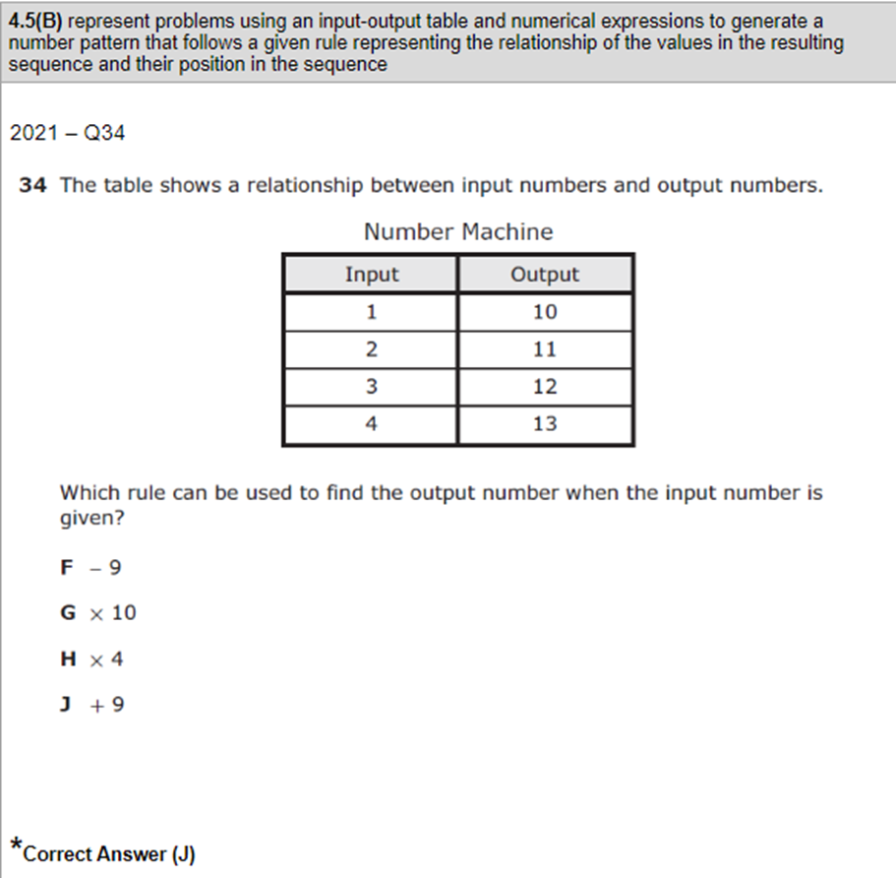
TEKS 4.6(D) - Classify two-dimensional figures based on the presence or absence of parallel or perpendicular lines or the presence or absence of angles of a specified size.
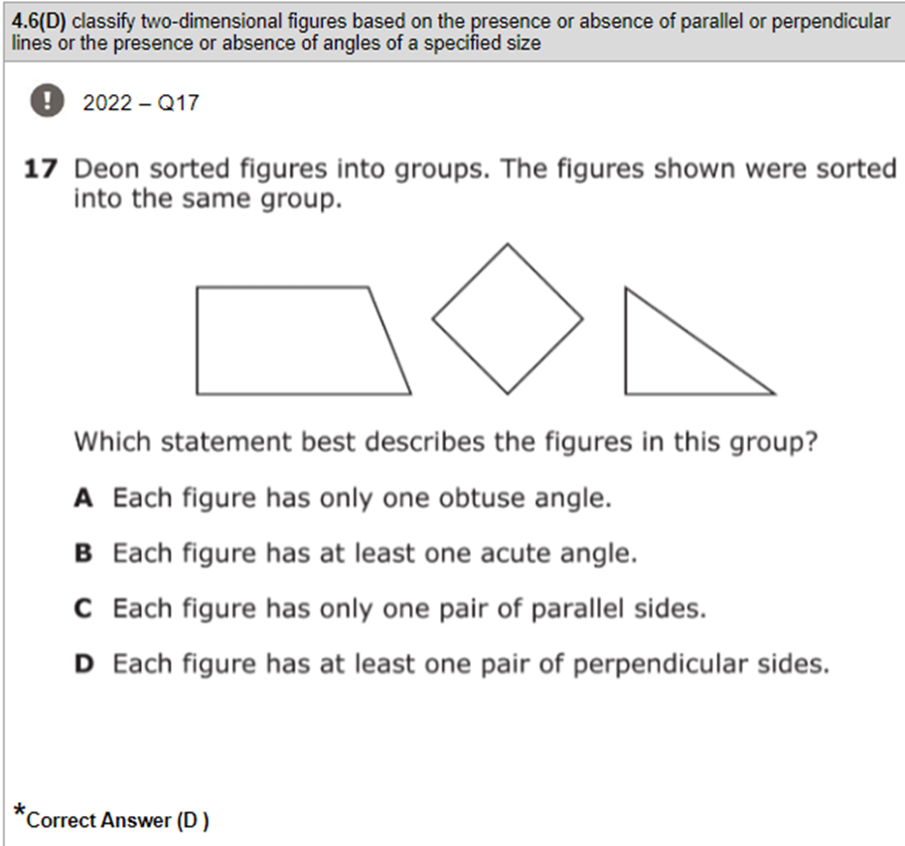 | Module 4 End of Module Assessment  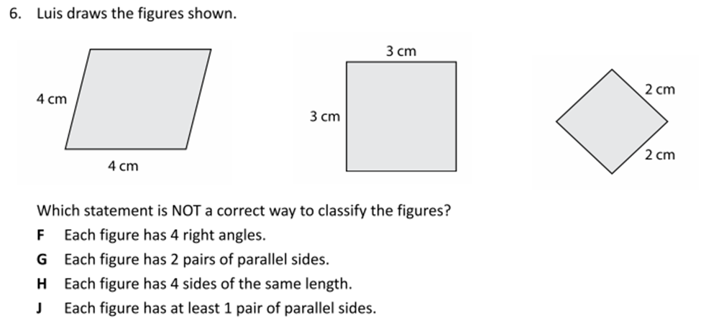
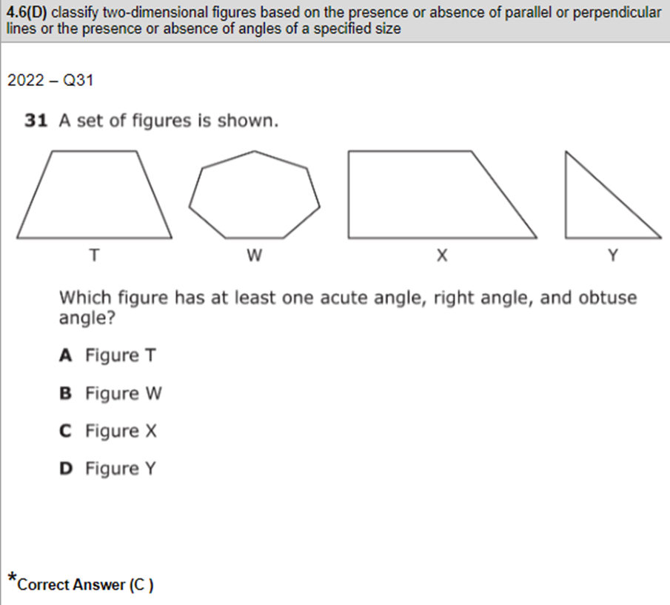 | Module 4 End of Module Assessment  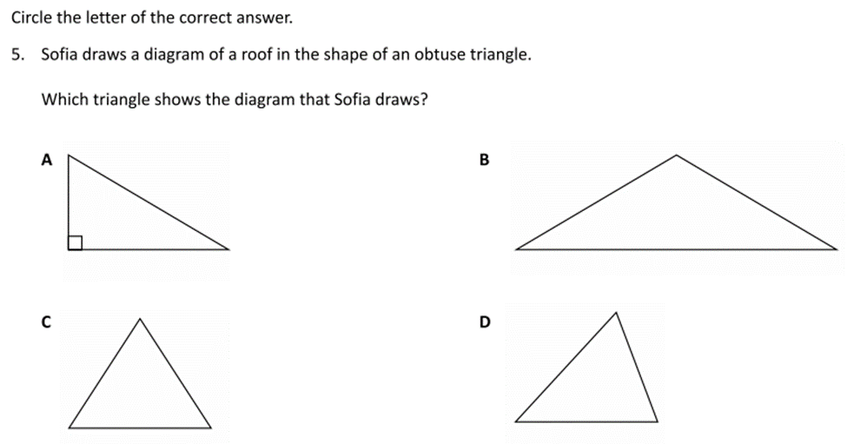
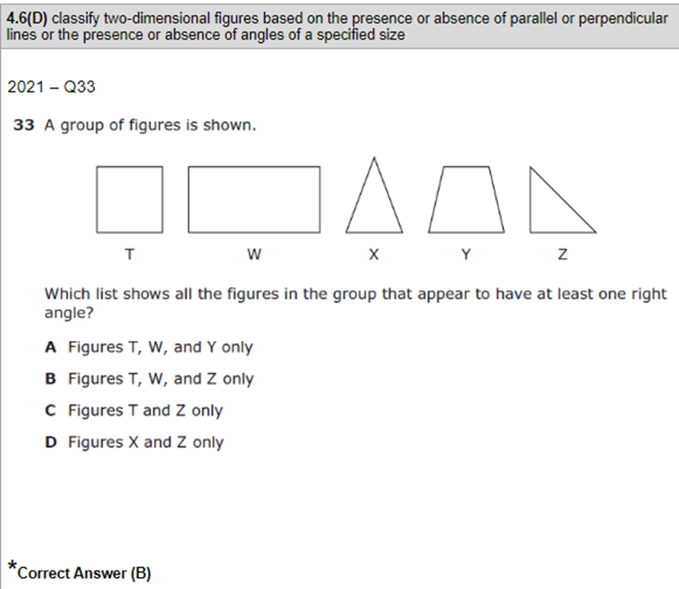 | Module 4 End of Module Assessment  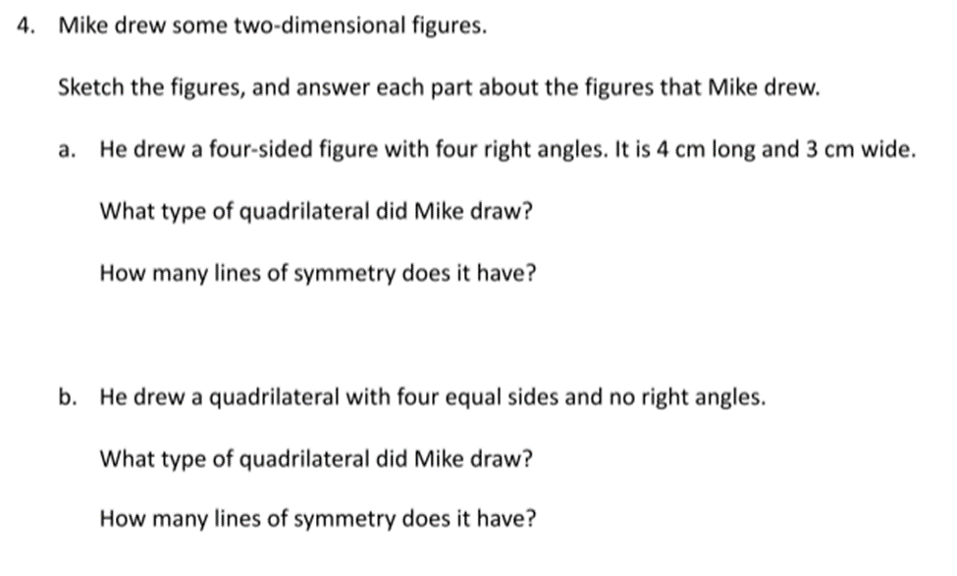
TEKS 4.7(C) - Determine the approximate measure of angles in degrees to the nearest whole numbers using a protractor.
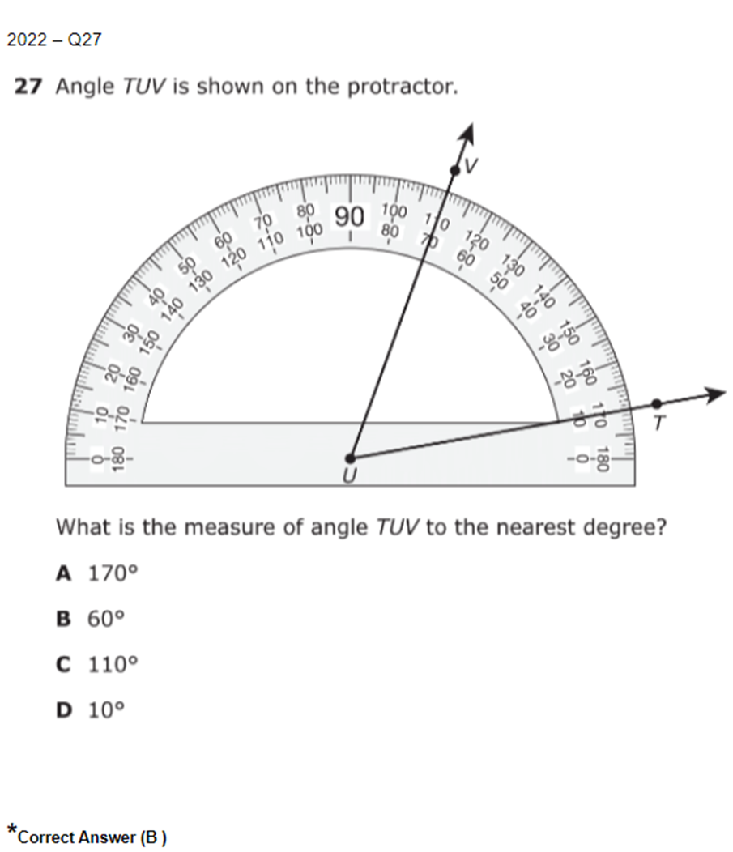 | Module 4 Lesson 7 Exit Ticket  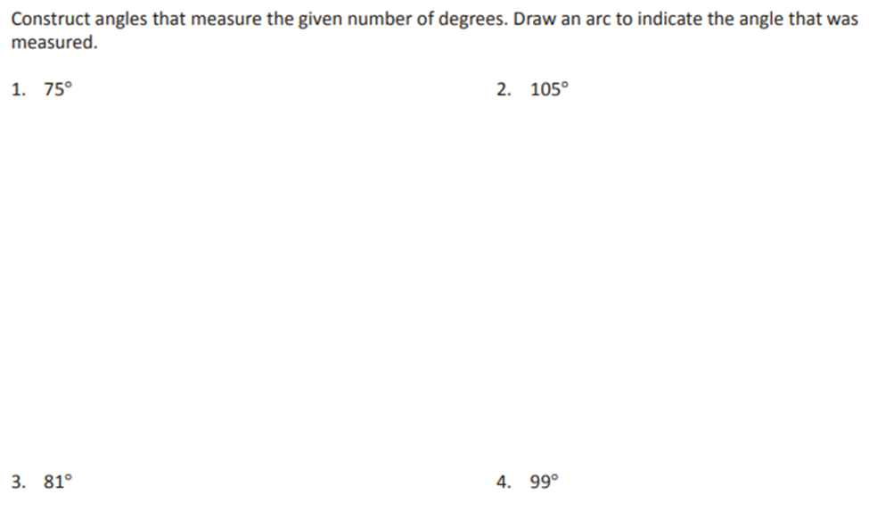  Module 4 Mid Module Assessment  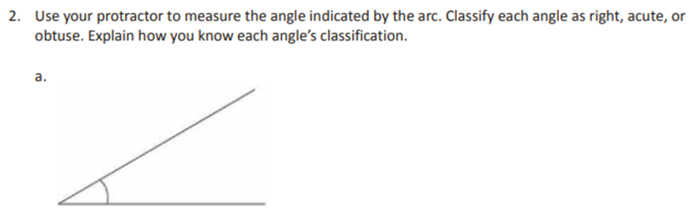
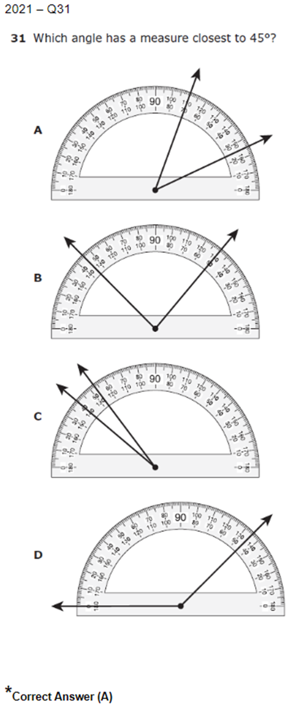 | Module 4 Lesson 6 Exit Ticket  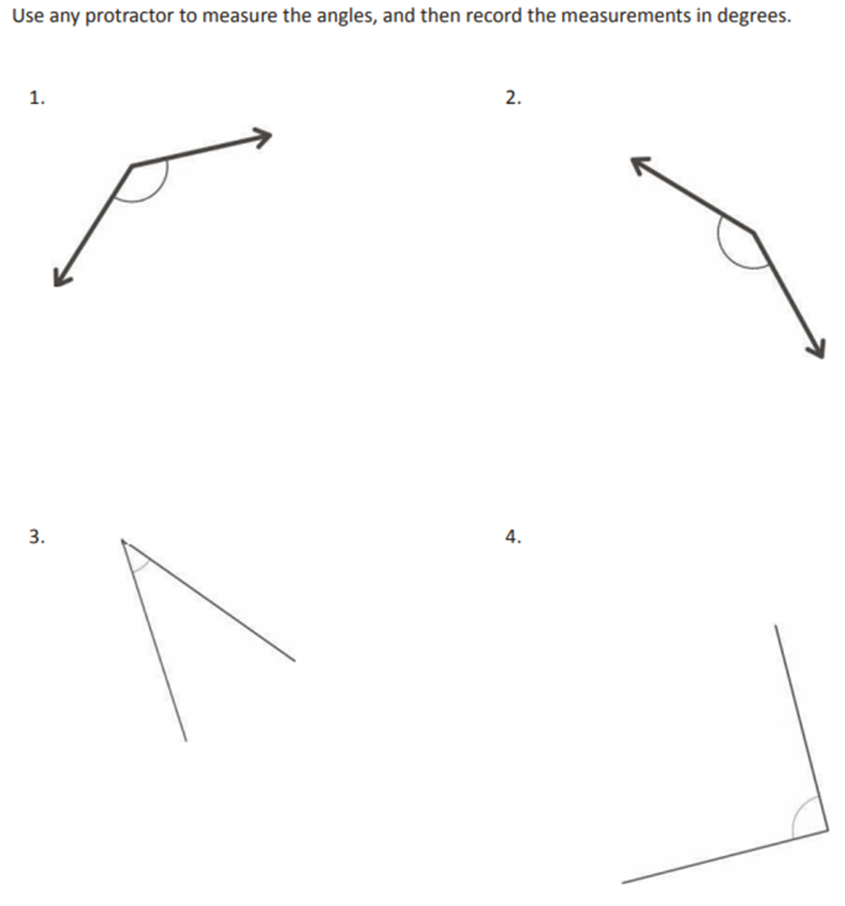
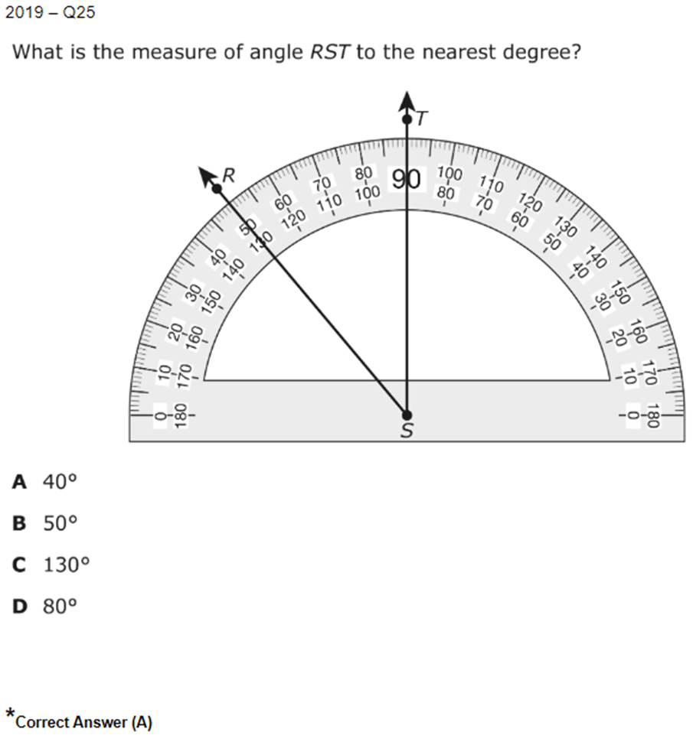 | Module 4 End of Module Assessment  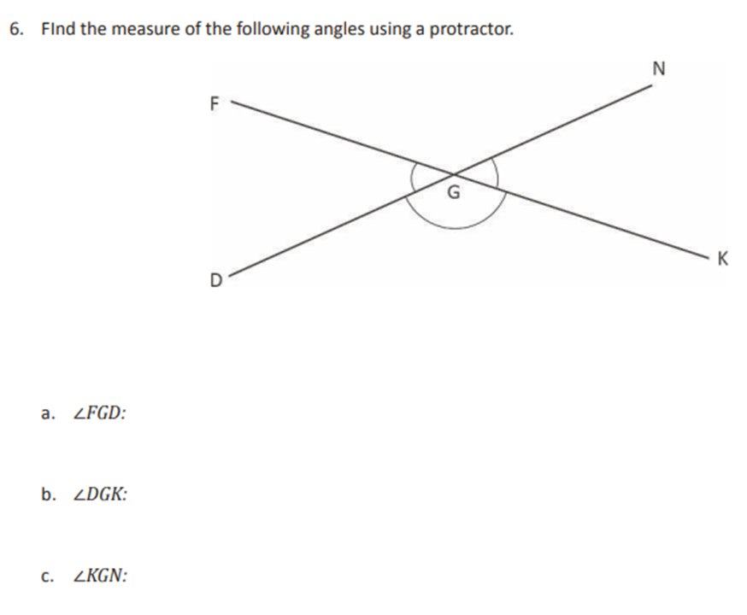  Module 4 End of Module Assessment  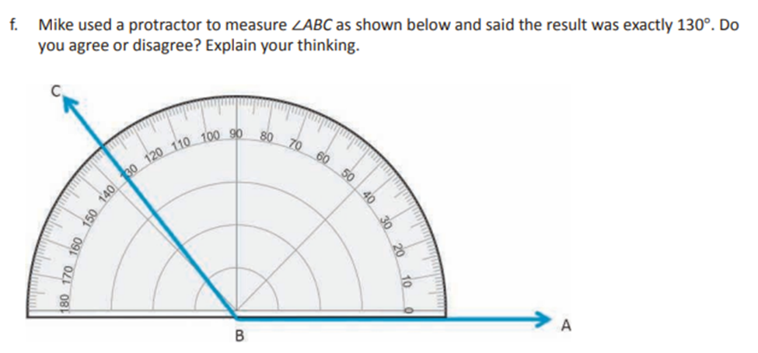
TEKS 4.5(D) - Solve problems related to perimeter and area of rectangles where dimensions are whole numbers.
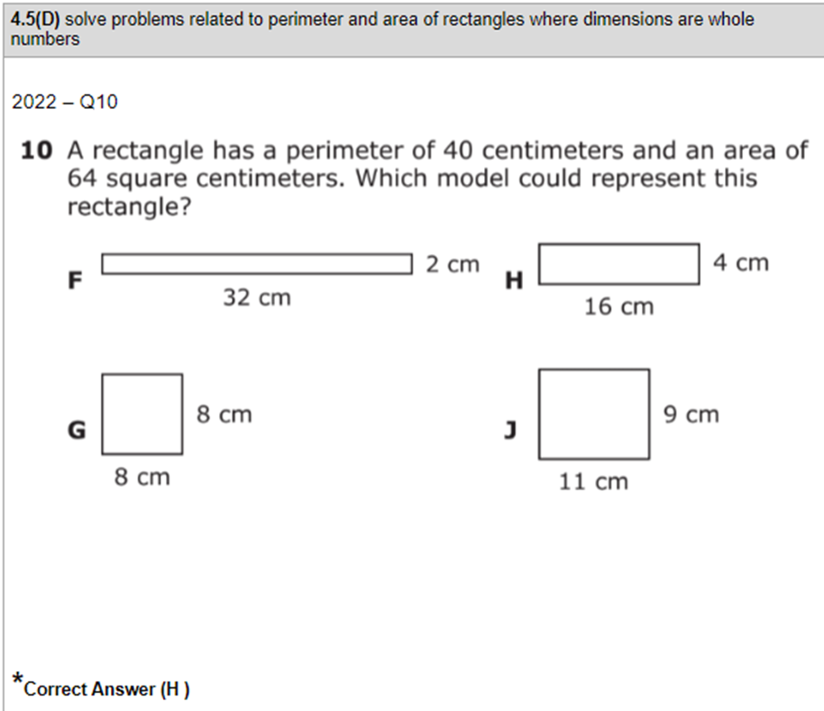
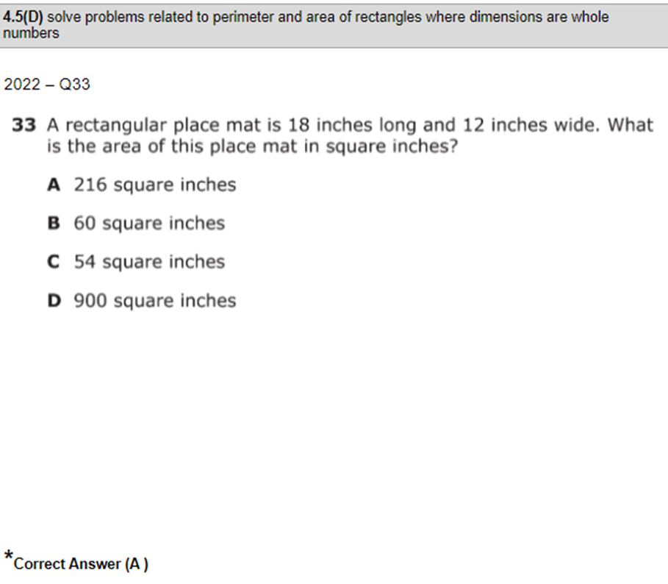 | Module 3 Lesson 1 Exit Ticket  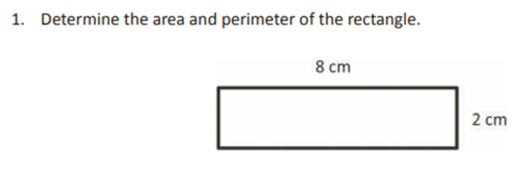  Module 3 Mid Module Assessment  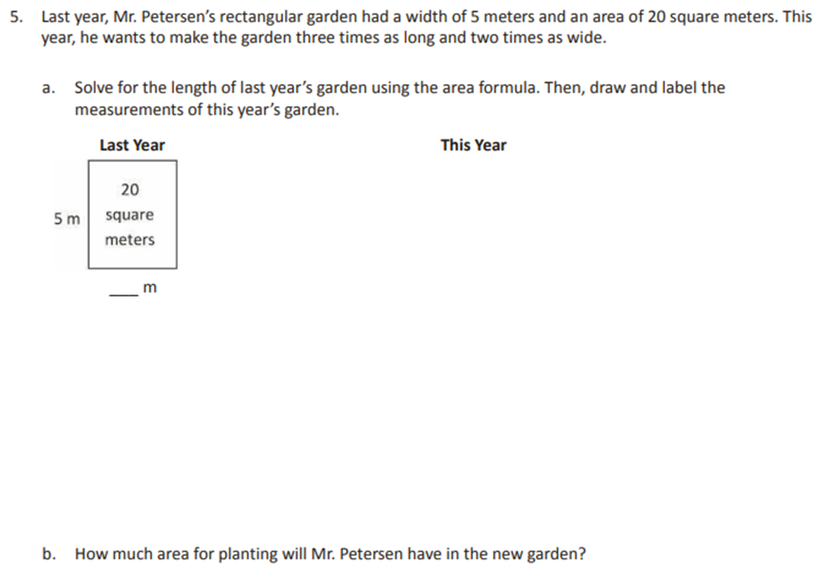
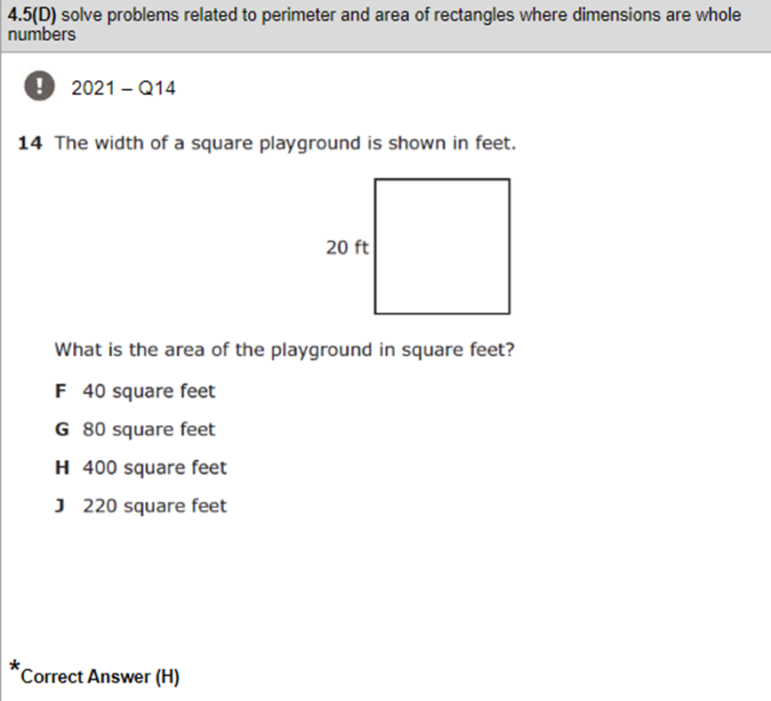
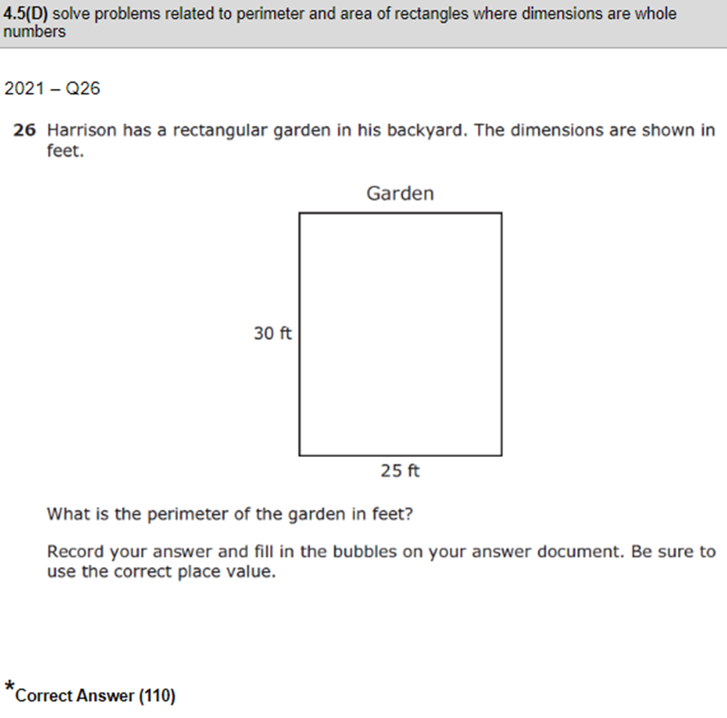 | Module 3 Lesson 3 Exit Ticket  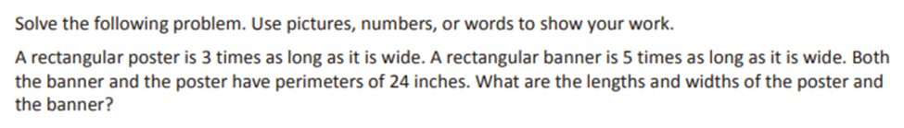  Module 3 End of Module Assessment  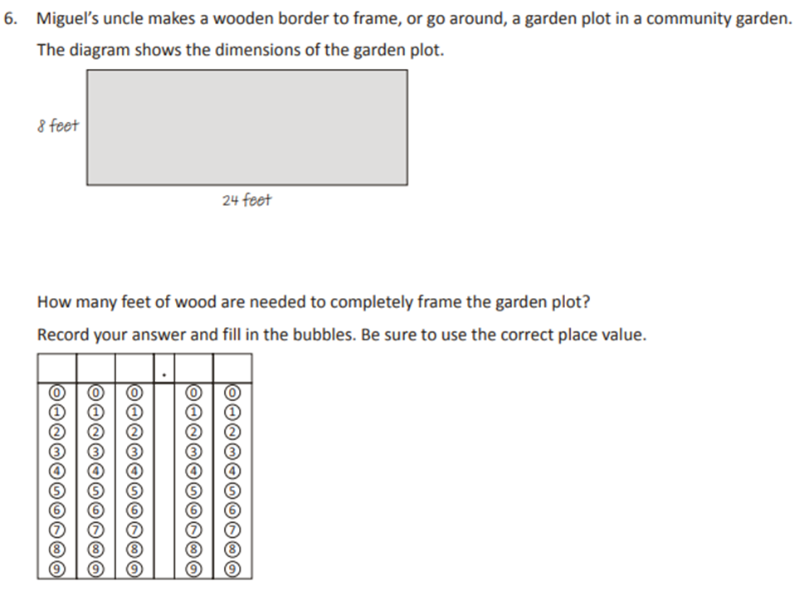
TEKS 4.8(C) - Solve problems that deal with measurements of length, intervals of time, liquid volumes, mass, and money using addition, subtraction, multiplication, or division as appropriate.
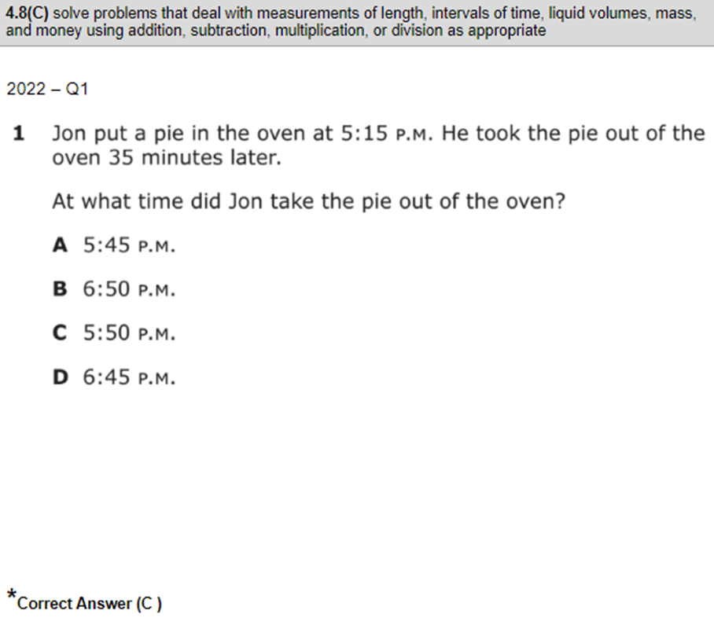
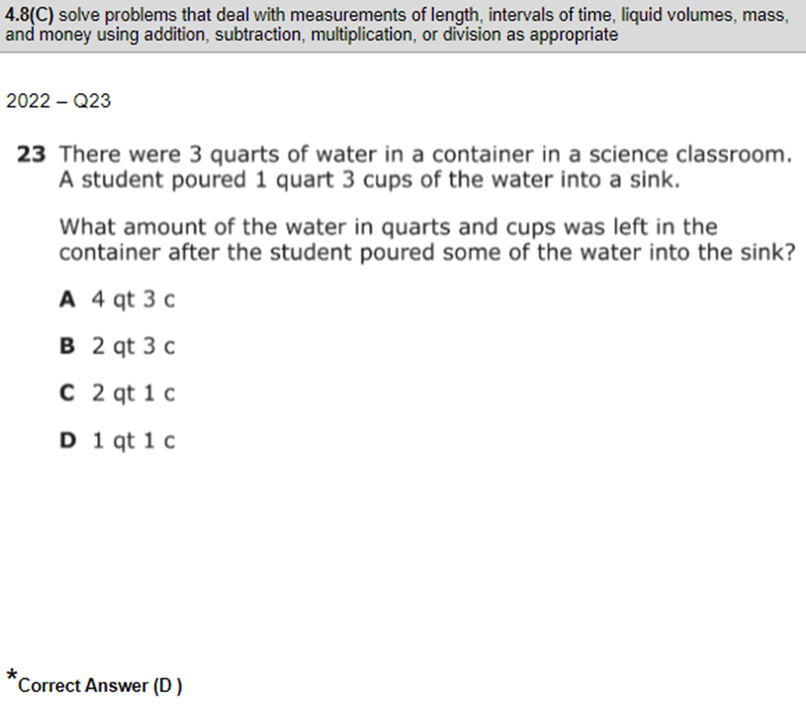
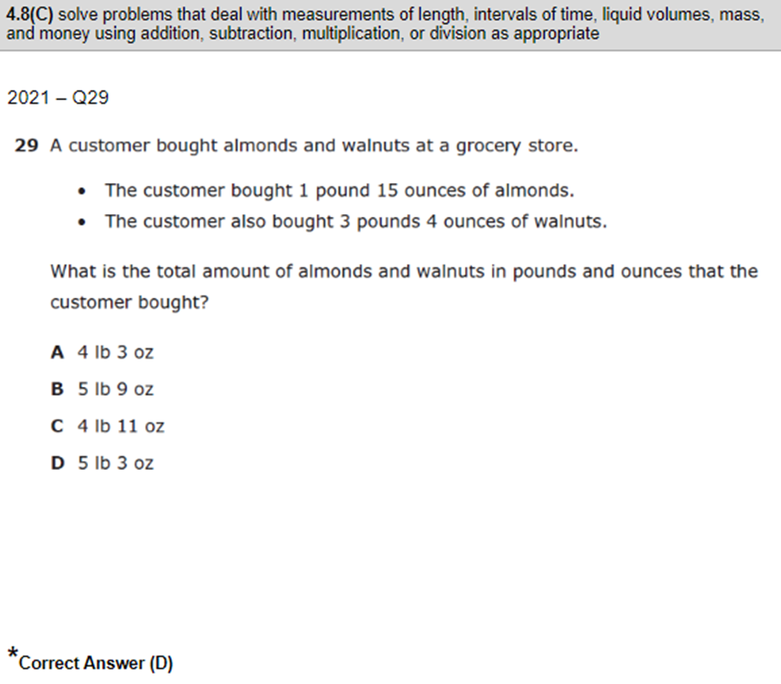
TEKS 4.9(A) - Represent data on a frequency table, dot plot, or stem and leaf plot marked with whole numbers and fractions.
