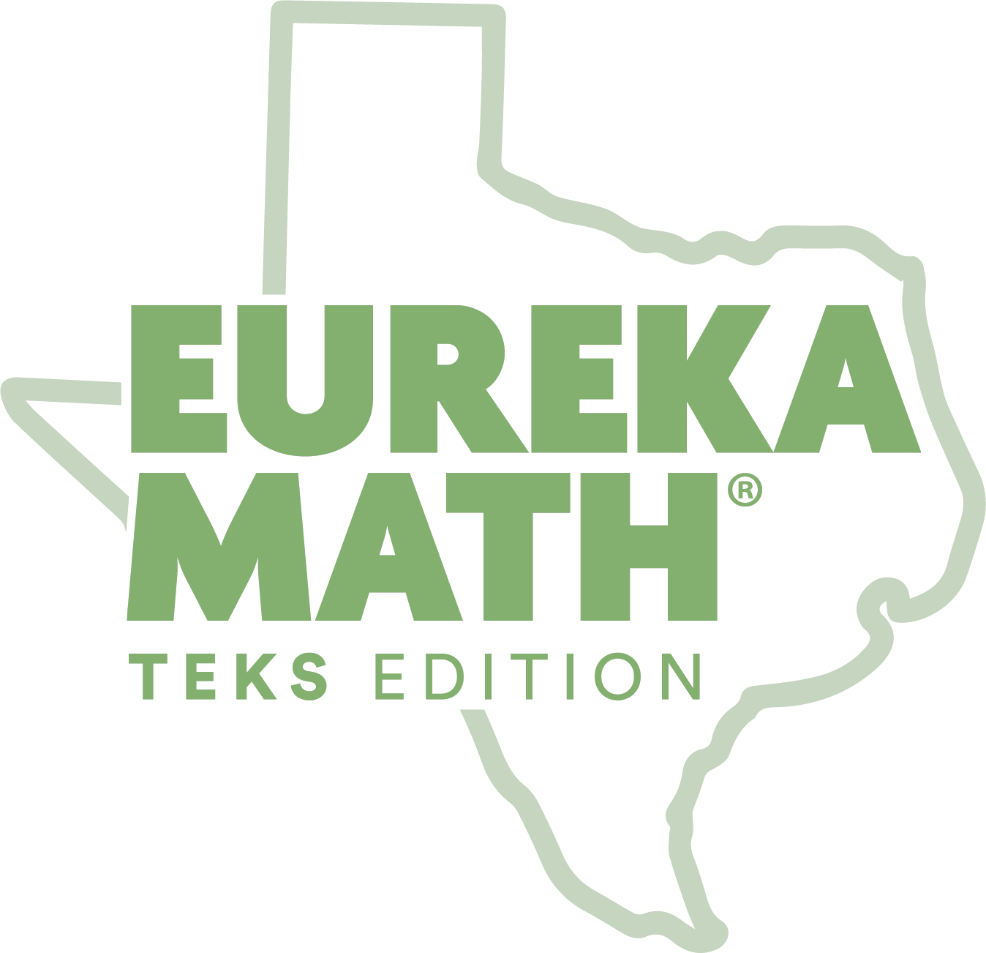
FAMILY MATH NIGHT
TEMPLATES

Invitation Templates
Page
Email invitation 2
Printable invitation 3
Flyer 4

Follow-up Templates

Follow-up email sample 5
Follow-up hard copy letter sample 6
Sample math night evaluation 7

[EMAIL INVITATION TEMPLATE]

Suggested subject line: “You’re Invited: Math Night”

Dear Parent OR <PARENT NAME>,

On <DATE> from <TIME> we’ll be hosting a Family Math Night to review what your child will learn in math this year and how you can support your child’s learning outside of the classroom with Eureka Math TEKS Edition.

Please return the RSVP with the following information by <DATE> via email to <NAME> at <EMAIL ADDRESS> so we can be prepared with the necessary supplies for the evening.
- Attending? Yes or No
- Student Name(s)
- Grade(s)
- Number of Guests (adults/children)

I look forward to seeing you at our Family Math Night!

Sincerely,
<YOUR NAME>

[PRINTABLE INVITATION TEMPLATE — CUSTOMIZE BEFORE PRINTING]

YOU’RE INVITED: FAMILY MATH NIGHT

Dear Families,

On <DATE> from <TIME> we’ll be hosting a Family Math Night to review what your child will learn in math this year and how you can support your child’s learning outside of the classroom with Eureka Math TEKS Edition Parent Resources.

Please return the RSVP card below by <DATE> via email to <NAME> at <EMAIL ADDRESS> or print and send to school with your child(ren) so we can be prepared with the necessary supplies for the evening.

I look forward to seeing you at our Family Math Night!

Sincerely,
<YOUR NAME>

FAMILY MATH NIGHT RSVP

Student Name: ____________________________
Grade:___
Teacher:___
Check one:
____ Yes, I/we will attend Family Math Night!
Number of people attending: adults___ children___
____ No, I am unable to attend Family Math Night, but please send me resources
to help me support my child with math.
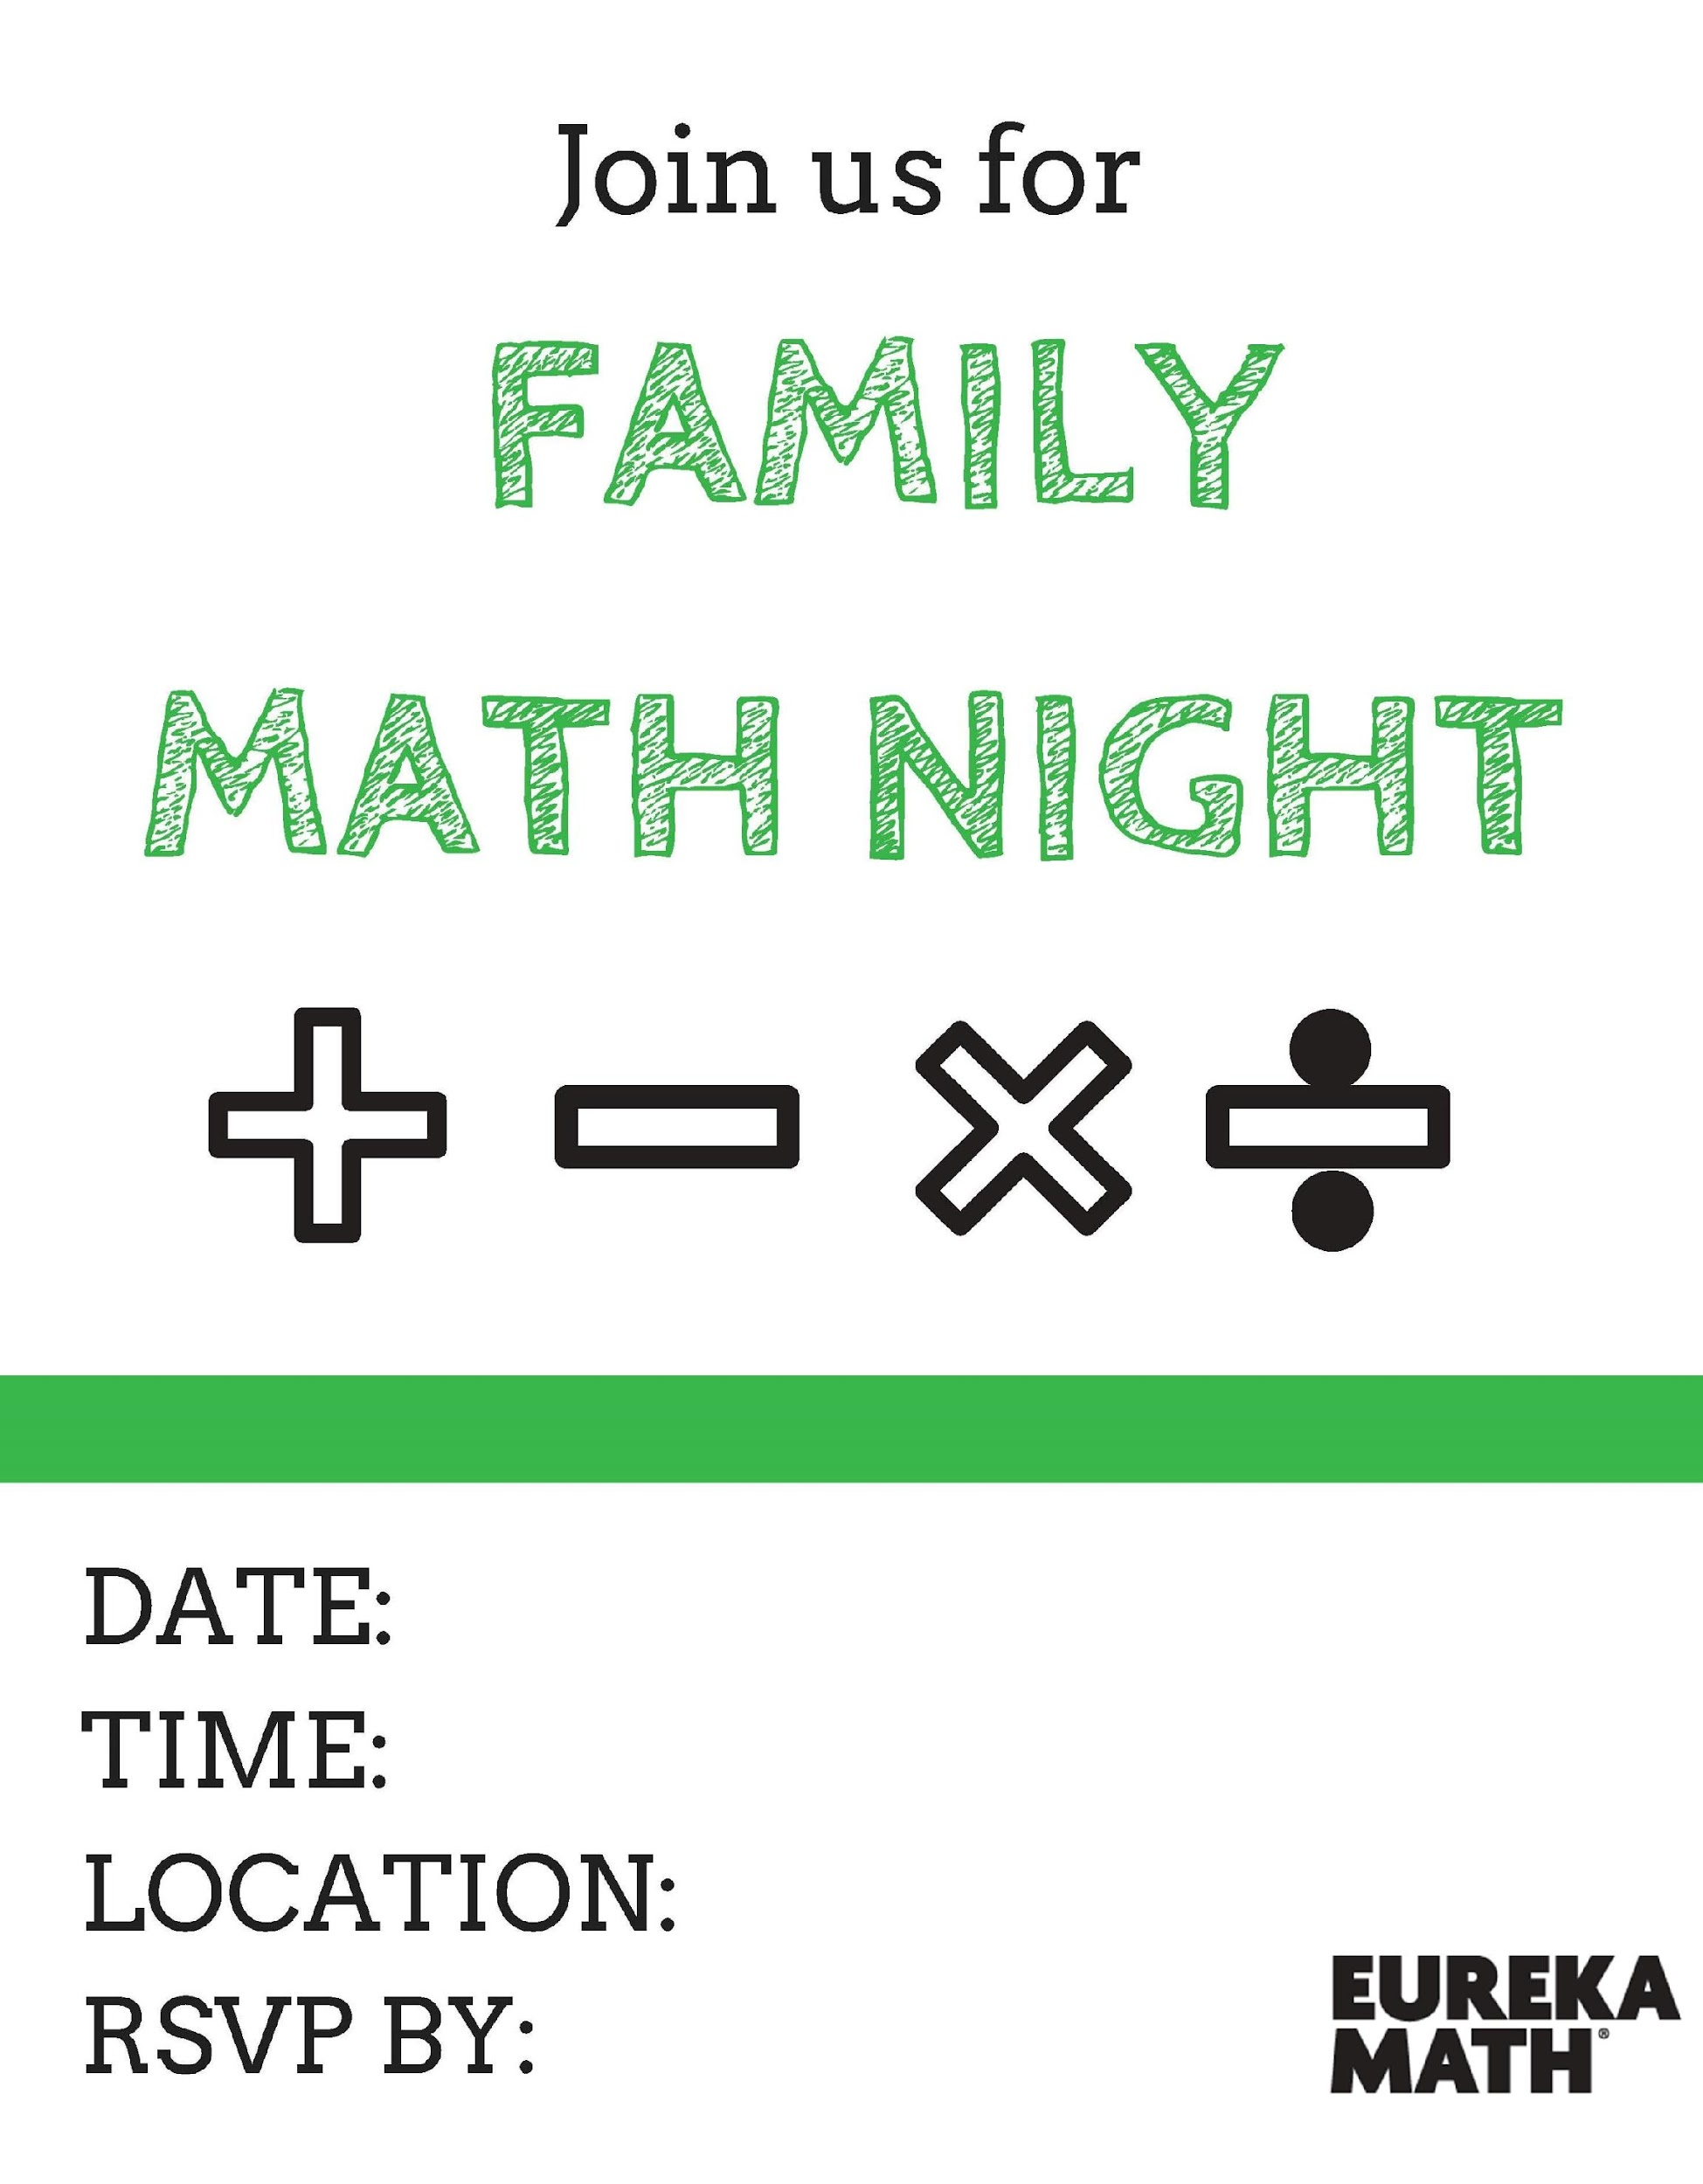
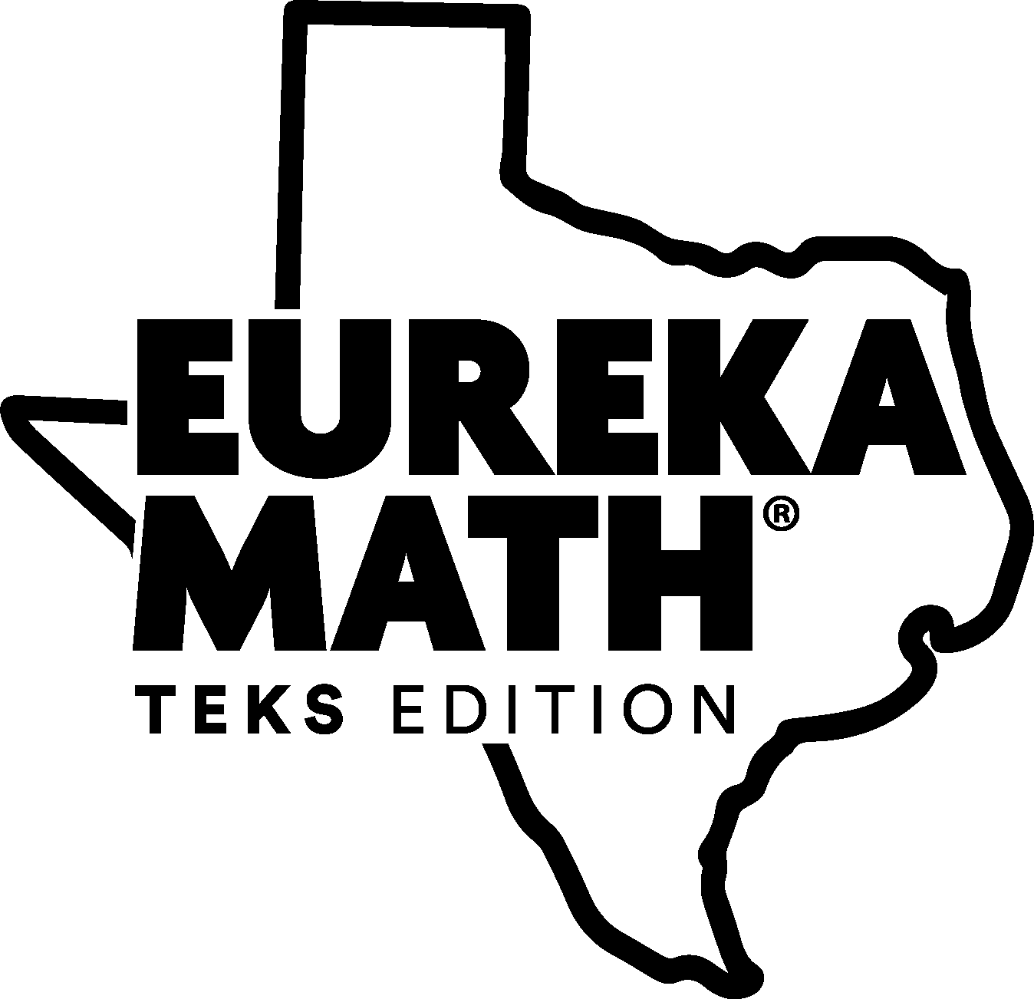

[FOLLOW-UP SAMPLE EMAIL]
Dear Parent,

Thank you to all the parents who attended our Family Math Night on <DATE>. It was great to see so many of you testing your math skills and learning more about our curriculum, Eureka Math TEKS Edition.

For those of you who could not make it, I’ve attached the handouts and some photos from our event.

If you have any questions or suggestions for our next Family Math Night, please contact me via email.

I look forward to an inspiring and exciting school year!

Sincerely,
<TEACHER NAME>

[FOLLOW-UP SAMPLE PRINTED LETTER]
Dear Parent,

Thank you to all the parents who attended our Family Math Night on <DATE>. It was great to see so many parents testing their math skills and learning more about our curriculum, Eureka Math TEKS Edition.

For those of you who could not make it, you can access the handouts on our class website or request that a copy be sent home with your child. You can also log on to your child’s insync account https://digital.greatminds.org/login to access all the free parent support resources available, including Parent Tip Sheets, videos, homework helpers and more. (These resources are available in English and Spanish.)

If you have any questions or suggestions for our next Family Math Night, please contact me via email.

I look forward to an inspiring and exciting school year!

Sincerely,
<TEACHER NAME>

[MATH NIGHT EVALUATION]
We recommend distributing this after your family math night event and collect responses before families leave.

Thank you for attending our Family Math Night! Please take a moment to provide your feedback on tonight’s event so we can improve our next event.

- What part of Family Math Night did you find to be most helpful?

- What would you like to learn about or see at the next Family Math Night?

Please circle your answer to indicate whether you agree or disagree with the following statements.

- I feel more knowledgeable about what my child will learn in math class this school year. | AGREE DISAGREE
- Family Math Night provided you with useful information and resources to help my child with their homework. | AGREE DISAGREE
- I am interested in attending another Family Math Night. | AGREE DISAGREE
- Do you have any other suggestions or feedback you’d like to share?

